NLP Ticket Triage Technical Report
Project: Support Ticket Urgency Classification

Problem Statement
Support teams receive free-text tickets that vary in wording, tone, and business impact. The project builds an NLP classifier that predicts whether a ticket is urgent or non-urgent. The practical goal is not to replace human judgment but to help route time-sensitive issues, such as outages, security incidents, data loss, and deadline-driven customer escalations, ahead of lower-risk informational requests.

Data Sources
The dataset is a newly created labeled corpus of 60 short support-ticket messages stored in data/raw/support_tickets.csv. Labels are binary: urgent and non_urgent. The dataset was intentionally created for this project so the contribution is novel rather than a replication of a common Kaggle benchmark. The corpus contains examples involving outages, billing problems, access issues, documentation questions, training requests, and UI-change requests.

Related Work
This project uses a traditional supervised text-classification pattern: transform raw text into numeric features and train a classifier. Scikit-learn documents TF-IDF as a way to convert raw documents into numerical features suitable for machine learning. Transformer models such as BERT showed the value of bidirectional language representations for broad NLP tasks, and DistilBERT showed that smaller distilled transformer models can preserve much of BERT-style performance with lower compute. Social-media sentiment tasks such as SemEval-2017 Task 4 also show that short, noisy text can be classified into meaningful categories. The novelty here is the project-specific urgency taxonomy and the comparison of lightweight methods for an operational triage use case. Sources reviewed inside this section: scikit-learn TF-IDF documentation; Devlin et al., 2019, BERT; Sanh et al., 2019, DistilBERT; Rosenthal et al., 2017, SemEval Twitter sentiment analysis.

Evaluation Strategy & Metrics
The dataset is split into stratified train and test sets using a 70/30 split. Accuracy is reported for general interpretability, but macro F1 and urgent-class precision, recall, and F1 are more important because the system is intended to detect urgent cases. Urgent recall matters because missed urgent tickets are costly; urgent precision matters because too many false alarms would reduce trust in the triage queue.

Modeling Approach
The modeling strategy compares increasing levels of complexity. The naive baseline establishes a minimum reference point. The classical model uses TF-IDF features with logistic regression, which is a strong and interpretable approach for small text datasets. The neural network model uses bag-of-words features and a compact PyTorch feed-forward network. The final deployed model is the classical TF-IDF logistic regression model because it had the strongest performance while remaining simple and explainable.

Data Processing Pipeline
The pipeline loads the CSV, validates that text and label fields exist, drops missing rows, lowercases text, normalizes whitespace, maps labels to numeric targets, and creates a stratified train-test split. TF-IDF is applied inside the classical model pipeline to avoid data leakage. The neural model uses a CountVectorizer representation before passing features into a feed-forward network.

Hyperparameter Tuning Strategy
Because the dataset is small, tuning is intentionally conservative. The classical model uses logistic regression with class_weight=balanced, max_iter=1000, and TF-IDF unigrams plus bigrams with a 2,000-feature cap. The neural model uses two hidden layers, dropout of 0.20, Adam optimization, and 20 training epochs. The focused experiment compares preprocessing alternatives rather than performing broad hyperparameter search that could overfit the small test set.

Models Evaluated
Three required models were implemented. The naive baseline is a majority-class DummyClassifier. The classical model is TF-IDF plus logistic regression. The deep learning model is a PyTorch neural network trained on bag-of-words features. The baseline shows the value of learning; the classical model tests a practical production-friendly NLP approach; the neural model tests whether a learned nonlinear representation improves results on this small corpus.

Results
The table below summarizes test-set results. The classical TF-IDF logistic regression model performed best overall and is selected as the final deployed model.
Model | Accuracy | Urgent Precision | Urgent Recall | Urgent F1 | Macro F1
Naive baseline | 0.50 | 0.00 | 0.00 | 0.00 | 0.33
Classical TF-IDF + Logistic Regression | 0.94 | 1.00 | 0.89 | 0.94 | 0.94
Neural BOW MLP | 0.83 | 1.00 | 0.67 | 0.80 | 0.83

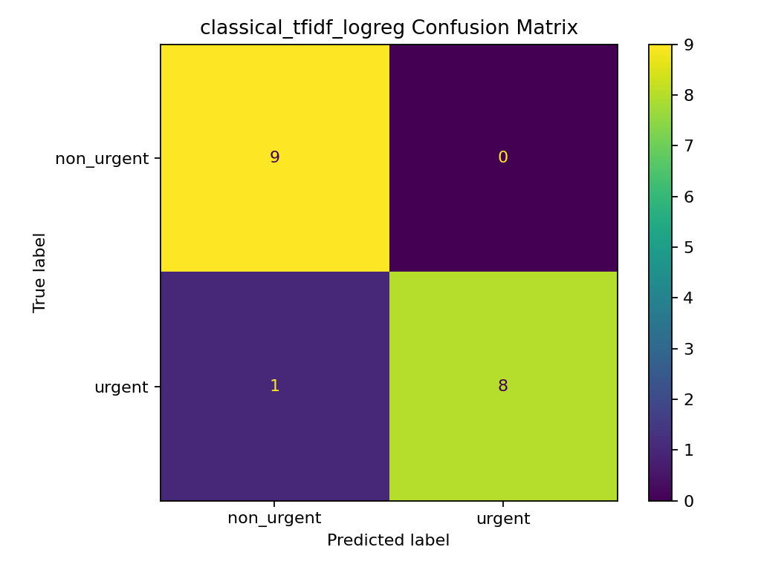
Figure: Confusion matrix for the selected classical model.

Error Analysis
Five specific mispredictions or high-risk error patterns are listed below. The first item is from the selected classical model; the remaining items are baseline errors included to show why the learned models are necessary.
Ticket text | True label | Predicted label | Root cause | Mitigation
Unauthorized charges need investigation | urgent | non_urgent | Looks like ordinary billing; few fraud examples. | Add fraud/payment-risk examples.
Mobile app login outage since 6 am | urgent | non_urgent | Baseline cannot learn outage terms. | Add outage escalation features.
Hospital users cannot access records | urgent | non_urgent | Regulated-context severity is missed. | Add healthcare/access examples.
Checkout failing; revenue dropping | urgent | non_urgent | Revenue-loss signal is missed. | Add business-impact terms.
Users locked out after MFA change | urgent | non_urgent | IAM urgency phrase is underlearned. | Add MFA/lockout examples.

Experiment Write-Up
Experimental plan: compare three preprocessing pipelines for the same logistic regression classifier: count unigrams, TF-IDF unigrams, and TF-IDF unigrams plus bigrams. This tests whether feature weighting and phrase features improve urgent-ticket detection.
Pipeline | Accuracy | Urgent Precision | Urgent Recall | Urgent F1 | Macro F1
Count unigram | 0.94 | 1.00 | 0.89 | 0.94 | 0.94
TF-IDF unigram | 0.94 | 1.00 | 0.89 | 0.94 | 0.94
TF-IDF unigram + bigram | 0.94 | 1.00 | 0.89 | 0.94 | 0.94

Results: all three preprocessing strategies tied on the test split. Interpretation: the dataset is small and contains strong urgency keywords, so all three representations capture the signal. Recommendation: keep TF-IDF unigrams plus bigrams for the deployed classical model because it should generalize better as the corpus grows and phrase patterns such as locked out, data loss, and production outage become more important.

Conclusions
The project satisfies the required NLP modeling scope by implementing a naive baseline, a classical ML model, and a neural network model. The classical TF-IDF logistic regression model is the recommended deployed model for this prototype because it performed best and is easier to explain than the neural network. The strongest conclusion is that even a lightweight NLP pipeline can separate urgent operational tickets from ordinary requests when the taxonomy is clear.

Future Work
With another semester, I would replace the synthetic project dataset with a larger real support corpus, add multi-class labels such as security, billing, outage, access, and documentation, test transformer fine-tuning, add confidence thresholds, build a human-review queue for borderline cases, and evaluate drift over time as product language changes.

Commercial Viability Statement
This is not suitable for direct commercial use yet because the dataset is small and created for coursework. It is suitable as a prototype architecture. A commercial version would need thousands of real tickets, privacy review, user acceptance testing, active monitoring, and a workflow that lets support managers override model decisions.

Ethics Statement
The main ethical risks are misclassification, automation bias, privacy leakage, and unequal performance across customer writing styles. The model should be used as decision support rather than an automatic gatekeeper. Sensitive customer data should be minimized or masked, predictions should include confidence scores, and urgent false negatives should be reviewed carefully because they can harm customers.

