Smart College Management System

Team Vortex
Westcliff University
PRG 100
Professor Vaidhya
Jun 21, 2026
Smart College Management System
This report formally initiates the project undertaken by Team Vortex as part of the PRG 100: Systems Analysis & Design course. This report confirms our group’s intention to develop the Smart College Management Platform. This report will describe the project, problem statement, our team, the technology to be used, the development process, and timeline. The report is a formal document stating that Team Vortex has agreed upon a project, understood its scope and is willing to undertake it through the entire Software Development Life Cycle (SDLC) as outlined in the requirements of the course.
Problem Statement
Many colleges manage attendance, assignments, notices, and student records through disconnected tools such as Facebook or WhatsApp groups, and spreadsheets. This leads to delayed communication, lost records, and poor academic tracking. Our project addresses this by centralizing all these operations into one structured, role-based web platform accessible to students, teachers, and administrators.
Objectives
The primary objectives of the Smart College Management System are:
- To centralize academic operations including attendance, assignments, and notices into a single web-based platform
- To provide role-based access for students, teachers, and administrators
- To eliminate dependency on informal communication channels such as social media groups.
- To improve transparency and efficiency in academic record management;
- To deliver a functional, tested, and documented system within the eight-week project timeline.
Team Composition
Team Vortex consists of four members, each assigned a primary role. All members will contribute to UML diagrams, testing, and the final presentation regardless of their designated role.
Table 1
Team Vortex: Member Roles
No. | Full Name | Role
1 | Rahul Rimal | Database & Documentation
2 | Bilakshana Neupane | Backend Developer
3 | Yugal Sapkota | Frontend/UI Designer
4 | Prasun Rimal | Testing & Quality Assurance

Proposed System
Overview
The system will operate across three modules. The Student Module allows students to view schedules, check attendance, submit assignments, and read notices. The Teacher Module enables faculty to upload assignments, mark attendance, and post announcements. The Admin Module allows administrators to manage users, departments, and generate reports.
Technology Stack
The system will be built using React.js for the frontend, Node.js with Express for the backend, and MySQL as the database. It will follow a 3-Tier Architecture separating the Presentation, Application, and Database layers. Draw.io will be used for system modeling.
Project Methodology
The team will work with the Agile Scrum approach to development. The Waterfall model is not preferred as the project lasts only 2 months and there are four of us in a group and requirements could change as development goes. This enables iterative development, continuous review, and flexibility to adapt the development to more testing and feedback along the way. The project will be broken down into sprints and sprints will have clear deliverables. Tasks will be distributed, tracked and reviewed in the team using the Scrum framework.
Sprint meetings will be held on a regular basis to review project progress, address obstacles, and keep everyone on team on track towards project goals. Once sprints have been completed, reviewed, and tested, modules and features will be reviewed and tested before moving onto the next phase of development. This methodology also promotes ongoing collaboration, quicker issues resolution and gradual improvement of the system throughout the project lifecycle in line with Agile software engineering principles presented by Pressman and Maxim [1] and the Agile Manifesto [2]. The Unified Modeling Language (UML) modeling techniques will also be used in the analysis and design stage, as suggested by Booch, Rumbaugh and Jacobson in UML framework [3] to visually represent the structures, workflows and interactions between the various components of the system.
Project Timeline
Week 1 covers requirement analysis and the SRS draft. Week 2 involves system design including all UML and DFD diagrams. Week 3 focuses on UI prototyping. Week 4 handles database development. Weeks 5 and 6 cover backend and frontend development. Week 7 is dedicated to testing and quality assurance. Week 8 is reserved for the final presentation and documentation submission.
Functional Requirements
The proposed system will allow students to log in and access academic resources. Teachers will be able to upload assignments and manage attendance records. Administrators will manage users, departments, and system reports. The system will maintain secure role-based access control for all users.
Gantt Chart
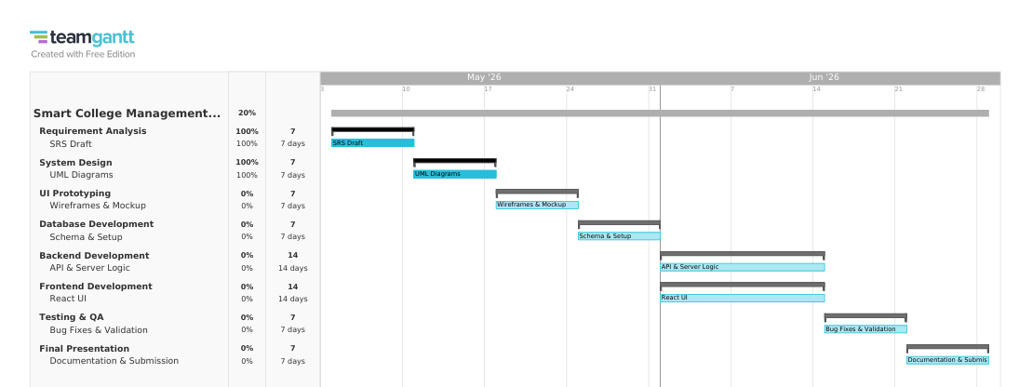
Figure 1. Gantt Chart for Team Vortex

UML Diagrams
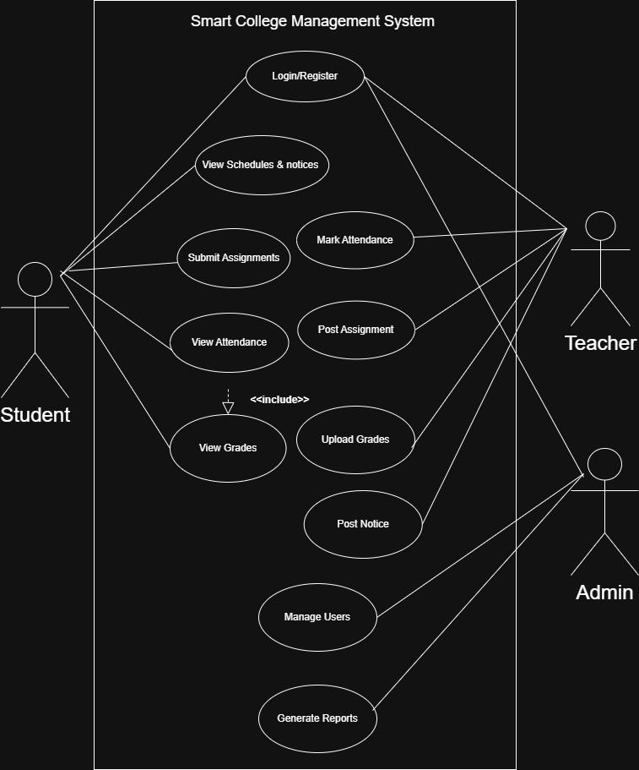
Figure 2. Use Case Diagram

DFD Diagrams
Figure 3. Data Flow Diagram (Level 0)
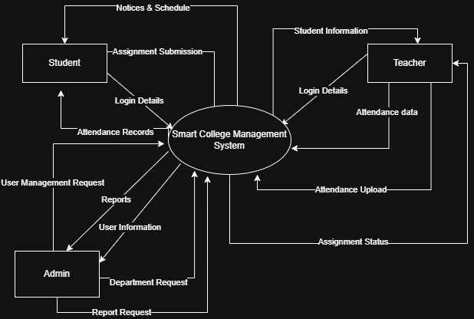

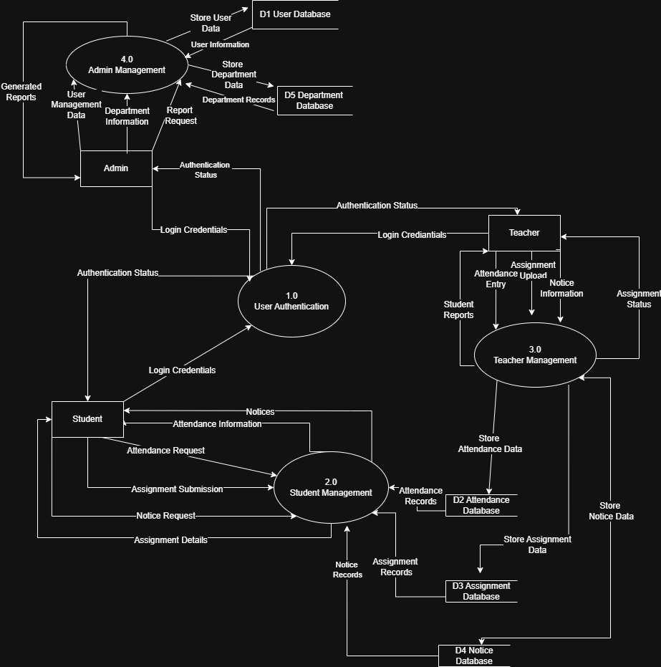
Figure 4. Data Flow Diagram (Level 1)

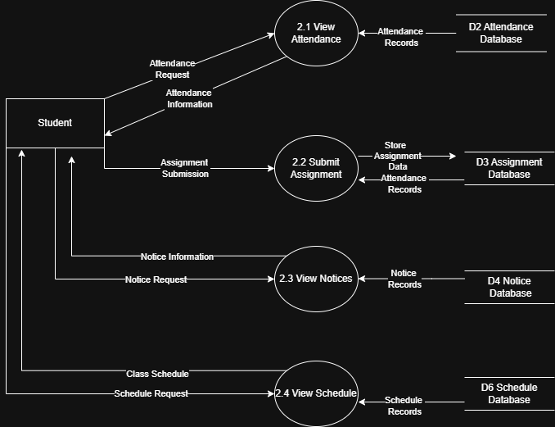
Figure 5. Data Flow Diagram Student (Level 2)

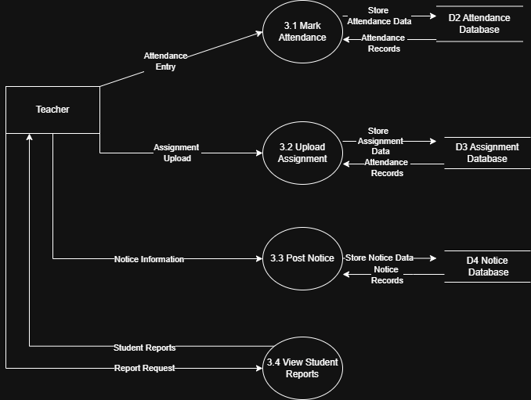
Figure 6. Data Flow Diagram Teacher (Level 2)

Figure 7. Data Flow Diagram Admin (Level 2)
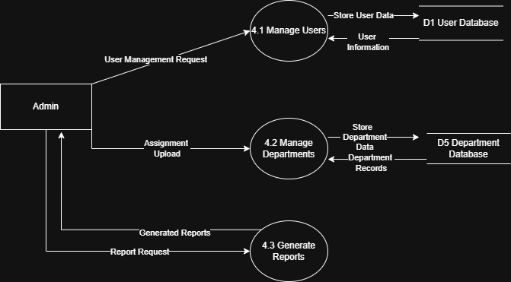

Figure 7. Activity Flow Diagram (Student)
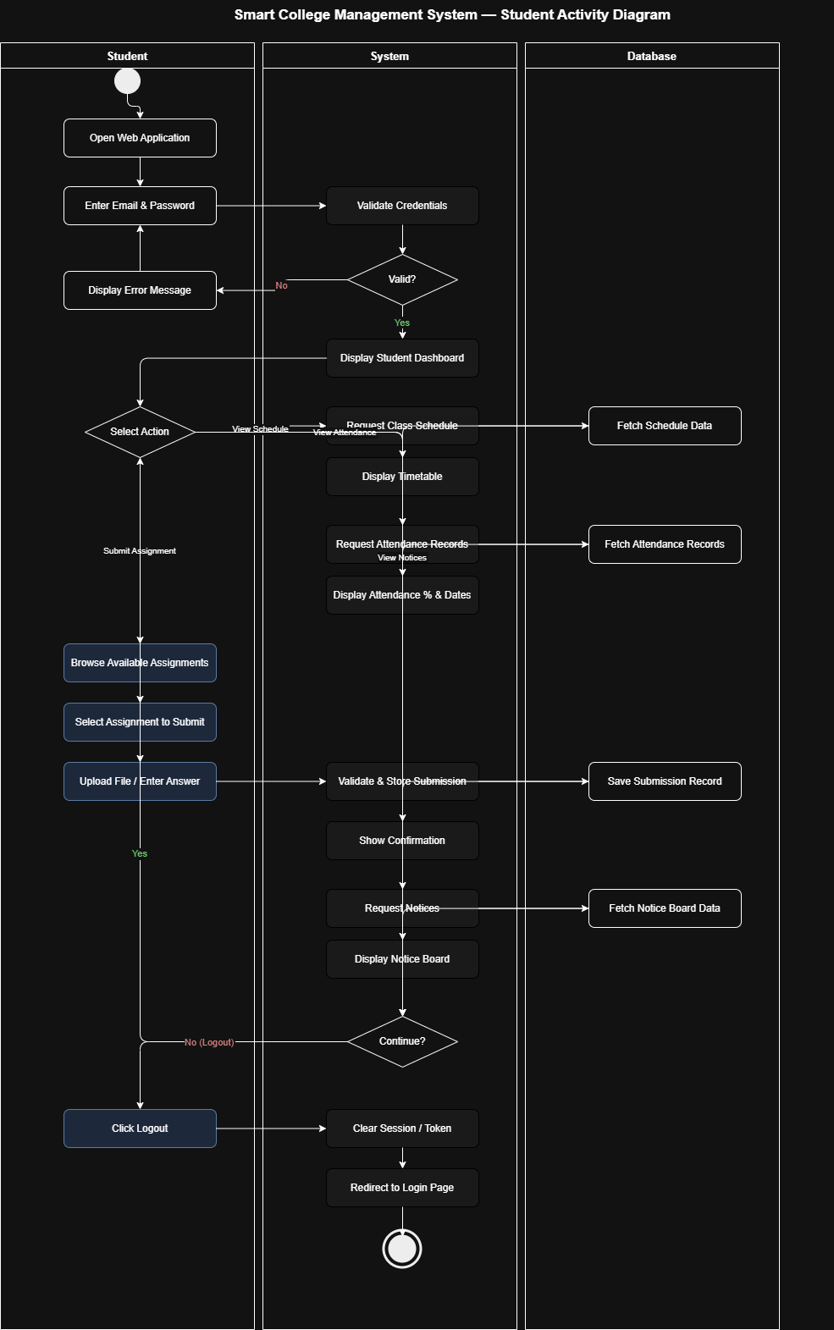

Figure 8. Activity Flow Diagram (Teacher)
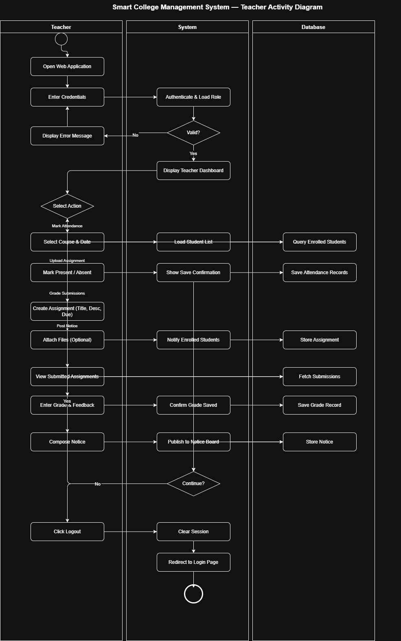

Figure 9. Activity Flow Diagram (Admin)
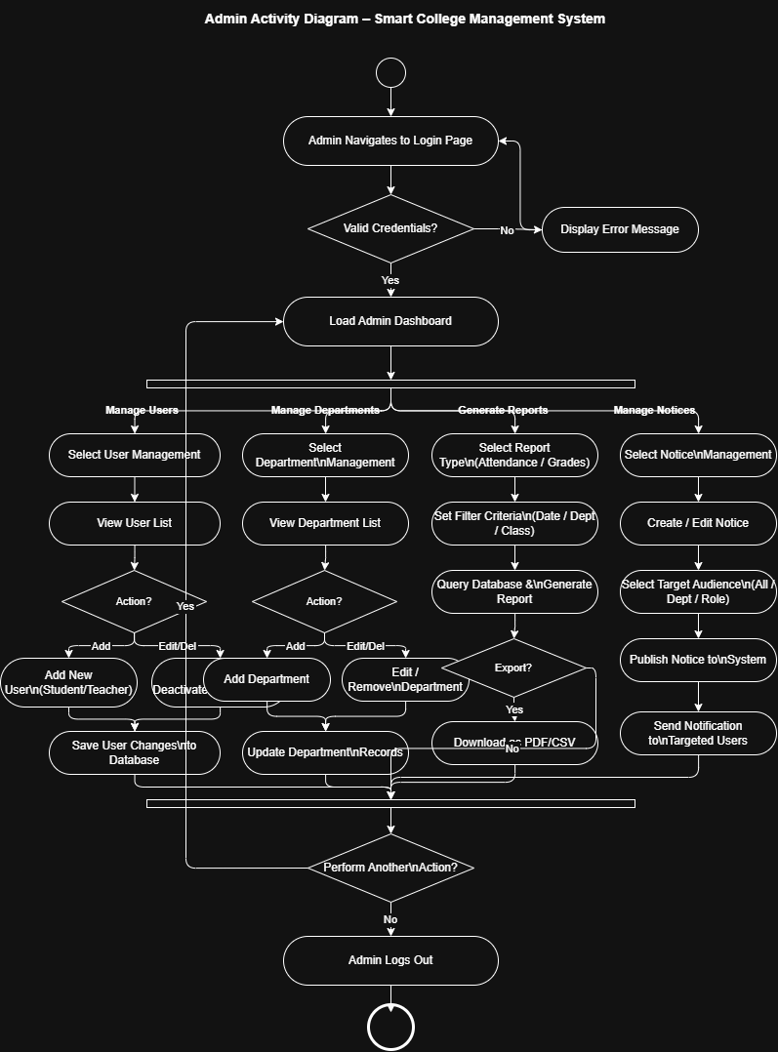

Figure 10: ER Diagram
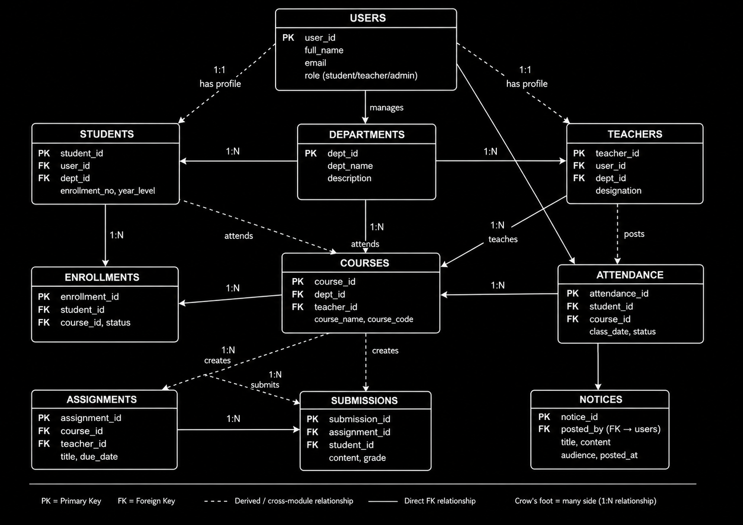

Figure 11: Relational Diagram
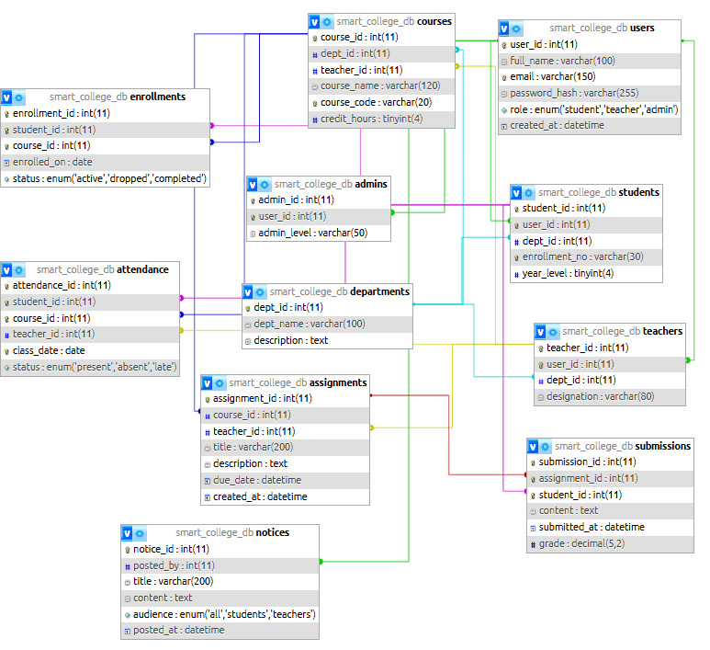

Figure 12: UML Class Diagram
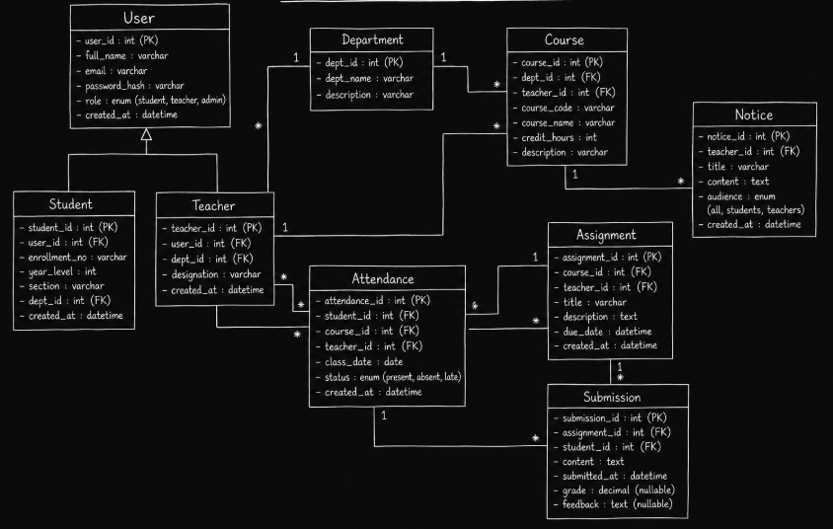

Figure 13: Sequential Diagram
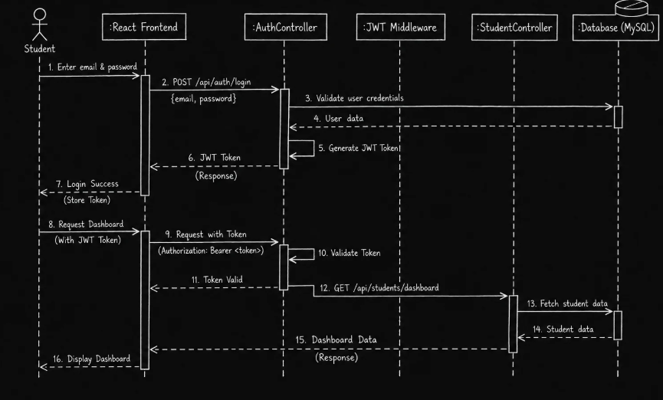

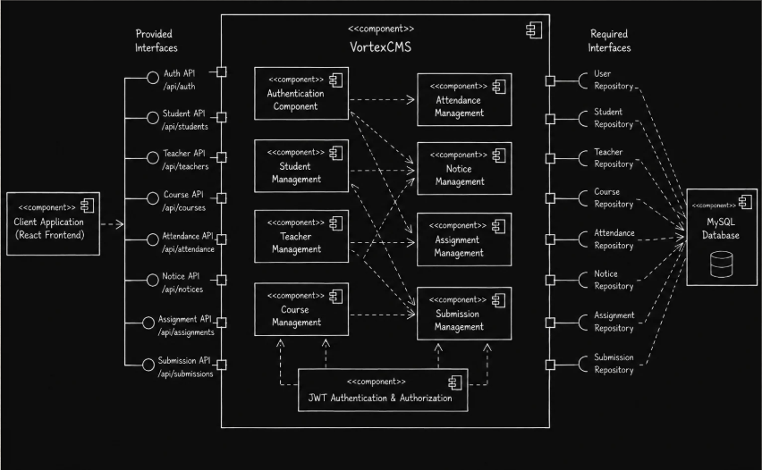
Figure 13: Component Diagram

Figure 14: Deployment Diagram
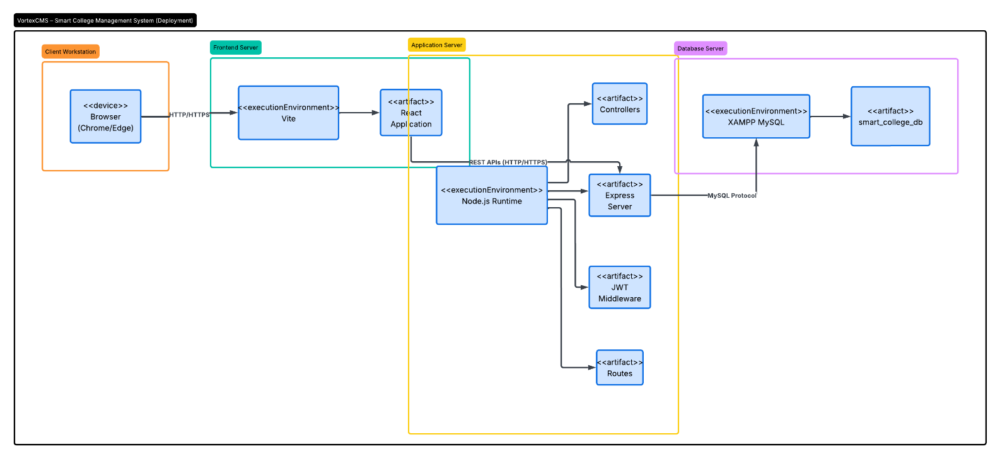

Figure 15: Risk Table
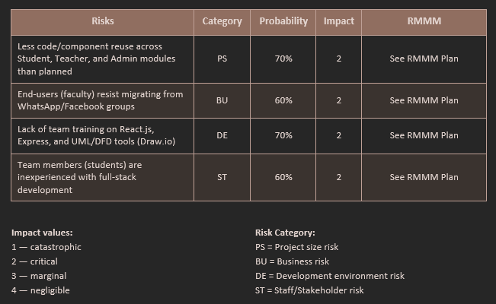

Figure 16: Risk Information Sheet: Component Reuse
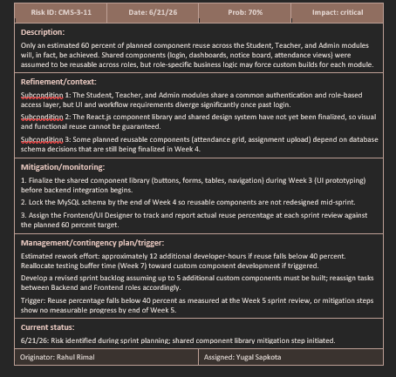

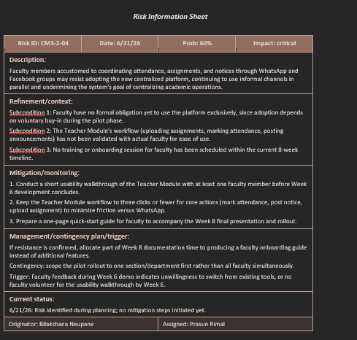
Figure 17: Risk Information Sheet: Faculty Adoption Risk

Deployment
The VortexCMS Smart College Management System comes with the three-layer architecture: Client Layer, Application Layer and Database Layer. The Users use the system via a Web Browser, which connects with the React front-end application that is running on the front-end server. The frontend communicates with the backend via the RESTful API, which consists of the Node.js and Express.js components, which process the requests, authenticate the users, and apply business logic to the requests. This backend is linked with a MySQL database that is running on XAMPP and that stores and manages all the data for the system: users, students, teachers, courses, attendance, assignments, notices, etc. This deployment pattern provides efficient communication, data management and security access to system resources.
Conclusion
Successfully designed and developed the VortexCMS Smart College Management System which resolves academic and administrative hassles in college. To design an Integrated Management Platform, software engineering principles like System Analysis, Database Design, UML Modelling, and Web Application Development were applied. Modules for authentication, student management, course management, attendance tracking and notices ensure an organized, efficient solution for dealing with institutional data. The project's overall results were satisfactory and demonstrated how cutting-edge web technologies can be implemented in the creation of scalable and user-friendly information systems.

References
[1] R. S. Pressman and B. R. Maxim, Software Engineering: A Practitioner’s Approach, 8th ed. New York, NY, USA: McGraw-Hill Education, 2014. [Online]. Available: https://www.mheducation.com/highered/product/software-engineering-a-practitioners-approach-pressman.html
[2] “Manifesto for Agile Software Development,” Agile Manifesto. [Online]. Available: https://agilemanifesto.org
[3] G. Booch, J. Rumbaugh, and I. Jacobson, The Unified Modeling Language User Guide, 2nd ed. Boston, MA, USA: Addison-Wesley, 2005. [Online]. Available: https://www.oreilly.com/library/view/the-unified-modeling/0321267974/

