From Conversation to Creation: Generative AI and the Transformation of Material Production and the Teacher’s Role in Foreign Language Education — A Bibliometric and Systematic Review
Author: [Author Name], [Institutional Affiliation]
Manuscript type: Bibliometric analysis and systematic review
Target outlet: Interactive Learning Environments (SSCI); secondary Computer Assisted Language Learning
Draft: Hybrid v3 (Makale_Taslak_v3.docx) — skill-based prose and argument structure (academic-paper full mode, literature-review structure, APA 7.0; writing-anti-ai) integrated with the verified figures and tables from Makale_Taslak_v2.docx.
Integrity note. Only the twelve references listed in the References section are verified and real. Every other source is marked with a [CITE: …] placeholder to be filled after full-text retrieval and DOI verification. Cohen’s κ and the final synthesis sample size remain placeholders ([κ], [N]) because the two-reviewer full-text screening has not yet been completed. The RQ3 thematic-evolution values are the corrected, word-boundary figures; the earlier inflated “production overtakes conversation” result was discarded (see §2.6 and AI Disclosure). No source, number, DOI, or figure has been fabricated.

Abstract
Generative artificial intelligence (GenAI) entered foreign language education first as a conversational partner, but the same tools now draft texts, build exercises, and assemble software-grade artifacts from natural-language instruction. This review asks whether that change is visible in the published record and what it implies for who authors instructional materials. We combined a bibliometric analysis of a broad corpus with a preliminary systematic synthesis of a focused subset, reported in accordance with PRISMA 2020. Searches of the Web of Science Core Collection and Scopus (2018–2026) returned 4,760 records; after de-duplication and removal of retracted items, the bibliometric corpus comprised 3,050 unique records. A focused layer constrained by a material/production concept block yielded 329 unique records, of which 223 met abstract-level eligibility and 56 were prioritized for human full-text screening. Publication output is steep and recent: 89.6% of the corpus appeared in 2024–2026. A clean, word-boundary lexical analysis shows the conversational frame declining across time slices (58.3% → 35.0% → 14.3%), while a production frame is emergent but has not overtaken it (absolute counts 2 → 7 → 51; production-to-conversation ratio 0.05 → 0.13). The honest reading is a strong, robust move away from conversation and a real but still nascent move toward production. Preliminary, abstract-based coding of the priority subset locates GenAI most often as a content producer rather than a conversational tutor. The shift in the center of material production toward the teacher is therefore better described as forming than as accomplished, and that very nascency is what justifies a synthesis now. Final synthesis findings (RQ4–RQ5), inter-rater agreement, and the final included sample await human full-text screening.
Keywords: generative artificial intelligence; foreign language education; instructional materials development; bibliometric analysis; systematic review; teacher role

1. Introduction

1.1 The historical production ceiling of teacher-made materials
Teachers have always made things. In foreign language education, adapting a text, writing a worksheet, or assembling a unit from scattered sources is ordinary professional work [CITE: materials development tradition / teacher-as-materials-developer, applied linguistics]. That work, however, sat under a ceiling. Skill, time, and tooling limited what an individual teacher could produce, so most teachers operated as consumers and adapters of materials rather than as authors of them. High-quality, software-grade resources — published textbooks, structured courseware, digital tools — came from publishers and specialist instructional designers, who held the means of production [CITE: courseware/publishing economics or instructional-design expertise]. The division of labor was stable because the ceiling was real.
This is the baseline against which any claim of transformation must be measured. If the center of material production is moving, it is moving away from an arrangement in which authorship of serious instructional resources was concentrated, by necessity, in a small number of expert hands.

1.2 Generative AI and the collapse of the ceiling: from conversation to production
The rapid diffusion of generative AI has changed what one teacher can make [CITE: GenAI in education foundational / ChatGPT diffusion]. Early educational interest treated these systems as conversational instruments, partners for dialogue and practice, and much of the first wave of scholarship in language learning followed that framing (Kohnke et al., 2023; Law, 2024). The capability did not stay there. The same models now generate texts and exercises, and through low- and no-code workflows they can assemble software-grade artifacts — applications, sites, and courseware — from instructions written in ordinary language [CITE: GenAI production / no-code material generation]. The instrument that began as something to talk to became something to build with.
This is the study’s central claim, and it is a specific one. As the production engine becomes available to anyone who can describe what they want, the historical ceiling falls, and the teacher is repositioned from material consumer and adapter toward potential material producer and developer. Whether the published literature actually reflects that repositioning is an empirical question, and RQ3 is designed to test it rather than assume it.

1.3 Not a revolution, but a shift in the center of production
It would be easy, and wrong, to call this a revolution. The history of educational technology is a history of tools that promised to remake teaching and instead produced uneven adoption and variable quality: language laboratories, successive waves of computer-assisted language learning, the Web 2.0 “teacher as content creator” moment [CITE: ed-tech history / CALL waves / Web 2.0 adoption]. Each democratized some form of production. None delivered uniform transformation. The more defensible reading of GenAI is a shift in the center of production — a change in who can credibly author instructional resources — rather than a clean break with the past.
That shift opens a set of tensions this review will track rather than resolve. Production capacity is not pedagogical validity; curriculum and CEFR alignment, accuracy, and the last-mile adaptation burden do not disappear when generation becomes cheap [CITE: pedagogical validity / CEFR alignment / output accuracy]. If teachers can produce software-grade artifacts, the standing of instructional-design expertise is unsettled, and polished-but-thin “design debt” becomes a risk [CITE: instructional design expertise]. Production may democratize even as value migrates from content, where publishers once captured it, toward the platforms that host the models [CITE: platform economics / value capture]. New competencies follow — AI, prompt, and design literacy, output evaluation, ethics — which several authors fold into a reconceptualized, AI-age account of teacher knowledge [CITE: TPACK / AI-age teacher competencies]. And uneven access threatens to widen gaps rather than close them [CITE: digital divide / equity]. The introduction names these tensions; the discussion returns to them with whatever the corpus can say.

1.4 The gap and the rationale for this review
A substantial body of reviews now synthesizes GenAI in education and language learning. Most read the trajectory as a movement from tool toward learner-centered use, foregrounding learner interaction, engagement, and outcomes (Davar et al., 2025; Huang et al., 2022; Jeon et al., 2023; Jeon et al., 2024; Ji et al., 2023; Zhai & Wibowo, 2023). These are careful, useful syntheses, and the conversational and tutoring functions of GenAI are well mapped because of them. The production dimension is not. The relocation of material authorship toward the teacher, and what that relocation does to the teacher’s role and agency, remains comparatively underexamined.
This review addresses that gap with a two-pronged design. A bibliometric analysis maps the structure and evolution of the field and tests whether thematic focus is shifting from conversation toward production (RQ1–RQ3). A preliminary systematic synthesis then examines how GenAI is conceptualized in material design and production, and the evidence, claims, and gaps surrounding the move toward the teacher-producer (RQ4–RQ5). The research questions are:
- RQ1. What is the publication landscape (volume, growth, and country, institution, and source distribution) of generative AI in foreign language education?
- RQ2. What are the intellectual (co-citation, bibliographic coupling) and conceptual (keyword co-occurrence, thematic mapping) structures of the field?
- RQ3. Is the thematic focus shifting from a conversational/tutoring tool toward a material-production/development tool?
- RQ4. With what roles is generative AI conceptualized in foreign-language material design and production?
- RQ5. What evidence, claims, and gaps exist regarding the relocation of the center of production from publishers and experts toward language teachers, and what does this imply for teacher role and agency?

2. Method

2.1 Design
The study pairs a bibliometric analysis with a systematic review, reported following the PRISMA 2020 statement (Page et al., 2021). The bibliometric component answers RQ1–RQ3 over a broad corpus; the synthesis component answers RQ4–RQ5 over a focused subset. The analysis covers published literature only, and no human participants were involved. The two-layer design is deliberate: the intersection of foreign language, material production, and generative AI is narrow, so a single tight query risks a corpus too thin for bibliometric mapping. A broad layer protects corpus robustness; a focused layer protects topical precision.

2.2 Information sources and search strategy
Two databases were searched, the Web of Science Core Collection and Scopus, on 19 June 2026. The broad layer (bibliometric corpus) intersected a generative-AI concept block (A) with a foreign-language-education concept block (D), expressed as A AND D. The focused layer (synthesis subset) added a material/production concept block (C), giving A AND D AND C. The complete Boolean strings, applied identically in both databases (WoS TS=; Scopus TITLE-ABS-KEY), are provided in Appendix A.

2.3 Eligibility criteria
Records were included if they addressed generative AI in foreign or second language education, were published between January 2018 and the search date, were written in English, and were peer-reviewed and indexed. For the synthesis subset, records additionally had to concern the design or production of materials, content, or tools. The bibliometric corpus comprised articles, reviews, and conference papers; the synthesis subset was restricted to journal articles and reviews. Excluded were AI studies outside language education, editorials, letters, notes, and errata (for synthesis), records without retrievable full text (for synthesis), and cross-database duplicates.
The January 2018 start has an analytic purpose. It captures a pre-ChatGPT baseline in which GenAI was framed mainly as a conversational tool, so that thematic change can be read across three slices — 2018–2021, 2022–2023, and 2024 onward — that bracket the late-2022 inflection. The slices are the instrument that makes any shift visible.

2.4 Selection process
Records from both databases were merged and de-duplicated by DOI and by normalized title-year matching. The broad layer identified 4,760 records (Web of Science 1,936; Scopus 2,824); removing 1,706 duplicates left 3,054 screened records, and removing 4 retracted items left a bibliometric corpus of 3,050. Of these, 1,929 Web of Science records carried cited-reference data and formed the base for co-citation and coupling analysis.
The focused layer identified 477 records (Web of Science 174; Scopus 303); removing 148 duplicates left 329 unique records, 328 with abstracts. An abstract-level eligibility pass — journal article or review, demonstrable material-production relevance, abstract available — identified 223 candidate records. From these, a priority shortlist of 40 records was selected for full-text screening, supplemented by 16 early-production “bridge” papers from 2018–2023 that fell outside the shortlist, giving a human full-text screening set of 56. Two independent reviewers will conduct full-text screening; inter-rater agreement will be reported as Cohen’s κ = [κ], with disagreements resolved by a third reviewer, and the final number of studies meeting eligibility for synthesis is [N]. The full selection process is shown in the PRISMA flow diagram (Figure 1).
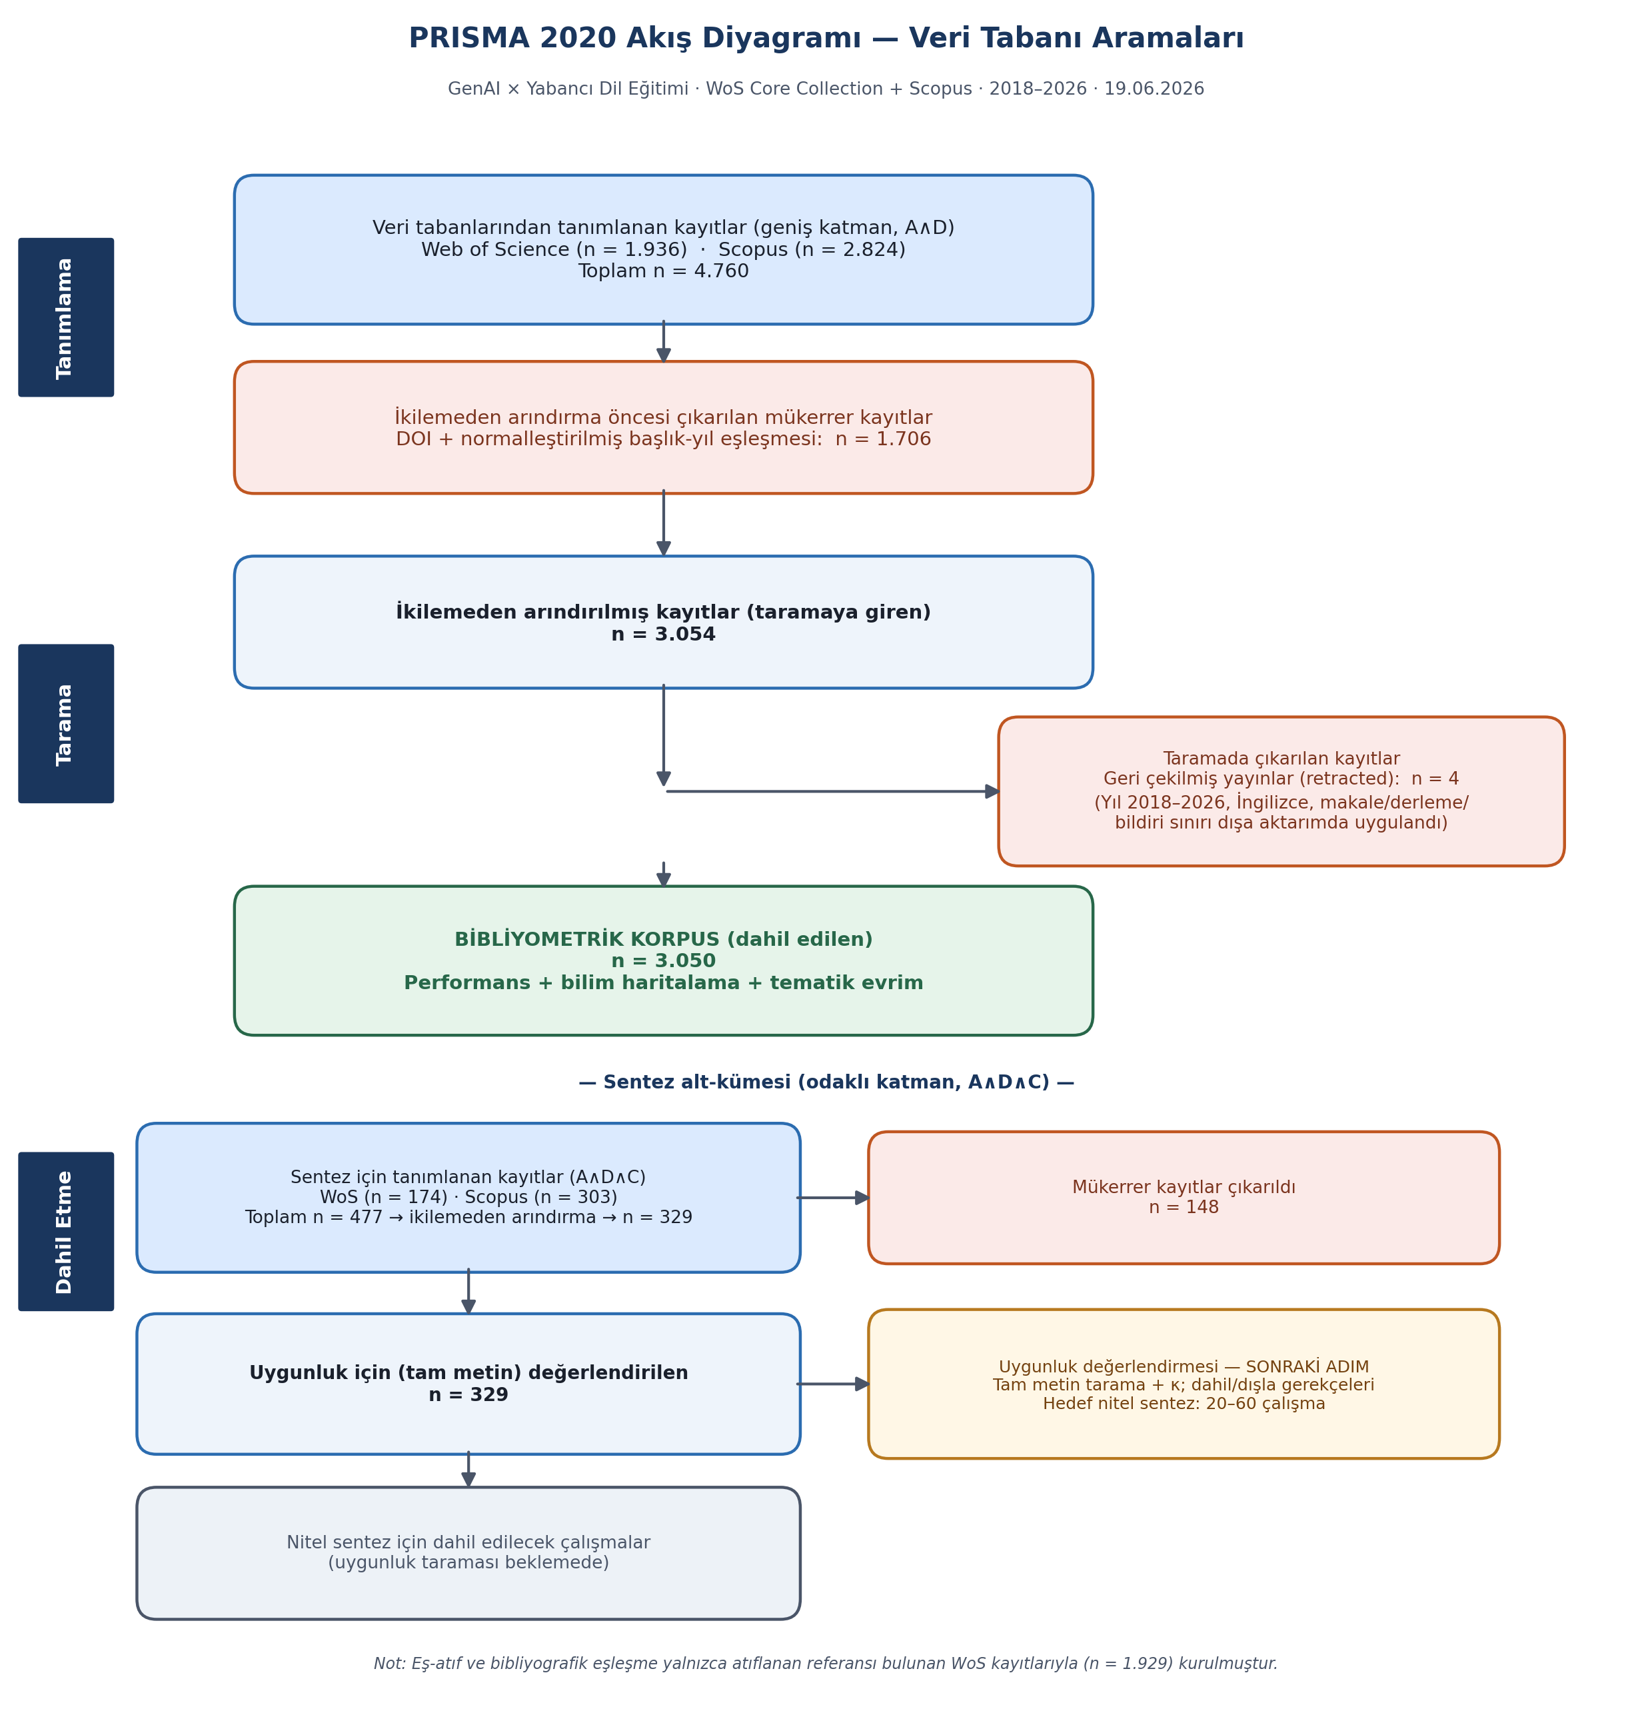
Figure 1. PRISMA 2020 flow diagram (database searches), showing identification, de-duplication, screening, and inclusion for the broad bibliometric corpus (n = 3,050) and the focused synthesis layer (329 → 223 → 56-record human screening set). Figure imported from the project’s verified analysis; box labels are to be localized to English at submission.
The status of the κ and final-N values matters for how the present draft should be read. They are not omissions to be filled with convenient numbers; they mark the boundary between what the abstract-level pipeline has established and what only human full-text adjudication can establish. The synthesis findings below are therefore labeled preliminary throughout.

2.5 Data extraction and coding
Bibliometric metadata — authors, affiliations, countries, sources, years, keywords, citations, and cited references — were extracted directly from the database exports. For the synthesis subset, structured extraction followed an a priori coding scheme of eight dimensions (C1–C8; Appendix B): AI role (C1), center of production (C2), teacher role and agency (C3), pedagogical validity and quality assurance (C4), competencies and teacher education (C5), critical and structural dimensions (C6), language-specific dimensions (C7), and claim/evidence type (C8). The scheme was applied deductively and refined inductively during coding.

2.6 Analysis
Bibliometric analysis (RQ1–RQ3) combined performance analysis — annual output, citation counts, and productive countries, institutions, and sources — with science mapping, including co-citation, bibliographic coupling, keyword co-occurrence, a Callon centrality–density thematic map, and time-sliced thematic evolution (Aria & Cuccurullo, 2017; Donthu et al., 2021). Performance metrics and thematic evolution were implemented in Python (pandas, matplotlib, networkx); network visualization used VOSviewer with the raw Web of Science records and a curated thesaurus (van Eck & Waltman, 2010). The environment used Python rather than R; this is stated for transparency and reproducibility, not as a methodological preference.
For RQ3, the thematic-evolution measure deserves a specific note because an earlier version of this analysis was wrong. A first pass used a permissive lexicon in which terms such as generative inflated the apparent “production” signal and produced a spurious headline that production had overtaken conversation. That result was discarded. The analysis reported here uses a cleaned, word-boundary dictionary that excludes the bare technology name and generic verbs and removes substring false matches (for example, oral matching inside unrelated words). The dictionaries are documented in Appendix C, and a sensitivity check varying lexicon breadth is reported with the findings (§3.3).
Qualitative synthesis (RQ4–RQ5) applied the C1–C8 scheme through qualitative content analysis, mapping findings onto a conversation-to-production continuum to characterize the relocation of the production center and its implications for teacher agency.

2.7 Reporting, reproducibility, and research integrity
Reporting follows the PRISMA 2020 checklist (Appendix D). All analyses are reproducible from date-stamped database exports and archived analysis scripts. Consistent with a strict integrity standard, no source, citation, DOI, or figure was fabricated; unverifiable sources were excluded, and journal indexing and quartile information was confirmed against JCR/Scopus and journal pages rather than asserted from memory. The correction of the RQ3 lexicon, described above, is recorded here as part of that standard. An AI-assistance disclosure is provided.

3. Findings: Bibliometric Analysis

3.1 Publication landscape (RQ1)
The field is small in history and large in the present. Across the bibliometric corpus of 3,050 records, output is concentrated overwhelmingly in the most recent years: 2,732 records (89.6%) appeared in 2024–2026, against 246 (8.1%) in 2022–2023 and just 72 (2.4%) in 2018–2021 (Figure 2; Table 1). The pre-2024 base totals 318 records, 10.4% of the corpus, and the 2024–2026 slice includes a 2026 that is itself only partial. Whatever this literature is, most of it was written very recently and under conditions set by the public release of large language models.
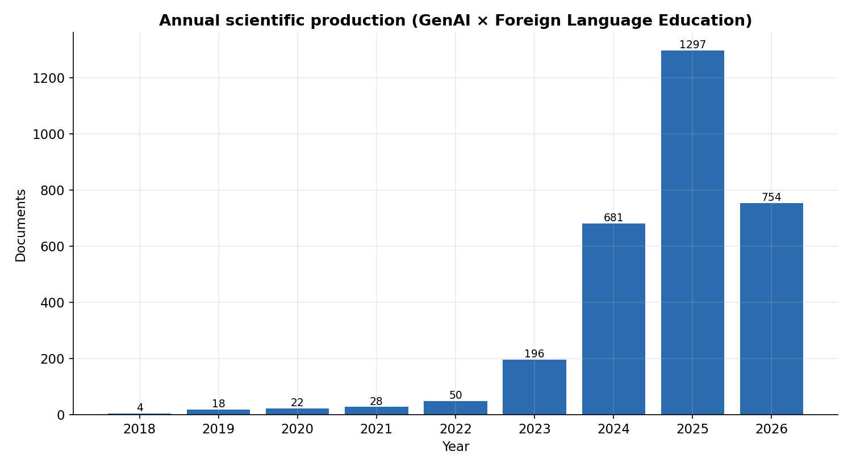
Figure 2. Annual scientific production, broad corpus (n = 3,050), 2018–2026; 2026 is a partial year.
Slice | Records | Share
2018–2021 | 72 | 2.4%
2022–2023 | 246 | 8.1%
2024–2026 | 2,732 | 89.6%
Total (dated) | 3,050 | —
Table 1. Broad-corpus distribution across time slices.
Geographically, output is led by China, followed at a distance by the United States, with Saudi Arabia, the United Kingdom, South Korea, Japan, and Türkiye forming a second tier (Figure 3; Table 2). The most productive sources are System, Computer Assisted Language Learning, and Arab World English Journal (Table 3). The source profile is consistent with a field anchored in applied linguistics and language-education journals rather than in general educational technology, which has implications for where the production question is likely to be heard (§5).
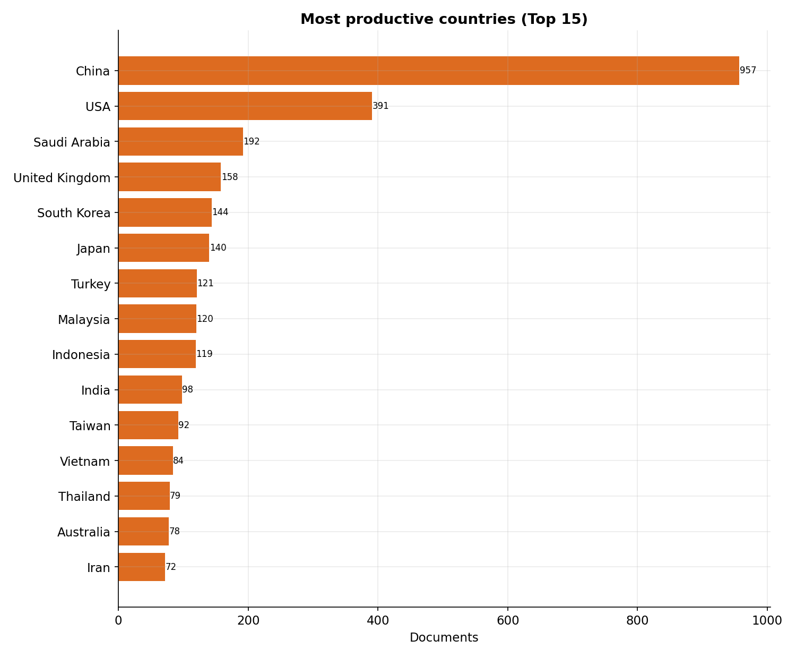
Figure 3. Most productive countries (top 15).
Country | Records
China | 957
United States | 391
Saudi Arabia | 192
United Kingdom | 158
South Korea | 144
Japan | 140
Türkiye | 121
Table 2. Most productive countries (top 7).
Source | Records
System | 66
Computer Assisted Language Learning | 59
Arab World English Journal | 55
Education and Information Technologies | 52
Innovation in Language Learning and Teaching | 44
Table 3. Most productive sources (top 5).

3.2 Intellectual and conceptual structure (RQ2)
Co-citation and bibliographic coupling were computed on the 1,929 Web of Science records carrying cited references. The co-citation network of cited references comprised 40 nodes and 363 edges (density 0.47), indicating a moderately integrated common knowledge base, and country-level bibliographic coupling (normalized by association strength) resolved into five components, indicating regional clustering. The author-keyword co-occurrence network (Figure 4) organizes around ChatGPT, generative AI, large language models, and artificial intelligence, with pedagogical nodes such as EFL/ESL, writing, feedback, and higher education. An overlay by average publication year places production- and development-related terms in the more recent regions of the map, which is the structural counterpart of the temporal result examined directly in §3.3: the conceptual core remains organized around interaction, chatbots, and learning outcomes, with production and material-development terms still at the periphery.
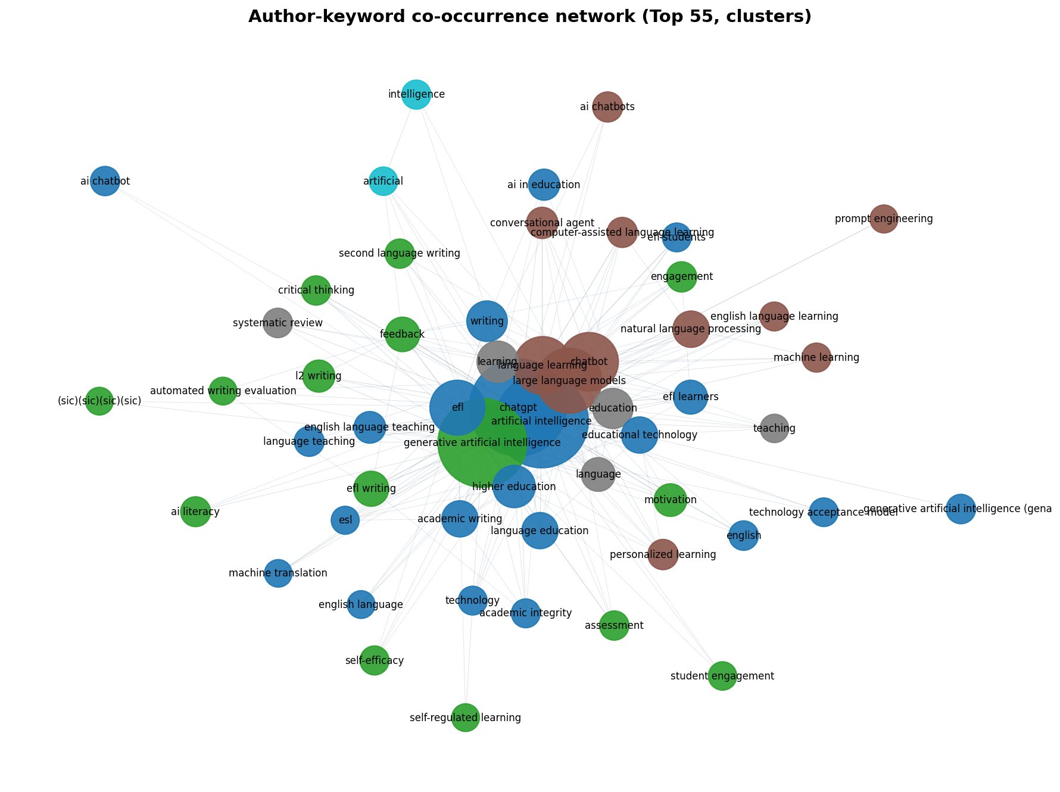
Figure 4. Author-keyword co-occurrence network (top 55 terms; clusters).

3.3 Thematic evolution: is the focus shifting? (RQ3)
This is the question the design was built to answer, and the honest answer has two parts (Figure 5; Table 4).
First, the conversational frame is in clear retreat. Its share of the thematically classifiable corpus falls across the three slices from 58.3% to 35.0% to 14.3%. The decline is large and monotonic, and it has an independent corroboration: the conversation-specific keywords that lead the early period (chatbot, conversational agent) are displaced in 2024–2026 by ChatGPT, generative AI, and large language models. The field is, demonstrably, talking less about GenAI as a thing to converse with.
Second, the production frame is emerging but has not taken over. It remains a small minority of the literature (frame prevalence 2.8% → 2.8% → 1.9% under a broad lexicon; 2.8% → 2.0% → 1.1% under a strict lexicon), yet it grows in absolute terms from 2 to 7 to 51 records across the slices, and the production-to-conversation ratio rises from 0.05 to 0.13. The two frames are not mutually exclusive, and together they account for a minority of documents — the majority carry neither frame-specific keyword — so the reported values are frame-prevalence shares, not a partition. The point is the trajectory: production is climbing, but it has not overtaken conversation, and the earlier claim that it had was an artifact of a contaminated dictionary (§2.6).
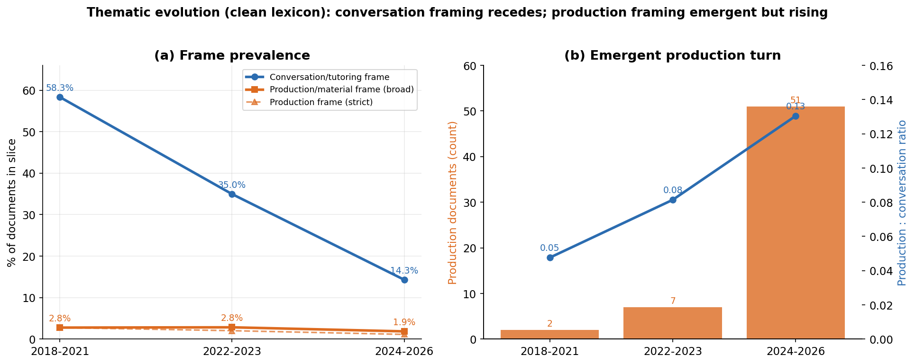
Figure 5. Thematic evolution (clean lexicon): conversational framing recedes (a); production framing is emergent but rising in absolute count and relative ratio (b).
Slice | Docs | Conversation % | Production % (broad) | Production % (strict) | Prod. abs. (broad)
2018–2021 | 72 | 58.3% | 2.8% | 2.8% | 2
2022–2023 | 246 | 35.0% | 2.8% | 2.0% | 7
2024–2026 | 2,732 | 14.3% | 1.9% | 1.1% | 51
Table 4. Frame prevalence by time slice (author-keyword based; word-boundary lexicon).
A sensitivity check confirms the direction is stable. Broadening the production term set (adding teaching/learning materials, content development, text generation, worksheets, curriculum and syllabus design, and authoring tools) raises the absolute production counts (2 → 7 → 51, versus 2 → 5 → 31 under the strict set) and the production-to-conversation ratio, but it leaves both the steady decline of the conversational frame and the emergent, still-minor status of the production frame unchanged. The conversational-decline finding is robust to lexicon choice; the production finding is directionally robust but small in magnitude.
The defensible characterization, then, is a qualified one. The move away from conversation is strong and robust. The move toward production is real but nascent — a frame that has appeared and is growing quickly inside a corpus that is itself only two years into its main expansion. Read together with the publication landscape, the most accurate description of RQ3 is a rapid reframing caught at its moment of emergence, not a completed transition. That this transition is forming rather than finished is not a weakness of the evidence; it is the finding, and it is precisely what makes a synthesis of the production literature timely.

4. Preliminary Synthesis
The findings in this section are preliminary and abstract-based. They derive from the priority shortlist of 40 records coded at the abstract level and have not yet been confirmed by two-reviewer full-text screening. The final synthesis sample [N] and inter-rater agreement [κ] are pending. These results should be read as a forward indication of the synthesis, not as its conclusion.

4.1 How GenAI is conceptualized in material production (RQ4)
Across the priority-40 subset, the dominant conceptualization of GenAI (dimension C1) is as a content producer rather than as a conversational partner (Table 5). Abstract-level coding placed 28 records in the content-producer category, 6 in co-designer/assistant, 4 in autonomous producer-developer, and only 1 in the conversational-tutor category. Even allowing for the focused layer’s production-oriented search bias, the internal distribution is informative: within studies that already concern material production, GenAI is overwhelmingly framed as generating content under teacher direction, with genuinely autonomous, software-grade development (applications, sites, courseware) still rare. The co-designer framing — GenAI as a drafting and proposing partner that a teacher then curates — occupies a modest middle position. The autonomous-developer role exists but is the exception, which matches the bibliometric picture of production as a real but young frame.
The evidence base behind these conceptualizations is mixed (dimension C8). Of the 40 records, 22 were coded as empirical, 10 as conceptual, 6 as indeterminate at the abstract level, and 2 as reviews. The empirical majority is encouraging for an evidence-based synthesis, but the share of conceptual and indeterminate work, together a quarter of the subset, signals that some of the strongest claims about teacher-producers may rest on argument rather than demonstration — a question full-text coding is designed to resolve.
Dimension | Category | Records
C1 — AI role | Content producer (C1a) | 28
 | Co-designer / assistant (C1c) | 6
 | Autonomous producer-developer (C1d) | 4
 | Conversational tutor (C1b) | 1
C8 — Claim/evidence | Empirical | 22
 | Conceptual | 10
 | Indeterminate (abstract-level) | 6
 | Review | 2
Table 5. Preliminary, abstract-based coding of the 40-record priority shortlist (provisional; pending full-text adjudication).

4.2 The center of production and the teacher’s role (RQ5)
[Preliminary; abstract-based.] Read through dimensions C2 and C3, the subset is consistent with a center of production that is beginning to move toward the teacher without having settled there. The prevalence of the content-producer framing, with the teacher directing generation, suggests a relocation that is partial: the teacher gains authorship capacity while the heaviest forms of development remain uncommon and expert mediation is reduced rather than removed. The implications for teacher agency are correspondingly two-sided and cannot be adjudicated from abstracts alone. A reskilling reading (teachers acquiring design and evaluation capacity) and a deskilling reading (teachers absorbing curation and quality-assurance labor previously held by publishers and designers) are both available in the data as currently coded, and the critical and structural dimensions (C6) — labor intensification, platform dependence, value capture — are unevenly addressed across abstracts. Establishing which reading the full texts support, and how often the strong claims are backed by evidence rather than asserted, is the central task of the full synthesis (RQ5) and depends on the human full-text screening that produces [N] and [κ].

5. Discussion

5.1 What the field is doing, and what it is not yet doing
The bibliometric picture and the preliminary synthesis tell a coherent story. The literature on GenAI in foreign language education is young, concentrated in the last two years, and visibly reorienting away from the conversational framing that defined its first wave. The production framing is the direction of travel. It is not yet the destination. This matters because it disciplines the study’s own thesis. The relocation of material authorship toward the teacher is forming, not formed, and a synthesis that claimed otherwise would overstate the record.
The honest, qualified support for RQ3 is more useful than a stronger but false claim would have been. A field caught at the moment a new frame emerges is exactly the field in which a careful review can shape how that frame develops, before the questions of validity, expertise, value, and equity raised in §1 harden into settled, and possibly poor, defaults.

5.2 Implications for the production tensions
The tensions named in the introduction can now be addressed with the corpus, if cautiously. The prevalence of the content-producer framing over autonomous development suggests that, for now, the ease-versus-validity tension is being negotiated mostly within teacher-directed generation, where the last-mile adaptation and quality-assurance burden falls on the teacher rather than being resolved by the tool [CITE: pedagogical validity / CEFR alignment]. This is consistent with a reskilling demand on teachers — output evaluation, prompt and design literacy, ethics — that the competencies literature anticipates [CITE: TPACK / AI-age teacher competencies]. The structural questions of value capture and platform dependence are, on the abstract-level evidence, under-discussed relative to their importance, which is itself a finding worth carrying into the research agenda [CITE: platform economics / value capture]. The source profile (§3.1), concentrated in applied-linguistics and language-education journals, suggests these structural and economic questions may be arriving more slowly in this field than in general educational technology.

5.3 Limitations
Several limitations bound these findings. The bibliometric corpus is dominated (89.6%) by 2024–2026 records, so the three time slices are highly unequal in size, and the thematic-evolution analysis must be read as describing a rapid emergence over a short, recent window rather than a long secular trend; the small 2018–2023 base supports but cannot carry the conclusion alone. The thematic classification depends on a lexical dictionary; although it has been cleaned and sensitivity-tested (§2.6; Appendix C), lexical methods approximate rather than read meaning. Most consequentially, the synthesis findings in §4 are preliminary and abstract-based: the priority-40 distributions reflect a production-oriented search and abstract-level judgments, not adjudicated full-text coding, and they will change as the 56-record human screening set is worked through. The final synthesis sample [N] and inter-rater agreement [κ] are not yet available, and any conclusion about teacher agency (RQ5) must wait for them.

5.4 Future directions
Three directions follow. First, complete the two-reviewer full-text screening to fix [N] and [κ] and to convert the preliminary C1/C8 distributions into adjudicated findings, with particular attention to whether strong teacher-producer claims rest on empirical evidence. Second, extend the structural coding (C6) deliberately, since value capture and platform dependence appear under-addressed and are where the production shift may matter most for teacher autonomy. Third, as the 2024–2026 literature matures, repeat the thematic-evolution analysis on a more balanced set of slices to test whether the emergent production frame continues to climb or plateaus.

6. Conclusion
Generative AI in foreign language education began as something teachers and learners talked to and is becoming something teachers build with. The published record, mapped here, shows that change underway: a robust retreat of the conversational frame and a real but still-emerging production frame, inside a literature that is overwhelmingly recent. The center of material production is beginning to move toward the teacher, but the move is partial, the heaviest forms of development remain uncommon, and the consequences for teacher role and agency are not yet settled in the evidence. That unsettled state is the reason to look now. A field reframes only once at its origin, and the questions of pedagogical validity, design expertise, value capture, competencies, and equity are easier to shape while the frame is forming than after it has set.

AI Disclosure
Generative AI tools were used to support the drafting and structuring of this manuscript and to assist bibliometric data processing (Python-based performance metrics and thematic-evolution analysis) and visualization. All analytic decisions, source verifications, and interpretations are the authors’. No citation, DOI, statistic, or figure was fabricated; all bibliometric figures derive deterministically from the dated Web of Science and Scopus exports (19 June 2026), and analysis scripts are archived for reproducibility. The RQ3 quantification was recomputed with a conservative, word-boundary lexicon after an internal audit found that an earlier lexicon (which counted the bare term “generative”) had inflated the production framing; the corrected, honest values are reported here with a sensitivity analysis. Items marked as placeholders are explicit pending values — Cohen’s κ and the final synthesis n await human full-text screening, and classic conceptual citations marked [CITE: …] are to be added and DOI-verified at the integrity stage. The authors take full responsibility for the content.

References
Aria, M., & Cuccurullo, C. (2017). bibliometrix: An R-tool for comprehensive science mapping analysis. Journal of Informetrics, 11(4), 959–975. https://doi.org/10.1016/j.joi.2017.08.007
Davar, N. F., Dewan, M. A. A., & Zhang, X. (2025). AI chatbots in education: Challenges and opportunities. Information, 16(3), 235. https://doi.org/10.3390/info16030235
Donthu, N., Kumar, S., Mukherjee, D., Pandey, N., & Lim, W. M. (2021). How to conduct a bibliometric analysis: An overview and guidelines. Journal of Business Research, 133, 285–296. https://doi.org/10.1016/j.jbusres.2021.04.070
Huang, W., Hew, K. F., & Fryer, L. K. (2022). Chatbots for language learning—Are they really useful? A systematic review of chatbot-supported language learning. Journal of Computer Assisted Learning, 38(1), 237–257. https://doi.org/10.1111/jcal.12610
Jeon, J., Lee, S., & Choe, H. (2023). Beyond ChatGPT: A conceptual framework and systematic review of speech-recognition chatbots for language learning. Computers & Education, 206, 104898. https://doi.org/10.1016/j.compedu.2023.104898
Jeon, J., Lee, S., & Choi, S. (2024). A systematic review of research on speech-recognition chatbots for language learning: Implications for future directions in the era of large language models. Interactive Learning Environments, 32(8), 4613–4631. https://doi.org/10.1080/10494820.2023.2204343
Ji, H., Han, I., & Ko, Y. (2023). A systematic review of conversational AI in language education: Focusing on the collaboration with human teachers. Journal of Research on Technology in Education, 55(1), 48–63. https://doi.org/10.1080/15391523.2022.2142873
Kohnke, L., Moorhouse, B. L., & Zou, D. (2023). ChatGPT for language teaching and learning. RELC Journal, 54(2), 537–550. https://doi.org/10.1177/00336882231162868
Law, L. (2024). Application of generative artificial intelligence (GenAI) in language teaching and learning: A scoping literature review. Computers and Education Open, 6, 100174. https://doi.org/10.1016/j.caeo.2024.100174
Page, M. J., McKenzie, J. E., Bossuyt, P. M., Boutron, I., Hoffmann, T. C., Mulrow, C. D., Shamseer, L., Tetzlaff, J. M., Akl, E. A., Brennan, S. E., Chou, R., Glanville, J., Grimshaw, J. M., Hróbjartsson, A., Lalu, M. M., Li, T., Loder, E. W., Mayo-Wilson, E., McDonald, S., … Moher, D. (2021). The PRISMA 2020 statement: An updated guideline for reporting systematic reviews. BMJ, 372, n71. https://doi.org/10.1136/bmj.n71
van Eck, N. J., & Waltman, L. (2010). Software survey: VOSviewer, a computer program for bibliometric mapping. Scientometrics, 84(2), 523–538. https://doi.org/10.1007/s11192-009-0146-3
Zhai, C., & Wibowo, S. (2023). A systematic review on artificial intelligence dialogue systems for enhancing English as foreign language students’ interactional competence in the university. Computers and Education: Artificial Intelligence, 4, 100134. https://doi.org/10.1016/j.caeai.2023.100134

Appendix A. Boolean search strings
Full strings (WoS TS=; Scopus TITLE-ABS-KEY) for the broad (A AND D) and focused (A AND D AND C) layers, with concept blocks A (generative AI), D (foreign language education), and C (material/production), to be attached from the project protocol.

Appendix B. Coding scheme (C1–C8)
The eight-dimension codebook — AI role (C1), center of production (C2), teacher role and agency (C3), pedagogical validity and quality assurance (C4), competencies and teacher education (C5), critical and structural dimensions (C6), language-specific dimensions (C7), and claim/evidence type (C8) — with category definitions, decision rules, and examples, to be attached from the project codebook.

Appendix C. Thematic-framing lexicons (RQ3)
Matching. Word-boundary matching against normalized author keywords. The bare technology name (for example, “generative AI/artificial intelligence”) and generic verbs (tool, development, design, creation, automatic) are deliberately excluded to prevent inflation.
Conversational/tutoring frame: chatbot; chatbots; conversational agent(s); conversational AI; dialogue system(s); dialog system; intelligent tutoring; spoken dialogue; voice assistant; virtual assistant; pronunciation; conversation practice; speech-recognition chatbot; dialogue-based.
Production/material frame — strict: materials/material development; materials/material design; content creation; content generation; courseware; lesson plan(s); instructional design; test/item/question/task/exercise generation; authoring; automatic item/question.
Production/material frame — broad (sensitivity): strict set + teaching/learning/instructional materials; content development; AI-generated content; text generation; worksheet(s); syllabus/curriculum design; curriculum development; material creation; authoring tool(s); reading materials.

Appendix D. PRISMA 2020 checklist (status)
Note. Location and status against the 27-item PRISMA 2020 checklist (Page et al., 2021). “Pending” items depend on completion of human full-text screening and the synthesis layer.
# | PRISMA 2020 item | Location / status
1 | Title — identifies as systematic review | Title page
2 | Abstract — structured summary | Abstract
3 | Rationale | §1 Introduction
4 | Objectives / questions | §1.4 (RQ1–RQ5)
5 | Eligibility criteria | §2.3; Appendix A
6 | Information sources | §2.2 (WoS, Scopus; 19 Jun 2026)
7 | Search strategy (full strings) | §2.2; Appendix A
8 | Selection process | §2.4; Figure 1
9 | Data collection process | §2.5
10 | Data items | §2.5; Appendix B (C1–C8)
11 | Risk of bias in studies | Pending (full-text synthesis)
12 | Effect measures | N/A (no meta-analysis)
13 | Synthesis methods | §2.6 (qualitative content analysis)
14 | Reporting bias assessment | Pending / addressed in limitations
15 | Certainty assessment | Pending (synthesis)
16 | Study selection results | §2.4; Figure 1 (broad 3,050; focused 329→223; 56-set)
17 | Study characteristics | §3; preliminary §4 (final pending)
18 | Risk of bias in studies | Pending (synthesis)
19 | Results of individual studies | Pending (synthesis)
20 | Results of syntheses | §3.1–3.3 (bibliometric); §4 preliminary
21 | Reporting biases | §5.3 Limitations
22 | Certainty of evidence | Pending (synthesis)
23 | Discussion / interpretation | §5
24 | Registration and protocol | A priori protocol (OSF optional); on file
25 | Support / funding | To be added
26 | Competing interests | To be added
27 | Availability of data/code | Date-stamped exports + archived scripts; SHA-256 manifest

