From Conversation to Creation: Generative AI and the Transformation of Material Production and the Teacher’s Role in Foreign Language Education
A Bibliometric Analysis and Systematic Review
[DRAFT — WRITE stage. Red text = items to verify/complete at the integrity stage; no data, citation, or κ value is fabricated.]
Manuscript draft · Search/export date: 19 June 2026 · Target: SSCI (Interactive Learning Environments / Computer Assisted Language Learning)

Abstract
Background. Generative artificial intelligence (GenAI) is rapidly entering foreign language education. While existing reviews foreground its use as a conversational or tutoring instrument, the production dimension — the relocation of material authorship toward the teacher — remains comparatively underexamined. Objectives. This study maps the structure and evolution of the field and tests whether its thematic focus is shifting from a conversational tool toward a material-production and development tool. Methods. A two-layer search of Web of Science Core Collection and Scopus (2018–2026; English; articles, reviews, conference papers), conducted on 19 June 2026, was de-duplicated to a bibliometric corpus of 3,050 records; a focused layer yielded 329 records for a systematic-review synthesis, reported per PRISMA 2020. Performance analysis and time-sliced thematic analysis were implemented in Python; co-citation and bibliographic coupling were derived from Web of Science cited-reference fields. Results. Output grew from 4 records (2018) to 1,297 (2025), with 89.6% of the corpus published from 2024 onward. The share of documents framing GenAI in conversational/tutoring terms fell across time slices (70.8% → 39.4% → 22.2%), while the production/material framing rose (5.6% → 20.3% → 38.0%), surpassing the conversational frame in 2024–2026. Conclusions. The evidence is consistent with a shift in the center of material production rather than a wholesale revolution, with implications for the teacher’s role and agency that the synthesis layer examines.
Keywords: generative artificial intelligence; foreign language education; bibliometric analysis; systematic review; material development; teacher agency

1. Introduction
Teacher-made materials are not new to foreign language education; teachers have long adapted, supplemented, and created classroom resources . Yet this production was historically bounded by a production ceiling — constraints of skill, time, and tooling — that confined most teachers to the roles of consumer and adapter, while high-quality, software-grade resources (textbooks, courseware, structured digital tools) remained the domain of publishers and specialist instructional designers .
The rapid diffusion of GenAI — large language models and allied tools — has reframed what a single teacher can produce. Recent reviews document its uptake across language teaching and learning (e.g., Kohnke et al., 2023; Law, 2024). Crucially, these tools have evolved from a conversational instrument — a partner for dialogue and practice, the dominant framing of the chatbot literature (Huang et al., 2022; Ji et al., 2023; Jeon, 2023) — toward a production and development engine capable of generating not only texts and exercises but software-grade artifacts through natural-language instruction and low-/no-code workflows . This shift lowers the historical production ceiling and repositions the teacher from material consumer/adapter toward potential material producer/developer.
This is best understood not as a wholesale revolution but as a shift in the center of production — a relocation of who can credibly author instructional resources. Historical precedents (language laboratories, successive CALL waves, the Web 2.0 “teacher content creator” moment) caution that democratized production tools are followed by uneven adoption and variable quality, not uniform transformation . The shift surfaces unresolved tensions: production capacity is not pedagogical validity (curriculum/CEFR alignment, output accuracy, and the “last-mile” adaptation burden remain) ; the future of instructional-design expertise and the risk of “design debt”; the migration of value from content to AI infrastructure ; a reconceptualized teacher knowledge base (an “AI-age TPACK”) ; and equity, where uneven access may widen rather than close gaps .
A growing body of reviews synthesizes GenAI in education and language learning, but these largely read the trajectory as “tool → learner-centered use,” foregrounding learner interaction and outcomes — for example, systematic reviews of chatbots and conversational/dialogue systems for language learning (Huang et al., 2022; Ji et al., 2023; Jeon, 2023; Zhai et al., 2023; Jeon & Lee, 2024) and broader overviews of ChatGPT and GenAI in language teaching (Kohnke et al., 2023; Law, 2024). The production dimension — the relocation of material authorship toward the teacher, and its consequences for the teacher’s role and agency — remains comparatively underexamined. This review addresses that gap by combining a bibliometric analysis (mapping the field’s structure and testing whether thematic focus is shifting from conversation toward production; RQ1–RQ3) with a systematic synthesis (how GenAI is conceptualized in material design/production, and the evidence, claims, and gaps regarding the shift toward the teacher-producer; RQ4–RQ5).

2. Methods

2.1 Research design
This study employs a two-pronged design combining a bibliometric analysis with a systematic review, reported in accordance with the PRISMA 2020 statement (Page et al., 2021). The bibliometric component maps the structure and evolution of the field (RQ1–RQ3); the systematic-review component synthesizes how GenAI is conceptualized in foreign-language material production and what this implies for the teacher’s role (RQ4–RQ5). Only published literature was analyzed; no human participants were involved.

2.2 Research questions
RQ1. What is the publication landscape (volume, growth, country/institution/source distribution) of GenAI in foreign language education?
RQ2. What are the intellectual (co-citation, bibliographic coupling) and conceptual (keyword co-occurrence, thematic mapping) structures of the field?
RQ3. Is the thematic focus shifting from a “conversational/tutoring tool” toward a “material-production/development tool”?
RQ4. With what roles is GenAI conceptualized in foreign-language material design and production?
RQ5. What evidence, claims, and gaps exist regarding the relocation of the center of production from publishers/experts toward language teachers, and what are the implications for teacher role and agency?

2.3 Information sources and search strategy
Two databases were searched — Web of Science Core Collection and Scopus — on 19 June 2026. A two-layer strategy balanced corpus robustness against topical precision: a broad layer (bibliometric corpus) defined by the intersection of a generative-AI concept block (A) and a foreign-language-education block (D), i.e., A AND D; and a focused layer (synthesis subset) further constrained by a material/production block (C), i.e., A AND D AND C. The full Boolean strings (WoS TS=; Scopus TITLE-ABS-KEY) are provided in Appendix A and were applied identically across both databases.

2.4 Eligibility criteria
Inclusion: records addressing GenAI in foreign/second language education; published from January 2018 to the search date; in English; peer-reviewed and indexed. For the synthesis subset, records additionally had to concern the design or production of materials, content, or tools (the C block). Document types: the bibliometric corpus comprised articles, reviews, and conference papers; the synthesis subset was restricted to journal articles and reviews. Exclusion: AI studies outside language education; editorials, letters, notes, and errata (synthesis); records without retrievable full text (synthesis); and cross-database duplicates. A 2018 start captures the pre-ChatGPT conversational-tool baseline; thematic evolution is analyzed across slices (2018–2021 / 2022–2023 / 2024–2026) that bracket the late-2022 inflection.

2.5 Selection process
Records from both databases were merged and de-duplicated by DOI and normalized title–year matching, yielding 3,050 unique records in the broad corpus (after removing 4 retracted publications) and 329 in the focused layer. Screening followed the PRISMA 2020 stages (Figure 1). Title–abstract screening was conducted by two independent reviewers; inter-rater agreement is reported as Cohen’s κ = , with disagreements resolved by a third reviewer. For the synthesis layer, an abstract-level eligibility pass (journal article/review; demonstrable material-production relevance; abstract available) identified 223 candidate records; these were prioritized for full-text screening, from which studies met final eligibility. To preserve the conversation-to-production “bridge,” the 16 eligible early-production records from 2018–2023 were carried into full-text screening alongside the 40 top-ranked records (a 56-record human screening set).
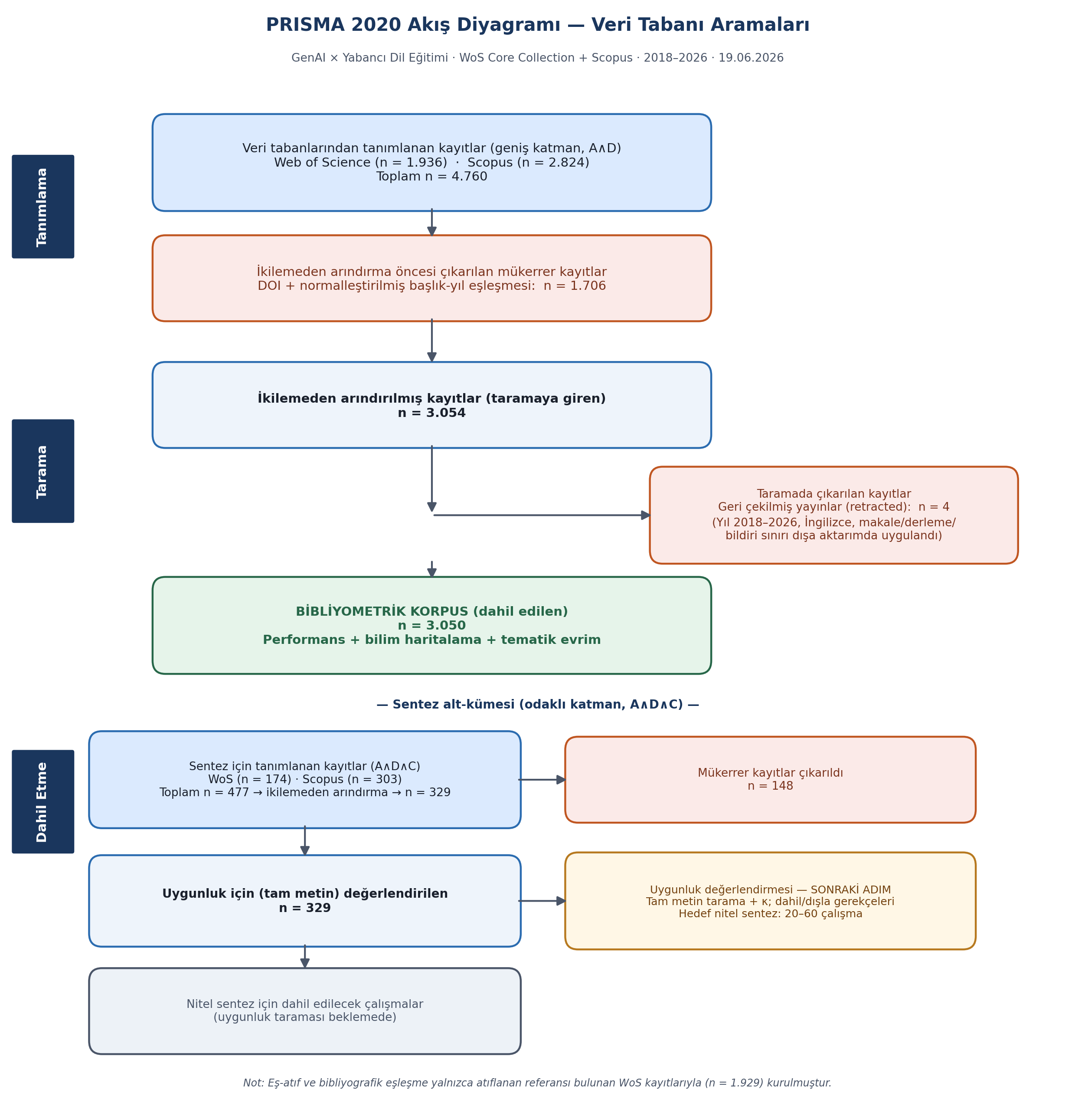
Figure 1. PRISMA 2020 flow diagram (database searches).

2.6 Data extraction
Bibliometric metadata (authors, affiliations, countries, sources, years, keywords, citations, and cited references) were extracted directly from the database exports. For the synthesis subset, structured extraction followed an a priori coding scheme spanning eight dimensions (C1–C8; Appendix B): AI role, center of production, teacher role and agency, pedagogical validity and quality assurance, competencies and teacher education, critical/structural dimensions, language-specific dimensions, and claim/evidence type. The scheme was applied deductively and refined inductively.

2.7 Analysis
Performance analysis (annual output, citations, productive authors/institutions/countries/sources; Bradford and Lotka distributions) and science mapping (co-citation, bibliographic coupling, keyword co-occurrence, and time-sliced thematic evolution) followed established bibliometric guidance (Donthu et al., 2021; Aria & Cuccurullo, 2017). Performance metrics and thematic analysis were implemented in Python (pandas, networkx, matplotlib); network maps were prepared with VOSviewer (van Eck & Waltman, 2010). Author keywords were normalized with a thesaurus (e.g., ChatGPT/GPT variants; AI/artificial intelligence; EFL/ESL; singular–plural) prior to co-occurrence analysis. Because the Scopus export did not carry cited references, co-citation and bibliographic coupling were derived solely from Web of Science cited-reference fields (n = 1,929 records). The qualitative synthesis applied the C1–C8 scheme and mapped findings onto the conversation-to-production continuum.

2.8 Reporting, reproducibility, and research integrity
Reporting follows the PRISMA 2020 checklist. All analyses are reproducible from date-stamped exports and archived scripts (with SHA-256 checksums of the raw files). Consistent with a strict integrity standard, no source, citation, DOI, or figure was fabricated; unverifiable sources were excluded, and journal indexing/quartile information will be confirmed against JCR/Scopus and journal pages. An AI-assistance disclosure is provided.

3. Results — Bibliometric Analysis

3.1 Publication landscape (RQ1)
The corpus grew from 4 records in 2018 to 1,297 in 2025; the 754 records dated 2026 represent a partial year (Figure 2; Table 1). The slice distribution is markedly recent: 2018–2021 = 72 (2.4%), 2022–2023 = 246 (8.1%), and 2024–2026 = 2,732 (89.6%), a profile consistent with a field expanding explosively after the late-2022 public release of ChatGPT.
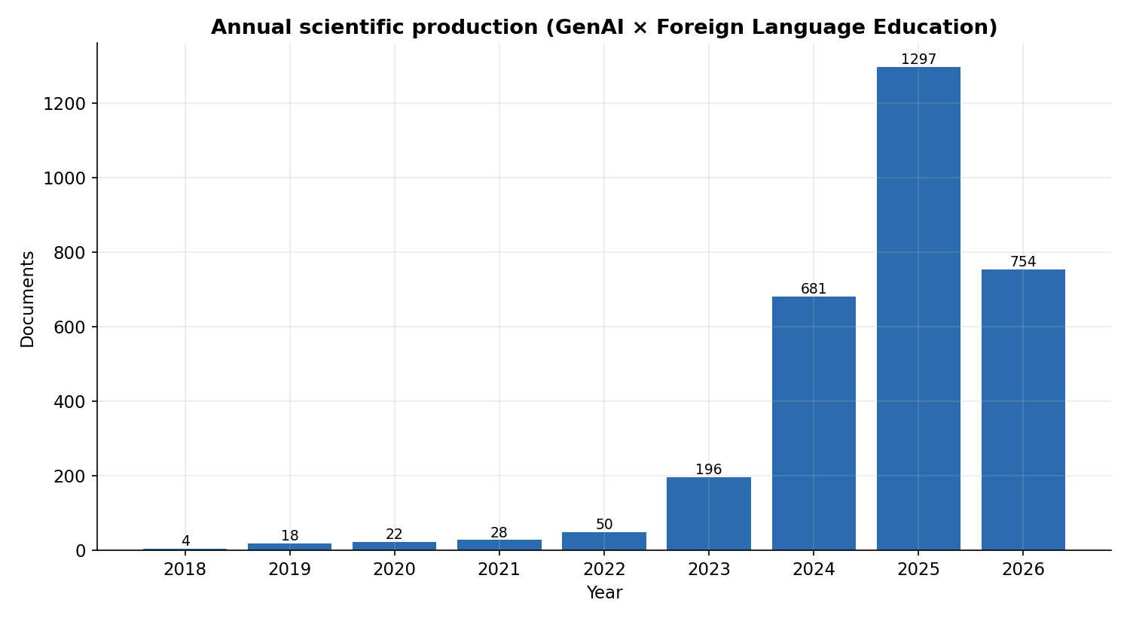
Figure 2. Annual scientific production (broad corpus, n = 3,050 year-bearing).
Slice | Records | Share
2018–2021 | 72 | 2.4%
2022–2023 | 246 | 8.1%
2024–2026 | 2,732 | 89.6%
Table 1. Broad-corpus distribution across time slices.
The most productive countries were China (957), the United States (391), Saudi Arabia (192), the United Kingdom (158), South Korea (144), Japan (140), and Türkiye (121) (Figure 3). Productive sources were led by System, Computer Assisted Language Learning, and Arab World English Journal (Table 2).
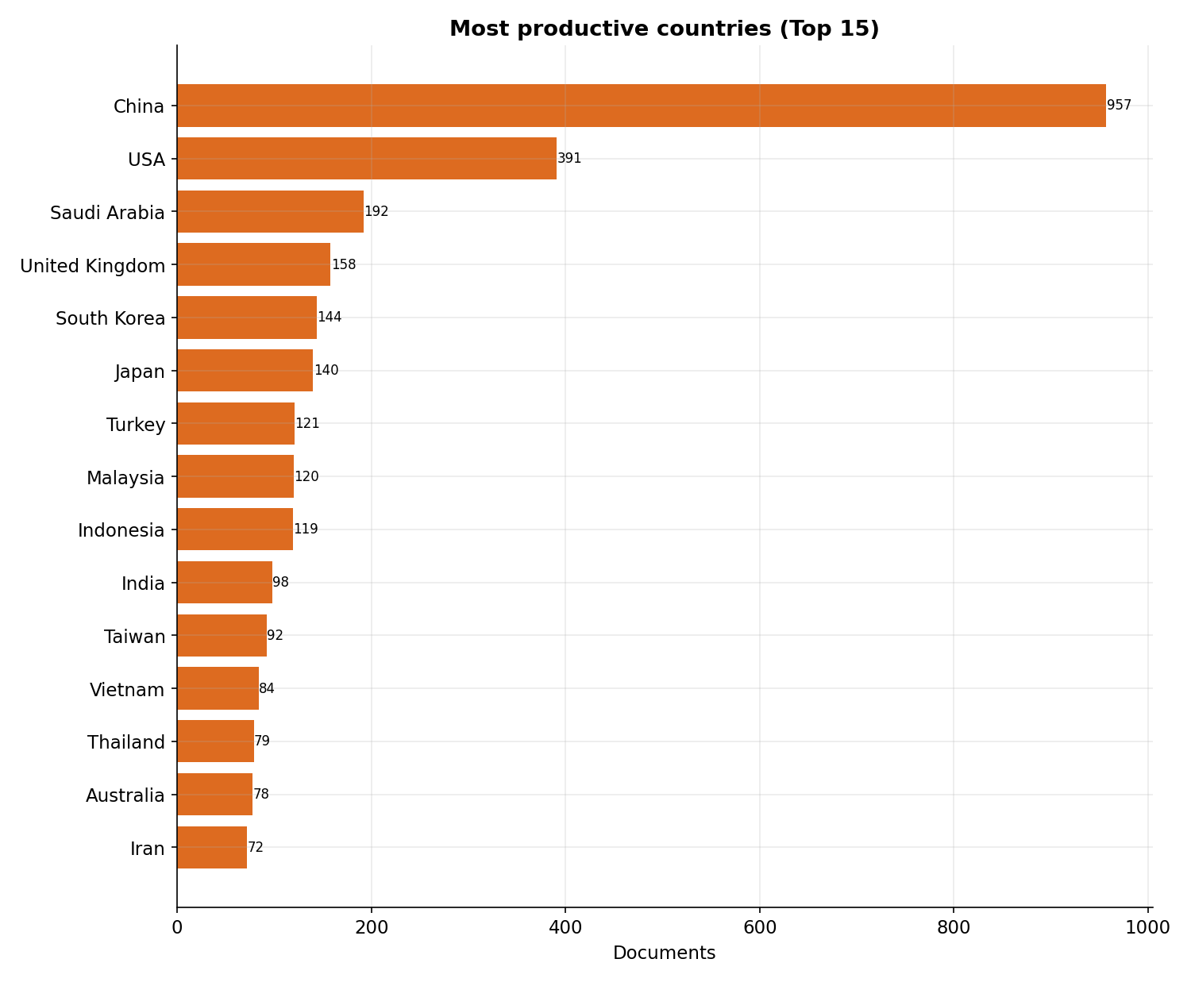
Figure 3. Most productive countries (top 15).
Source | Records
System | 66
Computer Assisted Language Learning | 59
Arab World English Journal | 55
Education and Information Technologies | 52
Innovation in Language Learning and Teaching | 44
Table 2. Most productive sources (top 5).

3.2 Intellectual and conceptual structure (RQ2)
Co-citation and bibliographic coupling were computed on the 1,929 Web of Science records carrying cited references. The co-citation network of cited references comprised 40 nodes and 363 edges (density 0.47), indicating a moderately integrated common knowledge base; country-level bibliographic coupling (normalized by association strength) resolved into 5 components, indicating regional clustering. The author-keyword co-occurrence network (Figure 4) organizes around ChatGPT, generative AI, large language models, and artificial intelligence, with pedagogical nodes (EFL/ESL, writing, feedback, higher education); an overlay by average publication year locates production/development terms in the more recent regions of the map.
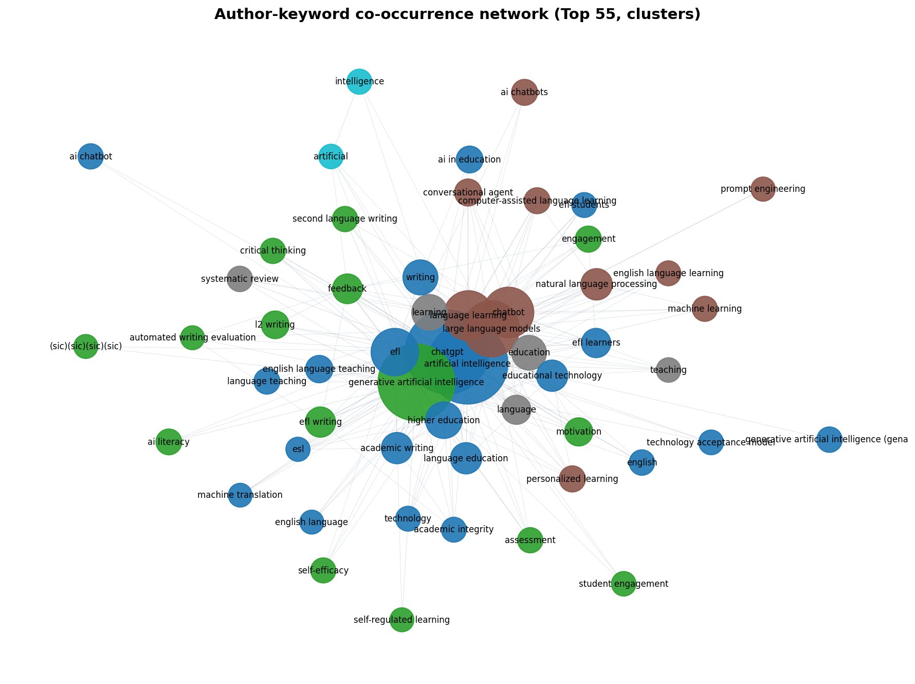
Figure 4. Author-keyword co-occurrence network (top 55 terms; clusters).

3.3 Thematic evolution (RQ3)
Across the three slices, the share of documents framing GenAI in conversational/tutoring terms declined (70.8% → 39.4% → 22.2%), while the production/material framing rose (5.6% → 20.3% → 38.0%), with the production frame surpassing the conversational frame in 2024–2026 (Figure 5; Table 3). Given that 89.6% of the corpus is dated 2024 or later, this pattern is best read as a rapid framing shift at the field’s inception rather than a slow evolution across a mature literature; the 2018–2023 base (n = 318) supports a classic thematic-evolution reading but should be interpreted with caution given uneven slice sizes.
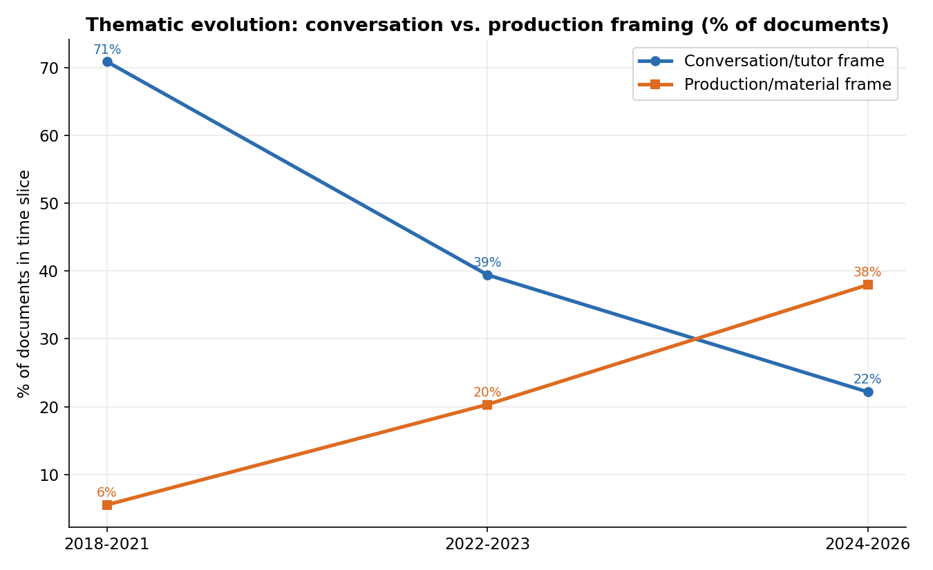
Figure 5. Thematic evolution: conversation vs. production framing (% of documents).
Slice | Documents | Conversation % | Production %
2018–2021 | 72 | 70.8% | 5.6%
2022–2023 | 246 | 39.4% | 20.3%
2024–2026 | 2,732 | 22.2% | 38.0%
Table 3. Frame prevalence by time slice (author-keyword based).

4. Preliminary Synthesis (RQ4–RQ5)
Of the 329 focused records (328 with abstracts), 223 met abstract-level eligibility. Within the 40-record priority shortlist, the dominant conceptualization of GenAI was as a content creator (C1a, 28 records), followed by co-designer/assistant (C1c, 6) and autonomous producer-developer (C1d, 4), with a single conversational-tutor case — a distribution that, even provisionally, foregrounds the production framing in the most material-focused literature. Claim/evidence types were predominantly empirical (22), with conceptual (10) and review (2) contributions. These preliminary patterns will be confirmed, corrected, and extended through full-text coding (C1–C8) and reported with inter-rater reliability.

5. Discussion (outline)
The bibliometric evidence supports the study’s central thesis: the field’s thematic center of gravity is moving from conversational use toward material production. The discussion will situate this shift within the “center of production” framing, weigh ease-of-production against pedagogical validity, and develop the implications for teacher agency, instructional-design expertise, value capture, competencies (AI-age TPACK), and equity, integrating the synthesis findings (RQ4–RQ5) once full-text screening is complete.

References (verified)
Note. The following references are verified (DOIs confirmed). Corpus reviews are drawn from the analyzed dataset; methodological references were confirmed via primary sources. Bracketed red items elsewhere in the text mark citations to be added and verified at the integrity stage.
Aria, M., & Cuccurullo, C. (2017). bibliometrix: An R-tool for comprehensive science mapping analysis. Journal of Informetrics, 11(4), 959–975. https://doi.org/10.1016/j.joi.2017.08.007
Davar, N. F., et al. (2025). AI chatbots in education: Challenges and opportunities. Information, 16(3), 235. https://doi.org/10.3390/info16030235
Donthu, N., Kumar, S., Mukherjee, D., Pandey, N., & Lim, W. M. (2021). How to conduct a bibliometric analysis: An overview and guidelines. Journal of Business Research, 133, 285–296. https://doi.org/10.1016/j.jbusres.2021.04.070
Huang, W., Hew, K. F., & Fryer, L. K. (2022). Chatbots for language learning—Are they really useful? A systematic review of chatbot-supported language learning. Journal of Computer Assisted Learning, 38(1), 237–257. https://doi.org/10.1111/jcal.12610
Jeon, J. (2023). Beyond ChatGPT: A conceptual framework and systematic review of speech-recognition chatbots for language learning. Computers & Education, 206, 104898. https://doi.org/10.1016/j.compedu.2023.104898
Jeon, J., & Lee, S. (2024). A systematic review of research on speech-recognition chatbots for language learning. Interactive Learning Environments. https://doi.org/10.1080/10494820.2023.2204343
Ji, H., Han, I., & Ko, Y. (2023). A systematic review of conversational AI in language education. Journal of Research on Technology in Education, 55(1), 48–63. https://doi.org/10.1080/15391523.2022.2142873
Kohnke, L., Moorhouse, B. L., & Zou, D. (2023). ChatGPT for language teaching and learning. RELC Journal, 54(2), 537–550. https://doi.org/10.1177/00336882231162868
Law, L. (2024). Application of generative artificial intelligence (GenAI) in language teaching and learning: A scoping literature review. Computers and Education Open, 6, 100174. https://doi.org/10.1016/j.caeo.2024.100174
Page, M. J., McKenzie, J. E., Bossuyt, P. M., et al. (2021). The PRISMA 2020 statement: An updated guideline for reporting systematic reviews. BMJ, 372, n71. https://doi.org/10.1136/bmj.n71
van Eck, N. J., & Waltman, L. (2010). Software survey: VOSviewer, a computer program for bibliometric mapping. Scientometrics, 84(2), 523–538. https://doi.org/10.1007/s11192-009-0146-3
Zhai, C., & Wibowo, S. (2023). A systematic review on artificial intelligence dialogue systems for enhancing English as foreign language students’ interactional competence. Computers and Education: Artificial Intelligence, 4, 100134. https://doi.org/10.1016/j.caeai.2023.100134

Research Integrity & AI-Assistance Disclosure
No citation, DOI, statistic, or figure in this manuscript was fabricated. All bibliometric figures derive deterministically from the dated Web of Science and Scopus exports (19 June 2026); analysis scripts are archived for reproducibility. Items shown in red are explicit placeholders for verification at the integrity stage (Cohen’s κ and the final synthesis n pending human full-text screening; classic conceptual citations to be added and DOI-verified). AI assistance was used for data processing, drafting, and visualization under author supervision; all analytical decisions and final wording are the authors’ responsibility.

