### 19.1.2 Find 2-3 Job Titles

**Job Tiles used in initial search**

Data Scientist

Data Analyst

**Word Cloud generated from job advertisements**

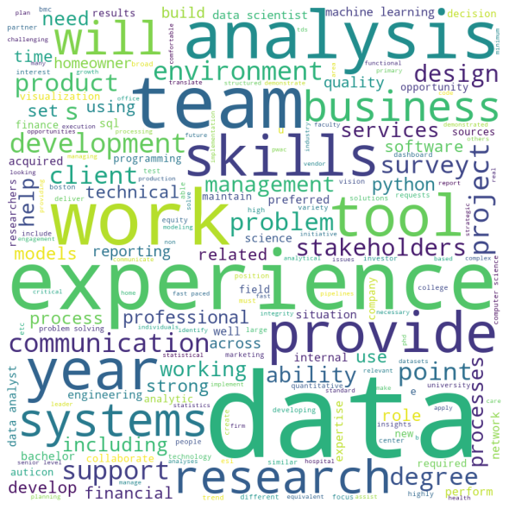

**Keywords searched:**

data experience team analysis skills work tool systems research degree provide problem business management development professional design product

**Additional Job Titles this search gives:**

**Data Analytics Consultant**

**Machine Learning Engineer**

**Business Analyst**

**Systems Analyst**

**Why are these jobs suitable for me?**

**Data Analytics Consultant**

This role requires the same characteristics as my current freelance tutoring and past scientific researcher roles:

- experience analyzing complex problems and producing concrete, actionable solutions;

- seeking to acquire knowledge in area of specialty;

- high commitment to quality;

- flexibility to work in a fast paced, dynamic environment;

- service-oriented and skilled in providing positive, friendly customer service;

This job aligns well with what I am currently studying at Springboard:

- experience with or interest in SQL, business intelligence/visualization software.

In addition, a nearby Indiana University has such positions, e.g., "IT Business Analyst" currently advertised.

**Machine Learning Engineer**

This role is entirely about Machine Learning, which I am currently studying at Springboard.

It would give me plenty of opportunities to apply my new knowledge and skills.

Additionally, I feel very interested and excited about learning and applying ML methods.

**Business Analyst**

This role requires advanced technical skills, which I am gradually mastering at Springboard, as well as deriving new knowledge from existing and generated data.

This is perfectly in line with my former theoretical researcher roles, which involved modeling, data collection, generation, and advanced analysis.

**Systems Analyst**

This role could allow me to apply advanced analytical and numerical optimization methods that I learned in Academia.