# **27.2.3 Relax Inc. Take-Home Challenge**

**Feature engineering**

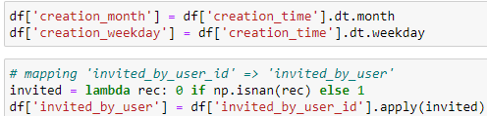



**Neural Network model**

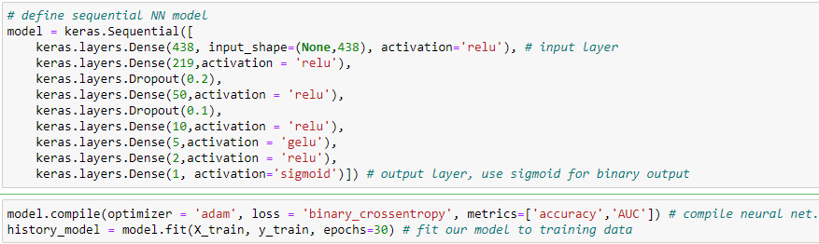

**Result**

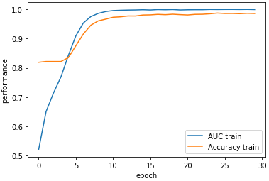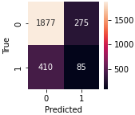

**Conclusions**

This is a strongly imbalanced set, presenting a difficulty for sequential NN model. In addition, the model is impossible to interpret. It is better to try tree-based ensemble models. Accuracy has increased after adding seasonal variables 'creation_month' and 'creation_weekday'.