Investment Memorandum: Confidential
Silicior: Proposal for a 10 MW Solar Farm in Abu Dhabi July 20, 2025
Modeled by: Youssef Eleyouta

1. Executive Summary
This document outlines an investment opportunity to provide AED 120 million in equity capital for the development and construction of Silicior, a hypothetical 10 MW ground-mounted solar farm in Abu Dhabi, UAE. The project revenue is modeled under a 25-year Power Purchase Agreement (PPA) with a fixed tariff of AED 0.275/kWh. Based on the financial model, the project is projected to generate a 37.75% Equity IRR and an NPV of AED 116.5 million.

2. Project Overview
- Project Description: A 10 MW ground-mounted solar photovoltaic (PV) power plant.
- Location: Abu Dhabi, UAE, modeled as a high-irradiance solar market with strong suitability for utility-scale photovoltaic assets.
- Key Agreement: A 25-year PPA assumption models offtake of generated power at a fixed price, creating stable and predictable revenue streams.

3. Market Context & Opportunity
- Strong Market Support: The project is modeled in the UAE clean-energy context, where solar, grid investment, and long-term infrastructure planning create a strong setting for project-finance analysis.
- Favorable Cost Trends: The model uses solar cost assumptions, operating costs, debt financing, and downside cases to test how capex, tariff, production, and financing changes affect investor returns.

4. Financial Summary
4.1. Sources and Uses of Funds The total required capital for the project is AED 400 million, structured with a 70:30 debt-to-equity ratio.
Sources of Funds | Amount (AED M) | Uses of Funds | Amount (AED M)
Equity Capital | 120.0 | Total Project Cost | 400.0
Debt Financing | 280.0
Total Sources | 400.0 | Total Uses | 400.0

4.2. Key Financial Metrics The project demonstrates robust financial returns for equity investors.
Metric | Value
Equity IRR | 37.75%
Net Present Value (NPV) | AED 116.5 million
Payback Period | 2 Years

4.3. Key Assumption Rationale
- PPA Tariff: The assumed tariff of AED 0.275/kWh is used as the model revenue driver and is stress-tested under downside cases.
- Capital Cost (CAPEX): The projected CAPEX of AED 40 million/MW is used to model project cost, debt sizing, cash flows, and equity returns for a 10 MW Abu Dhabi solar asset.
4.4. Projected Financials The project is projected to be profitable, with stable cash flows generated over the 25-year PPA term.
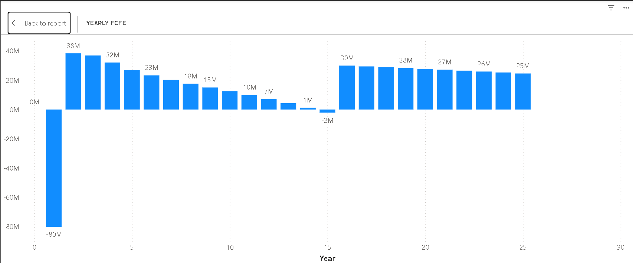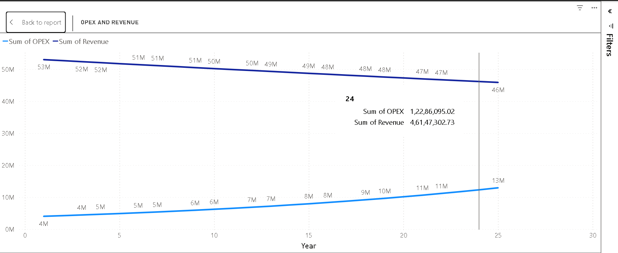

5. Risk Analysis & Mitigation
A summary of key risks and the strategies in place to mitigate them.
- Construction Risk: Risk of delays or cost overruns.
  - Mitigation: Hiring an experienced EPC (Engineering, Procurement, and Construction) contractor with a fixed-price, date-certain contract.
- Operational Risk: Risk of the plant generating less electricity than expected.
  - Mitigation: Using Tier-1 equipment suppliers with performance guarantees; having a professional O&M (Operations & Maintenance) team.
- Counterparty Risk: Risk of the entity buying the power failing to pay.
  - Mitigation: The model assumes a creditworthy long-term offtaker, fixed-tariff contract structure, and standard lender protections to reduce counterparty and revenue risk.
Portfolio note: Based on a public fork; rebuilt, renamed, and customized for portfolio learning.

