

Real time programmation

report : workshop 3

*Encadré par :*

*Pr. Saad MOTAHHIR*

EL KANTRI Youssef - 14 | GSEEI2 | A.U 2019 – 2020

# about project :

It’s a home made project providing a smart soap bottle that can protect user against Covid-19 , it’s allow users to wash their hands without touching the bottle of soap, this product will avoid the spread of the virus between users of the bottle

# Components :

## Arduino Uno :

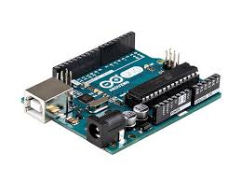The **Arduino Uno** Board A000066 R3 is a microcontroller board based on the **ATmega328**.

It has 14 digital input/output pins (of which 6 can be used as PWM outputs), 6 analog inputs, a 16 MHz crystal oscillator, a USB connection, a power jack, an ICSP header, and a reset button. It contains everything needed to support the microcontroller - simply connect it to a computer with a USB cable or power it with an AC-to-DC adaptor or battery to get started

## Servo Motor:

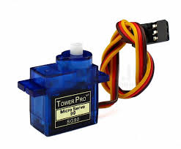well specified servo ideal for use in radio-controlled models and for interfacing with microcontroller systems like Arduino, Raspberry Pi, PICAXE, etc

## ultra sonic sensor :

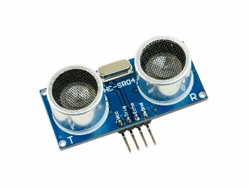The HC-SR504 is a non-contact ultrasonic ranging module with a 20 to 4000mm range. The module includes ultrasonic transmitter, receiver, and control circuit - all on a compact circuit board

# APPS and online services :

## Arduino IDE :

The open-source Arduino Software (IDE) makes it easy to write code and upload it to the board. It runs on Windows, Mac OS X, and Linux. The environment is written in Java and based on Processing and other open-source software.

## Proteus :

Proteus PCB tools seamlessly combines schematic capture and PCB layout to provide a powerful, integrated and easy to use suite of tools for professional PCB Design

# schematic :

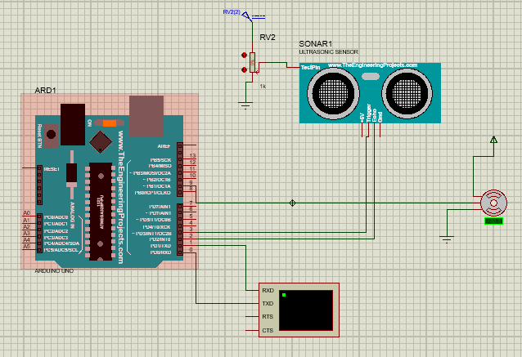

# code :

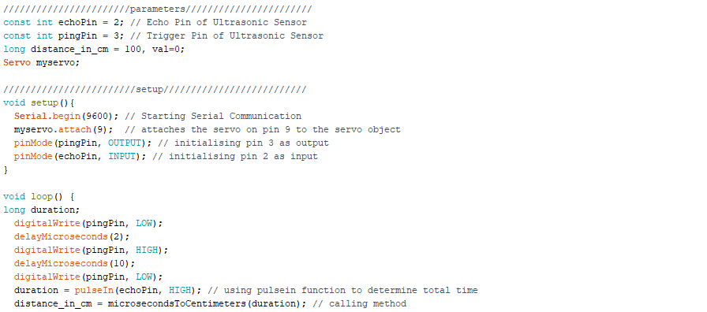 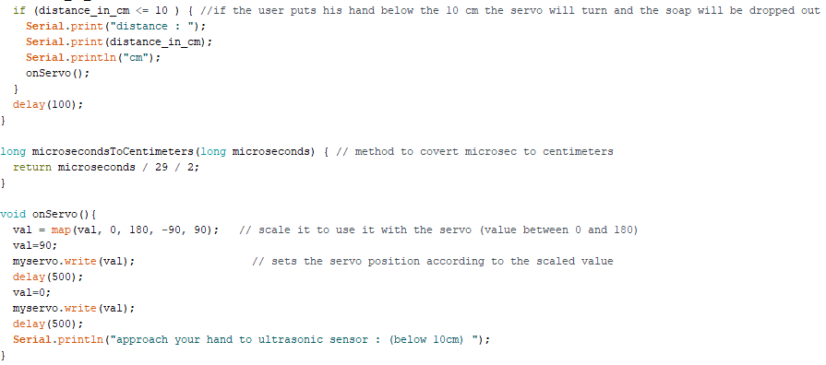

# Result :

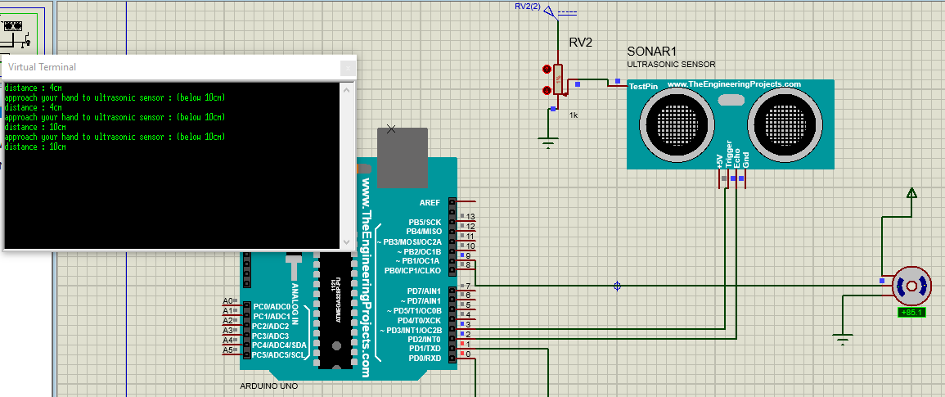

# Conclusion :

After realizing this project, we’ve learned how to connect the servo motor and ultrasound with the Arduino uno, and how an engineer can protect his self and his entourage by providing simple ideas.

#### Link to GitHub:

<https://github.com/ysfelkantri/Covid_19/tree/master/automatic_soap_pump_bottle>