# Manage ACCESS to a folder in DOORS:

* Right click the folder you want to give access to
* Click on properties you will get the window below :

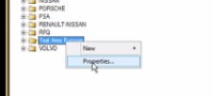

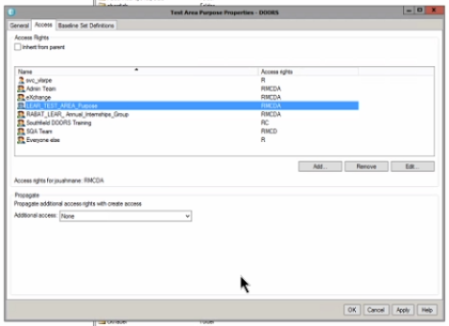

RWCDA : **read**, **modify**, create, **delete**, and **admin**

* You should be database manager to continue the process
* In menu bar click “Tools -> Manage Users”

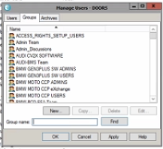

* Search the group name where to add User
* Click Edit :

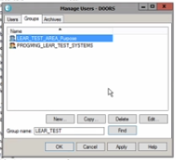

* Select non member to add or member to remove from the group .

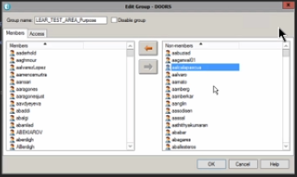

* Restart DOORS and enjoy :)