# Module attributes template :

You should be set Edit mode to “read only”

Open the module inside : “project_name/requirement managements/attribute template…”

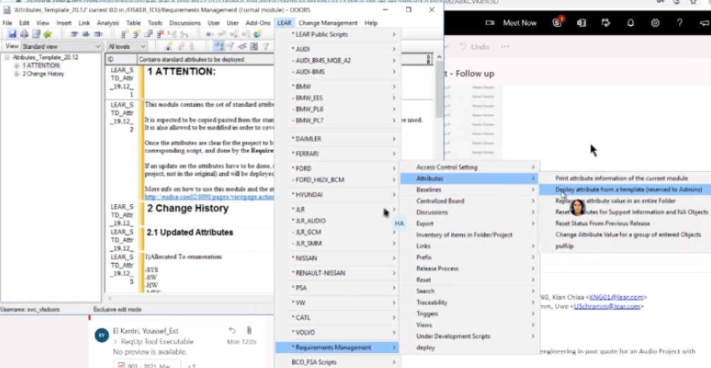

Then in menu bar : “LEAR/Requirement management/Attributes/Deploy attribute from a template (reserved to admin)”

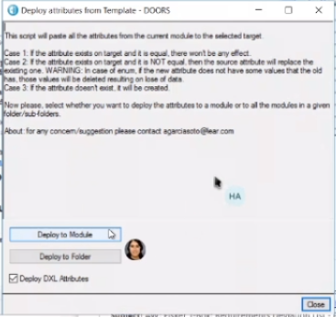

Browse the module/folder to deploy on it .

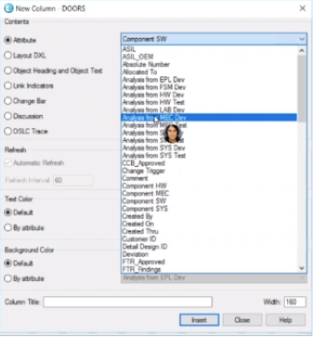

Here are the added attribute’s template , enjoy :)