YUSUF KAYMAZ/295024

BU RAPOR SAYISAL TASARIM LABARATUARI DERSİNDE VHDL İLE DEVRE TASARIMI İÇİN VERİLEN SERBEST ÖDEV İÇİN HAZIRLANMIŞTIR

**4 BIT FULL ADDER**

.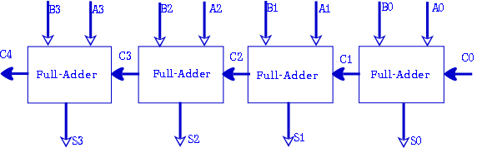

PORTLAR:

Port ( A: in std_logic_vector(3 downto 0);  
B : in std_logic_vector(3 downto 0);   
S : out std_logic_vector(3 downto 0);  
Cin : in std_logic);

İŞLEMLER:

S(0) <= A(0) XOR B(0) XOR Cin ;  
Cout(0) <= (A(0) AND B(0)) OR (Cin AND A(0)) OR (Cin AND B(0)) ;  
S(1) <= A(1) XOR B(1) XOR Cout(0) ;  
Cout(1) <= (A(1) AND B(1)) OR (Cout(0) AND A(1)) OR (Cout(0) AND B(1)) ;  
S(2) <= A(2) XOR B(2) XOR Cout(1);  
Cout(2) <= (A(2) AND B(2)) OR (Cout(1) AND A(2)) OR (Cout(1) AND B(2)) ;  
S(3) <= A(3) XOR B(3) XOR Cout(2) ;  
Cout(3) <= (A(3) AND B(3)) OR (Cout(2) AND A(3)) OR (Cout(2) AND B(3)) ;

**4 BIT HALF ADDER**

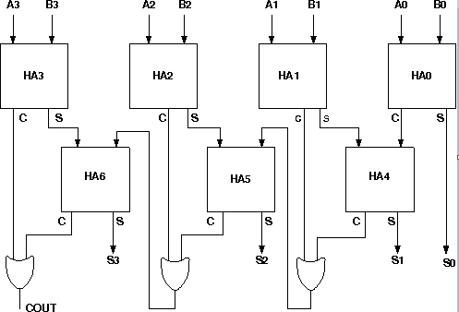

PORTLAR:

Port ( A: in std_logic_vector(3 downto 0);  
B : in std_logic_vector(3 downto 0);  
S : out std_logic_vector(3 downto 0);  
Carry: out std_logic  
);

İŞLEMLER:

S(0)<=A(0) xor B(0);  S(2)<=Orr(0) xor Sara(1);  
Cout(0)<=A(0) and B(0);--ha0 bitti. Cout(4)<=Orr(0) and Sara(1);  
Sara(0)<=A(1) xor B(1); Orr(1)<=Cout(3) or Cout(4);  
Cout(1)<=A(1) and B(1);--ha1 bitti Sara(2)<=A(3) xor B(3);  
S(1)<=Cout(0) xor Sara(0); Cout(5)<=A(3) and B(3);  
Cout(2)<=Cout(0) and Sara(0); S(3)<=Orr(1) xor Sara(2);  
Orr(0)<=Cout(1) or Cout(2); Cout(6)<=Orr(1) and Sara(2);

Sara(1)<=A(2) xor B(2); Carry<=Cout(5) or Cout(6);  
Cout(3)<=A(2) and B(2);

**FOUR INPUTS SEVEN SEGMENT DISPLAY BCDCODER**

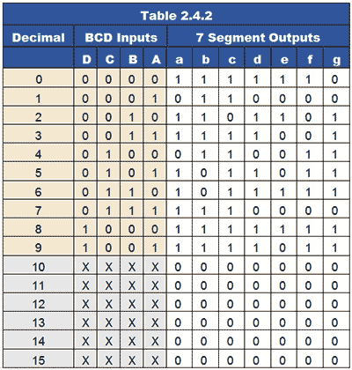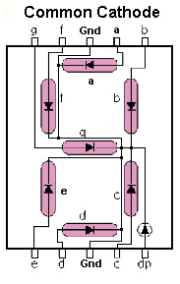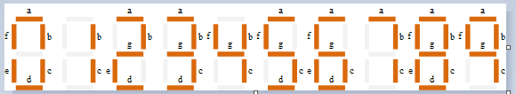

PORTLAR:

Port (

s : in std_logic; -- saat

A: in std_logic_vector(3 downto 0);

B: out std_logic_vector(6 downto 0));

İŞLEMLER:

If( A="0000" ) Then B <= "1111110";

elsif( A="0001" ) Then B <= "0110000";

elsif( A="0010" ) Then B <= "1101101";

elsif( A="0011" ) Then B <= "1111001";

elsif( A="0100" ) Then B <= "0110011";

elsif( A="0101" ) Then B <= "1011011";

elsif( A="0110" ) Then B <= "1011111";

elsif( A="0111" ) Then B <= "1110000";

elsif( A="1000" ) Then B <= "1111111";

elsif( A="1001" ) Then B <= "1111011";