**BUSINESS DATA MANAGEMENT**

**PROJECT REPORT**

By:

                                                                                     Yash Shah

**Part 1**

1. **General description:**

The objective of this Project is to build a database system for boutique hotel business. Below are the entities considered while building the system-

Entities -

1. P_CUSTOMER- Primary customer responsible for bookings, payments and events

2. DEPENDANTS- Customers who are related to the primary customer

3. ROOMS- Rooms available in the hotel

4. OFFERS- Offers that are applicable for the season

5. EVENT- Events that are organized by customers

6. PAYMENT- Payment details of the bookings

7. BOOKINGS- Reservations made by each primary customer

Assumptions based on the entities listed above-

1. A Primary customer can book only one event at a time

2. A Dependent cannot exist without a primary customer

3. A Primary customer can book many rooms

4. All rooms including the rooms used for events is identified by a unique room no- rid

5. Reservations can be searched only through the primary customer phone number

6. Primary Customer no is key to for the entities - events, bookings, payment and dependents

7. Customer should book an event in order to register for an event

8. All the details about the customers, room bookings and events are entered by hotel staff

1. **Entity- Relationship Diagram:**

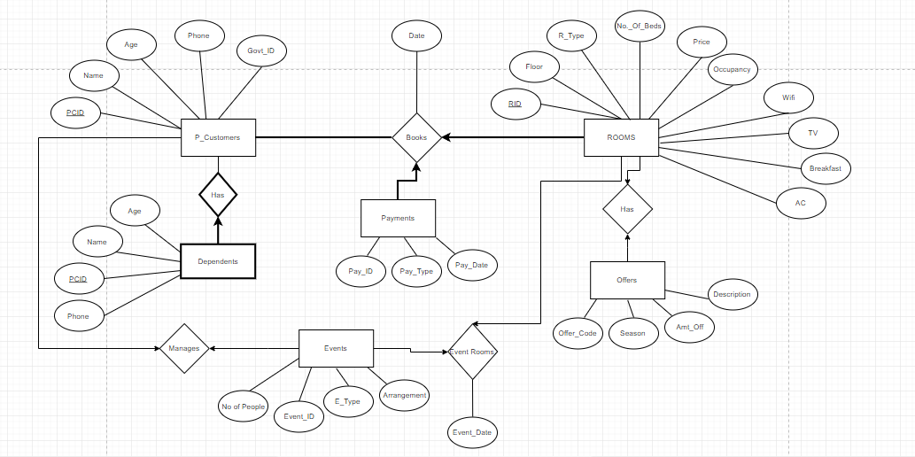

**Part 2**

Realize the above database and express the following query in Relational Algebra and in SQL:

Find the customer (or customers) who paid the highest room rate in 2017 and is also related to at least one more non-primary customer.

Relational Algebra Query

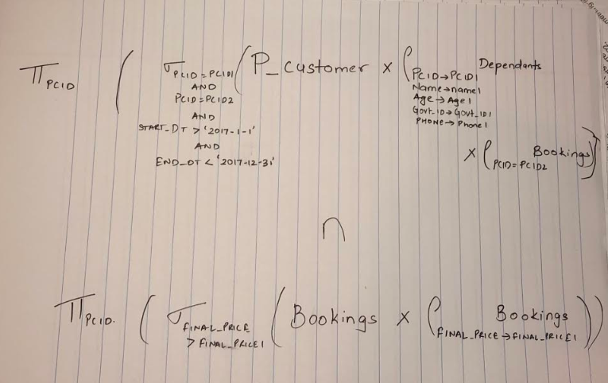

SQL Query

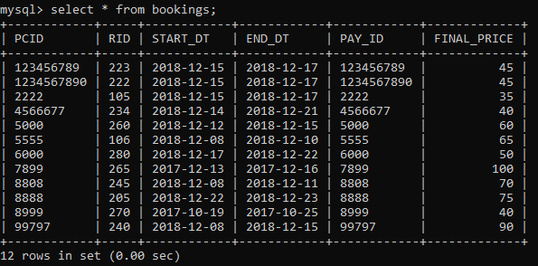

https://lh5.googleusercontent.com/HqO0NlrBJDhn1yf5BD6h8Aed9HRFVkLjb3BwT6WQ6Nmd5L1IXMYK00ya4HFkaUzoZVc7rQ4cuHzYmxJdohwFu2ynzUiY2pvybg2mcdPLhO6SAPHeHaKLHAHtemXTFvZ3LAk13LLCkxC0F_77cA

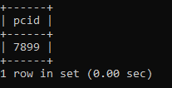

**Part 3**

* The landing page of the website is **Customer.html**. On this page as displayed below the staff fills in the Primary customer details which are the customer’s Name, age, Phone number, government id and type of payment and clicks on submit button

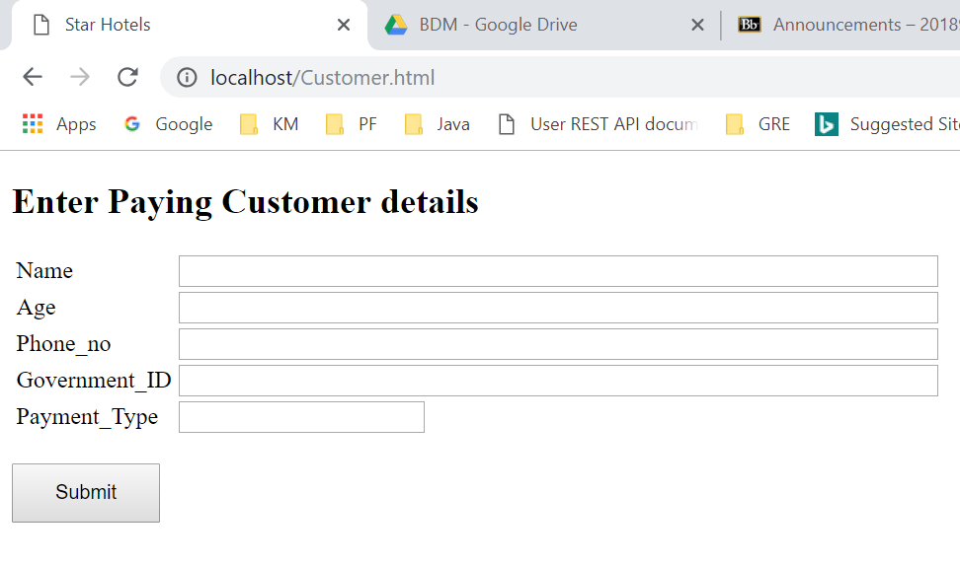

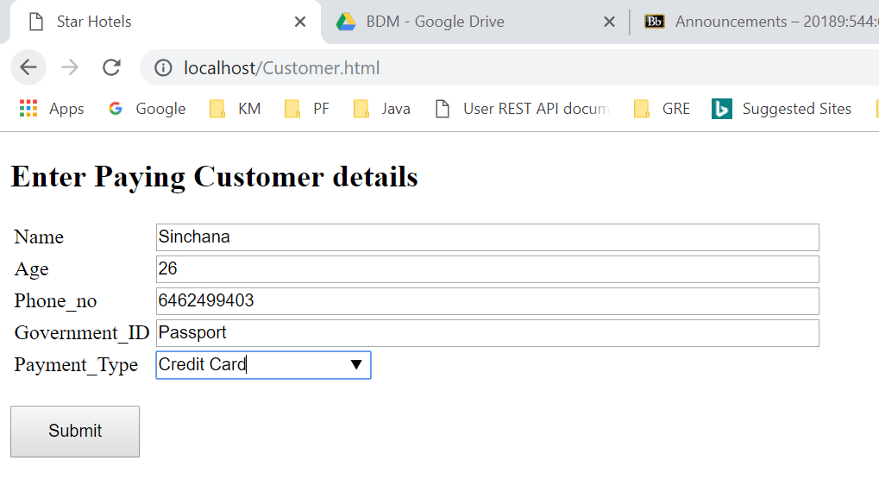

* The staff will be navigated to the next page which is **Customer.py**. It shows the Customer details and the type of rooms available to the customer.

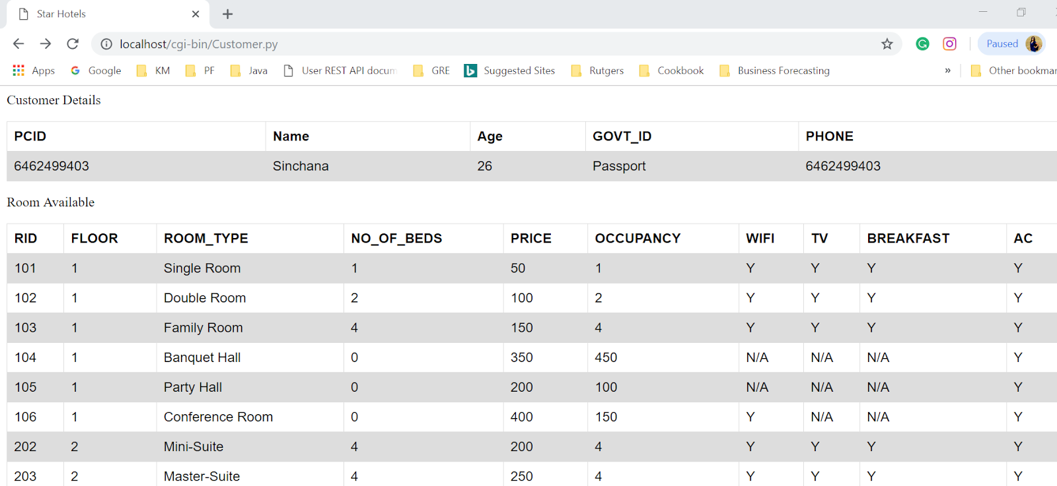

* At the end of customer.py, the staff can click on submit button to check the offers on some selected room and can apply those offers while selecting the room type.

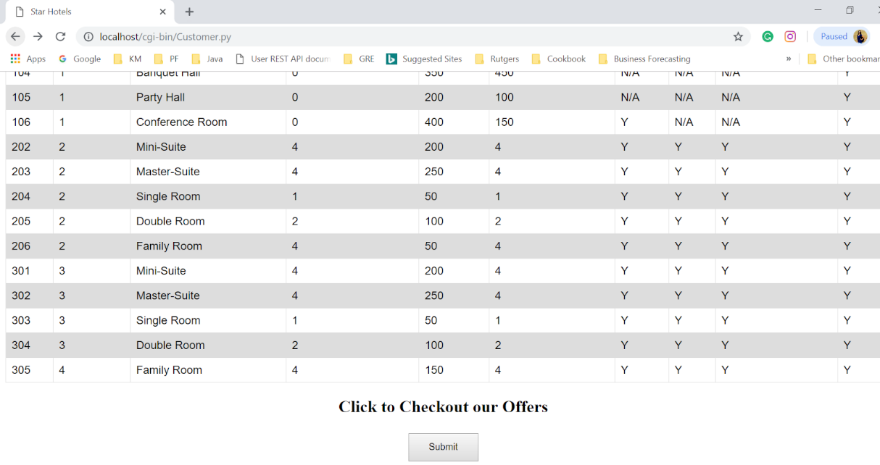

* Once the staff clicks on submit button, the customer is then navigated to Offers.py page which shows the seasonal offers offered. The staff can then fill in the details for room preference which has the customer contact (phone no.) room number, room type, floor, number of beds, occupancy(no. of people that can stay in the room), availability of wifi, tv and breakfast.

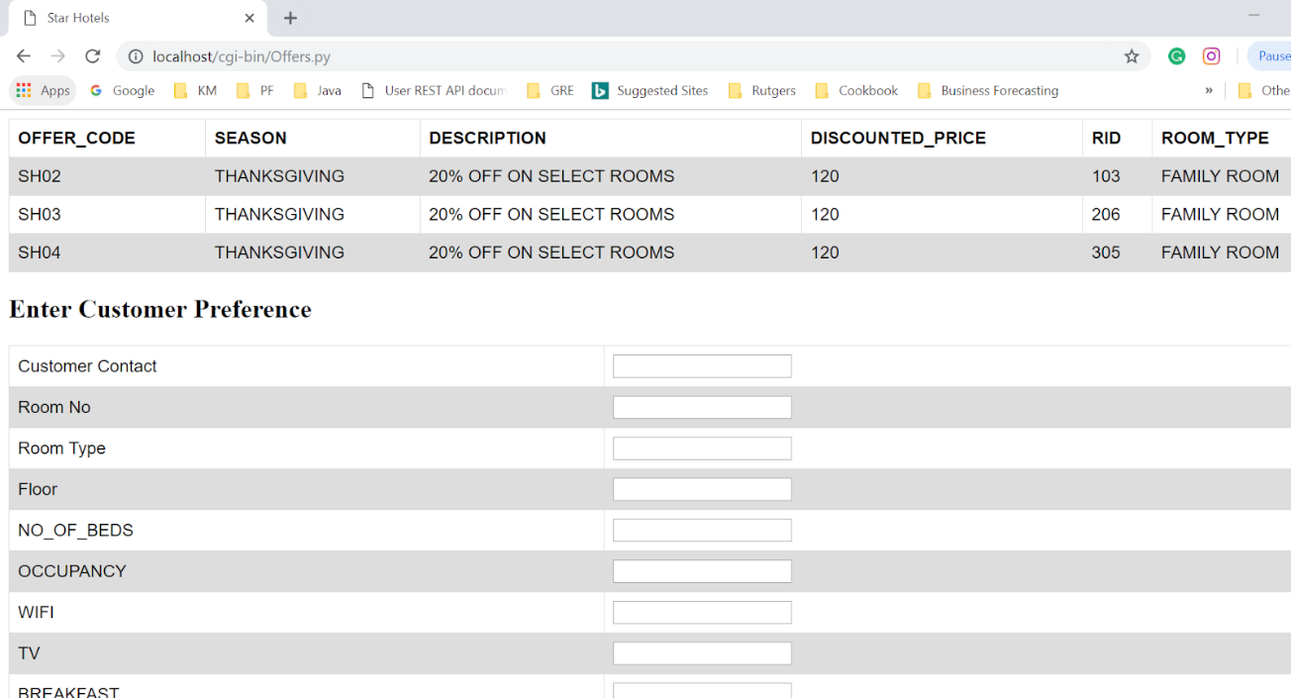

* Once the staff has filled in the customer room preferences and clicked on submit button, the staff is navigated to the next page which is Room.py. On this page staff can see customer booking details. There is also an option to search bookings on this page where staff can search bookings by entering customer phone number.

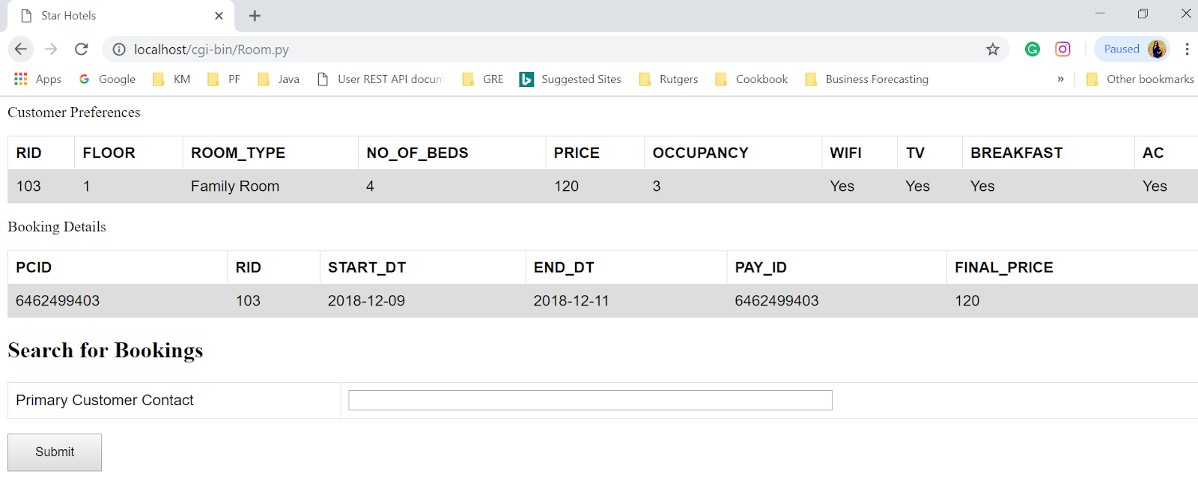

* The staff can look for customer room bookings through Search_Customer.html page. Enter the primary contact details of a booking which is Phone no of the Primary customer. The staff will be able to see all the rooms reserved under the customer.

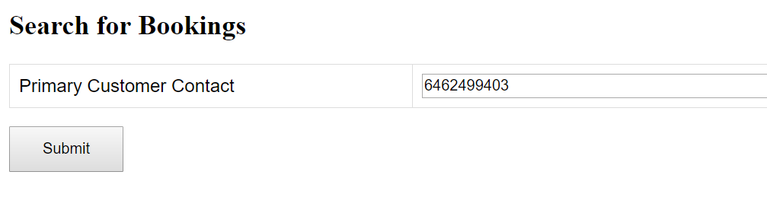

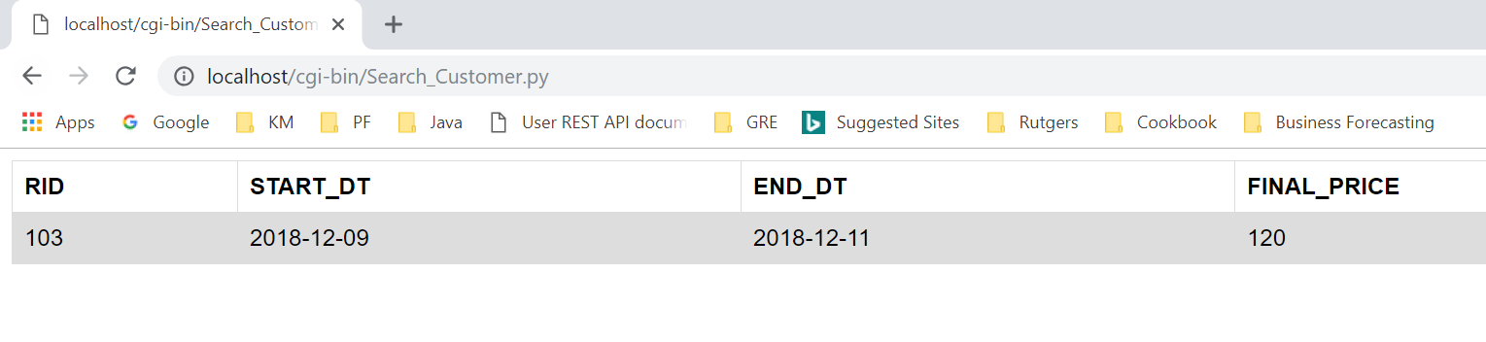

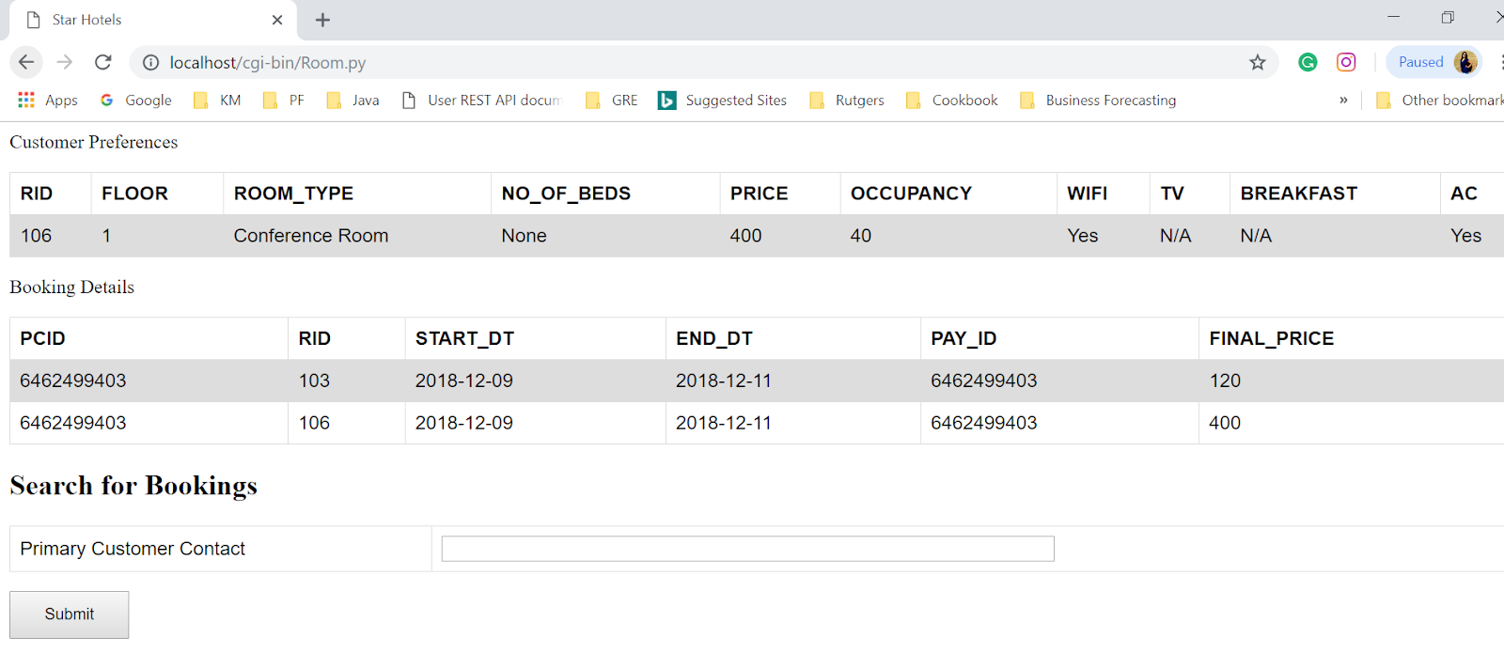

* A customer can also book rooms for events. If customer wants to book an event, navigated to event page by opening event.html in your local host. The staff fills in the event details i.e. customers contact, type of event, arrangements required, number of people, event date and the room number.

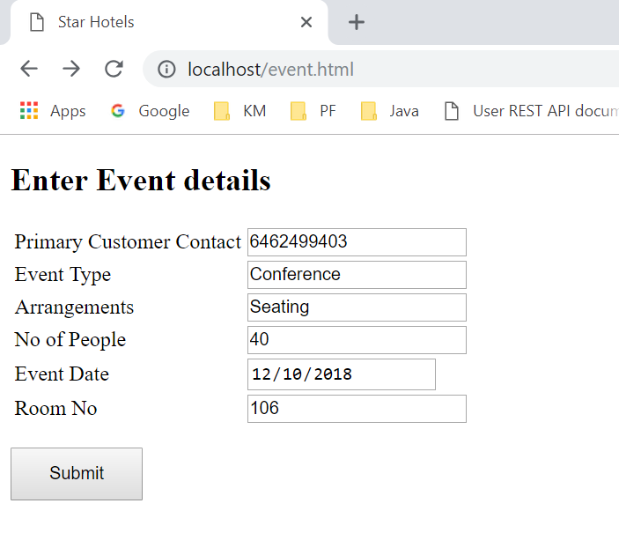

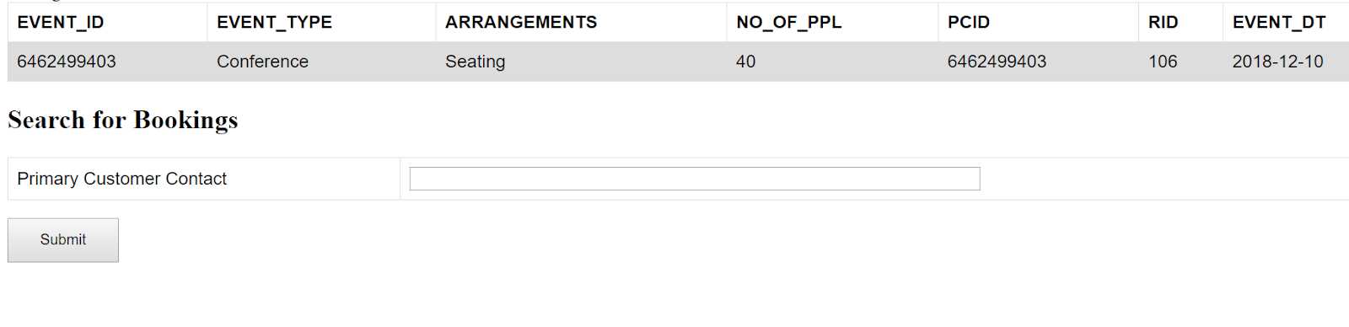

* The details of the dependents are entered in a separate page for dependents. Open dependant.html in your browser where the staff can enter the dependent customer details, name of the dependent, age, phone number, govt. id and the phone number of the customer.

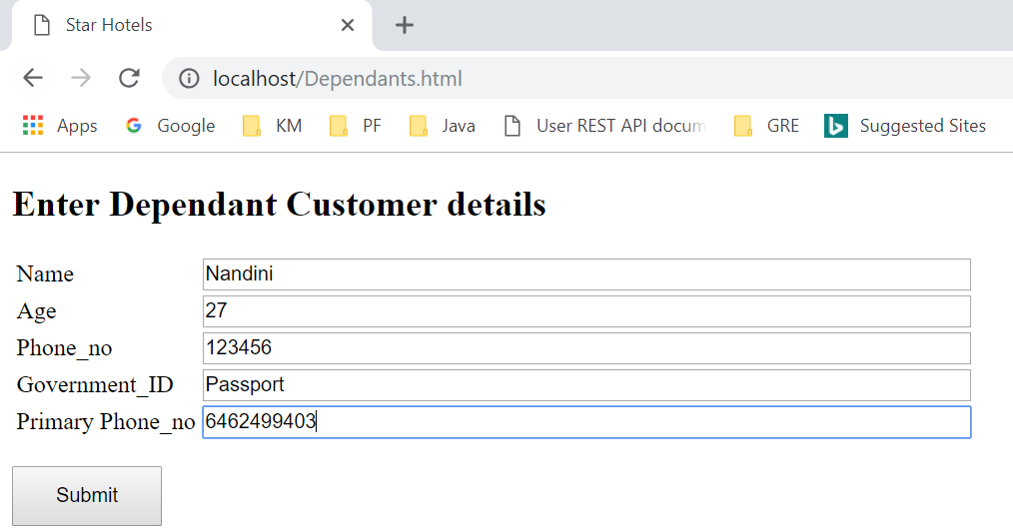

* When the staff clicks on submit button, the staff is navigated to dependants.py which shows the details of the Dependent Customer.

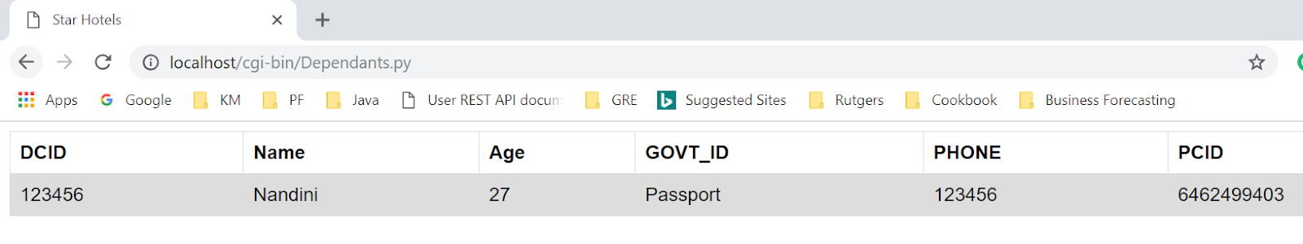

**Part 4**

**Installation Details:**

The steps below are as per windows machine. Please make sure you have apache, MySQL and Python installed in your laptop before attempting to run the code

Steps:

1. Run the SQL script- HOTEL_DB.SQL. This will create the hotel database system
2. Place all the .html files under Apache24/htdocs folder
3. Place all .py files under Apache24/cgi-bin folder
4. Change the path at the beginning of all the .py files to your python home directory

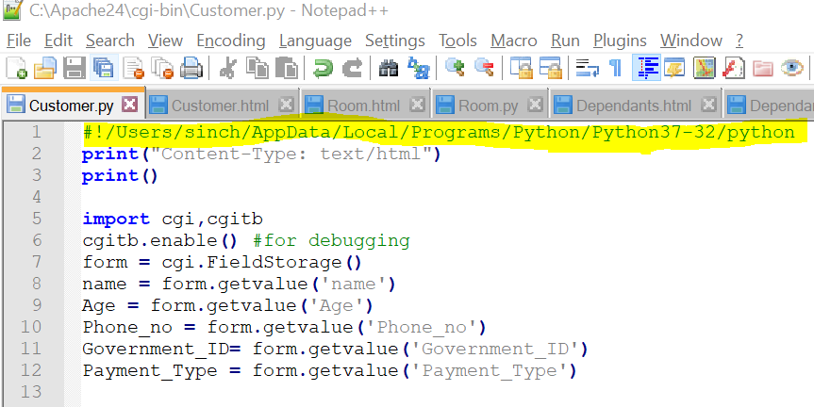

1. The .html files are linked so it very important to change the path of the html files. Find the below lines of code in the .py files and change the path according your system

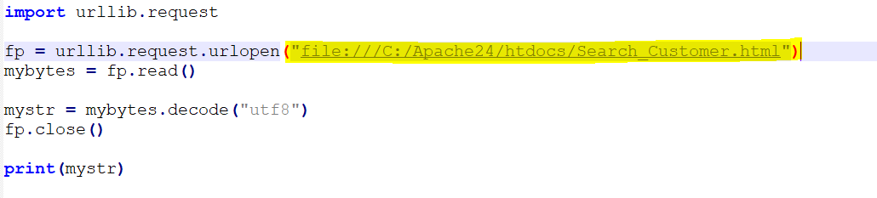

1. Change the database details to make sure that your python file can access your local database



Please follow the steps mentioned in **Part 3** of this report to run the code