1)Customer table

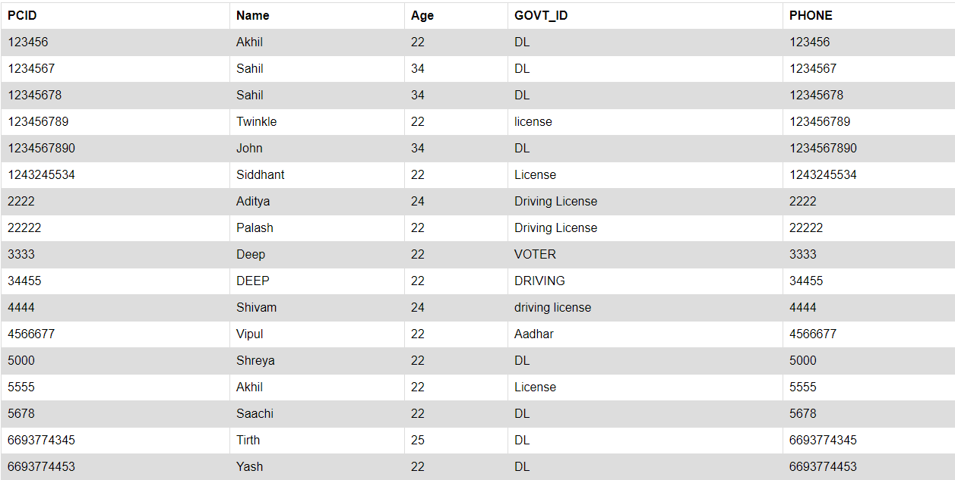

2)Offers table

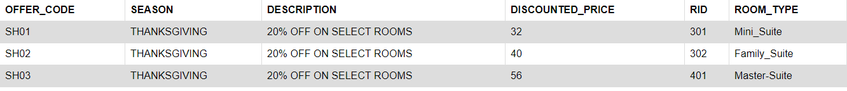

3)Rooms table

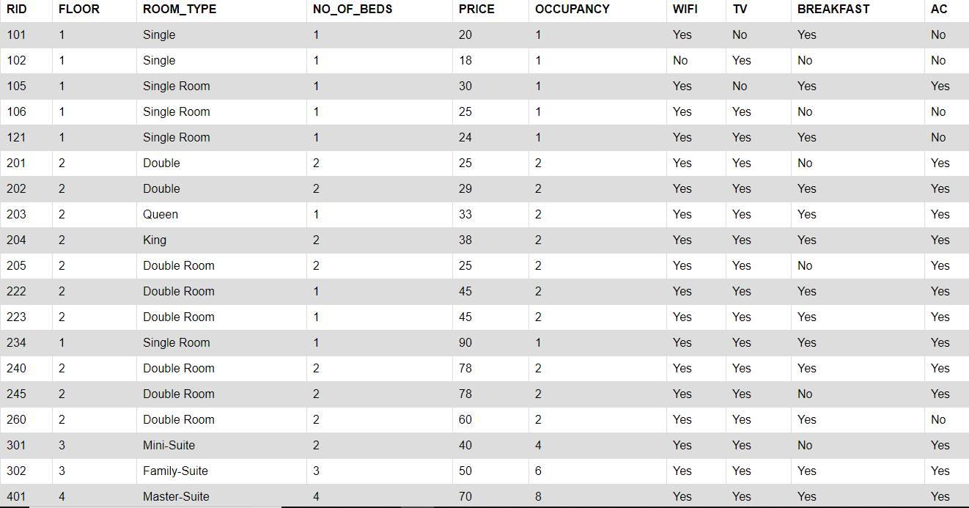

4)search customer table



5)Dependants table

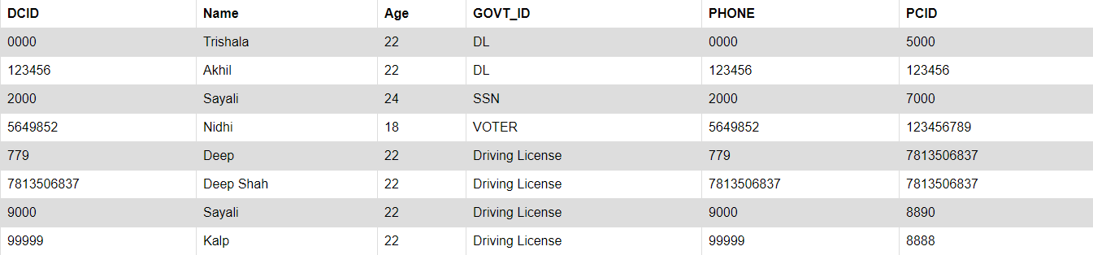

6)events table

