**Introduction**

This report's purpose is to explore all possibilities regarding the translation of the general human elbow into a working robotic model. It will include research regarding the elbow's degrees of freedom, skeletal structure, ligaments and muscle structure.

**Degrees of Freedom**

The elbow is capable of two different types of movement. The first, and more apparent, is the elbow's ability to move up and down, similar to how a hinge would move. The degree of freedom for this type of movement, also known as pitch, is about 150 degrees for the elbow. The lesser noticed type of movement, is the elbow's ability of rotating the forearm without movement of the shoulder. This type of movement, called roll, is almost 180 degrees. Many times the roll is excluded when discussing the elbow's degrees of freedom, but due to the proximity of the roll action to the elbow, I felt it was important to include it here.

**Skeletal Structure**

The skeletal structure of the elbow is not complicated. Coming down from the shoulder is the humerus and coming up from the hand are two bones that run parallel to one another, the radius and the ulna. The bone structure of the joint is pictured in Figure A.

Figure A

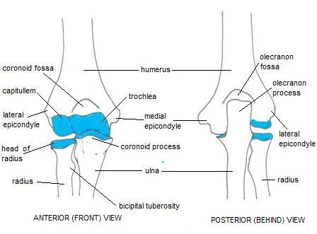

Figure A lists numerous other parts of the elbow, but for our purposes most may be ignored as the hinge joint in the elbow is mainly comprised of the three aforementioned bones. One thing to note would be the olecranon process which is at the end of the ulna. This bone wraps around the back of the humerus and helps keep the elbow rotating 180 degrees (this is assuming the elbow rotates from 30 to 180 degrees).

**Ligaments**

There are three ligaments present in the elbow: the radial collateral ligament, the annular ligament of radius, and the ulnar collateral ligament. The location of these ligaments and what they cover is portrayed in Figure B.

Figure B

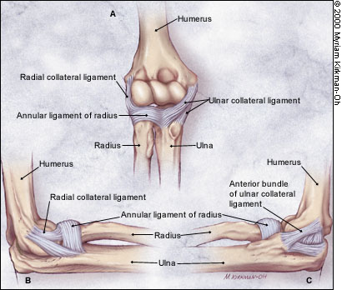

The radial collateral ligament is located on the outside of the elbow, or the side which generally points away from the torso. It is responsible for preventing excessive adduction of the elbow joint. The annular ligament is located more toward the middle of the joint and is responsible for keeping the head of the radius in contact with its notch in the ulna. Lastly, the ulnar collateral ligament is located on what could be called the inside of the elbow, or that which generally faces the torso. It's responsibility is to prevent excessive abduction of the elbow joint.

**Muscle Structure**

Two muscles running down the upper arm are needed for a majority of the hinge movement in the elbow. These muscles include the triceps brachii and the biceps brachii. The position of the muscles can be seen in Figure C.

Figure C

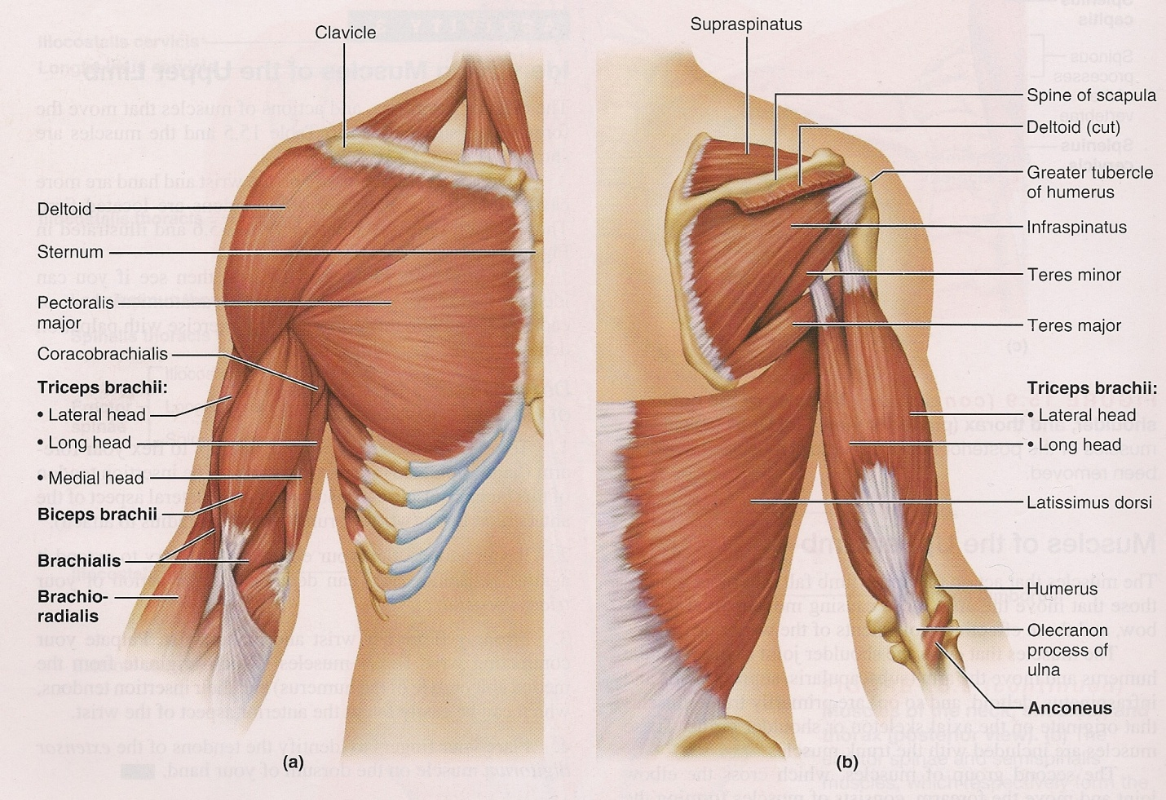

Figure C includes many other muscles not mentioned above, however these do not need to be included in this report as they should not affect our build strategy. The biceps brachii, better known as the bicep, is used for retracting the forearm toward the shoulder. The triceps brachii, or tricep, does the opposite and works to extend the arm. These two muscles working in concert are what create the hinge motion of the elbow.

The roll motion of the forearm mentioned in the degrees of motion section is located below the elbow. It is known as the pronator teres and it works in concert with the pronator quadratus near the wrist to create a rolling motion independent of the shoulder. The position of these muscles can be seen in Figure D.

Figure D

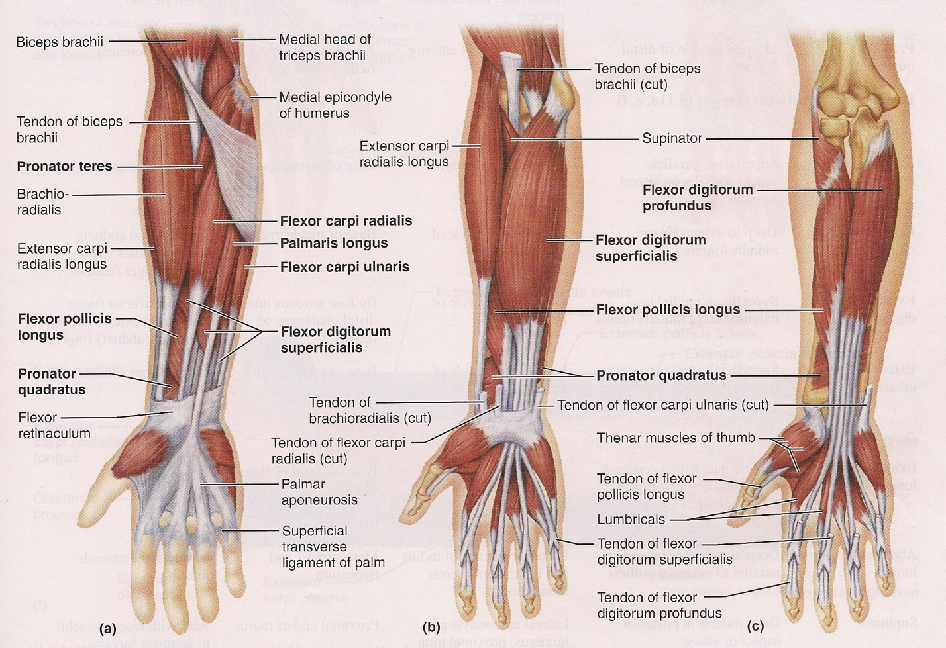

These two muscles, though they do not affect the elbow themselves, are important to include as the movement they allow extends from this region and not explicitly from the shoulder or hand.

Figure A:

<http://usmlelinks.com/wp-content/uploads/2010/07/elbow_joint_anatomy001.jpg>

Figure B:

<http://www.aafp.org/afp/20000201/691_f2.jpg>

Figure C & D:

Human Anatomy and Physiology by Elaine N. Marieb and Susan J. Mitchell

Resources:

<http://physicaltherapy.about.com/od/humananatomy/p/elbowjoint.htm>

<http://en.wikipedia.org/wiki/Anular_ligament_of_radius>

Human Anatomy and Physiology by Elaine N. Marieb and Susan J. Mitchell