**Homework 4**

**Programming Languages Principles and Implementation**

**Yevgeniy Shatrovskiy**

**Grammars**

*Due on 11/13*

The work has to be done alone or in a group of 2 students.

A hard copy is required. Professional presentation is important.

100 points

**Exercise 1:**

We consider the BNF grammar below:

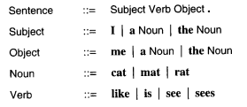

1. Show that **I like the cat.** is recognized by this BNF grammar using a rightmost derivation and, then, a parse tree.

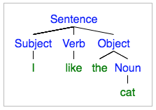

Sentence => Subject Verb Object.

=> Subject Verb the Noun.

=> Subject Verb the cat.

=> Subject like the cat.

=> I like the cat.

1. Provide an expression that is NOT recognized by the grammar.

I like cats.

Explanation: Object needs either “a” or “the” if not using “me”. Also, “Cats” is not a known noun.

**Exercise 2:**

We consider the following grammar:

EXPRESSION ::= NUMERAL | ( EXPRESSION OPERATOR EXPRESSION )

NUMERAL ::= 0 | 1 | 2 | 3 | 4 | 5 | 6 | 7 | 8 | 9

OPERATORS ::= + | -

Show that (4 - (3 + 2)) is a legal EXPRESSION using a leftmost derivation, and,then, a parse tree.

EXPRESSION => (EXPRESSION OPERATOR EXPRESSION)

=> (NUMERAL OPERATOR EXPRESSION)

=> (4 OPERATOR EXPRESSION)

=> (4 - EXPRESSION)

=> (4 - (EXPRESSION OPERATOR EXPRESSION)

=> (4 - (NUMERAL OPERATOR EXPRESSION)

=> (4 - (3 OPERATOR EXPRESSION)

=> (4 - (3 + EXPRESSION)

=> (4 - (3 + NUMERAL)

=> (4 - (3 + 2))

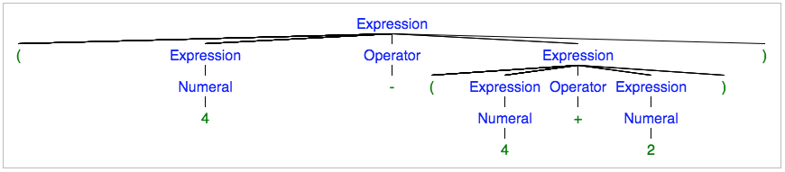

**Exercise 3:**

Show that the following grammar is ambiguous:

X -> a | bX | bXcX

where a,b,c are terminals.

There are two parse trees possible:

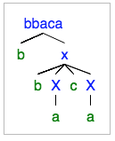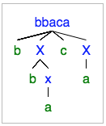

**Exercise 4:**

1. Design a BNF grammar that recognizes expressions of the form Ai where A is in {a,b,c} and i is a digit.

EXPRESSION ::= LETTER DIGIT

LETTER ::= {a, b, c}

DIGIT ::= {0,1,2,3,4,5,6,7,8,9}

1. Design a BNF grammar that recognizes lists of the form A1, A2, A3, …, An. Use question a).

EXPRESSION ::= SET | ,EXPRESSION

SET ::= LETTER DIGIT

LETTER ::= {a, b, c}

DIGIT ::= {0,1,2,3,4,5,6,7,8,9}

**Exercise 5:**

1. Write a JAY program that computes the sum of the *n* first numbers with a loop.

void main () {

int n, counter, total;

n = 5 // Example Input

counter = 1;

total = 0;

while (counter <= n) {

total = total + counter;

counter = counter + 1;

}

}

1. Write a JAY program that assigns the minimum of two numbers in a variable called min.

void main () {

int min, firstNum, secondNum;

min = 0;

firstNum = 10;

secondNum = 12;

if (firstNum <= secondNum)

min = firstNum;

else

min = secondNum;

}

1. Provide 2 examples of lexical errors in JAY.
2. &

“&&” is recognized, but a single “&” is not.

1. |

“||” is recognized, but a single “|” is not.

1. Provide 2 examples of JAY programs with 2 different syntax errors.
2. firstVar = firstVar + 2

Missing “;” to close the statement.

1. if () firstVar = firstVar + 2

The if statement cannot have a blank Expression.

1. Provide 2 examples of JAY programs with errors that are neither detected during the lexical analysis nor during the syntactic analysis.

1 & 2)

void main () {

boolean min, first, second;

min = 5;

first = true;

second = first + min;

}

Explanation:

1. Assigning an integer value to a boolean is not possible, but neither analysis would find the error.
2. The concrete syntax of Jay allows the user to add two identifiers, but adding two boolean values is not possible.