**CPSC1520 – JavaScript 6 Exercise: Fetch API**

# **Introduction**

The Fetch API is essential to most client side JavaScript applications. In this in class exercise, you will be using fetch and your local web server to fetch data and render the data. The data is located in the project folder inside **public/data/contacts.json** folder

|  |  |
| --- | --- |
|  |  |

# **Task 1: Fetch Contacts JSON Data.**

1. Create a function named “getContacts”. You can keep the function body empty for now.
2. Inside the getContacts function use the fetch api to load the contacts.json file.
3. Call the getContacts function to load the json data.
4. Call your render function and pass the contacts data to the render function you will create in the next Task.

**NOTE**

To ensure that you’ve successfully loaded the data, log out the result from the fetch to the console.

# **Task 1: Render the JSON Data**

1. Create a function named "renderContacts". The template for the data is inside the index.js file. Use this template to add the email and name properties from the json data objects.

* Select the element in the index.html document with the id of “contacts”. This is where you will display the contacts.
* Set the innerHTML of the div element to an empty string .
* Render the contact data using the display templating technique. Loop through each one of the contacts and seed the template with the name and email properties. Your final output should look like the image below.
* Make sure to call the renderContacts function from the getContacts() function and pass along the array of contacts from getContacts to the renderContacts() method.

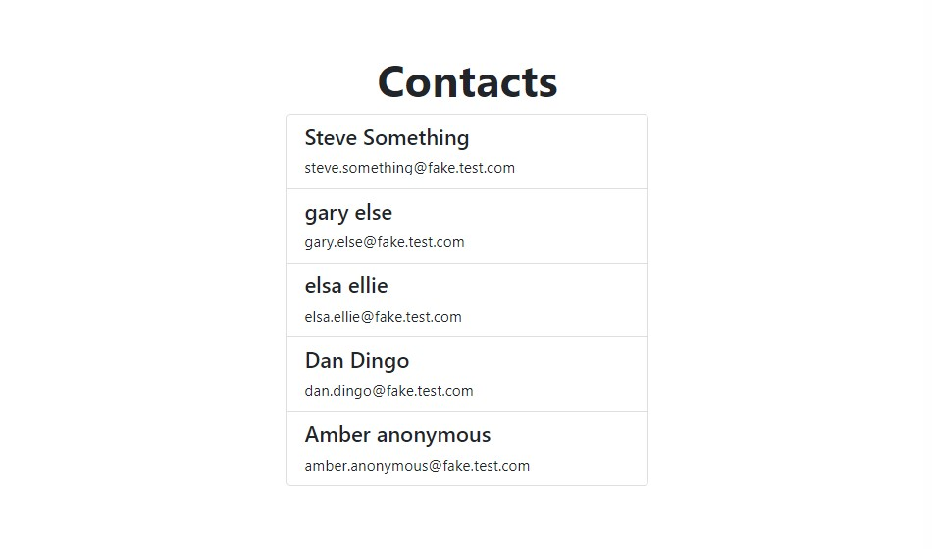

# **TASK Step 3 – Submission**

1. Sign in to your Netlify account <https://netlify.com/>
2. Create a new site and upload your lab files. Add the URL that Netlify provides you and submit the URL to Moodle.
3. Create a new GitHub repository for your lab files. Upload the repository URL to Moodle.
4. Create a zip file for your project and submit the zip file as part of your Moodle submission.