Aim- To implement a Binary Search Tree (Insertion,Deletion,Searching)
Description- Binary Search Tree, is a node-based binary tree data structure which has the following properties:
- The left subtree of a node contains only nodes with keys less than the node’s key.
- The right subtree of a node contains only nodes with keys greater than the node’s key.
- The left and right subtree each must also be a binary search tree.
There must be no duplicate nodes.

Algorithm for Insertion-Whenever an element is to be inserted, first locate its proper location. Start searching from the root node, then if the data is less than the key value, search for the empty location in the left subtree and insert the data. Otherwise, search for the empty location in the right subtree and insert the data.
Algorithm for Searching- Whenever an element is to be searched, start searching from the root node. Then if the data is less than the key value, search for the element in the left subtree. Otherwise, search for the element in the right subtree. Follow the same algorithm for each node.
Algorithm for Deletion- 1) Node to be deleted is leaf: Simply remove from the tree.
2) Node to be deleted has only one child: Copy the child to the node and delete the child
3) Node to be deleted has two children: Find inorder successor of the node. Copy contents of the inorder successor to the node and delete the inorder successor. Note that inorder predecessor can also be used.

Implementation-
// C program to demonstrate insert operation in binary search tree
#include<stdio.h>
#include<stdlib.h>

struct node
{
int key;
struct node *left, *right;
};

// A utility function to create a new BST node
struct node *newNode(int item)
{
struct node *temp = (struct node *)malloc(sizeof(struct node));
temp->key = item;
temp->left = temp->right = NULL;
return temp;
}

// A utility function to do inorder traversal of BST
void inorder(struct node *root)
{
if (root != NULL)
{
inorder(root->left);
printf("%d \n", root->key);
inorder(root->right);
}
}

/* A utility function to insert a new node with given key in BST */
struct node* insert(struct node* node, int key)
{
/* If the tree is empty, return a new node */
if (node == NULL) return newNode(key);

/* Otherwise, recur down the tree */
if (key < node->key)
node->left = insert(node->left, key);
else if (key > node->key)
node->right = insert(node->right, key);

/* return the (unchanged) node pointer */
return node;
}

// Driver Program to test above functions
int main()
{
struct node *root = NULL;
root = insert(root, 50);
insert(root, 30);
insert(root, 20);
insert(root, 40);
insert(root, 70);
insert(root, 60);
insert(root, 80);

// print inoder traversal of the BST
inorder(root);

return 0;
}

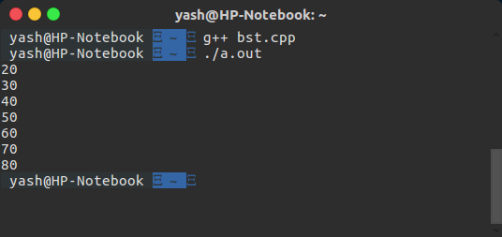
// C program to demonstrate delete operation in binary search tree
#include<stdio.h>
#include<stdlib.h>

struct node
{
int key;
struct node *left, *right;
};

// A utility function to create a new BST node
struct node *newNode(int item)
{
struct node *temp = (struct node *)malloc(sizeof(struct node));
temp->key = item;
temp->left = temp->right = NULL;
return temp;
}

// A utility function to do inorder traversal of BST
void inorder(struct node *root)
{
if (root != NULL)
{
inorder(root->left);
printf("%d ", root->key);
inorder(root->right);
}
}

/* A utility function to insert a new node with given key in BST */
struct node* insert(struct node* node, int key)
{
/* If the tree is empty, return a new node */
if (node == NULL) return newNode(key);

/* Otherwise, recur down the tree */
if (key < node->key)
node->left = insert(node->left, key);
else
node->right = insert(node->right, key);

/* return the (unchanged) node pointer */
return node;
}

/* Given a non-empty binary search tree, return the node with minimum
key value found in that tree. Note that the entire tree does not
need to be searched. */
struct node * minValueNode(struct node* node)
{
struct node* current = node;

/* loop down to find the leftmost leaf */
while (current->left != NULL)
current = current->left;

return current;
}

/* Given a binary search tree and a key, this function deletes the key
and returns the new root */
struct node* deleteNode(struct node* root, int key)
{
// base case
if (root == NULL) return root;

// If the key to be deleted is smaller than the root's key,
// then it lies in left subtree
if (key < root->key)
root->left = deleteNode(root->left, key);

// If the key to be deleted is greater than the root's key,
// then it lies in right subtree
else if (key > root->key)
root->right = deleteNode(root->right, key);

// if key is same as root's key, then This is the node
// to be deleted
else
{
// node with only one child or no child
if (root->left == NULL)
{
struct node *temp = root->right;
free(root);
return temp;
}
else if (root->right == NULL)
{
struct node *temp = root->left;
free(root);
return temp;
}

// node with two children: Get the inorder successor (smallest
// in the right subtree)
struct node* temp = minValueNode(root->right);

// Copy the inorder successor's content to this node
root->key = temp->key;

// Delete the inorder successor
root->right = deleteNode(root->right, temp->key);
}
return root;
}

// Driver Program to test above functions
int main()
{
struct node *root = NULL;
root = insert(root, 50);
root = insert(root, 30);
root = insert(root, 20);
root = insert(root, 40);
root = insert(root, 70);
root = insert(root, 60);
root = insert(root, 80);

printf("Inorder traversal of the given tree \n");
inorder(root);

printf("\nDelete 20\n");
root = deleteNode(root, 20);
printf("Inorder traversal of the modified tree \n");
inorder(root);

printf("\nDelete 30\n");
root = deleteNode(root, 30);
printf("Inorder traversal of the modified tree \n");
inorder(root);

printf("\nDelete 50\n");
root = deleteNode(root, 50);
printf("Inorder traversal of the modified tree \n");
inorder(root);

return 0;
}
Output-
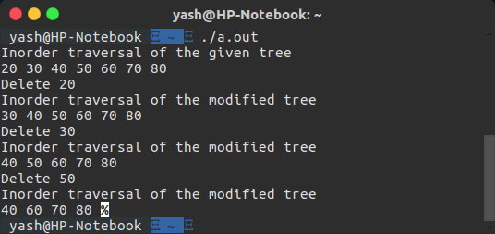
LearningOutcomes- I learnt the Implementation of Binary Search Tree and the various operations like Insertion,Deletion and Searching in BST.

Aim- To perform Tree Traversals on a Binary Tree/Binary Search Tree.
Description- Unlike linear data structures (Array, Linked List, Queues, Stacks, etc) which have only one logical way to traverse them, trees can be traversed in different ways. Following are the generally used ways for traversing trees. Unlike linear data structures (Array, Linked List, Queues, Stacks, etc) which have only one logical way to traverse them, trees can be traversed in different ways. Following are the generally used ways for traversing trees.
Inorder (Left, Root, Right)
Preorder (Root, Left, Right)
Postorder (Left, Right, Root)

Algorithm- Inorder(tree)

1. Traverse the left subtree, i.e., call Inorder(left-subtree)

2. Visit the root.

3. Traverse the right subtree, i.e., call Inorder(right-subtree)
Preorder(tree)
1. Visit the root.
2. Traverse the left subtree, i.e., call Preorder(left-subtree)
3. Traverse the right subtree, i.e., call Preorder(right-subtree)
Postorder(tree)
1. Traverse the left subtree, i.e., call Postorder(left-subtree)
2. Traverse the right subtree, i.e., call Postorder(right-subtree)
3. Visit the root.
Implementation-
// C program for different tree traversals
#include <stdio.h>
#include <stdlib.h>

/* A binary tree node has data, pointer to left child
and a pointer to right child */
struct node
{
int data;
struct node* left;
struct node* right;
};

/* Helper function that allocates a new node with the
given data and NULL left and right pointers. */
struct node* newNode(int data)
{
struct node* node = (struct node*)
malloc(sizeof(struct node));
node->data = data;
node->left = NULL;
node->right = NULL;

return(node);
}

/* Given a binary tree, print its nodes according to the
"bottom-up" postorder traversal. */
void printPostorder(struct node* node)
{
if (node == NULL)
return;

// first recur on left subtree
printPostorder(node->left);

// then recur on right subtree
printPostorder(node->right);

// now deal with the node
printf("%d ", node->data);
}

/* Given a binary tree, print its nodes in inorder*/
void printInorder(struct node* node)
{
if (node == NULL)
return;

/* first recur on left child */
printInorder(node->left);

/* then print the data of node */
printf("%d ", node->data);

/* now recur on right child */
printInorder(node->right);
}

/* Given a binary tree, print its nodes in preorder*/
void printPreorder(struct node* node)
{
if (node == NULL)
return;

/* first print data of node */
printf("%d ", node->data);

/* then recur on left sutree */
printPreorder(node->left);

/* now recur on right subtree */
printPreorder(node->right);
}

/* Driver program to test above functions*/
int main()
{
struct node *root = newNode(1);
root->left = newNode(2);
root->right = newNode(3);
root->left->left = newNode(4);
root->left->right = newNode(5);

printf("\nPreorder traversal of binary tree is \n");
printPreorder(root);

printf("\nInorder traversal of binary tree is \n");
printInorder(root);

printf("\nPostorder traversal of binary tree is \n");
printPostorder(root);

getchar();
return 0;
}

Output-

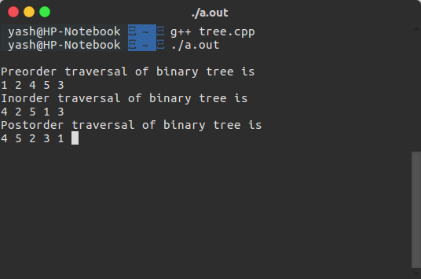
Learning Outcomes- I learnt the three possible Traversals in a binary Tree-Inorder,Preorder,Postorder.

