Aim: To implement Linked List Data Structure and its operations Insertion (At the beginning,at the end ), Deletion at nth position and Display and to Implement Stack and Queue Using LinkedList.

Description: Linked List is a linear data structure and it is very common data structure which consists of group of nodes in a sequence which is divided in two parts. Each node consists of its own data and the address of the next node and forms a chain. Linked Lists are used to create trees and graphs.They are a dynamic in nature which allocates the memory when required.Insertion and deletion operations can be easily implemented.Stacks and queues can be easily executed.Linked List reduces the access time.

Code:
#include<iostream>
using namespace std;
struct Node
{
int num;
Node *next;
};
Node *head=NULL;
Node *tail=NULL;
void AddnodeAtbeggining(){
Node *temp=new Node;
cout<<"Enter the item";
cin>>temp->num;
temp->next=NULL;
if (head==NULL)
{
head=temp;
tail=temp;
}
else
{
temp->next=head;
head=temp;
} }
void addnodeAtend()
{
Node *temp=new Node;
cout<<"Enter the item";
cin>>temp->num;
temp->next=NULL;
if (head==NULL){
head=temp;
tail=temp;
}
else{
tail->next=temp;
tail=temp;
}
}
void displayNode()
{
cout<<"\nDisplay Function\n";
Node *temp=head;
for(Node *temp=head;temp!=NULL;temp=temp->next)
cout<<temp->num<<" ";

}
void deleteNode ()
{
for(Node *temp=head;temp!=NULL;temp=temp->next)
delete head;

}

int main ()
{
AddnodeAtbeggining();
addnodeAtend();
displayNode();
deleteNode();
displayNode();
}

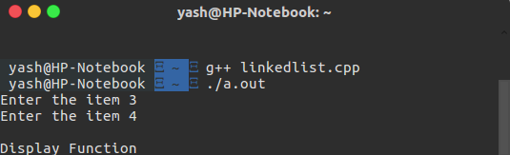

Learning Outcome: When you have completed this section you should be able to:Write a class which implements a simple list-like abstract data type.Appreciate that arrays and linked lists are two different data structures which may be used to implement list-like abstract data types.Write code which manipulates linked list in Java, and use cells and pointers diagrams to illustrate the effect.Appreciate the need to write your own equals method when you are implementing an abstract data type.

Stack using linked list:

#include <cstdlib>
#include<iostream>
using namespace std;

class node
{
public:
int data;
node* next;
};

class StackusingList
{
public:
StackusingList(int max)
{
top = NULL;
maxnum = max;
count=0;
}

void push(int element)
{
if(count == maxnum)
cout<<"stack is full";
else
{
node *newTop = new node;
if(top == NULL)
{
newTop->data = element;
newTop->next = NULL;
top = newTop;
count++;
}
else
{
newTop->data = element;
newTop->next = top;
top = newTop;
count++;
}
}
}

void pop()
{
if(top == NULL)
cout<< "nothing to pop";
else
{
node * old = top;
top = top->next;
count--;
delete(old);
}
}
void print()
{
node *temp;
temp = top;
while(temp!=NULL)
{
cout<<temp->data<<",";
temp=temp->next;
}
}
private:
node *top;
int count; //head
int maxnum;
int stackData;
};

int main(int argc, char** argv) {
StackusingList *sl = new StackusingList(5);
sl->push(1);
sl->push(2);
sl->push(3);
sl->push(4);
sl->push(5);
sl->push(6);

sl->pop();
cout<<"new stack\n";
sl->print();

return 0;
}

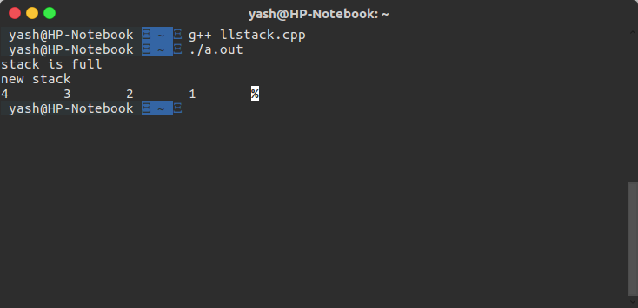

Queue using Linked List:

#include<iostream>
#include<stdio.h>
using namespace std;
struct node
{
int data;
node *next;
}*front = NULL,*rear = NULL,*p = NULL,*np = NULL;
void push(int x)
{
np = new node;
np->data = x;
np->next = NULL;
if(front == NULL)
{
front = rear = np;
rear->next = NULL;
}
else
{
rear->next = np;
rear = np;
rear->next = NULL;
}
}
int remove()
{
int x;
if(front == NULL)
{
cout<<"empty queue\n";
}
else
{
p = front;
x = p->data;
front = front->next;
delete(p);
return(x);
}
}
int main()
{
int n,c = 0,x;
cout<<"Enter the number of values to be pushed into queue\n";
cin>>n;
while (c < n)
{
cin>>x;
cout<<x;
push(x);
c++;
}
cout<<"\n\nRemoved Values\n\n";
while(true)
{
if (front != NULL)
cout<<remove()<<endl;
else
break;
}
}
