OOP LAB
PRACTICAL FILE
(DEPARTMENT OF IT)


SUBMITTED BY:
Yash Sharma
2K16/IT/127
INDEX

Q1. WAP to print the personal details like name,surname,gender,marks by taking the input from the user.

#include <iostream>
using namespace std;

class Pdetails
{
char name[20];
char surname[20];
float marks;
char gender;

public:
void getdata();

void printdata();

};

void Pdetails::getdata()
{
cout<<"ENTER NAME: ";
cin>>name;
cout<<"ENTER SURNAME: ";
cin>>surname;
cout<<"ENTER MARKS: ";
cin>>marks;
cout<<"ENTER GENDER FOR MALE 'M' AND FOR FEMALE 'F': ";
cin>>gender;
}

void Pdetails::printdata()
{
cout << "\nYour Personal Details:\n";
cout<<"NAME: "<<name<<"\n";
cout<<"SURNAME: "<<surname<<"\n";
cout<<"GENDER: "<<gender<<"\n";
cout<<"MARKS: "<<marks<<"\n";
}

int main()
{
Pdetails p;
p.getdata();
p.printdata();

return 0;
}
OUTPUT:

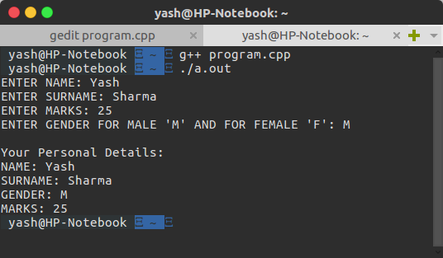

Q.2 Create a class ‘Employee’ that has employee number,employee name as data members,and member functions ’getdata’ to input the data and ‘showdata’ to display the output data.Write the main function to create an array of ‘Employee’ objects,accept and print the details of atleast 6 employees.

#include<iostream>

using namespace std;

class Employee
{
char empname[20];
int empnum;
public:
void getdata();
void showdata();

};

void Employee::getdata()
{
cout<<"EMPLOYEE NO. ";
cin>>empnum;
cout<<"EMPLOYEE NAME: ";
cin>>empname;

}

void Employee::showdata()
{
cout<<"\nEMPLOYEE NO. " << empnum <<"\n";
cout<<"EMPLOYEE NAME: "<< empname <<"\n";

}

int main()
{
Employee e[6];
cout<<"Enter the Data: \n";
for(int i=0;i<6;i++)
{
e[i].getdata();
}

cout<<"\nOUTPUT: \n";
for(int j=0;j<6;j++)
{
e[j].showdata();
}

return 0;
}
OUTPUT:
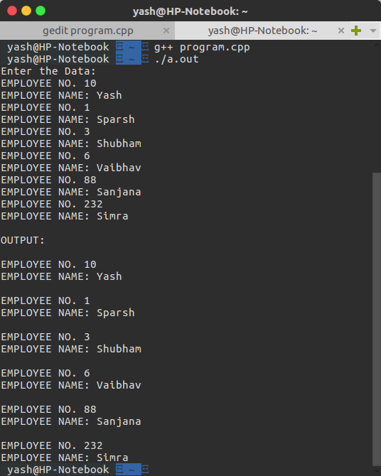
Q3. Write a CPP program to swap two numbers by both call by value and call by reference mechanism, using two functions swap_value() and swap_reference() respectively, by getting the choice from the user and executing the user’s choice by switch case.

Code:

#include <iostream>
using namespace std;

void swap_value(int a, int b){
int temp;
temp = a;
a = b;
b = temp;
}

void swap_reference(int *a, int *b){

int temp;
temp = *a;
*a = *b;
*b = temp;
}

int main() {

int a, b;
int choice;

cout<<"Enter the first number: ";
cin>>a;

cout<<"Enter the second number: ";
cin>>b;

cout<<"Enter '1' for calling call by value and '2' for calling call by reference ";
cin>>choice;

switch(choice){

case 1: swap_value(a, b);
break;

case 2:swap_reference(&a, &b);
break;

default:cout<<"Wrong input";

}

cout<<"Now, the first number is "<<a<<" and the second number is "<<b<<endl;

}

Output:

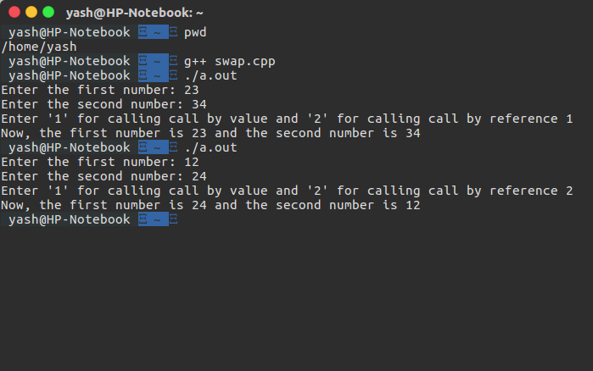
Q4. Write a C++ program to create a banking system in which the initial balance and rate of interest are read from the keyboard and these values are initialized using constructor. The destructor is also defined in this program to destroy the class object created using constructor member function. The class consists of the functions: deposit(), withdraw(), compound(), getBalance(), menu().

Code:

#include <iostream>
#include <math.h>
using namespace std;

class bank{

float balance, rate;

public:

bank(float balance_, float rate_){

balance = balance_;
rate = rate_;
}

void deposit(){

float amount;
cout<<"Enter amount to be deposited: ";
cin>>amount;
balance+=amount;
cout<<"New balance is: "<<balance;
menu();

}

void withdraw(){

float amount;
cout<<"Enter amount to be withdrawn: ";
cin>>amount;
balance-=amount;
menu();

}

void compound(){

float CI, yr;
cout<<"Enter number of years: ";
cin>>yr;
CI=balance*pow((1+rate/100),yr) - balance;
cout<<CI;
menu();

}

void dispBal(){

cout<<"Balance is: "<<balance;
menu();

}

void menu(){

int choice;

cout<<endl<<endl;
cout<<"Please enter your choice"<<endl<<endl;
cout<<"1. Deposit"<<endl;
cout<<"2. Withdraw"<<endl;
cout<<"3. Calculate Compound Interest"<<endl;
cout<<"4. Get Balance"<<endl<<endl;

cin>>choice;

switch(choice){

case 1: deposit();
break;

case 2: withdraw();
break;

case 3: compound();
break;

case 4: dispBal();
break;

default:cout<<"Wrong input";

}

}

};

int main(){

float bal, rate;
cout<<"Enter initial balance: ";
cin>>bal;
cout<<"Enter rate of interest: ";
cin>>rate;
bank b(bal, rate);
b.menu();

return 0;

}

Output:
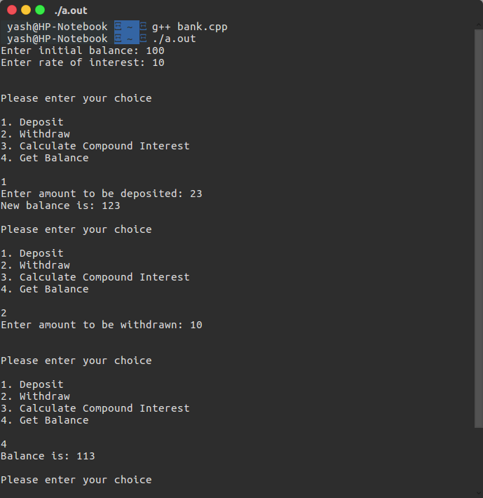

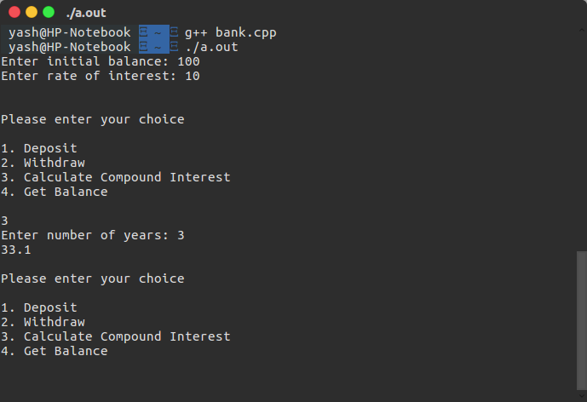

Q5. Write a program to accept five different numbers by creating a class called friendfunc1 and friendfunc2 taking 2 and 3 arguments respectively and calculate the average of these numbers by passing object of the class to friend function.

Code:

#include <iostream>
using namespace std;

class friendfunc2; //prototype for class declared

class friendfunc1{

int a, b;

public:

friendfunc1(int a_, int b_){
a = a_;
b = b_;
}

friend void calcAvg(friendfunc1, friendfunc2); //friend func prototype

};

class friendfunc2{

int c, d, e;

public:

friendfunc2(int c_, int d_, int e_){
c = c_;
d = d_;
e = e_;
}

friend void calcAvg(friendfunc1, friendfunc2); //friend func prototype

};

//friend function
void calcAvg(friendfunc1 f1, friendfunc2 f2){
int average;
average = (f1.a + f1.b + f2.c + f2.d + f2.e) / 5;
cout<<endl<<"Average is: "<<average<<endl;
}

int main(){

int a, b, c, d, e;

cout<<"Enter two values of friendfunc1 "<<endl;
cin>>a>>b;
cout<<"Enter three values of friendfunc2 "<<endl;
cin>>c>>d>>e;

friendfunc1 f1(a, b);
friendfunc2 f2(c, d, e);
calcAvg(f1, f2);
return 0;

}

Output:

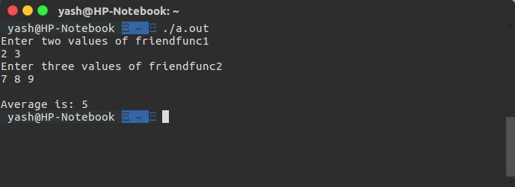

Q7: WAP to perform different arithmetic operations such as addition, subtraction ,division ,modulus ,multiplication using inline function.

CODE:
#include<iostream>

using namespace std;

class operations{
int a;
int b;
public:
void takeInput()
{
char ch;
int i=3;
while(i>0)
{
cout<<"Enter the 2 operands: "<<endl;
cin>>a;
cin>>b;

cout<<"Enter the operation to be performed: ";
cin>>ch;

switch(ch)
{
case '+': add(a,b);
break;
case '-':subtract(a,b);
break;
case '*':multiply(a,b);
break;
case '/':divide(a,b);
break ;
case '%': modulus(a,b);

}
i--;
}

}
void add(int a,int b)
{
cout<<"The answer is: "<<a+b<<"\n\n";
}
void subtract(int a,int b)
{
cout<<"The answer is: "<<a-b<<"\n\n";
}
void multiply(int a,int b)
{
cout<<"The answer is: "<<a*b<<"\n\n";
}
void divide(int a,int b)
{
if(b==0)
{
cout<<"Error: Divide by zero"<<"\n\n";
return;
}
else{
cout<<"The answer is: "<<a/b<<"\n\n";
}

}
void modulus(int a,int b)
{
if(b==0)
{
cout<<"Error: Divide by zero"<<"\n\n";
return;
}
else{
cout<<"The answer is: "<<a%b<<"\n\n";
}
}
};

int main()
{
operations obj;
obj.takeInput();
return 0;
}

OUTPUT:
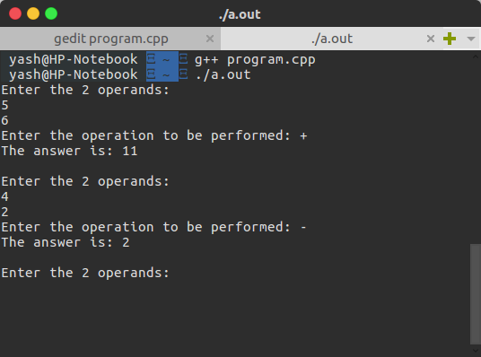

Q8: WAP to return absolute value of variable typed integer and float using function overloading .

CODE
#include<iostream>

using namespace std;

int AbsoluteValue(int a)
{
if(a<0)
{
return -1*a;
}
else
{
return a;
}
}
float AbsoluteValue(float a)
{
if(a<0)
{
return -1.0*a;
}
else
{
return a;
}
}
int main()
{
cout<<"Enter integer whose absolute value you want to calculate: "<<endl;
int a;
cin>>a;
cout<<"The absolute value is "<<AbsoluteValue(a)<<endl;
cout<<"\n\nEnter float value whose absolute value you want to calculate: "<<endl;
float b;
cin>>b;
cout<<"The absolute value is: "<<AbsoluteValue(b);
return 0;
}

OUTPUT

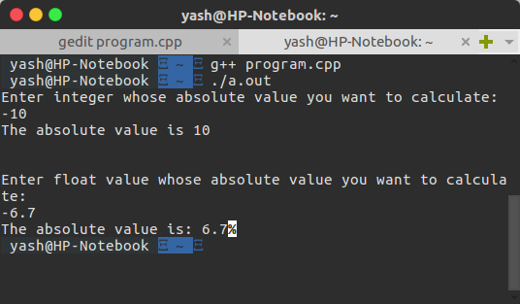
Q9: WAP to perform string operations using operator overloading in c++
String copy(=),string equality(<,>,==),string concatenation(+).

CODE
#include<iostream>
#include<conio.h>
#include<stdio.h>
#include<string.h>
using namespace std;
class string1
{
protected:
char str[25];
public:
void getstring();
void putstring(string1&);
void display();
string1 operator+(string1&);
int operator==(string1&);
void operator=(string1&);
int operator>(string1&);
int operator<(string1&);
};
void string1::getstring()
{
cout<<"Enter string:";
gets(str);
}
void string1::putstring(string1 &s)
{

int len=strlen(s.str);
cout<<len;

}
string1 string1::operator+(string1 &s)
{
string1 temp;
if((strlen(str)+strlen(s.str))<25)
{
strcpy(temp.str,str);
strcat(temp.str,s.str);
}
else
{
cout<<endl<<"\nconcatenation is not possible";
}
return temp;
}
int string1::operator==(string1 &s)
{
return(strcmp(str,s.str)==0?1:0);
}
void string1::operator=(string1 &s)
{
strcpy(str,s.str);
}
int string1::operator<(string1 &s)
{
if(strlen(this->str)<strlen(s.str))
{
return 1;
}
else
{
return 0;
}
}
int string1::operator>(string1 &s)
{
if(strlen(this->str)>strlen(s.str))
{
return 1;
}
else
{
return 0;
}
}
void string1::display()
{
cout<<str;
}
int main()
{
string1 s1,s2,s3;

s1.getstring();
s2.getstring();
s3=s1;
cout<<"\nFirst string length=";
s1.putstring(s1);
cout<<"\nSecond string length=";
s2.putstring(s2);
cout<<endl<<"Copied string from string3 which was copied from string 1"<<endl;
s3.display();
cout<<endl<<"\nConcatenated string:";
(s1+s2).display();
if(s1==s2)
cout<<endl<<"\nComparison:Equal";
else
cout<<endl<<"\nComparison:Not equal\n";
if(s1>s2)
{
cout<<"String 1 is greater than string 2"<<endl;
}
return 0;
}

Output:
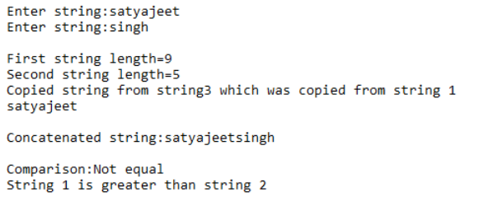

Q10: WAP to depict the class network consisting of class master which derives information from both account and admin classes which in turn derive information from class person. Also demonstrate the use of different access specifiers by means of member variables and member function.

CODE
#include <iostream>
#include <string>
#include <conio.h>
using namespace std;

class person {
protected:
char name[20];
int code;

};
class account: public virtual person {
protected:
float pay;
};
class admin: public virtual person {
protected:
float experience;
};
class master: public account, public admin {
public:
void display()

{
cout << "Name : " << name << endl;
cout << "Code : " << code << endl;
cout << "Pay : " << pay << endl;
cout << "Experience :" << experience;

}
void getdata() {
cout << "Enter name: ";
cin >> name;
cout << endl;
cout << "Enter code: \n";
cin >> code;
cout << "Enter pay: \n";
cin >> pay;
cout << "Enter experience: \n";
cin >> experience;
}};
int main() {
master m;
m.getdata();
m.display();
return 0;
}

OUTPUT:

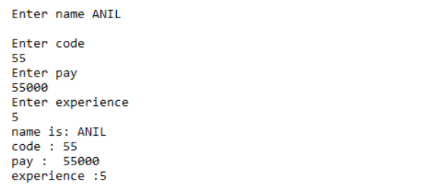

Q11: WAP to create three objects for a class named pntr_obj with data members such as roll_no and name .Create a member function set_data() for setting the data values and print() member function to print data which object has invoked it using the this pointer .

CODE

#include<iostream>

using namespace std;

class pntr_obj{
static int num;
int roll_no;
char str[100];
public:
void set_data()
{
num++;
cout<<"Enter the Roll No. of" << " student " << num << ": ";
cin>>roll_no;
cout<<"Enter name of"<< " student " << num<<": ";
cin>>str;
cout << endl;
//this->print();
}
void print()
{
cout<<"Roll number: "<<this->roll_no;
cout<<"\nName: "<<this->str;
cout << "\n\n";
}
};

int pntr_obj:: num = 0;

int main()
{
pntr_obj X,Y,Z;
X.set_data();
Y.set_data();
Z.set_data();
X.print();
Y.print();
Z.print();

return 0;
}

OUTPUT:

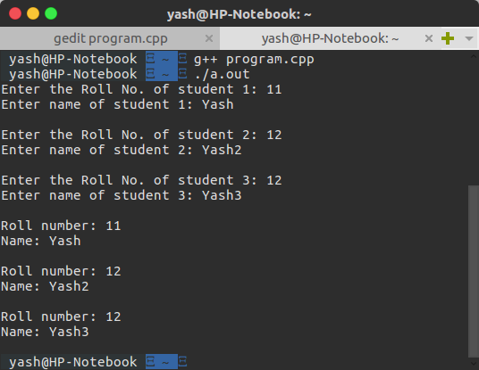

Q12: WAP to explain the virtual function(polymorphism) by creating a base class c_polygon which has virtual function area(). Two classes c_rectangle and c_triangle derived from c_polygon and they have area() to calculate their respective areas .

CODE
#include<iostream>

using namespace std;

class c_polygon{
public:
virtual float area()=0;

};
class c_rectangle :public c_polygon{
float length;
float breadth;
public:
c_rectangle(float length,float breadth)
{
this->length=length;
this->breadth=breadth;

}
float area()
{
return length*breadth;
}

};
class c_triangle: public c_polygon{
float base ;
float height;
public:
c_triangle(float base ,float height)
{
this->base=base;
this->height=height;
}
float area()
{
return 0.5*base*height;
}

};
int main()
{
c_triangle triangle(22.5,10);
c_rectangle rectangle(50,40);
c_polygon *polygon=NULL;

polygon=&triangle;
cout<<"The area of triangle is: "<<polygon->area()<<" sq units"<<endl;

polygon=&rectangle;
cout<<endl<<"The are of rectangle is: "<<polygon->area()<<" sq units"<<endl;

return 0;
}

OUTPUT:

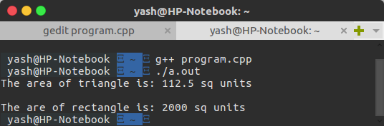

Q13:Write a program to explain class template by creating a template class T for a class named pair having two data members of type T which are inputted by a constructor and a member function getMax() return the greatest of two numbers to main Note: the value of T depends upon the data type specified during object creation .
CODE:
#include<iostream>

using namespace std;

template<class T>
class Pair{
T first;
T second;
public:
Pair(T first,T second)
{
this->first=first;
this->second=second;
}

Pair getMax(Pair & A)
{
if(this->first+this->second>A.first+A.second)
{
return *this;
}
else {
return A;
}
}
void displayData()
{
cout<<"First: "<<this->first<<endl;
cout<<"Second: "<<this->second<<endl;
}

};
int main()
{
cout<<"Pair 1"<<endl;
Pair<int> one(100,50);
one.displayData();
cout<<endl<<"Pair 2"<<endl;
Pair<int> two(25,98);
two.displayData();
cout<<endl<<"Pair which is largest among the two pairs"<<endl;
one.getMax(two).displayData();

return 0;
}

OUTPUT:
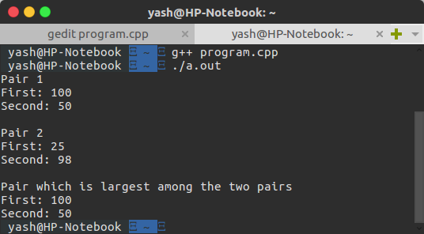

Q14: WAP to illustrate
1:Division by zero
2: Array index out of bounds exception
Also use multiple catch blocks.

CODE:

#include<iostream>

using namespace std;

template<class T>
void divide(T x,T y){
try{
if(y!=0)
cout<<endl<<"The result of "<<x<<"/"<<y<<" is "<<x/y<<endl;
else
throw y;
}
catch(int ){
cout<<endl<<"Integer exception found - DIVIDE BY ZERO\n"<<endl;
}
catch(float){
cout<<endl<<"Float exception found - DIVIDE BY ZERO\n"<<endl;
}
catch(...){
cout<<endl<<"Exception found\n"<<endl;
}
}
void array(int arr[],int size){
int loc;
cout<<endl<<"Enter the location to be searched for ";
cin>>loc;
try{
if(loc>size)
throw loc;
else
cout<<endl<<"Element at location "<<loc<<" is "<<arr[loc]<<endl;
}
catch(int a){
cout<<endl<<"Entered location is out of bounds of the array\n"<<endl;
}
}
int main(){
int choice;
do{
cout<<"EXCEPTION HANDLING";
cout<<endl<<"1. Divide by Zero";
cout<<endl<<"2. Array Index out of bounds";
cout<<endl<<"3. Exit:\nSelect any option from above: ";
cin>>choice;
if(choice==1){
cout<<endl<<"Enter the two numbers ";
float x,y;
cin>>x>>y;
if(((x-(int)x)==0)&&((y-(int)y)==0))
divide((int)x,(int)y);
else
divide(x,y);
}
else if(choice==2){
int arr[100];
int size;
cout<<endl<<"Enter the size of array ";
cin>>size;
cout<<endl<<"Enter the array ";
for(int i=0;i<size;i++)
cin>>arr[i];
array(arr,size);
}
}while(choice!=3);
return 0;
}

OUTPUT:
