**Machine Learning Using Deep Learning and Natural Language Processing**

**Peraton**

**www.peraton.com**

**Design**

**Date:**

10/22/2021

**Team Members:**

Rolando Gonzalez

Elshaday Alemayehu

Yusuf Siddiqui

Arial Carvalho

Eduardo Heredia

# Abstract

This document details the agreement between the sponsor and the development team. The detailed design model of our system represents the design decisions related to overall software components and behaviors of the system. The design document is produced based on the stakeholders requirements as documented in the requirement document.

This design document defines software interfaces, methods, functions, objects, and the overall structure and interaction of our code so that the resulting functionality will satisfy our stakeholder’s requirements. In this deliverable, we will see the detailed software design and representation of the complete software components and behavior before implementing the actual software. This includes the design of Graphical User Interface (GUI), class diagrams, sequence diagrams, and traceability matrix from requirements to detailed design model.  This document is not final and is subject to change as needed by the sponsor.

Table of Contents

Abstract 2

List of Figures 4

List of Tables 5

Introduction 6

GUI (Graphic User Interface) Design 7

Login Screen 7

Normal User Main Page 8

Normal User Document Results 8

Administrator Main Page 9

Administrator Document Results 9

Static Model Class Diagram 10

Dynamic Model Sequence Diagrams 11

Rationale for Your Detailed Design Model 12

Traceability From Requirements to Detailed Design Model 13

Evidence the Document Has Been Placed Under Configuration Management 17

References 18

# List of Figures

Figure 1: Login Screen 7

Figure 2: Normal User Main Page 8

Figure 3: Normal User Document Results 8

Figure 4: Administrator Main Page 9

Figure 5: Administrator Document Results 9

Figure 6: Class Diagram 10

Figure 7: Account Sequence Diagram 11

Figure 8: Upload Sequence Diagram 11

# List of Tables

Table 1: Requirements Traceability 13

# Introduction

The Design Document provides insight into the look-and-feel of the product’s graphical user interface (GUI), inner structure of the class diagrams, sequence diagrams, and traceability from requirements. The purpose of this document is to ensure that the development team and sponsor agree regarding design decisions such as the look-and-feel and overall structure of the project.

The Design Document structure is as follows:

1. The GUI (Graphical User Interface) Design provides the look-and-feel and demonstrates an example of the screens in the product.
2. The static model class diagrams provide the blueprints of the system and show the relationships between classes, what those classes do, and the services they provide.
3. The dynamic model sequence diagrams to show the control structure between objects in the system.
4. The traceability from requirements to detailed design model to align requirements with their business (BUC) and product use cases (PUC).

# GUI (Graphic User Interface) Design

## Login Screen

Figure : Login Screen

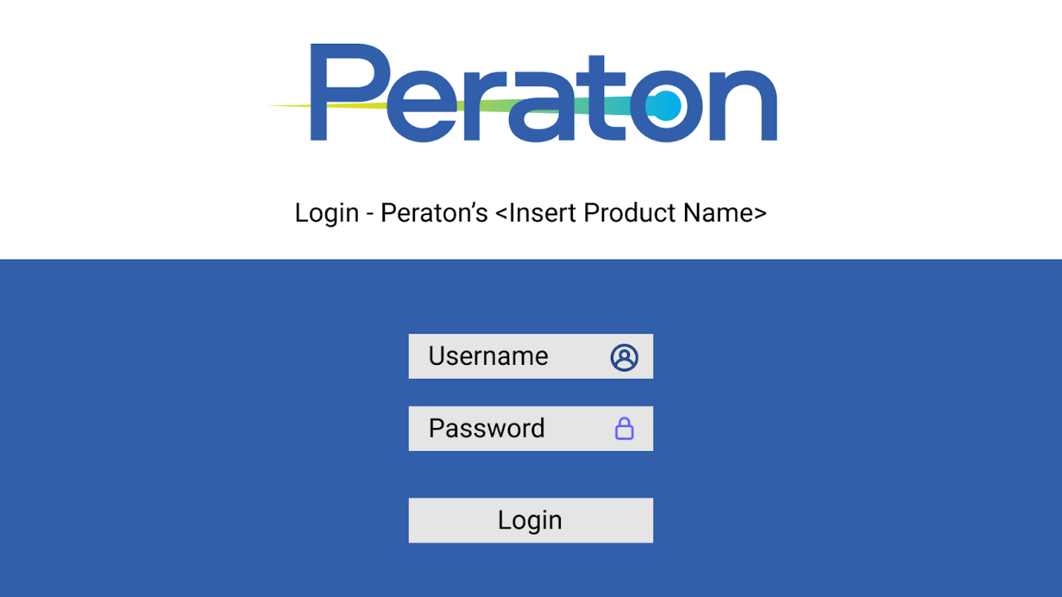

## Normal User Main Page

Figure : Normal User Main Page

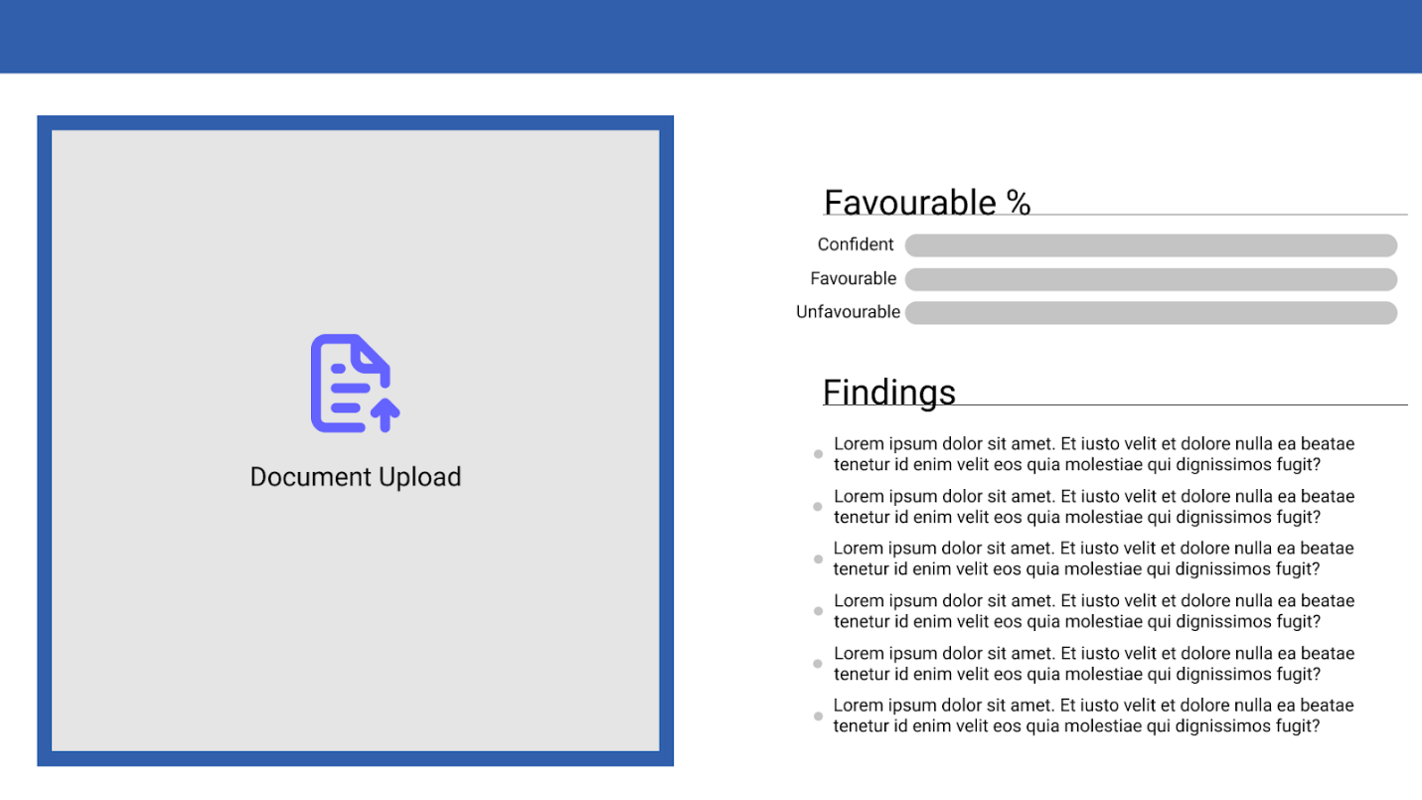

## Normal User Document Results

Figure : Normal User Document Results

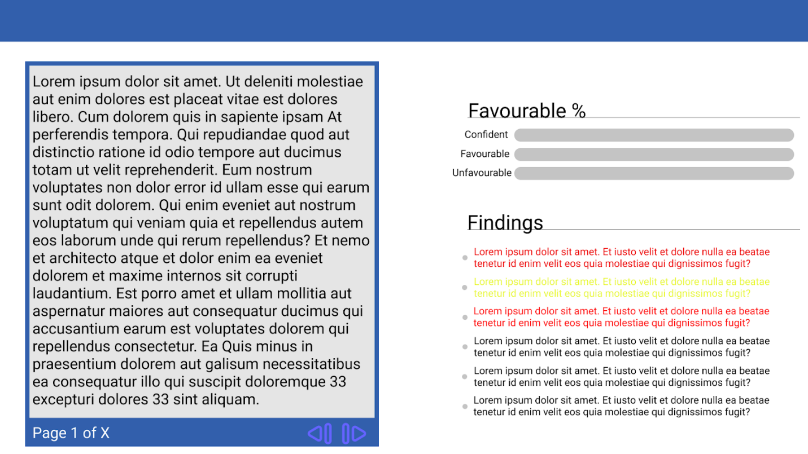

## Administrator Main Page

Figure : Administrator Main Page

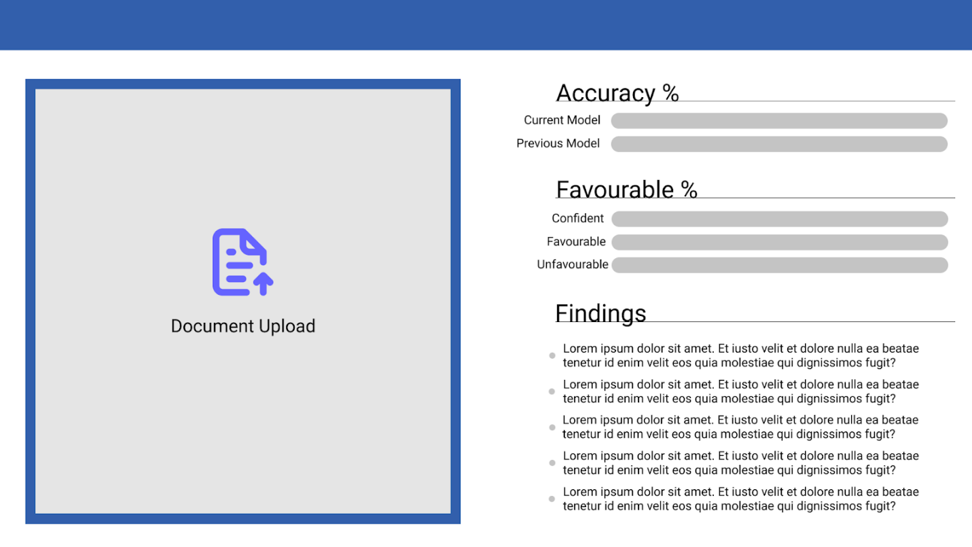

## Administrator Document Results

Figure : Administrator Document Results

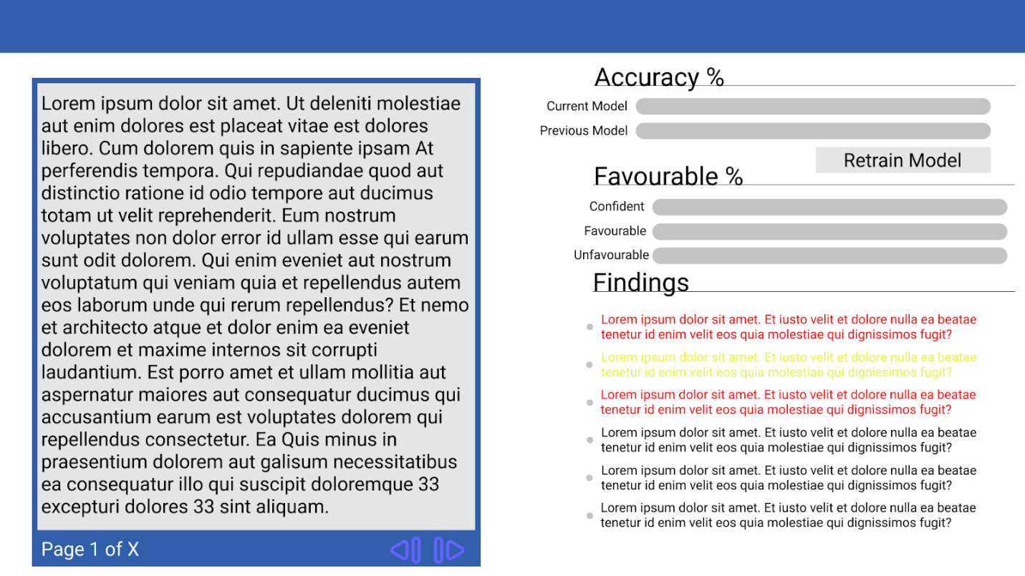

# Static Model Class Diagram

Figure : Class Diagram

# Dynamic Model Sequence Diagrams

Figure : Account Sequence Diagram

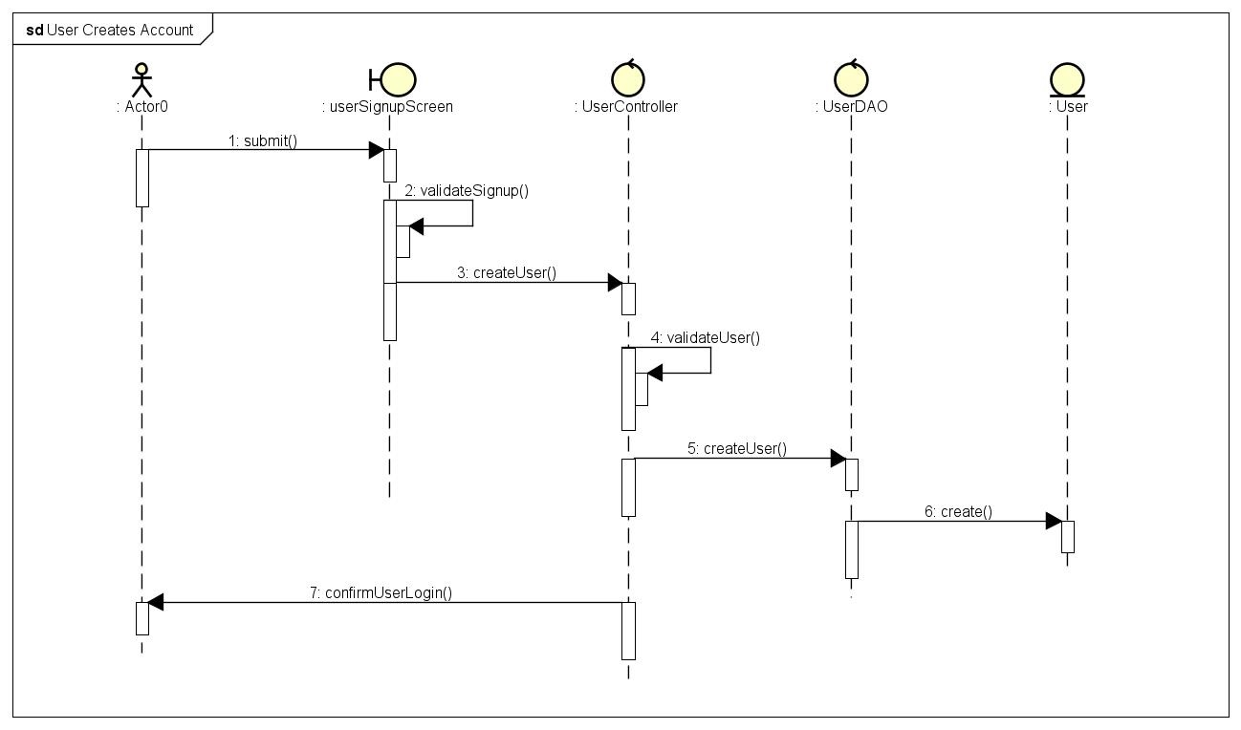

Figure : Upload Sequence Diagram

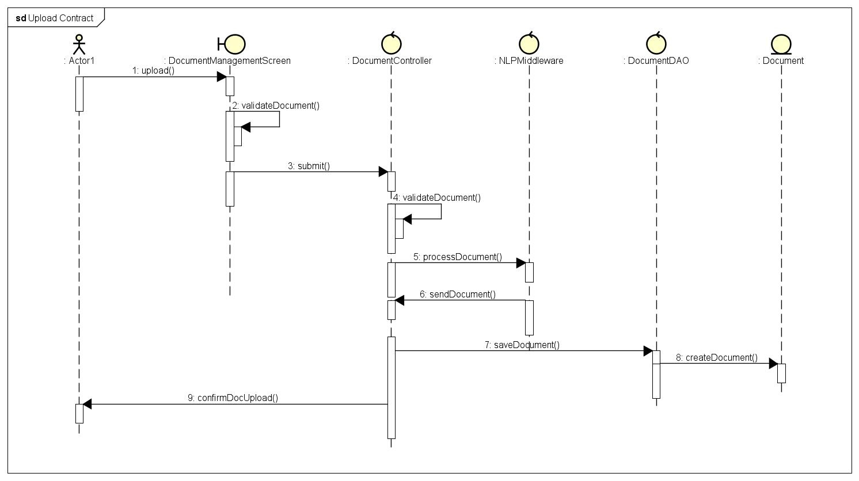

# Rationale for Your Detailed Design Model

The user pages demonstrated in this document of the GUI can be divided into several key parts: document upload/preview, accuracy rating, favorability rating, findings. The purpose of the document upload/preview is to allow users to upload a file and show the raw text of the document from text extraction and will help users to identify whether there were issues in reading any part of the document. The accuracy rating available to administrators is to show and compare model performance between the current model and previous model. This allows for retraining the model and will lead to a new screen (not shown here) that allows for model selection and configuring the model. The favorability rating will show the model’s confidence level and keywords that are favorable and unfavorable from the document. The findings will provide the sentences in which those keywords are found to allow the user to see the context.

The class diagram shows how we intend to implement our dashboard and how the components will interact. The interconnected classes and their dependencies in this diagram cover the process from when the user logs in and uploads a document to the results presented to the user after processing the document.

The sequence diagram shows the implementation of use cases into the design’s workflow. On both diagrams we can see how the response from the user is handled in all the three layers of the system architecture: presentation, service, and data. The façade design is demonstrated by the controller class that attributes services to other classes in the application tier. The DAO design pattern is being implemented by the DAO class in the data tier to create the entity and save it in the database.

# Traceability From Requirements to Detailed Design Model

Table : Requirements Traceability

|  |  |  |  |  |  |  |
| --- | --- | --- | --- | --- | --- | --- |
|  | Req# | Description | Description | Description | #PUC | Description |
| **Functional Requirements** | F1 | User creates account | User wants to sign-up for an account | System validates user information  System creates account for user | 1 | Sign up |
| F2 | User logs in to account | User wants to log in to existing account  Ask for authentication of login credentials | System displays login page  System displays main menu from the dashboard | 2 | Login Page |
| F3 | User sets system to their preferred language | User sets system to their preferred language | System gives an option to choose from multiple languages | 3 | Setting Page |
| F4 | Upload Contract | User wants to upload desired contract in pdf file format | Display user uploaded document in the correct format | 3 | Main Page |
| F6 | Text Extraction | The system will extract text from user input documents | System cleans and processes data from 6. and prepares and organizes text in the correct format | 3 | Main Page |
| F7 | Check Contract Favorability Skew | User wants to view flagged keywords and phrases | The model  determines which keywords and phrases and provide insight on the  favorability of flagged information | 4 | Dashboard |
| F8 | View ML model performance | User shall be able to view overall performance of the ML model | The model provides information regarding words that did not meet the  threshold parameters specified by the user. | 4 | Dashboard |
|  | F9 | View Logs | System keeps logs to ensure that user is valid elevated within the system and has successfully logged in | System provides logs regarding information about application status | 2 | Login page |
| **Usability** | NF1 | The system must work on OSX, Windows, and Unix-based systems | User can use different Operating System | Display valid dashboard in OSX, Windows, and Unix environments | 4 | Dashboard |
| NF2 | The system may support multiple languages | A possible add-on would be to support contracts that may be in other languages | Display the options from F3. | 5 | Setting Page |
| NF3 | The system must provide sorting functionality | System must sort using highest confidence levels, favorable/unfavorable  keywords, etc. | Display the sorted information in the dashboard | 4 | Dashboard |
| **Availability** | NF4 | The system must retrieve contract documents one at a time | A user will be able to input one pdf document at a time instead of allowing users to  input multiple files at a time. | System displays appropriate screen for upload successful/failed status | 3 | Main Page |
| NF5 | The system should not take longer than 3 seconds to login the user | The system should validate user login by cross checking email and password and this  should be complete in less than 3 seconds | System displays appropriate screen for login  status(successful/failed) | 2 | Login Page |
| NF6 | The system must be able to process contract analysis within hours | User request to process contract | System process contract analysis within hours depending on the document size | 3 | Main Page |
| **Security** | NF7 | Passwords must be hashed and stored securely in the database | The application will not be available to all users, valid users must authenticate and verify  identity with their title/position, employee id (if applicable), and password | System stores password in secure database | 2 | Login Page |
| NF8 | Sensitive information shall be encrypted for in-flight data | Information contained within the contracts that the program works with may be  sensitive and will require some form of encryption when the application is run over a  network | System will encrypt all sensitive data in the application | 3 | Main Page |
| NF9 | System will automatically sign out within 15 minutes if no work is in progress and no response  from the user is detected | Login session will be terminated to prevent sensitive data from being leaked when users  are no longer using the application and no work is running | System will notify users session termination and ask users to log in again | 2 | Login page |
| NF10 | Passwords must contain at least 8 characters including at least one special character, upper case  letter, and number | Valid users will need to create a strong password as the program will deal with sensitive  information | Display message and notify users to reenter   strong password combination | 1 | Sign up Page |
| NF11 | Password delay after 10 consecutive failed login attempts | Too many failed login attempts will require the user to verify their identity or wait a  certain amount of time to prevent brute-force attempts | Display attempt amount left in each trial | 2 | Login Page |
| NF12 | The user account database must use column-level transparent data encryption or better | A database that holds login information is sensitive and needs to be adequately  encrypted in order to be properly protected | System require every column in the database a password for authorizing access to column data | 6 | Database |
| **Maintainability** | NF12 | The system shall allow elevated users to provide a new training set of contractual documents | When there is high deviation from the expected outcome and the ML model’s accuracy  is performing poorly, the model may need to be retrained with a new set of documents | Display the accuracy percentage and inform user to retrain model again | 3 | Main Page |

# Evidence the Document Has Been Placed Under Configuration Management

# References