**ADS-Design Pool 1**

**(Agile Delivery Services – Design Pool)**

**High Level Design Document**

**Version <1.0>**

|  |  |
| --- | --- |
| **Reviewed and Approved By :** | **Krish Karunakaram** |
| **Date:** | **07/06/2015** |

**Yakshna Solutions, Inc.**

1043 Sterling Road, #201, Herndon VA 20170

Tel: 703-880-8408 | Fax: 509-756-9198

Revision History

|  |  |  |  |  |  |
| --- | --- | --- | --- | --- | --- |
| **#** | **Revision No.** | **Date** | **Author** | **Reviewed By** | **Comments** |
| 1 | 1.0 | 07/06/2015 | Neha Bansal | Krish | Initial version |
|  |  |  |  |  |  |

# **Introduction**:

# **High Level Design For Design Pool:**

**Open Source Technologies:**

1. Open source modern technologies should be used like HTML5,CSS3,Jquery,Bootstrap

**Architectural Diagram**

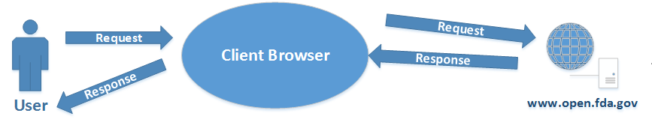

**Use Case Diagram**

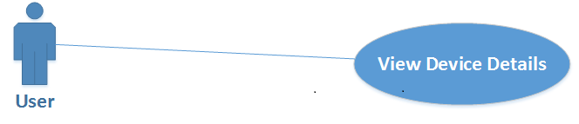

**Assumptions:**

NA