ADS-Development Pool 2
(Agile Delivery Services – Development Pool)

System Test Plan Document

Version <1.0>

Reviewed and Approved By : | Krish Karunakaram
Date: | 07/06/2015

Yakshna Solutions, Inc.
1043 Sterling Road, #201, Herndon VA 20170
Tel: 703-880-8408 | Fax: 509-756-9198

Revision History

# | Revision No. | Date | Author | Reviewed By | Comments
1 | 1.0

Table of Contents

1 Purpose 1
2 Test Scope 1
3 Test Approach 1
4 Test Entrance/Exit Criteria 2
5 Risk and Constraints 4
6 Test Environment 4
7 Test Tools 4
8 Defect Management 5
9 Roles and Responsibilities 7
10 Definitions, Acronyms and Abbreviations 7

- Purpose

This defines the specific System Test Plan for the Agile Delivery Service – 18F-Development Pool release; it contains the scope, schedule, known risks and issues, and resources of intended testing activities. It identifies what items (systems, subsystems, and major functional areas) are being tested, what types of tests are being performed, the tasks involved, responsibilities and associated risks. It describes the testing strategy and approach to testing the Test Team will use to validate the quality of this product prior to release.

Test Scope

Following defines the Test Type Scope for the ADS-18F application release for development pool.

UT-PCAS Applicable Test Stages/Test Type
Test Type |  | Testing Stage
 |  | Requirement  Review  Process | Development  Test | System  Test | User Acceptance Test | Production Deployment  (BOT)
Requirement Testing
Functional  Testing | Unit Test |  | *
Functional  Testing | Smoke/Shakeout Testing
Functional  Testing | Progression Functional Testing |  |  | *
Functional  Testing | Regression Testing
Functional  Testing | Integration Testing
Non  Functional  Testing | Performance/Load Testing
Non  Functional  Testing | Compatibility Testing-Browser
Non  Functional  Testing | Technical Operational Testing  -Recovery,  -Scalability  -Failover

Test Approach

- Requirement Testing
The primary objective of Requirements Testing is to ensure that Test Input Documents are clear, succinct and capture the needs of the business accurately prior to moving through the Software lifecycle. Test Input Documents may include any document that depicts the business need that will be used to develop test artifacts. Validation of Test Input Documents prior to the development and test stages with upfront quality control measures will reduce defects downstream and enhance cost savings. Requirements’ testing is a formal validation of the Test Input Documents by the Test Teams to identify gaps, track and resolve defects and ultimately produce clear and accurate information downstream.
Test Teams shall log the findings captured during the reviews using the Defect Management System. Requirement testing summary should be included in testing summary report.
- Functional Testing
The Test Teams will perform testing to ensure that each element of the application meet the functional requirements.
- Unit/Development Testing: Unit testing is a method by which individual units of source code are tested to determine if they are fit for use. A unit is a smallest testable part of an application or software program. Development Team will perform Unit Testing.

- Smoke Testing/Shakeout Testing: The purpose of Smoke/Shakeout testing is to confirm that changes in the code function as expected and meet the minimum requirement and that there is no disruption in system functionality due to the new code deployment.

- Progression Functional Testing: The test teams will perform targeted functional testing to ensure that each element of the application meets the functional requirements and that the application can handle unexpected input or user behavior.
  - The System Test Progression Functional :
    - This test will be conducted based on the changes mentioned in the Stakeholder Requirements and Solution Specifications/Design document.
    - It includes testing of the every component build by development team. The execution of test cases will ensure that application navigation, data entry, processing and retrieval adhere to business and technical requirements/rules.
    - System Test cases will be developed using Control Flow Graph Test Script Methodology to have wide test coverage.
    - This type of testing is primarily based on Black Box techniques, that is, verifying the application (and its internal processes) by interacting with the application via the GUI and analyzing the output (results). However some application processes are created to store information in specific locations and formats. To that end, testing will also include White Box techniques.
    - These tests will verify, under the covers, that the execution of the application functional requests has affected the platform and application spaces appropriately.
    - Test cases will utilize valid and invalid data conditions. Although testing will focus on the subject application, if they exist, upstream and downstream interfaces/interactions with other applications will be verified as well.
  - The UAT Progression Functional
    - This test will be based on the Business Requirement Documents and other available Functional Requirements.
    - UAT will develop test cases based on Business Scenarios and/or Use Cases to verify the application meets the business need and expectations of the business sponsors.
    - UAT test cases often take into consideration the business process or workflow that the system will support,
- Regression Testing: Regression testing is required when a software or hardware change occurs. Once the new change is in place, regression tests must be performed to ensure that
    - The change has been correctly implemented
    - The change did not adversely affect previously verified functionality.
  - After the final defect build for each Functional test phase, the test teams will rerun all previous executed test cases as a regression test to ensure that the defect builds did not adversely impact previously tested functionality.
  - Regression Testing will be performed based on developed Functionality and Test case Risk Matrix.

- Non Functional Testing:
This testing is performed to test the non functional requirements. Based on the different types of the applications, non-functional testing can include:
- Browser Compatibility Test
  - The application will be tested in various browsers – IE, Firefox and Google Chrome to test the compatibility.

Test Entrance/Exit Criteria

The following criteria will be followed for each Test Type

Test Stage | Entry Criteria | Exit Criteria
Requirement Review  Process Stage | - Project scope and requirement are baseline.  - Stakeholder requirement is base lined and approved. | - All Test Input Document defects have been documented and made available for review  - Statement of effort on the requirement testing is ready for review  - Requirement testing defect list is available for review.  - All open defects are closed or deferred
Development  Test Stage | - Requirement review process exit criteria has been satisfied  - Development environment is setup | - Completion of Unit Testing  - Evidence of code review by developers  - Development test cases reviewed by technology lead  - Development Test Results Summary Report is approved  - Application code is under version control.
System Test Stage | - Business Requirements are complete and approvals received  - Walkthrough of solution specifications is complete and approvals received  - Technical design documentation is complete and base lined  - System Test Plan is complete and approvals received  - Scope, Business Requirement and Solution Specification mapping should be completed in the requirement repository.  - System Test Mapping of Requirement Traceability Matrix is complete and approvals received  - A separate, controlled test environment has been implemented for System Test  - Code build is complete and deployed to the system test environment  - Test data is available for use in testing  - No critical or high severity defects outstanding from unit/development testing | - 100% execution of all test scripts  - The pass rate shall be 90% or higher  - Zero (0) open Critical defects  - Zero (0) open High defects  - All Medium and Low Defects are documented and communicated to User Test Team  - Business and Technology sign-off (acceptance of test results) received  - All Defects should be either Closed or Deferred.
User Acceptance Test Stage | - System Test has been completed  - System Test team documented all known issues and defects  - Test data has been defined, obtained, populated, or prepared and is ready for use as per the Test Data/Preparation section above  - User Test Plan is complete and approvals received  - Test scripts have been completed, reviewed, accepted, and are ready for use  - Test environments have been configured as per the Test Environment section above  - Build is complete and deployed to the test environment  - Test environment shake out is successful and no show stopper incidents are found | - 100% execution of all test scripts  - The pass rate shall be 90% or higher  - Zero (0) open Critical defects  - Zero (0) open High defects  - All Medium and Low Defects are documented and communicated to User Test Team  - Business and Technology sign-off (acceptance of test results) received  - All Defects should be either Closed or Deferred.

Risk and Constraints
N/A

Test Environment

Following are the environment details-

Environment | URL
System | http://184.183.181.68/ADSDemo/Pool2/

Test Tools
The following tools will be used for this project:

Purpose | Tool | Details
Requirements Management | Word
Test Management (Test case repository) | JIRA | http://jira.yakshna.com:9000/ -PROT
Defect Management | JIRA | http://jira.yakshna.com:9000/ -PROT
Reporting management | Email/Excel
Automation Tool | Selenium with web driver and Automation Testing Utilities Report | HTML Test Report

Defect Management

- A defect is a variation from intended or expected system behavior based on documented requirements or, in the absence of requirements, the tacit knowledge of the tester.

- This definition is purposely broader than the more common “variance from business requirements or system specifications”. Software failures often originate in the analysis or design tasks of development projects. Requirements and specifications may be incomplete, inaccurate, or vague. By keeping the defect definition broad, the QA analyst may draw upon all of his/her knowledge of the customers’ need to determine if a defect exists. In an agile development approach, QA analysts contribute to all aspects of system development. They are involved in project scoping discussions, business requirements definitions, and specification design sessions. Through this participation, they acquire much knowledge about customer expectations that is never captured in a formal document. This knowledge enables QA analysts to gauge quality -- that is, identify defects –- based on the standard of customers’ need.

- Below are the scenarios where defects are required are recorded into the defect repository:
  - Defects found during Development Testing phase that are still pending resolution at the end of the phase.
  - Defects found during System Test phase.
  - Defects found during User Acceptance phase.
  - Defects found during Implementation phase.
  - Defect found during Post-Implementation phase.
- The defect management flow is depicted below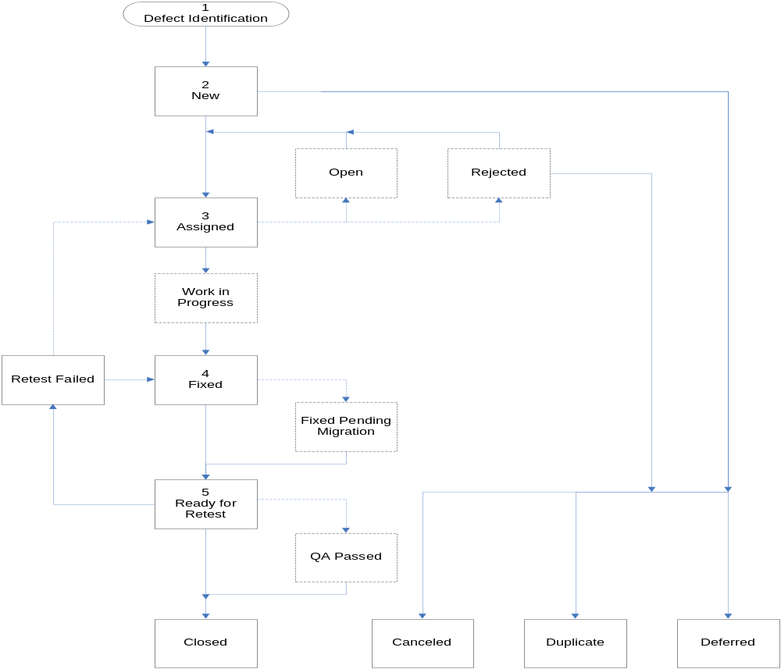
- Status Definitions- Each of the defect states is comprised of several work statuses, which are defined in the following tables
Open Defects
Status | Definition
New | Defect is newly identified, and is awaiting assignment for repair or investigation.
Open | Defect is recognized by the Development Manager as legitimate and is awaiting assignment for repair.
Rejected | Development Manager refutes that the defect is a variance from requirements and/or believes that no action is required given the current scope.
Assigned | Defect has been assigned to a developer who can effect a repair that will allow defect to be closed.
Work In Progress | Developer has acknowledged the defect and is taking action to effect a repair that will allow defect to be closed.
Retest Failed | Defect repair has been tested, and defect still exists.

Fixed Defects
Status | Definition
Fixed | Defect has been repaired, and the repair is being packaged for migration to the appropriate test environment.
Fixed Pending Migration | Defect has been repaired, and the repair is awaiting migration to the appropriate test environment.
Ready for Retest | Defect repair has been migrated to the appropriate test environment.
QA Passed | Defect not entered by QA has been repaired and QA has verified that the fix has worked.

Resolved Defects
Status | Definition
Closed | Defect repair has been tested, and defect no longer exists.
Canceled | Defect is not a variance from requirements, and no repair is needed.
Duplicate | Defect was already documented.
Deferred | Defect will be repaired in a later release of the software.

Roles and Responsibilities

Program Role | Program Function
System Test Team | Overall responsibility for all System Test planning, execution, management, project-level status reporting, and project oversight. Develop test cases, test scripts, and test data. Execute test cases. Validate and document testing results. Compile and distribute defect reports. Coordinate resolution of defects.
Business Team | Overall signoff on test results. Provide business feedback and assistance during development of test cases. Provide input to resolve business and functional design issues. Validate test conditions and expected results.
Project Manager | Support UAT , System Test , and Development, as needed, to facilitate efforts associated with planning, scheduling and status reporting of UAT/System Test to Test PM and PMO. This includes coordination of Change Management.
Infrastructure and Environments Liaison | Responsible for application environment management strategy for each the release. Ensure availability of testing environments and test data in accordance with planned testing activities.
Application Development Team | Responsible for application development and support for each impacted system associated with the release. Release functionality to testing team in accordance with development and test plans. Responsible for software version control. Resolve programming defects.

Definitions, Acronyms and Abbreviations
Acronym | Expansion
BA | Business Analyst
CCB | Configuration Control Board
CMP | Configuration Management Plan
H/S | Hardware/Software
JIRA | Project Management and Issue Tracking Tool
Milestone | A important entry / exit point for review of status of project by stakeholders
MPP | Microsoft Project Plan
PL | Project Leader
PM | Project Manager
PMP | Project Management Plan

