**ADS-Full Stack Pool 3**

**(Agile Delivery Services – Full Stack Pool)**

**High Level Document**

**Version <1.0>**

|  |  |
| --- | --- |
| **Reviewed and Approved By :** | **Krish Karunakaram** |
| **Date:** | **07/06/2015** |

**Yakshna Solutions, Inc.**

1043 Sterling Road, #201, Herndon VA 20170

Tel: 703-880-8408 | Fax: 509-756-9198

Revision History

|  |  |  |  |  |  |
| --- | --- | --- | --- | --- | --- |
| **#** | **Revision No.** | **Date** | **Author** | **Reviewed By** | **Comments** |
| 1 | 1.0 | 07/06/2015 | Neha Bansal | Krish | Initial version |
|  |  |  |  |  |  |

# **Introduction**:

# **High Level Design For Full Stack Pool:**

**Open Source Technologies:**

1. Open source modern technologies should be used like HTML5,CSS3,Jquery,Bootstrap

**Architectural Diagram**

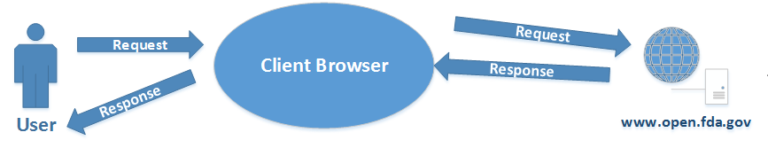

**Use Case Diagram**

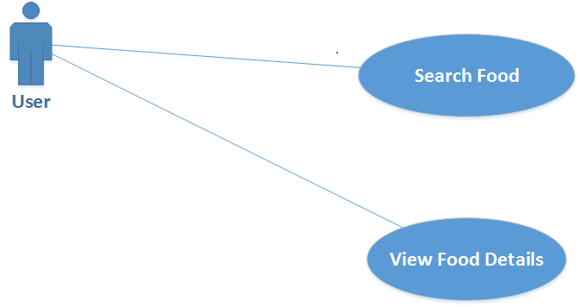

**Assumptions:**

Data will be shown on UI if API used from <http://api.fda.gov/food/enforcement.json?api_key=fWh0obWpVFaBBNvdpFZYqQBMszwc7nKJY9wKxEJb&search>= returns Dataset. If API does not work then data on Full Stack pool will not be shown.