Exact



{

"face": {

"attrs": {

"age": 0,

"face_quality": {

"blurness": 0,

"expression": 0,

"illumination": 0,

"occlusion": 0,

"pose": 0

},

"gender": {

"female": 0,

"male": 0

},

"left_eye_status": {

"darkglasses": 0,

"noglass_eyeclose": 0,

"noglass_eyeopen": 0,

"normalglass_eyeclose": 0,

"normalglass_eyeopen": 0,

"other_occlusion": 0

},

"pose": {

"pitch": 0,

"roll": 0,

"yaw": 0

},

"right_eye_status": {

"darkglasses": 0,

"noglass_eyeclose": 0,

"noglass_eyeopen": 0,

"normalglass_eyeclose": 0,

"normalglass_eyeopen": 0,

"other_occlusion": 0

}

},

"quality": 0,

"rect": {

"height": 0,

"left": 0,

"top": 0,

"width": 0

}

},

"feature": "string",

"rect": {

"height": 0,

"left": 0,

"top": 0,

"width": 0

}

}

/comapare



{

"face1": {

"attrs": {

"age": 0,

"face_quality": {

"blurness": 0,

"expression": 0,

"illumination": 0,

"occlusion": 0,

"pose": 0

},

"gender": {

"female": 0,

"male": 0

},

"left_eye_status": {

"darkglasses": 0,

"noglass_eyeclose": 0,

"noglass_eyeopen": 0,

"normalglass_eyeclose": 0,

"normalglass_eyeopen": 0,

"other_occlusion": 0

},

"pose": {

"pitch": 0,

"roll": 0,

"yaw": 0

},

"right_eye_status": {

"darkglasses": 0,

"noglass_eyeclose": 0,

"noglass_eyeopen": 0,

"normalglass_eyeclose": 0,

"normalglass_eyeopen": 0,

"other_occlusion": 0

}

},

"quality": 0,

"rect": {

"height": 0,

"left": 0,

"top": 0,

"width": 0

}

},

"score": 0

}

/detect



{

"faces": [

{

"attrs": {

"age": 0,

"face_quality": {

"blurness": 0,

"expression": 0,

"illumination": 0,

"occlusion": 0,

"pose": 0

},

"gender": {

"female": 0,

"male": 0

},

"left_eye_status": {

"darkglasses": 0,

"noglass_eyeclose": 0,

"noglass_eyeopen": 0,

"normalglass_eyeclose": 0,

"normalglass_eyeopen": 0,

"other_occlusion": 0

},

"pose": {

"pitch": 0,

"roll": 0,

"yaw": 0

},

"right_eye_status": {

"darkglasses": 0,

"noglass_eyeclose": 0,

"noglass_eyeopen": 0,

"normalglass_eyeclose": 0,

"normalglass_eyeopen": 0,

"other_occlusion": 0

}

},

"quality": 0,

"rect": {

"height": 0,

"left": 0,

"top": 0,

"width": 0

}

}

],

"image_rect": {

"height": 0,

"left": 0,

"top": 0,

"width": 0

}

}

/g

{

"groups": [

{

"id": "string",

"name": "string",

"slave": true,

"syncing": true,

"version": 0

}

]

}

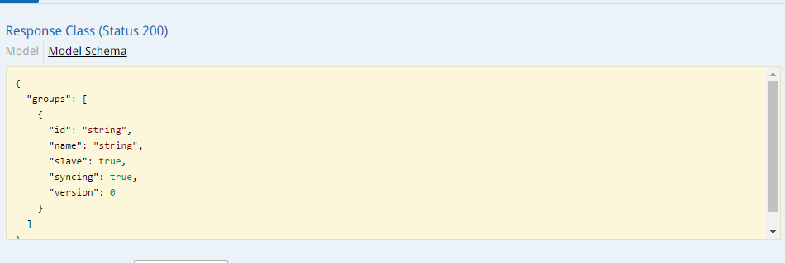

/g/group delete

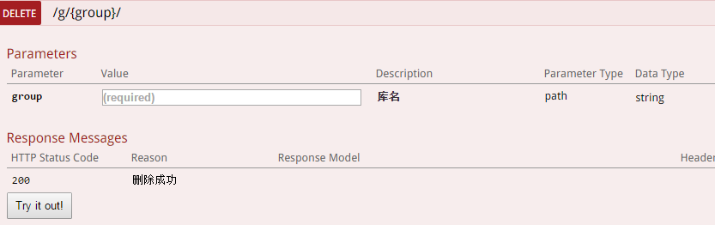

/g/group get

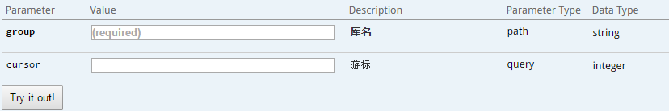

{

"name": "string",

"next_cursor": 0,

"photos": [

{

"id": 0,

"tag": "string"

}

],

"total_photos": 0

}

/g/group post  


{

"face": {

"attrs": {

"age": 0,

"face_quality": {

"blurness": 0,

"expression": 0,

"illumination": 0,

"occlusion": 0,

"pose": 0

},

"gender": {

"female": 0,

"male": 0

},

"left_eye_status": {

"darkglasses": 0,

"noglass_eyeclose": 0,

"noglass_eyeopen": 0,

"normalglass_eyeclose": 0,

"normalglass_eyeopen": 0,

"other_occlusion": 0

},

"pose": {

"pitch": 0,

"roll": 0,

"yaw": 0

},

"right_eye_status": {

"darkglasses": 0,

"noglass_eyeclose": 0,

"noglass_eyeopen": 0,

"normalglass_eyeclose": 0,

"normalglass_eyeopen": 0,

"other_occlusion": 0

}

},

"quality": 0,

"rect": {

"height": 0,

"left": 0,

"top": 0,

"width": 0

}

},

"id": 0,

"image_rect": {

"height": 0,

"left": 0,

"top": 0,

"width": 0

}

}

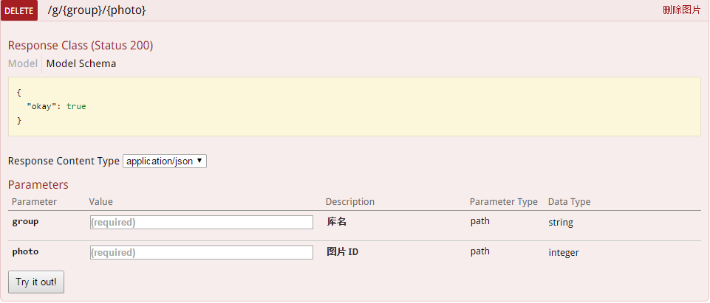

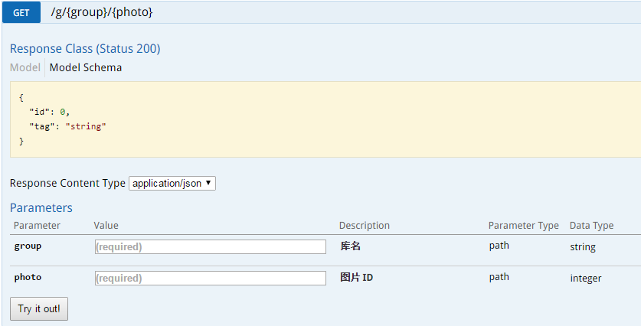

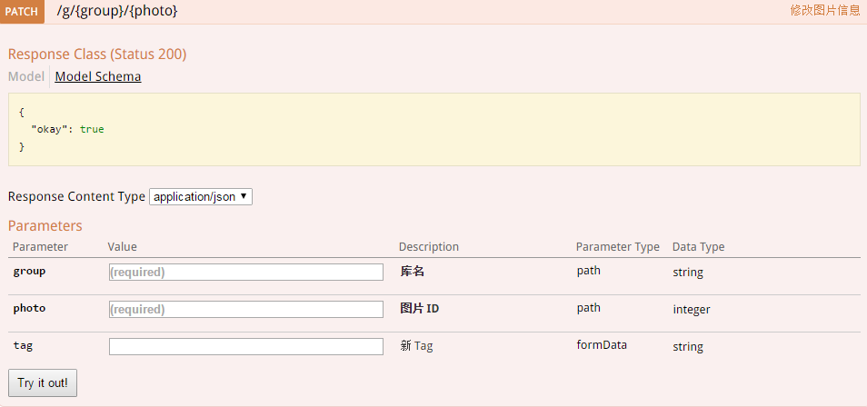



{

"face": {

"attrs": {

"age": 0,

"face_quality": {

"blurness": 0,

"expression": 0,

"illumination": 0,

"occlusion": 0,

"pose": 0

},

"gender": {

"female": 0,

"male": 0

},

"left_eye_status": {

"darkglasses": 0,

"noglass_eyeclose": 0,

"noglass_eyeopen": 0,

"normalglass_eyeclose": 0,

"normalglass_eyeopen": 0,

"other_occlusion": 0

},

"pose": {

"pitch": 0,

"roll": 0,

"yaw": 0

},

"right_eye_status": {

"darkglasses": 0,

"noglass_eyeclose": 0,

"noglass_eyeopen": 0,

"normalglass_eyeclose": 0,

"normalglass_eyeopen": 0,

"other_occlusion": 0

}

},

"quality": 0,

"rect": {

"height": 0,

"left": 0,

"top": 0,

"width": 0

}

},

"groups": [

{

"group": "string",

"photos": [

{

"id": 0,

"score": 0,

"tag": "string"

}

]

}

]

}

/get/video





{

"body": {

"image": "string",

"rect": {

"height": 0,

"left": 0,

"top": 0,

"width": 0

}

},

"clip": {

"expired_from": 0,

"name": "string",

"now": 0,

"seq": 0,

"valid_from": 0

},

"face": {

"image": "string",

"rect": {

"height": 0,

"left": 0,

"top": 0,

"width": 0

}

},

"full": {

"image": "string",

"rect": {

"height": 0,

"left": 0,

"top": 0,

"width": 0

}

},

"pts": 0,

"record_id": 0,

"result": {

"face": {

"attrs": {

"age": 0,

"face_quality": {

"blurness": 0,

"expression": 0,

"illumination": 0,

"occlusion": 0,

"pose": 0

},

"gender": {

"female": 0,

"male": 0

},

"left_eye_status": {

"darkglasses": 0,

"noglass_eyeclose": 0,

"noglass_eyeopen": 0,

"normalglass_eyeclose": 0,

"normalglass_eyeopen": 0,

"other_occlusion": 0

},

"pose": {

"pitch": 0,

"roll": 0,

"yaw": 0

},

"right_eye_status": {

"darkglasses": 0,

"noglass_eyeclose": 0,

"noglass_eyeopen": 0,

"normalglass_eyeclose": 0,

"normalglass_eyeopen": 0,

"other_occlusion": 0

}

},

"quality": 0,

"rect": {

"height": 0,

"left": 0,

"top": 0,

"width": 0

}

},

"groups": [

{

"group": "string",

"photos": [

{

"id": 0,

"score": 0,

"tag": "string"

}

]

}

]

},

"timestamp": 0,

"track": 0,

"type": "string"

}