Phenomenon name meta-analysis

Github link: <https://github.com/yskjdm/Experimental-Meta-Analysis-Template/tree/master>

This is a RMarkdown template for experimental studies meta-analysis in Psychology, developed by Siu Kit Yeung (MPhil student) and Dr. Gilad Feldman (Assistant Professor) from the University of Hong Kong Department of Psychology. This is integrated and adapted with reference to Yeung, Yay, and Feldman (2020) Omission-commission asymmetries in morality and decisions: Meta-analysis of the Omission-bias, as well as Fillon, Kutscher, and Feldman (2020) Impact of past behavior normality on regret: Meta-analysis of exceptionality effect. The corresponding datafile is “Experimental Meta-Analysis Template Full Coding Sheet.xlsx” (simulated data). Other collaborators include John Protzko, Adrien Fillon, Mahmoud Medhat Elsherif, and David Moreau.

For your own analysis, please replace “Cell.1.N”, “Cell.1.M”, “Cell.1.SD”, “Cell.2.N”, “Cell.2.M”, “Cell.2.SD”, “DV1”, “DV2”, “DV3”, “Possible.Moderator.1”, “Possible.Moderator.2”, “Possible.Moderator.3” and “Possible.Moderator.4”, “Category1”, “Category2”, “Category3” with meaningful labels of Cells descriptives column heads, Dependent Variables, Moderators column heads and Moderators categories. Please also replace “Phenomenon name” with the effect you are investigating, “Independent Variable” with your independent variable and “Dependent Variable 1, Dependent Variable 2, Dependent Variable 3” with your dependent variable(s) and “Lastname” with your last name. To do so efficiently, in RStudio, you can click “edit” -> “Replace and find” (or Ctrl+Shift+J). Similarly, in Excel, you can click “Home” -> “Find & Select” -> “Replace” -> “Replace all”.

# Phenomenon name main effect analyses

This file documents the analyses conducted for Lastname (2021) *Phenomenon name meta-analysis*

Analyses were conducted using the file Experimental Meta-Analysis Template Full Coding Sheet.xlsx, to examine the impact of Independent Variable over Dependent Variable 1, Dependent Variable 2 and Dependent Variable 3.

## Phenomenon name effect meta-analysis summary - Random-Effects Two-Level Model

Firstly, we start by running Random-Effects Two-Level Model.

##   
## Random-Effects Model (k = 24; tau^2 estimator: REML)  
##   
## tau^2 (estimated amount of total heterogeneity): 1.0519 (SE = 0.3218)  
## tau (square root of estimated tau^2 value): 1.0256  
## I^2 (total heterogeneity / total variability): 98.04%  
## H^2 (total variability / sampling variability): 50.92  
##   
## Test for Heterogeneity:  
## Q(df = 23) = 918.6956, p-val < .0001  
##   
## Model Results:  
##   
## estimate se zval pval ci.lb ci.ub   
## 0.5403 0.2133 2.5330 0.0113 0.1222 0.9583 *   
##   
## ---  
## Signif. codes: 0 '***' 0.001 '**' 0.01 '*' 0.05 '.' 0.1 ' ' 1

## Phenomenon name effect meta-analysis summary - Multivariate Two-Level Model

Secondly, we run a multivariate two-level model. Multi-variate random-effects model takes account into two or more effect sizes within some of the studies. Check Cheung (2013) - <https://www.tandfonline.com/doi/abs/10.1080/10705511.2013.797827> for further information.

##   
## Multivariate Meta-Analysis Model (k = 51; method: REML)  
##   
## Variance Components:  
##   
## estim sqrt nlvls fixed factor   
## sigma^2 0.9235 0.9610 24 no articlestudy   
##   
## Test for Heterogeneity:  
## Q(df = 50) = 3087.5295, p-val < .0001  
##   
## Model Results:  
##   
## estimate se zval pval ci.lb ci.ub   
## 0.4608 0.1991 2.3140 0.0207 0.0705 0.8511 *   
##   
## ---  
## Signif. codes: 0 '***' 0.001 '**' 0.01 '*' 0.05 '.' 0.1 ' ' 1

##   
## Multivariate Meta-Analysis Model (k = 51; method: REML)  
##   
## Variance Components:  
##   
## estim sqrt nlvls fixed factor   
## sigma^2 0.924 0.961 24 no articlestudy   
##   
## Test for Heterogeneity:  
## Q(df = 50) = 3087.530, p-val < .001  
##   
## Model Results:  
##   
## estimate se zval pval ci.lb ci.ub   
## 0.461 0.199 2.314 0.021 0.071 0.851 *   
##   
## ---  
## Signif. codes: 0 '***' 0.001 '**' 0.01 '*' 0.05 '.' 0.1 ' ' 1

## Phenomenon name effect meta-analysis summary - Multivariate Three-Level Model

Afterwards, we run a Multivariate Three-Level Model, with the third level being Article Name. This takes account into the possible dependence between effect sizes of the same articles. We believe that this is a better approach for estimating effect size than two-level model. For details, see Cheung (2014) - <https://pdfs.semanticscholar.org/8038/1b0d516d07e42e308f983624bffd497b1d9b.pdf> .

##   
## Multivariate Meta-Analysis Model (k = 51; method: REML)  
##   
## Variance Components:  
##   
## estim sqrt nlvls fixed factor   
## sigma^2.1 0.4802 0.6930 16 no Article.Name   
## sigma^2.2 0.4869 0.6978 24 no Article.Name/articlestudy   
##   
## Test for Heterogeneity:  
## Q(df = 50) = 3087.5295, p-val < .0001  
##   
## Model Results:  
##   
## estimate se zval pval ci.lb ci.ub   
## 0.3807 0.2319 1.6413 0.1007 -0.0739 0.8352   
##   
## ---  
## Signif. codes: 0 '***' 0.001 '**' 0.01 '*' 0.05 '.' 0.1 ' ' 1

## | | | 0% | |==== | 5% | |======= | 10% | |========== | 15% | |============== | 20% | |================== | 25% | |===================== | 30% | |======================== | 35% | |============================ | 40% | |================================ | 45% | |=================================== | 50% | |====================================== | 55% | |========================================== | 60% | |============================================== | 65% | |================================================= | 70% | |==================================================== | 75% | |======================================================== | 80% | |============================================================ | 85% | |=============================================================== | 90% | |================================================================== | 95% | |======================================================================| 100%

## | | | 0% | |==== | 5% | |======= | 10% | |========== | 15% | |============== | 20% | |================== | 25% | |===================== | 30% | |======================== | 35% | |============================ | 40% | |================================ | 45% | |=================================== | 50% | |====================================== | 55% | |========================================== | 60% | |============================================== | 65% | |================================================= | 70% | |==================================================== | 75% | |======================================================== | 80% | |============================================================ | 85% | |=============================================================== | 90% | |================================================================== | 95% | |======================================================================| 100%

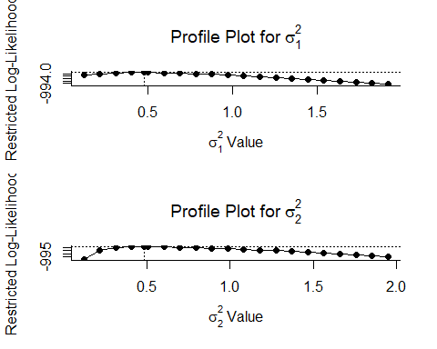

## [1] 0.497

##   
## Multivariate Meta-Analysis Model (k = 51; method: REML)  
##   
## Variance Components:  
##   
## outer factor: Article.Name (nlvls = 16)  
## inner factor: factor(articlestudy) (nlvls = 24)  
##   
## estim sqrt fixed   
## tau^2 0.9671 0.9834 no   
## rho 0.4965 no   
##   
## Test for Heterogeneity:  
## Q(df = 50) = 3087.5295, p-val < .0001  
##   
## Model Results:  
##   
## estimate se zval pval ci.lb ci.ub   
## 0.3807 0.2319 1.6413 0.1007 -0.0739 0.8352   
##   
## ---  
## Signif. codes: 0 '***' 0.001 '**' 0.01 '*' 0.05 '.' 0.1 ' ' 1

### Summary

This analysis is based on 24 studies that evaluated the impact of Independent Variable over Dependent Variable 1, Dependent Variable 2 and Dependent Variable 3.

### What is the effect size for Independent Variable over Dependent Variable 1, Dependent Variable 2 and Dependent Variable 3?

A random effects two-level meta-analysis was conducted (k=24) to explore the effect of Independent Variable on Dependent Variable 1, Dependent Variable 2 and Dependent Variable 3. The average effect-size was Hedge’s g = 0.54, (*p* 0.011, 95% CI [0.12, 0.96]). See table below.

Two-Level Meta-Analysis Summary Table

|  |  |  |  |  |  |  |
| --- | --- | --- | --- | --- | --- | --- |
|  | Hedge’s g | *SE* | *p* | CI Lower | CI Upper | *k* |
| Independent Variable - Dependent Variable 1, Dependent Variable 2 and Dependent Variable 3 | 0.54 | 0.213 | 0.011 | 0.122 | 0.958 | 24 |

Furthermore, A multivariate three-level meta-analysis was conducted (k=51) to explore the effect of Independent Variable on Dependent Variable 1, Dependent Variable 2 and Dependent Variable 3. The average effect-size was Hedge’s g = 0.381 (*p* 0.101, 95% CI [-0.07, 0.84]). See table below.

Multivariate Three-Level Meta-Analysis Summary Table

|  |  |  |  |  |  |  |
| --- | --- | --- | --- | --- | --- | --- |
|  | Hedge’s g | *SE* | *p* | CI Lower | CI Upper | *k* |
| Independent Variable - Dependent Variable 1, Dependent Variable 2 and Dependent Variable 3 | 0.381 | 0.232 | 0.101 | -0.074 | 0.835 | 51 |

### Does the effect-size vary across studies?

A Cochran’s Q test was conducted to examine whether variations in the observed effect-size are likely to be attributable solely to sampling error (*Q* (24)=918.7, *p*=< .001). The variation in effect-size is greater than would be expected from sampling error alone. It appears that the true effect varies betweeen studies.

The *I2* statistics indicates the *proportion* of variance in the observed effect attributable to sampling error. In this instance, the *I2* = 98.04%.

Heterogeneity statistics are summarised below

Heterogeneity Summary Table for Two-Level Model

|  |  |  |
| --- | --- | --- |
| *Q* | *p* | *I2* |
| 919 | < .001 | 98 |

For multivariate three-level model, similarly, a Cochran’s Q test was conducted to examine whether variations in the observed effect-size are likely to be attributable solely to sampling error (*Q* (51)=3087.53, *p*=< .001). The variation in effect-size is greater than would be expected from sampling error alone. It appears that the true effect varies betweeen studies.

The *I2* statistics indicates the *proportion* of variance in the observed effect attributable to sampling error. In this instance, the *I2* = 97.38%.

Heterogeneity statistics are summarised below

Heterogeneity Summary Table for Multivariate Three-Level Model

|  |  |  |
| --- | --- | --- |
| *Q* | *p* | *I2* |
| 3088 | < .001 | 97.4 |

### Forest plot

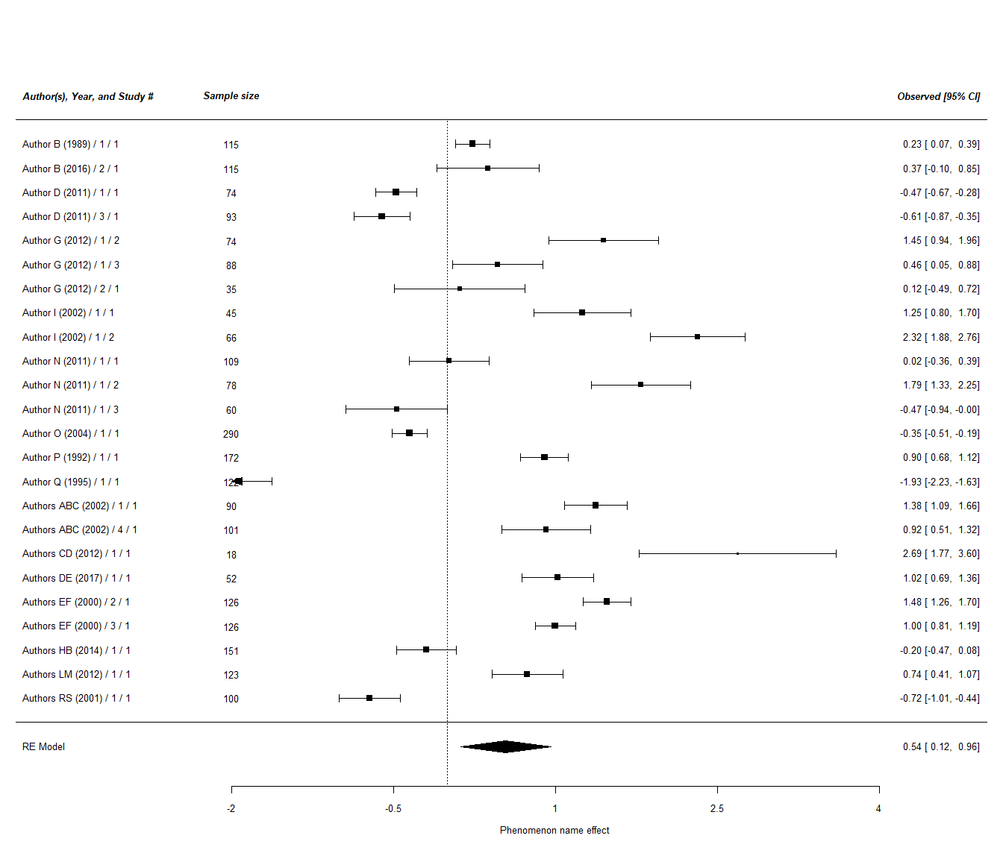

### Publication Bias

#### Basic tests

[Note: Below are some common tests for publication bias. You may add or remove. Read Carter, Schönbrodt, Gervais, and Hilgard (2018) for a comprehensive review and comparison of publication bias tests in psychology: <https://journals.sagepub.com/doi/abs/10.1177/2515245919847196>]

Please read Schwarzer, Carpenter and Rücker (2015) book chapter 5 pages 107-138 for for explanation of trimfill and failsafe. (Also, can check Borenstein, Hedges, Higgins & Rothstein (2009) book, pages 284-287 )

### Funnel plot

In a funnel plot, the standard error or inverse of the standard error is plotted against observed effect sizes. Without publication bias, the plot should look like an inverted funnel whereas asymmetric funnel plots may imply publication bias. For details, read Copas and Shi (2000) - <https://academic.oup.com/biostatistics/article/1/3/247/260794>

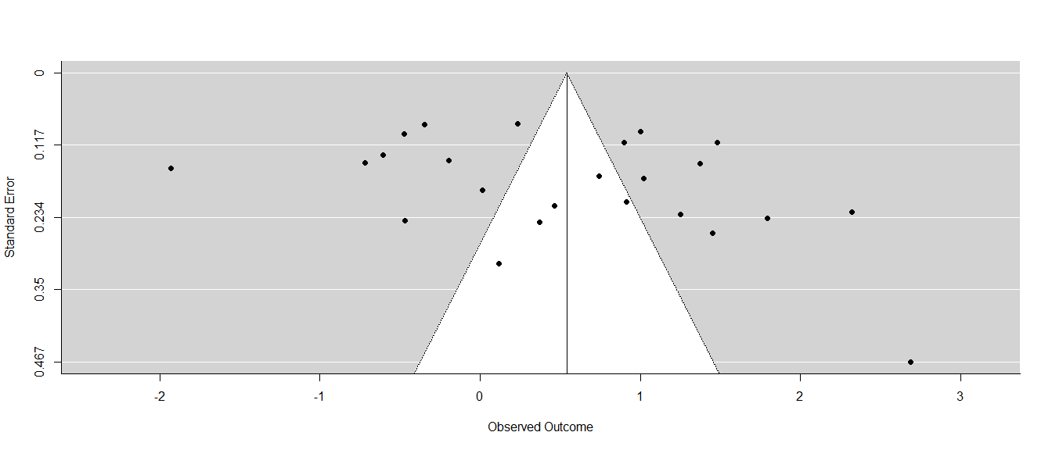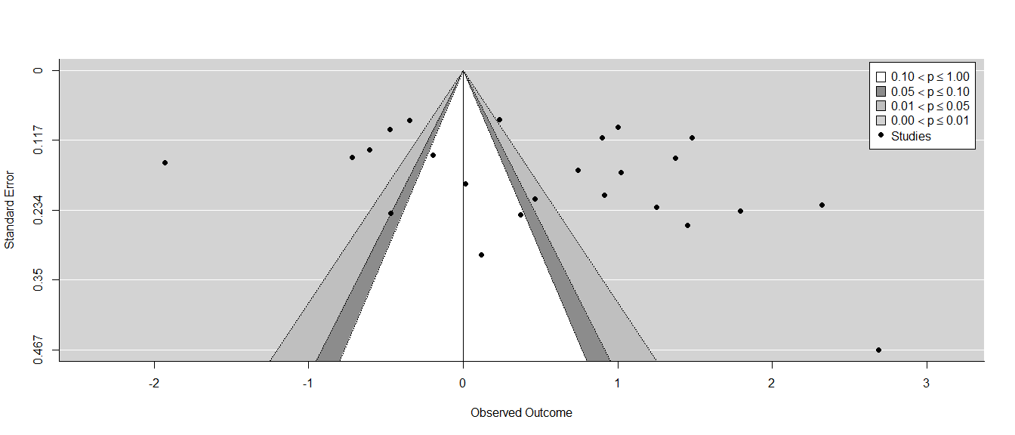

### Trim and Fill

Trim and Fill is based on funnel plot. It aims at estimating possibly missing studies as a result of publication bias in the funnel plot, in order to adjust the effect estimate (Shi & Lin, 2019). For details, read Shi and Lin (2019) (<https://journals.lww.com/md-journal/fulltext/2019/06070/the_trim_and_fill_method_for_publication_bias_.70.aspx>) and Duval and Tweedie (2000) (<http://citeseerx.ist.psu.edu/viewdoc/download?doi=10.1.1.943.1394&rep=rep1&type=pdf>) for details.

##   
## Estimated number of missing studies on the left side: 0 (SE = 2.9917)  
##   
## Random-Effects Model (k = 24; tau^2 estimator: REML)  
##   
## tau^2 (estimated amount of total heterogeneity): 1.0519 (SE = 0.3218)  
## tau (square root of estimated tau^2 value): 1.0256  
## I^2 (total heterogeneity / total variability): 98.04%  
## H^2 (total variability / sampling variability): 50.92  
##   
## Test for Heterogeneity:  
## Q(df = 23) = 918.6956, p-val < .0001  
##   
## Model Results:  
##   
## estimate se zval pval ci.lb ci.ub   
## 0.5403 0.2133 2.5330 0.0113 0.1222 0.9583 *   
##   
## ---  
## Signif. codes: 0 '***' 0.001 '**' 0.01 '*' 0.05 '.' 0.1 ' ' 1

### Rank test

Rank test is a correlational test based on funnel plot asymmetry, aiming to assess the association between standardized effect size and its standard error, with Kendall’s tau as the measure of association. Strong correlation may imply publication bias. Read Begg and Mazumdar (1994) (<https://www.ncbi.nlm.nih.gov/pubmed/7786990>) for details.

##   
## Rank Correlation Test for Funnel Plot Asymmetry  
##   
## Kendall's tau = 0.1449, p = 0.3371

### Egger’s Regression test

Egger’s regression test is based on asymmetry of the funnel plot. The below mixed-effects meta regression examines the relationship between observed outcomes and standard error. Check Sterne and Egger (2006) (<https://www.researchgate.net/publication/281952928_Regression_Methods_to_Detect_Publication_and_Other_Bias_in_Meta-Analysis>) for details.

##   
## Regression Test for Funnel Plot Asymmetry  
##   
## model: mixed-effects meta-regression model  
## predictor: standard error  
##   
## test for funnel plot asymmetry: z = 2.3015, p = 0.0214

### Fail safe

Fail safe N (or the Rosenthal file drawer analysis) represents the number of studies averaging null results to be added to the observed outcomes to refute significant (alpha = .05) meta-analytic means. Rosenthal proposed that if failsafe N < 5k+10, there is a concern for publication bias. Read Becker (2005) (<https://onlinelibrary.wiley.com/doi/10.1002/0470870168.ch7>) for details.

##   
## Fail-safe N Calculation Using the Rosenthal Approach  
##   
## Observed Significance Level: <.0001  
## Target Significance Level: 0.05  
##   
## Fail-safe N: 1462

#### Advanced tests

### PET PEESE

PET stands for precision-effect test. It is a weighted-least-squares regression test, in which effect size is regressed on its standard error. PEESE stands for the precision-effect estimate with standard error (PEESE). It is a weighted-least-squares regression test, in which effect size is regressed on the square of the standard error. The rationale behind these tests is that publication bias is generally stronger with a larger standard error. Purposed by Stanley and Doucouliagos (2014), PET-PEESE considers the statistical significance of the PET estimate to determine the choice of PET versus PEESE as final estimate. When PET is non-significant in a one-sided test with alpha = .05, PET estimate is used. But when the estimate from PET is significant with alpha = .05, the PEESE estimate is used. Read Carter et al. (2019) for details (<https://journals.sagepub.com/doi/abs/10.1177/2515245919847196>).

##   
## Call:  
## lm(formula = totalexp$es ~ totalexp$SE, weights = 1/totalexp$var)  
##   
## Weighted Residuals:  
## Min 1Q Median 3Q Max   
## -15.12 -4.20 1.45 3.56 11.14   
##   
## Coefficients:  
## Estimate Std. Error t value Pr(>|t|)  
## (Intercept) -0.223 0.472 -0.47 0.64  
## totalexp$SE 4.081 3.298 1.24 0.23  
##   
## Residual standard error: 6.25 on 22 degrees of freedom  
## Multiple R-squared: 0.065, Adjusted R-squared: 0.0225   
## F-statistic: 1.53 on 1 and 22 DF, p-value: 0.229

## 2.5 % 97.5 %  
## (Intercept) -1.20 0.755  
## totalexp$SE -2.76 10.921

## [1] -0.223 -1.201 0.755

##   
## Call:  
## lm(formula = totalexp$es ~ totalexp$var, weights = 1/totalexp$var)  
##   
## Weighted Residuals:  
## Min 1Q Median 3Q Max   
## -14.77 -3.95 0.58 3.84 11.23   
##   
## Coefficients:  
## Estimate Std. Error t value Pr(>|t|)  
## (Intercept) 0.0795 0.2548 0.31 0.76  
## totalexp$var 11.5175 8.7425 1.32 0.20  
##   
## Residual standard error: 6.22 on 22 degrees of freedom  
## Multiple R-squared: 0.0731, Adjusted R-squared: 0.031   
## F-statistic: 1.74 on 1 and 22 DF, p-value: 0.201

## 2.5 % 97.5 %  
## (Intercept) -0.449 0.608  
## totalexp$var -6.613 29.648

## [1] 0.0795 -0.4489 0.6078

### puniform

P-uniform focuses on statistically-significant results. It is based on the assumption that p-distribution is “uniform conditional on the population effect size” (van Assen, van Aert, & Wicherts, 2015). It provides a bias-corrected fixed-effects estimate. Read Carter et al. (2019) for details (<https://journals.sagepub.com/doi/abs/10.1177/2515245919847196>).

##   
## Method: P  
##   
## Effect size estimation p-uniform  
##   
## est ci.lb ci.ub L.0 pval ksig  
## 1.14 0.95 1.41 -5.85 <.001 14  
##   
## ===  
##   
## Publication bias test p-uniform  
##   
## L.pb pval  
## -4.95 1  
##   
## ===  
##   
## Fixed-effect meta-analysis  
##   
## est.fe se.fe zval.fe pval.fe ci.lb.fe ci.ub.fe Qstat Qpval  
## 0.315 0.0292 10.8 <.001 0.258 0.372 919 <.001

### Three-parameter selection model

Developed by Iyengar and Greenhouse (1988), the three parameters represent the average true underlying effect size, the heterogeneity of the random effect sizes and the probability that a non-significant effect goes into the literature.

##   
## Unadjusted Model (k = 24):  
##   
## tau^2 (estimated amount of total heterogeneity): 1.0051 (SE = 0.3058)  
## tau (square root of estimated tau^2 value): 1.0026  
##   
## Test for Heterogeneity:  
## Q(df = 23) = 918.6956, p-val = 0.000000000000000000000000000000000000000000000000000000000000000000000000000000000000000000000000000000000000000000000000000000000000000000000000000000000000000000000000000000000159  
##   
## Model Results:  
##   
## estimate std.error z-stat p-val ci.lb ci.ub  
## Intercept 0.5396 0.2087 2.585 0.01 0.1305 0.9487  
##   
## Adjusted Model (k = 24):  
##   
## tau^2 (estimated amount of total heterogeneity): 1.0151 (SE = 0.3126)  
## tau (square root of estimated tau^2 value): 1.0075  
##   
## Test for Heterogeneity:  
## Q(df = 23) = 918.6956, p-val = 0.000000000000000000000000000000000000000000000000000000000000000000000000000000000000000000000000000000000000000000000000000000000000000000000000000000000000000000000000000000000159  
##   
## Model Results:  
##   
## estimate std.error z-stat p-val ci.lb ci.ub  
## Intercept 0.4750 0.3454 1.375 0.2 -0.2020 1.152  
## 0.025 < p < 1 0.8501 0.5821 1.460 0.1 -0.2909 1.991  
##   
## Likelihood Ratio Test:  
## X^2(df = 1) = 0.0563, p-val = 0.8

### Henmi and Copas (2010)

Henmi and Copas (2010) proposed a new confidence interval for meta-analysis. It retains the assessment of the extra uncertainty of the random effects setting for describing heterogeneity between studies, but focuses on the fixed effects estimate to construct a confidence interval. For more details, read Henmi and Copas (2010) (<https://www.ncbi.nlm.nih.gov/pubmed/20963748>).

##   
## method tau2 estimate se ci.lb ci.ub   
## rma REML 1.0519 0.5403 0.2133 0.1222 0.9583   
## hc DL 0.8207 0.3149 0.2419 -0.1879 0.8178

### P-curve

P-curve refers to the distribution of (only) significant (*p* < .05) p-values. It differs from asymmetry tests mentioned above. It is based on the assumption that publication bias is a result of “p-hacking” - which means playing around the data to ensure the p-value drops below 0.05, obtaining “statistical significance”. The effect size adjusted estimation is based on significant effects. It is important to recognize that, when the heteorogeneity is medium to high (I sqaure 50% or above, the I square of our study is over 90%), the adjusted effect size is an overestimation (van Aert, Wicherts, & van Assen, 2016 - <https://journals.sagepub.com/doi/pdf/10.1177/1745691616650874>). For more information about P-curve, please check Simonsohn, Nelson, and Simmons (2014) - <https://repository.upenn.edu/cgi/viewcontent.cgi?article=1077&context=oid_papers>

## 95%-CI %W(fixed) %W(random)  
## Author B (1989) / 1 / 1 0.2338 [ 0.0739; 0.3938] 12.8 4.3  
## Author B (2016) / 2 / 1 0.3733 [-0.0997; 0.8463] 1.5 4.1  
## Author D (2011) / 1 / 1 -0.4742 [-0.6668; -0.2816] 8.8 4.3  
## Author D (2011) / 3 / 1 -0.6059 [-0.8650; -0.3467] 4.9 4.3  
## Author G (2012) / 1 / 2 1.4494 [ 0.9416; 1.9572] 1.3 4.0  
## Author G (2012) / 1 / 3 0.4649 [ 0.0451; 0.8848] 1.9 4.1  
## Author G (2012) / 2 / 1 0.1157 [-0.4890; 0.7203] 0.9 3.9  
## Author I (2002) / 1 / 1 1.2502 [ 0.8016; 1.6987] 1.6 4.1  
## Author I (2002) / 1 / 2 2.3186 [ 1.8789; 2.7582] 1.7 4.1  
## Author N (2011) / 1 / 1 0.0165 [-0.3555; 0.3885] 2.4 4.2  
## Author N (2011) / 1 / 2 1.7946 [ 1.3349; 2.2544] 1.5 4.1  
## Author N (2011) / 1 / 3 -0.4705 [-0.9382; -0.0028] 1.5 4.1  
## Author O (2004) / 1 / 1 -0.3496 [-0.5134; -0.1859] 12.2 4.3  
## Author P (1992) / 1 / 1 0.9005 [ 0.6792; 1.1219] 6.7 4.3  
## Author Q (1995) / 1 / 1 -1.9300 [-2.2332; -1.6268] 3.6 4.2  
## Authors ABC (2002) / 1 / 1 1.3750 [ 1.0875; 1.6626] 4.0 4.3  
## Authors ABC (2002) / 4 / 1 0.9150 [ 0.5065; 1.3236] 2.0 4.1  
## Authors CD (2012) / 1 / 1 2.6889 [ 1.7736; 3.6042] 0.4 3.5  
## Authors DE (2017) / 1 / 1 1.0233 [ 0.6894; 1.3572] 2.9 4.2  
## Authors EF (2000) / 2 / 1 1.4788 [ 1.2597; 1.6980] 6.8 4.3  
## Authors EF (2000) / 3 / 1 0.9992 [ 0.8131; 1.1853] 9.4 4.3  
## Authors HB (2014) / 1 / 1 -0.1967 [-0.4737; 0.0802] 4.3 4.3  
## Authors LM (2012) / 1 / 1 0.7402 [ 0.4135; 1.0669] 3.1 4.2  
## Authors RS (2001) / 1 / 1 -0.7204 [-1.0054; -0.4353] 4.0 4.3  
##   
## Number of studies combined: k = 24  
##   
## 95%-CI z p-value  
## Fixed effect model 0.3149 [0.2577; 0.3721] 10.79 < 0.0001  
## Random effects model 0.5361 [0.1650; 0.9072] 2.83 0.0046  
##   
## Quantifying heterogeneity:  
## tau^2 = 0.8207 [0.5397; 1.9680]; tau = 0.9059 [0.7346; 1.4029];  
## I^2 = 97.5% [96.9%; 98.0%]; H = 6.32 [5.72; 6.98]  
##   
## Test of heterogeneity:  
## Q d.f. p-value  
## 918.70 23 < 0.0001  
##   
## Details on meta-analytical method:  
## - Inverse variance method  
## - DerSimonian-Laird estimator for tau^2  
## - Jackson method for confidence interval of tau^2 and tau

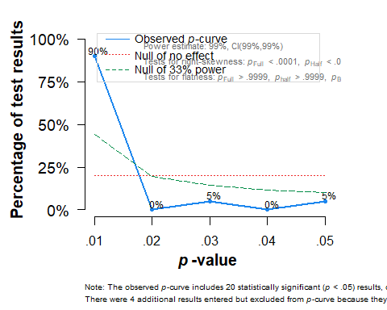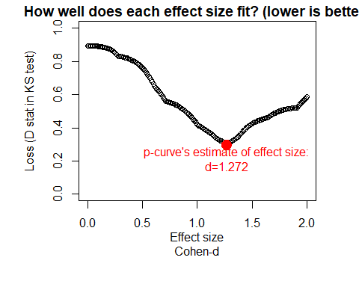

## P-curve analysis   
## -----------------------   
## - Total number of provided studies: k = 24   
## - Total number of p<0.05 studies included into the analysis: k = 20 (83.33%)   
## - Total number of studies with p<0.025: k = 18 (75%)   
##   
## Results   
## -----------------------   
## pBinomial zFull pFull zHalf pHalf  
## Right-skewness test 0.000 -21.3 0 -22.3 0  
## Flatness test 0.989 18.3 1 20.7 1  
## Note: p-values of 0 or 1 correspond to p<0.001 and p>0.999, respectively.   
## Power Estimate: 99% (99%-99%)  
##   
## Evidential value   
## -----------------------   
## - Evidential value present: yes   
## - Evidential value absent/inadequate: no   
##   
## P-curve's estimate of the true effect size: d=1.27   
##   
## Warning: I-squared of the meta-analysis is >= 50%, so effect size estimates are not trustworthy.

# Moderator analyses

## Our theoretical moderators

## MetaForest results  
##   
## Type of analysis: MetaForest  
## Number of studies: 51   
## Number of moderators: 5   
## Number of trees in forest: 500   
## Candidate variables per split: 2   
## Minimum terminal node size: 5   
## OOB prediction error (MSE): 3.6376   
## R squared (OOB): -0.1972   
##   
## Tests for Heterogeneity:   
## tau2 tau2_SE I^2 H^2 Q-test df  
## Raw effect sizes: 2.8815 0.5862 99.1053 111.7705 3087.5295 50  
## Residuals (after MetaForest): 3.5783 0.7256 99.2783 138.5536 4049.8293 50  
## Q_p   
## Raw effect sizes: 0.0000  
## Residuals (after MetaForest): 0.0000  
##   
##   
## Random intercept meta-analyses:  
## Intercept se ci.lb ci.ub p   
## Raw effect sizes: 0.3451 0.2398 -0.1249 0.8150 0.1501  
## Residuals (after MetaForest): -0.0112 0.2667 -0.5340 0.5116 0.9665

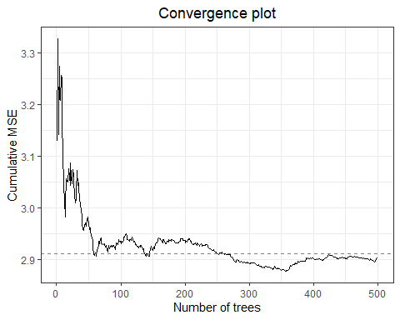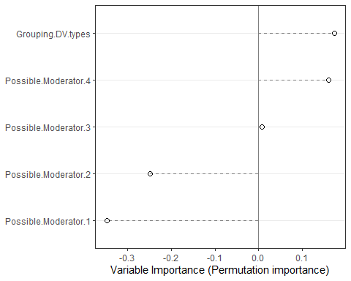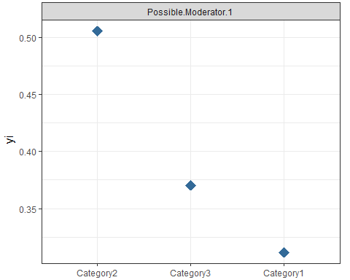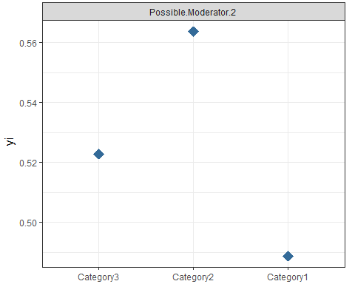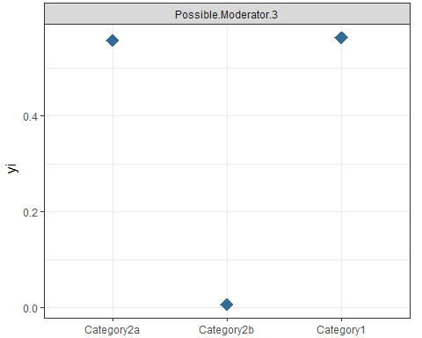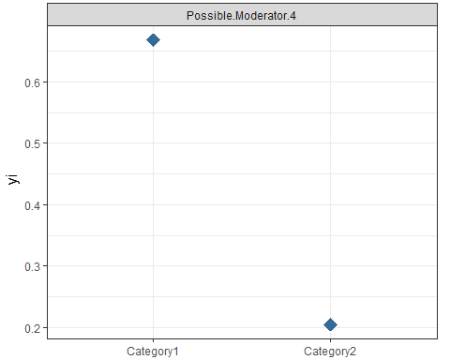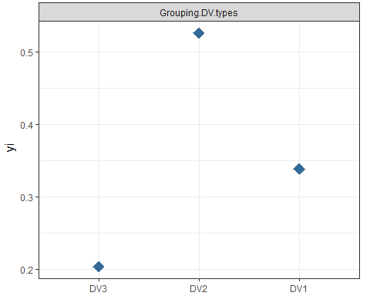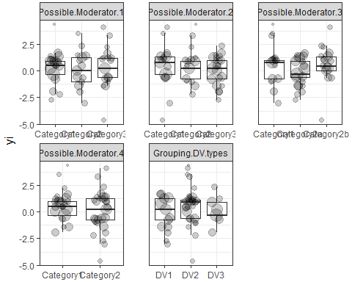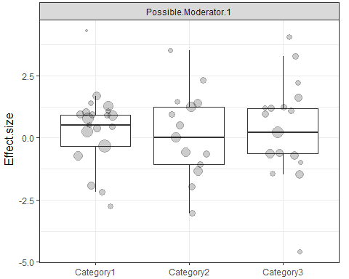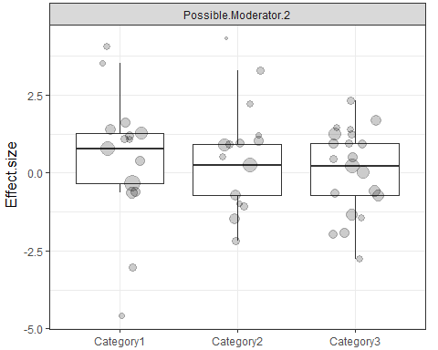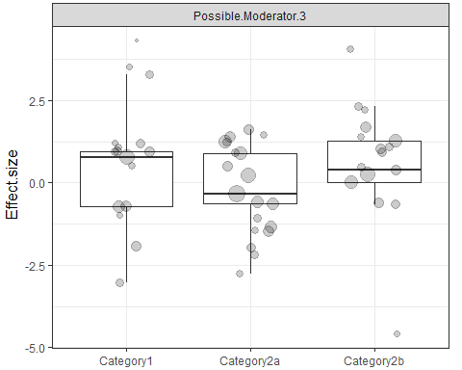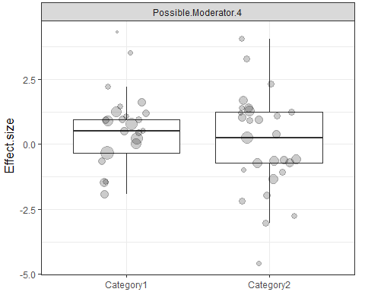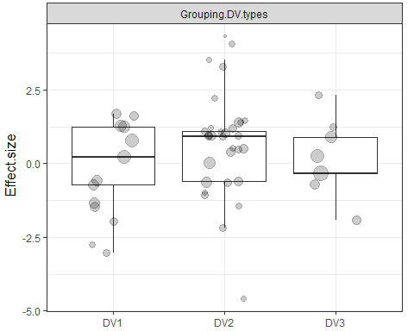

### DV type as a moderator

##   
## Mixed-Effects Model (k = 51; tau^2 estimator: REML)  
##   
## tau^2 (estimated amount of residual heterogeneity): 2.7909 (SE = 0.5799)  
## tau (square root of estimated tau^2 value): 1.6706  
## I^2 (residual heterogeneity / unaccounted variability): 99.05%  
## H^2 (unaccounted variability / sampling variability): 104.73  
## R^2 (amount of heterogeneity accounted for): 3.14%  
##   
## Test for Residual Heterogeneity:  
## QE(df = 48) = 2983.9079, p-val < .0001  
##   
## Test of Moderators (coefficients 2:3):  
## QM(df = 2) = 3.6887, p-val = 0.1581  
##   
## Model Results:  
##   
## estimate se zval pval ci.lb ci.ub   
## intrcpt -0.3835 0.4653 -0.8243 0.4098 -1.2955 0.5284   
## Grouping.DV.typesDV2 1.0625 0.5556 1.9123 0.0558 -0.0265 2.1514 .   
## Grouping.DV.typesDV3 0.6232 0.7866 0.7923 0.4282 -0.9185 2.1650   
##   
## ---  
## Signif. codes: 0 '***' 0.001 '**' 0.01 '*' 0.05 '.' 0.1 ' ' 1

#### DV1

##   
## Random-Effects Model (k = 7; tau^2 estimator: REML)  
##   
## tau^2 (estimated amount of total heterogeneity): 2.4077 (SE = 1.4023)  
## tau (square root of estimated tau^2 value): 1.5517  
## I^2 (total heterogeneity / total variability): 99.41%  
## H^2 (total variability / sampling variability): 168.24  
##   
## Test for Heterogeneity:  
## Q(df = 6) = 677.7402, p-val < .0001  
##   
## Model Results:  
##   
## estimate se zval pval ci.lb ci.ub   
## -0.4914 0.5891 -0.8343 0.4041 -1.6460 0.6631   
##   
## ---  
## Signif. codes: 0 '***' 0.001 '**' 0.01 '*' 0.05 '.' 0.1 ' ' 1

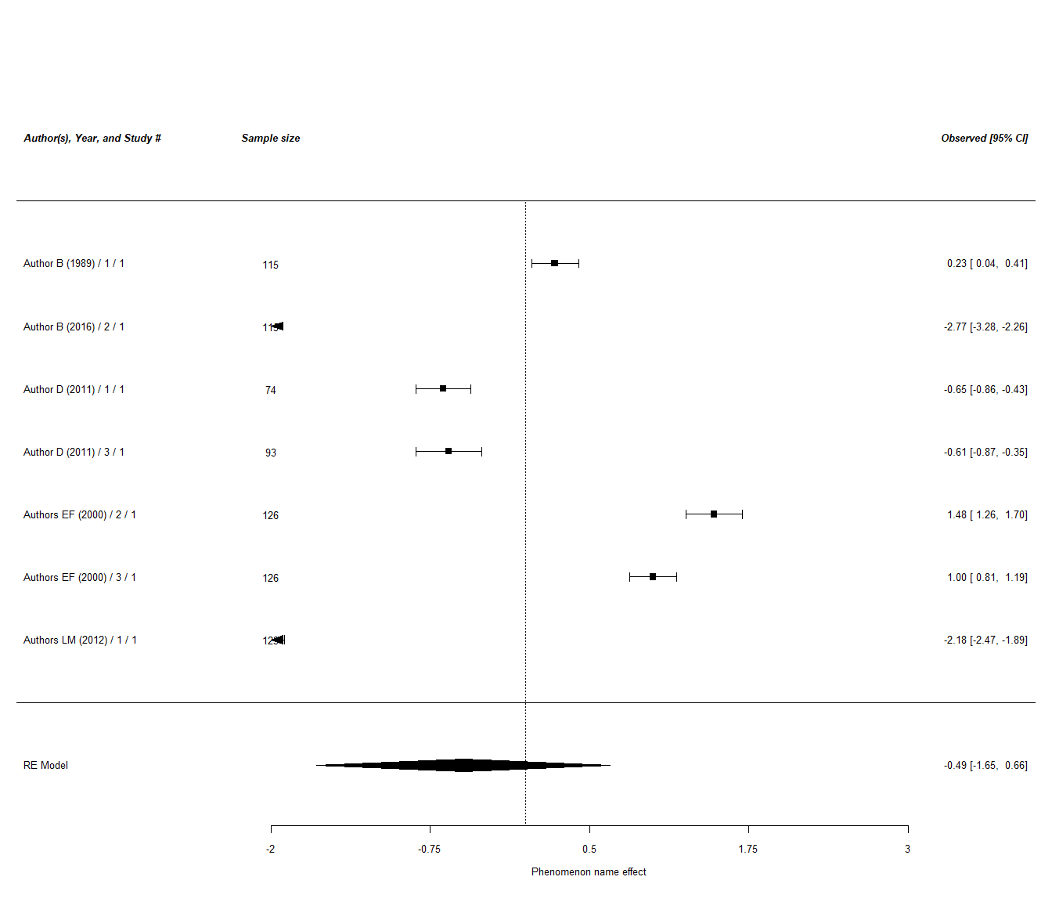

#### DV2

##   
## Random-Effects Model (k = 14; tau^2 estimator: REML)  
##   
## tau^2 (estimated amount of total heterogeneity): 1.7882 (SE = 0.7241)  
## tau (square root of estimated tau^2 value): 1.3372  
## I^2 (total heterogeneity / total variability): 97.96%  
## H^2 (total variability / sampling variability): 48.91  
##   
## Test for Heterogeneity:  
## Q(df = 13) = 523.4159, p-val < .0001  
##   
## Model Results:  
##   
## estimate se zval pval ci.lb ci.ub   
## 1.1318 0.3632 3.1164 0.0018 0.4200 1.8436 **   
##   
## ---  
## Signif. codes: 0 '***' 0.001 '**' 0.01 '*' 0.05 '.' 0.1 ' ' 1

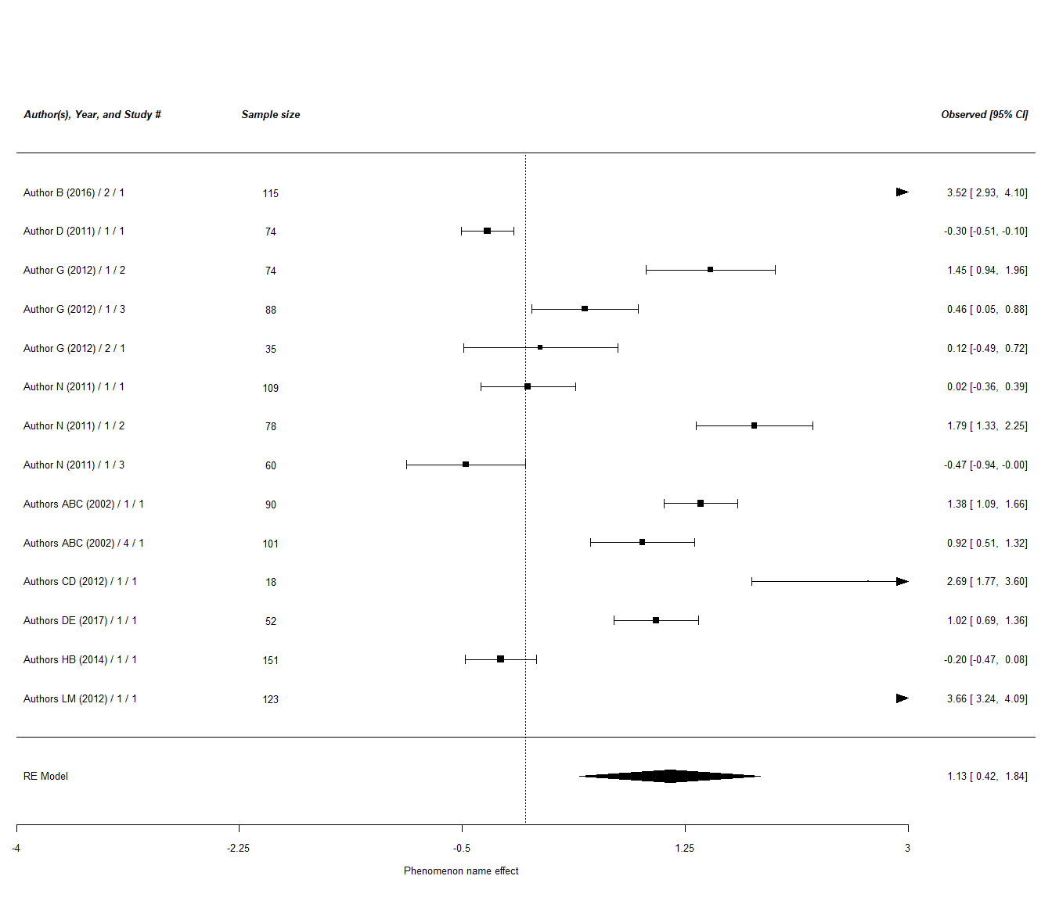

#### DV3

##   
## Random-Effects Model (k = 7; tau^2 estimator: REML)  
##   
## tau^2 (estimated amount of total heterogeneity): 1.9147 (SE = 1.1199)  
## tau (square root of estimated tau^2 value): 1.3837  
## I^2 (total heterogeneity / total variability): 99.15%  
## H^2 (total variability / sampling variability): 118.06  
##   
## Test for Heterogeneity:  
## Q(df = 6) = 404.4525, p-val < .0001  
##   
## Model Results:  
##   
## estimate se zval pval ci.lb ci.ub   
## 0.2377 0.5264 0.4515 0.6516 -0.7941 1.2695   
##   
## ---  
## Signif. codes: 0 '***' 0.001 '**' 0.01 '*' 0.05 '.' 0.1 ' ' 1

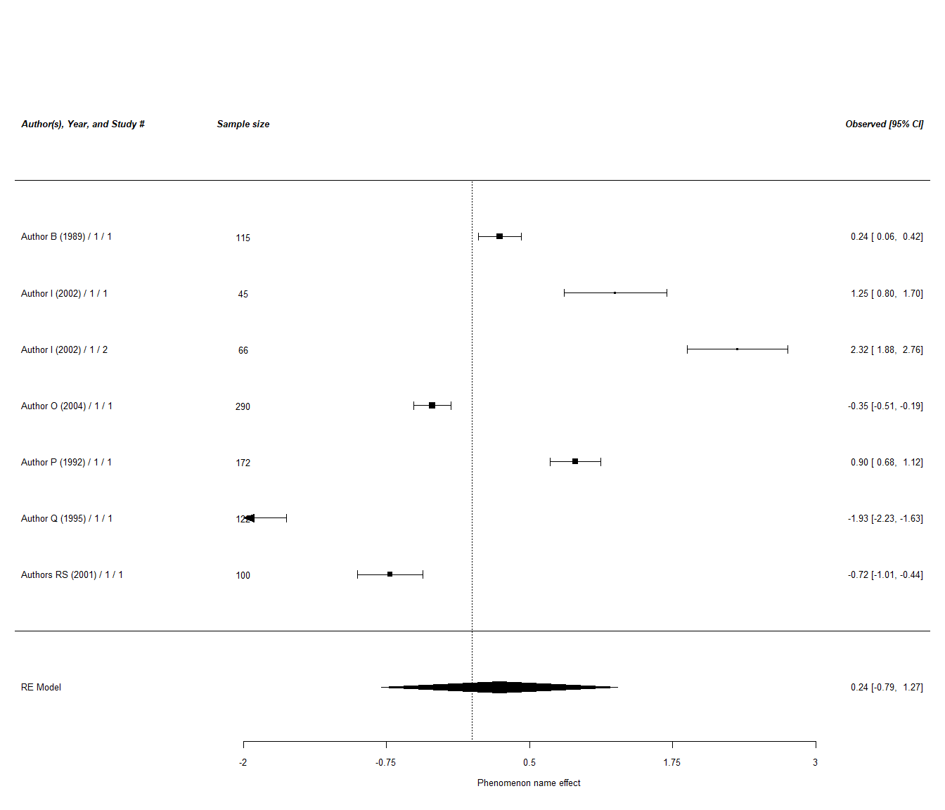

### Comparing DV types

## estimate stderror numstudies meta tau2  
## 1 1.132 0.363 14 2 - DV2 1.79  
## 2 0.238 0.526 7 3 - DV3 1.91  
## 3 -0.491 0.589 7 1 - DV1 2.41

##   
## Fixed-Effects with Moderators Model (k = 3)  
##   
## I^2 (residual heterogeneity / unaccounted variability): 0.00%  
## H^2 (unaccounted variability / sampling variability): 1.00  
##   
## Test for Residual Heterogeneity:  
## QE(df = 0) = 0.000, p-val = 1.000  
##   
## Test of Moderators (coefficients 2:3):  
## QM(df = 2) = 6.038, p-val = 0.049  
##   
## Model Results:  
##   
## estimate se zval pval ci.lb ci.ub   
## intrcpt -0.491 0.589 -0.834 0.404 -1.646 0.663   
## factor(meta)2 - DV2 1.623 0.692 2.346 0.019 0.267 2.980 *   
## factor(meta)3 - DV3 0.729 0.790 0.923 0.356 -0.819 2.277   
##   
## ---  
## Signif. codes: 0 '***' 0.001 '**' 0.01 '*' 0.05 '.' 0.1 ' ' 1

### Possible Moderator 1 analyses

##   
## Mixed-Effects Model (k = 51; tau^2 estimator: REML)  
##   
## tau^2 (estimated amount of residual heterogeneity): 2.9984 (SE = 0.6222)  
## tau (square root of estimated tau^2 value): 1.7316  
## I^2 (residual heterogeneity / unaccounted variability): 99.12%  
## H^2 (unaccounted variability / sampling variability): 113.88  
## R^2 (amount of heterogeneity accounted for): 0.00%  
##   
## Test for Residual Heterogeneity:  
## QE(df = 48) = 3059.5693, p-val < .0001  
##   
## Test of Moderators (coefficients 2:3):  
## QM(df = 2) = 0.1553, p-val = 0.9253  
##   
## Model Results:  
##   
## estimate se zval pval ci.lb   
## intrcpt 0.4141 0.3908 1.0595 0.2894 -0.3519   
## Possible.Moderator.1Category2 -0.2241 0.6079 -0.3687 0.7124 -1.4156   
## Possible.Moderator.1Category3 -0.0204 0.5765 -0.0354 0.9718 -1.1502   
## ci.ub   
## intrcpt 1.1801   
## Possible.Moderator.1Category2 0.9673   
## Possible.Moderator.1Category3 1.1094   
##   
## ---  
## Signif. codes: 0 '***' 0.001 '**' 0.01 '*' 0.05 '.' 0.1 ' ' 1

#### Possible Moderator 1 Category 1 studies

##   
## Random-Effects Model (k = 15; tau^2 estimator: REML)  
##   
## tau^2 (estimated amount of total heterogeneity): 1.7223 (SE = 0.6665)  
## tau (square root of estimated tau^2 value): 1.3124  
## I^2 (total heterogeneity / total variability): 98.87%  
## H^2 (total variability / sampling variability): 88.21  
##   
## Test for Heterogeneity:  
## Q(df = 14) = 703.9367, p-val < .0001  
##   
## Model Results:  
##   
## estimate se zval pval ci.lb ci.ub   
## 0.2936 0.3429 0.8563 0.3918 -0.3785 0.9658   
##   
## ---  
## Signif. codes: 0 '***' 0.001 '**' 0.01 '*' 0.05 '.' 0.1 ' ' 1

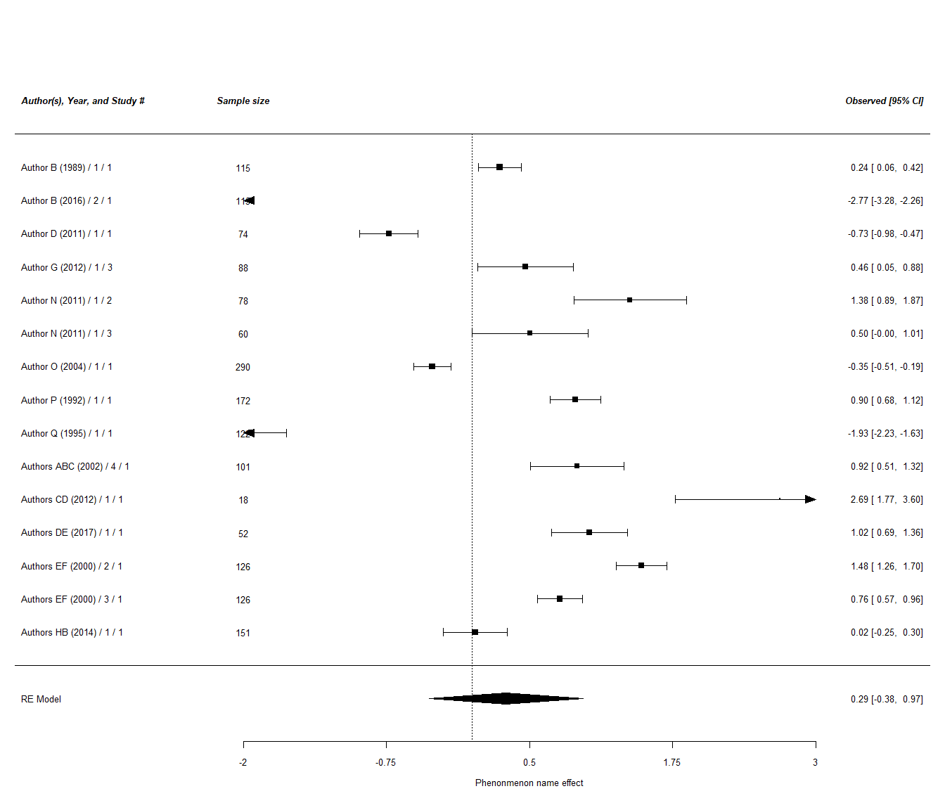

#### Possible Moderator 1 Category 2 studies

##   
## Random-Effects Model (k = 10; tau^2 estimator: REML)  
##   
## tau^2 (estimated amount of total heterogeneity): 3.3878 (SE = 1.6149)  
## tau (square root of estimated tau^2 value): 1.8406  
## I^2 (total heterogeneity / total variability): 99.23%  
## H^2 (total variability / sampling variability): 129.46  
##   
## Test for Heterogeneity:  
## Q(df = 9) = 837.9631, p-val < .0001  
##   
## Model Results:  
##   
## estimate se zval pval ci.lb ci.ub   
## 0.4594 0.5853 0.7849 0.4325 -0.6878 1.6066   
##   
## ---  
## Signif. codes: 0 '***' 0.001 '**' 0.01 '*' 0.05 '.' 0.1 ' ' 1

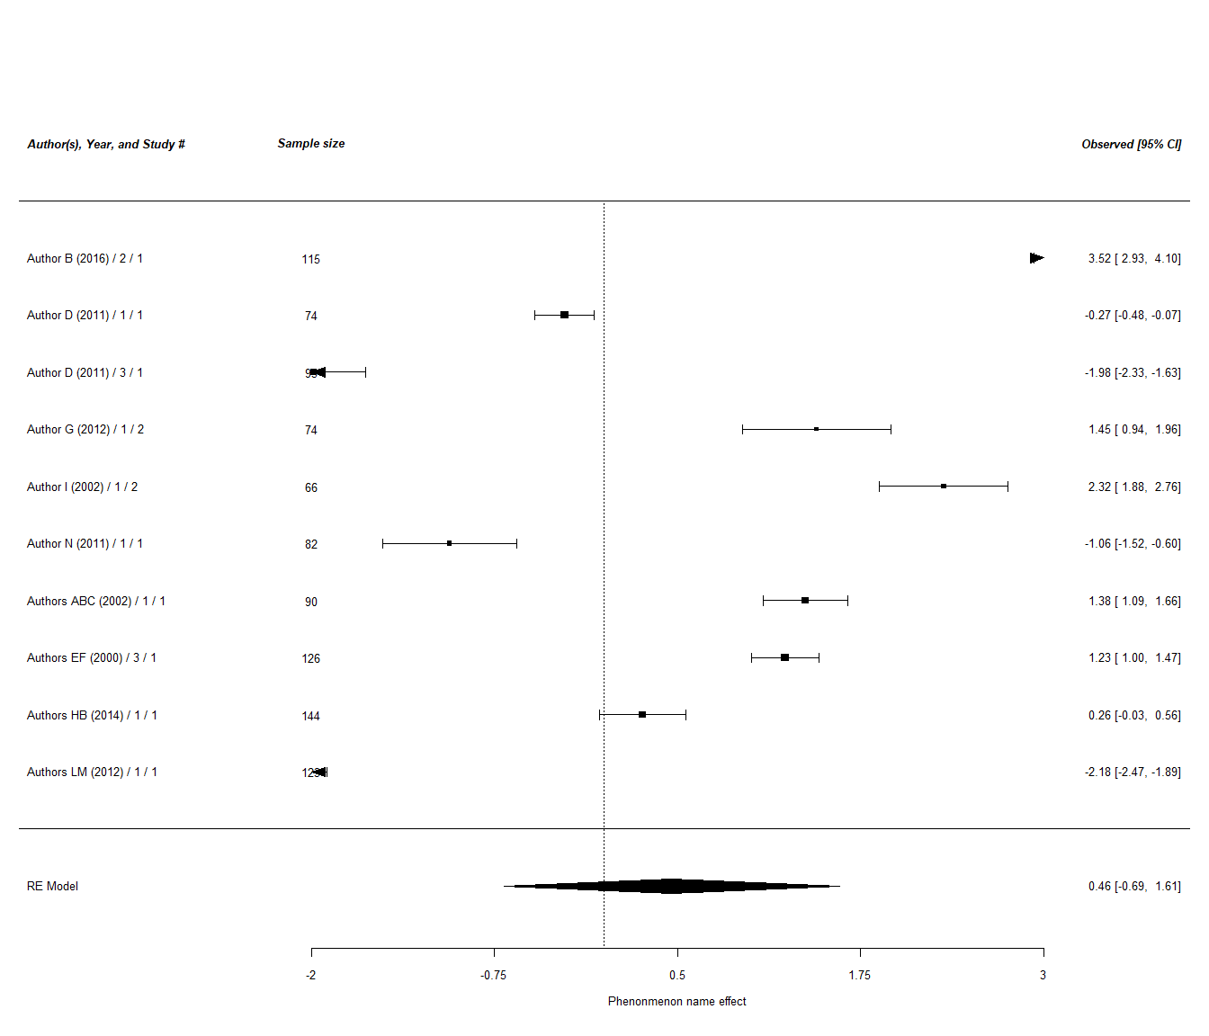

#### Possible Moderator 1 Category 3 studies

##   
## Random-Effects Model (k = 11; tau^2 estimator: REML)  
##   
## tau^2 (estimated amount of total heterogeneity): 2.1737 (SE = 0.9921)  
## tau (square root of estimated tau^2 value): 1.4743  
## I^2 (total heterogeneity / total variability): 98.71%  
## H^2 (total variability / sampling variability): 77.72  
##   
## Test for Heterogeneity:  
## Q(df = 10) = 490.4587, p-val < .0001  
##   
## Model Results:  
##   
## estimate se zval pval ci.lb ci.ub   
## 0.4591 0.4491 1.0223 0.3066 -0.4211 1.3393   
##   
## ---  
## Signif. codes: 0 '***' 0.001 '**' 0.01 '*' 0.05 '.' 0.1 ' ' 1

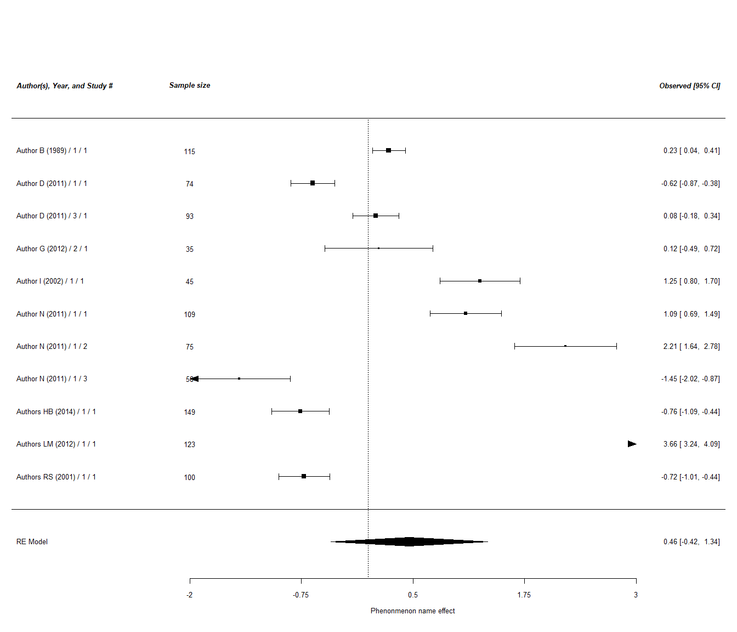

### Comparing Possible Moderator 1 Categories 1 to 3 designs

[Insert Hypothesis, if there is - e.g. Phenomenon name under Category 1 condition is stronger than that under Category 2 condition and Category 3 condition] [Indicate whether the hypothesis is supported / not supported / partially supported - simulation: The hypothesis is not supported]

## estimate stderror numstudies meta tau2  
## 1 0.294 0.343 15 1 - Category1 1.72  
## 2 0.459 0.585 10 2 - Category2 3.39  
## 3 0.459 0.449 11 3 - Category3 2.17

##   
## Fixed-Effects with Moderators Model (k = 3)  
##   
## I^2 (residual heterogeneity / unaccounted variability): 0.00%  
## H^2 (unaccounted variability / sampling variability): 1.00  
##   
## Test for Residual Heterogeneity:  
## QE(df = 0) = 0.000, p-val = 1.000  
##   
## Test of Moderators (coefficients 2:3):  
## QM(df = 2) = 0.112, p-val = 0.945  
##   
## Model Results:  
##   
## estimate se zval pval ci.lb ci.ub   
## intrcpt 0.294 0.343 0.856 0.392 -0.378 0.966   
## factor(meta)2 - Category2 0.166 0.678 0.244 0.807 -1.164 1.495   
## factor(meta)3 - Category3 0.165 0.565 0.293 0.770 -0.942 1.273   
##   
## ---  
## Signif. codes: 0 '***' 0.001 '**' 0.01 '*' 0.05 '.' 0.1 ' ' 1

## estimate stderror numstudies meta tau2  
## 1 0.294 0.343 15 Category1 1.72  
## 2 0.459 0.585 10 Category2 3.39

##   
## Fixed-Effects with Moderators Model (k = 2)  
##   
## I^2 (residual heterogeneity / unaccounted variability): 0.00%  
## H^2 (unaccounted variability / sampling variability): 1.00  
##   
## Test for Residual Heterogeneity:  
## QE(df = 0) = 0.000, p-val = 1.000  
##   
## Test of Moderators (coefficient 2):  
## QM(df = 1) = 0.060, p-val = 0.807  
##   
## Model Results:  
##   
## estimate se zval pval ci.lb ci.ub   
## intrcpt 0.294 0.343 0.856 0.392 -0.378 0.966   
## factor(meta)Category2 0.166 0.678 0.244 0.807 -1.164 1.495   
##   
## ---  
## Signif. codes: 0 '***' 0.001 '**' 0.01 '*' 0.05 '.' 0.1 ' ' 1

### Possible Moderator 2 moderator analyses

##   
## Mixed-Effects Model (k = 51; tau^2 estimator: REML)  
##   
## tau^2 (estimated amount of residual heterogeneity): 2.9612 (SE = 0.6146)  
## tau (square root of estimated tau^2 value): 1.7208  
## I^2 (residual heterogeneity / unaccounted variability): 99.11%  
## H^2 (unaccounted variability / sampling variability): 111.88  
## R^2 (amount of heterogeneity accounted for): 0.00%  
##   
## Test for Residual Heterogeneity:  
## QE(df = 48) = 3044.6287, p-val < .0001  
##   
## Test of Moderators (coefficients 2:3):  
## QM(df = 2) = 0.7896, p-val = 0.6738  
##   
## Model Results:  
##   
## estimate se zval pval ci.lb   
## intrcpt 0.4786 0.4473 1.0699 0.2847 -0.3982   
## Possible.Moderator.2Category2 0.0921 0.6348 0.1450 0.8847 -1.1520   
## Possible.Moderator.2Category3 -0.3868 0.5855 -0.6607 0.5088 -1.5344   
## ci.ub   
## intrcpt 1.3554   
## Possible.Moderator.2Category2 1.3362   
## Possible.Moderator.2Category3 0.7608   
##   
## ---  
## Signif. codes: 0 '***' 0.001 '**' 0.01 '*' 0.05 '.' 0.1 ' ' 1

#### Possible Moderator 2 Category 1 studies

##   
## Random-Effects Model (k = 11; tau^2 estimator: REML)  
##   
## tau^2 (estimated amount of total heterogeneity): 1.4402 (SE = 0.6593)  
## tau (square root of estimated tau^2 value): 1.2001  
## I^2 (total heterogeneity / total variability): 98.59%  
## H^2 (total variability / sampling variability): 71.06  
##   
## Test for Heterogeneity:  
## Q(df = 10) = 505.9514, p-val < .0001  
##   
## Model Results:  
##   
## estimate se zval pval ci.lb ci.ub   
## 0.8392 0.3661 2.2923 0.0219 0.1217 1.5568 *   
##   
## ---  
## Signif. codes: 0 '***' 0.001 '**' 0.01 '*' 0.05 '.' 0.1 ' ' 1

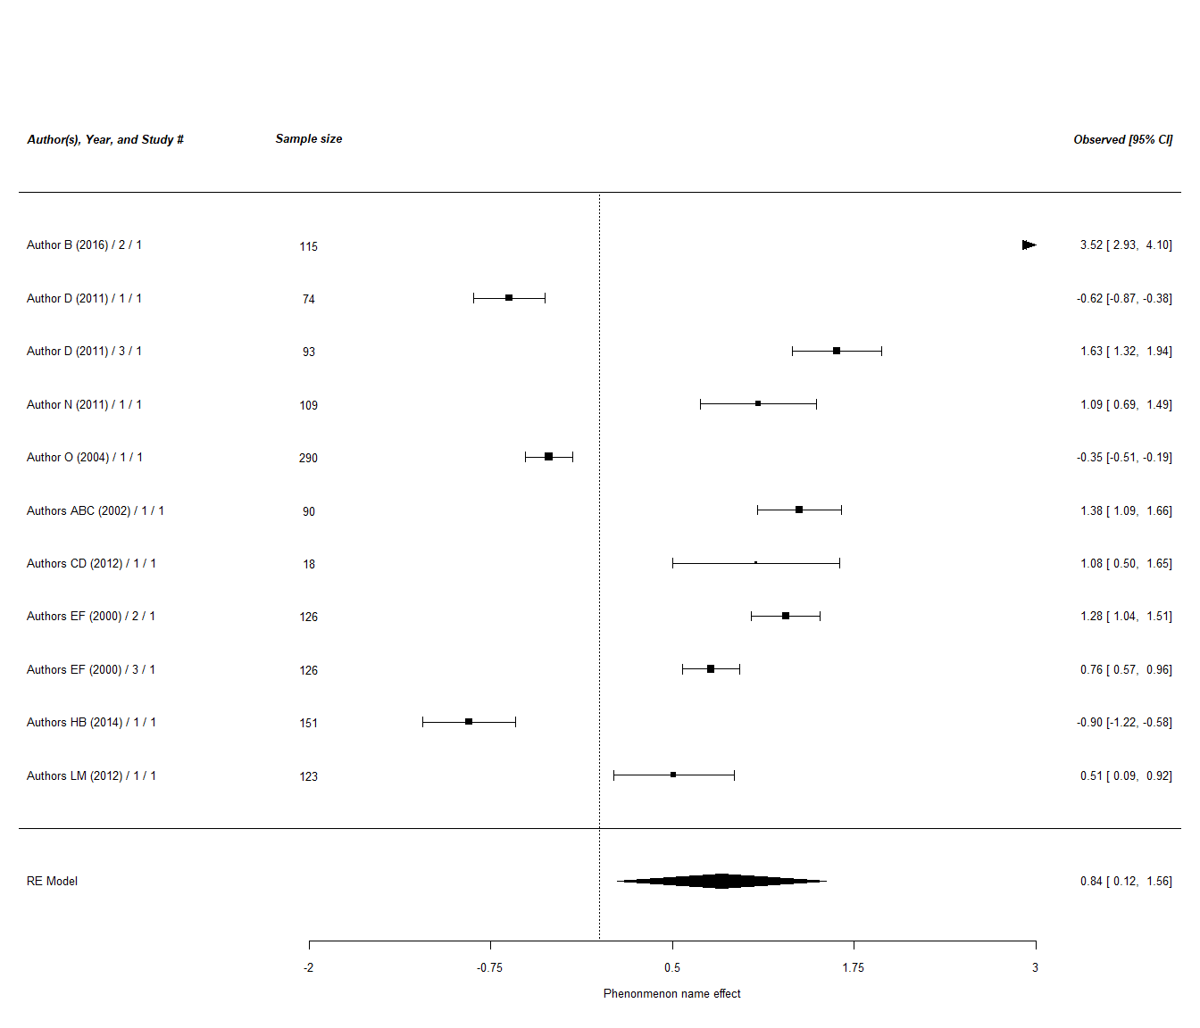

#### Possible Moderator 2 Category 2 studies

##   
## Random-Effects Model (k = 13; tau^2 estimator: REML)  
##   
## tau^2 (estimated amount of total heterogeneity): 2.5021 (SE = 1.0519)  
## tau (square root of estimated tau^2 value): 1.5818  
## I^2 (total heterogeneity / total variability): 98.80%  
## H^2 (total variability / sampling variability): 83.09  
##   
## Test for Heterogeneity:  
## Q(df = 12) = 552.1795, p-val < .0001  
##   
## Model Results:  
##   
## estimate se zval pval ci.lb ci.ub   
## 0.6896 0.4454 1.5482 0.1216 -0.1834 1.5625   
##   
## ---  
## Signif. codes: 0 '***' 0.001 '**' 0.01 '*' 0.05 '.' 0.1 ' ' 1

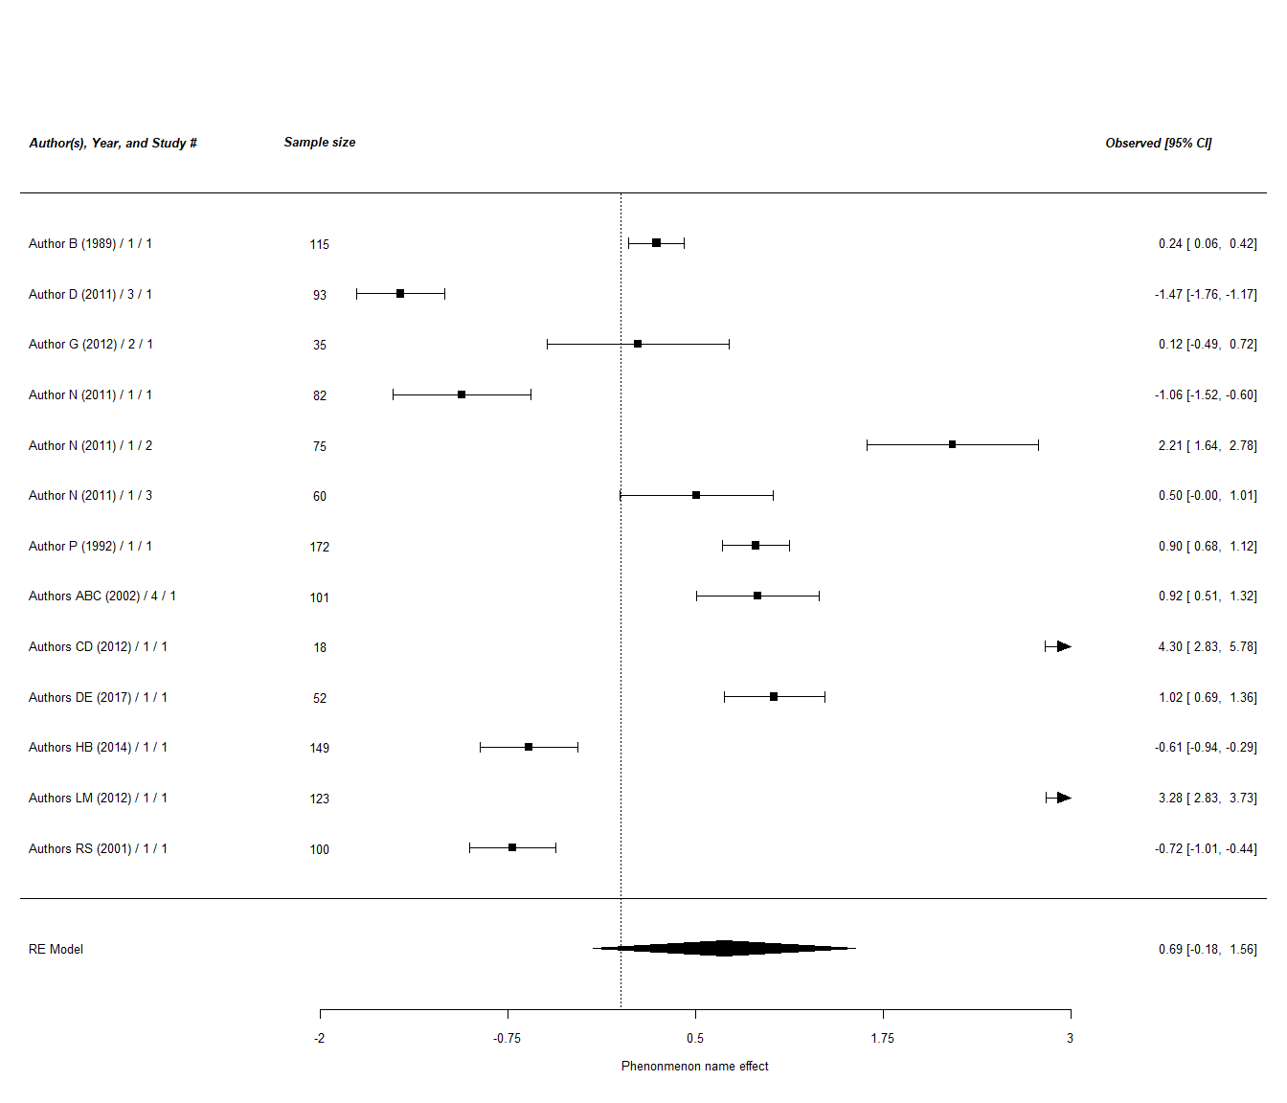

#### Possible Moderator 2 Category 3 studies

##   
## Random-Effects Model (k = 15; tau^2 estimator: REML)  
##   
## tau^2 (estimated amount of total heterogeneity): 2.4586 (SE = 0.9436)  
## tau (square root of estimated tau^2 value): 1.5680  
## I^2 (total heterogeneity / total variability): 99.02%  
## H^2 (total variability / sampling variability): 102.55  
##   
## Test for Heterogeneity:  
## Q(df = 14) = 1031.0920, p-val < .0001  
##   
## Model Results:  
##   
## estimate se zval pval ci.lb ci.ub   
## 0.0437 0.4080 0.1070 0.9148 -0.7560 0.8433   
##   
## ---  
## Signif. codes: 0 '***' 0.001 '**' 0.01 '*' 0.05 '.' 0.1 ' ' 1

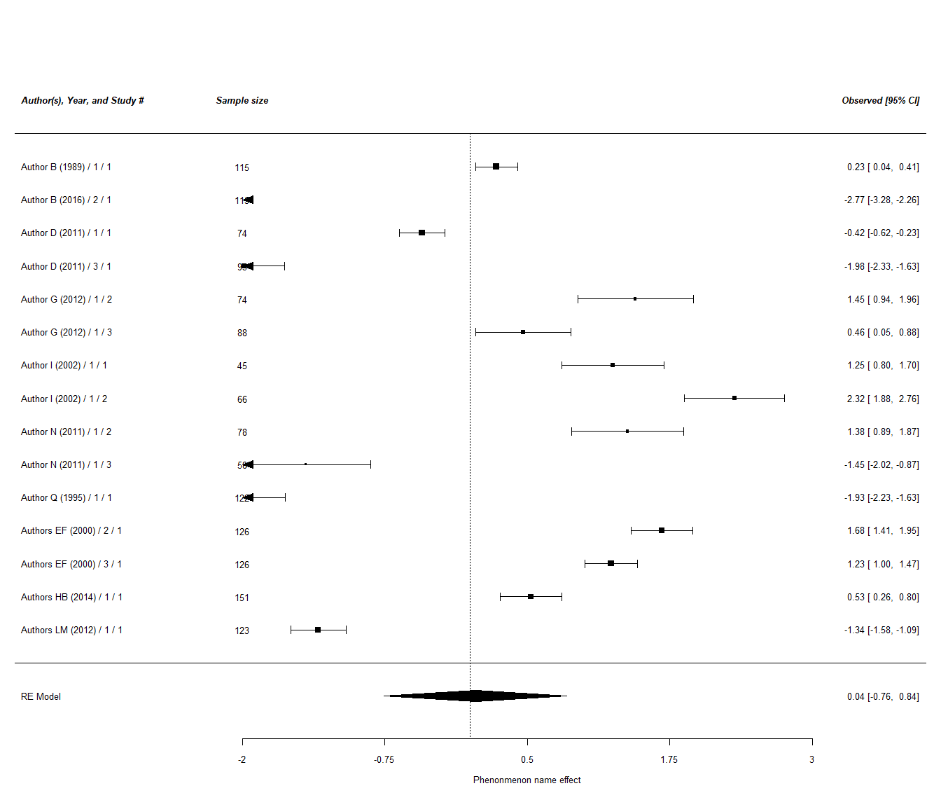

### Comparing Moderator 2 Categories 1 to 3 studies groups

[Insert Hypothesis, if there is - e.g. Phenomenon name under Category 1 condition is stronger than that under Category 2 condition and Category 3 condition] [Indicate whether the hypothesis is supported / not supported / partially supported - simulation: The hypothesis is not supported]

## estimate stderror numstudies meta tau2  
## 1 0.8392 0.366 11 1 - Category1 1.44  
## 2 0.6896 0.445 13 2 - Category2 2.50  
## 3 0.0437 0.408 15 3 - Category3 2.46

##   
## Fixed-Effects with Moderators Model (k = 3)  
##   
## I^2 (residual heterogeneity / unaccounted variability): 0.00%  
## H^2 (unaccounted variability / sampling variability): 1.00  
##   
## Test for Residual Heterogeneity:  
## QE(df = 0) = 0.000, p-val = 1.000  
##   
## Test of Moderators (coefficients 2:3):  
## QM(df = 2) = 2.261, p-val = 0.323  
##   
## Model Results:  
##   
## estimate se zval pval ci.lb ci.ub   
## intrcpt 0.839 0.366 2.292 0.022 0.122 1.557 *   
## factor(meta)2 - Category2 -0.150 0.577 -0.260 0.795 -1.280 0.980   
## factor(meta)3 - Category3 -0.796 0.548 -1.451 0.147 -1.870 0.279   
##   
## ---  
## Signif. codes: 0 '***' 0.001 '**' 0.01 '*' 0.05 '.' 0.1 ' ' 1

## estimate stderror numstudies meta tau2  
## 1 0.6896 0.445 13 2 - Category2 2.50  
## 2 0.0437 0.408 15 3 - Category3 2.46

##   
## Fixed-Effects with Moderators Model (k = 2)  
##   
## I^2 (residual heterogeneity / unaccounted variability): 0.00%  
## H^2 (unaccounted variability / sampling variability): 1.00  
##   
## Test for Residual Heterogeneity:  
## QE(df = 0) = 0.000, p-val = 1.000  
##   
## Test of Moderators (coefficient 2):  
## QM(df = 1) = 1.144, p-val = 0.285  
##   
## Model Results:  
##   
## estimate se zval pval ci.lb ci.ub   
## intrcpt 0.690 0.445 1.548 0.122 -0.183 1.563   
## factor(meta)3 - Category3 -0.646 0.604 -1.069 0.285 -1.830 0.538   
##   
## ---  
## Signif. codes: 0 '***' 0.001 '**' 0.01 '*' 0.05 '.' 0.1 ' ' 1

### Possible Moderator 3 moderator analyses

##   
## Mixed-Effects Model (k = 51; tau^2 estimator: REML)  
##   
## tau^2 (estimated amount of residual heterogeneity): 2.8033 (SE = 0.5823)  
## tau (square root of estimated tau^2 value): 1.6743  
## I^2 (residual heterogeneity / unaccounted variability): 99.06%  
## H^2 (unaccounted variability / sampling variability): 106.51  
## R^2 (amount of heterogeneity accounted for): 2.72%  
##   
## Test for Residual Heterogeneity:  
## QE(df = 48) = 2903.3919, p-val < .0001  
##   
## Test of Moderators (coefficients 2:3):  
## QM(df = 2) = 3.4552, p-val = 0.1777  
##   
## Model Results:  
##   
## estimate se zval pval ci.lb   
## intrcpt 0.6672 0.4245 1.5716 0.1160 -0.1649   
## Possible.Moderator.3Category2a -0.8900 0.5740 -1.5505 0.1210 -2.0151   
## Possible.Moderator.3Category2b 0.0354 0.5983 0.0592 0.9528 -1.1372   
## ci.ub   
## intrcpt 1.4992   
## Possible.Moderator.3Category2a 0.2351   
## Possible.Moderator.3Category2b 1.2081   
##   
## ---  
## Signif. codes: 0 '***' 0.001 '**' 0.01 '*' 0.05 '.' 0.1 ' ' 1

#### Possible Moderator 3 Category 1 studies

##   
## Random-Effects Model (k = 10; tau^2 estimator: REML)  
##   
## tau^2 (estimated amount of total heterogeneity): 2.4889 (SE = 1.2006)  
## tau (square root of estimated tau^2 value): 1.5776  
## I^2 (total heterogeneity / total variability): 98.83%  
## H^2 (total variability / sampling variability): 85.62  
##   
## Test for Heterogeneity:  
## Q(df = 9) = 492.8993, p-val < .0001  
##   
## Model Results:  
##   
## estimate se zval pval ci.lb ci.ub   
## 0.5123 0.5047 1.0151 0.3101 -0.4769 1.5016   
##   
## ---  
## Signif. codes: 0 '***' 0.001 '**' 0.01 '*' 0.05 '.' 0.1 ' ' 1

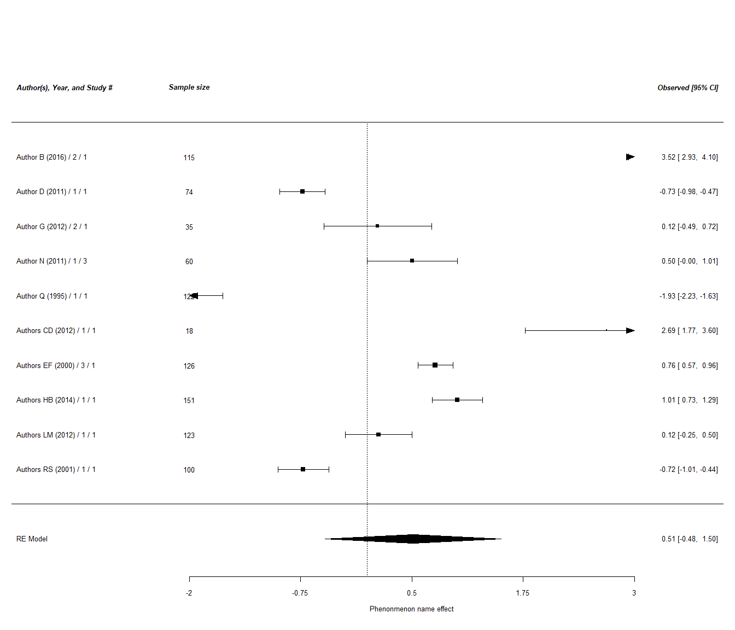

#### Possible Moderator 3 Category 2 studies

##   
## Random-Effects Model (k = 20; tau^2 estimator: REML)  
##   
## tau^2 (estimated amount of total heterogeneity): 1.4807 (SE = 0.4914)  
## tau (square root of estimated tau^2 value): 1.2168  
## I^2 (total heterogeneity / total variability): 98.64%  
## H^2 (total variability / sampling variability): 73.29  
##   
## Test for Heterogeneity:  
## Q(df = 19) = 866.9390, p-val < .0001  
##   
## Model Results:  
##   
## estimate se zval pval ci.lb ci.ub   
## 0.4707 0.2752 1.7105 0.0872 -0.0687 1.0101 .   
##   
## ---  
## Signif. codes: 0 '***' 0.001 '**' 0.01 '*' 0.05 '.' 0.1 ' ' 1

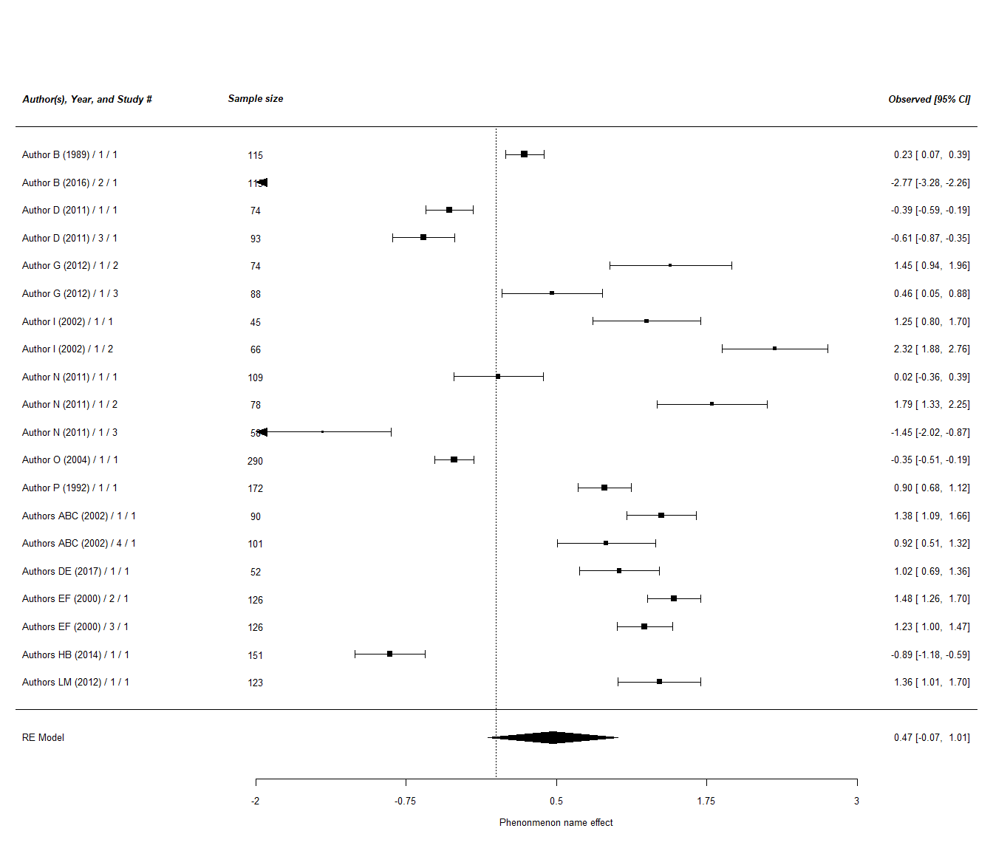

### Comparing Moderator 3 Categories 1 and 2 groups

[Insert Hypothesis, if there is - e.g. Phenomenon name under Category 1 condition is stronger than that under Category 2 condition] [Indicate whether the hypothesis is supported / not supported / partially supported - simulation: The hypothesis is not supported]

## estimate stderror numstudies meta tau2  
## 1 0.512 0.505 10 Category1 2.49  
## 2 0.471 0.275 20 Category2 1.48

##   
## Fixed-Effects with Moderators Model (k = 2)  
##   
## I^2 (residual heterogeneity / unaccounted variability): 0.00%  
## H^2 (unaccounted variability / sampling variability): 1.00  
##   
## Test for Residual Heterogeneity:  
## QE(df = 0) = 0.000, p-val = 1.000  
##   
## Test of Moderators (coefficient 2):  
## QM(df = 1) = 0.005, p-val = 0.942  
##   
## Model Results:  
##   
## estimate se zval pval ci.lb ci.ub   
## intrcpt 0.512 0.505 1.015 0.310 -0.477 1.502   
## factor(meta)Category2 -0.042 0.575 -0.072 0.942 -1.168 1.085   
##   
## ---  
## Signif. codes: 0 '***' 0.001 '**' 0.01 '*' 0.05 '.' 0.1 ' ' 1

### Published vs Unpublished moderator analyses

##   
## Mixed-Effects Model (k = 51; tau^2 estimator: REML)  
##   
## tau^2 (estimated amount of residual heterogeneity): 2.9207 (SE = 0.6001)  
## tau (square root of estimated tau^2 value): 1.7090  
## I^2 (residual heterogeneity / unaccounted variability): 99.11%  
## H^2 (unaccounted variability / sampling variability): 112.97  
## R^2 (amount of heterogeneity accounted for): 0.00%  
##   
## Test for Residual Heterogeneity:  
## QE(df = 49) = 3079.7209, p-val < .0001  
##   
## Test of Moderators (coefficient 2):  
## QM(df = 1) = 0.3624, p-val = 0.5472  
##   
## Model Results:  
##   
## estimate se zval pval ci.lb ci.ub   
## intrcpt 0.7853 0.7699 1.0200 0.3077 -0.7237 2.2943   
## PublishedYes -0.4881 0.8108 -0.6020 0.5472 -2.0772 1.1010   
##   
## ---  
## Signif. codes: 0 '***' 0.001 '**' 0.01 '*' 0.05 '.' 0.1 ' ' 1

#### Published studies

##   
## Random-Effects Model (k = 22; tau^2 estimator: REML)  
##   
## tau^2 (estimated amount of total heterogeneity): 1.1441 (SE = 0.3656)  
## tau (square root of estimated tau^2 value): 1.0696  
## I^2 (total heterogeneity / total variability): 98.23%  
## H^2 (total variability / sampling variability): 56.46  
##   
## Test for Heterogeneity:  
## Q(df = 21) = 893.4633, p-val < .0001  
##   
## Model Results:  
##   
## estimate se zval pval ci.lb ci.ub   
## 0.5103 0.2321 2.1984 0.0279 0.0553 0.9652 *   
##   
## ---  
## Signif. codes: 0 '***' 0.001 '**' 0.01 '*' 0.05 '.' 0.1 ' ' 1

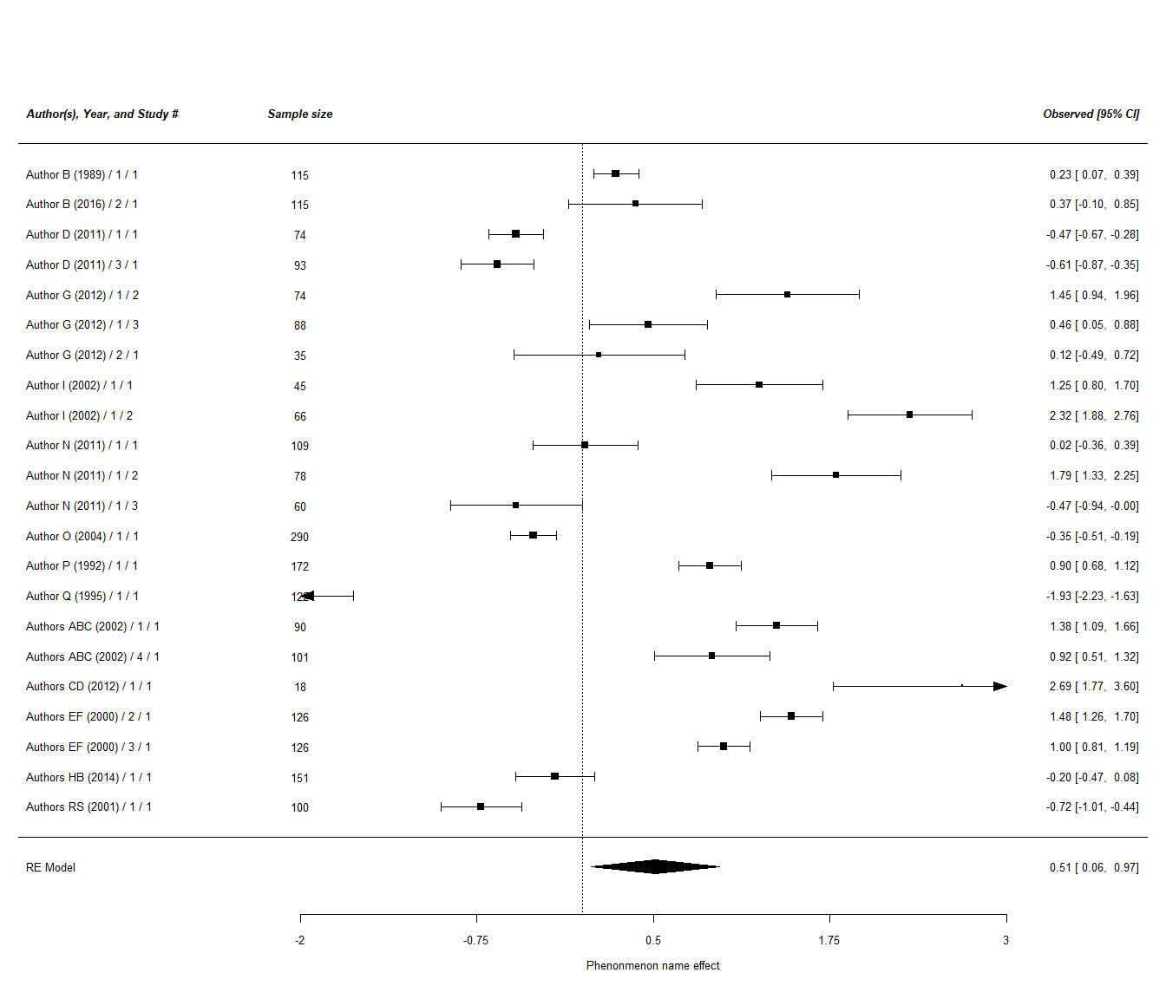

#### Unpublished studies

##   
## Random-Effects Model (k = 2; tau^2 estimator: REML)  
##   
## tau^2 (estimated amount of total heterogeneity): 0.0117 (SE = 0.0567)  
## tau (square root of estimated tau^2 value): 0.1080  
## I^2 (total heterogeneity / total variability): 29.12%  
## H^2 (total variability / sampling variability): 1.41  
##   
## Test for Heterogeneity:  
## Q(df = 1) = 1.4109, p-val = 0.2349  
##   
## Model Results:  
##   
## estimate se zval pval ci.lb ci.ub   
## 0.8796 0.1415 6.2148 <.0001 0.6022 1.1570 ***   
##   
## ---  
## Signif. codes: 0 '***' 0.001 '**' 0.01 '*' 0.05 '.' 0.1 ' ' 1

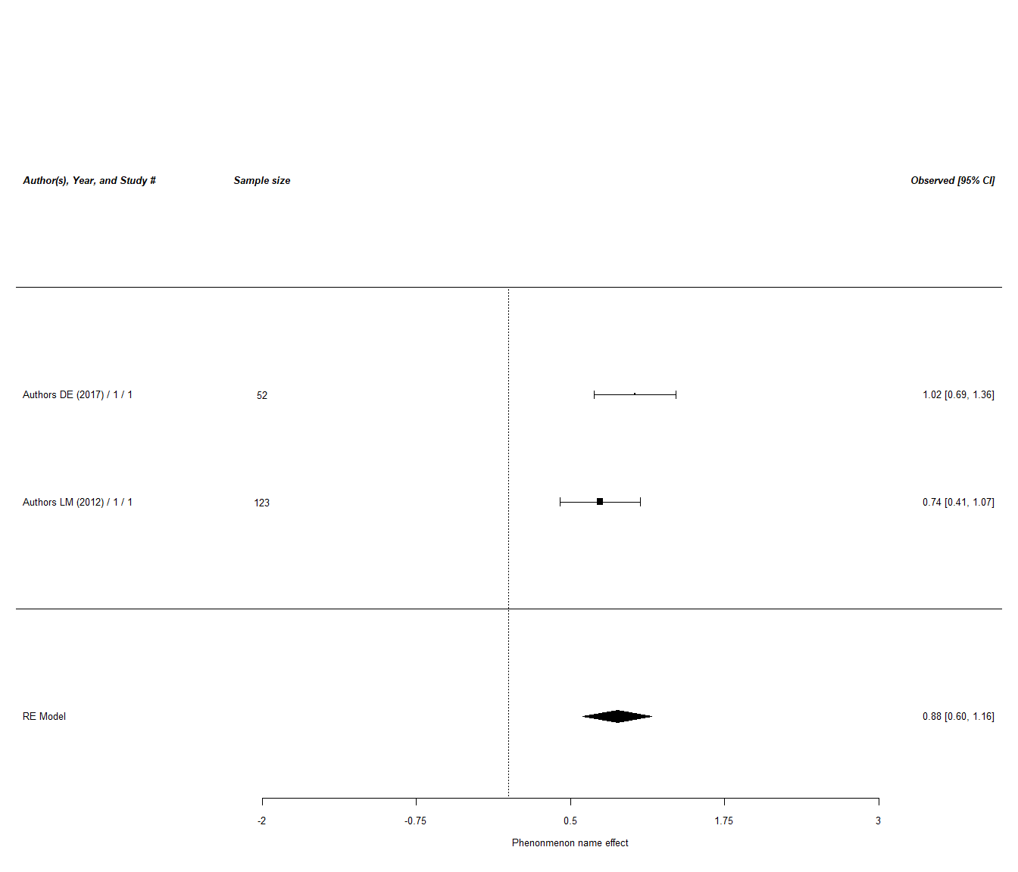

### Comparing published versus unpublised study groups

## estimate stderror numstudies meta tau2  
## 1 0.51 0.232 22 Published studies 1.1441  
## 2 0.88 0.142 2 Unpublished studies 0.0117

##   
## Fixed-Effects with Moderators Model (k = 2)  
##   
## I^2 (residual heterogeneity / unaccounted variability): 0.00%  
## H^2 (unaccounted variability / sampling variability): 1.00  
##   
## Test for Residual Heterogeneity:  
## QE(df = 0) = 0.000, p-val = 1.000  
##   
## Test of Moderators (coefficient 2):  
## QM(df = 1) = 1.845, p-val = 0.174  
##   
## Model Results:  
##   
## estimate se zval pval ci.lb ci.ub   
## intrcpt 0.510 0.232 2.198 0.028 0.055 0.965   
## factor(meta)Unpublished studies 0.369 0.272 1.358 0.174 -0.164 0.902   
##   
## intrcpt *   
## factor(meta)Unpublished studies   
##   
## ---  
## Signif. codes: 0 '***' 0.001 '**' 0.01 '*' 0.05 '.' 0.1 ' ' 1

### Possible Moderator 4 analyses

##   
## Mixed-Effects Model (k = 51; tau^2 estimator: REML)  
##   
## tau^2 (estimated amount of residual heterogeneity): 2.8360 (SE = 0.5829)  
## tau (square root of estimated tau^2 value): 1.6840  
## I^2 (residual heterogeneity / unaccounted variability): 99.08%  
## H^2 (unaccounted variability / sampling variability): 108.65  
## R^2 (amount of heterogeneity accounted for): 1.58%  
##   
## Test for Residual Heterogeneity:  
## QE(df = 49) = 3043.5722, p-val < .0001  
##   
## Test of Moderators (coefficient 2):  
## QM(df = 1) = 1.9148, p-val = 0.1664  
##   
## Model Results:  
##   
## estimate se zval pval ci.lb   
## intrcpt 0.7090 0.3547 1.9987 0.0456 0.0137   
## Possible.Moderator.4Category2 -0.6617 0.4782 -1.3837 0.1664 -1.5990   
## ci.ub   
## intrcpt 1.4043 *   
## Possible.Moderator.4Category2 0.2755   
##   
## ---  
## Signif. codes: 0 '***' 0.001 '**' 0.01 '*' 0.05 '.' 0.1 ' ' 1

#### Possible Moderator 4 Category 1 studies

##   
## Random-Effects Model (k = 14; tau^2 estimator: REML)  
##   
## tau^2 (estimated amount of total heterogeneity): 1.8421 (SE = 0.7406)  
## tau (square root of estimated tau^2 value): 1.3572  
## I^2 (total heterogeneity / total variability): 98.95%  
## H^2 (total variability / sampling variability): 95.24  
##   
## Test for Heterogeneity:  
## Q(df = 13) = 583.1206, p-val < .0001  
##   
## Model Results:  
##   
## estimate se zval pval ci.lb ci.ub   
## 0.7227 0.3673 1.9677 0.0491 0.0028 1.4426 *   
##   
## ---  
## Signif. codes: 0 '***' 0.001 '**' 0.01 '*' 0.05 '.' 0.1 ' ' 1

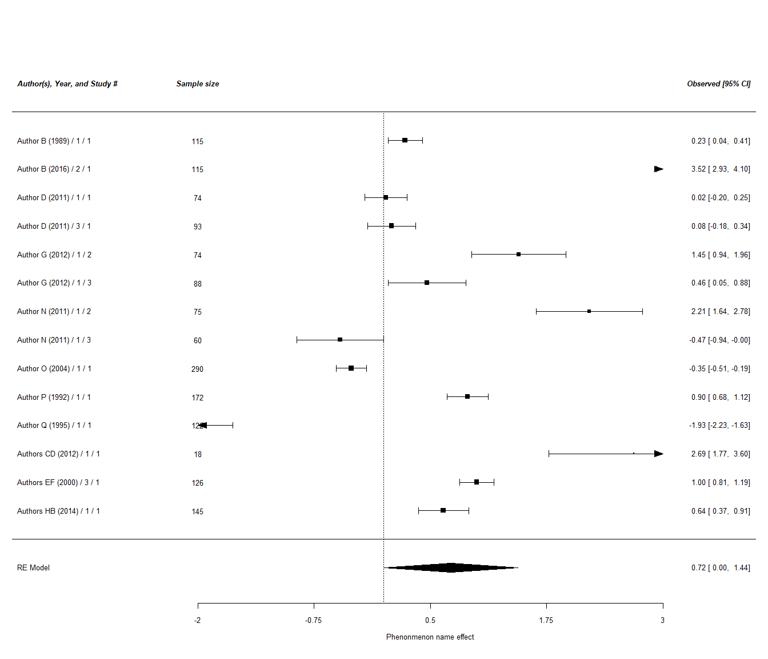

#### Possible Moderator 4 Category 2 studies

##   
## Random-Effects Model (k = 16; tau^2 estimator: REML)  
##   
## tau^2 (estimated amount of total heterogeneity): 1.8544 (SE = 0.6906)  
## tau (square root of estimated tau^2 value): 1.3618  
## I^2 (total heterogeneity / total variability): 98.65%  
## H^2 (total variability / sampling variability): 74.01  
##   
## Test for Heterogeneity:  
## Q(df = 15) = 837.4574, p-val < .0001  
##   
## Model Results:  
##   
## estimate se zval pval ci.lb ci.ub   
## 0.2216 0.3438 0.6446 0.5192 -0.4523 0.8955   
##   
## ---  
## Signif. codes: 0 '***' 0.001 '**' 0.01 '*' 0.05 '.' 0.1 ' ' 1

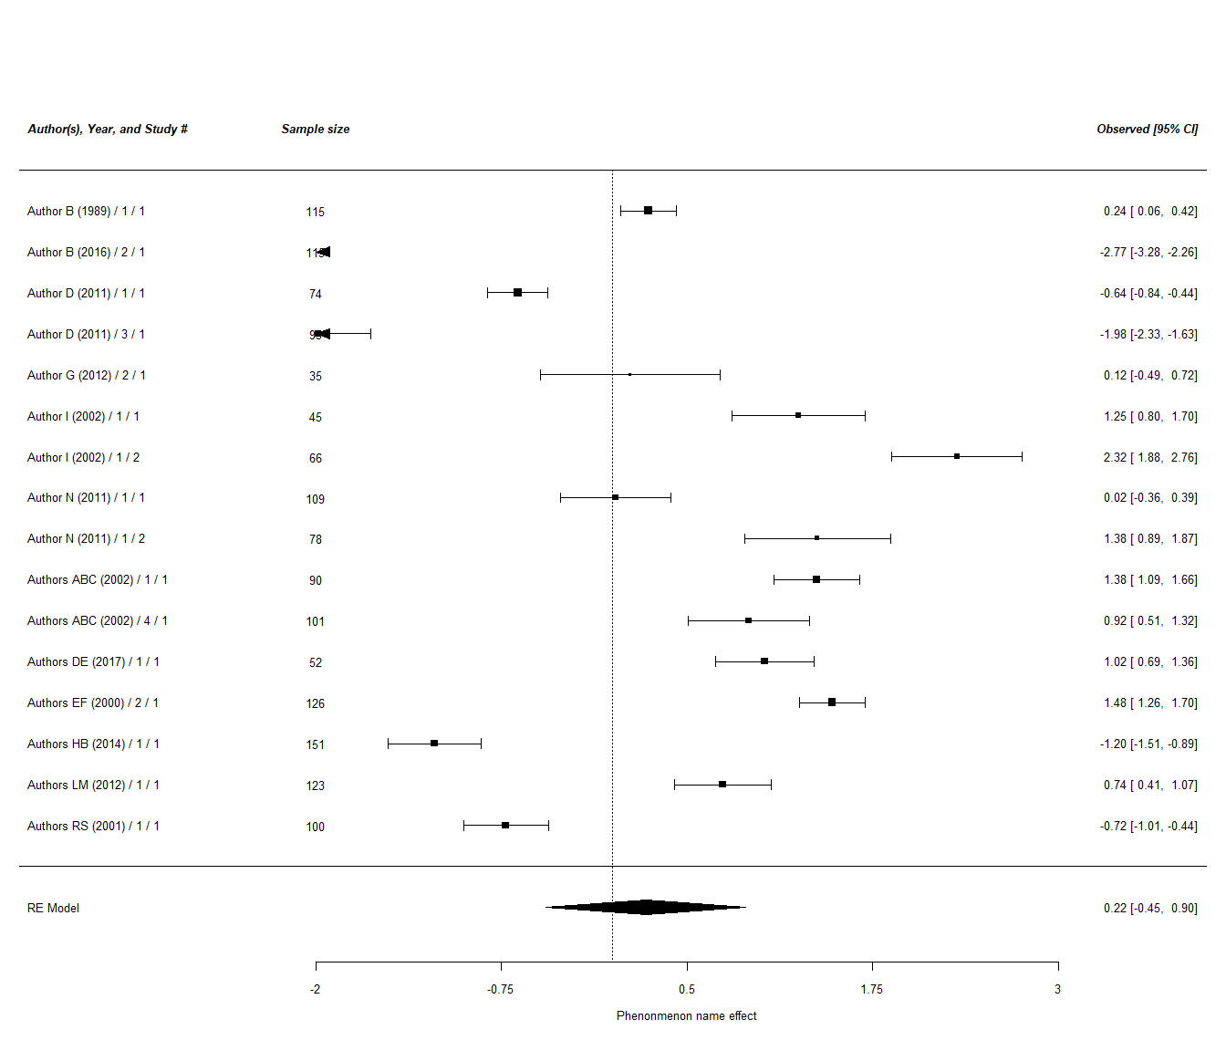

### Comparing Possible Moderator 4 Categories 1 and 2 designs

[Insert Hypothesis, if there is - e.g. Competing hypotheses: Phenomenon name under Category 1 condition is stronger than that under Category 2 condition / It is expected that there is no meaningful difference in effect of Phenomenon name under Category 1 condition vs Category 2 condition] [Indicate whether the hypotheses are supported / not supported / partially supported - simulation: The second no-meaningful-difference hypothesis is supported whereas the first meaningful-difference hypothesis is not supported]

## estimate stderror numstudies meta tau2  
## 1 0.723 0.367 14 1 - Category1 1.84  
## 2 0.222 0.344 16 2 - Category2 1.85

##   
## Fixed-Effects with Moderators Model (k = 2)  
##   
## I^2 (residual heterogeneity / unaccounted variability): 0.00%  
## H^2 (unaccounted variability / sampling variability): 1.00  
##   
## Test for Residual Heterogeneity:  
## QE(df = 0) = 0.000, p-val = 1.000  
##   
## Test of Moderators (coefficient 2):  
## QM(df = 1) = 0.992, p-val = 0.319  
##   
## Model Results:  
##   
## estimate se zval pval ci.lb ci.ub   
## intrcpt 0.723 0.367 1.968 0.049 0.003 1.443 *   
## factor(meta)2 - Category2 -0.501 0.503 -0.996 0.319 -1.487 0.485   
##   
## ---  
## Signif. codes: 0 '***' 0.001 '**' 0.01 '*' 0.05 '.' 0.1 ' ' 1

## estimate stderror numstudies meta tau2  
## 1 0.723 0.367 14 Category1 1.84  
## 2 0.222 0.344 16 Category2 1.85

##   
## Fixed-Effects with Moderators Model (k = 2)  
##   
## I^2 (residual heterogeneity / unaccounted variability): 0.00%  
## H^2 (unaccounted variability / sampling variability): 1.00  
##   
## Test for Residual Heterogeneity:  
## QE(df = 0) = 0.000, p-val = 1.000  
##   
## Test of Moderators (coefficient 2):  
## QM(df = 1) = 0.992, p-val = 0.319  
##   
## Model Results:  
##   
## estimate se zval pval ci.lb ci.ub   
## intrcpt 0.723 0.367 1.968 0.049 0.003 1.443 *   
## factor(meta)Category2 -0.501 0.503 -0.996 0.319 -1.487 0.485   
##   
## ---  
## Signif. codes: 0 '***' 0.001 '**' 0.01 '*' 0.05 '.' 0.1 ' ' 1

### Study design analyses

##   
## Mixed-Effects Model (k = 51; tau^2 estimator: REML)  
##   
## tau^2 (estimated amount of residual heterogeneity): 2.9207 (SE = 0.6001)  
## tau (square root of estimated tau^2 value): 1.7090  
## I^2 (residual heterogeneity / unaccounted variability): 99.11%  
## H^2 (unaccounted variability / sampling variability): 112.97  
## R^2 (amount of heterogeneity accounted for): 0.00%  
##   
## Test for Residual Heterogeneity:  
## QE(df = 49) = 3079.7209, p-val < .0001  
##   
## Test of Moderators (coefficient 2):  
## QM(df = 1) = 0.3624, p-val = 0.5472  
##   
## Model Results:  
##   
## estimate se zval pval ci.lb ci.ub   
## intrcpt 0.7853 0.7699 1.0200 0.3077 -0.7237 2.2943   
## PublishedYes -0.4881 0.8108 -0.6020 0.5472 -2.0772 1.1010   
##   
## ---  
## Signif. codes: 0 '***' 0.001 '**' 0.01 '*' 0.05 '.' 0.1 ' ' 1

#### Between subject studies

##   
## Random-Effects Model (k = 9; tau^2 estimator: REML)  
##   
## tau^2 (estimated amount of total heterogeneity): 0.5176 (SE = 0.2849)  
## tau (square root of estimated tau^2 value): 0.7194  
## I^2 (total heterogeneity / total variability): 91.81%  
## H^2 (total variability / sampling variability): 12.22  
##   
## Test for Heterogeneity:  
## Q(df = 8) = 93.9193, p-val < .0001  
##   
## Model Results:  
##   
## estimate se zval pval ci.lb ci.ub   
## 0.4909 0.2517 1.9506 0.0511 -0.0023 0.9841 .   
##   
## ---  
## Signif. codes: 0 '***' 0.001 '**' 0.01 '*' 0.05 '.' 0.1 ' ' 1

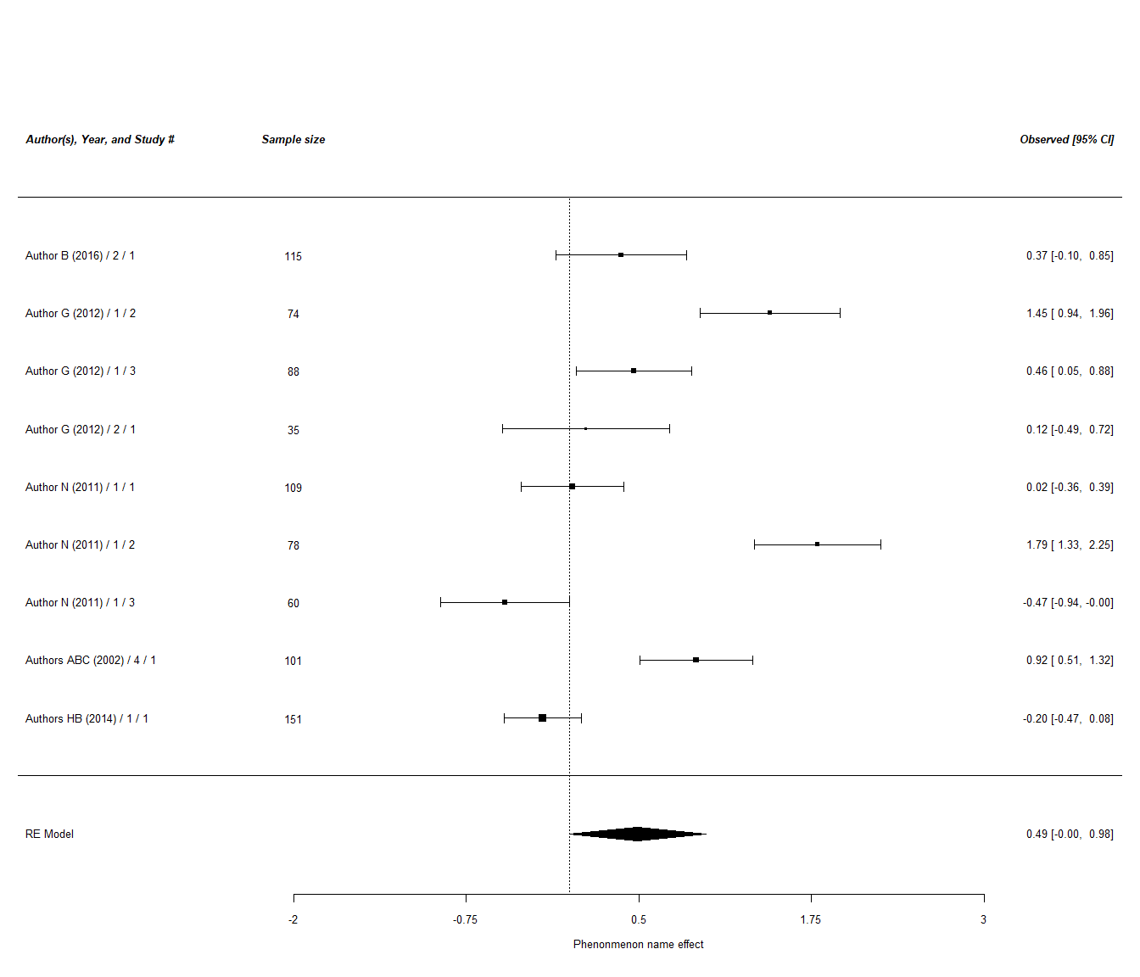

#### Within subject studies

##   
## Random-Effects Model (k = 15; tau^2 estimator: REML)  
##   
## tau^2 (estimated amount of total heterogeneity): 1.4371 (SE = 0.5554)  
## tau (square root of estimated tau^2 value): 1.1988  
## I^2 (total heterogeneity / total variability): 98.90%  
## H^2 (total variability / sampling variability): 91.24  
##   
## Test for Heterogeneity:  
## Q(df = 14) = 823.9003, p-val < .0001  
##   
## Model Results:  
##   
## estimate se zval pval ci.lb ci.ub   
## 0.5745 0.3131 1.8350 0.0665 -0.0391 1.1881 .   
##   
## ---  
## Signif. codes: 0 '***' 0.001 '**' 0.01 '*' 0.05 '.' 0.1 ' ' 1

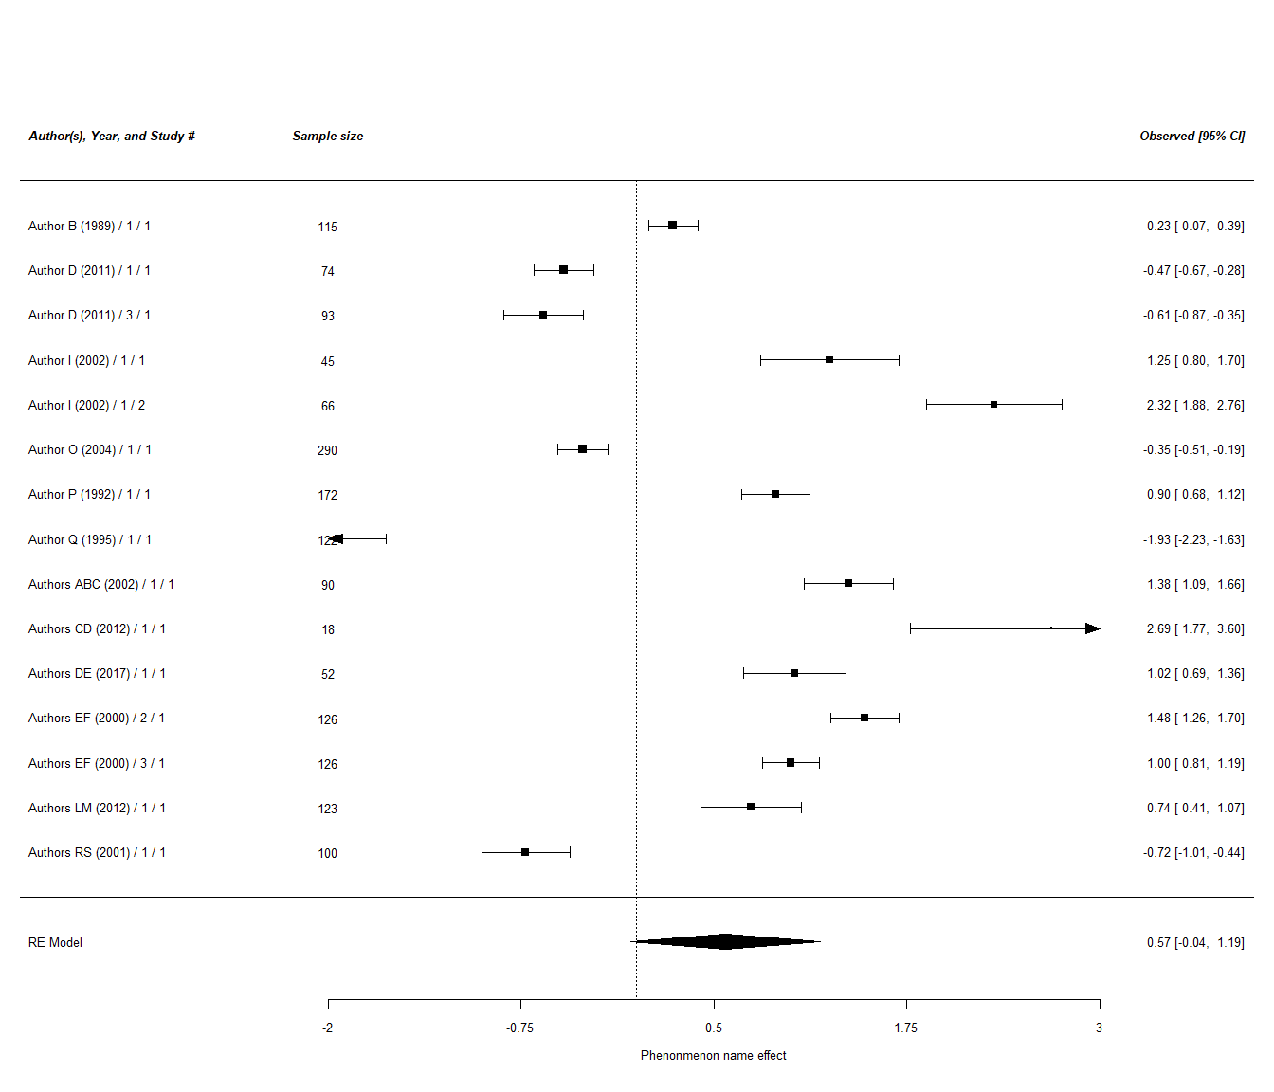

### Comparing within to between designs

[Insert hypothesis, if there is, e.g. It is expected that Phenomenon name is stronger for within-subject designs compared to between-subject designs.] [Indicate whether the hypothesis is supported / not supported / partially supported]

## estimate stderror numstudies meta tau2  
## 1 0.491 0.252 9 Between studies 0.518  
## 2 0.574 0.313 15 Within studies 1.437

##   
## Fixed-Effects with Moderators Model (k = 2)  
##   
## I^2 (residual heterogeneity / unaccounted variability): 0.00%  
## H^2 (unaccounted variability / sampling variability): 1.00  
##   
## Test for Residual Heterogeneity:  
## QE(df = 0) = 0.000, p-val = 1.000  
##   
## Test of Moderators (coefficient 2):  
## QM(df = 1) = 0.043, p-val = 0.835  
##   
## Model Results:  
##   
## estimate se zval pval ci.lb ci.ub   
## intrcpt 0.491 0.252 1.951 0.051 -0.002 0.984 .   
## factor(meta)Within studies 0.084 0.402 0.208 0.835 -0.704 0.871   
##   
## ---  
## Signif. codes: 0 '***' 0.001 '**' 0.01 '*' 0.05 '.' 0.1 ' ' 1

# write.csv(dataset, “Experimental-Studies-Meta-Analysis-Excel-Template-V3W-outfile.csv”)

```