2. Creating a class for the whole application

Here we create a class that represents the whole application, so that we can execute the application only by creating an instance of that main class.

- Abstract out the class in a diagram to remember what you
- Create a class called MainApp in vscode. Remember to use ALT+X so that the header files with the proper #includes are created automatically
- Build the header file
- The header file will have the specification.
- We make all the methods public.
- Start by writing the specification for the constructor, which has the same name as the class
- Copy the methods to the header file then strip out the implementation.
- When stripping out the implementation you also remove the {} .
- Remember to include the argument of the functions in the specification
- In the implementation file, implement the bodies of these functions
- Remember to prefix them all with the name of the class because they belong to the class nameSpace
- Copy all the functions from the initial file
- Prefix all the methods with the name of the class
- Add an init method to the class. With an empty implementation. We will use it later as an entry point to the class. We can also use the constructor as an entry point to the class, so I am not sure what init() is used for but, we shall see. We do this because if we call the constructor, it will start the whole program. We want, instead, to call methods individually. So, we create an instance of the app, and from it we call each method individually. Then we have a separate init method that we will use to run the whole app.
- Include the header file
- In the main file, import the header. Create an instance of the main app. Remember to use the {} (or () ) because there is a constructor, even if there are not arguments yet passed to the class
- Now in main.cpp, delete all the code inside the int main(). You see that we can now make the main file super lean . Create an instance of the app, and call the printMenu() function only
- Observe how the code is beautiful. The main app is lean The header file contains the specifications so from it you can have a bird eye’s view of what the app can do. And in the implementation file you have messy the details of the implementations.

- To run the file remeber to link main.cpp to the two classes that you have now: The orderBookEntry class

So here is the code

#include <iostream>
#include <string>
#include <vector>
#include "OrderBookEntry.h"
#include "ExchangeApp.h"

int main () {
ExchangeApp app{};
app.printMenu();
}

/*
std::vector<OrderBookEntry> orders;

orders.push_back(OrderBookEntry {5319.450228,
0.00020075,
"2020/03/17 17:01:24.884492",
"BTC/USDT",
OrderBookType::bid}
);

orders.push_back(OrderBookEntry {1000,
2,
"2020/03/17 17:01:24.884492",
"USDJPY",
OrderBookType::ask}
);

// Iterator by reference
for (OrderBookEntry& order: orders)
{
std::cout << "The price of " << order.product << " is " << order.price << std::endl;
}

return 0;

}
*/

// to generate a named binary
// g++ g++ exhangeApp.cpp OrderBookEntry.cpp
// .a/out

/*
void printMenu()
{
// 1 print help
std::cout << "1: Print Help" << std::endl;
// 2 print exchange stats
std::cout << "2: Print exchange stats" << std::endl;
// 3 make an offer
std::cout << "3: Make an offer" << std::endl;
// 4 make a bid = buy; offer = sell
std::cout << "4: Make a bid" << std::endl;
// 5 print wallet
std::cout << "5: Print a wallet" << std::endl;
// 6 continue
std::cout << "5: Continue" << std::endl;
}

int getUser()
{
std::cout << "================" << std::endl;
std::cout << "Type in 1-6" << std::endl;
int userOption;
std::cin >> userOption;
std::cout << "You chose: " << userOption << std::endl;
return userOption;

}

void printHelp()
{
std::cout << "Your aim is to make money, analyze the market" <<std::endl;
}

void printMarketStats()
{
std::cout << "Market looks good" <<std::endl;
}

void enterOffer()
{
std::cout << "make an offer - enter the amount" <<std::endl;
}

void enterBid()
{
std::cout << "make a bid - enter the amount" <<std::endl;
}

void printWallet()
{
std::cout << "Your wallet is empty" <<std::endl;
}

void gotoNextTimeframe()
{
std::cout << "Going to next time frame" <<std::endl;
}

void processUserOption(int userOption)
{
if (userOption == 0)
{
std::cout << "Invalid Choice. Choose 1-6" <<std::endl;
}
if (userOption == 1)
{
printHelp();
}
if (userOption == 2)
{
printMarketStats();
}
if (userOption == 3)
{
enterOffer();
}
if (userOption == 4)
{
enterBid() ;
}
if (userOption == 5)
{
printWallet();
}
if (userOption == 6)
{
gotoNextTimeframe();
}
}

*/

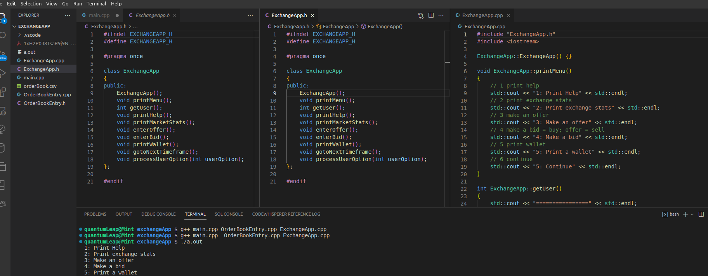
Implement the init function
We have both a constructor and an init function. The logic is
- Constructor: = CREATION is to create an instance of the object and make sure it is ready to be used
- init() = DOING STUFF is to start the object running, which is a separate concern
Here are the steps
- Create the specification for the init function in the header file. In the line before defining the function, add an official documentation comment using /** */. The init() function returns void
- Create the implementation for the init function in the implementation file . Remember here that we launched the app as follows
int main () {

while (true) {
printMenu();
int userOption = getUser();
processUserOption(userOption);
}
return 0;

Here is the code
file:///home/quantumleap/Documents/git/uol/course/3_Level5S2/oop/code/exchangeApp/main.cpp

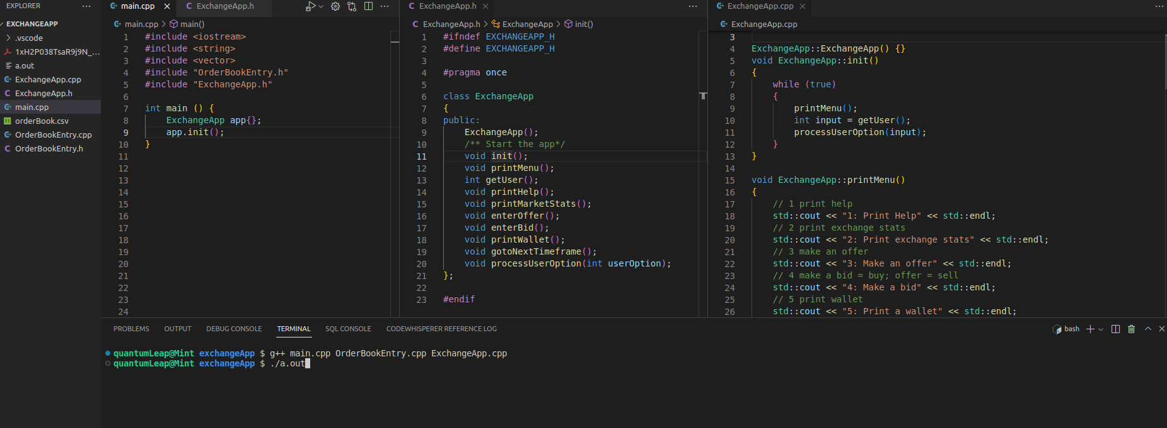

Limiting exposure

