Notes

Background text based simulation

He presents example of text based software
He has a midi hardware and he clickson buttons on that hardware which changes how he is presented in the screen

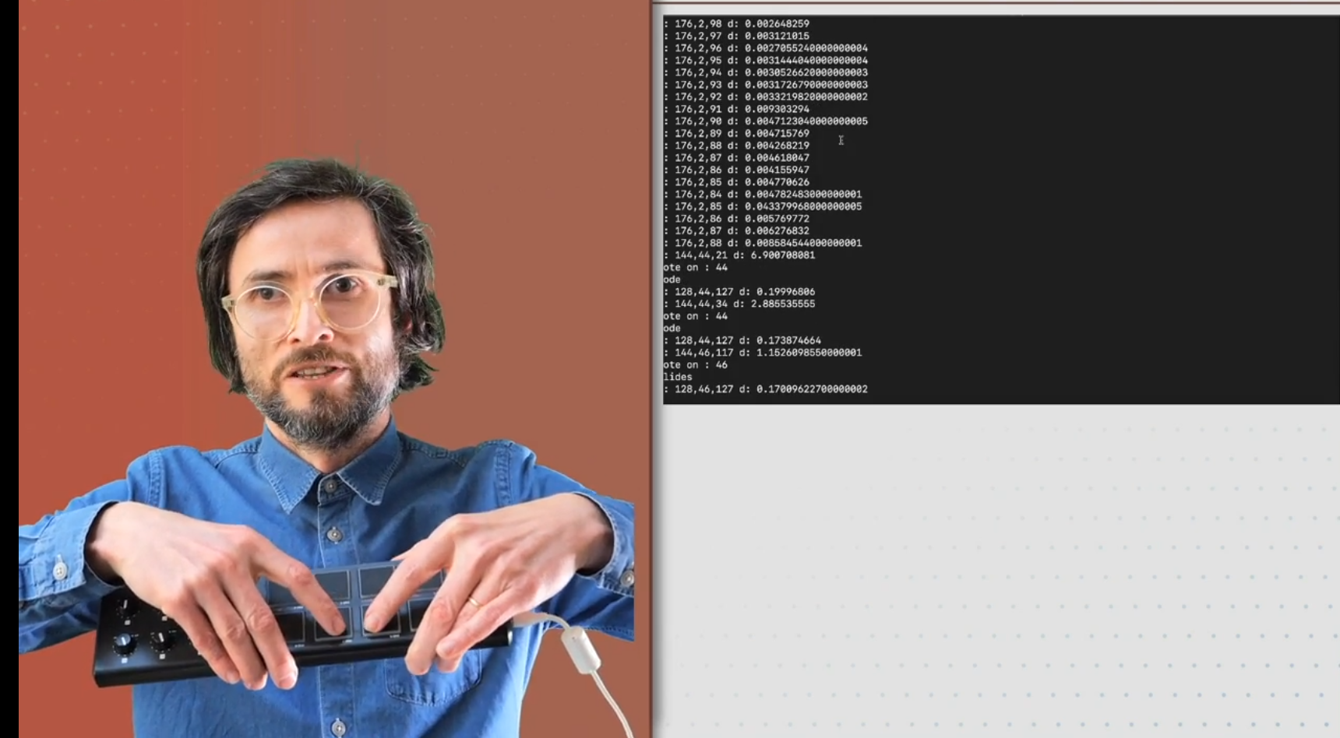
Others: tree, ssh, ie any command line programs

When to refactor
You know that your code is not modular enough if it has too many indentations ie too many for loops. So whatever you are doing inside that for loop that should be a separate module
Even if you are using a function once that is fine because you are really ;making it clear what you are doing

We will refactor the code into three functions
- Printing the menu
- receiving input from the user
- process the input from the user

print menu and process option

TODO inside main write a printMenu() function, then run. It should return void
TODO create a getUser() function that contains the code for taking user input. It should return the int userOption. Call it so that it prodces the userOption variable in main
TODO create a processUserOption() function that receives an input userOption and it returns nothing
At the end your main function should look like this which is much better

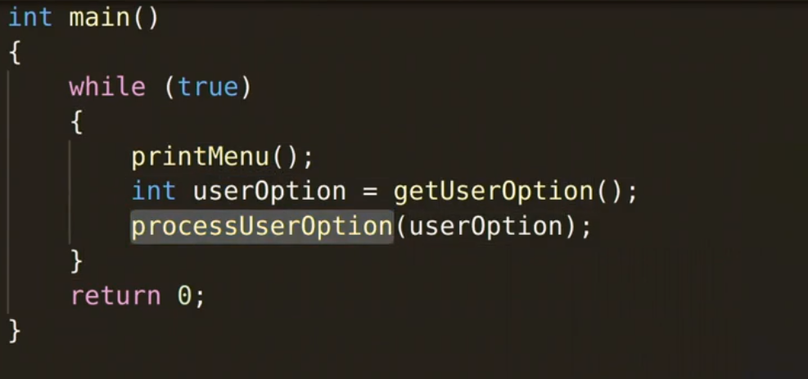
Attention the function definitions must be above the main() function otherwise it will not work
Answer: Here is the refactord code. Note that
- the functions should be defined outside of main(). Since their scope is global they can be called inside the main() function
- in C++ the opening bracket should be in a new line
- The only slightly tricky part is the getUser() function. There are two fifferent yuserOption variables one defined locally inside the getUser() FUNCTION and one defined inside main() as the returned variable from getUser(). Those are two separate variables they could be named differently.

The code

#include <iostream>

void printMenu()
{
// 1 print help
std::cout << "1: Print Help" << std::endl;
// 2 print exchange stats
std::cout << "2: Print exchange stats" << std::endl;
// 3 make an offer
std::cout << "3: Make an offer" << std::endl;
// 4 make a bid = buy; offer = sell
std::cout << "4: Make a bid" << std::endl;
// 5 print wallet
std::cout << "5: Print a wallet" << std::endl;
// 6 continue
std::cout << "5: Continue" << std::endl;
}

int getUser()
{
std::cout << "================" << std::endl;
std::cout << "Type in 1-6" << std::endl;
int userOption;
std::cin >> userOption;
std::cout << "You chose: " << userOption << std::endl;
return userOption;

}

void processUserOption(int userOption)
{
if (userOption == 0)
{
std::cout << "Invalid Choice. Choose 1-6" <<std::endl;
}
if (userOption == 1)
{
std::cout << "Your aim is to make money, analyze the market" <<std::endl;
}
if (userOption == 2)
{
std::cout << "Market looks good" <<std::endl;
}
if (userOption == 3)
{
std::cout << "make an offer - enter the amount" <<std::endl;
}
if (userOption == 4)
{
std::cout << "make a bid - enter the amount" <<std::endl;
}
if (userOption == 5)
{
std::cout << "Your wallet is empty" <<std::endl;
}
if (userOption == 6)
{
std::cout << "Going to next time frame" <<std::endl;
}
}

int main () {

while (true) {
printMenu();
int userOption = getUser();
processUserOption(userOption);
}
return 0;

}
// to generate a named binary
// g++ listOfOptions.cpp -o merklerex
// .merkelrex

