Machine Learning: Assignment #3

Fall 2017

1. Neural Networks

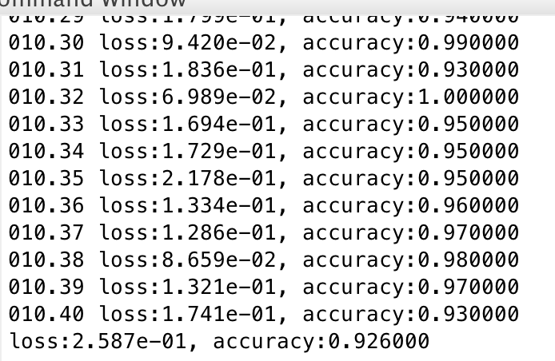

2. K-Nearest Neighbor

(a)

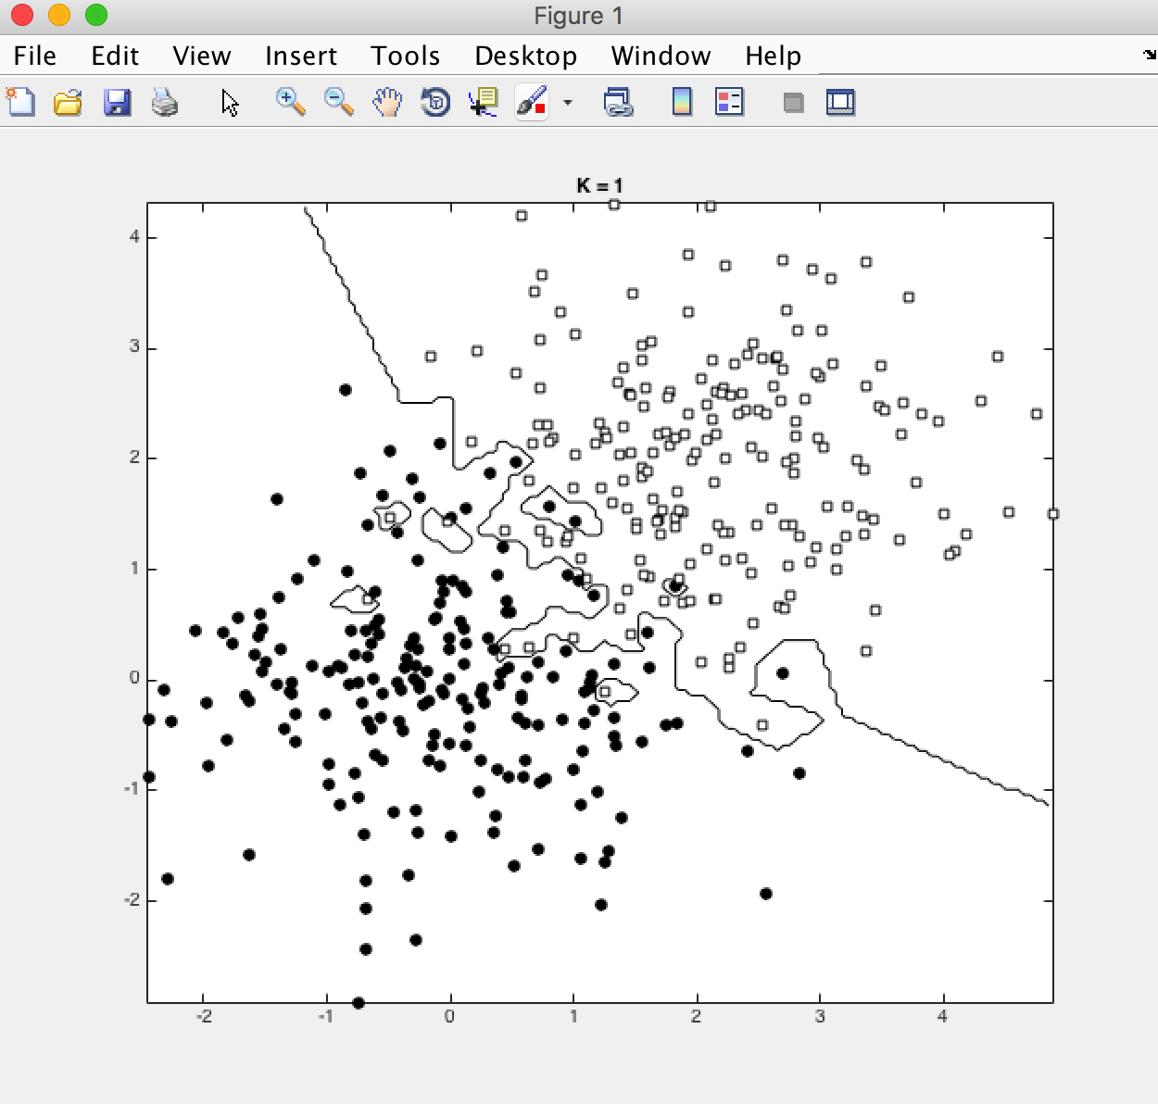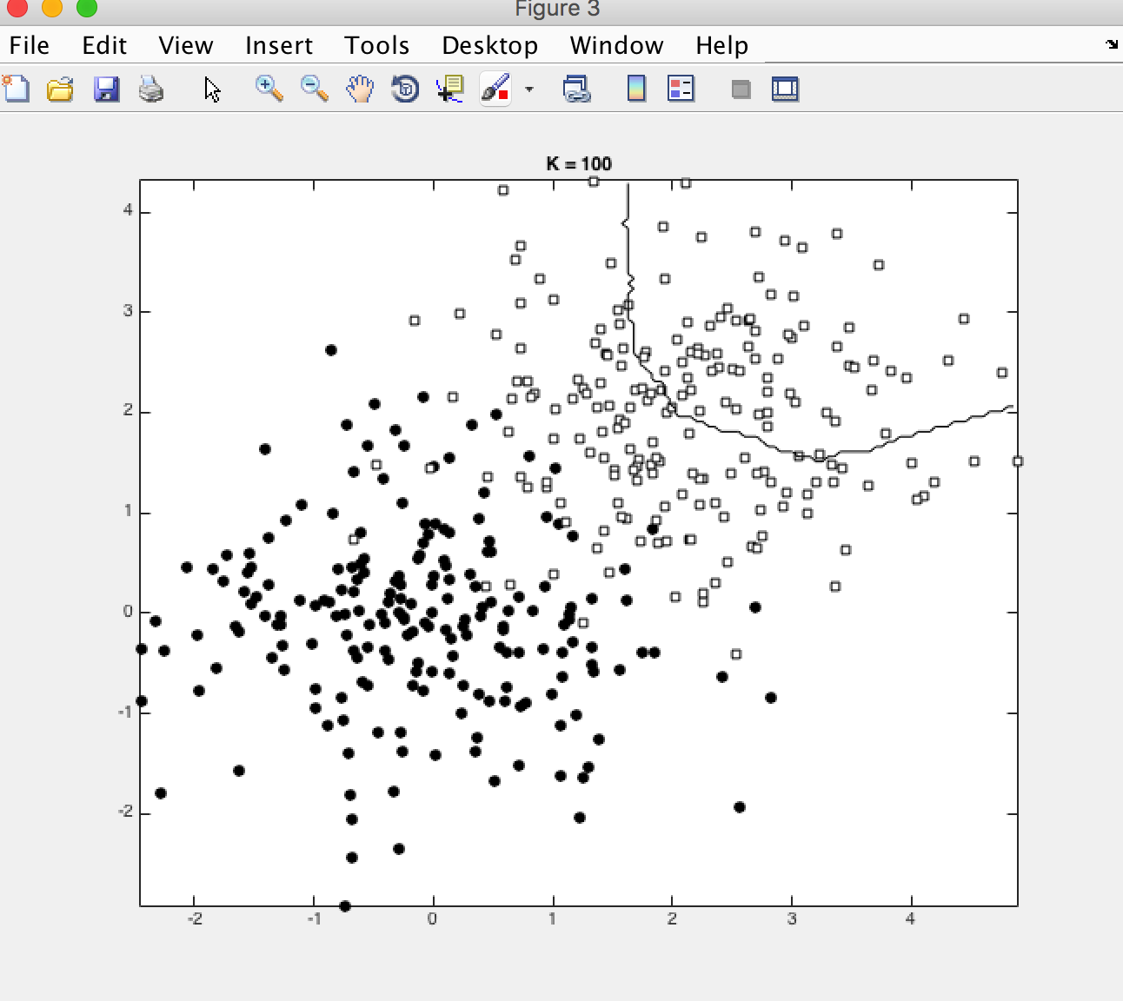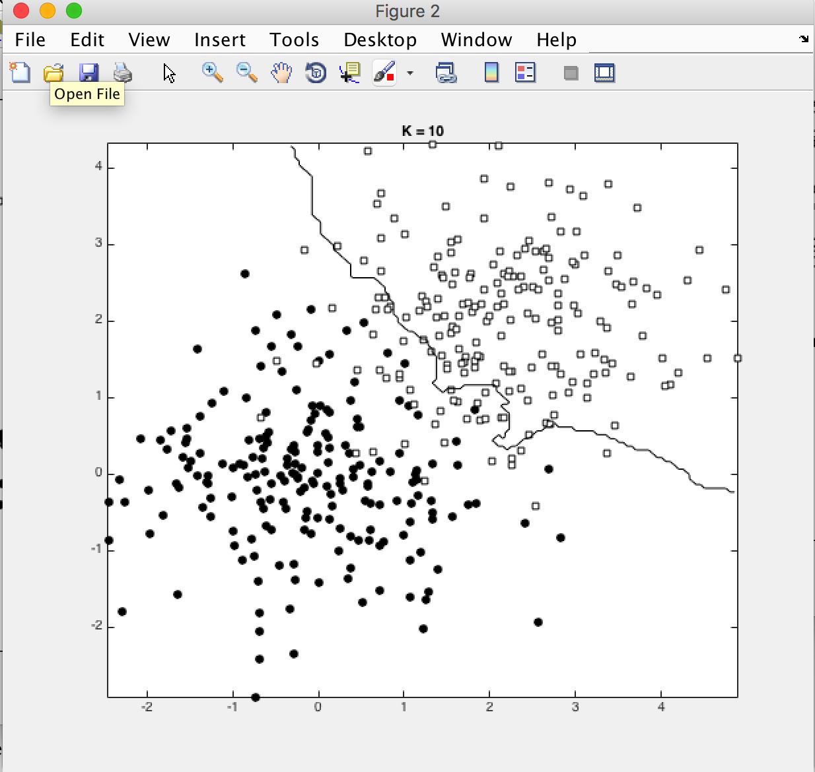

b)

Q: How can you choose a proper K when dealing with real-world data

A: Cross Validation

c)

Example: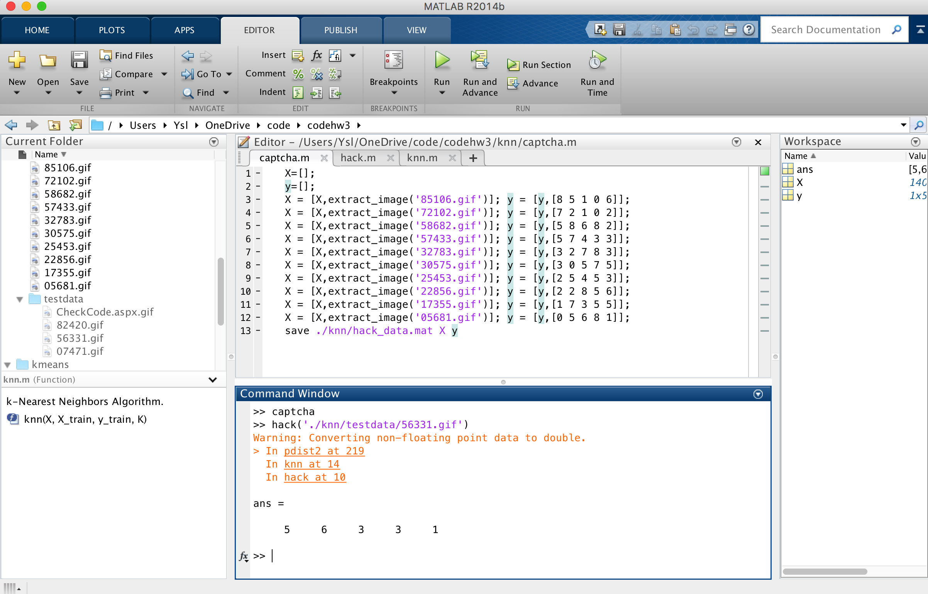

3.Decision Tree and ID3

High

Low

M

M

F

F

-

+

-

+

4.K-Means Clustering

a)

Smallest SD

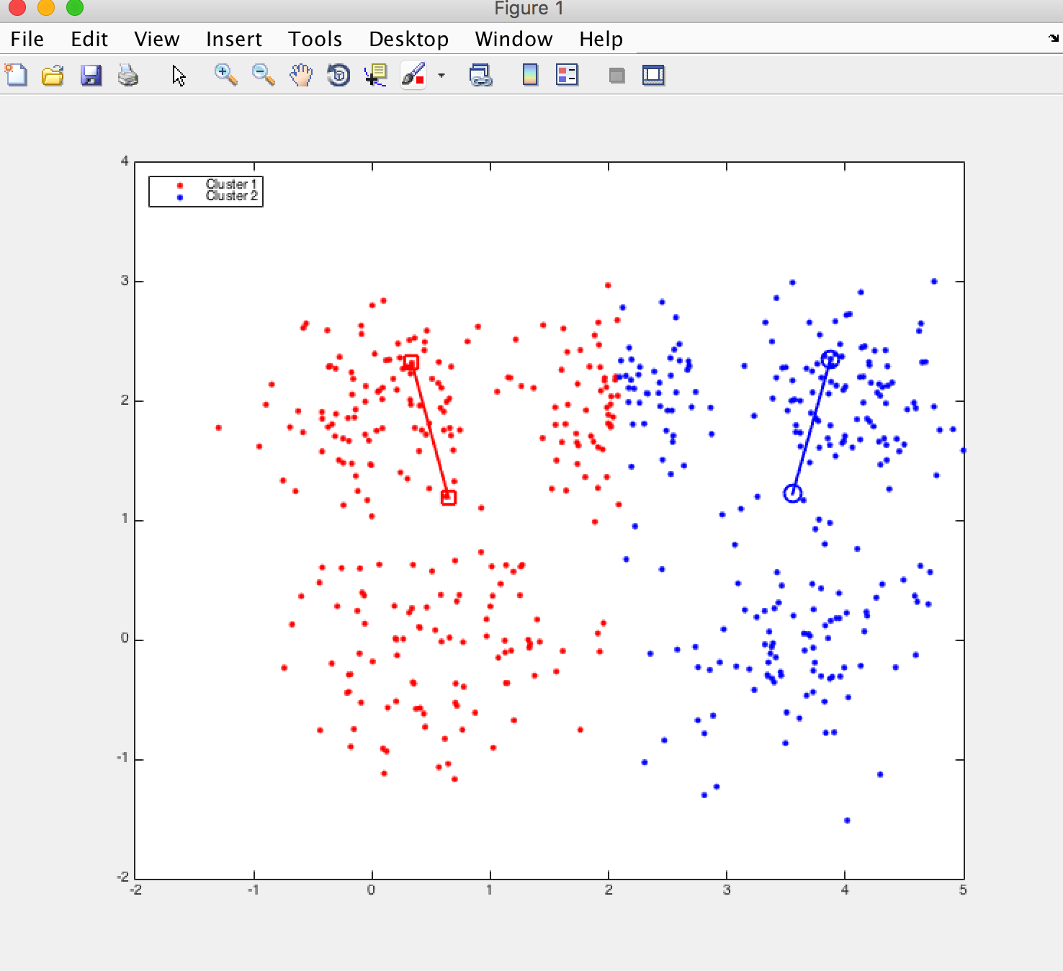

Largest SD

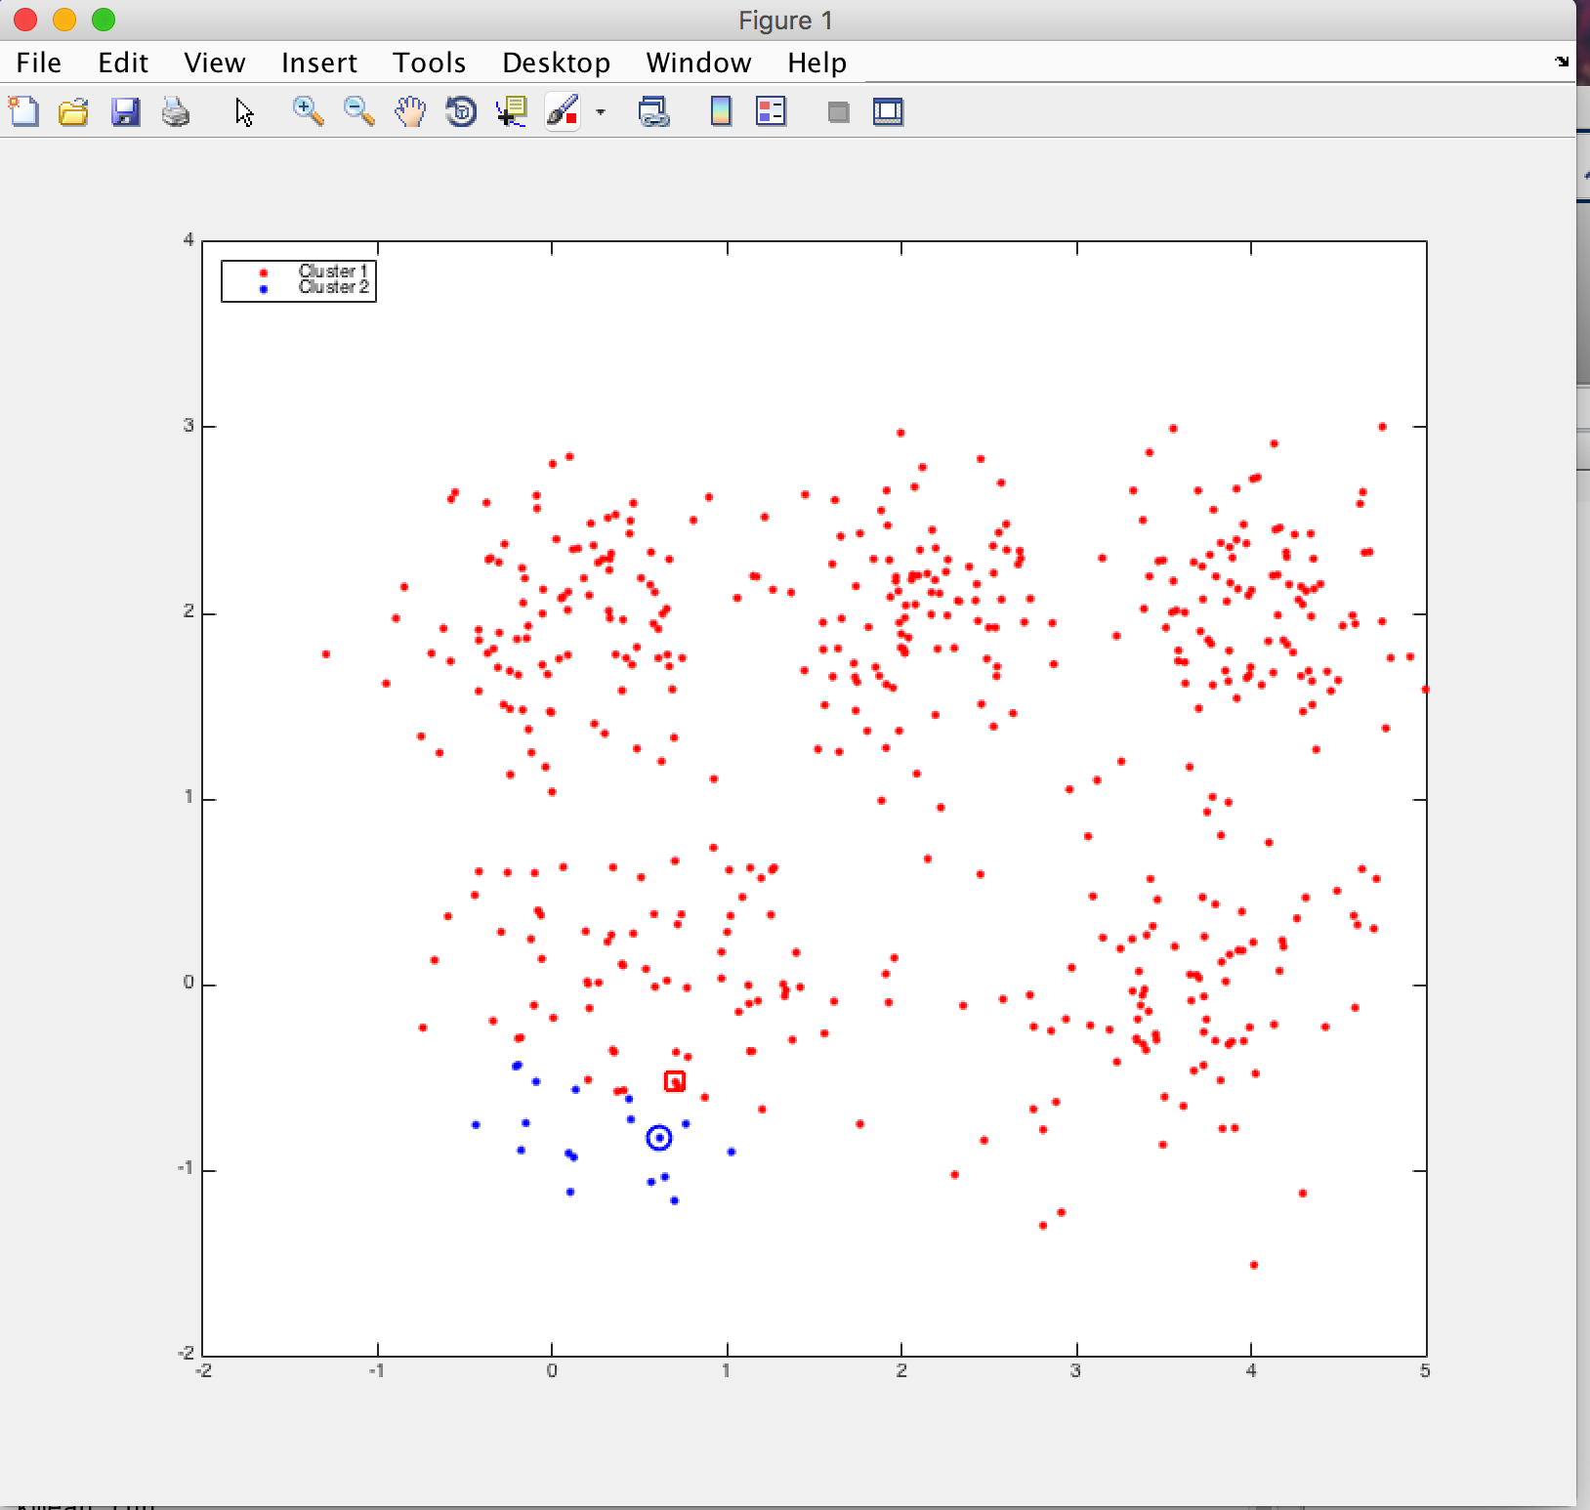

b)

Q: How can we get a stable result using k-means

A:

c)

k=10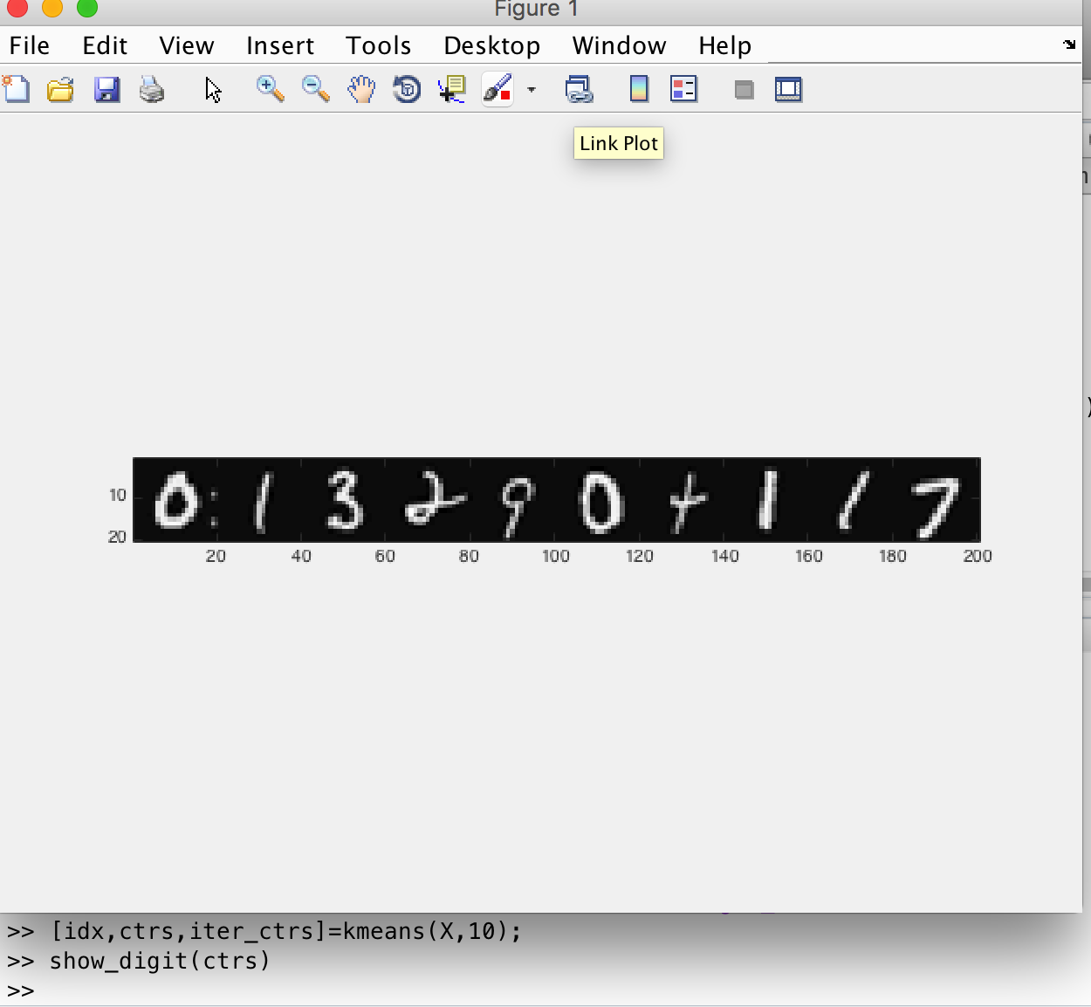

k=20

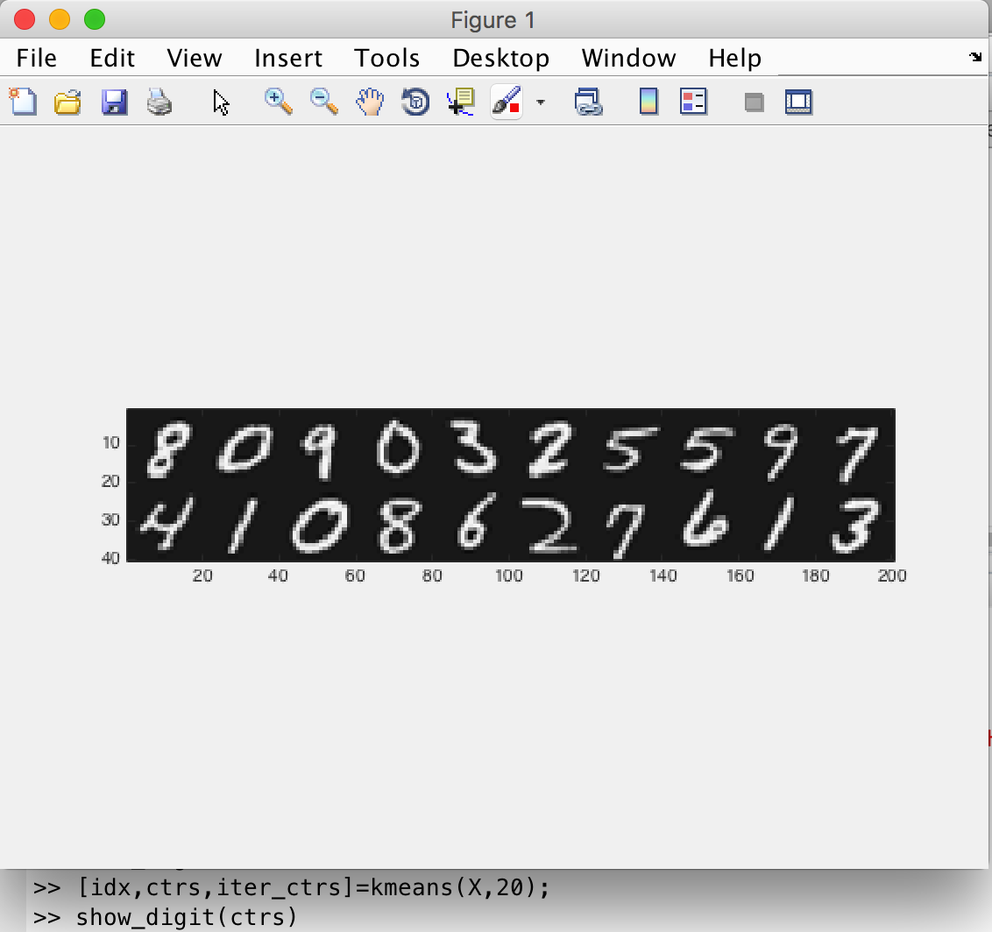

k=50

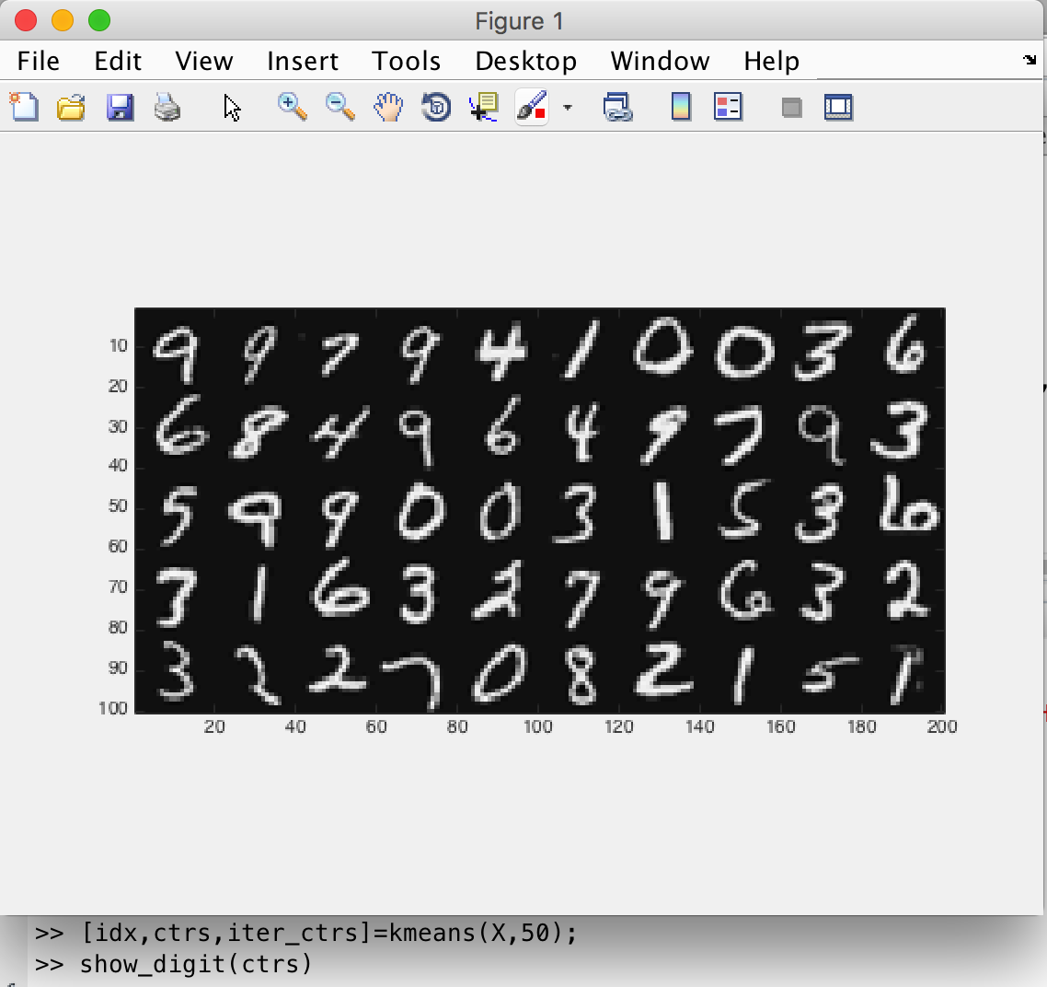

k=100

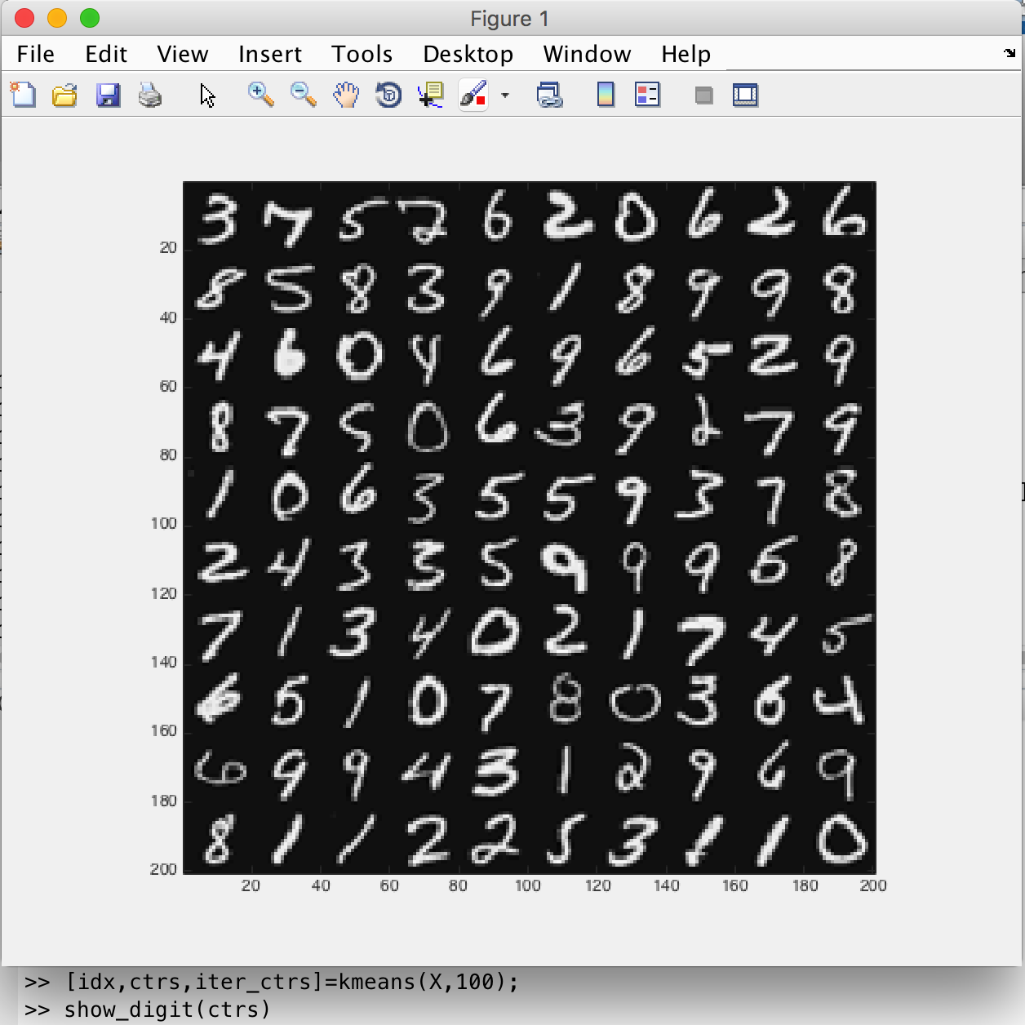

d)

k=8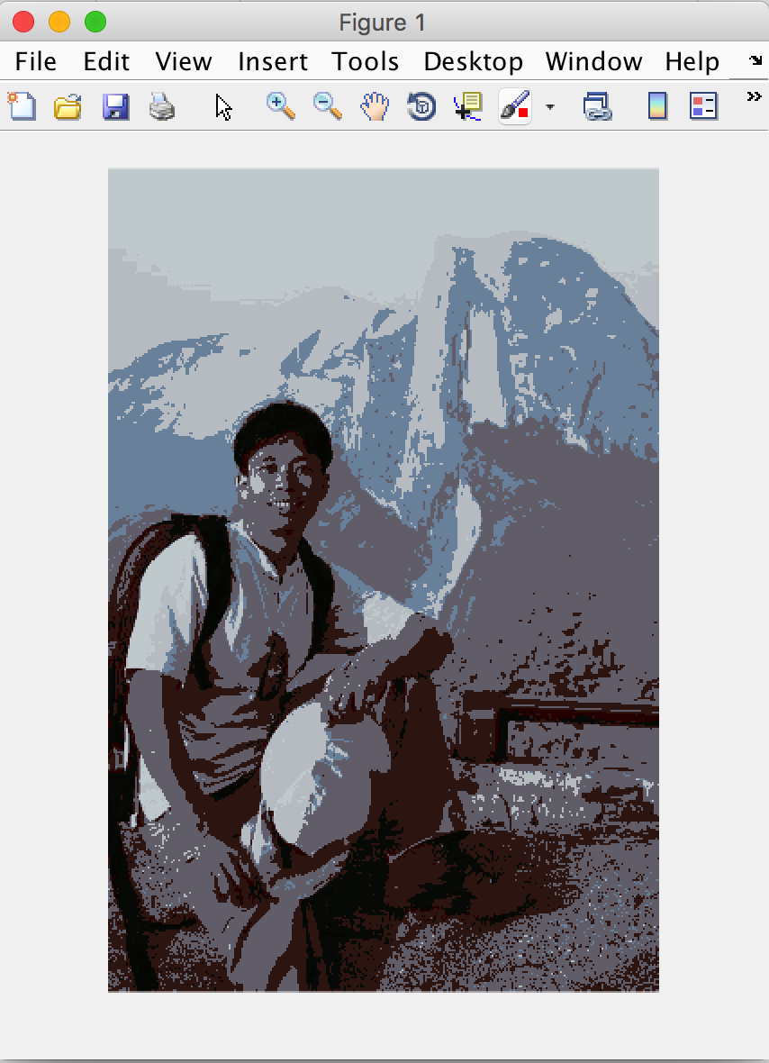

k=16



k=32



k=64



(d) When choose Huffman code for compression, we need to store the image encoded with Huffman code, Huffman code and the cluster centers(color). So a final compressed image has three components.

Here are the results:

Sample0: k=64, Compression Ratio:24.22%

Sample1: k=64, Compression Ratio:22.46%

Sample2: k=64, Compression Ratio:23.95%