# HOMA - RAMCloud

**HOMA - RAMCloud** **0**

Architecture 1

Configurations: 2

Installation 2

Packages to install 2

Useful commands: 3

Set Java Path: 3

GCC version check: 4

Dpdk installation: 4

Switch Access: 5

Recommended changes 5

GNUmakefile: 5

Git branch: 5

Adding hostnames: 5

Openssh server: 5

Grant user permissions: 5

Make ssh passwordless (including self): 6

Make no host verification passwordless (including self): 6

NFS Setup: 6

Create replication files: 7

Results 7

Homa+Udp & TCP : W1 load 8

Homa+Udp & TCP : W2 load 9

Homa+Udp & TCP : W3 load 10

Homa+Udp & TCP : W4 load 10

Homa+Udp & TCP : W5 load 10

Troubleshooting tips: 10

Issue 1: Ulimit: 11

Resolution 11

Issue 2: Sudo issue 11

Resolution 11

Issue 3: Image Privileges 11

Resolution 12

Issue 4: Compilation FPIC error 12

Resolution 12

Issue 5: Shared Compilation FPIC error 12

Resolution: 13

Issue 6: HugePages info 13

Resolution (reference solution to redhat) 14

Issue 7: No free pages 14

Resolution: 14

Issue 8: rte_service_init() failed 14

Resolution (Partial): 15

Questions 15

# 

## 

## 

## 

## 

## 

## 

## 

## 

## **Architecture**

---------------------------------- Switch (1G) ssh-------------------------

| | | |

BareMetal 1 BareMetal2 BareMetal3 BareMetal 4

| | | |

---------------------------- Switch (10G) -----------------------------------

### Configurations:

Set up same username on all host machines.

Bare Metal servers used (4)

Intel(R) Xeon(R) CPU E7-8893 v3

3.20GHz

8 core

128 GB Memory

Switch:

1Gbps for ssh

10Gbps for setting up dpdk

Vlan configuration:

Vlan - 10.10.10.*/24

Useful Links:

<https://ramcloud.atlassian.net/wiki/spaces/RAM/pages/6848614/General+Information+for+Developers>

<https://platformlab.stanford.edu/Presentations/2018/Yilong%20Li.pdf>

## 

## 

## **Installation**

### Packages to install

* build-essential
* doxygen
* libpcre3-dev
* protobuf-compiler
* libprotobuf-dev
* libcrypto++-dev
* libevent-dev
* libboost-all-dev
* libgtest-dev
* libzookeeper-mt-dev
* zookeeper
* libssl-dev
* Openjdk-8
* Libstdc++6:i386
* Git
* Openssh-server

### Useful commands:

**sudo apt-get install build-essential git-core doxygen libpcre3-dev protobuf-compiler libprotobuf-dev libcrypto++-dev libevent-dev libboost-all-dev libgtest-dev libzookeeper-mt-dev zookeeper libssl-dev**

**sudo apt-get install git**

**sudo apt-get install libstdc++6:i386**

**sudo apt-get install openjdk-8-jdk**

**sudo apt-get purge openssh-server**

**sudo apt-get install openssh-server**

### Set Java Path:

**nano ~/.bash_profile**

**export JAVA_HOME=/usr/lib/jvm/java-8-openjdk-amd64**

**export PATH=$PATH:/usr/lib/jvm/java-8-openjdk-amd64/bin**

**source ~/.bash_profile**

### GCC version check:

Check different versions of GCC installed on your system

Useful command:

**dpkg -l | grep gcc | awk '{print $2}'**

RAMCloud with Homa supports gcc5, if gcc doesn’t exist please install gcc5.

Make sure to have gcc-5 as gcc version

Useful command:

**sudo rm /usr/bin/gcc**

**sudo rm /usr/bin/g++**

**sudo ln -s /usr/bin/gcc-5 /usr/bin/gcc**

**sudo ln -s /usr/bin/g++-5 /usr/bin/g++**

### Dpdk installation:

Homa bypasses the kernel and uses dpdk.

Useful commands:

**git clone http://dpdk.org/git/dpdk**

**# Build code**

**cd dpdk**

**make config T=x86_64-native-linuxapp-gcc**

**make**

**# Install kernel modules**

**sudo modprobe uio**

**sudo insmod build/kmod/igb_uio.ko**

**# Configure hugepages**

**echo 1024 | sudo tee /sys/kernel/mm/hugepages/hugepages-2048kB/nr_hugepages**

**sudo mkdir /mnt/huge**

**sudo mount -t hugetlbfs nodev /mnt/huge**

**# Bind secondary network adaptor**

**sudo ifconfig enp0s9 down**

**sudo ./usertools/dpdk-devbind.py --bind=igb_uio enp0s9**

**sudo ./usertools/dpdk-devbind.py --status**

### Dpdk installation with RAMCloud:

1) Go to following directory

**<Your path>/platformlab/RAMCloud/scripts**

2) Edit for **dpdkBuild.sh**

a) Change **DPDK_OPTIONS="CONFIG_RTE_BUILD_SHARED_LIB=n** " to

**DPDK_OPTIONS="CONFIG_RTE_BUILD_SHARED_LIB=y "**

b) Edit the DPDK build version which you want to build by mentioning like this :-

if [ "$MLNX_DPDK" != "y" ];

then

**# Use DPDK community release.**

**DPDK_VER="18.02"**

3) Run the script

**./dpdkBuild.sh**

4) Go to one level up and edit **GNUmakefile**

1. Uncomment and Change **DPDK ?= no** to **DPDK ?= yes**
2. Uncomment and Change

**DPDK_DIR ?=<Yourpath>/platformlab/RAMCloud/scripts/dpdk**

1. Uncomment and Change **DPDK_SHARED ?= no** to **DPDK_SHARED ?= yes**
2. Save the changes

5) Go to **<Your path>/platformlab/RAMCloud/** and run

**make install T=x86_64-native-linuxapp-gc**c

6) Go to **<Your path>/platformlab/RAMCloud/scripts/dpdk/ x86_64-native-linuxapp-gcc**

Edit the file "**.config**" in that directory to change the value of the **CONFIG_RTE_BUILD_SHARED_LIB** variable to "**y**" (you can also leave it

"n" to build without shared libraries, in which case you will need to

modify other variables below here). Then recompile: "make clean; make"

### Switch Access:

Make sure to have access to switch for setting up different priorities like hom, homa1, homa2, homa4 etc.,

Useful link: <https://platformlab.stanford.edu/Presentations/2018/Yilong%20Li.pdf>

## **Recommended changes**

### GNUmakefile:

Directory: RAMCloud

File: GNUmakefile

**GLIBCXX_USE_CXX11_ABI ?= yes**

### Git branch:

**Git checkout branch of origin/homa-transport**

### Adding hostnames:

**# Sample /etc/hosts file**

**IP hostname**

Useful link: <https://askubuntu.com/questions/874724/ssh-could-not-resolve-hostname-server-name-or-service-not-known>

### Openssh server:

Make sure openssh server is running

**sudo service ssh status**

**sudo service ssh start**

### Grant user permissions:

Edit the /etc/sudoers with following

**simulation1 ALL = NOPASSWD: ALL**

### Make ssh passwordless (including self):

Homa script requires users to login without password

Add public key value to authorized_keys

Useful link:

<https://www.tecmint.com/ssh-passwordless-login-using-ssh-keygen-in-5-easy-steps/>

Useful commands:

**cat ~/.ssh/id_rsa.pub | ssh homa@IP_Server_1 'cat >> ~/.ssh/authorized_keys'**

**cat ~/.ssh/id_rsa.pub | ssh homa@IP_Server_2 'cat >> ~/.ssh/authorized_keys'**

**cat ~/.ssh/id_rsa.pub | ssh homa@IP_Server_3 'cat >> ~/.ssh/authorized_keys'**

**cat ~/.ssh/id_rsa.pub | ssh homa@IP_Server_4 'cat >> ~/.ssh/authorized_keys'**

### Make no host verification passwordless (including self):

Make host verification not a necessary step

Useful commands:

**sudo nano /etc/ssh/ssh_config**

**\*\*\*\*\*\*\*\*\*\*\*\*Make sure you add at the bottom of the file \*\*\*\*\*\*\*\*\*\***

**Host 172.17.0.\***

**StrictHostKeyChecking no**

**UserKnownHostsFile=/dev/null**

Useful link: (Note: Think about security considerations)

<https://superuser.com/questions/125324/how-can-i-avoid-sshs-host-verification-for-known-hosts/125325>

### NFS Setup:

Homa requires the systems has nfs setup. A single mount point (server) can be created on one machine and replicated to other machines (clients). This makes sure all the log files are remotely accessible.

Useful link:

<https://www.digitalocean.com/community/tutorials/how-to-set-up-an-nfs-mount-on-ubuntu-14-04>

Useful Commands:

homa@homa1:~$ df -h

/dev/sdb4 328G 2.9G 309G 1% /home

homa@homa2:~$ df -h

10.145.94.33:/home/homa/platformlab 328G 2.9G 309G 1% /home/homa/platformlab

homa@homa3:~$ df -h

10.145.94.33:/home/homa/platformlab 328G 2.9G 309G 1% /home/homa/platformlab

homa@homa4:~$ df -h

10.145.94.33:/home/homa/platformlab 328G 2.9G 309G 1% /home/homa/platformlab

### Create replication files:

Homa requires the systems has replication files across systems.

Sample example :

**touch /home/homa/platformlab/RAMCloud/rp1**

**touch /home/homa**/**platformlab/RAMCloud/rp2**

Change the default_disks argument in GNUmake file

**default_disks = '-f /home/homa/platformlab/RAMCloud/rp1,/home/homa/platformlab/RAMCloud/rp2'**

## Results

Following results are done with kernel.

### 

### 

### 

### 

### Homa+Udp & TCP : W1 load

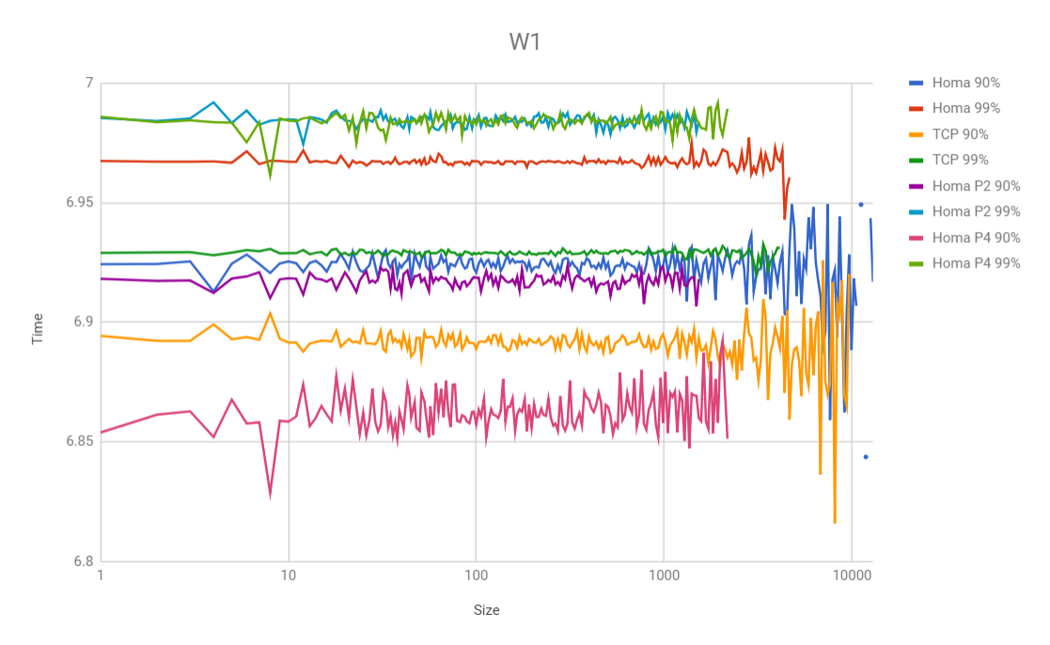

### 

### 

### 

### 

### 

### 

### 

### Homa+Udp & TCP : W2 load

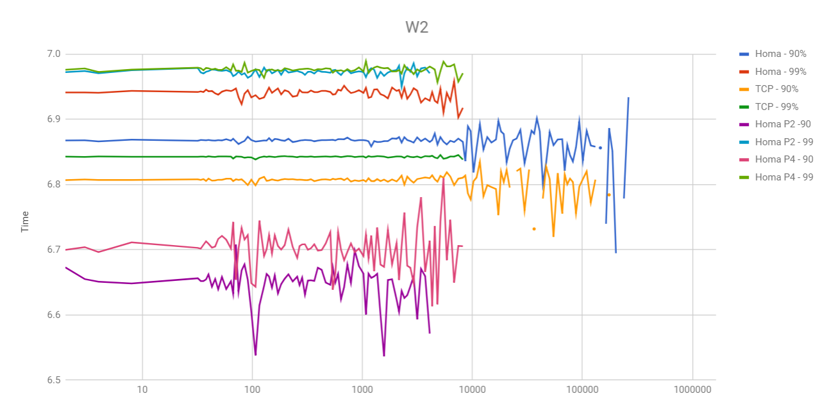

### Homa+Udp & TCP : W3 load

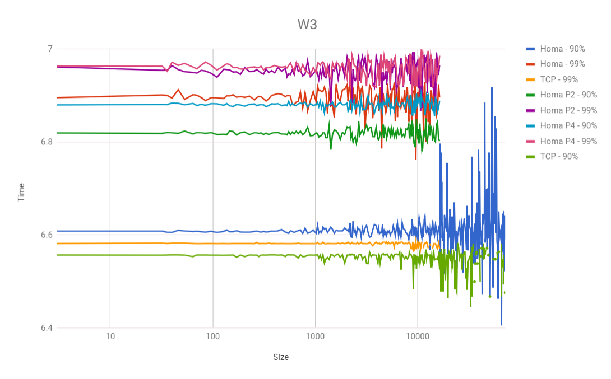

### Homa+Udp & TCP : W4 load

No. of samples are less in less case of W4 load, due to which 90/99% are zeroes.

### Homa+Udp & TCP : W5 load

No. of samples are less in less case of W4 load, due to which 90/99% are zeroes.

## Troubleshooting tips:

#### Issue 1: Ulimit:

machine2@machine2-VirtualBox:~/RAMCloud$ ./obj/coordinator

1524010398.009366564 CoordinatorMain.cc:96 in main NOTICE[1]: Command line: ./obj/coordinator

1524010398.009411988 CoordinatorMain.cc:97 in main NOTICE[1]: Coordinator process id: 2403

1524010398.013366073 Common.cc:221 in pinAllMemory WARNING[1]: Could not lock all memory pages (Cannot allocate memory), so the OS might swap memory later. Check your user's "ulimit -l" and adjust /etc/security/limits.conf as necessary.

1524010398.013611881 TransportManager.cc:587 in dumpTransportFactories NOTICE[1]: Known transports: kernelTcp (tcp), basic+kernelUdp (basic+udp), homa+kernelUdp (homa+udp)

1524010398.014763563 CoordinatorMain.cc:153 in main ERROR[1]: Fatal error in coordinator at fast+udp:host=0.0.0.0,port=12246: RAMCloud::Exception: Servers must listen on at least one service locator, but no possible transports were found for 'fast+udp:host=0.0.0.0,port=12246', thrown at TransportManager::initialize at src/TransportManager.cc:317

##### Resolution

Change following file /etc/security/limits.conf

Username here is machine2 or homa

@machine2 - memlock unlimited

@homa - memlock unlimited

#### 

#### Issue 2: Sudo issue

What is sudo doesn’t exist ?

##### Resolution

Install sudo package with root privileges

apt-get install sudo

#### Issue 3: Image Privileges

##### Resolution

Make sure your machine starts with privileged mode for changing any sys level parameters

#### Issue 4: Compilation FPIC error

can not be used when making a shared object; recompile with "fPIC" : error adding symbols: Bad value

##### Resolution

From dpdk/x86_64-native-linuxapp-gcc directory

Ran following command

./configure CFLAGS=-fPIC; make

Then from platformlab/RAMCloud/

Run following command

HOMA_BENCHMARK=yes make all

#### Issue 5: Shared Compilation FPIC error

homa@homa1:~/platformlab/RAMCloud$ scripts/clusterperf.py --transport basic+dpdk --dpdkPort 0 -r 0 --superuser echo_basic

Warning: Permanently added 'homa4,10.145.94.63' (ECDSA) to the list of known hosts.

Warning: Permanently added 'homa4,10.145.94.63' (ECDSA) to the list of known hosts.

/home/homa/platformlab/RAMCloud/obj.homa_branch_with_changes/coordinator: error while loading shared libraries: librte_ethdev.so.9.1: cannot open shared object file: No such file or directory

/home/homa/platformlab/RAMCloud/obj.homa_branch_with_changes/apps/ensureServers: error while loading shared libraries: librte_ethdev.so.9.1: cannot open shared object file: No such file or directory

Warning: Permanently added 'homa4,10.145.94.63' (ECDSA) to the list of known hosts.

Warning: Permanently added 'homa4,10.145.94.63' (ECDSA) to the list of known hosts.

Traceback (most recent call last):

File "scripts/clusterperf.py", line 1101, in <module>

run_test(test, options)

File "scripts/clusterperf.py", line 384, in run_test

test.function(test.name, options, cluster_args, client_args)

File "scripts/clusterperf.py", line 434, in echo

default(name, options, cluster_args, client_args)

File "scripts/clusterperf.py", line 411, in default

flatten_args(client_args), name), **cluster_args)

File "/home/homa/platformlab/RAMCloud/scripts/cluster.py", line 652, in run

cluster.start_coordinator(coordinator_host, coordinator_args)

File "/home/homa/platformlab/RAMCloud/scripts/cluster.py", line 299, in start_coordinator

self.ensure_servers(0, 0)

File "/home/homa/platformlab/RAMCloud/scripts/cluster.py", line 441, in ensure_servers

self.sandbox.rsh(self.coordinator_host[0], ensureCommand)

File "/home/homa/platformlab/RAMCloud/scripts/common.py", line 126, in rsh

subprocess.check_call(sh_command, **kwargs)

File "/usr/lib/python2.7/subprocess.py", line 541, in check_call

raise CalledProcessError(retcode, cmd)

subprocess.CalledProcessError: Command '['ssh', 'homa4', 'sudo', '/home/homa/platformlab/RAMCloud/scripts/remoteexec.py', "' /home/homa/platformlab/RAMCloud/obj.homa_branch_with_changes/apps/ensureServers -C basic+udp:host=10.145.94.63,port=12246 -m 0 -b 0 -l 1 --wait 30 --logFile logs/20180503110543/ensureServers.log'", '/home/homa/platformlab/RAMCloud']' returned non-zero exit status 127

homa@homa1:~/platformlab/RAMCloud$

##### 

##### Resolution:

Compiling dpdk on all machines

From dpdk/x86_64-native-linuxapp-gcc directory

Run following command

./configure CFLAGS=-fPIC; make

#### Issue 6: HugePages info

homa@homa1:~/platformlab/RAMCloud/logs/latest$ cat coordinator.homa4.log

1525371811.908166956 CoordinatorMain.cc:96 in main NOTICE[1]: Command line: /home/homa/platformlab/RAMCloud/obj.homa_branch_with_changes/coordinator -C basic+udp:host=10.145.94.63,port=12246 -l NOTICE --logFile logs/20180503112331/coordinator.homa4.log --dpdkPort 0 --configDir config

1525371811.908190647 CoordinatorMain.cc:97 in main NOTICE[1]: Coordinator process id: 2729

1525371811.908257797 DpdkDriver.cc:146 in DpdkDriver NOTICE[1]: Using DPDK version DPDK 18.05.0-rc0

1525371811.911372895 FileLogger.cc:100 in write NOTICE[1]: DPDK: EAL: Detected 32 lcore(s)

1525371811.911395505 FileLogger.cc:100 in write NOTICE[1]: DPDK: EAL: Detected 4 NUMA nodes

1525371811.911592940 FileLogger.cc:100 in write NOTICE[1]: DPDK: EAL: Multi-process socket /var/run/.homa4_unix

1525371811.912717295 FileLogger.cc:100 in write NOTICE[1]: DPDK: EAL: No free hugepages reported in hugepages-1048576kB

1525371811.913162741 FileLogger.cc:100 in write NOTICE[1]: DPDK: EAL: Probing VFIO support...

1525371812.023396593 CoordinatorMain.cc:153 in main ERROR[1]: Fatal error in coordinator at ???: RAMCloud::DriverException: Failed to allocate memory for packet buffers: No such file or directory, thrown at DpdkDriver at src/DpdkDriver.cc:172

##### Resolution (reference solution to redhat)

<https://access.redhat.com/documentation/en-us/red_hat_enterprise_linux/6/html/virtualization_tuning_and_optimization_guide/sect-Virtualization_Tuning_Optimization_Guide-Memory-Huge_Pages-1GB-runtime>

# mkdir /dev/hugepages1G  
# mount -t hugetlbfs -o pagesize=1G none /dev/hugepages1G

# systemctl restart libvirtd

#### Issue 7: No free pages

DPDK: EAL: No free hugepages reported in hugepages-1048576kB

##### Resolution:

echo 4 | sudo tee /sys/kernel/mm/hugepages/hugepages-1048576kB/nr_hugepages

#### Issue 8: rte_service_init() failed

DPDK: EAL: FATAL: rte_service_init() failed error allocating rte services array

homa@homa2:~/platformlab/RAMCloud/logs/latest$ cat coordinator.homa4.log

1525459212.185781925 CoordinatorMain.cc:96 in main NOTICE[1]: Command line: /home/homa/platformlab/RAMCloud/obj.homa_branch_with_changes/coordinator -C basic+udp:host=10.145.94.33,port=12246 -l NOTICE --logFile logs/20180504114011/coordinator.homa4.log --dpdkPort 0 --configDir config

1525459212.185809659 CoordinatorMain.cc:97 in main NOTICE[1]: Coordinator process id: 27123

1525459212.185895469 DpdkDriver.cc:146 in DpdkDriver NOTICE[1]: Using DPDK version DPDK 18.05.0-rc0

1525459212.189995217 FileLogger.cc:100 in write NOTICE[1]: DPDK: EAL: Detected 32 lcore(s)

1525459212.190016116 FileLogger.cc:100 in write NOTICE[1]: DPDK: EAL: Detected 4 NUMA nodes

1525459212.190255862 FileLogger.cc:100 in write NOTICE[1]: DPDK: EAL: Multi-process socket /home/homa/.homa4_unix

1525459212.191613561 FileLogger.cc:100 in write NOTICE[1]: DPDK: EAL: 4 hugepages of size 1073741824 reserved, but no mounted hugetlbfs found for that size

1525459212.192090760 FileLogger.cc:100 in write NOTICE[1]: DPDK: EAL: Probing VFIO support...

1525459212.199060909 FileLogger.cc:100 in write NOTICE[1]: DPDK: EAL: Cannot obtain physical addresses: No such file or directory. Only vfio will function.

1525459212.303281779 FileLogger.cc:100 in write NOTICE[1]: DPDK: EAL: rte_service_init() failed

1525459212.303299817 FileLogger.cc:100 in write NOTICE[1]: DPDK:

1525459212.303565887 CoordinatorMain.cc:153 in main ERROR[1]: Fatal error in coordinator at ???: RAMCloud::DriverException: rte_eal_init failed,

##### Resolution (Partial):

sudo chown -R $USER: /sys/class/uio/uio0/device/

sudo chown -R $USER: /dev

sudo chown -R $USER: /mnt/huge

sudo chown -R $USER: /sys/devices/system/node/

sudo chmod u+w /sys/class/

sudo chmod u+w /dev

sudo chmod u+w /mnt/huge

sudo chmod u+w /sys/devices/system/node/

## 

## Questions

**Number of samples**

The number of samples are low in most of the W3/W4/W5 work loads.

Because of low number of samples the graph says zero value for 90% and 99% percentile.

**Network Load**

How did they implement variation of the network load and how is it measured

**Dpdk initialization issues**

How did they let dpdk initialized for coordinator/server/client to run