Matlab.mathworks login instructions.

Step 1: Create a mathworks account using your student/staff email address if you don't already have this.

1. Go to mathworks.com.au. On the top right corner, click Login.
2. Click on Create an account\*.
3. Enter your details. Ensure that you are using your Unimelb account.
4. When asked how you will use Matlab, choose academic use. Do not select student use.
5. You will receive a validation email. Click on the link and follow instructions.
6. After entering your details, you will be asked to associate with a license. Enter the following:
   * Staff: 24759-36418-71647-13382-89362
   * Student: 18098-22076-81253-90866-03229

\* If you already have an account follow these instructions instead:

1. While logged in, on your homepage, find My Licenses.
2. Under 'Associate with a License' click the Associate license button.
3. When prompted, enter the license numbers as mentioned above.

Step 2:

1. While still in the License Centre, select the "Download Products" link and follow the instructions on each dialog box in the download procedure.
2. Start the MathWorks installer
   * Windows: Double-click the setup.exe file
   * Macintosh: Double-click the InstallForMacOSX file
   * Linux/Unix: Run the install script
3. Choose "Log in with a MathWorks Account" and follow the prompts.

Alternately instead of downloading the Matlab software, you can also use Matlab online. To do this:

1. Go to <https://matlab.mathworks.com/>.
2. Use mathworks.com Username and Password you just created to login and follow instructions.
3. You are now ready to use Matlab online.

This bit needs to go under environment?.

In order to use Matlab online, we need to upload files to the shared folder. We will upload the m-files from the google drive link you were sent for this course.

Click on the upload button and follow instructions. The upload button is located next to the New button in the home tab. Uploaded files will appear in the shared folder. You are now ready to use Matlab Online.

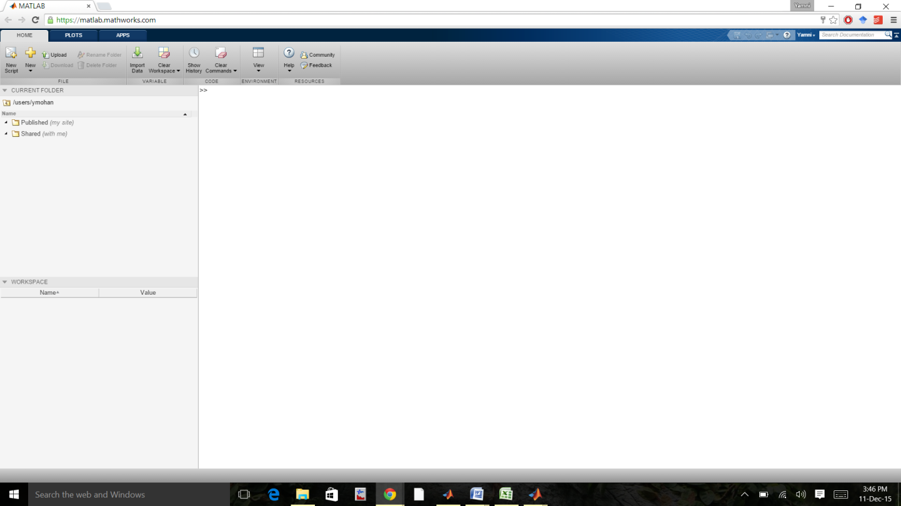

While using Matlab online for your own use, make sure ALL the files you need are uploaded.