**The primary visual cortex of the Tree shrews (Layers 4 and 2/3)**

**Analysis:**

As a first measure, the orientation selectivity of all cortical neurons was calculated using the circular variance (CV). The CV indicates how far the responses of a neuron deviate from a circle and is given by the following formula and the data is presented in a histogram.

CV= ………………………………………………………………(1)

The segregation index is a method of calculating the overlap of the on and off responses of a neuron and is calculated as follows

SI=

Where Rtonis the response of the neuron at a given time to a light bar crossing the receptive field and Rtoff is the response of the neuron to a dark bar. A separate segregation index at each direction of movement was calculated and the final segregation index was the average of the segregation indices calculated for the two directions. An SI value close to 1 indicated that there was no overlap in responses and an SI value close to 0 indicated that there was a complete overlap of responses.

**Results:**

**Histology:**

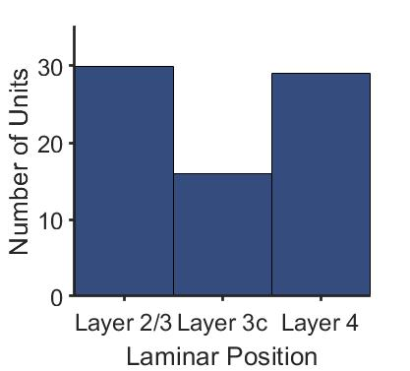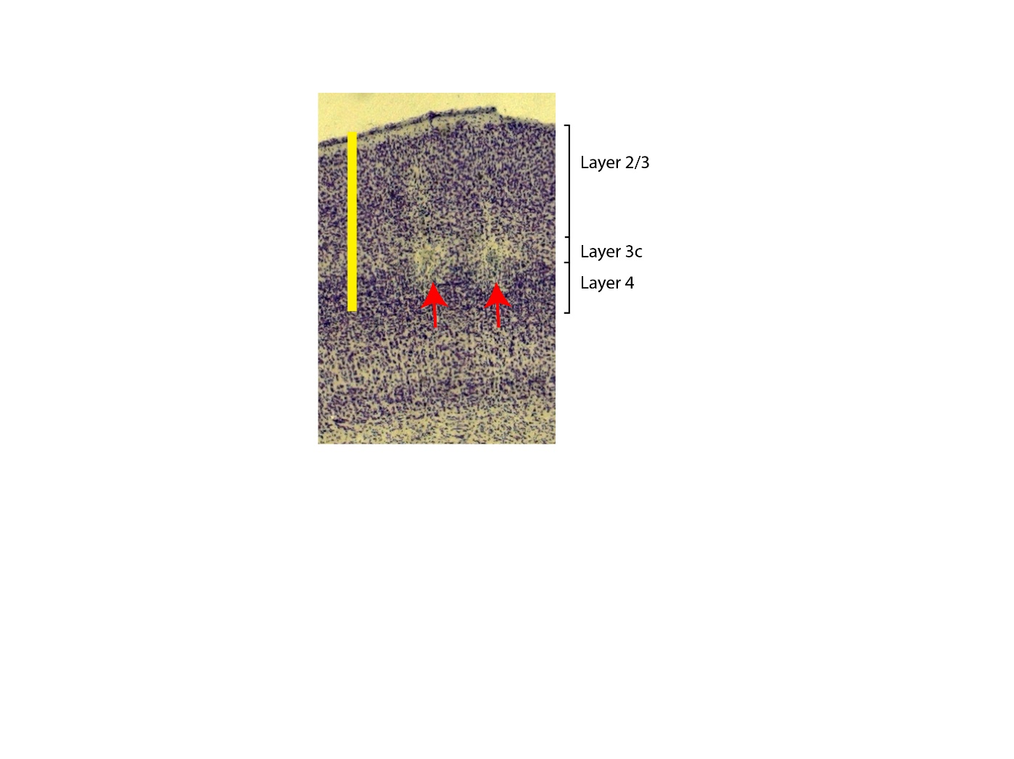

Figure 1: A photomicrograph of the tree shrew primary visual cortex. The different layers are demarcated. The red arrows show two lesions that were made in layer 4 in two different tracks. The scale bar is 1mm. The histogram on the right indicates the number of units recorded from each of the lamina.

**Orientation selectivity of neurons.**

A total of 73 neurons had orientation information recorded using a bar. Of the 73 neurons, 42 were recorded from layer 2/3 and 31 were recorded from layer 4. The distribution of the circular variances of the neurons based on their laminar position is presented below. The layer 4 neurons had a median CV=0.88 (95% CI=[0.84, 0.90]). The median CV of the layer 2/3 neurons was 0.71 (95% CI=[0.58, 0.84]). While the median of the CV of layer 2/3 neurons is significantly lower than the CV of layer 4 neurons (Wilcoxon rank sum test; z=-3.74; p<0.0001), this does not reflect the bimodal distribution of the circular variances of the layer 2/3 neurons that was observed.

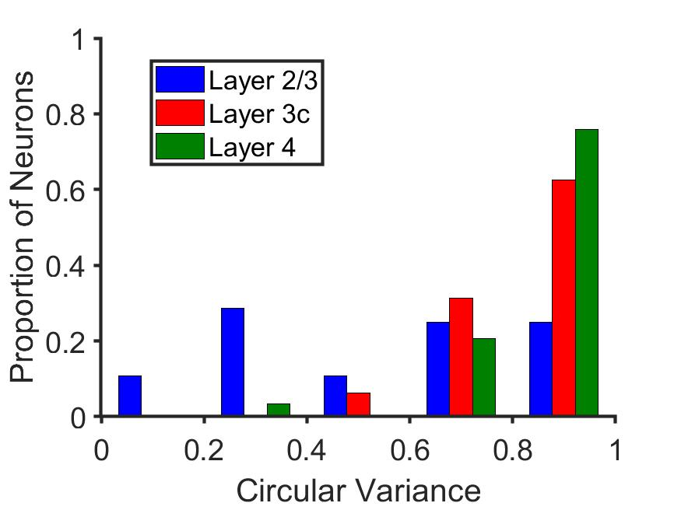

Figure 2: Distribution of the circular variance by layer. In (a) only the data is separated into layer 2/3 and layer 4 whereas in (b), the layer 2/3 data is further sub-divided to show layer IIIc data

Layer IIIc is found just above the layer 4 in the tree shrews (see Fig. 1) and is meant to receive inputs from Layer 6 of the LGN. Of the 42 neurons that we recorded from, 14 were from layer IIIc. The median CV of the layer IIIc neurons was 0.87 (95% CI=[0.63, 0.91]). Layer III c neurons show significantly broader orientation selectivity compared to the layer 2/3 neurons (Wilcoxon rank sum test, z=3.24; p<0.005) whereas Layer IIIc neurons showed orientation tuning comparable to that of layer 4 neurons (Wilcoxon rank sum test, z=0.65; p=0.52).

**Optimum orientation of neurons.**

Kruskal-Wallis multiple comparisons with boneferroni correction

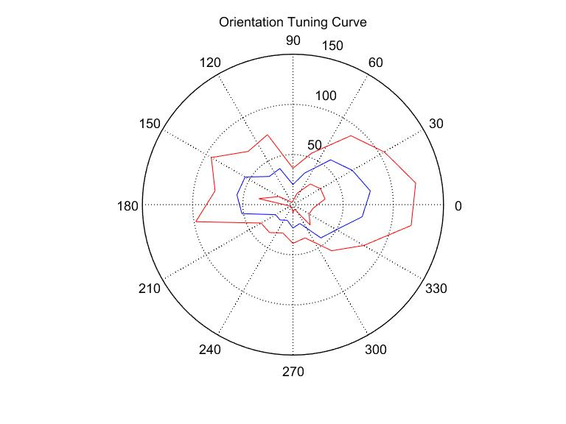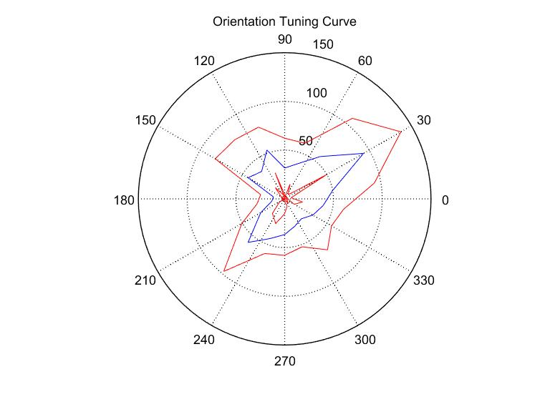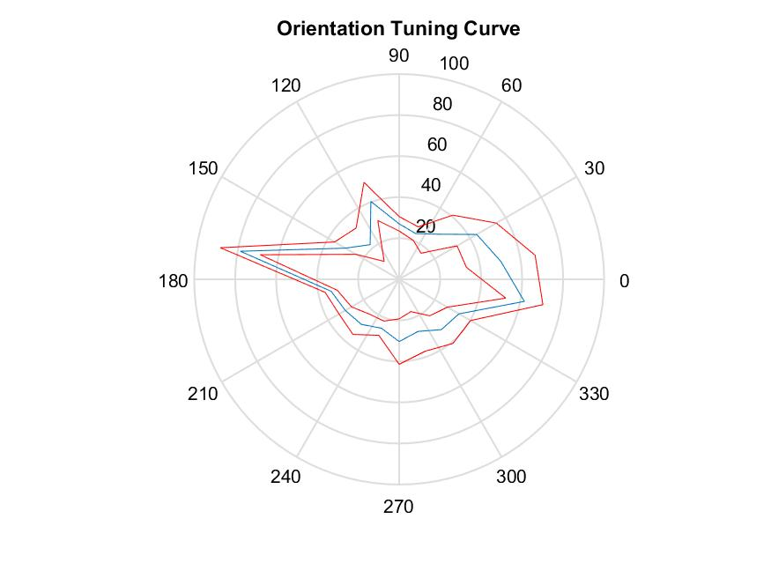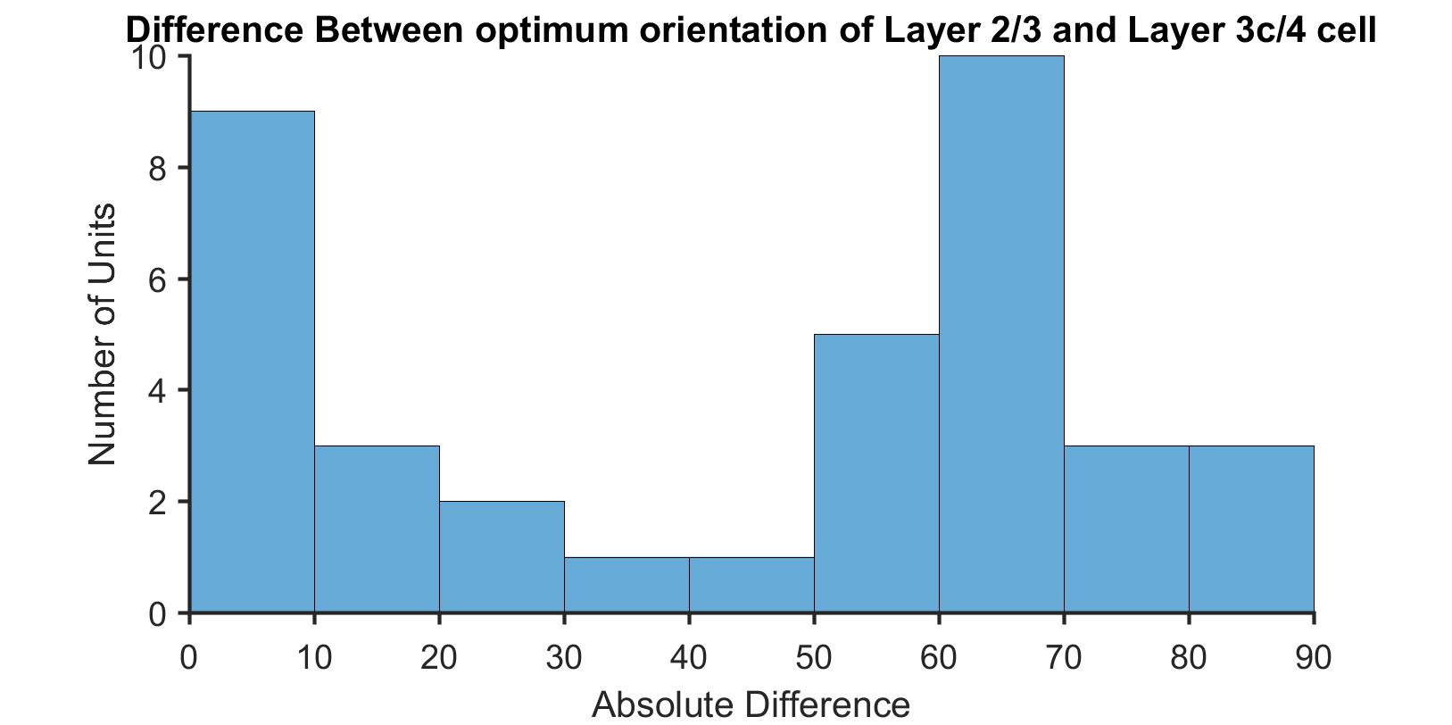

Layer 2/3

Layer 3c

Layer 4

Cm= -5.7o

Cm= 60.36o

Cm= 174.75o

Control 1:

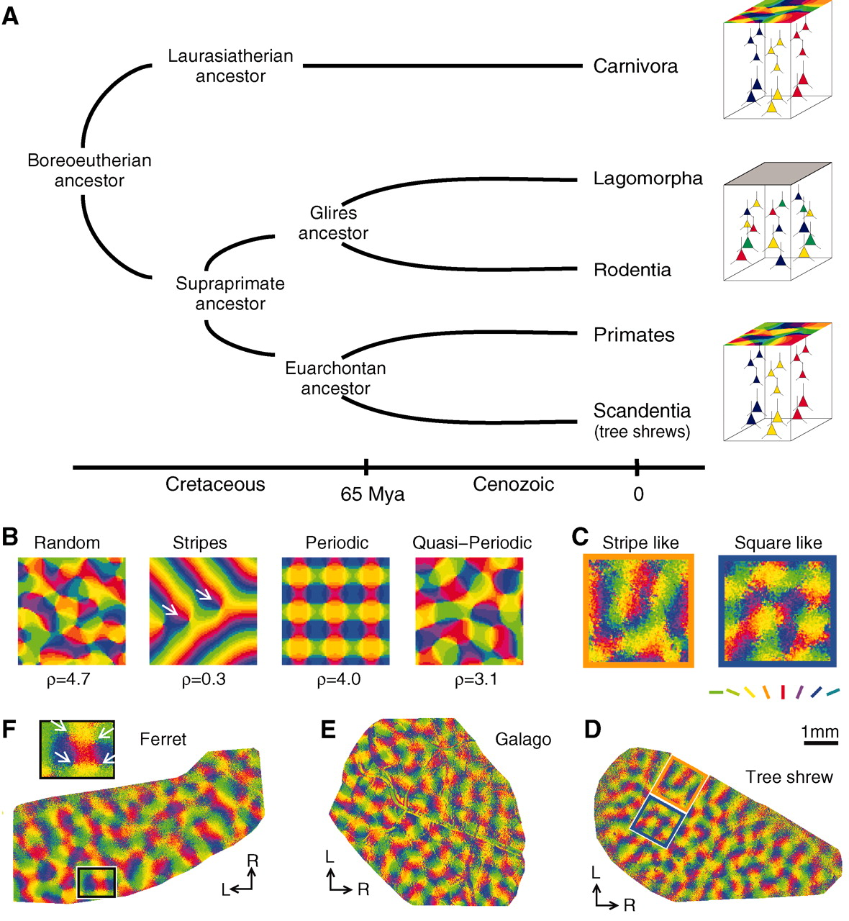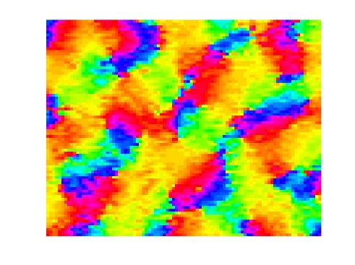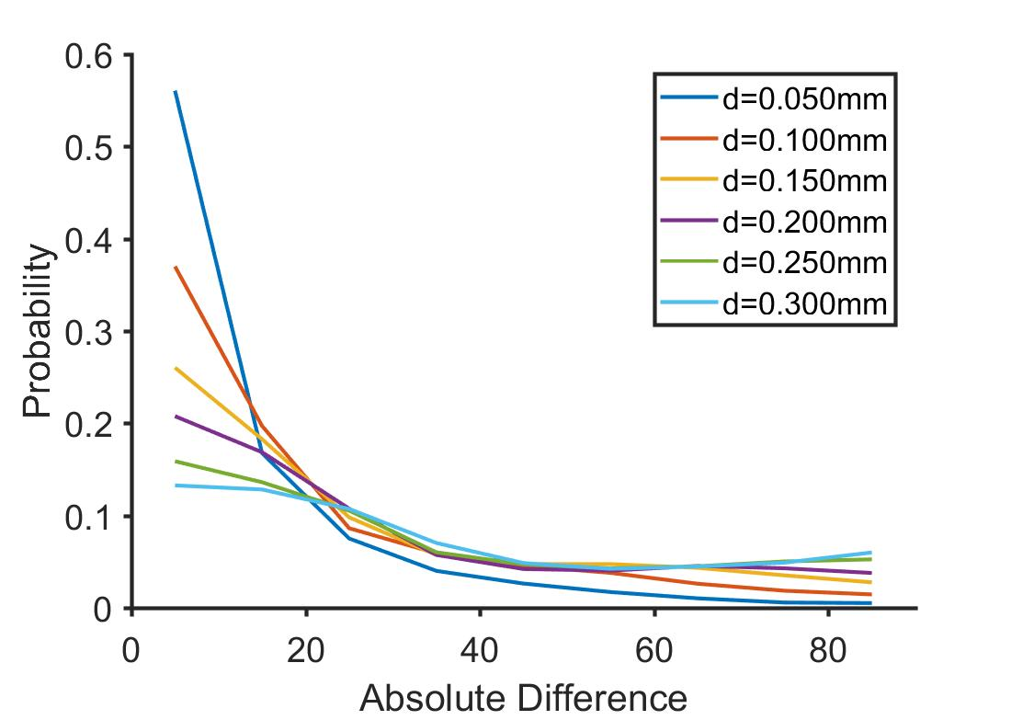

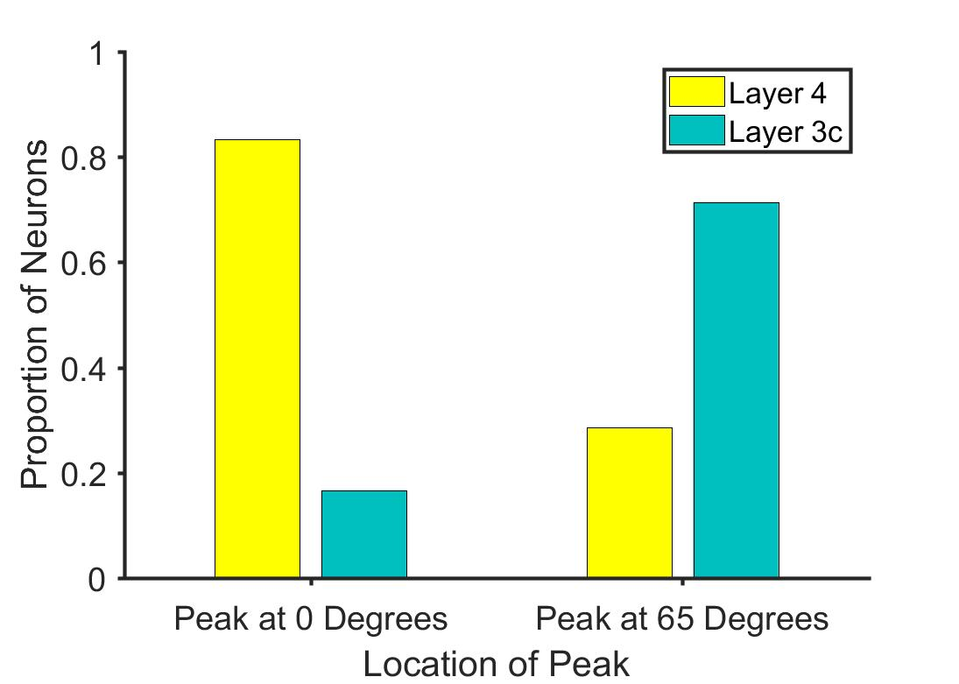

**Spatial Frequency Tuning**

The Spatial Frequency tuning responses of the layer 4 and layer 2/3 neurons are summarised in Figure 2.

Figure : Distribution of segregation indices of neurons according to their laminar position.