**Orientation biases in the Tree Shrew Superior Colliculus neurons.**

**Summary**

Though earlier theories of orientation selectivity suggested that orientation biases observed in V1 inputs are the result of excitatory convergence, studies have shown that orientation bias in the inputs to V1 may be inherited from neurons in sub-cortical structures, namely the lateral geniculate nucleus (dLGN) and ultimately the retina. Congruent with this theory, retinal and LGN neurons have been shown to be tuned to orientation at higher spatial frequencies. However, there is some controversy as to whether these biases arise from cortical feedback instead of biased inputs. If orientation selectivity arises from the retina, it should be evident in other targets of retinal projections. The superior colliculus (SC) is one such area. Here, orientation selectivity of SC neurons in tree shrews was measured using thin bars and gratings of different spatial frequencies. SC neurons showed orientation tuning comparable to that observed in the LGN of tree shrews. At higher spatial frequencies, the orientation selectivity was more evident, similar to that reported in the retina and LGN of cats. These results indicate that orientation tuning observed in the cortex is probably the result of sharpening of orientation biases observed in the retina and the geniculate. Direction selectivity and linearity of the superior colliculus neurons were also studied.

**Introduction**

The tree shrew superior colliculus (SC) is a large well laminated structure (Tigges & Shanta, 1969; Zhou et al., 2016). It is sub-divided into areas important for visual form processing and visuomotor processing (Casagrande et al., 1972; Casagrande & Diamond, 1974) and has been implicated in an alternative pathway to the visual cortices (Killackey et al., 1971; Killackey & Diamond., 1971). While the functional role and the projections of the SC have been extensively studied, few studies have characterised the receptive field properties of individual neurons. In this study, the receptive field properties, specifically orientation and spatial frequency tuning of the tree shrew SC neurons were studied and compared with the properties of the geniculo-striate system of the tree shrews.

Due to its extensive reciprocal projections to sensory as well as motor areas of the brain, the SC was implicated in oculomotor behaviour (Sherrington, 1947). However, studies where different layers of the SC were lesioned showed that the SC consisted of two separate functional systems --- the superficial layers essential for visual form discrimination and the inferior layers implicated in oculomotor function and orienting behaviour (Casagrande et al., 1972; Casagrande & Diamond, 1974). The superficial layers of the tree shrew SC are further divided into stratum zonale (SZ), stratum griseum superficiale (SGS) and stratum opticum (SO) with the SGS further subdivided into upper and lower SGS (uSGS and lSGS respectively). As these are the layers of the SC that predominantly receive visual input (from the retina and primary visual cortex (V1); see May, 2006 for review), only the response properties of neurons in these superficial layers were studied.

In the present study, we aimed to examine orientation biases and spatial frequency tuning in the tree shrew SC. More than 50 years after its first report, the mechanism underlying orientation selectivity is still debated (Refs?.. Priebe,…; V&E.,,,). The model of excitatory convergence proposed by Hubel & Wiesel (1962, 1968) for orientation selectivity in cats and macaques assumed that orientation selectivity was first generated along the visual pathway only in the primary visual cortex. A similar mechanism of orientation selectivity has been proposed in the tree shrews (Chisum et al., 2003; Mooser et al., 2004) These theories have largely ignored the orientation biases that have been demonstrated in sub-cortical areas. Subcortical orientation biases have been reported in the retina and the dLGN of most species (cats- Levick & Thibos, 1980; Vidyasagar & Urbas, 1982; Levick & Thibos, 1982; Shou & Leventhal, 1989; macaques- Smith et al., 1991; Xu et al., 2002, Passaglia et al., 2002; tree shrews- Van Hooser et al., 2013; rodent- Tan et al., 2011; Sun et al., 2016). However, oriented neurons in the superior colliculus have only been reported in rodents (Wang et al., 2010; Inayat et al., 2015; Ahmadlou et al., 2015; Shi et al., 2017). In cats and macaques, direction selectivity has been reported in the Superior Colliculus (McIlwain & Buser, 1967; Sterling & Wickelgren, 1969; Rosenquist & Palmer, 1971; Cynader & Berman, 1972; Goldberg & Wurtz, 1972), but units can be selective to direction without being selective to orientation (see figure 8a and 8b in results). In one detailed study that examined receptive field properties in the tree shrew SC, a small proportion (~20%) of SC neurons were orientation tuned (response at optimum orientation greater than 3 times the response at non-optimum orientation) in the superficial layers of the SC (Albano et al., 1978). A recent study in the tree shrew geniculostriate system however, showed that nearly 50% of tree shrew LGN neurons showed orientation biases (Van Hooser et al., 2013), albeit to a smaller extent than that reported by Albano et al. (1978). Here the orientation biases of the shrew SC were characterized using bars and gratings and compared to that of the shrew LGN.

Since neurons in the superficial SC receive inputs from both retina and the primary visual cortex, we also aimed to elucidate the source of receptive field properties of superficial SC neurons. Certain properties of the SC neurons such as binocularity, direction selectivity and colour selectivity have been attributed to cortical feedback in carnivores and primates (Sterling & Wickelgren, 1969; Cynader & Berman, 1971 Tailby et al, 2012). In the rodents however, it has been shown that direction and orientation selectivity were inherited directly from the retinal projections on to the SC neurons (Shi et al., 2017). Therefore, one key aim of this experiment was to determine whether the receptive field properties of SC neurons were inherited from the cortex or the retina. Neurons of the primary visual cortex show sharp orientation selectivity and a bandpass spatial frequency tuning (Movshon et al., 1978a; Movshon et al., 1978b; Movshon et al., 1978c; DeValois et al., 1982). Retinal neurons are broadly tuned to orientation and have a low pass spatial frequency tuning and at higher spatial frequencies, retinal neurons show sharper orientation tuning (Enroth-Cugell & Robson, 1966; Levick & Thibos, 1980; Levick & Thibos, 1982). The LGN neurons of cats reflect a similar pattern of orientation and spatial frequency tuning observed in the retina (Vidyasagar & Urbas, 1982; Vidyasagar & Heide, 1984; Shou & Leventhal, 1989). Here, we examined the orientation and spatial frequency responses of the neurons of the superior colliculus. We predicted that the SC neurons in the tree shrews, like the LGN, inherits its orientation bias from the retina. This was tested using the following hypotheses:

a) Superficial SC neurons will show oriented responses when shown thin bars (which contain high spatial frequency information).

b) Superficial SC neurons will have low pass spatial frequency tuning when tested using sinusoidal gratings.

c) When gratings of different spatial frequencies are used, the superficial SC neurons will show better response at the optimum orientation when compared to the non-optimum orientation (i.e., orientation selective response).

**Methods**

**Surgery and anaesthesia**

Surgical procedures have been outlined in the Methods chapter. Briefly, the animal was anaesthetized using a mixture of Ketamine and Xylazine, a venous catheter was inserted in to the femoral vein and a tracheostomy performed to assist in the breathing during the experiment. The animal was administered muscle paralysant (Vecuronium Bromide) intravenously and was anaesthetised using Isoflurane (0.5-1%) for the duration of the experiment. Hard contact lenses were fitted to the eye to prevent corneal drying. A craniotomy and durotomy were performed over the location of the superior colliculus (Horsley-Clarke Co-ordinates A2.5 to P2.5). Frontal EEG and ECG were monitored during the experiment. At the end of the experiment, the animal was euthanized using an overdose of pentobarbital sodium and perfused (using 0.1M Phosphate Buffer (PB) solution followed by 4% Paraformaldehyde in 0.1M PB), the brain was removed and stored in sucrose (20-25%) for histology.

**Electrophysiology**

High impedence, lacquer coated tungsten microelectrodes (FHC Metal Microelectrodes Inc., ME, USA; impedance= 12-18 MΩ) were lowered into the brain and the signal was amplified and filtered (x 10,000 gain, bandpass filtered between 300-3000 Hz, A-M systems) and fed into an audio speaker as well as an analog to digital converter (Cambridge Electronic Design Limited, Cambridge, UK; digitised at 22.5 kHz). The SC was identified by listening to the neuronal activity in the speaker. The electrode was first quickly descended to a depth of 3 mm and then slowly descended until visual neurons were identified. Lesions (6 μA for 6s) were made at the end of each track. The electrode was withdrawn and lesions were made at regular intervals to trace the path of the electrode through the brain. The data was recorded as a spike trace using the spike 2 software (CED, Cambridge, UK). The spikes were templated and the spike timing exported as a text file. Further analysis was performed using custom MATLAB code (The Mathworks Inc, USA).

**Stimuli**

A hand held projectoscope was initially used to demarcate the receptive field boundaries. Using this, the centre of the monitor was aligned with centre of the receptive field prior to stimulus presentation. Stimuli were presented using a BARCO monitor (Frame Refresh Rate= 80 Hz; Reference Calibrator Plus; Barco Video and Communications, Belgium) and generated using Visage (VSG, Cambridge Research Systems, Cambridge, UK) and custom Stimulus Description Language (SDL) scripts. The monitor had a mean luminance of 32.6 cdm-2. While recording, the monitor was placed at a distance of 114 cm from the eye. For each of the different stimuli described below, ten complete stimulus presentations were completed.

For each SC neuron, the preferred stimulus orientation was initially measured using a thin moving bar. The bar was presented in 9 different orientations sweeping bi-directionally (a total of 18 orientations.). The background was a uniform gray screen. Depending on the polarity of the neurons, either a bright bar or a dark bar was used (contrast= 100 %). The bar was usually 8o long (ranging between 4 and 8 degrees) and 0.5o wide (ranging between 0.1 and 1 degree). The velocity of the bar was between 5 and 20 o/second. Long, thin bars were chosen as the initial stimuli to characterize orientation biases in the SC as bars have high spatial frequency component and retinal and geniculate neurons showed orientation biases at higher spatial frequencies (Levick and Thibos, 1982; Vidyasagar and Urbas, 1982; Vidyasagar and Heide, 1984). As a result, if orientation biases were present in the superior colliculus, thin bars have the best chance of eliciting oriented responses. As a result, the width of the bars were usually reduced until an oriented response was observed. Where the thinnest bar we presented did not elicit an oriented response during the experiment, the neuron was classified as unoriented.

Peri-stimulus-time-histograms (20 ms bin-width; PSTHs) were generated using the spike 2 software for online analysis. Based on the PSTHs generated following the presentation of the bar, the optimum orientation of the bar was determined as the orientation that gave the maximum response. This orientation was used for further testing.

The spatial frequency responses to gratings were then measured. The animals were presented with drifting sine-wave gratings (Temporal Frequency= 4Hz; Contrast=100%) of varying spatial frequencies (SF; SF between 0 cycles per degree (cpd) to 2 cpd) at atleast two different orientations (optimum, optimum + 90o). Where we could perform stable recordings, SF responses at two more orientations (optimum+45 o, optimum-45 o) were also collected.

**Data Analysis**

Regardless of the stimulus presented, the following analysis was performed on the extracellular trace before any specific analysis was undertaken. Spikes were templated and the spike time and stimulus markers were exported into text files. Using custom scripts in MATLAB, PSTHs (bin-width= 20ms) were constructed for each of the stimulus conditions. Spike density functions were created using a moving Gaussian envelope with σ of 60 ms (3 bins). This SDF was used for further analysis.

Analysis of Bar Stimuli

For orientation tuning recorded using a bar, the peak response in the SDF for each direction of movement was plotted on a polar diagram. The circular variance (CV; Ringach et al., 2002) and the orientation bias (bias, Vidyasagar & Urbas, 1982) were also calculated as follows:

CV= ………………………………………………………………(1)

Where θis the direction of movement of the bar (between 0 and 340 degrees) and r is the response at that direction. A CV value of 0 meant that the neuron was sharply tuned to orientation and a circular variance value of 1 meant that the neuron responded equally at all orientations. In this study, neurons with a CV greater than 0.9 were classified as unoriented neurons (Ringach et al., 2002).

Bias= ……………………………………………………………………………..(2)

Where Ropt is the response of the neuron to the optimum direction of movement and Rorth is the response of the neuron to the orientation 90 degrees away from the optimum direction of movement. Unoriented neurons have a value close to 1 and oriented neurons can have bias values close to Infinity.

Direction selectivity of the neurons was also calculated using two different methods to enable comparison with previous studies in the superior colliculus. In the first study, direction selectivity was calculated by simply taking the ratio of the response at the optimum direction of movement and the response at the opposite direction of movement (Goldberg & Wurtz, 1972). Neurons whose directions selectivity index was less than 0.5 (i.e. response in the opposite direction less than half of response in the optimum orientation) were termed direction selective. In the second method, the following formula was used to measure the directional circular variance (VanHooser et al., 2013).

DCV= ………………………………………………………….....(3)

Conventions are as described for the calculation of circular variance (Equation 1). Once again neurons that had a DCV less than 0.5 were not direction selective.

Analysis of Grating Stimuli

For gratings, the Discrete Fourier Transform (DFT) of the spike density function was calculated using the MATLAB Fast Fourier Transform algorithm (FFT). The F1 and the F0 components of the response were calculated (see General Methods for details) and the modulation index (Van Hooser et al., 2013) was calculated as follows:

Modulation ratio= ……………………………………………………………..(4)

Where F1 is the maximum response of the modulated component of the response and F0 is the maximum response of the unmodulated component of the response. If the modulation ratio was less than 1, the cell was considered to show non-linear summation over its receptive field and the unmodulated component of the response was used for further analysis. If the ratio was greater than 1, the cell was considered to show linear summation and the F0 component of the response was used.

In order to characterize the spatial frequency tuning response of the neurons, the peak spatial frequency of the neuron was taken as the spatial frequency where the firing rate was maximum. The lower cut-off was the frequency lower than the peak spatial frequency that gave a response that was half the magnitude of the peak response. If the response did not reach half the maximum response, the neuron was classified as a low pass tuned neuron. The high cut-off was the frequency higher than the peak spatial frequency where response was half the magnitude of the peak response. The spatial frequency tuning bandwidth was then the difference between the high cut-off and the low cut-off spatial frequencies.

In order to see if the neurons showed sharper orientation tuning at higher spatial frequencies, first the spatial frequency tuning curve at the optimum and orthogonal orientations were used. The bandwidth during which the superior colliculus neurons responded for the optimum orientation but not for the orthogonal orientation was calculated. In order to do this, a ‘minimum response’ was defined as the response rate at the spatial frequency where the response between the optimum and orthogonal orientations was no longer significantly different. The spatial frequency where the response rate for the optimum and orthogonal orientations first reached the minimum response was termed the optimum cut-off and orthogonal cut-off. The difference between the cut-off frequencies for the optimum and orthogonal orientations were calculated (see figure 1).

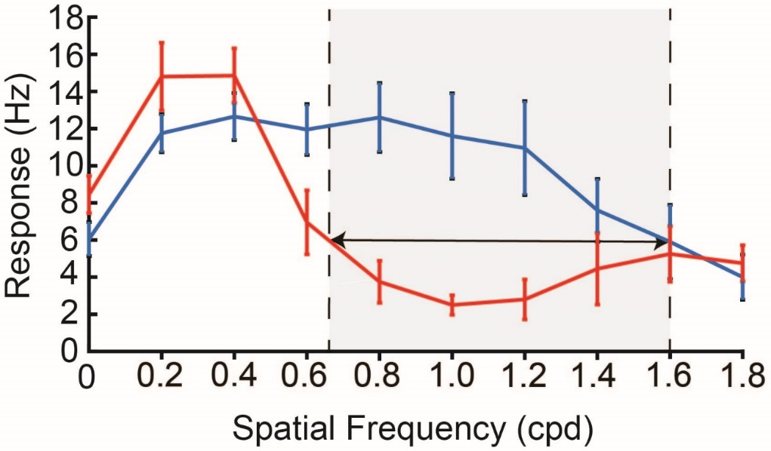

*Figure 1:* *Example SF tuning curves for optimum (blue) and orthogonal (red) orientations. The cut-off frequency at the optimal orientation is the SF at which the response at optimal orientation is no longer significantly different from the response at orthogonal orientation. The response at the cut-off frequency for optimum orientation is called the minimum response. For the orthogonal orientation, the cut-off frequency was the SF at which minimum response was first reached. Error bars are 95% confidence intervals.*

Circular variance of the neurons at each spatial frequency was also calculated using the circular variance formula described in Equation 1 where spatial frequency tuning data at atleast four different orientations was calculated. The orientation selectivity index (OSI) at each spatial frequency was also calculated as 1- reciprocal of orientation bias (Equation 2). The OSI instead of the bias was calculated in this instance as 1) no comparison to previous studies were made using this data; 2) The value of OSI would always be within 0 and 1 whereas the maximum value of bias could be infinity; and 3) As this calculation only requires the spatial frequency data at the optimum orientation and orthogonal orientations, a more complete data set could be achieved where the relationship between orientation tuning and the spatial frequency tuning of the neurons was recorded. The relationship between the OSI and CV were also examined in the results.

**Histology**

The brain that was stored in the sucrose at the end of the experiment was cut into 50 micron sections using a cryostat and then mounted on gelatinised slides. The sections were then stained using Cresyl Violet acetate solution. Lesions were identified and the electrode tracks reconstructed to verify that all our neurons were indeed recorded from the superior colliculus.

**Results**

**Summary of Results:**

A total of 22 units were recorded from five tracks in three anaesthetised Tree Shrews (2 female and 1 male). All neurons were from the superficial layers of superior colliculus. Of the 22 neurons, 20 were biased for orientation. Spatial frequency tuning information was collected only for 16 units, 12 of which showed low pass spatial frequency tuning. 13 of the 16 neurons also showed sharper orientation tuning at higher spatial frequencies.

**Anatomical location of units**

The laminar position of all the units were determined by reconstructing the electrode tracks using electrolytic lesions. The photomicrograph from one of the Nissl stained sections in one of the tree shrews is presented in figure 2a with the different layers demarcated. Electrode track reconstructions were completed in all animals and the laminar position of each of the neurons is shown in Figure 2b. All the neurons we recorded from were located in the superficial layers with the majority being in the Stratum Griseum Superficiale (SGS) where the majority of the retinal inputs terminate.

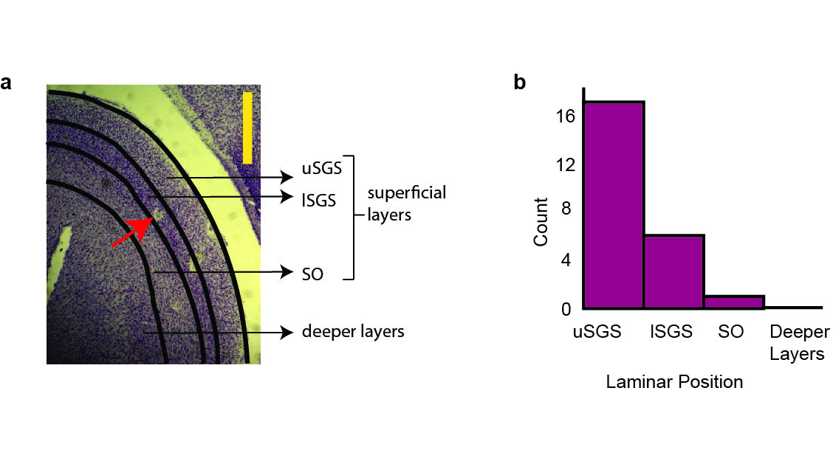

*Figure 2:* *Laminar position of the neurons. (a) A photomicrograph of a tree shrew superior colliculus from the right hemisphere showing the different subdivisions of the superficial layers. The red arrow points to a lesion. Two other lesions from a different track are visible to the right of the lesion. The yellow scale bar is 1mm. (b) Number of cells sampled from each layer. Majority of the cells were from uSGS. Abbreviations: uSGS- upper Stratum Griseum Superficiale; lSGS- lower Stratum Griseum Superficiale; SO- Stratum Opticum.*

**Orientation Selectivity using bars**

The distribution of two measures of orientation selectivity are shown in Figure 3. Figure 3a shows the distribution of circular variances. The median circular variance for the sample was 0.80 (95% confidence interval(CI)= [0.70 0.82]). The orientation tuning curves of the most selective, least selective neuron with CV less than 0.9 and the least selective neuron in the entire sample are presented in figure 4 and the orientation tuning curve of a neuron close to the median circular variance is presented in figure 5. The response was the average of 10 trials and the error bars are ± standard error of the mean (SEM).

*Figure 3*: *Orientation selectivity of neurons (a) This figure shows the distribution of circular variances of all neurons. (b) This figure shows the distribution of orientation biases.*

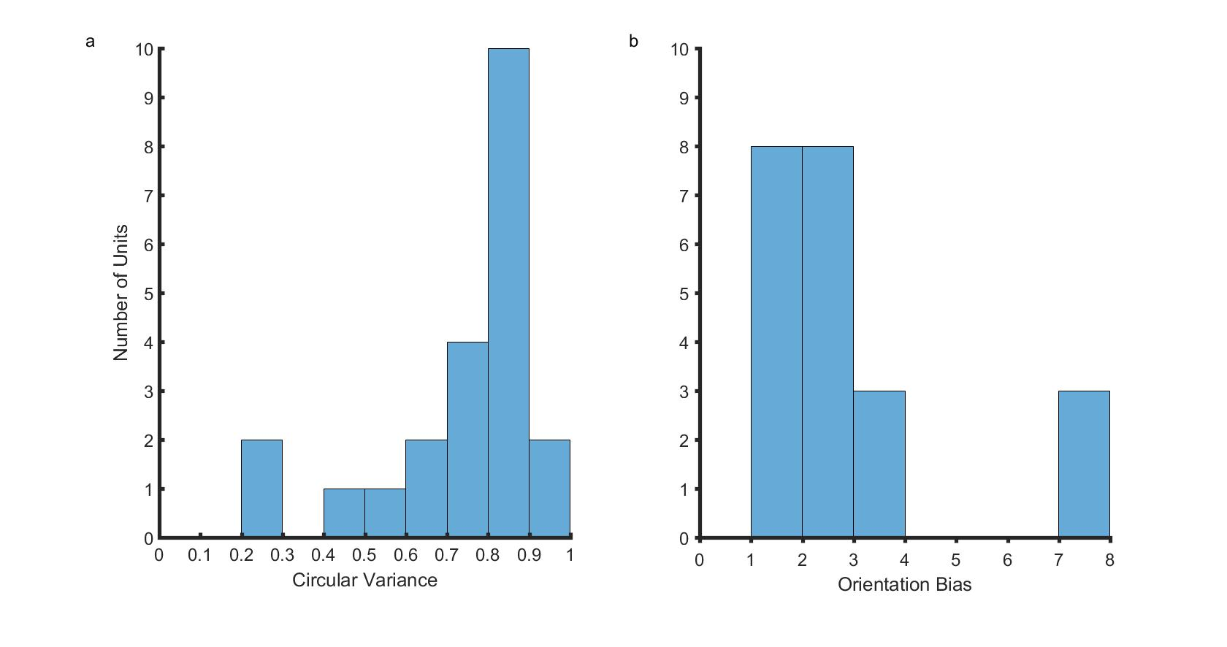

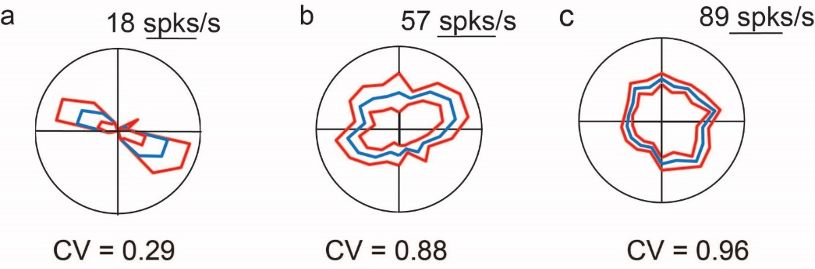

*Figure 4:* *Polar plot showing the orientation tuning curves of the sharpest (a) and the least tuned b) neurons included in our analysis. (c) was the least tuned neuron in our sample. Error bars are Standard Error. The circular variances of the neurons are shown below each polar plot. Scale bar also corresponds with the maximum firing rate of each neuron.*

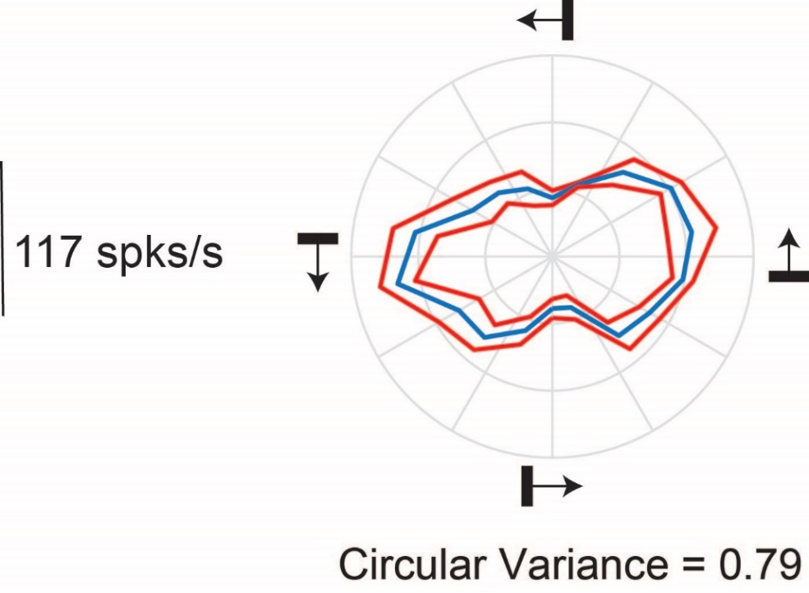

*Figure 5: Orientation response of a representative cell. The polar plot of the orientation responses of a neuron in the tree shrew superior colliculus. The orientation and direction of movement of the bar are shown using the small black bars and the arrows.*

Any neuron with CV greater than 0.9 was classified as not selective to orientation. Two neurons had a CV greater than 0.9 and were not tuned to orientation. These neurons were also not tested with gratings of orthogonal orientations as we were unable to determine the optimum and the orthogonal orientations.

An additional measure of orientation selectivity, the orientation bias (Bias; figure 3b) was also calculated. The median bias was 2.31 (95% CI=[1.85, 3.20]). A bias of one would indicate that the response of the neuron at the optimum and orthogonal orientations were the same. Therefore, lower values of bias indicated that the neurons were more broadly tuned. The two neurons that had circular variances greater than 0.9 had bias values closer to 1 (1.16 and 1.26). The orientation bias was calculated to enable comparison with previous studies and further analysis was not conducted on these values.

In order to see if there were any laminar differences in the orientation biases, the circular variance of the neurons were also plotted against the laminar position in figure 6. The neurons that showed the sharpest orientation tuning were all located in the uSGS.

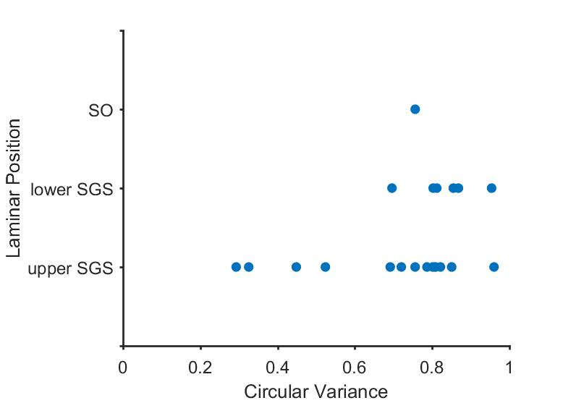

*Figure 6: Laminar distribution of the circular variances of the neurons.*

**Direction selectivity of neurons**

The distribution of the direction selecitivity index and the DCV of 22 neurons are shown in Figure 7a and b. All 22 neurons were included in the analysis as neurons that are not tuned to orientation can be tuned to direction. Figure 8a shows a neuron that is selective to both orientation and direction. 8b shows a neurons selective to direction but not to orientation. The median direction selectivity index was 0.69 (95% CI= [0.5, 0.83]), suggesting that the majority of the neurons were not direction selective. Of the 22 neurons that were recorded from, only 5 (~20 %) satisfied our criteria for direction selective neurons. The distribution of the DCV is shown in figure 7b. The median DCV was 0.90 (95% CI= [0.85, 0.93]). The DCV was a more conservative measure of direction selectivity and none of the neurons we measured from were selective to direction.

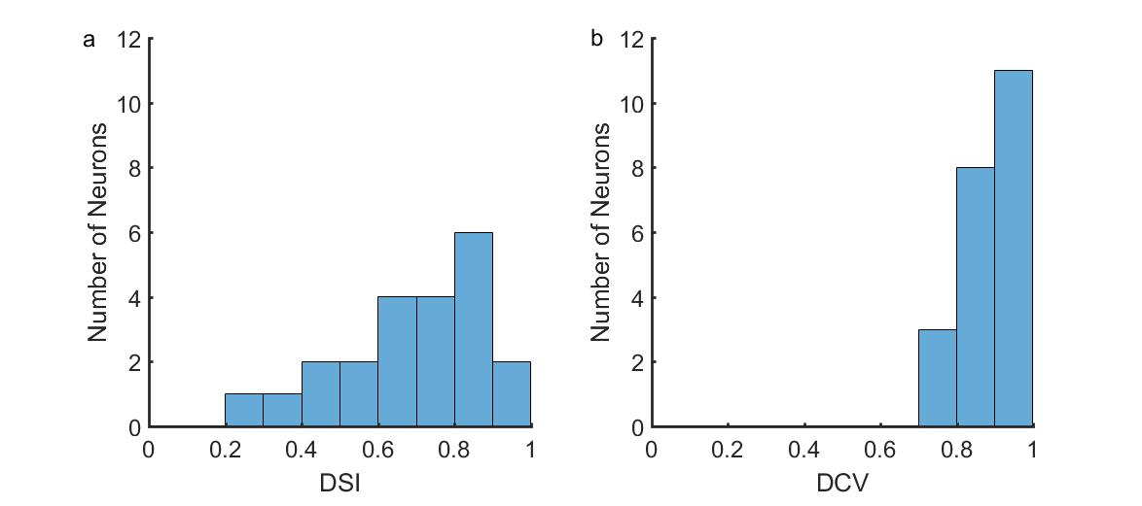

*Figure 7:* *Distribution of direction selectivity index of 22 superior colliculus neurons using two different measures: the direction selectivity index (a) and the directional circular variance (DCV; b).*

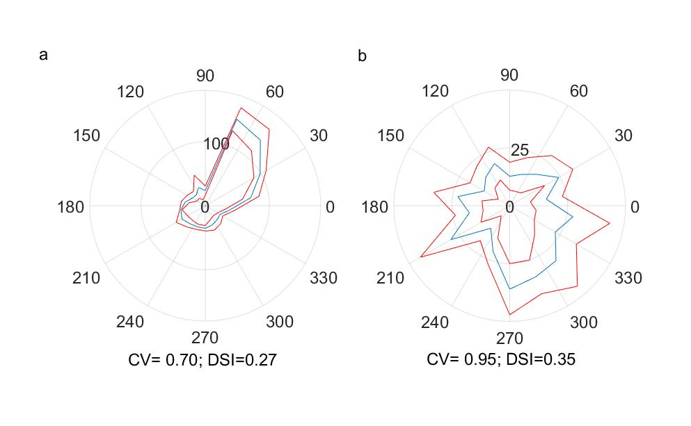

*Figure 8:* Example of a cell that is selective to both direction and orientation (a) and a cell that is selective to direction but not orientation (b).

**Spatial Frequency Tuning**

A summary of the results of spatial frequency tuning we obtained from 16 neurons is presented in figure 9a. The median peak spatial frequency was 0.2 cpd (95% CI= [0, 0.2]) and the median half width at half height was 0.35 cpd (95% CI= [0.15, 0.55]). Although most neurons reached their peak firing rate quickly, they tended to fire over a range of spatial frequencies as indicated by the slower rise of the high spatial frequency cut off curve. A significant proportion (80%) of superior colliculus neurons in our sample were also low-pass tuned to spatial frequency (12/16, p= 0.028).

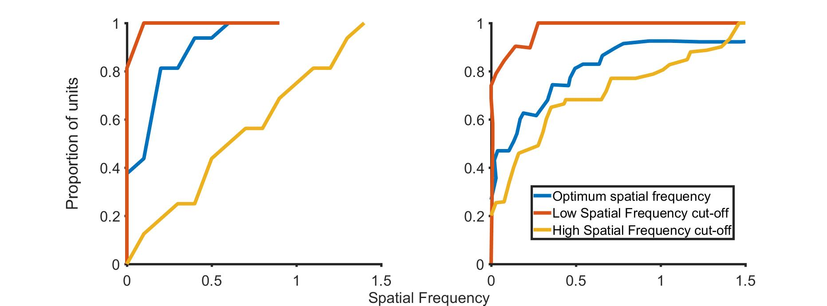

*Figure 9:* *Cumulative sum of the low-cutoff, optimum and high cut off spatial frequencies in the tree shrew Superior Colliculus for 16 neurons (a) and the Lateral Geniculate Nucleus for 30 neurons (b; LGN). The LGN results were published in the paper by Van Hooser et al., 2013 and the right side panel is from figure 7b, plotted on the same scale as the SC data in the left hand side panel.*

In order to enable a direct comparison between the superior colliculus and the lateral geniculate nucleus, data from the LGN (from Van Hooser et al., 2013, Figure 7b, 30 neurons) is plotted next to the superior colliculus data (Figure 7b). LGN cells tended to have a higher peak spatial frequencies and lower high frequency cut-offs. However, a similar proportion of neurons are bandpass tuned when compared to the superior colliculus (80% in the SC vs 76% in the LGN).

**Orientation tuning using gratings**

The circular variance of the orientation response of eleven neurons was calculated at the peak spatial frequency and compared with those of previously published data in the geniculostriate system of the tree shrews. The distribution of these circular variances are shown in figure 10. The median CV was 0.84 (95% CI= [0.77 0.91]). The distribution of the CVs of the superior colliculus and the LGN were similar. While in the LGN nearly 50% were not tuned to orientation at the peak spatial frequency, only 30% of the SC neurons did not show orientation tuning (1-CV<0.1). None of the neurons demonstrate sharp orientation tuning (1-CV> 0.5).

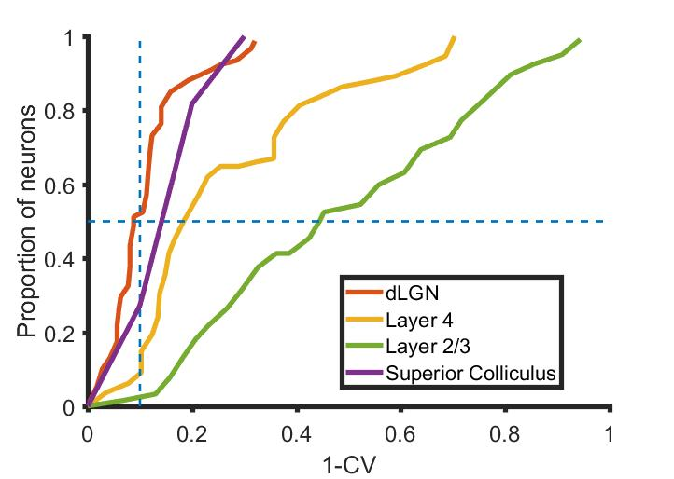

*Figure 10: Comparison of the distribution of the orientation selectivity of the LGN, Layer 4 and Layer 2/3 neurons to the distribution of orientation selectivity of the superior colliculus neurons. Horizontal dotted line indicates the 50% of neurons and the vertical dotted line is the orientation tuning cut off.*

As there was only enough data in 11 neurons to enable circular variance calculations, the orientation selectivity index (OSI) was calculated for the 16 neurons were gratings of both optimum and orthogonal orientation were shown. The relationship of the OSI and the CV is shown in figure 11.

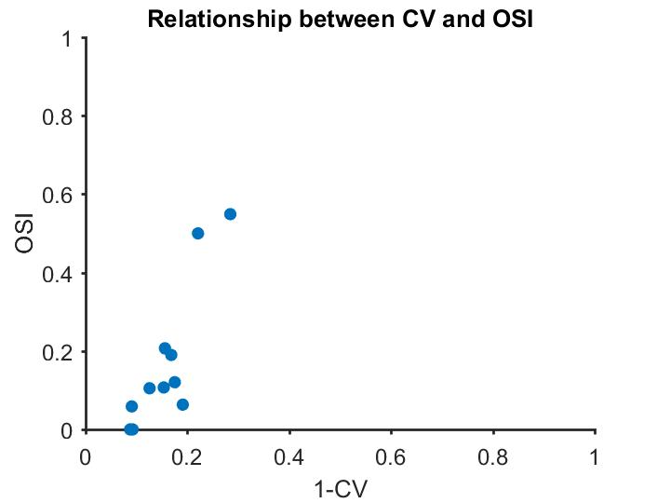

*Figure 11: Relationship between the circular variance and orientation selectivity index*

Levick and Thibos (1982) calculated the circular variance of the neurons in their study at different spatial frequencies and found that neurons showed sharper tuning at spatial frequencies higher than the optimum spatial frequency. Since the circular variance and orientation selectivity index show a strong correlation (r= 0.87, p<0.005, n=11), here OSI is used to conduct a similar analysis.

**Relationship between spatial frequency and orientation tuning.**

When the spatial frequency tuning response of the neuron at different orientations was observed, 13 of 16 neurons were tuned to orientation at higher spatial frequencies. The F0 component of a neuron’s response to gratings of increasing spatial frequencies at the optimum and the orthogonal orientations is shown in figure 1. The gray shaded area represents the spatial frequencies where the neuron still responds to gratings of the optimum orientation but no longer responds when gratings of the orthogonal orientation are presented (i.e., the neuron is orientation tuned). The upper limit of the gray shaded area (the dotted line to the right) is the cut off spatial frequency at the optimum orientation. The spatial frequency corresponding to the lower limit of the shaded gray area is the cut off spatial frequency at the orthogonal orientation. The difference in response between the optimum and non-optimum orientation cut off frequencies was calculated. These results for the group are presented in figure 12. A one tailed Wilcoxon Signed Rank test showed that the spatial frequency cutoff at the optimum orientation was significantly higher than the spatial frequency cutoff at the orthogonal orientation (median difference= 0.4 cpd; z=3.15; p=0.0008). The magenta circles in figure 12 show the peak spatial frequency of the respective neuron. The green circles indicate the spatial frequency where the neuron was most tuned to orientation (where the OSI was maximum). The spatial frequency where the orientation tuning of the neuron was greatest was significantly higher than the peak spatial frequency of the neuron (One-tail Wilcoxon Signed Rank test; z=3.3096; p=0.0005), indicating that orientation tuning was only observed at higher spatial frequencies in the tree shrew Superior Colliculus.

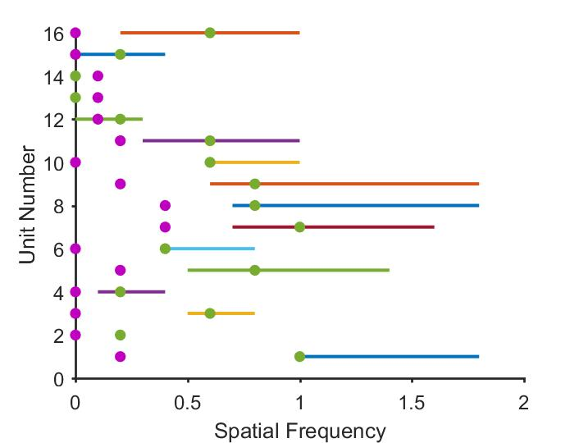

*Figure 13:* *The difference between the cut-off frequencies for the optimum and orthogonal orientations for 16 units is shown in the above figure. The purple circles are the peak spatial frequencies of the respective neurons and the green circles are the spatial frequency where the cell is most tuned to orientation. In most cases, the neurons are most tuned for orientation at spatial frequencies well past the peak spatial frequency.*

**Modulation Index of the neurons.**

For the 16 units whose spatial frequency tuning were recorded, the distribution of modulation ratios is presented in figure 14. A modulation ratio less than one means that the modulated component of the response was lower than the unmodulated component (linear cells) while a modulation ratio of greater than 1 indicates that the respective neurons were non-linear. Most neurons in our sample showed non-linear summation over their receptive fields (Modulation index less than 1).

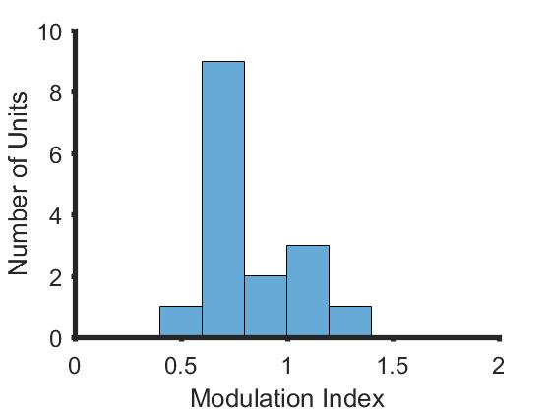

*Figure 14:* *The distribution of modulation indices of the neurons in our sample. Most neurons had a modulation index less than 1.*

**Discussion**

Our results show that majority of the neurons in the superficial layers of the tree shrew superior colliculus show orientation biases when tested with thin bar stimuli. When shown grating stimuli, most neurons also showed low pass spatial frequency tuning and were tuned for orientations at higher spatial frequencies. We also found that a small proportion of neurons were tuned to direction and majority of the neurons showed non-linear summation over their receptive fields.

We used bars to study the orientation selectivity of neurons in the superior colliculus and found that most units (90%) were biased for orientation. We calculated two measures of orientation selectivity the circular variance and bias. The bias was the ratio of the response at the optimum orientation divided by the response at the orientation orthogonal to the optimum orientation. Neurons with a bias greater than or equal to 3 were comparable to the elongated receptive field units reported by Albano and colleagues. Six out of twenty-two neurons (27 %) had a bias greater than 3. This is comparable to the proportion of elongated receptive field units (19%) that were reported by Albano et al (1978). Most of the elongated receptive field units reported by Albano et al (1978) were found in the lSGS and SO layers and none were recorded from the uSGS. In our sample, most neurons were biased for orientation to some degree and neurons that had a bias greater than 3 were found in both the upper and lower SGS with the sharpest tuned neurons found in the uSGS. We only recorded from one neuron in the SO which had a bias value of 2.85. This discrepancy in the detection of orientation biased neurons in the uSGS may be due to the thickness of the bar stimulus used.

Neurons in the subcortical areas show more tuned responses when shown thinner bars (Vidyasagar and Urbas, 1982). This is in line with sub-cortical neurons being tuned to orientation at higher spatial frequencies (Levick & Thibos, 1980; Levick & Thibos, 1982). In response to gratings, as in cat and macaque retinal and LGN neurons, at the peak spatial frequency, the SC neurons showed minimal orientation biases. The orientation tuning of a neuron peaked at spatial frequencies greater than the optimum spatial frequency of the neuron in most cases. As a result, if Albano et al., had used thicker bars than we have, they may have found neurons that had elongated receptive fields even in the uSGS.

When the spatial frequency tuning of SC neurons and the LGN neurons in the tree shrew were compared, both LGN and SC neurons showed low pass spatial frequency tuning. However, when compared to the LGN neurons (as published in Van Hooser et al., 2013), the peak spatial frequencies we observed were lower. This could be related to the type of neurons the SC neurons get their inputs from. SC neurons in most species receive inputs from achromatic Y-like or W-like cells (DeMonasterio, 1978; Shapley & Perry, 1986; Schiller & Malpeli, 1977; Bunt et al., 1975; Leventhal et al., 1981) These cells show non-linear summation over their receptive fields and tend to have lower peak spatial frequencies (Enroth-Cugell & Robson, 1966; Derrington & Fuchs, 1979; So & Shapley, 1981). The LGN neurons tended to show more modulated responses, typical of X-like neurons (Van Hooser et al., 2013) and as the SC neurons in this study showed non-linear summation (as Y and W like cells do) over their receptive fields, this could explain the difference in the peak spatial frequency tuning. One other difference between the LGN and the SC spatial frequency tuning curves was the high spatial frequency cut-offs. The SC neurons generally tended to have higher spatial frequency cut-offs compared to the LGN neurons. A possible reason for this difference could be the optics. In our study, we carefully tested the responses of the neurons to stimuli of different spatial frequencies to ensure that the animal could resolve gratings of higher spatial frequencies. If uncorrected refractive errors were present in the tree shrews in the study by Van Hooser and colleagues, so that they could not resolve gratings of higher spatial frequencies, then this could explain the difference in the high cut-off values reported between the LGN and the SC.

Most neurons in the tree shrew superior colliculus were not tuned to direction. Van Hooser et al reported that only one neuron in their entire sample was tuned to direction using the DCV. Using the same measure, we found that none of our neurons exhibited direction selectivity. A larger sample may show a small proportion of neurons being tuned for direction using the DCV in the superior colliculus. In their study, Albano and colleagues reported that a proportion of the elongated receptive field cells were also selective to directions and that these cells were found in the lSGS and the SO. However, the proportion of neurons tuned to direction was not reported. Using a less conservative measure than the DCV, the DSI, we found that approximately 20% of the neurons were tuned to direction. Of the 5 direction selective neurons, 2 were from the uSGS (13% of the uSGS neurons) and 3 were from the lSGS (50% of the lSGS neuons) suggesting that direction selective neurons were sparser in the uSGS when compared to the lSGS.

In their study, Albano et al., (1978) proposed that the uSGS and the lSGS could play different functional roles. They found that the uSGS neurons were composed of only one type of neuron (the stationary –responsive type) while the lSGS consisted of a combination of different type of neurons. This claim was supported by anatomical and morpjological evidence; namely, uSGS neurons were generally smaller (5-8 μm) and received predominantly retinal inputs lSGS neurons were larger (8-12 μm) and received inputs from both the retina and the cortex (Abplanalp, 1971). A later study however showed that the retinal inputs dominated the SGS of the tree shrews with the uSGS receiving lesser cortical inputs than the lower SGS. (Graham & Casagrande, 1980). We found that the uSGS contained the sharpest tuned neurons in our sample and a smaller proportion of these neurons were tuned to direction whereas, all the neurons in the lSGS were broadly tuned to orientation and a higher proportion of neurons were tuned to direction. When compared to Albano et al., we found more diverse response properties in the uSGS rather than the lSGS (e.g.: see figure 6). However, our sample size was small (15 uSGS and 6 uSGS neurons) and any differences we found could be due to sampling differences.

In this study we found that neurons in the superior colliculus were tuned to orientation at higher frequencies. Most neurons were low pass tuned to spatial frequency and at the peak spatial frequency, a similar proportion of neurons were biased for orientation in the LGN as well as the SC. In the SC, neurons were sharply tuned to orientation at higher spatial frequencies. This result is consistent with that observed in the retina and the LGN of cats and macaques. Layer 4 neurons of the tree shrews, which resemble LGN neurons (Van Hooser et al., 2013), also respond similarly at higher spatial frequencies (See Tree Shrew Chapter). This similarity in subcortical orientation response across both the geniculo-striate system as well as the SC indicates that orientation biases are present in the tree shrew retina. In the tree shrew, sharp orientation tuning observed in the supra-granular layers could be due to the sharpening of orientation biases by cortical inhibition rather than through Hubel and Wiesel like excitatory convergence as has been proposed (Chisum et al., 2003; Mooser et al., 2004).

**References**

Ahmadlou, M., & Heimel, J. A. (2015). Preference for concentric orientations in the mouse superior colliculus. *Nature Communications*, *6*, 6773.

Albano, J. E., Humphrey, A. L., & T.Norton, T. (1978). Laminar Organization of Receptive-Field Properties in Tree Shrew Superior Colliculus. *Journal of Neurophysiology*, *41*(5), 1140–1164.

Bunt, A. N. N. H., Hendrickson, A. E., Lund, Z. J. S., Lund, R. D., & Fuchs, A. F. (1975). Monkey Retinal Ganglion Cells: Morphometric Analysis and Tracing of Axonal Projections , with a Consideration of the Peroxidase Technique. *Journal of Comparative Neurology*, *164*, 265–286.

Casagrande, V. A., & Diamond, I. T. (1975). Ablation Study of the Superior Colliculus in the Tree Shrew (Tupaia glis). *Journal of Comparative Neurology*, *156*, 207–238.

Casagrande, V. A., Harting, J. K., Hall, W. C., Diamond, I. T., & Martin, G. F. (1972). Superior Colliculus of the Tree Shrew: A Structural and Functional Subdivision into Superficial and Deep Layers. *Science*, *177*(4047), 444–447.

Chisum, H. J., & Fitzpatrick, D. (2003). Emergent Properties of Layer 2 / 3 Neurons Reflect the Collinear Arrangement of Horizontal Connections in Tree Shrew Visual Cortex. *The Journal of Neuroscience*, *23*(7), 2947–2960.

Cynader, M., & Berman, N. (1972). Receptive-Field Organisation of Monkey Superior Colliculus. *Journal of Neurophysiology*, *35*(2), 187–201.

De Monasterio, F. M. (1978). Properties of Concentrically Organized X and Y Ganglion Cells of Macaque Retina. *Journal of Neurophysiology*, *41*(6), 1394–1417.

DeValois, R. L., & Albright, D. G. (1982). Spatial Frequency Selectivity of Cells in Macaque Visual Cortex. *Vision Research*, *22*, 545–559.

Derrington, A. M., & Fuchs, A. F. (1979). Spatial and Temporal Properties of X and Y Cells in the Cat Lateral Geniculate Nucleus. *Journal of Physiology*, *293*, 347–364.

Enroth-cugell, C., & Robson, J. G. (1966). The Contrast Sensitivity of Retinal Ganglion Cells of the Cat. *Journal of Physiology*, *187*, 517–552.

Goldberg, M. E., & Wurtz, R. H. (1972). Activity of Superior Colliculus in Behaving Monkey. I. Visual Receptive Fields of Single Neurons. *Journal of Neurophysiology*, *35*(4), 542–559.

Graham, J., & Casagrande, V. (1980). A Light Microscopic and Electron Microscopic Study of the Superficial Layers of the Superior Colliculus of the Tree Shrew (Tupaia glis). *The Journal of Comparative Neurology*, *191*, 133–151.

Hubel, D., & Wiesel, T. (1962). Receptive fields, binocular interaction and functional architecture in the cat’s visual cortex. *The Journal of Physiology*, *160*, 106–154.

Inayat, X. S., Barchini, J., Chen, X. H., Feng, L., Liu, X., & Cang, X. J. (2015). Neurons in the Most Superficial Lamina of the Mouse Superior Colliculus Are Highly Selective for Stimulus Direction. *The Journal of Neuroscience*, *35*(20), 7992–8003.

Killackey, H., & Diamond, I. T. (1971). Visual Attention in the Tree Shrew : An Ablation Study of the Striate and Extrastriate Visual Cortex. *Science*, *171*, 696–699.

Killackey, H., Snyder, M., & Diamond, I. T. (1971). Function of Striate and Temporal Cortex in the Tree Shrew. *Journal of Comparative Physiological Psychology Monograpg*, *74*(1), 1–29.

Leventhal, A. G., Rodieck, R. W., & Dreher, B. (1981). Retinal Ganglion Cell Classes in the Old World Monkey : Morphology and Central Projections. *Science*, *213*(4512), 1139–1142.

Levick, W. R., & Thibos, L. N. (1982). Analysis of orientation bias in cat retina. *The Journal of Physiology*, *329*, 243–61.

Levick, W. R., & Thibos, L. N. (1980). Orientation bias of cat retinal ganglion cells. *Nature*, *286*, 389–390.

May, P. J. (2006). The mammalian superior colliculus: laminar structure and connections. In *Progress in Brain Research* (Vol. 151, pp. 321–378). Elsevier.

McIlwain, J. T., & Buser, P. (1968). Receptive Fields of Single Cells in the Cat’s Superior Colliculus. *Experiment Brain Research*, *5*, 314–325.

Mooser, F., Bosking, W. H., & Fitzpatrick, D. (2004). A morphological basis for orientation tuning in primary visual cortex. *Nature Neuroscience*, *7*(8), 872–880.

Movshon, B. Y. J. A., Thompson, I. D., & Tolhurst, D. J. (1978). Spatial Summation in the Receptive Fields of Simple Cells in the Cat’s Striate Cortex. *Journal of Physiology*, *283*, 53–77.

Movshon, B. Y. J. A., Thompson, I. D., & Tolhurst, D. J. (1978). Spatial and Temporal Contrast Sensitivity of Neurones in areas 17 and 18 of the Cat’s Visual Cortex. *Journal of Physiology*, *283*, 101–120.

Movshon, J. A., Thompson, I. D., & Tolhurst, D. J. (1978). Receptive Field Organization of Complex Cells in the Cat’s Striate Cortex. *Journal of Physiology*, *283*, 79–99.

Passaglia, C. L., Troy, J. B., Lukas, R., & Lee, B. B. (2002). Orientation sensitivity of ganglion cells in primate retina. *Vision Research*, *42*, 683–694.

Ringach, D., Shapley, R. M., & Hawken, M. J. (2002). Orientation selectivity in macaque V1: diversity and laminar dependence. *The Journal of Neuroscience*, *22*(13), 5639–5651.

Rosenquist, A. C., & Palmer, L. A. (1971). Visual Receptive Field Properties of Cells of the Superior Colliculus after Cortical Lesions in the Cat. *Experimental Neurology*, *33*, 629–652.

Schiller, P. H., & Malpeli, J. G. (1977). Properties and Tectal Projections of Monkey Retinal Ganglion Cells. *Journal of Neurophysiology*, *40*(2), 428–445.

Shapley, R., & Perry, V. H. (1986). Cat and Monkey retinal ganglion cells and their visual functional roles. *Trends in Neuronsciences*, *9*, 229–235.

Sherrington, C. (1947). *The Integrative Action of the Nervous System*. New Haven: Yale University Press.

Shi, X., Barchini, J., Ledesma, H. A., Koren, D., Jin, Y., Liu, X., … Eye, T. (2017). Retinal Origin of Direction Selectivity in the Superior Colliculus. *Nature Neuroscience*, *20*(4), 550–558.

Shou, T., & Leventhal, A. (1989). Organized arrangement of orientation-sensitive relay cells in the cat’s dorsal lateral geniculate nucleus. *The Journal of Neuroscience*, *9*(12), 4287–4302.

Smith, E. L., Chino, Y. M., Ridder, W. H., Kitagawa, K., & Langston, A. (1990). Orientation bias of neurons in the lateral geniculate nucleus of Macaque monkeys. *Visual Neuroscience*, *5*, 525–545.

So, Y. T., & Shapley, R. (1981). Spatial Tuning of Cells In and Around Lateral Geniculate Nucleus of the Cat : X and Y Relay Cells and Perigeniculate Interneurons. *Journal of Neurophysiology*, *45*(1), 107–120.

Sterling, P., & Wickelgren, B. C. (1969). Visual Receptive Fields in the Superior Colliculus of the Cat. *Journal of Neurophysiology*, *32*(1), 1–15.

Sun, W., Tan, Z., Mensh, B. D., & Ji, N. (2016). Thalamus provides layer 4 of primary visual cortex with orientation- and direction-tuned inputs. *Nature Neuroscience*, *19*(2), 308–315.

Tailby, C., Cheong, S. K., Pietersen, A. N., Solomon, S. G., & Martin, P. R. (2012). Colour and pattern selectivity of receptive fields in superior colliculus of marmoset monkeys. *Journal of Physiology*, *590*(16), 4061–4077.

Tan, A. Y. Y., Brown, B. D., Scholl, B., Mohanty, D., & Priebe, N. J. (2011). Orientation Selectivity of Synaptic Input to Neurons in Mouse and Cat Primary Visual Cortex. *The Journal of Neuroscience*, *31*(34), 12339–12350.

Tigges, J., & Shantha, T. R. (1969). *Stereotaxic Brain Atlas of the Tree Shrew (Tupaia glis)*.

Van Hooser, S. D., Roy, A., Rhodes, H. J., Culp, J. H., & Fitzpatrick, D. (2013). Transformation of receptive field properties from lateral geniculate nucleus to superficial V1 in the tree shrew. *The Journal of Neuroscience*, *33*(28), 11494–505.

Vidyasagar, T., & Heide, W. (1984). Geniculate orientation biases seen with moving sine wave gratings: implications for a model of simple cell afferent connectivity. *Experimental Brain Research*, *57*, 196–200.

Vidyasagar, T., & Urbas, J. (1982). Orientation sensitivity of cat LGN neurones with and without inputs from visual cortical areas 17 and 18. *Experimental Brain Research*, *46*, 157–169.

Vidyasagar, T. R., & Eysel, U. T. (2015). Origins of feature selectivities and maps in the mammalian primary visual cortex. *Trends in Neurosciences*, *38*(4), 475–485.

Wang, L., Sarnaik, R., Rangarajan, K., Liu, X., & Cang, J. (2010). Visual Receptive Field Properties of Neurons in the Superficial Superior Colliculus of the Mouse. *The Journal of Neuroscience*, *30*(49), 16573–16584.

Wickelgren, B. G., & Sterling, P. (1969). Influence of Visual Cortex on Receptive Fields in the Superior Colliculus of the Cat. *Journal of Neurophysiology*, *32*(1), 16–23.

Xu, X., Ichida, J., Shostak, Y., Bonds, A. B., & Casagrande, V. A. (2002). Are primate lateral geniculate nucleus ( LGN ) cells really sensitive to orientation or direction ? *Visual Neuroscience*, *19*, 97–108.

Zhou, J.-N., & Rong-Jun, N. (2016). *The Tree Shrew (Tupaia belangari chinensis) Brain in Stereotaxic Coordinates*. Beijing: Science Press Beijing.