Orientation Selectivity in the tree shrew primary visual cortex.

1. Topographic organisation of the orientation column system in the Striate Cortex of the Tree Shrew (Tupaia glis). I. Microelectrode Recording

Recorded orientation selectivity both parallel and perpendicular to the surface.

Results: Most neurons were orientation selective (75%)

Bar orientation tuning

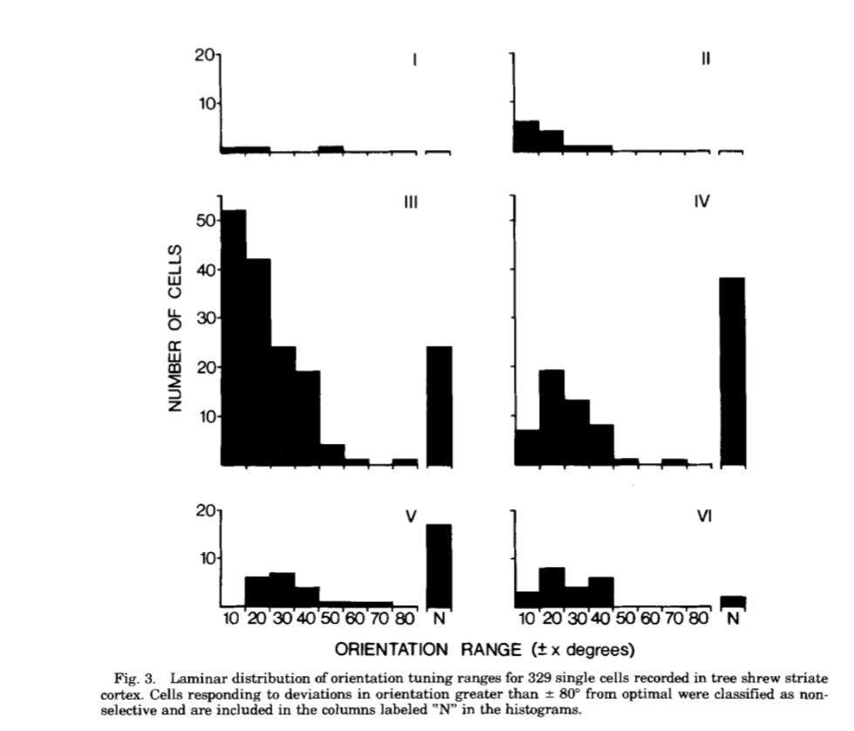

Most unoriented cells in layer 4 using bar. Layer 3 also had a fair few unoriented cells. Most number of cells from layer 3?

Did not really look for columnar organisation but suggest that it exists.

Orientation columns something about it being strip like.

1. Anatomical Banding of Intrinsic Connections in Striate Cortex of Tree Shrews

Rockland, Lund and Humphrey 1982; JCN: 209: 41-58

Used HRP periodically organised stripe like connections in layers 1 to 3c

Architectonic Characteristics

Layer 4

Layer III C – Cell Sparse zone- in some aspects resembles layer 4b in macaques. Lie between zones of thalamic input- layer 4 and layer 3b. Contains a heavily myelinated plexus of tangentially oriented fibres. Does not appear to contain pyramidal neurons. Myelinated zone does not extend to layer 4. Horizontally oriented fibres in layer 3c and layer 5a.

Intrastriate injections

Injected HRP+ 3H-proline in white matter

Horizontal bands of label in layer 1, III C and V.

Regularly arranged intrinsic connections

HRP gets carried to similar orientation columns?

1. Chisum et al., 2003

Emergent Properties of Layer 2/3 Neurons Reflect the collinear arrangement of horizontal connections in tree shrew visual cortex

Journal of Neuroscience 23: 7

* Horizontal connections in the tree shrew Layers 2/3
* Bar Orientation tuning: Layer 2/3 neurons showed sharper orientation tuning. OSI= 0.81 vs OSI=0.31.
* RF accordingly elongated. Layer 2/3 mean= 2.3:1 and :ayer 4 average 1.2:1.
* Length summation in Layer 2/3.
* Some cells in Layer 4 were **Length Tuned** whereas others were not.
* Axially faciliatation. When presented Gabors of the same orientation along the axis of preferred orientation (along which there are also horizontal connections), there is facilitation.

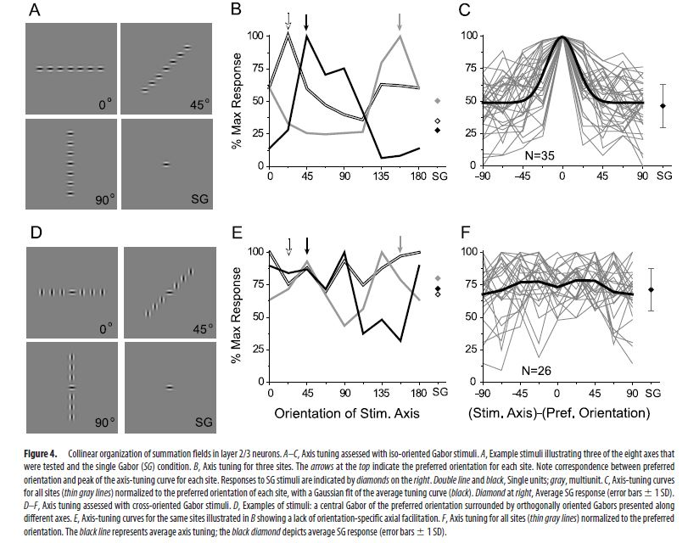

* This is not due to a lack of resolution as orthogonal orientations along the axis don’t provide any such facilitation.
* Bouton density- distribution similar to that of the length summation profile.

Thoughts: This paper makes me want to cry. WHYYYY???!?!?!?

Orientation selectivity more dependent on horizontal connections.

Suggest that orientation of the inputs don’t matter. An SG stimulus that occupied only a portion of the MDF evoked orientation specific response. This would also work if only one rf was providing orientation selectivity rather than a group of neurons.

Why would the activation region be elongated in optical imaging? What does this activation even mean? Also how you get activation? Activation in regions getting input from the layer 4 neurons…

Main story: Horizontal connections play an important role in establishing rf features- especially orientation selelctivity, length summation. They affect the properties of the centre and not just the surround. Are activated only when the layer 4 neurons are activated and this is how they maintain their resolution.

1. A morphological basis for orientation tuning in primary visual cortex

Mooser et al., 2004 Nature Neuroscience

Injected biocytin in layer 4 neurons +used optical imaging and looked at the way axons are arranged in layer 2/3. Conclude that the way these inputs are arranged in layer 2/3 are enough for orientation tuning- in direct contrast to earlier paper which says that this is not enough? But not really say that?

Compared the orientation of the target with the axis of displacement of the boutons. Found that there was higher bouton density where the axis of displacement was the same as the orientation of the target. But also they found something similar with the horizontal projections? What if this was just a smaller version of the same? Does it still mean the same thing???

Also why only pick certain orientations? Shouldn’t there be response all along the diagonal line?? What does that mean (eg: TS 002)? Why anisotropies in different animals? Radial?? There is a bit of a trend towards this.

Also what sort of control is this?

“Thus, the actual position of the boutons in layer 2/3 is crucial for the observed correlation between orientation preference and axis of displacement”

Yes.. but why would you expect otherwise? How would that show that this isn’t a relation to the visual space map? IT would matter if the relation was resent regardless of the visual space. But it doesn’t… whhyyyyy

Also what do boutons mean? Do they come from one neuron? Many neurons? How do you distinguish? What is to stop all boutons coming from neurons sharing the same RF? 100 microns worth of cells take up 300 microns worth of boutons.

Suggest that not just feedforward inputs are responsible but also inhibition and non-linearities. Further deviation from the h and w model of orientation selectivity. No simple cells – Unpublished observations.

OK. Not sure Nature Neuroscience worthy. As for the actual work, not sure really if this means anything. Their own data shows that horizontal projections are elongated along the axis. Taken together with the columnar architecture and layer 4 cells being tuned to the same orientation of layer 2/3 cells, eventhough it’s been , this could simply mean that the axon terminals make contact along an elongated layer 2/3 dendritic arbor. Event where they say there s and increased number along certain axes, I am not sure that is actually present. There is potentially an outlier which could potentially be eliminated by filtering. Elongation along the other axis seems to be present. If it’s present simply along one axis, corresponding with the orientation where the boutons terminate it probably means that orientation of the neuron corresponds to the orientation of the input cell?

Or if it happens at all orientaitons, then something along the lines of what they are proposing I suppose.

Can use the bits about the aspect ratios. 2.3:1 of the layer 2/3 cell vs 1.6:1 of the layer 4 cells. Like intracellular work from the cats.

1. Circuits for Local and Global Signal Integration in Primary Visual Cortex

Angelucci et al 2002, Journal of Neuroscience, 22(19)

Not reading fully but found that feedforward monosynaptic circuits in the V1 were of a good size for modulating the spatial summation field while the feedback projections from extrastriate areas were an appropriate size for modulating the surround.

1. Tanaka, 1985; Organisation of Geniculate inputs to visual cortical cells in the cat

Vision Research 25(3)

Multiple X and y cells converge on to simple and complex cells- more than 10 for simple and more than 30 for complex. The on and off neurons are spatially segregated.

Mooser et al., 2001- abstract; Mooser et al., 2004 instead. Tucker and Fitzpatrick, 2003; Muly and Fitzpatrick, 1992; Angelucci et al 2002; Ringach et al., 2002; bosking et al., 2002; Tanaka 1985; Reid and Alonso 1995; Ferster et al., 1996; Chung and ferster 1998