BACKTEST PARAMETER COMPARISON
Screening yield, confirmation coverage, and parameter sensitivity
Evaluation window: January 1, 2022 to June 9, 2026 | Parameter sets: 192 | Compact outcomes: 4,550
Key conclusion: volume-ratio threshold is the dominant driver of screening yield. The broadest configuration selected 92 A-F and 23 A-H securities, while stricter volume settings reduced the candidate pool rapidly. This report compares screening coverage, not realized investment-return quality.

Executive Summary
- The run completed successfully across all 192 parameter combinations with no duplicate outcomes, missing core prices, invalid dates, or high/low inconsistencies.
- A-F produced 3,698 parameter-security outcomes across all 192 parameter sets and 92 unique securities.
- A-H produced 852 outcomes across 132 parameter sets and 23 unique securities; weekly confirmation substantially narrows the candidate universe.
- Lower volume-ratio thresholds and shorter fundamental-history requirements produce the largest candidate pools.
- Return, median return, win rate, and drawdown ranking are not present in the execution log; those metrics should be queried from `backtest_selection_outcome` before selecting a final strategy.

Validated Run Overview
Screen | Outcomes | Sets with results | Unique stocks | Earliest | Latest
A-F | 3,698 | 192 | 92 | 2022-01-26 | 2026-05-27
A-H | 852 | 132 | 23 | 2022-02-18 | 2026-04-10
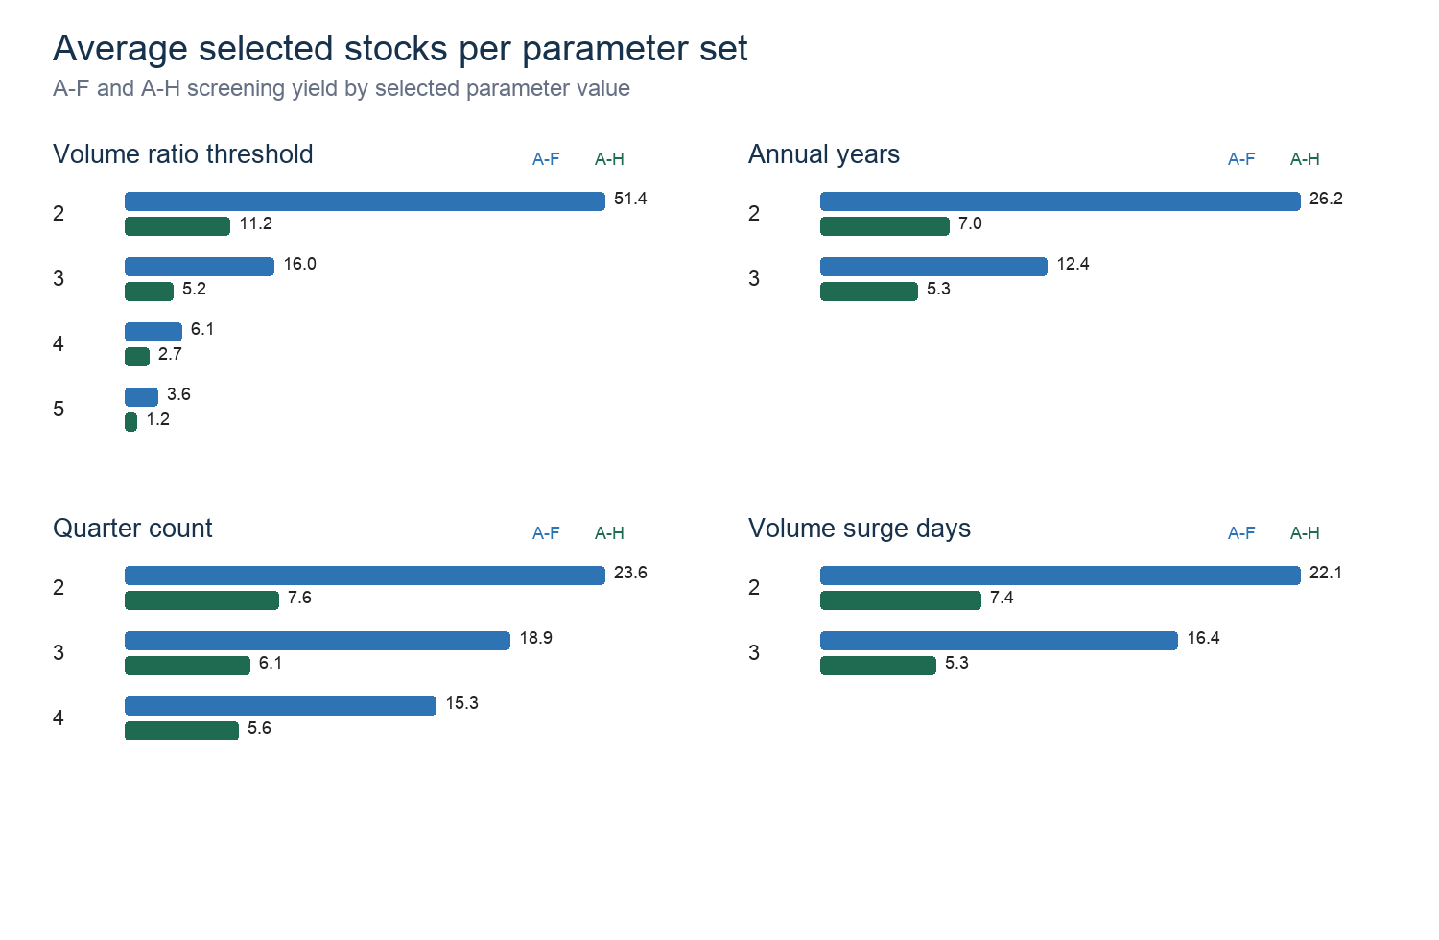
Figure 1. Average screening yield by parameter choice.

Parameter Sensitivity
Factor | Compared values | Avg A-F yield | Avg A-H yield
Annual growth threshold | 2 -> 3 | 19.9 -> 18.6 | 6.6 -> 6.3
Quarterly growth threshold | 2 -> 3 | 20.1 -> 18.5 | 6.6 -> 6.3
Annual periods | 2 -> 3 | 26.2 -> 12.4 | 7.0 -> 5.3
Quarterly periods | 2 -> 4 | 23.6 -> 15.3 | 7.6 -> 5.6
Volume ratio threshold | 2 -> 5 | 51.4 -> 3.6 | 11.2 -> 1.2
Volume surge days | 2 -> 3 | 22.1 -> 16.4 | 7.4 -> 5.3

Interpretation
- Volume ratio is the strongest selectivity lever: average A-F yield falls from 51.4 stocks at 2x volume to 3.6 at 5x; average A-H yield falls from 11.2 to 1.2.
- Requiring three annual periods instead of two roughly halves average A-F yield, from 26.2 to 12.4.
- Increasing the quarterly requirement from two to four periods reduces average A-F yield from 23.6 to 15.3.
- Moving from two to three surge days reduces average A-F yield from 22.1 to 16.4, a meaningful but less severe reduction than volume ratio.

Highest-Coverage Parameter Sets
ID | Growth A/Q | Periods A/Q | Volume | A-F | A-H | Total
1 | 2/2 | 2/2 | 2x/2d | 92 | 23 | 115
97 | 3/2 | 2/2 | 2x/2d | 88 | 21 | 109
49 | 2/3 | 2/2 | 2x/2d | 85 | 22 | 107
145 | 3/3 | 2/2 | 2x/2d | 81 | 20 | 101
9 | 2/2 | 2/3 | 2x/2d | 79 | 20 | 99
105 | 3/2 | 2/3 | 2x/2d | 76 | 18 | 94
2 | 2/2 | 2/2 | 2x/3d | 78 | 16 | 94
57 | 2/3 | 2/3 | 2x/2d | 73 | 17 | 90
50 | 2/3 | 2/2 | 2x/3d | 73 | 16 | 89
98 | 3/2 | 2/2 | 2x/3d | 74 | 14 | 88

Recommended Comparison Set
Role | ID | Configuration | A-F / A-H | Use
Broad discovery | 1 | 2%/2%, 2 annual, 2 quarters, 2x volume, 2 surge days | 92 / 23 | Largest sample; suitable baseline.
Moderate volume | 3 | 2%/2%, 2 annual, 2 quarters, 3x volume, 2 surge days | 36 / 13 | Meaningfully stricter while retaining A-H coverage.
Strict volume | 7 | 2%/2%, 2 annual, 2 quarters, 5x volume, 2 surge days | 9 / 2 | Small sample; useful only as a high-conviction comparator.
Durability focus | 41 | 2%/2%, 3 annual, 4 quarters, 2x volume, 2 surge days | 33 / 7 | Longer fundamental history with usable sample size.

Decision Guidance
- Do not label the highest-coverage parameter set as the best-performing investment strategy. Coverage and return quality answer different questions.
- Require a minimum sample size before ranking return performance. A practical initial threshold is at least 20 A-F outcomes or at least 10 A-H outcomes.
- Compare mean and median return together. A large gap often indicates that a few extreme winners dominate the average.
- Use win rate and maximum drawdown alongside returns; parameter sets with high average returns but severe drawdowns may be unsuitable.
- Evaluate A-F and A-H separately. A-H is a stricter weekly-confirmed strategy and should not be pooled with A-F.

Required Return-Performance Query
To complete an investment-performance ranking, export the following aggregate query from Supabase and use it for a second report:
SELECT p.parameter_set_id, p.parameter_set_name, o.screen_type, COUNT(*) AS sample_size,
ROUND(AVG(o.return_pct), 2) AS avg_return_pct,
ROUND(PERCENTILE_CONT(0.5) WITHIN GROUP (ORDER BY o.return_pct)::numeric, 2) AS median_return_pct,
ROUND(100.0 * COUNT(*) FILTER (WHERE o.return_pct > 0) / COUNT(*), 2) AS win_rate_pct,
ROUND(AVG(o.max_drawdown_pct), 2) AS avg_drawdown_pct,
ROUND(AVG(o.max_return_pct), 2) AS avg_max_return_pct
FROM backtest_parameter_set p JOIN backtest_selection_outcome o USING (parameter_set_id)
GROUP BY p.parameter_set_id, p.parameter_set_name, o.screen_type
ORDER BY o.screen_type, sample_size DESC;

Scope and Limitations
- This report uses the validated execution log and compares selection yield, not realized portfolio returns.
- The same security may appear in many parameter sets, so outcome rows are not independent observations.
- Fundamental histories use `datadate <= selected_date`; actual public filing-availability dates are unavailable, so some look-ahead-bias risk remains.
- No transaction costs, liquidity constraints, holding rules, or overlapping-position controls are included.

