2.3. Data Flow Diagram
Visual representation of information flow through the system
The Data Flow Diagram (DFD) shows how information moves through the Temple Management System, between different processes, outside users, and data storage.

2.3.1. Level 0 DFD (Context Diagram)
Figure 2.1: Temple Management System Context Diagram
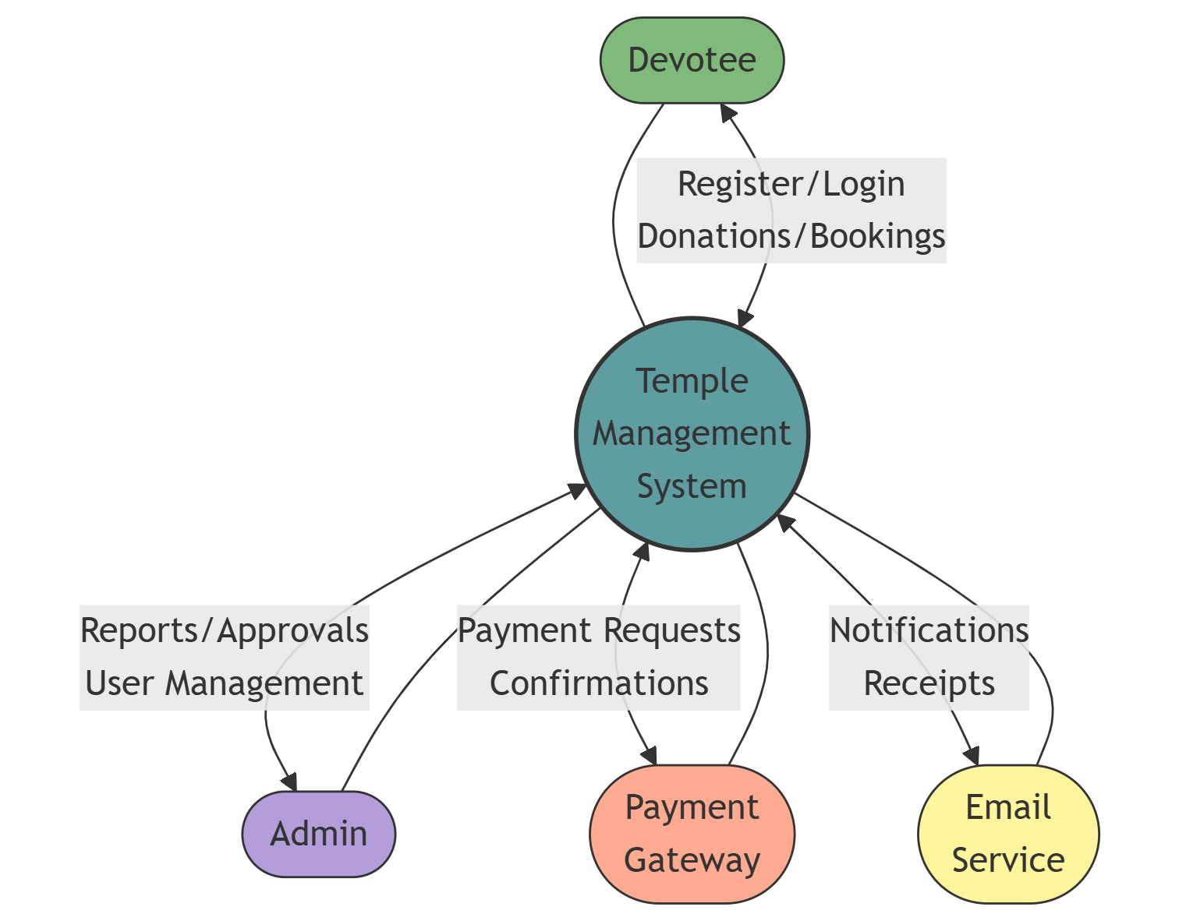

2.3.2. Level 1 DFD (Major Processes)
Figure 2.2: Temple Management System Level 1 DFD
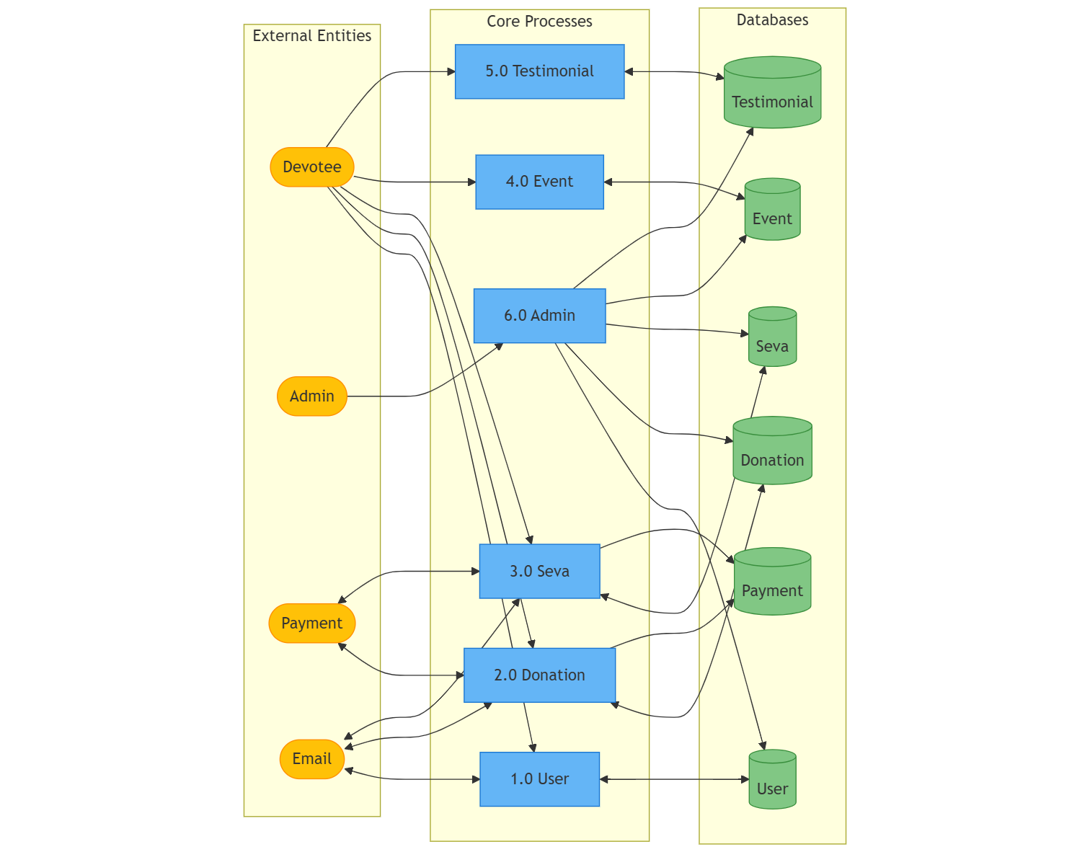

2.3.3. Level 2 DFD (Detailed Processes)
Figure 2.3: Temple Management System Level 2 DFD - User Management
[Place for Temple Management System User Management DFD]
User Management Split (4 DFDs)
Figure 2.3.1: Temple Management System Level 2 DFD - User Registration and Verification 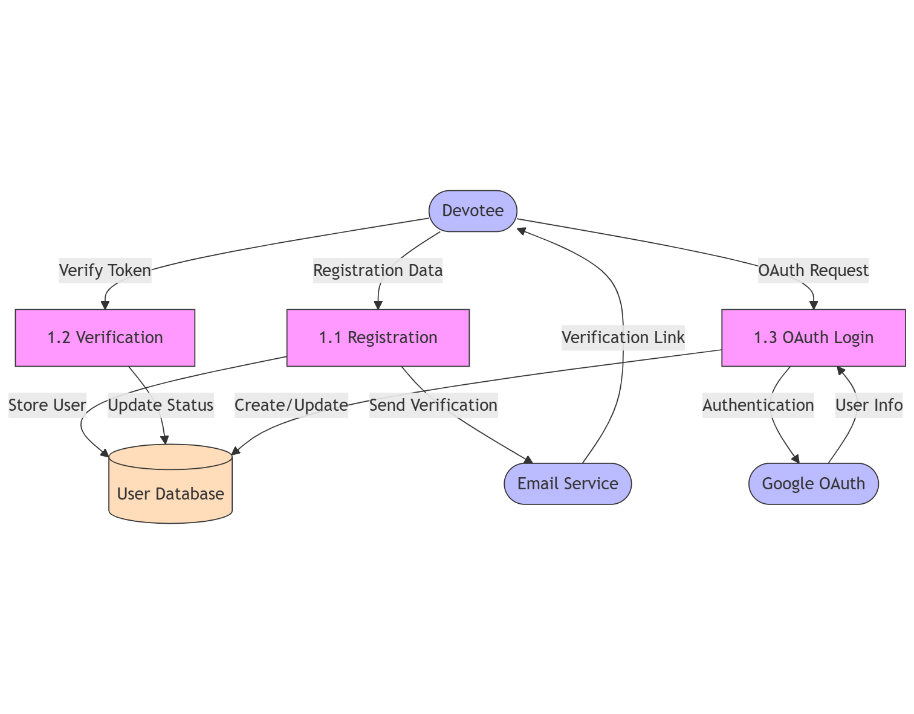
- Focus: Initial account creation and verification flows
- Processes: Registration form processing, Email verification, Google OAuth integration
- Key data flows: User registration data, verification tokens, email notifications
Figure 2.3.2: Temple Management System Level 2 DFD - User Authentication
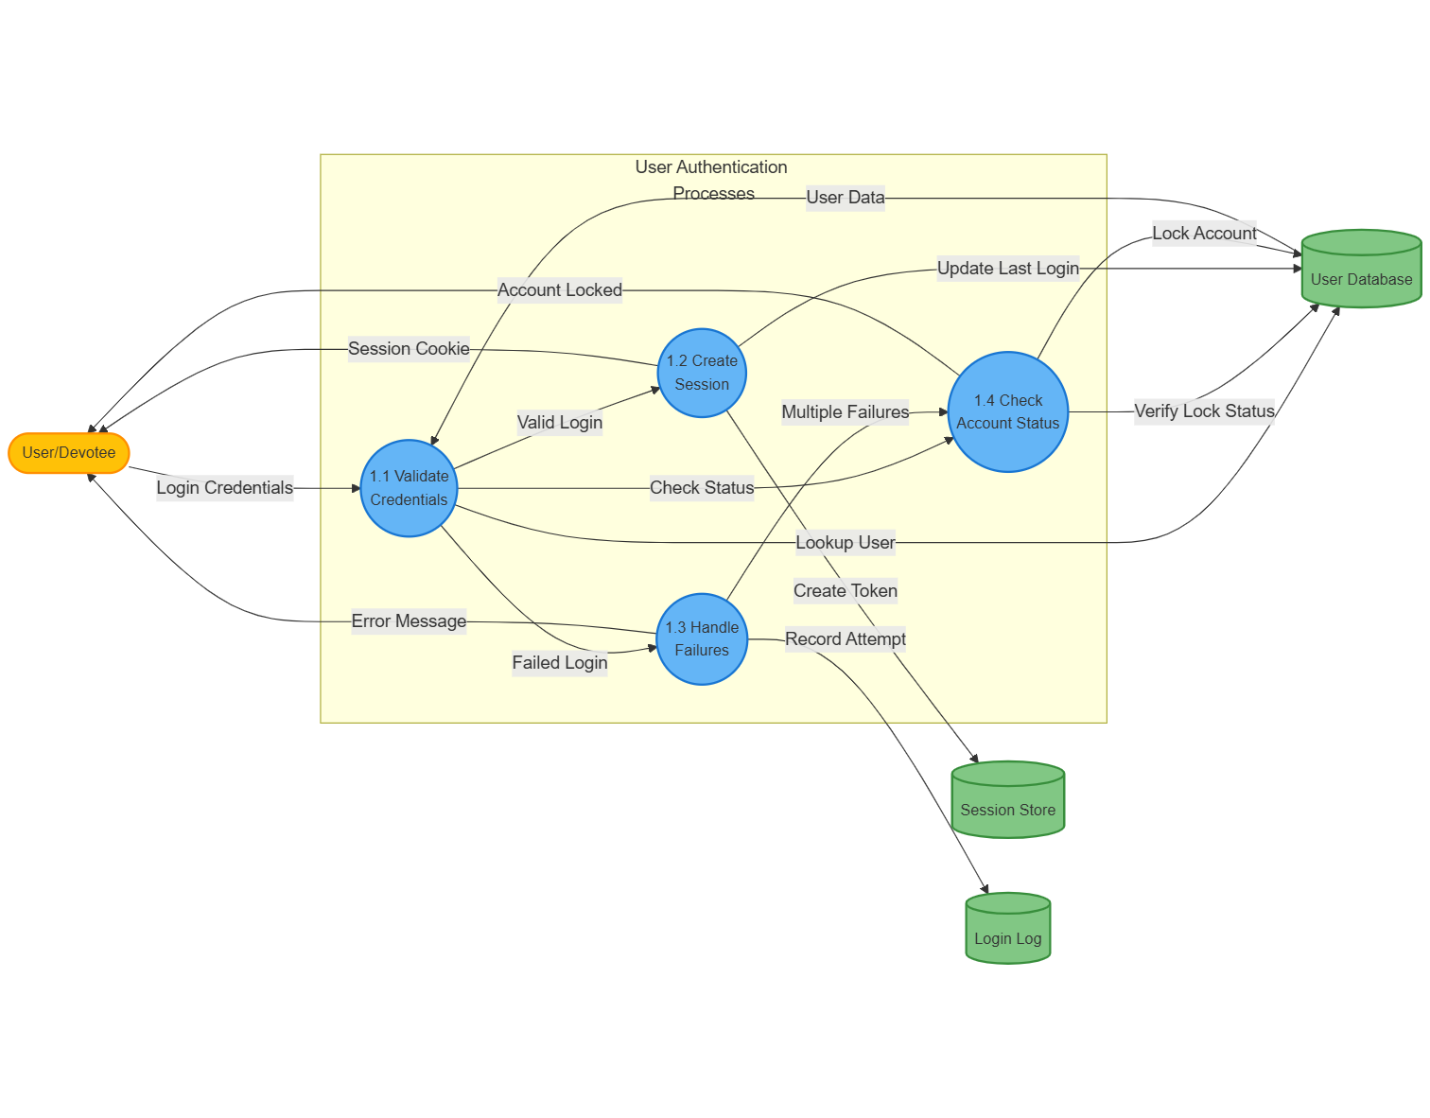
- Focus: Login processes and session management
- Processes: Credential validation, Session creation, Login tracking, Logout processing
- Key data flows: Login credentials, session tokens, authentication responses
Figure 2.3.3: Temple Management System Level 2 DFD - User Profile Management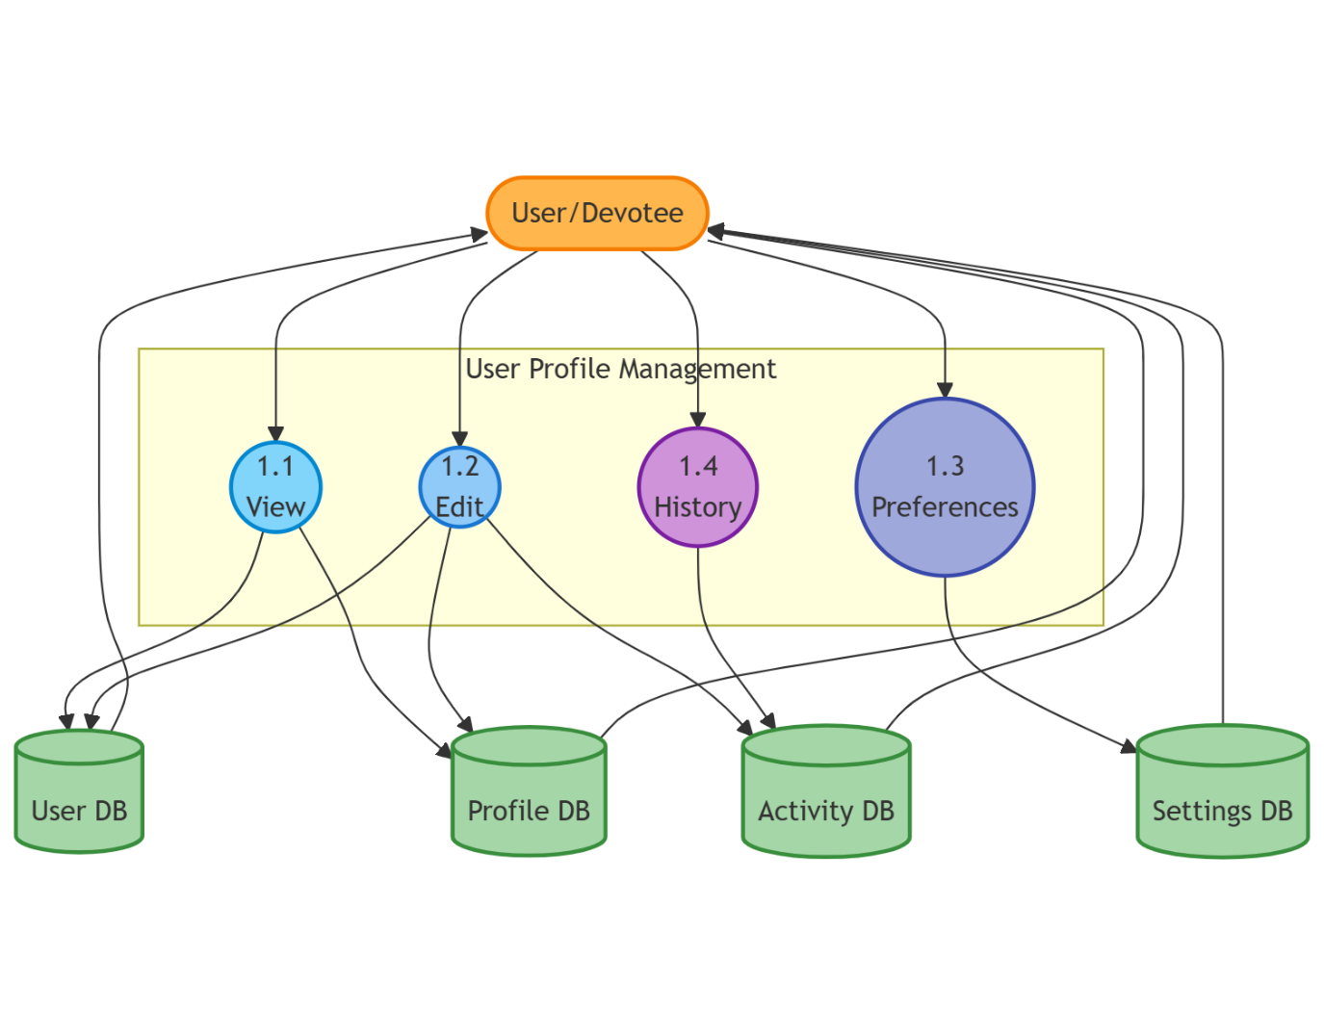
- Focus: User data maintenance
- Processes: Profile viewing, Profile editing, Preference settings, Privacy controls
- Key data flows: Profile update requests, user data retrieval, preference settings
Figure 2.3.4: Temple Management System Level 2 DFD - Account Recovery
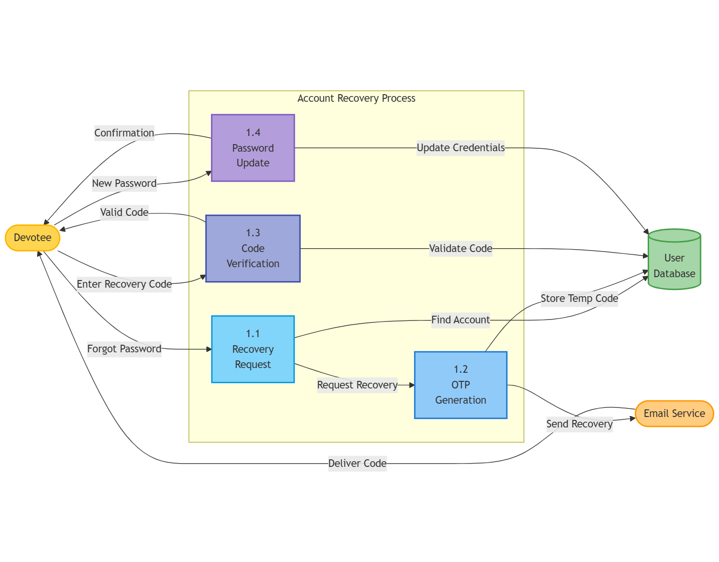
- Focus: Password reset and account recovery
- Processes: Password reset requests, OTP generation, Password updating
- Key data flows: Reset requests, verification codes, password changes

Figure 2.4: Temple Management System Level 2 DFD - Donation Management
[Place for Temple Management System Donation Management DFD]
Donation Management Split (4 DFDs)
Figure 2.4.1: Temple Management System Level 2 DFD - Donation Form Processing
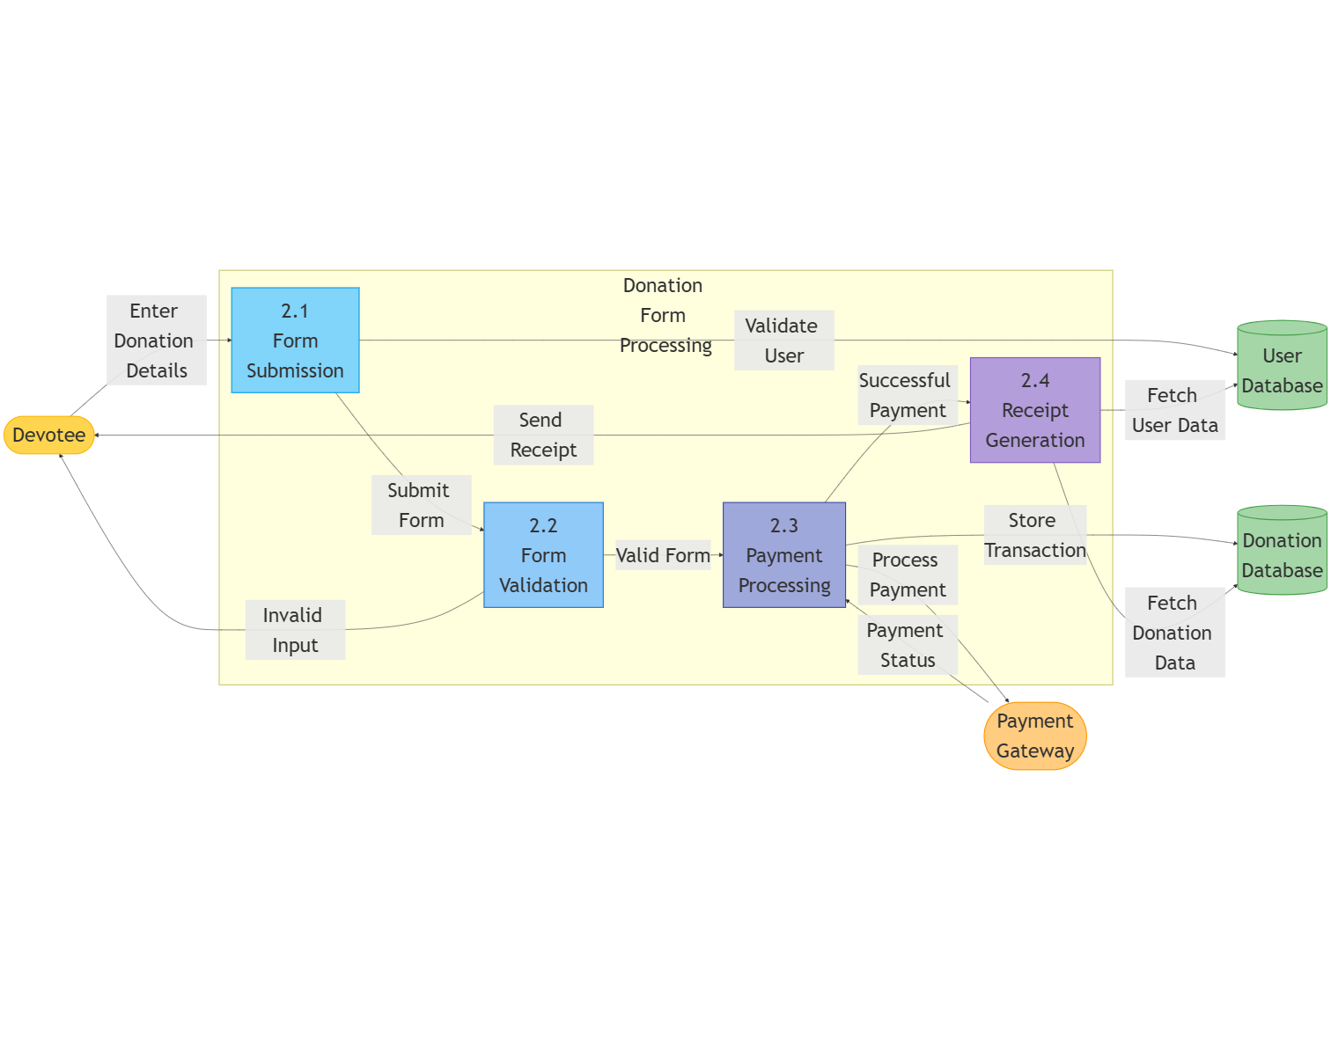
- Focus: Donation initiation and form handling
- Processes: Donation type selection, Amount input, Donor information collection
- Key data flows: Donation form data, donor details, donation type information
Figure 2.4.2: Temple Management System Level 2 DFD - Payment Processing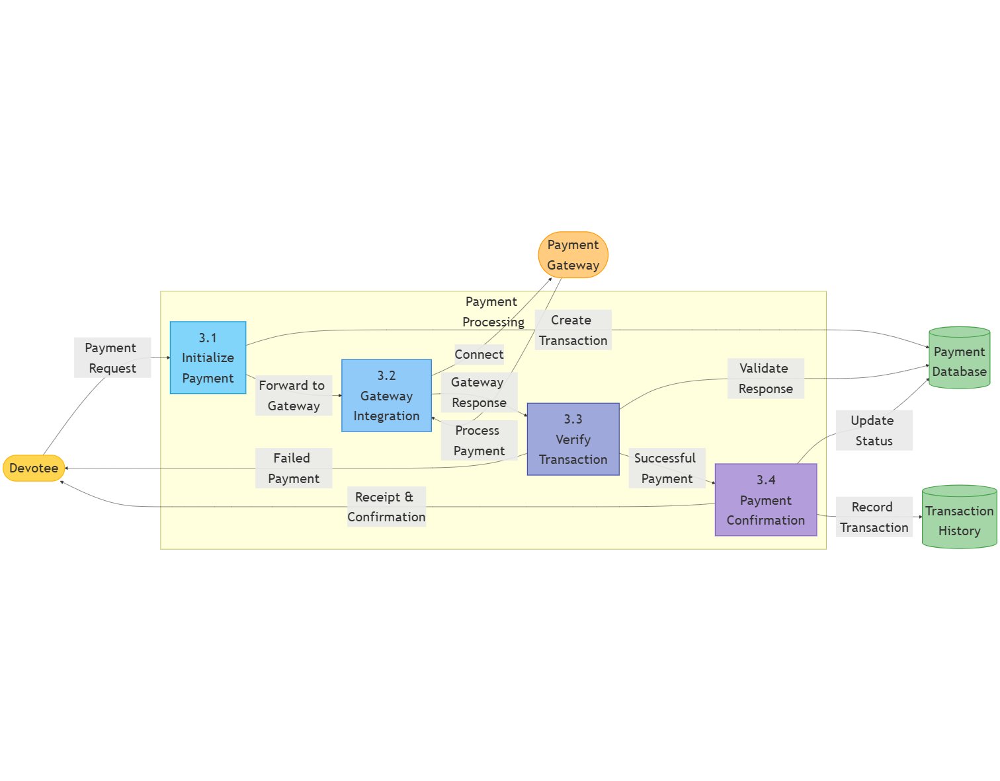
- Focus: Payment gateway integration
- Processes: Payment initiation, Gateway redirection, Transaction verification
- Key data flows: Payment requests, gateway responses, transaction confirmations
Figure 2.4.3: Temple Management System Level 2 DFD - Receipt Generation
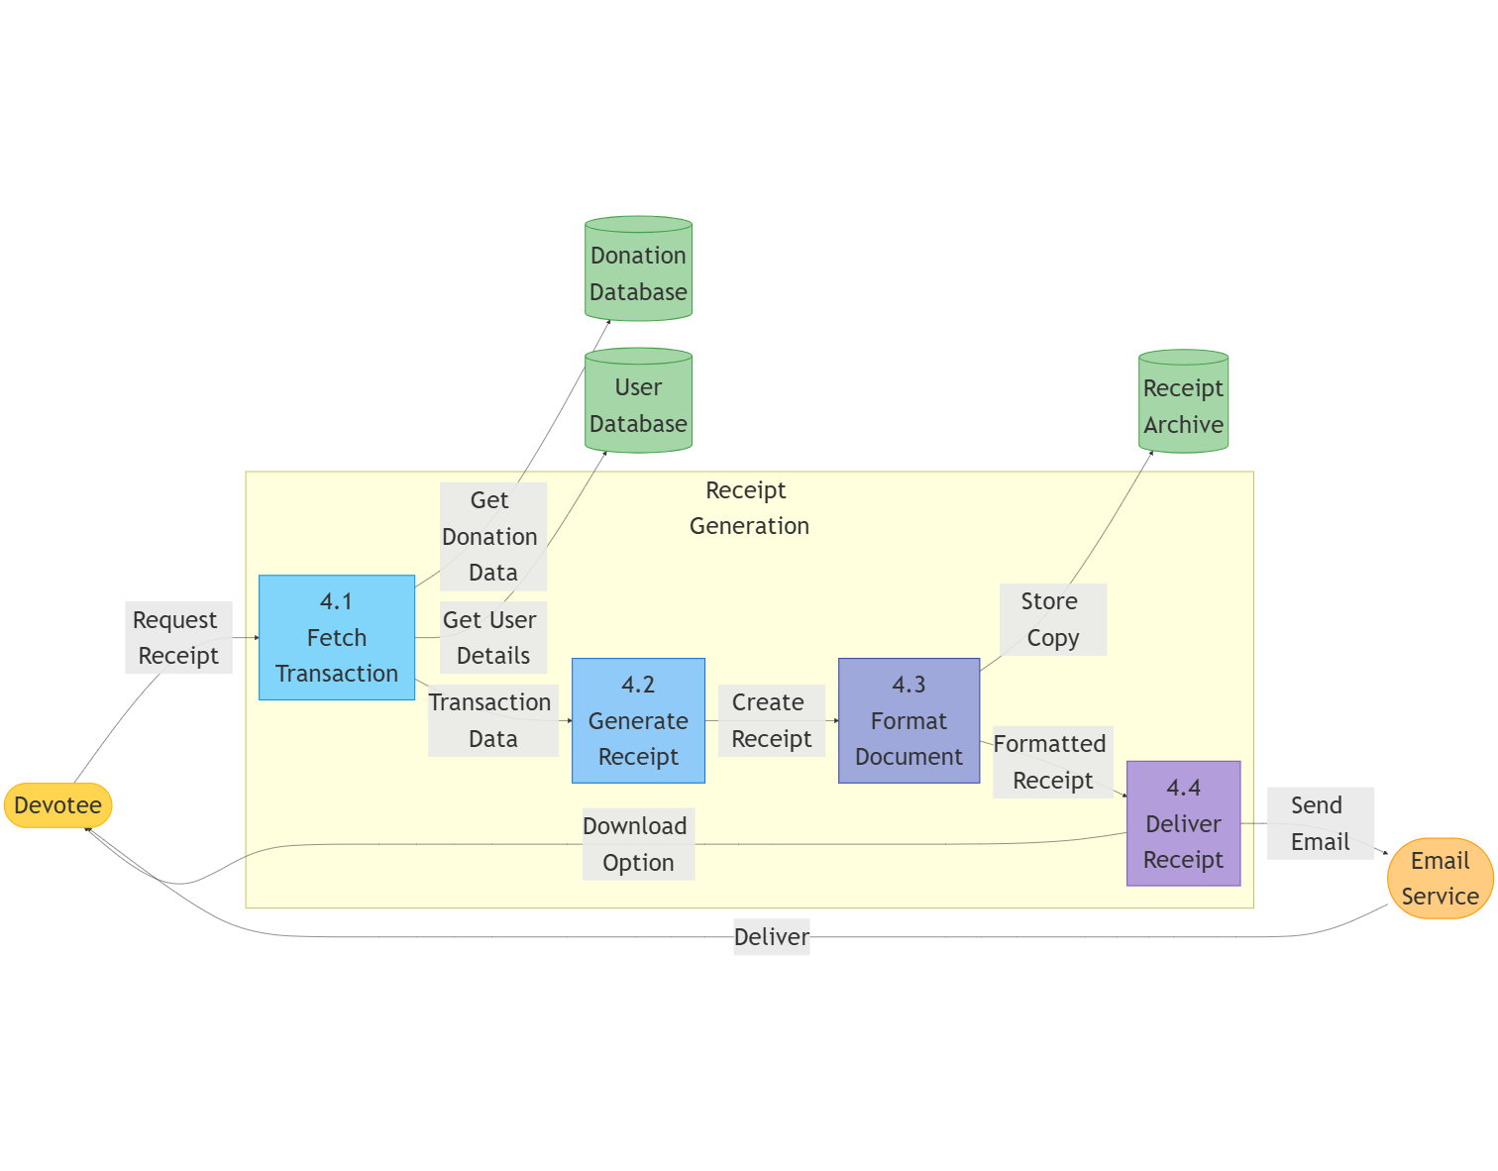
- Focus: Donation acknowledgment
- Processes: Receipt creation, Email notification, Tax receipt generation
- Key data flows: Receipt data, email notifications, downloadable documents
Figure 2.4.4: Temple Management System Level 2 DFD - Donation Reporting 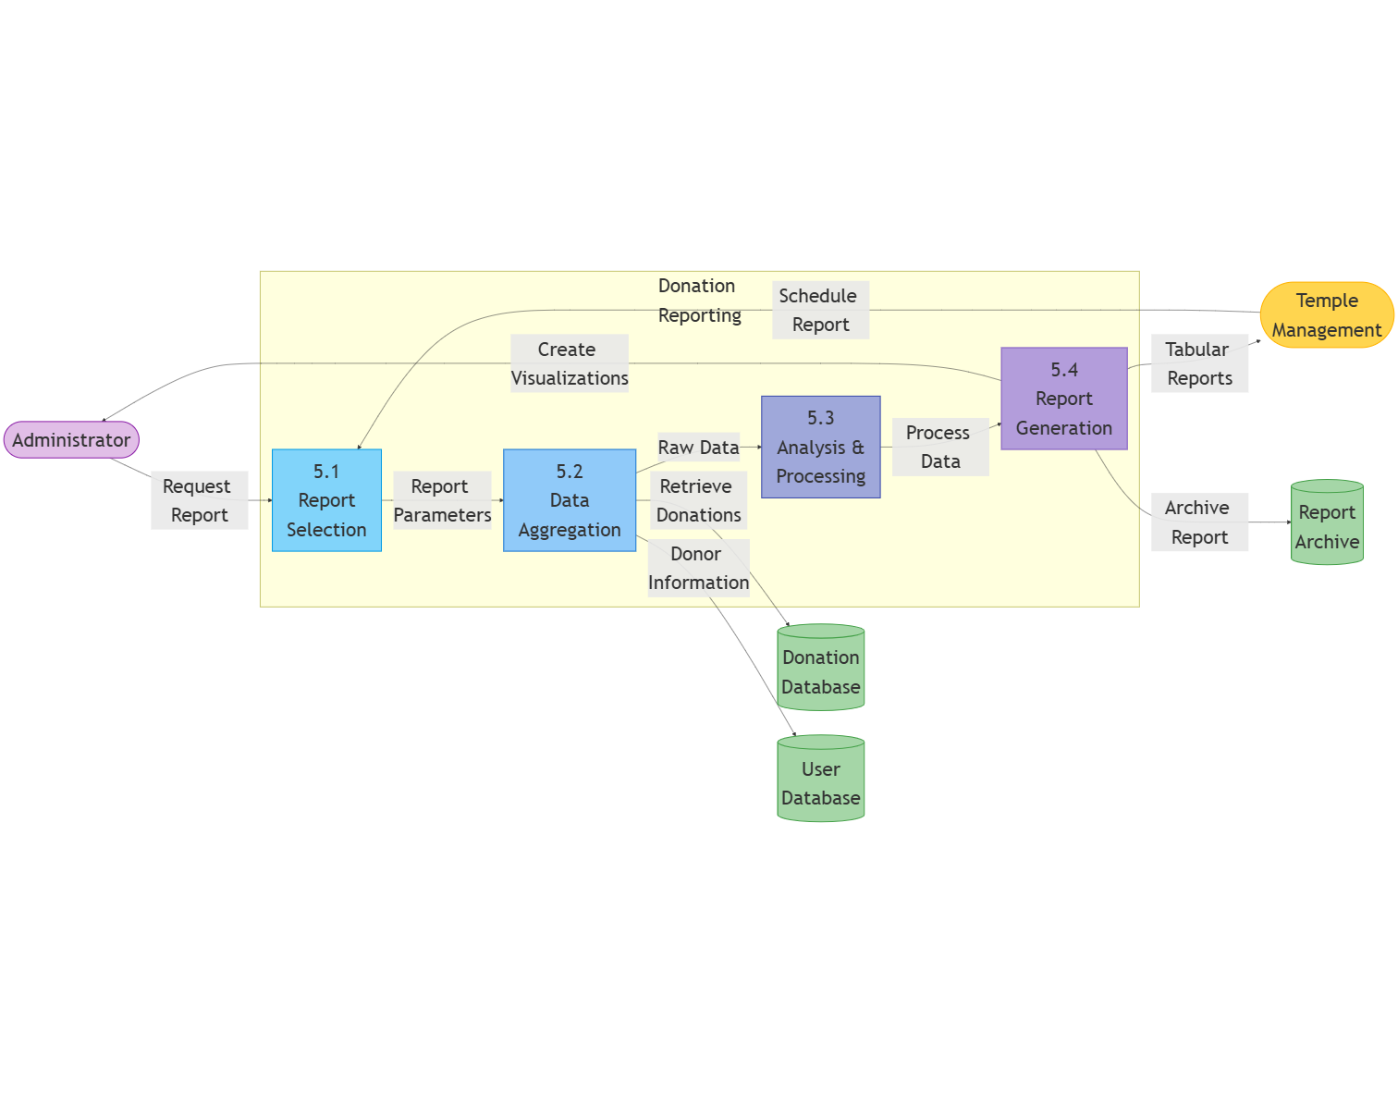
- Focus: Donation history and analysis
- Processes: Donation history retrieval, Reporting, Donation analytics
- Key data flows: History requests, donation records, statistical data

Figure 2.5: Temple Management System Level 2 DFD - Seva Management
[Place for Temple Management System Seva Management DFD]
Seva Management Split (4 DFDs)
Figure 2.5.1: Temple Management System Level 2 DFD - Seva Catalog Management
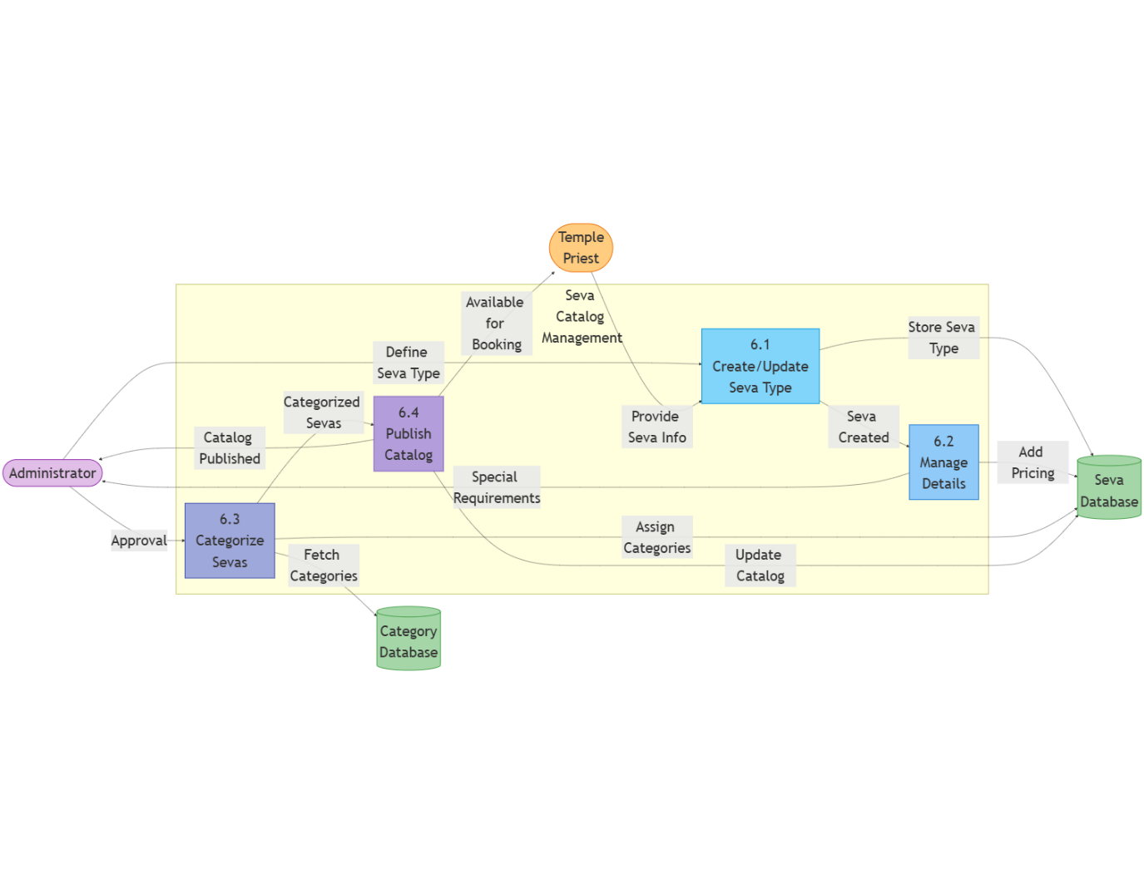
- Focus: Seva offerings display
- Processes: Seva listing, Category filtering, Seva details display
- Key data flows: Catalog requests, seva descriptions, availability information
Figure 2.5.2: Temple Management System Level 2 DFD - Seva Booking
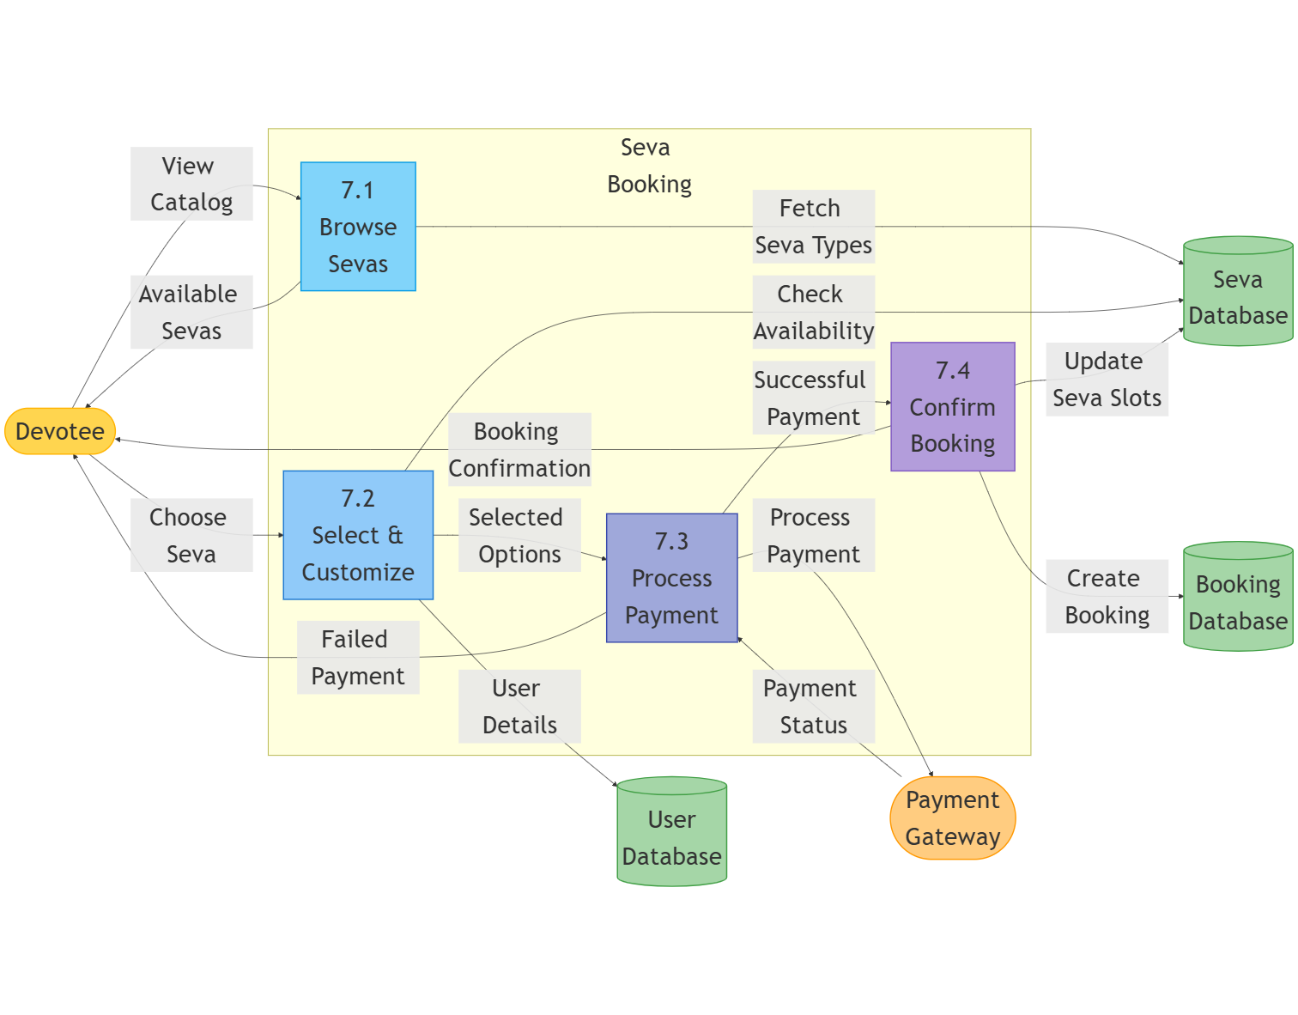
- Focus: Scheduling and reservation
- Processes: Date/time selection, Participant information, Special request handling
- Key data flows: Booking requests, scheduling data, participant information
Figure 2.5.3: Temple Management System Level 2 DFD - Seva Payment Processing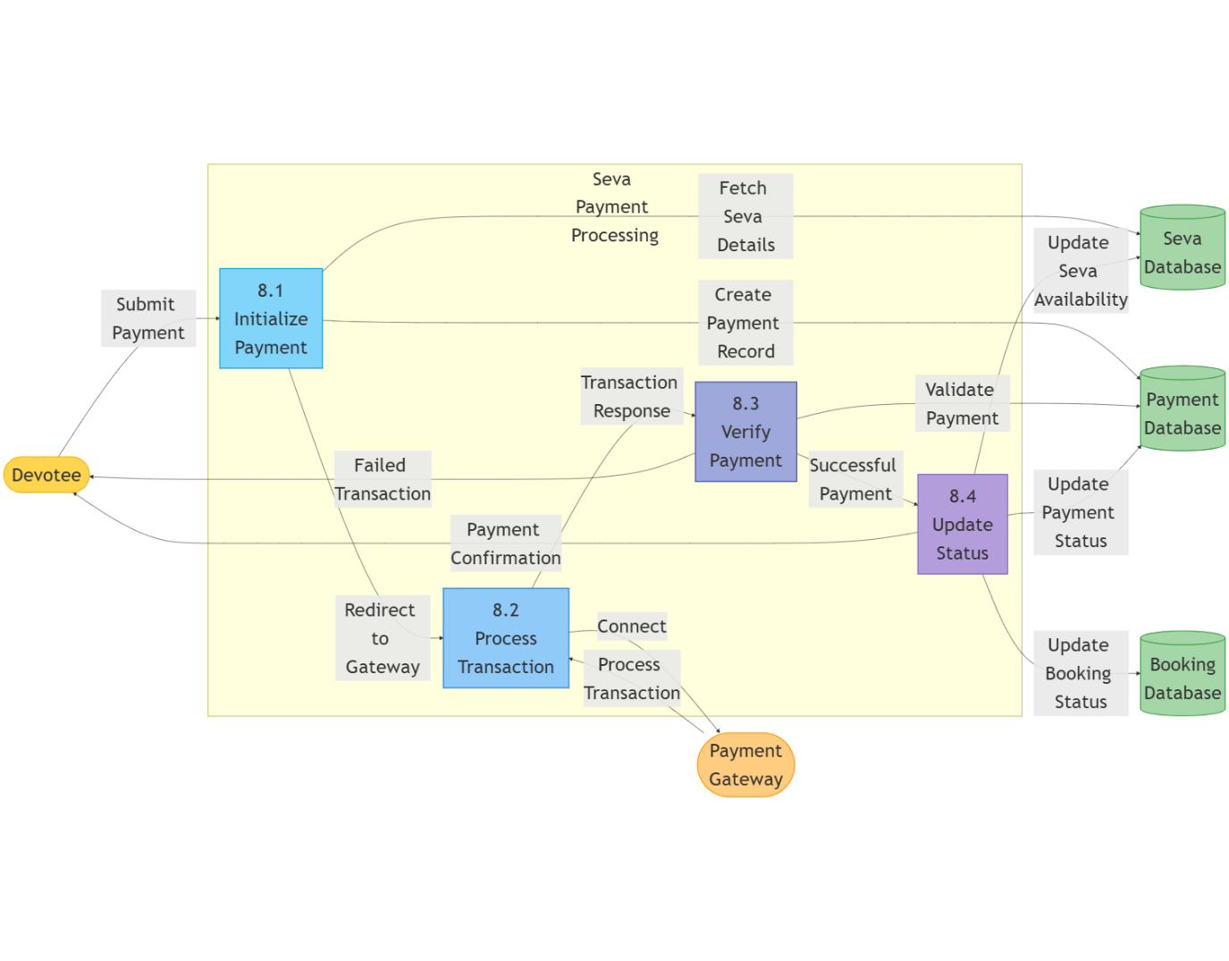
- Focus: Seva booking payments
- Processes: Payment calculation, Payment processing, Order status tracking
- Key data flows: Payment data, transaction processing, payment confirmations
Figure 2.5.4: Temple Management System Level 2 DFD - Booking Management
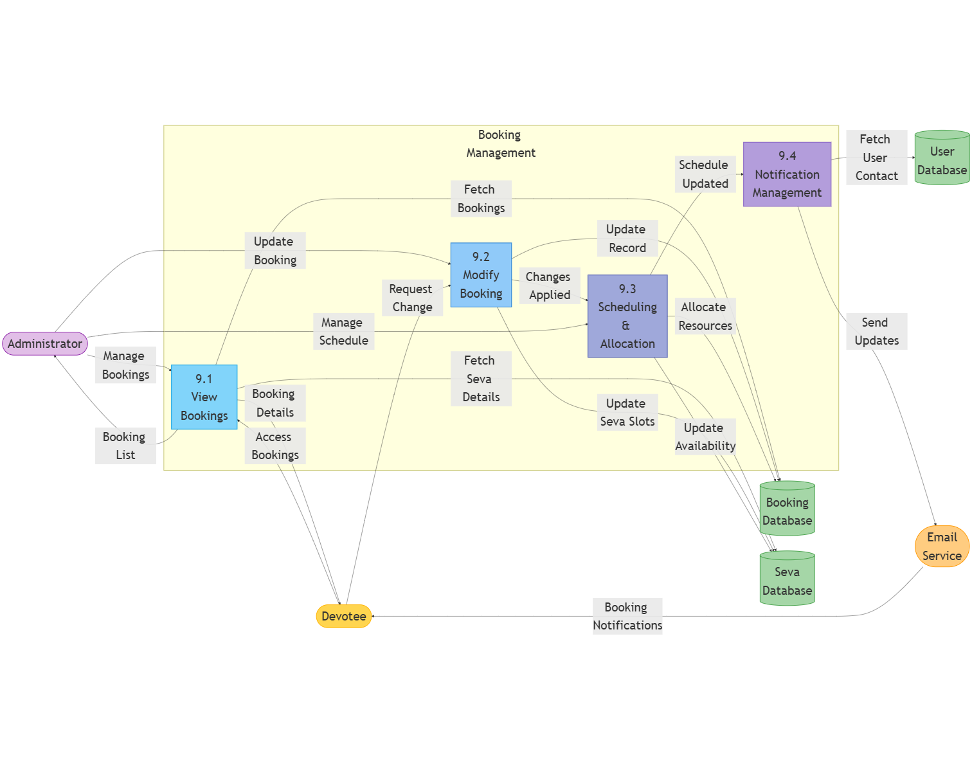
- Focus: Booking confirmations and modifications
- Processes: Booking confirmation, Booking modification, Booking cancellation
- Key data flows: Confirmation messages, modification requests, status updates

2.3.4. Level 3 DFD (Process Details)
Level 3 DFDs provide the most detailed view of specific processes within the system.
Figure 2.6: Temple Management System Level 3 DFD - User Authentication Process
[Place for Temple Management System User Authentication Process DFD]
User Authentication Process Split (5 DFDs)
Figure 2.6.1: Temple Management System Level 3 DFD - Credential Validation Process

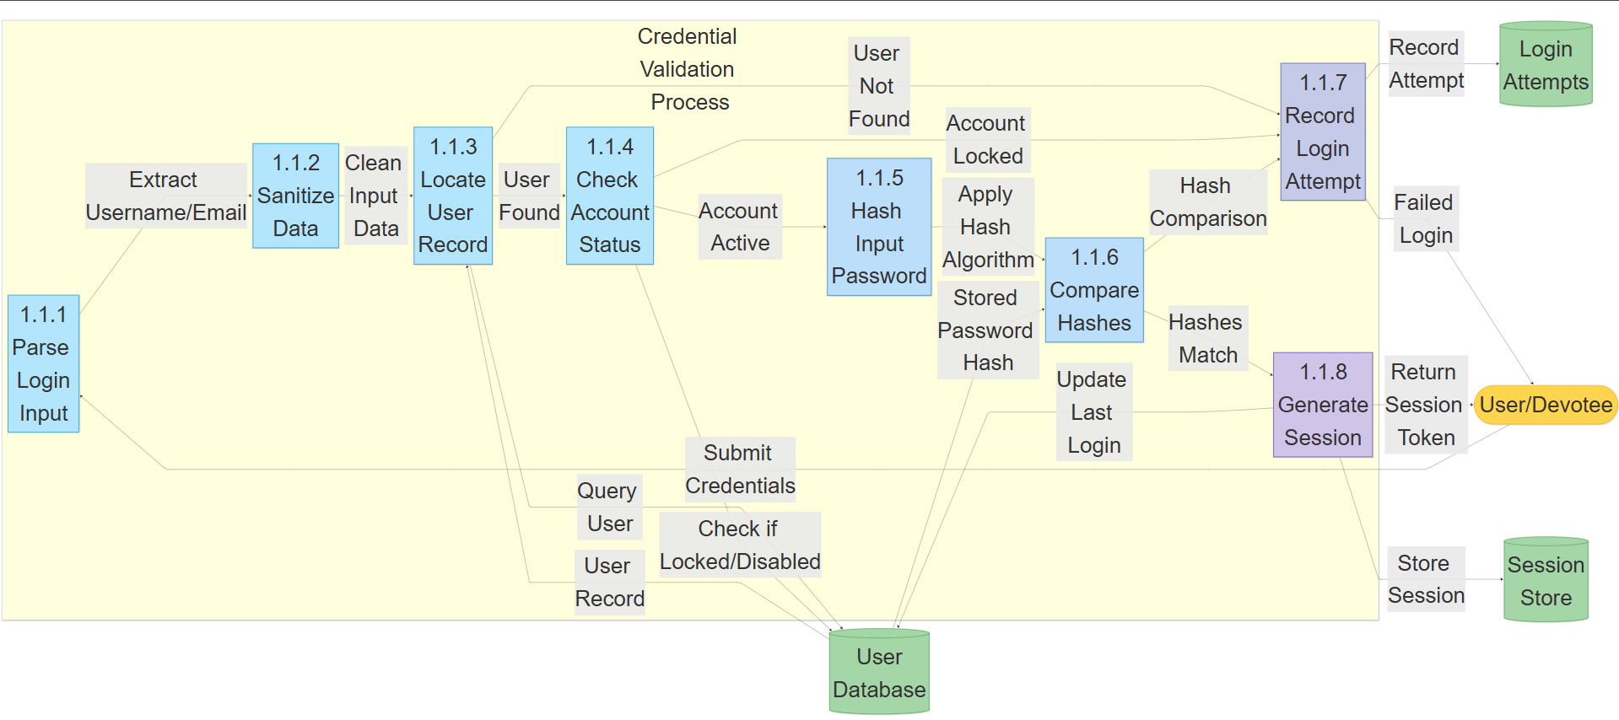

- Focus: Detailed validation of user credentials
- Processes:
- Input sanitization
- Username/email lookup
- Password hash comparison
- Account status verification
- Login attempt tracking
- Key data flows: Sanitized credentials, database queries, validation results
Figure 2.6.2: Temple Management System Level 3 DFD - Session Management Process
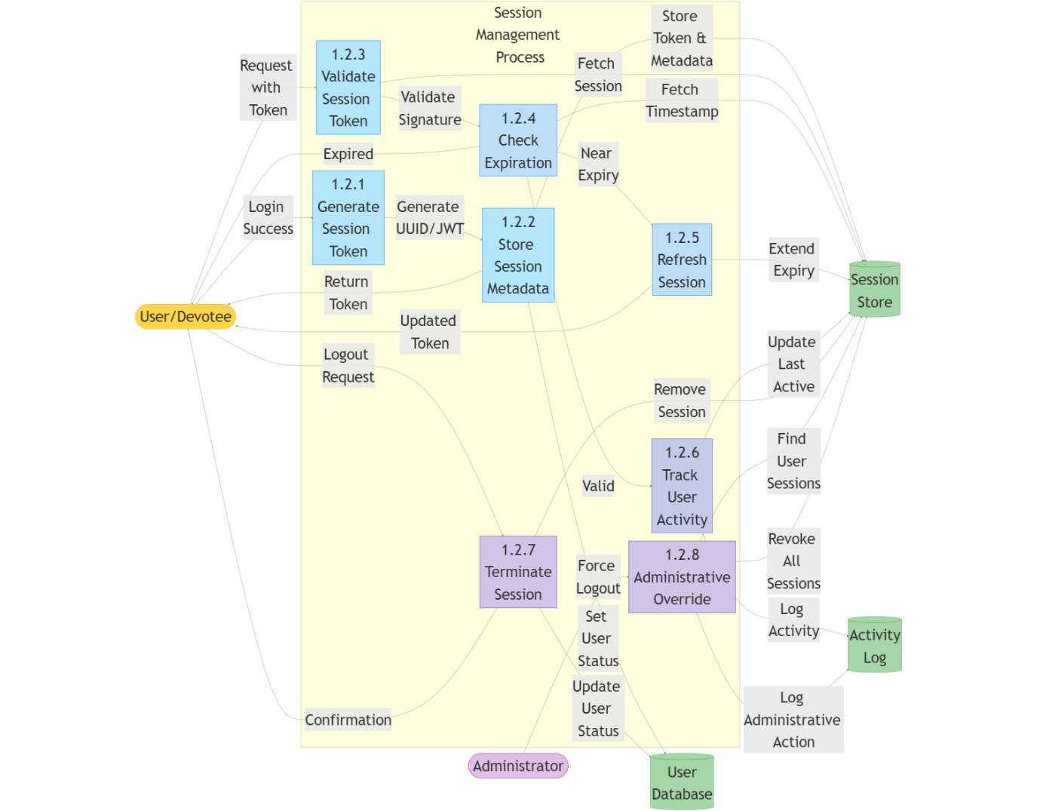
- Focus: Creation and management of user sessions
- Processes:
- Session token generation
- Session storage
- Cookie setting
- Session expiration handling
- Multi-device session management
- Key data flows: Session tokens, cookie data, expiration timestamps
Figure 2.6.3: Temple Management System Level 3 DFD - Authentication Failure Handling
- Focus: Processing of failed login attempts
- Processes:
- Error detection
- Error classification
- Error messaging
- Failed attempt counting
- Security alert generation
- Key data flows: Error codes, failure notifications, security alerts
Figure 2.6.4: Temple Management System Level 3 DFD - Password Recovery Process
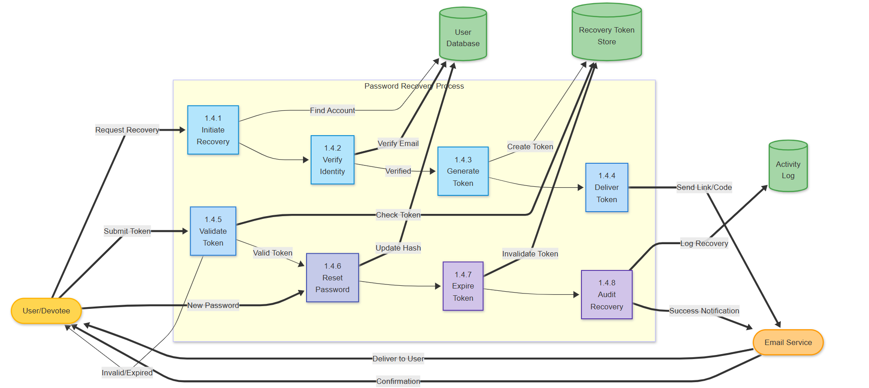
- Focus: Complete password reset workflow
- Processes:
- Recovery request validation
- OTP generation and delivery
- OTP verification
- Password reset form processing
- Password update and notification
- Key data flows: Reset tokens, verification codes, new password data
Figure 2.6.5: Temple Management System Level 3 DFD - Account Lockout Management
- Focus: Security mechanisms for suspicious activities
- Processes:
- Threshold monitoring
- Account locking
- Notification of lockout
- Unlock verification
- Unlock processing
- Key data flows: Failed attempt counts, lockout notifications, unlock requests

This diagram shows the detailed data flow for user authentication, including:
- Login credential validation
- Session creation
- Authentication failure handling
- Password recovery flow
- Account lockout procedures
Figure 2.7: Temple Management System Level 3 DFD - Payment Processing
[Place for Temple Management System Payment Processing DFD]
Payment Processing Split (5 DFDs)
Figure 2.7.2: Temple Management System Level 3 DFD - Payment Gateway Integration
- Focus: Communication with external payment service
- Processes:
- Order creation
- Gateway API communication
- Redirect handling
- Callback processing
- Payment session management
- Key data flows: API requests, payment tokens, redirect URLs
Figure 2.7.3: Temple Management System Level 3 DFD - Transaction Verification Process
- Focus: Confirming payment completion
- Processes:
- Signature validation
- Transaction status checking
- Amount reconciliation
- Order status updating
- Transaction logging
- Key data flows: Verification signatures, transaction IDs, status codes
Figure 2.7.4: Temple Management System Level 3 DFD - Receipt Generation Process
- Focus: Creating and delivering payment confirmations
- Processes:
- Receipt data compilation
- Receipt formatting
- PDF generation
- Email delivery
- Receipt storage
- Key data flows: Transaction data, formatted receipts, delivery statuses
Figure 2.7.5: Temple Management System Level 3 DFD - Payment Error Handling
- Focus: Managing payment failures and exceptions
- Processes:
- Error detection
- Error classification
- User notification
- Recovery options
- Transaction rollback
- Key data flows: Error codes, failure notifications, recovery instructions

This diagram details the payment processing flow, including:
- Payment information collection
- Payment gateway interaction
- Transaction verification
- Receipt generation
- Error handling procedures

2.4. ER Diagram
Database structure and relationships between entities
Figure 2.9: Temple Management System ER Diagram
[Place for Temple Management System ER Diagram]
User Management ER Diagram
Figure 2.9.1: Temple Management System ER Diagram - User Domain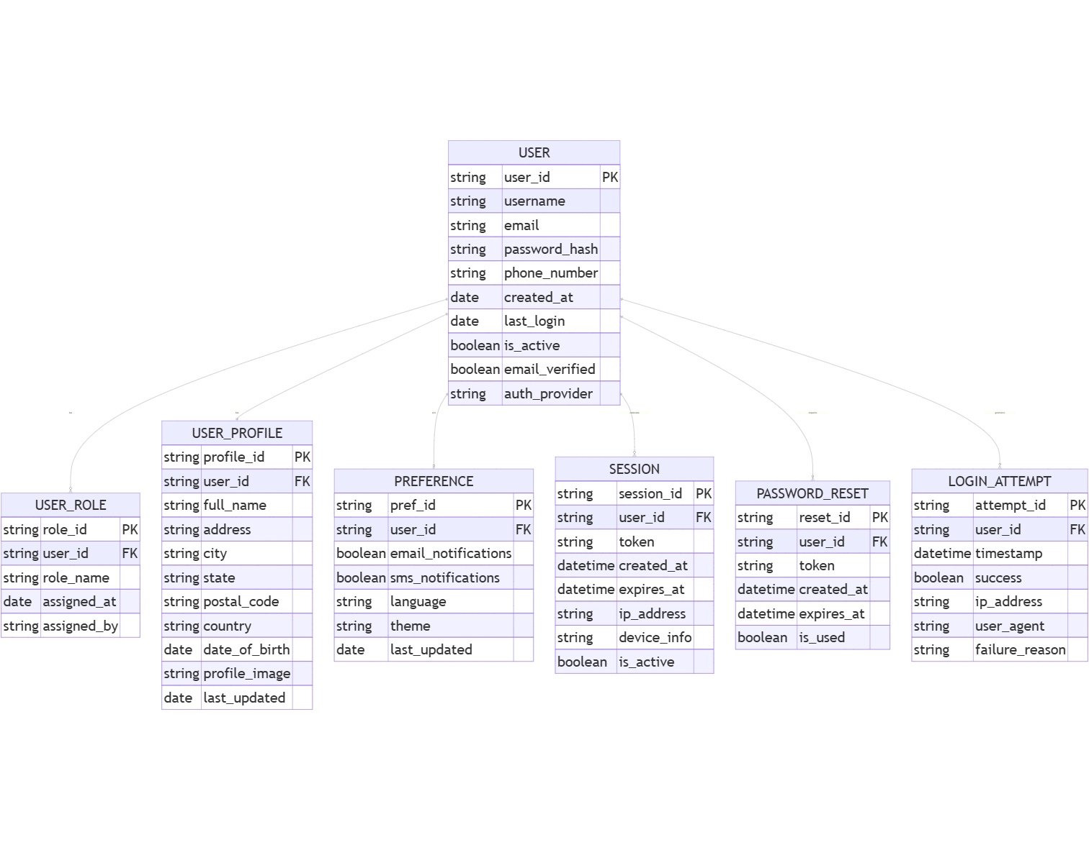
- Focus: User-related data structures
- Primary Entities:
- User (with user types: devotee, staff, administrator)
- UserRole (role-based permissions)
- UserProfile (extended user information)
- LoginHistory (authentication tracking)
- UserPreference (personalization settings)
- Key Relationships:
- User has_one UserProfile
- User has_many LoginHistory
- User belongs_to UserRole
- User has_one UserPreference
- Important Attributes:
- User: id, email, password_hash, verified, created_at, last_login
- UserProfile: user_id, full_name, address, phone, date_of_birth, profile_photo
- UserRole: id, role_name, permissions
Donation Management ER Diagram
Figure 2.9.2: Temple Management System ER Diagram - Donation Domain
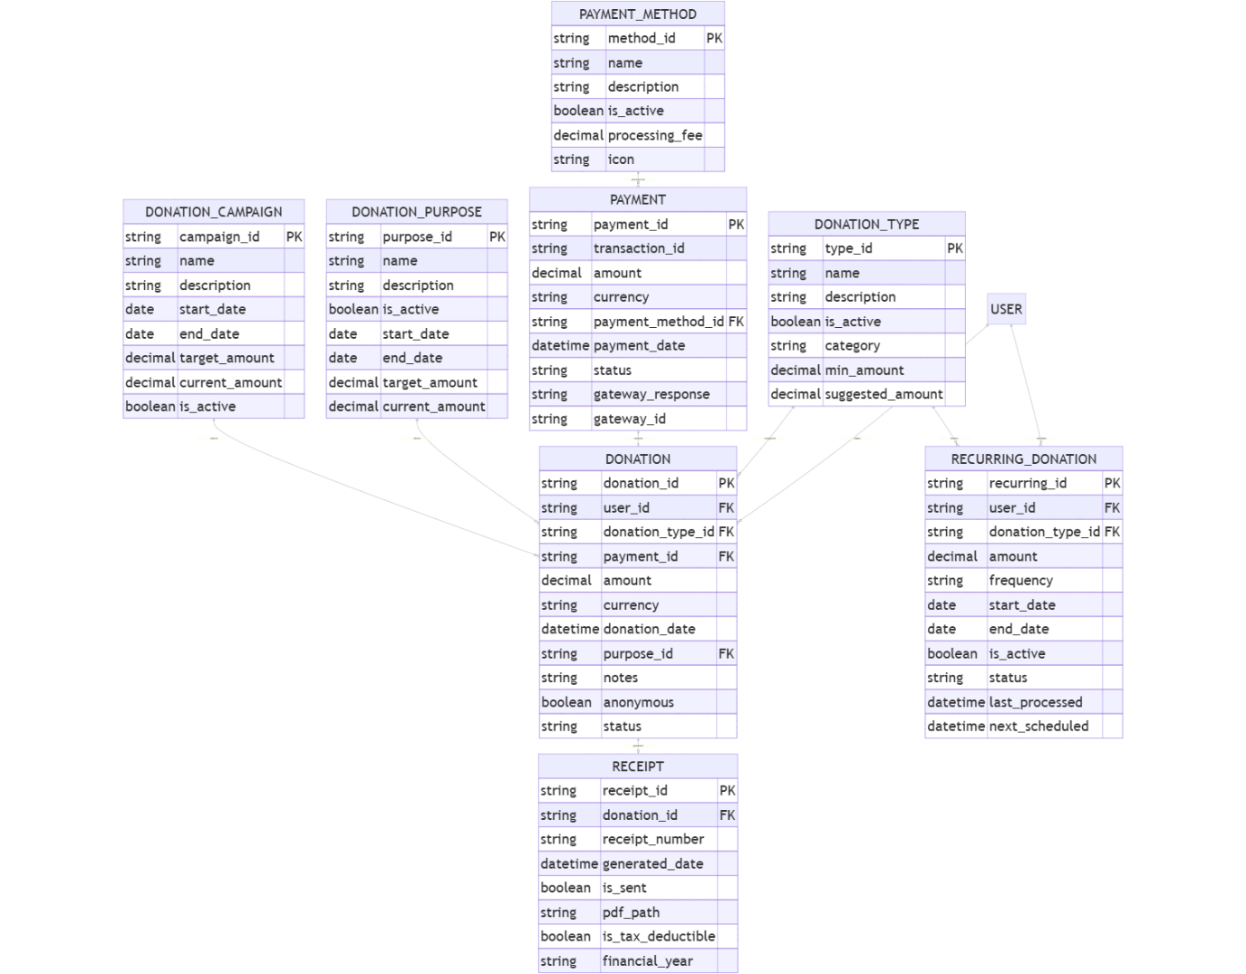
- Focus: Financial contributions structure
- Primary Entities:
- Donation (donation transactions)
- DonationType (categories of donations)
- Receipt (donation acknowledgments)
- Payment (payment transactions)
- DonationPurpose (specific donation purposes)
- Key Relationships:
- Donation belongs_to User
- Donation has_one Receipt
- Donation belongs_to DonationType
- Donation has_one Payment
- Donation belongs_to DonationPurpose
- Important Attributes:
- Donation: id, user_id, amount, date, is_anonymous, status
- Receipt: id, donation_id, receipt_number, issue_date, pdf_path
- Payment: id, transaction_id, amount, payment_method, status
Seva Management ER Diagram
Figure 2.9.3: Temple Management System ER Diagram - Seva Domain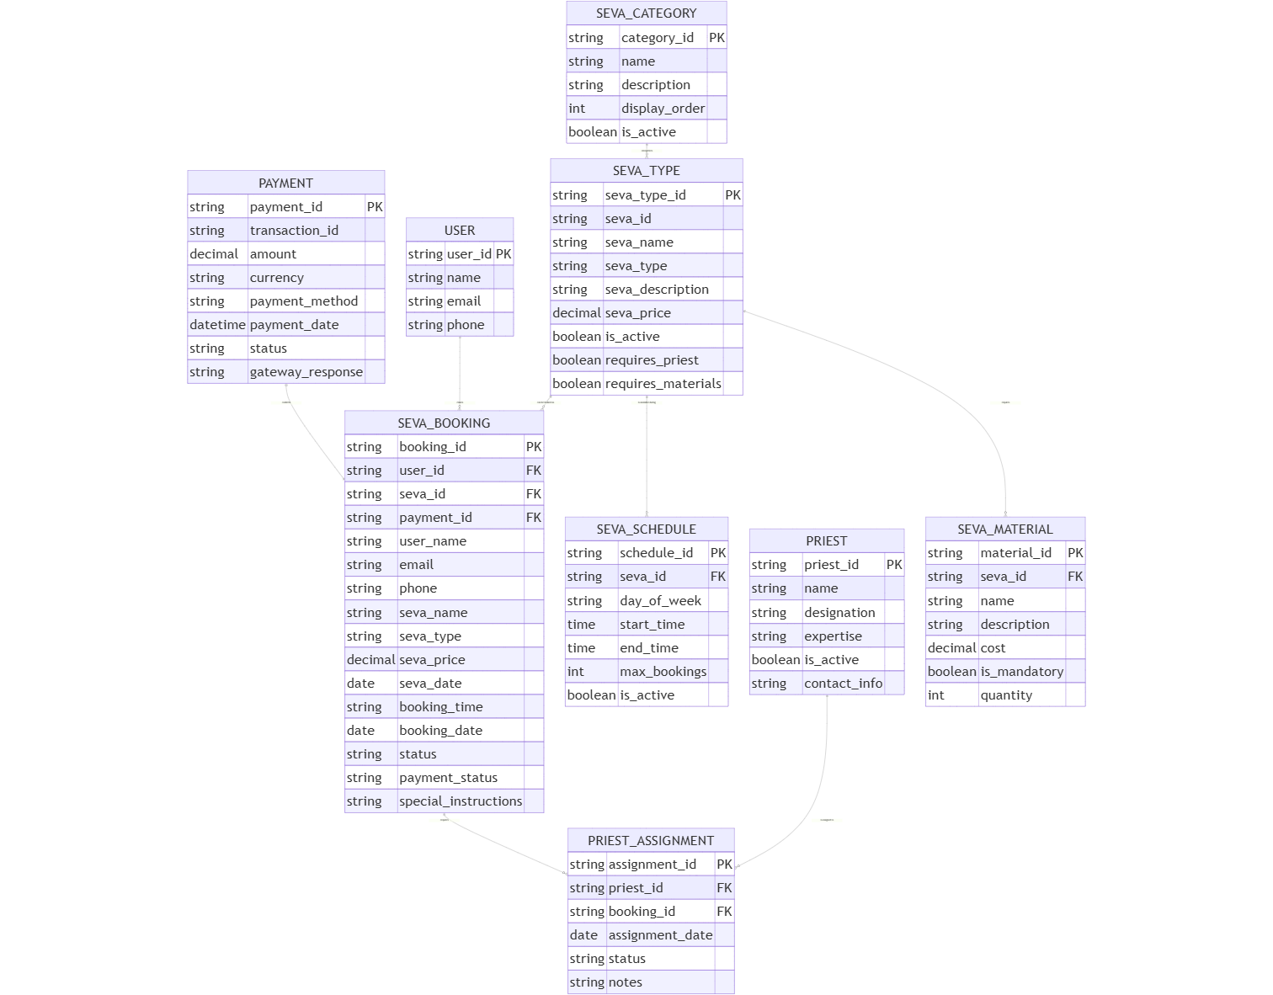
- Focus: Temple services structure
- Primary Entities:
- SevaType (available service types)
- SevaBooking (service reservations)
- SevaSchedule (service availability)
- Payment (payment transactions - shared)
- SevaParticipant (additional attendees)
- Key Relationships:
- SevaBooking belongs_to User
- SevaBooking belongs_to SevaType
- SevaBooking has_one Payment
- SevaBooking has_many SevaParticipant
- SevaType has_many SevaSchedule
- Important Attributes:
- SevaType: id, name, description, price, duration, max_participants
- SevaBooking: id, user_id, seva_type_id, scheduled_date, scheduled_time, status
- SevaSchedule: id, seva_type_id, day_of_week, start_time, end_time
Event Management ER Diagram
Figure 2.9.4: Temple Management System ER Diagram - Event Domain
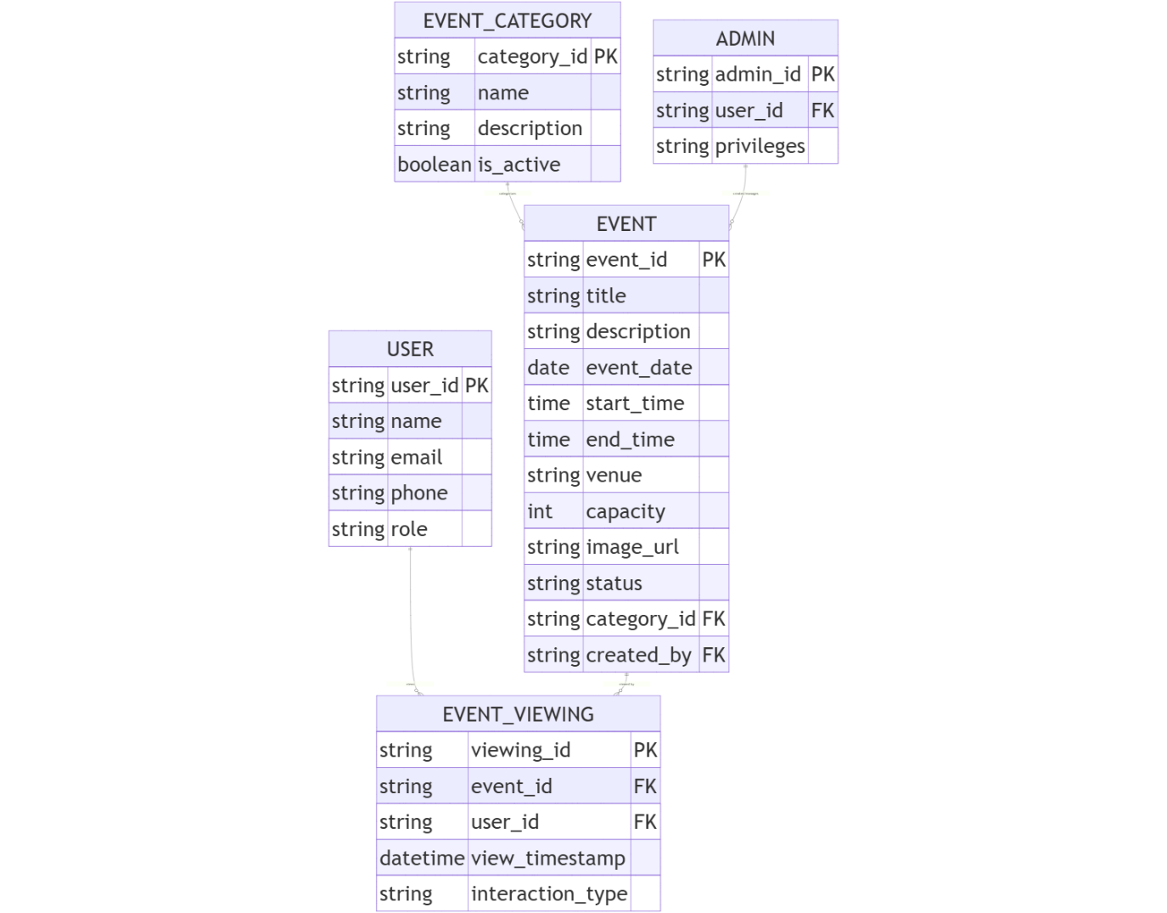
- Focus: Temple events structure
- Primary Entities:
- Event (temple programs/ceremonies)
- EventCategory (types of events)
- EventRegistration (attendance tracking)
- EventSchedule (timing information)
- Venue (location information)
- Key Relationships:
- Event belongs_to EventCategory
- Event has_many EventRegistration
- Event has_one EventSchedule
- Event belongs_to Venue
- EventRegistration belongs_to User
- Important Attributes:
- Event: id, title, description, start_date, end_date, is_recurring, max_participants
- EventRegistration: id, event_id, user_id, registration_date, attendance_status
- Venue: id, name, address, capacity, facilities
Testimonial and Category Management ER Diagram
Figure 2.9.5: Temple Management System ER Diagram - Feedback and Categorization Domain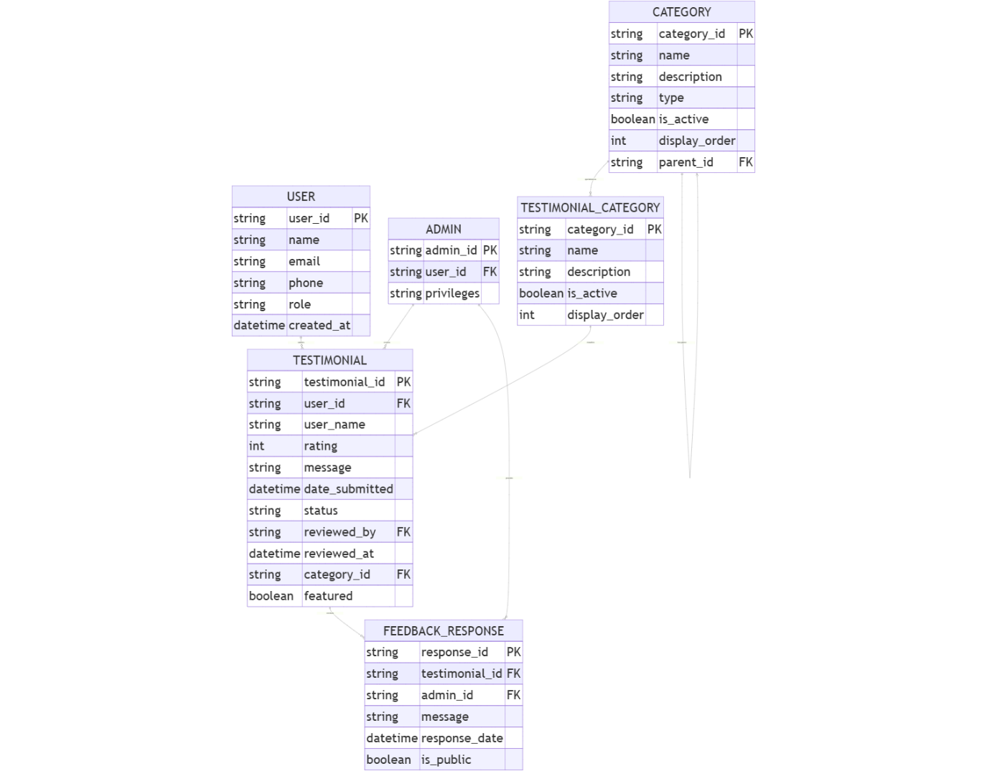
- Focus: User feedback and system categorization
- Primary Entities:
- Testimonial (user feedback)
- Category (generalized categories)
- DonationType (references from donation domain)
- SevaType (references from seva domain)
- EventCategory (references from event domain)
- Key Relationships:
- Testimonial belongs_to User
- DonationType belongs_to Category
- SevaType belongs_to Category
- EventCategory belongs_to Category
- Category has_many SubCategories (self-referential)
- Important Attributes:
- Testimonial: id, user_id, rating, message, date_submitted, status, reviewed_by
- Category: id, name, description, parent_category_id, image_path

Key entities in the ER diagram include:
- User: Represents devotees, staff, and administrators with attributes like username, password, contact information, etc.
- Donation: Records donation transactions with amount, date, purpose, etc.
- Receipt: Stores receipt information associated with donations.
- Seva Booking: Contains details of service bookings including service type, date, time, etc.
- Event: Holds information about temple events including title, description, date, venue, etc.
- Payment: Records payment transactions across donations, services, and event registrations.
- Testimonial: Stores user testimonials with content, approval status, etc.
- Category: Represents categories for both donations and services.
- Registration: Contains event registration information.
The relationships between these entities capture the essential data associations in the system, enabling comprehensive data management and retrieval. Each entity contains appropriate attributes that store specific pieces of information, and the connections between entities establish the logical structure of the database.

