# MARKETING DATASET

## KNN

Best params:

Best Hyperparameters: n_neighbors=15, p=2, weights=distance

Best Cross-Validation Accuracy: 0.8718

Varying K with uniform weight

With distance weight

Learning curve with k=15

## SVM

Best Hyperparameters: C=10.0, kernel=linear, gamma=None, degree=None

Best Cross-Validation Accuracy: 0.8845

SVM tuning

LC without shuffle or random_state

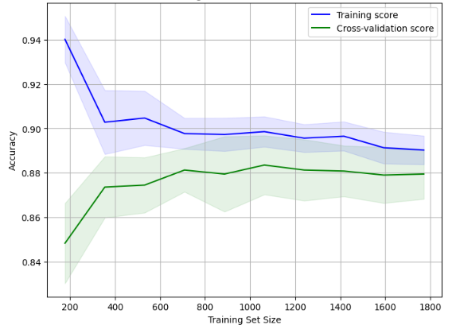

With shuffling and random state

## ANN

Best trial:

Value: 0.8986486196517944

Params:

units: 9

optimizer: rmsprop

epochs: 38

batch_size: 33

