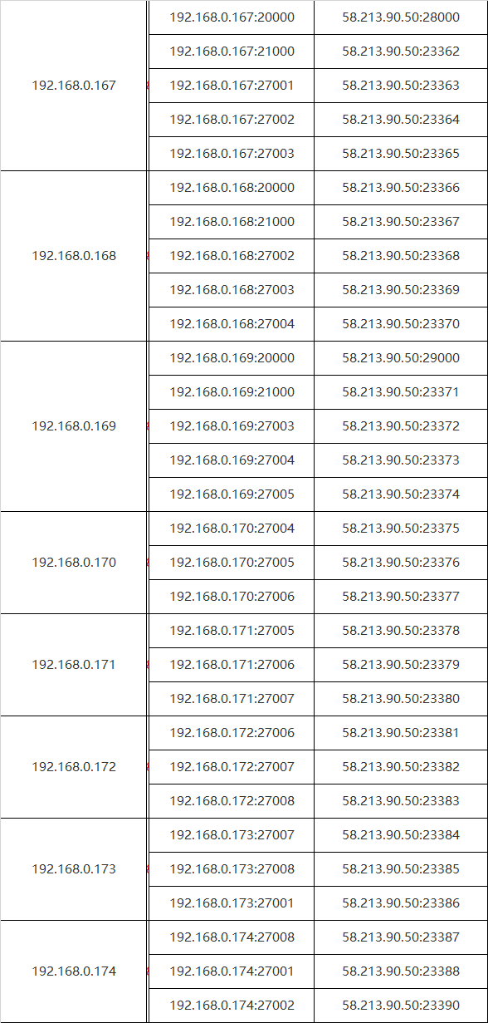

1. **去除验证**
2. **注释 auth = true**
3. **注释 keyfile路径**
4. **重启进程**

mongod -f /home/administrator/mongodb/conf/config.conf

mongod -f /home/administrator/mongodb/conf/shard1.conf

mongos -f /home/administrator/mongodb/conf/mongos.conf

1. **将每个分片的内网IP修改为外网IP**

1

cfg = rs.conf()

cfg.members[0].host = "58.213.90.50:23363"

cfg.members[1].host = "58.213.90.50:23364"

cfg.members[2].host = "58.213.90.50:23365"

rs.reconfig(cfg)

2

cfg = rs.conf()

cfg.members[0].host = "58.213.90.50:23368"

cfg.members[1].host = "58.213.90.50:23369"

cfg.members[2].host = "58.213.90.50:23370"

rs.reconfig(cfg)

3

cfg = rs.conf()

cfg.members[0].host = "58.213.90.50:23372"

cfg.members[1].host = "58.213.90.50:23373"

cfg.members[2].host = "58.213.90.50:23374"

rs.reconfig(cfg)

4

cfg = rs.conf()

cfg.members[0].host = "58.213.90.50:23375"

cfg.members[1].host = "58.213.90.50:23376"

cfg.members[2].host = "58.213.90.50:23377"

rs.reconfig(cfg)

5

cfg = rs.conf()

cfg.members[0].host = "58.213.90.50:23378"

cfg.members[1].host = "58.213.90.50:23379"

cfg.members[2].host = "58.213.90.50:23380"

rs.reconfig(cfg)

6

cfg = rs.conf()

cfg.members[0].host = "58.213.90.50:23381"

cfg.members[1].host = "58.213.90.50:23382"

cfg.members[2].host = "58.213.90.50:23383"

rs.reconfig(cfg)

7

cfg = rs.conf()

cfg.members[0].host = "58.213.90.50:23384"

cfg.members[1].host = "58.213.90.50:23385"

cfg.members[2].host = "58.213.90.50:23386"

rs.reconfig(cfg)

8

cfg = rs.conf()

cfg.members[0].host = "58.213.90.50:23387"

cfg.members[1].host = "58.213.90.50:23388"

cfg.members[2].host = "58.213.90.50:23390"

rs.reconfig(cfg)

1. **将configs 内网IP 修改为外网IP**

cfg = rs.conf()

cfg.members[0].host = "58.213.90.50:23362"

cfg.members[1].host = "58.213.90.50:23367"

cfg.members[2].host = "58.213.90.50:23371"

rs.reconfig(cfg)

1. **使用阿里云的mongos连接进行测试**
2. **添加验证**
3. **取消注释 keyfile路径**
4. **取消注释 auth = true**
5. **重启所以的进程**
6. **配置阿里云服务器的验证，保持与集群key一致**

vim /usr/local/mongodb/key/keyFile.key

*#然后要给该文件限定权限，必须是600*

chmod 600 /usr/local/mongodb/key/keyFile.key

#mongos

*#指向keyFile*

keyFile=/usr/local/mongodb/key/keyFile.key

1. **启动阿里云mongos进程 进行测试**