# Installation guides

During the installation of these programs, you may need to modify some options. Please ensure you read the instructions thoroughly before installing.

|  |  |
| --- | --- |
| **Git Bash**(Window user only) | To use bash command lines on Windows |
| **R / Rstudio** | To run a dummy script during our activity |
| **Emory VPN Client** | To connect to Emory VPN |
| **Filezila Client** | To copy files to/from a remote server |
|  |  |

## Installing Git Bash

1. Visit the official Git website at <https://git-scm.com/download/win>.
2. Download the right version of Git. If you’re unsure which one is suitable, click on “Click here to download,” which generally selects the correct version for you automatically. 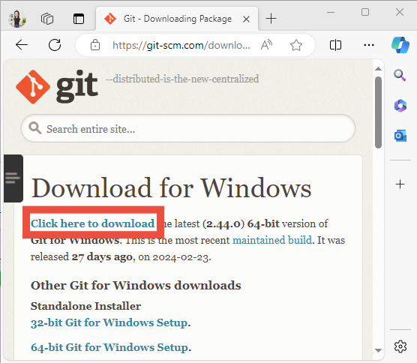
3. Once downloaded, install the program, changing these options. Beyond these, keep the default settings (which means you can simply click “Next”).
   1. **Select Components**: check “Add a Git Bash Profile to Windows Terminal.” 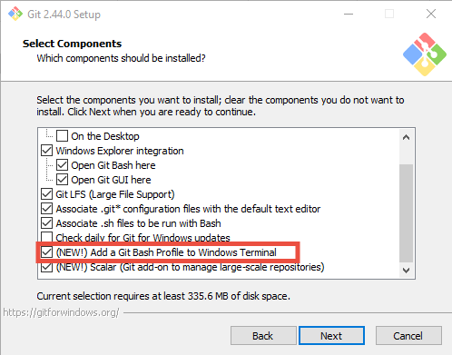
   2. **Adjusting your PATH environment**: Select “Use Git and optional Unix tools from the Command Prompt.” 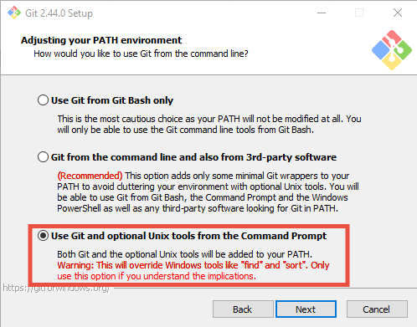
   3. **Configuring the terminal emulator to use with Git Bash**: select “Use Windows’ default console window.” 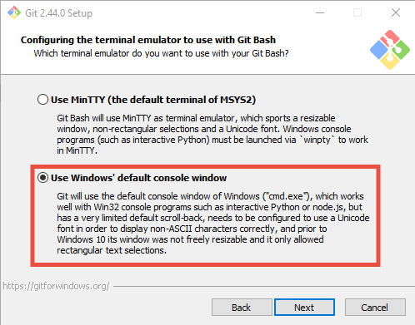
4. Now, you can open Git Bash from your Start Menu

## Installing R (for running a dummy script)

1. Visit <cloud.r-project.org> and choose the right version of R.
2. For Windows users: When installing R, set the Destination location to somewhere that is easy to find, for example at the directory where you downloaded your materials. 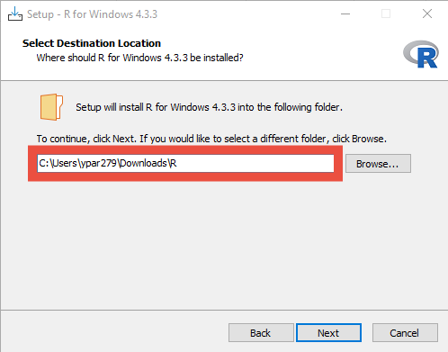
3. If you already have R installed on your laptop/desktop, you can find the directory where R is installed by using file.path(R.home(“bin”), “Rscript”) from RStudio. Use this path instead of Rscript to run analysis using R. 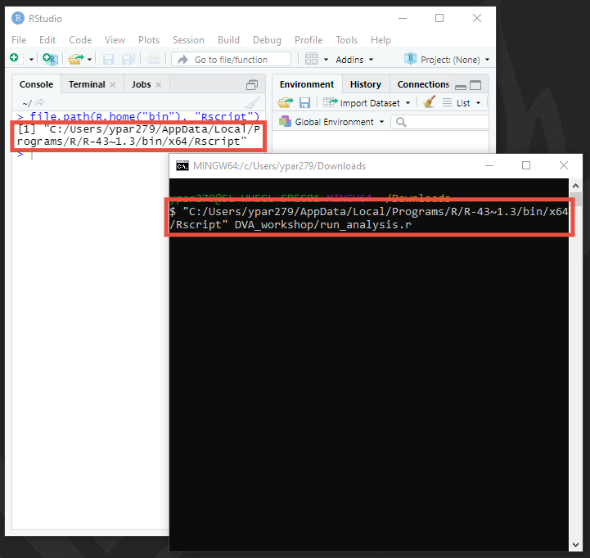

## Installing Emory VPN

1. Visit <https://it.emory.edu/vpntools/>.
2. For Windows users, download BIGIPWindowsEdgeClient. For Mac users, download both BIGIPMacEdgeClient and mac_f5epi. 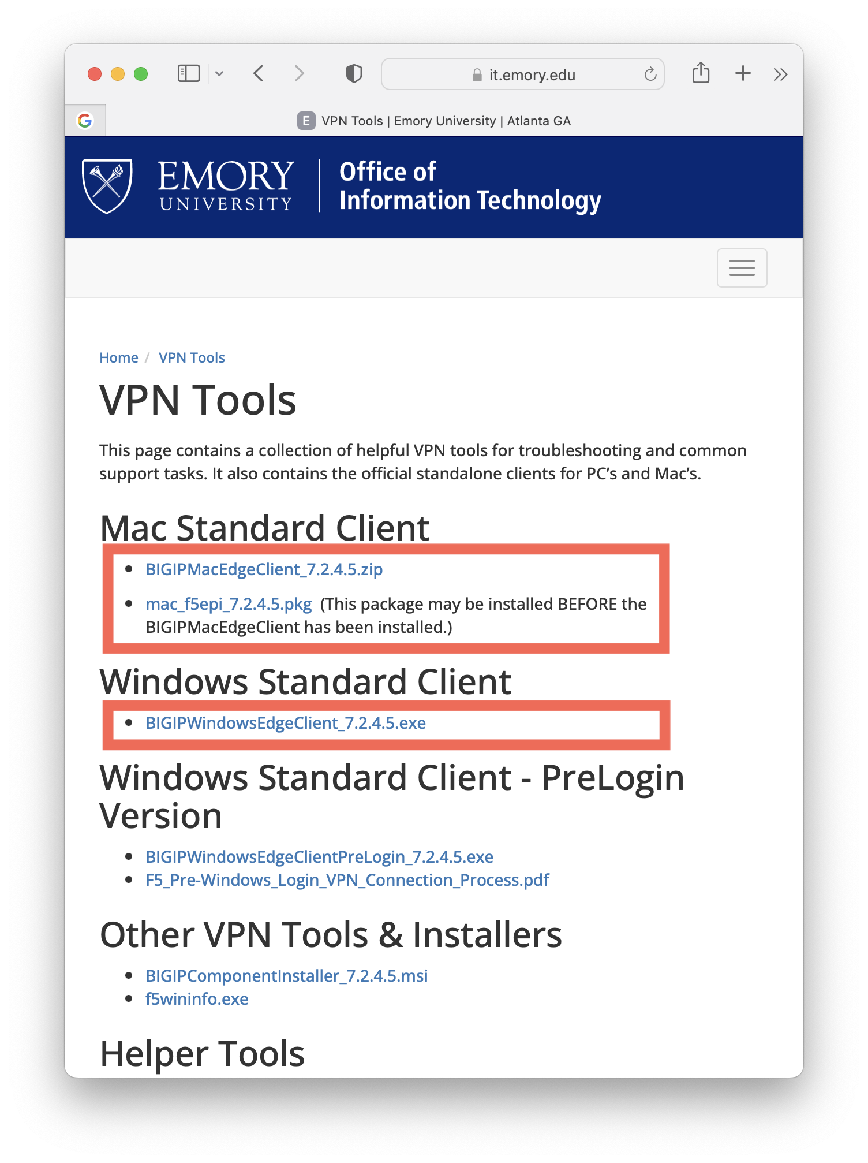

## Installing FileZila

1. Visit the FileZilla download page at <https://filezilla-project.org/download.php?type=client>.
2. Choose the version of the FileZilla Client suitable for your operating system and click the download link. 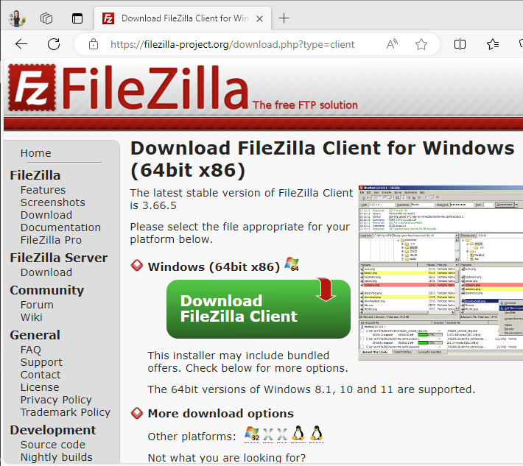
3. Select the FileZilla edition without the manual. 