Explainable Single-Step RL-PPO Framework for
AI-Native 6G Radio Access Network
Dr. Rao S. Yenamandra¹ and Asokan Ram²
¹Digital Twin Simulation, raosy@digitaltwinsim.com ²Wireless Research Center, asokan.ram@wrc.nc.org
Abstract- This paper presents RANOpt AI Beta v17.8, a neural single-step Proximal Policy Optimization (PPO) implementation for AI-assisted RAN scheduling/RRM studies. The v17.8 update replaces the audited v17.7 browser-local bounded action-weight continuation rule with trainable policy/value neural networks containing two 64-node hidden layers. Training now includes forward propagation, action-probability evaluation, advantage estimation, the PPO old/new probability ratio, clipped surrogate policy objective, value loss, backpropagation through both hidden layers, and optimizer-based weight updates. Each sample remains a one-step contextual decision rather than a sequential multi-step MDP. The morphology-aware synthetic-data framework, persistence, carrier-data continuation path, deterministic radio comparison, and engineering traceability are retained.
Index Terms- 6G, RAN, reinforcement learning, PPO, single-step RL, neural network, backpropagation, clipped surrogate objective, MAC scheduling, RRM.
I. INTRODUCTION
AI-native RAN operation introduces a coupled decision space across carrier aggregation, FDD/TDD spectrum, MIMO, traffic load, mobility, fairness, cell-edge performance, utilization, and normalized resource/energy-efficiency. The MAC scheduler is a useful controlled research target because improving one KPI may require accepting a smaller improvement, or even a bounded degradation, in another KPI.
RANOpt AI Beta v17.8 materially changes the learning path relative to v17.7. The two 64-node hidden layers are now directly trainable by PPO. The purpose of this paper is to describe that single-step neural PPO mechanism accurately while retaining the transparent simulator assumptions and limitations of the earlier study.
II. NEURAL POLICY/VALUE NETWORK AND BACKPROPAGATION
The v17.8 neural model receives an 11-feature normalized state/context vector derived from the selected radio scenario. Forward propagation is state s -> Hidden Layer 1 (64 nodes) -> Hidden Layer 2 (64 nodes) -> policy and value heads. The policy head generates five logits and a softmax converts them into probabilities for five bounded RRM/scheduler actions. The value head generates the scalar baseline V(s).
Backpropagation and trainable hidden layers: In v17.8, both 64-node hidden layers participate directly in PPO learning. After forward propagation produces action probabilities and the value estimate, the selected action is evaluated and the PPO policy loss and value loss are calculated. The resulting loss gradients are propagated backward from the policy and value heads through Hidden Layer 2 and then Hidden Layer 1. Consequently, W2 and W1, their biases, and the policy/value output weights are modified by the optimizer. Unlike the v17.7 browser-local continuation mechanism, the hidden layers in v17.8 are therefore not fixed feature-processing layers; their weights learn from the reward-driven PPO error.
Backpropagation does not itself decide whether an RRM action is good. The reward and advantage provide the learning signal. PPO defines a constrained policy objective; differentiation determines how each trainable parameter contributed to that objective; backpropagation applies the chain rule through the neural graph; and the optimizer changes the numerical weights and biases.
Forward: h1=f(W1s+b1), h2=f(W2h1+b2), π(a|s)=softmax(Wp h2+bp), V(s)=Wv h2+bv.
Backward: Loss -> policy/value heads -> Hidden Layer 2 -> Hidden Layer 1 -> dL/dW; Wnew = Wold - α(dL/dW).
III. SINGLE-STEP EXPERIENCE, REWARD, AND ADVANTAGE
For each training sample the environment supplies context s, the policy selects one RRM action a, the simulator/model evaluates that action, and a scalar reward r is formed. Because the episode terminates after this action, the one-step advantage can be expressed as A = r - V(s). A positive A indicates that the selected action performed better than the value baseline predicted; a negative A indicates worse-than-expected performance.
The multi-objective engineering reward remains R = wT T + wF F + wEdge Eedge + wEta η - P. T, F, Eedge, and η denote normalized throughput, Jain fairness, cell-edge performance, and normalized resource/energy-efficiency. For the Balanced objective the representative weights are 0.40, 0.30, 0.20, and 0.10. This construction permits realistic KPI trade-offs rather than requiring every KPI to improve simultaneously.
Definition of the normalized resource/energy-efficiency index: In the present study, η is a dimensionless simulator index normalized to the AI-OFF/PF reference value of 1.000. It represents relative resource/energy efficiency within the modeled RAN operating point and is used as one component of the multi-objective reward. A PPO value of 1.040 therefore denotes a 4% improvement in this normalized index relative to the reference; it is not a direct physical measurement of bits/J. The current simulator does not include a sufficiently detailed gNB/UE power-consumption model to claim physical energy efficiency in bits/J. Such a result would require explicit modeling of relevant transmit, RF, baseband, and operating power and would be a future extension.
IV. PPO PROBABILITY RATIO AND SURROGATE OBJECTIVE
PPO retains the probability assigned to the sampled action by the old policy and compares it with the probability assigned by the current trainable policy. The probability ratio is ρ(θ)=πθ(a|s)/πold(a|s). A ratio of 1 means no change in probability; above 1 means the action became more probable; below 1 means it became less probable.
The PPO objective is called a surrogate objective because the true expected policy return is not directly differentiated. Instead, PPO optimizes a tractable local proxy constructed from sampled advantages and the old/new action-probability ratio. This remains a surrogate policy objective even though v17.8 uses a one-action episode.
Lclip(θ) = E[min(ρ(θ)A, clip(ρ(θ), 1-ε, 1+ε)A)].
V. WHY PPO CLIPPING IS REQUIRED
Without a constraint, one favorable sample could produce an excessively large policy update. PPO clipping restricts the surrogate benefit of moving the probability ratio outside [1-ε,1+ε]. For example, with ε=0.20, if an action probability changes from 0.25 under the old policy to 0.35 under the new policy, ρ=1.40, but the clipped positive-advantage surrogate uses at most 1.20. Clipping therefore limits the incentive for a large policy jump; it does not clip the KPI or reward itself.
The value head is trained toward the observed reward using a value-error term such as Lv=(r-V(s))². The policy term changes action preference; the value term improves the baseline used to estimate future advantages. Their gradients both enter the shared hidden representation.
VI. HOW THE NEURAL WEIGHTS ACTUALLY CHANGE
The PPO loss produces derivatives with respect to the action logits. Through the softmax and policy-head matrix, these derivatives create an error signal at Hidden Layer 2. Multiplication by the hidden activation derivative determines the gradient for each active hidden unit and produces gradients for W2 and b2. The chain rule then propagates the signal into Hidden Layer 1, producing gradients for W1 and b1. The value-loss derivative follows an analogous path from the value head into the shared hidden layers.
For any weight wij, the basic optimizer step is wij(new)=wij(old)-α(dL/dwij), where α is the learning rate. For illustration, if wij=0.120, dL/dwij=+0.030, and α=0.001, the simple gradient-descent contribution changes the weight to approximately 0.11997 before optimizer-specific adaptive scaling. Across many independent one-step samples, coordinated changes reshape the hidden representation and future action probabilities.
This is the principal technical distinction from v17.7. The audited v17.7 local continuation path could modify five action preferences and a scalar value baseline but did not retrain the declared 64x64 hidden matrices. In v17.8 the loss is connected to the neural computation graph, so W1, W2, policy-head parameters, value-head parameters, and their biases are trainable.
Stage | v17.8 operation
Input | 11 normalized context/state features
Hidden 1 | 64 trainable nodes; W1,b1
Hidden 2 | 64 trainable nodes; W2,b2
Policy head | 5 logits -> softmax action probabilities
Value head | Scalar V(s)
Learning signal | Advantage A=r-V(s)
PPO constraint | Old/new probability ratio + clipped surrogate
Gradient | Backpropagation through heads and both hidden layers
Update | Optimizer changes weights and biases
TABLE I. End-to-end single-step neural PPO learning path in v17.8.
VII. SYNTHETIC TRAINING DATA AND PERSISTENCE
The built-in workspace retains the morphology-aware synthetic generator: 10 sites with three sectors per site produce 30 cells; each cell has 96 records at 15-minute intervals, giving 2,880 base cell-time records over a synthetic 24-hour period. Expansion into Suburban, Urban, and Dense-Urban variants produces 8,640 morphology-aware rows. The generator seed is 1701 and local training uses seed 12345.
Generated columns are correlated through engineering relationships among active UE count, PRB utilization, SINR, CQI, MCS, throughput, mobility, buffer/load, and related variables rather than independently randomized. Explicit PPO training updates the neural checkpoint. Normal simulator runs remain inference-only unless training is invoked. Validated carrier CSV records may later be used for continued training.
VIII. REPRESENTATIVE RADIO CONFIGURATION
The controlled study retains an Urban Macro single-cell FDD+TDD carrier-aggregation point: n3 FDD at 1800 MHz with 50 MHz bandwidth and n78 TDD at 3.5 GHz with 100 MHz bandwidth; total configured bandwidth 150 MHz; ISD 500 m; 20 active UEs with Medium eMBB traffic; PF AI-OFF baseline; 32T32R gNB MIMO; UE maximum DL/UL layers 4/2; UE/gNB NF 7/2 dB; mobility 30 km/h; and Balanced PPO objective.
KPI | AI OFF / PF | Single-Step PPO v17.8 | Change
Cell DL capacity | 0.677 Gb/s | 0.765 Gb/s | +13.0%
Median UE DL | 33.84 Mb/s | 38.23 Mb/s | +13.0%
5th-pct UE DL | 24.00 Mb/s | 27.34 Mb/s | +13.9%
Jain fairness | 0.920 | 0.895 | −2.7%
Normalized resource/energy-efficiency index | 1.000 | 1.000 | 0.0%
TABLE II. Fresh deterministic v17.8 single-step neural PPO rerun, 1,000 training episodes, training/simulation seed 12345, using the representative FDD+TDD CA configuration.
IX. REPRESENTATIVE RESULTS AND INTERPRETATION
The results below are from a fresh deterministic v17.8 rerun using 1,000 single-step neural PPO training episodes with seed 12345 and the representative FDD+TDD CA configuration. The trained policy selected the throughput-biased RRM action for this operating point. Relative to the AI-OFF/PF baseline, cell DL capacity increased from 0.677 to 0.765 Gb/s (+13.0%), median UE DL increased from 33.84 to 38.23 Mb/s (+13.0%), and 5th-percentile UE DL increased from 24.00 to 27.34 Mb/s (+13.9%). Jain fairness decreased from 0.920 to 0.895 (−2.7%), illustrating the intended multi-objective trade-off rather than forcing every KPI to improve simultaneously. The normalized resource/energy-efficiency index remained 1.000 because the selected throughput-biased action carries no energy-efficiency multiplier in the current v17.8 action model. The 2.7% decrease in Jain fairness occurs because the trained v17.8 policy selected the throughput-biased RRM action for this operating point. This action increases aggregate and UE throughput by allocating resources more aggressively toward favorable radio conditions, which reduces the equality of resource/rate distribution among UEs. The decrease is therefore an expected throughput-versus-fairness trade-off rather than a PPO training failure.”

Neural-PPO audit for this rerun: after 1,000 training episodes, the deterministic policy chose the throughput-biased action. At the reported radio state, the five learned action probabilities were approximately 10.2%, 27.7%, 17.4%, 22.1%, and 22.6% for the five RRM actions, respectively; the highest probability therefore selected the throughput-biased action. These probabilities are internal policy outputs and are included here only to establish result provenance.
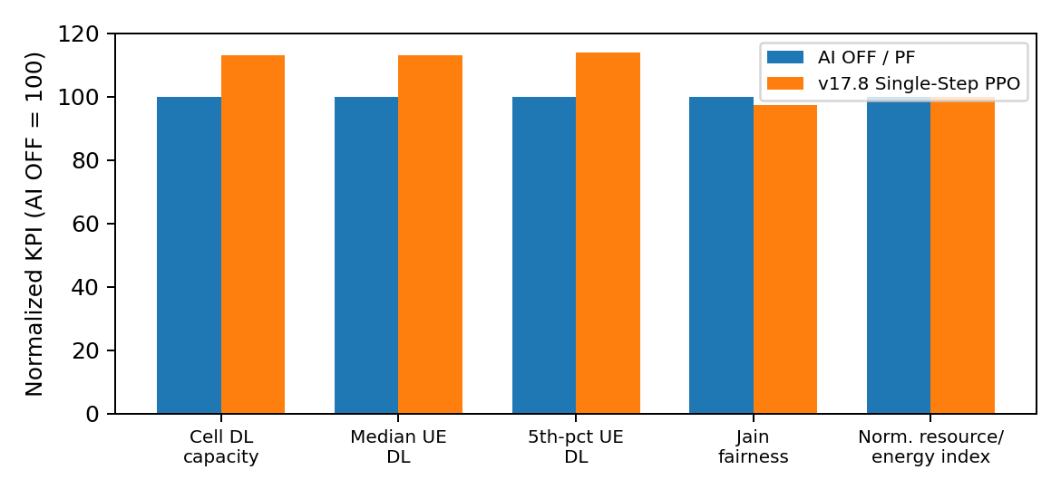
Fig. 1. Fresh AI-OFF/PF versus v17.8 single-step neural PPO rerun, normalized to AI OFF = 100.
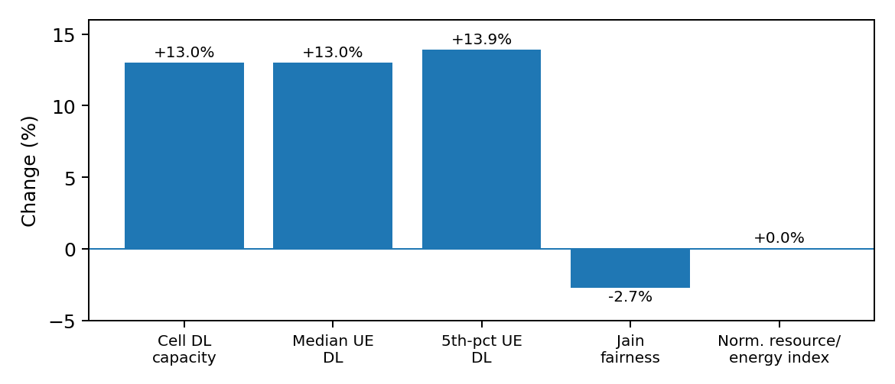
Fig. 2. Relative KPI changes from the fresh v17.8 single-step neural PPO rerun.
X. SINGLE-STEP PPO VERSUS A FUTURE MULTI-STEP MDP
Single-step does not mean that only one neural update occurs during training. Many independent samples/episodes can be processed and each can update the network. Within one episode the sequence is context/state -> one RRM action -> one reward -> PPO update -> termination. A future multi-step MDP would carry the post-action state into the next scheduling interval and accumulate rewards across a trajectory.
XI. EXPLAINABILITY AND AUDITABILITY
Engineering explainability remains outcome-based rather than assigning physical meanings to individual hidden neurons. A useful trace can expose configuration ID, model/checkpoint version, selected action, old action probability, new action probability, probability ratio, advantage, clipping status, reward components, and resulting KPI vector.
XII. LIMITATIONS AND FUTURE VALIDATION
The built-in data are synthetic engineering data rather than operator measurements. Multi-cell context does not yet imply coordinated multi-cell RL, and the current PPO environment remains single-step. The results reported here are a fresh deterministic v17.8 implementation rerun for one configuration and one training/simulation seed; they are not yet a statistical multi-seed validation or carrier-network measurement.
Recommended validation includes paired AI-OFF/PPO cases, multiple independent seeds, confidence intervals, held-out load/mobility/CA configurations, carrier-trace train/test separation, checkpoint compatibility checks, and action-sensitivity tests.
XIII. CONCLUSION
RANOpt AI Beta v17.8 changes the learning mechanism materially. The two 64-node hidden layers now participate directly in training. The policy head produces action probabilities; the value head supplies a learned baseline; the one-step reward forms the advantage; old and new action probabilities form the PPO ratio; the clipped surrogate objective constrains excessive policy change; and backpropagation carries the gradients through Hidden Layer 2 and Hidden Layer 1 so their neural weights are actually modified. The implementation is therefore appropriately described as an explainable neural single-step RL-PPO framework while remaining distinct from a future multi-step MDP.
APPENDIX A - STEP-BY-STEP v17.8 PPO TRAINING CYCLE
1) Build and normalize the 11-feature state vector s. 2) Forward-propagate s through Hidden-64 -> Hidden-64. 3) Compute five softmax policy probabilities and V(s). 4) Select/evaluate one RRM action and obtain reward r. 5) Compute A=r-V(s). 6) Retain old action probability and form ρ=πnew/πold. 7) Form the clipped surrogate policy objective and value loss. 8) Backpropagate gradients through the policy/value heads, Hidden Layer 2, and Hidden Layer 1. 9) Apply optimizer updates to weights and biases. 10) Persist the compatible neural checkpoint when enabled.
REFERENCES
[1] R. S. Sutton and A. G. Barto, Reinforcement Learning: An Introduction, 2nd ed., MIT Press, 2018.
[2] J. Schulman et al., "Proximal Policy Optimization Algorithms," arXiv:1707.06347, 2017.
[3] E. Dahlman, S. Parkvall, and J. Skold, 5G NR: The Next Generation Wireless Access Technology, 2nd ed., Academic Press, 2020.
[4] 3GPP TR 38.901, "Study on channel model for frequencies from 0.5 to 100 GHz."
[5] R. S. Yenamandra, "RANOpt AI: Interactive 5G/6G RAN decision platform," implementation documentation, 2026.

