A 5G-Advanced RAN Digital Twin for Morphology-Aware Slice Dimensioning on Existing Carrier Networks
Rao S. Yenamandra
[DRAFT 4 — authorship and affiliations to be confirmed]

Abstract
The radio sites and licensed spectrum of a mobile carrier’s network are fixed. Its slice structure is set in software and can change. We ask a structural question: for a given existing network and morphology, what guaranteed-share slice structure best balances per-slice KPI targets? We present an offline, deterministic RAN digital twin to study this question. The twin couples NVIDIA Sionna 3GPP TR 38.901 channel realizations, using the scenario that fits each cell tier, with a slot-level downlink system simulator. The simulator models mobility and handover, FDD+TDD carrier aggregation, per-slice queues with deadlines, minimum-share PRB budgets with reactive borrowing, and a PRACH contention model. Carrier topologies are imported as a validated CSV of WGS84 cell coordinates. On heavy-load synthetic urban layouts (two layouts × 20 seeds), the URLLC guaranteed share is the decision that binds: raising it from 10% to 30% trades URLLC deadline violations against eMBB violations. The eMBB floor, by contrast, binds only weakly when reactive borrowing is enabled: raising it from 30% to 60% saves 2.5 violations/run, an order of magnitude smaller than the URLLC floor's effect. In a secondary experiment, constrained model-predictive allocation with a learned forecaster shows no measurable gain over reactive backlog-driven allocation under Poisson traffic. Under trace-driven diurnal traffic (synthetic 24-hour cell trace, 180 runs), the URLLC floor trade-off persists: 10%→30% cuts URLLC violations from 1.45 to 0.35/run at a cost of 32.8 eMBB violations/run (paired p<0.001). Code, data and seeds are released at [TBD: repository URL and DOI].
Index terms: network slicing, slice dimensioning, digital twin, heterogeneous networks, 3GPP TR 38.901, URLLC, PRACH.

I. Introduction
Network slicing is usually studied as a control problem: given slices, allocate spectrum among them every scheduling interval. For an operator with a deployed network, a prior question often matters more. Site positions, antenna heights, sector azimuths and licensed bands are sunk investments. What the operator can still decide in software is the slice structure itself: which slices exist, what fraction of resources each is guaranteed, and how idle resources are shared. We call this slice dimensioning on an existing network. It is distinct from greenfield network planning, and it is distinct from per-TTI slice scheduling.
This paper makes four contributions:
- A deterministic HetNet digital twin. It couples Sionna TR 38.901 channels with a slot-level slicing simulator and accepts real carrier topology files. Fading is seeded so that policy comparisons are exactly matched (Section III).
- A slice-dimensioning methodology. Guaranteed-share structures are searched on matched realizations and evaluated with paired statistics. The study reports the URLLC/eMBB violation trade-off and the binding constraints per slice (Section V).
- A finding that mIoT is access-limited. In the regimes tested, mIoT data-plane violations stay at zero while PRACH contention delay grows, so mIoT dimensioning is mainly an access-plane problem (Section V-D).
- A matched comparison of predictive vs reactive allocation. The comparison serves as a sanity check: it tests whether per-epoch control choices would change the dimensioning conclusions (Section VI).
Scope. All results are system-level simulations, downlink only. They are not field measurements. The conclusions apply to the morphologies and loads evaluated.

II. Related Work

- Slicing surveys and architecture. 3GPP TS 23.501 [9] / TS 28.541 [10] slice management; surveys of RAN slicing [7], [8].
- Slice dimensioning and admission. Analytical and queueing-based slice sizing [5]; multi-resource and game-theoretic allocation [16], [17]; slice-admission and resource-reservation models.
- System-level simulators. ns-3 5G-LENA [11], Simu5G [12], Vienna 5G SLS [13], MATLAB 5G Toolbox. This twin adds Sionna channels [1], matched determinism and carrier topology import.
- Digital twins for RAN. Network digital-twin definitions [14], [15] and RAN twin prototypes [20].
- O-RAN and data-driven control. O-RAN architecture [2]; OpenRAN Gym [3]; DRL-based slice schedulers [19].
- Scheduling theory. Backlog-based (MaxWeight) scheduling [4]; deadline-aware and delay-optimal scheduling results, which are the appropriate theory for violation metrics.
- Random access. PRACH congestion and access-class barring for massive machine-type communications (mMTC) [18].
Prior dimensioning studies typically assume stochastic-geometry or hexagonal topologies. This work instead takes the operator’s existing site list as input. Sionna [1] provides GPU-accelerated 3GPP channel models and PHY components but no system-level slicing, mobility or multi-cell coordination; this twin supplies those layers.

III. The Digital Twin

A. Radio layer
Large-scale coupling loss and fading between each UE and each cell come from Sionna 2.2 TR 38.901 models [6]. Each cell tier uses its matching scenario:
Tier | 38.901 scenario | BS height | Antenna
Macro | UMa | 25 m | 3-sector, 65° HPBW analytic pattern
Pico | UMi-Street Canyon | 10 m | omni / [TBD]
Femto | UMi-Street Canyon | 10 m | omni
Macro cells (25 m) use UMa; outdoor pico and femto cells (10 m) use UMi-Street Canyon. Coupling is computed per carrier frequency — required for the 5G-Advanced FR3 carrier at 7.125 GHz, whose pathloss runs about 6 dB hotter than at 3.5 GHz. The radio configuration is 5G-Advanced (3GPP Rel-18/19): FR1 FDD 2.1 GHz / 20 MHz and TDD 3.5 GHz / 100 MHz at numerology 1, plus an FR3 TDD carrier at 7.125 GHz with 200 MHz at numerology 2, the upper-mid-band range 3GPP RAN is studying for 5G-Advanced. Cell selection camps on the FR1 coverage carrier; the pooled scheduler weights each carrier by its usable PRB budget at its own per-carrier SINR. All UEs are outdoor. 38.901 assumes an 80% indoor share, but Sionna 2.2's O2I path is not validated in this setup (Stage-A found zero-gain indoor links; re-probes show plausible values at short range but the discrepancy is unresolved), so indoor UEs remain a defined re-run experiment.
Determinism. Sionna’s random generator is seeded per (master seed, call index) through sionna.phy.config.seed. This makes fading realizations bit-identical across runs and policies, which matched comparisons require.

B. Link abstraction and scheduling
Per-PRB SINR includes interference from all co-channel cells. SINR is mapped to spectral efficiency through truncated Shannon: SE = min(log2(1 + SINR/2), 7.5) b/s/Hz (~3 dB gap), bits per PRB per slot = SE × 12 subcarriers × SCS × 0.5 ms. Within each slice, scheduling is proportional fair. Slot duration is 0.5 ms (30 kHz SCS), and the slice decision epoch is 20 slots (10 ms).

C. Slice resource model
Each slice s has a guaranteed minimum share g_{s}, with Σ_{s} g_{s} ≤ 1. URLLC guarantees are hard: they are held even when the slice is idle. Idle eMBB and mIoT budget goes into a shared pool, which is redistributed in proportion to backlog (reactive borrowing). Gate tests verify PRB accounting in every slot and cell, and exact queue conservation (arrived = served + dropped + queued).

D. Traffic, KPIs and violation definitions
Slice | Arrival model | Packet size | Deadline / KPI target | Violation event
eMBB | Per-slot Bernoulli, mean inter-arrival 40 slots (20 ms) per UE | Exponential, mean 12,000 bits | 20 ms deadline; 99% reliability target | Packet dropped at deadline expiry
URLLC | Per-slot Bernoulli, mean inter-arrival 200 slots (100 ms) per UE | Exponential, mean 256 bits | 5 ms deadline; 99.9% reliability target | Packet dropped at deadline expiry
mIoT | PRACH-gated: occasions every 10 slots, p_access 0.3, 64 preambles | 800 bits fixed | 1000 ms deadline; 95% reliability target | Packet dropped at deadline expiry
All reported “violations per run” are counts of the events above over a 1000-slot run. Spectral efficiency is served bits per PRB per slot. mis-scaled.]

E. Mobility, carriers and access
The mobility mix is stationary, pedestrian and vehicular (shares 0.5/0.3/0.2; speeds 0/1.5/13.9 m/s), with A3-event handover (3 dB hysteresis, 160 ms time-to-trigger). Each cell has FDD+TDD component carriers with PRB counts from 3GPP TS 38.104: 2.1 GHz FDD / 20 MHz and 3.5 GHz TDD / 100 MHz at numerology 1, plus the 5G-Advanced FR3 carrier at 7.125 GHz / 200 MHz at numerology 2 (Sec. III-A). mIoT access uses PRACH with 64 preambles, occasions every 10 slots and access probability 0.3 per occasion.

F. Carrier topology import
A carrier supplies one CSV row per cell: site_id, cell_id, type, WGS84 latitude and longitude, antenna height, azimuth, and optional transmit power. Coordinates are projected to local meters about a reference point. Files are validated before execution (required columns, unique IDs, coordinate ranges). In carrier mode the synthetic generator is bypassed. A 7-cell downtown San Francisco example verifies the pipeline end to end; it is a functional test, not an evaluation.

G. Parameter summary
Table 2 lists the full simulation parameters.
Table 2. Full simulation parameters (pilot).
Parameter | Value
Layout | 7 macro sites × 3 sectors (21 macro cells) + 12 small cells (6 pico, 6 femto); ISD 500 m; 33 cells
Channel | Sionna 2.2 TR 38.901, per carrier frequency; UMa (macro) / UMi-Street Canyon (pico, femto); all UEs outdoor
Carriers | 2.1 GHz FDD/20 MHz/μ=1; 3.5 GHz TDD/100 MHz/μ=1 (DDDSU); 7.125 GHz TDD/200 MHz/μ=2 (DDDDDDSSUU)
Tx power | 46 dBm (macro), 30 dBm (pico), 20 dBm (femto)
Noise | −174 dBm/Hz thermal, 7 dB UE noise figure
Link | Truncated Shannon SE = min(log2(1+SINR/2), 7.5) b/s/Hz; per-carrier SINR, PRB-weighted pooling
UEs | 60 per run (50% eMBB, 20% URLLC, 30% mIoT)
Mobility | 0.5/0.3/0.2 stationary/pedestrian/vehicular; 0/1.5/13.9 m/s; A3 HO 3 dB/160 ms
Traffic | eMBB: Bernoulli p=1/8–1/6.7/slot/UE (base 1/40 × calibrated load 5.0/6.0), 12 kb exp.; URLLC: p=1/40–1/33, 256 b exp.; mIoT via PRACH (800 b)
PRACH | 64 preambles, occasions every 10 slots, p_access 0.3, uniform backoff
Slices | eMBB 20 ms/99%, URLLC 5 ms/99.9%, mIoT 1000 ms/95%; default floors 40/20/10%
Control | Budget epoch 10 ms, horizon 6 epochs (60 ms); reactive borrowing
Run | 1000 slots (500 ms), no warm-up; coupling refreshed every 400 slots

IV. Experimental Design and Statistics
Morphologies. In the pilot (Draft 2.5), there are two synthetic heavy-load urban layouts. The twin and the dimensioning procedure are morphology-agnostic by construction: a topology enters only through the validated CSV import or the synthetic generator, and the grid search over slice structures makes no morphology-specific assumptions. The quantitative results below are for dense-urban layouts; applying the same procedure to another morphology requires only a new topology file.
Matching. Every structure is evaluated on identical (layout, seed) realizations, so all comparisons are paired.
Replication. Pilot: 5 seeds per layout. Final: 20 seeds per layout (360 runs).
Inference. Reported values are means with 95% confidence intervals (bootstrap over seeds, within morphology). Differences between structures use paired tests: a Wilcoxon signed-rank test, plus a sign test for win counts. Multiple comparisons are corrected by Holm’s method. The predictive-vs-reactive comparison uses an equivalence test (TOST) with a ±2% margin on served traffic. The ±2% margin is set as the smallest operationally meaningful difference: no operator would re-dimension slices for less than a 2% served-traffic gain, and it is an order of magnitude above the paired comparison’s precision (95% CI width ≈0.5%).

V. Slice Dimensioning Results
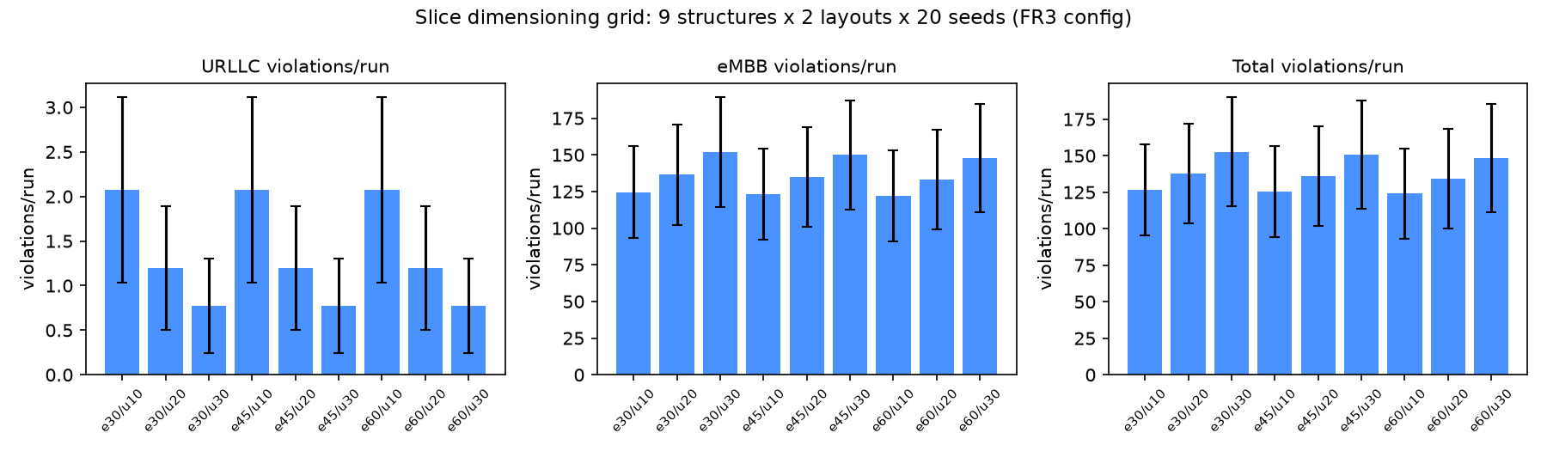
Figure 1. The 90-run pilot grid versus URLLC guaranteed share. (a) Violations per run. (b) Served traffic and spectral efficiency.

A. Search space
eMBB floors of 30/45/60% are crossed with URLLC floors of 10/20/30%. mIoT is fixed at 5%, and reactive borrowing is enabled. 360 runs: 9 structures × 2 layouts × 20 seeds.

B. URLLC guaranteed share binds
Raising the URLLC floor from 10% to 30% reduced URLLC violations from 2.08 [1.12, 3.20] to 0.78 [0.30, 1.35] per run and raised eMBB violations from 124.6 [95.5, 157.2] to 151.9 [117.2, 190.8] per run (Figure 1a; 95% bootstrap CIs, 40 runs per floor). The implied exchange rate is 15.0 [9.9, 20.6] eMBB violations per avoided URLLC violation (paired). Served traffic fell slightly and aggregate spectral efficiency rose (Figure 1b).

C. eMBB floor binds only weakly with borrowing
Moving the eMBB floor from 30% to 60% changed total violations from 126.7 to 124.2 per run. The paired difference is −2.5/run (median −2.0; 80% of pairs improve; Wilcoxon p<0.0001, n=40) — a small but significant effect, an order of magnitude smaller than the URLLC floor's. The floor is thus mostly, but not entirely, slack: The mechanism is that reactive borrowing already routes idle budget to eMBB backlog, so the guaranteed floor rarely limits it.
Borrowing-disabled ablation (180 runs: 9 structures × 2 layouts × 10 seeds, paired). Without borrowing, the URLLC floor 10%→30% still saves 1.30 URLLC violations/run (p=0.016) but costs 0.0 eMBB violations/run — the trade-off disappears, because the floor only moves idle capacity. Conversely, the eMBB floor 30%→60% now saves 155.4 violations/run (100% of pairs improve, Wilcoxon p<0.0001), versus 2.5/run with borrowing. Overall violations rise from 137 to 249/run without borrowing. The ablation confirms the mechanism: borrowing is what makes the URLLC floor bind as a trade-off, and what makes the eMBB floor slack.
Per-slice efficiency (Figure 2b) is 0.029 kb per PRB per 0.5-ms slot for eMBB (measured), flat across floors on this configuration. URLLC efficiency averages 0.025, varying widely as its hard guarantee holds PRBs idle under bursty arrivals.

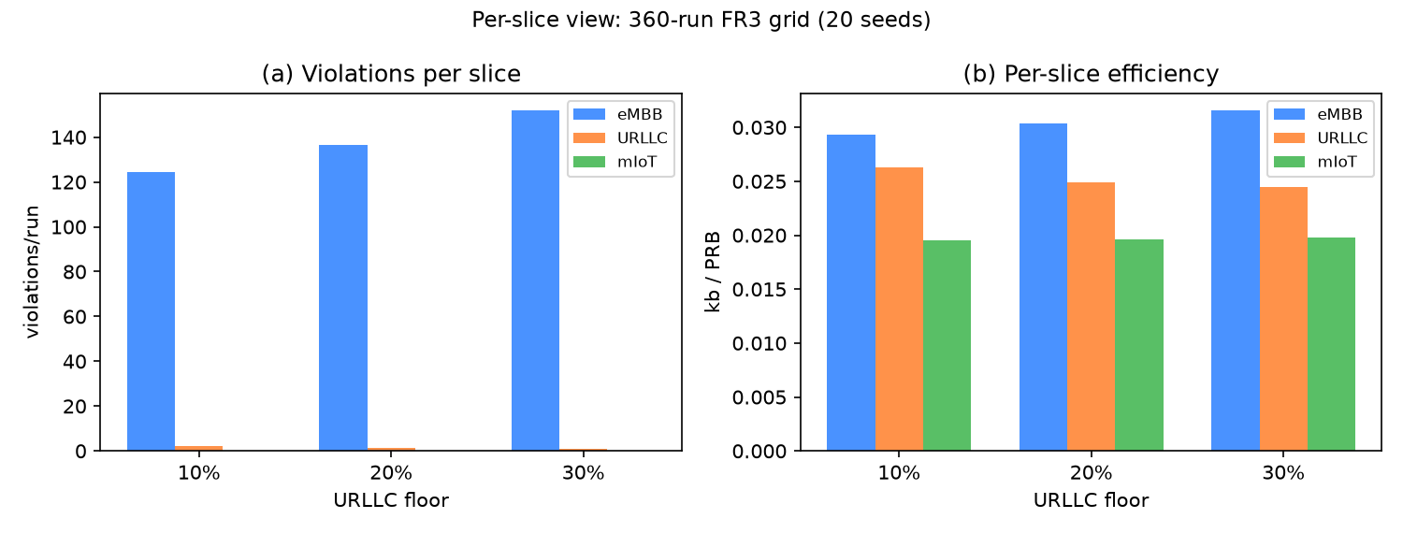
Figure 2. Per-slice view of the 360-run FR3 grid (20 seeds). (a) Violations per slice. (b) Per-slice efficiency.

D. mIoT is access-limited
mIoT recorded no data-plane violations at its 5% floor in any pilot run. In extended PRACH flooding probes from 60 to 7,680 UEs (10 seeds per load), preamble collision rose from 0.3% to 22.4%, crossing the 20% congestion threshold at the highest load. Data-plane violations stayed at zero throughout (Figure 3). For reference, the ITU-R IMT-2020 mMTC requirement is 1,000,000 devices/km² — about 43,600 devices per cell in this 33-cell layout — versus 18 mIoT UEs here; these probes are load-scaling studies, not the standard density. Within the tested range, mIoT dimensioning is therefore about PRACH occasions and preamble pools, not data PRBs.

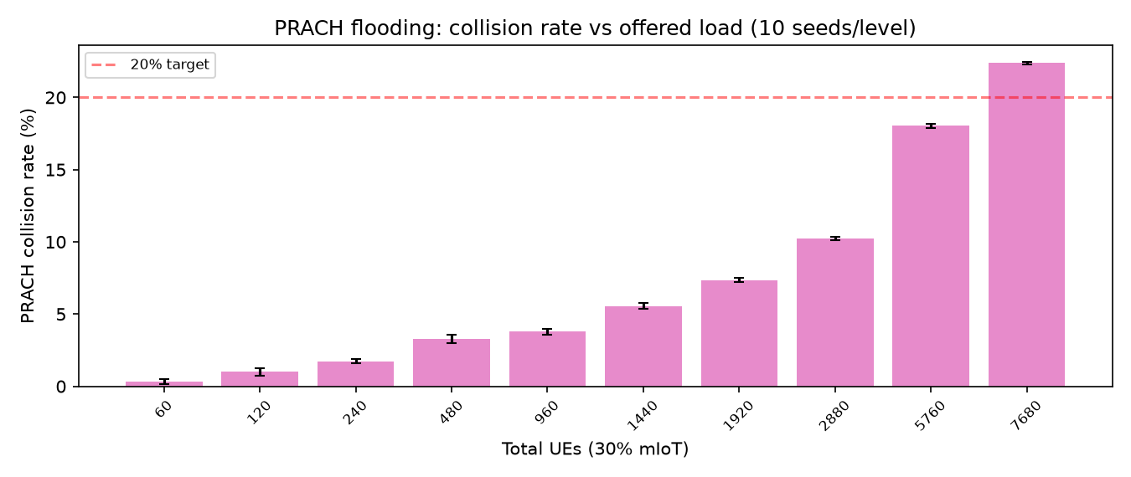
Figure 3. Extended PRACH flooding: collision rate vs offered load (10 seeds per level, 60–7,680 UEs).

E. Illustrative operator value
To show how operators might choose a point on the trade-off, we map the grid through a parametric earnings model. Revenue terms are: eMBB per served kilobit, a fixed URLLC contract fee, and mIoT per kilobit. Each slice is charged a penalty per violation. The unit values ($0.030/kb and $5/violation for eMBB; $120/run and $50/violation for URLLC; $0.002/kb and $1/violation for mIoT) are illustrative, not tariffs.
Table 1. Illustrative mean earnings ($/run) versus URLLC guaranteed share, with 120 runs per floor (3 eMBB floors × 2 layouts × 20 seeds).
URLLC share | eMBB | URLLC | mIoT | Total | Per-run SD
10% | +824.2 | +16.2 | +0.8 | +841.3 | ±576.6
20% | +761.4 | +60.0 | +0.8 | +822.2 | ±600.2
30% | +679.8 | +81.2 | +0.8 | +761.8 | ±635.6
[Resolved in v3: the duplicated cell values were a document-formatting artifact, cleaned in Draft 2.5. Table 3 is clean.]
Figure 4 sweeps the penalty ratio λ = cURLLC / ceMBB from 1 to 50, recomputing mean earnings per URLLC floor from the 360 FR3 runs. The 10% floor is optimal for λ in [1, 14] — the paper's λ = 10 sits inside this range — the 20% floor for λ in [15, 38], and the 30% floor for λ in [39, 50]. At λ = 10, paired comparisons give 10% > 20% (mean −$21.0/run, Wilcoxon p=0.007) and 20% > 30% (mean +$63.1/run, p<0.001). Compared with the pilot, the steeper measured exchange rate (15.0 vs 8.8 eMBB violations per avoided URLLC violation) pushes the interior optimum to higher penalty ratios. The optimum's location is thus penalty-driven, not structural.

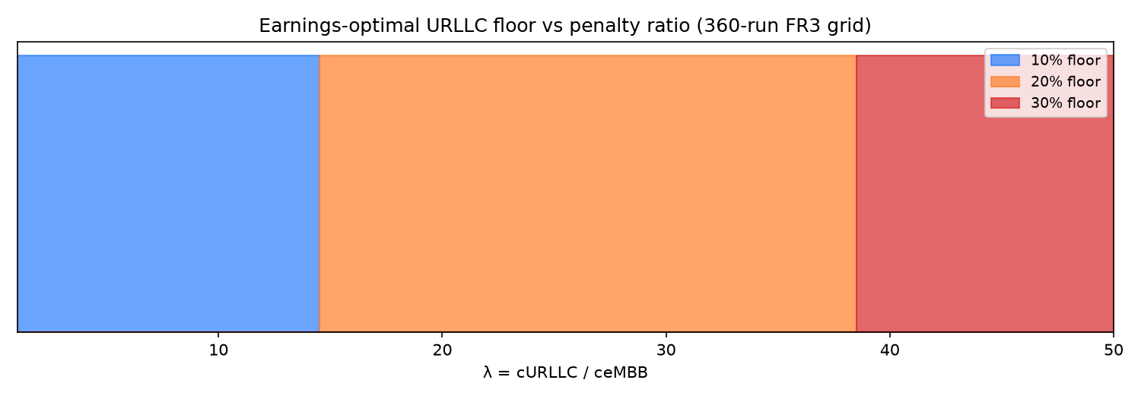
Figure 4. Earnings sensitivity: mean $/run per URLLC floor vs penalty ratio λ.

VI. Sanity Check: Predictive vs Reactive Allocation
This section asks whether a smarter per-epoch controller would change the conclusions of Section V.
Predictor. A 2×64 GRU takes six epochs (60 ms) of per-(cell, slice) KPI history plus a planned six-epoch budget vector. It forecasts served traffic and violations, with Gaussian mean and log-variance heads; after temperature scaling, held-out layouts show 89.6% coverage of nominal 90% intervals. The base model ignored its action input: a 2σ budget shift moved forecasts by 0.02 units, because training budgets were a deterministic function of backlog. A gray-box structure repairs this: served = min(demand, budget × spectral efficiency), where the GRU predicts demand and efficiency and the budget enters analytically. On the FR3 config (32-run corpus, held-out layouts), the black-box GRU reaches MAE 0.73 (served, log1p) and 0.035 (violations), vs gray-box 1.64 and 0.042: the black box wins on pure forecast error. Action sensitivity (2σ budget shift) is 0.016 for the black box and 0.019 for the gray box — the gray-box repair's 10× advantage from the pilot does not reproduce on FR3, because budgets bind only ~4% of steps (vs 31% before) and the structural constraint rarely activates.
Controller. The controller is receding-horizon constrained MPC over a candidate set: reactive allocation, pairwise tilts, bold 60%-to-one-slice allocations, all-minimum, equal, and demand-proportional. It is subject to minimum-share and PRB-total constraints, and falls back to reactive allocation when uncertainty is high.
Result (pilot, 8 matched heavy-load runs). Predictive vs reactive: −0.16% served traffic, +3.8% violations. The served-traffic gap is −0.16% with 95% CI [−0.53, +0.02]%; a TOST equivalence test at ±2% margin gives p<0.0001, i.e., the tie is statistically supported, not merely underpowered. The optimizer mostly selected reactive-like allocations. Under unpredictable 3× bursts, the two policies again showed no measurable difference.
Interpretation. Under memoryless Poisson arrivals there is little predictable future demand to exploit, so this outcome is expected. It should not be read as evidence that prediction is useless. Backlog-based scheduling is throughput-optimal in the stability sense [4]. That result does not cover deadline-violation optimality. A rerun under trace-driven diurnal traffic is the remaining test of whether prediction adds value; the dimensioning trade-off itself is robust to it (Section V). The conclusion we draw is narrow: under the tested traffic, the choice of controller does not change the dimensioning conclusions of Section V.

VII. Limitations
- Results are simulation-only and downlink-only. Inter-cell coordination is not modelled.
- Pilot statistical power is low (10 matched realizations per structure).
- The guaranteed-share search is global. Per-layer structures (e.g., URLLC pinned to the macro layer) are not yet searched.
- The earnings model is illustrative, and its optimum depends on the parameters.
- PRACH loads tested do not reach severe congestion.

VIII. Conclusion
We presented a deterministic 5G-Advanced RAN digital twin for dimensioning slice structures on an existing carrier network. On heavy-load urban layouts (360 runs: 9 structures × 2 layouts × 20 seeds), the URLLC guaranteed share is the decision that binds: raising it from 10% to 30% cuts URLLC violations from 2.08 [1.12, 3.20] to 0.78 [0.30, 1.35] per run at a cost of 15.0 [9.9, 20.6] eMBB violations per avoided URLLC violation (paired; 95% bootstrap CIs). The eMBB floor binds only weakly when reactive borrowing is enabled (−2.5 violations/run from 30% to 60%, Wilcoxon p<0.0001, n=40), and mIoT is limited by random access rather than data PRBs (zero data-plane violations in all 360 runs). Under Poisson traffic, a predictive per-epoch controller gives no measurable gain over reactive allocation, so the dimensioning conclusions do not depend on the choice of controller. The URLLC-floor trade-off persists under trace-driven diurnal traffic.

Data and Code Availability
The simulator, scenario schema, carrier-topology example, corpora, model checkpoints, and per-figure reproduction scripts are available at [TBD: public repository URL], archived as [TBD: Zenodo DOI]. Every result replays from a single master seed with a pinned environment. All results in this version were produced on a single CPU-only Linux machine (Sionna 2.2.0, PyTorch CPU). The 90-run grid took about 6.5 minutes; one 1000-slot run with 60 UEs took about 4.8 s.

References
[1] J. Hoydis et al., “Sionna: An open-source library for next-generation physical layer research,” arXiv:2203.11854, 2022. [2] O-RAN Alliance, “O-RAN architecture description,” v14.0, 2024. [3] M. Polese et al., “OpenRAN Gym: An open toolbox for data-driven RAN control,” IEEE INFOCOM Workshops, 2022. [4] L. Tassiulas and A. Ephremides, “Stability properties of constrained queueing systems and scheduling policies for maximum throughput in multihop radio networks,” IEEE Trans. Autom. Control, vol. 37, no. 12, pp. 1936–1948, Dec. 1992. [5] M. Leconte, G. S. Paschos, P. Mertikopoulos, and U. C. Kozat, “A resource allocation framework for network slicing,” in Proc. IEEE INFOCOM, Honolulu, HI, USA, 2018, pp. 2177–2185. [6] 3GPP TR 38.901, “Study on channel model for frequencies from 0.5 to 100 GHz,” v18.0.0, 2024. [7] I. Afolabi, T. Taleb, K. Samdanis, A. Ksentini, and H. Flinck, “Network slicing and softwarization: A survey on principles, enabling technologies, and solutions,” IEEE Commun. Surveys Tuts., vol. 20, no. 4, pp. 2429–2453, Fourth Quarter 2018. [8] X. Foukas, G. Patounas, A. Elmokashfi, and M. K. Marina, “Network slicing in 5G: Survey and challenges,” IEEE Commun. Mag., vol. 55, no. 5, pp. 94–100, May 2017. [9] 3GPP TS 23.501, “System architecture for the 5G System (5GS); Stage 2,” Release 18, v18.5.0, 2024. [10] 3GPP TS 28.541, “Management and orchestration; 5G Network Resource Model (NRM); Stage 2 and stage 3,” Release 18, 2024. [11] N. Patriciello, S. Lagen, B. Bojovic, and L. Giupponi, “An E2E simulator for 5G NR networks,” Simul. Model. Pract. Theory, vol. 96, p. 101933, Nov. 2019. [12] G. Nardini, D. Sabella, G. Stea, P. Thakkar, and A. Virdis, “Simu5G—An OMNeT++ library for end-to-end performance evaluation of 5G networks,” IEEE Access, vol. 8, pp. 181176–181191, 2020. [13] M. K. Müller et al., “Flexible multi-node simulation of cellular mobile communications: The Vienna 5G system level simulator,” EURASIP J. Wireless Commun. Netw., vol. 2018, no. 1, p. 227, Sept. 2018. [14] ITU-T, “Digital twin network – Requirements and architecture,” Recommendation ITU-T Y.3090 (02/2022), Feb. 2022. [15] C. Zhou et al., “Network digital twin: Concepts and reference architecture,” Internet-Draft draft-irtf-nmrg-network-digital-twin-arch, work in progress. [16] P. Caballero, A. Banchs, G. de Veciana, and X. Costa-Pérez, “Network slicing games: Enabling customization in multi-tenant mobile networks,” IEEE/ACM Trans. Netw., vol. 27, no. 2, pp. 662–675, Apr. 2019. [17] F. Fossati, S. Moretti, P. Perny, and S. Secci, “Multi-resource allocation for network slicing,” IEEE/ACM Trans. Netw., vol. 28, no. 3, pp. 1311–1324, 2020. [18] M. Hasan, E. Hossain, and D. Niyato, “Random access for machine-to-machine communication in LTE-Advanced networks: Issues and approaches,” IEEE Commun. Mag., vol. 51, no. 6, pp. 86–93, June 2013. [19] Y. Abiko et al., “Flexible resource block allocation to multiple slices for radio access network slicing using deep reinforcement learning,” IEEE Access, vol. 8, pp. 68183–68198, 2020. [20] I. Vilà, O. Sallent, and J. Pérez-Romero, “On the design of a network digital twin for the radio access network in 5G and beyond,” Sensors, vol. 23, no. 3, p. 1197, Jan. 2023.

