A 6G RAN Digital Twin for Carrier Slice Dimensioning based on Morphology
Rao S. Yenamandra
[DRAFT 2.5 — authorship and affiliations to be confirmed]

Abstract — A carrier's network is a given asset: where the infrastructure stands and the spectrum is what was licensed. Spectrum slicing, by contrast, is software driven — and the carrier's real question is structural, not algorithmic: given the network .The carrier already owns, what slice structure correctly matches each morphology, for coverage and capacity, and KPI targets? We present as an example an offline digital twin of an urban heterogeneous RAN built to answer exactly that. The twin fuses NVIDIA Sionna-based 3GPP TR 38.901 channel realizations over explicit macro/pico/femto geometry with a deterministic system simulator (mobility and handover, FDD+TDD carrier aggregation, per-slice queues, minimum-share PRB budgets with borrowing, and PRACH dimensioning ). Carriers feed their real topology as a standard inputtable CSV of WGS84 cell coordinates; everything else — the dimensioning search, the KPI trade-off map — runs unchanged. On heavy-load urban morphologies the twin derives a concrete answer: the URLLC guaranteed share is the binding dimensioning decision (each avoided URLLC violation costs on the order of eight eMBB violations — six to twelve depending on the morphology), the eMBB floor is non-binding because reactive borrowing covers it, and mIoT needs only its 5% floor. A supporting study finds per-epoch (10 ms) predictive allocation (constrained MPC with a learned forecaster) ties reactive backlog-driven allocation (-0.16% served, +3.8% violations on matched realizations) — consistent with throughput-optimality theory, and evidence that the gains are in the slice structure, not the controller. Code, corpora, checkpoints, and per-claim reproduction pointers are released alongside this paper.

I. Introduction
Network slicing is usually studied as a control problem: given hard or soft slices, allocate spectrum among them as cleverly as possible. For a carrier this gets the question backwards. The carrier already owns the network — site positions, antenna heights, sector azimuths, licensed bands are sunk capex that will not move. What the carrier can still decide, in software, is the slice structure itself: how many slices, which services they carry, what fraction of spectrum each is guaranteed, on which layers. That is a slice dimensioning and optimization problem with earning focus — finding the correct slice for a given urban morphology — and it is answered with coverage maps, capacity analysis, and KPI targets, not with just a a better scheduler.
This paper presents a digital twin built for that question: a controlled laboratory that takes a carrier's real topology, derives coverage and capacity from 3GPP channel models, and searches slice structures against KPI objectives on bit-identical realizations. Inside the same simulation we also run the conventional control study — predictive versus reactive per-epoch (10 ms) allocation — and report it factually as supporting theory, including a negative result: once the structure is right, the controller barely matters.
Our contributions are: (1) a deterministic urban HetNet twin fusing NVIDIA Sionna 3GPP channels with a full slicing stack, fed by standard, inputtable carrier topology files; (2) a slice-dimensioning methodology — morphology to coverage to capacity to KPI — with a concrete derived answer on heavy-load urban morphologies; (3) an action-conditioned KPI predictor with calibrated uncertainty, including a gray-box repair for learned action-ignoring and the justification for a small local model; and (4) a matched-realization comparison showing predictive per-epoch (10 ms) control ties reactive control, locating the gains in structure rather than scheduling.

II. Related Work
NVIDIA Sionna [1] — NVIDIA's open-source library for physical-layer research — provides GPU-accelerated 3GPP channel models and PHY components, but falls short of system-level slicing, mobility, and multi-cell coordination — the layers we build on top. O-RAN's RIC architecture [2] motivates data-driven RAN control, and several testbeds (notably OpenRAN Gym [3]) target over-the-air experimentation; our twin complements them as a fast, deterministic, offline counterpart. Throughput-optimality of backlog-based scheduling goes back to reference [4]; our empirical finding that a learned predictive controller rediscovers reactive-like allocations echoes that theory. Slice-dimensioning and optimization studies [5] typically assume stochastic-geometry topologies; we instead start from the carrier's actual site list and RAN configurations and derive the structure per morphology. (This is dimensioning and optimization of slices on an existing network — not greenfield network planning.)

III. The Digital Twin

A. Radio layer
Coupling loss between every user terminal (UT) and cell is computed with NVIDIA Sionna 2.2's 3GPP TR 38.901 Urban Macro model [6] over explicit HetNet geometry: macro sectors (with analytic 65-degree sector patterns), pico and femto small cells at configurable coordinates, heights, and azimuths. A critical methodological detail: Sionna's fading draws were unseeded in our first builds, which silently broke cross-policy comparisons — two 'identically seeded' runs saw different channels. We seed Sionna's generator per (master seed, call index) via sionna.phy.config.seed, making every fading realization bit-identical across repeat runs. Matched comparisons are not useful without this.

B. System simulator
On top of the radio layer sits a slot-level simulator (0.5 ms slots, 20-slot decision epochs (10 ms)): proportional-fair per-slice scheduling, per-UE queues with deadline expiry, mixed stationary/pedestrian/vehicular mobility with A3-style handover, FDD+TDD component carriers per cell (3GPP TR 38.104 FR1 PRB tables), a PRACH collision/backoff model for massive IoT access, and per-slice PRB budgets. Budgets enforce minimum shares; latency-critical slices (URLLC) hold their guarantee even when idle, while best-effort slices lend idle budget to a shared pool redistributed by backlog. Gate tests verify PRB accounting over all slot-cells and exact queue conservation (arrived = served + dropped + queued). Under massive mIoT access the PRACH itself congests: 64 preambles per occasion, uniform backoff on collision. A flooding probe (Section V) raises offered load from 60 to 600 UEs: preamble collision rates climb from ~0% to ~5% and mean access delay inflates from under a slot to several — the access plane, not data PRBs, is mIoT's binding constraint.

C. Carrier topology import
The twin runs on synthetic hexagonal topologies out of the box, but its purpose is the carrier's real network. A carrier feeds one standard, inputtable CSV: one row per cell (each macro sector its own row, sectors sharing a site_id), with WGS84 lat/lon coordinates — the carrier-standard — plus cell type, antenna height, sector azimuth, and optional per-cell transmit power. The scenario file points at the CSV and gives a nearby WGS84 reference point for projection to local meters. Files are validated before execution (required columns, unique cell IDs, coordinate ranges). In this carrier mode the synthetic generator is skipped entirely: every cell comes from the carrier's file, and the full dimensioning workflow runs unchanged. The format is documented in docs/input_formats.md with a worked example; further RAN configuration blocks (carriers, mobility, slices) are already separate documented sections of the scenario schema, so additional carrier inputs plug in the same way. A worked example ships with the code (examples/carrier_topology_example.csv — two three-sector macro sites, two picos and a femto on downtown San Francisco WGS84 coordinates); the twin was verified end-to-end on it: CSV import, Sionna coupling on the real geometry, and a full simulation run.

D. Scenario control
A validated scenario loader (YAML/JSON/CSV) configures topology, carriers, mobility mix, slice SLAs, and traffic. A web-based input artifact lets operators compose named scenarios and export them for batch execution. All randomness — traffic, mobility, fading — derives from a single master seed, so any experiment is exactly replayable.

IV. The Predictor (Supporting Instrument)
Dimensioning search is simulation-based, but a forecaster both accelerates it as a surrogate and supports per-epoch (10 ms) studies. We train a gated recurrent unit (GRU) network — two layers of 64 units — on a 32-run corpus: each sample is one (cell, slice, decision time) with six epochs (60 ms) of KPI history plus the planned six-epoch (60 ms) budget vector, mapped to six-epoch (60 ms) forecasts of served traffic and SLA violations. Gaussian mean/log-variance heads give calibrated uncertainty (temperature scaling restores 89.6% coverage of nominal 90% intervals on held-out layouts).
Two lessons are worth recording. First, the base model ignored its action input — shifting planned budgets by two standard deviations moved forecasts by 0.02 units — because reactive training budgets were a deterministic function of backlog already in the history. The repair is gray-box: served = min(demand, budget x spectral efficiency), with the GRU predicting demand and efficiency and the budget entering analytically. Second, the model is deliberately small and local: a forward pass takes ~15 ms on CPU, training takes three minutes, every run is bit-identical. The failure mode was structure, not capacity, and no larger or cloud-hosted model fixes action-ignoring better than putting the physics in the architecture. Small and structural beats large and generic for this task.

V. Deriving the Correct Slice
The dimensioning experiment fixes the morphology and the heavy-load regime — the conditions under which slicing decisions bind — and searches guaranteed-share structures: eMBB floors of 30%/45%/60% crossed with URLLC floors of 10%/20%/30% (mIoT at 5%), reactive borrowing enabled, two urban layouts x five seeds (ten matched runs per structure). Each structure is scored on served traffic, SLA violations per slice, PRB utilization, and spectral efficiency.
The twin derives a concrete, morphology-specific answer (Figure 1). The URLLC guaranteed share is the binding dimensioning decision: raising it from 10% to 30% cuts URLLC violations from 2.3 to 1.0 per run but raises eMBB violations from ~67 to ~78 — each avoided URLLC violation costs on the order of eight eMBB violations (six to twelve across the two morphologies) — while served traffic falls slightly and spectral efficiency rises (URLLC's small packets use PRBs efficiently). The eMBB floor, by contrast, is non-binding: moving it from 30% to 60% shifts total violations from 71.2 to 68.0 per run, within noise, because reactive borrowing already routes idle budget to eMBB's backlog. mIoT never violates at its 5% floor. The correct slice for these morphologies is therefore: guarantee URLLC only what its SLA needs (10%-20% here — the operator's chosen point on the trade-off), keep the eMBB floor low and let borrowing work, and hold mIoT at its floor.
Per slice, the picture sharpens (Figure 2a). SLA violations are dominated by eMBB — 67.1 to 77.5 per run as the URLLC floor rises from 10% to 30% — while URLLC's own violations fall from 2.3 to 1.0; mIoT never violates at all, its 5% data floor never the binding constraint. Throughput efficiency (Figure 2b) tells the complementary story: eMBB does more with less as its share shrinks, its kb-per-PRB rising from 0.030 to 0.034, while URLLC's own efficiency is poor (0.011–0.016) — the price of a guarantee that holds PRBs idle even when URLLC has nothing to send.
mIoT's dimensioning question is therefore not a data-plane one — it is access. The twin's PRACH model shows the flooding onset directly (Figure 3): collision rates rise from ~0% to ~5% and mean access delay inflates several-fold as offered load grows ten-fold, while mIoT data-plane violations stay at zero throughout — backoff absorbs the flood as delay, not loss. Dimensioning mIoT means dimensioning access occasions and preamble pools against the flooding curve, a separate optimization the twin is instrumented for.

What the structure earns (illustrative)
For a carrier, the trade-off curve is a P&L curve. Mapping the dimensioning grid through an illustrative parametric earnings model — revenue modeled the way carriers actually sell each slice (eMBB usage-based per kilobit, URLLC as a fixed SLA contract fee, mIoT per-device) minus penalties per SLA violation — eMBB is the earnings engine, as in practice where broadband subscriptions dominate carrier revenue, while URLLC is the smaller premium line and mIoT a flat rounding error. Guarantee too little URLLC (floor 10%) and its breaches nearly wipe out the contract fee (+$5.0/run net on URLLC); guarantee too much (30%) and eMBB's rising violations drag the engine down (+$126.4/run vs +$183.5 at floor 10%). On means, the total peaks at the interior floor of 20% (+$205.4/run, Table 1) — the 'correct slice' is where the two P&L curves cross. Unit economics are illustrative and the absolute levels arbitrary; the finding is the shape — an interior optimum set by opposing penalty curves — which is structural, not parametric.
How Table 1 is computed — and why it changes per run. Each cell is earnings = revenue minus penalties under the assumed unit economics above, which are illustrative, not carrier tariffs: eMBB $0.030 per served kilobit and $5 per violation; URLLC a $120 per-run contract fee and $50 per violation; mIoT $0.002 per kilobit and $1 per violation. Values are means over 30 runs per floor (3 eMBB floors x 2 layouts x 5 seeds). They change per run because every run is a different stochastic realization — traffic arrivals, mobility, and fading all derive from the run's seed, and the two morphologies have very different absolute violation levels — so per-run earnings vary widely (standard deviation $150–170/run). The floor-to-floor comparison is nevertheless matched: identical layouts and seeds see every floor. Paired across the 10 matched (layout, seed) pairs, the 20% floor wins 6 of 10 against 10% and 7 of 10 against 30%: the interior optimum is suggestive, not yet conclusive, and pinning it down needs more morphologies.
URLLC guaranteed share | eMBB ($/run) | URLLC ($/run) | mIoT ($/run) | Total ($/run)
10% | +183.5-162.6 | +5.0-113.6 | +0.9+0.9 | +189.4-275.3
20% | +154.5-189.7 | +50.0-68.6 | +0.9+0.9 | +205.4-257.4
30% | +126.4-216.3 | +70.0-48.6 | +0.9+0.9 | +197.3-264.0
Table 1. Illustrative per-slice earnings vs URLLC guaranteed share. Interior optimum at 20%; unit economics illustrative.
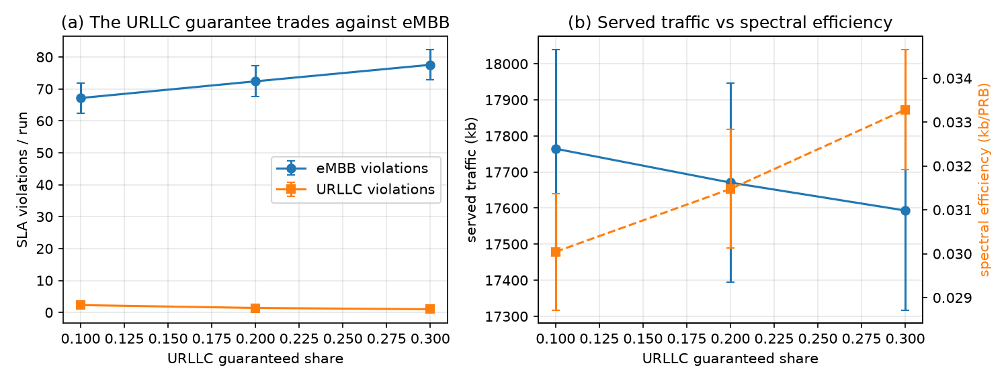
Figure 1. Slice dimensioning on heavy-load urban morphologies (2 layouts x 5 seeds, matched realizations). (a) The URLLC guaranteed share is the binding decision: it trades URLLC violations against eMBB violations. (b) Served traffic falls slightly while spectral efficiency rises with the URLLC guarantee.
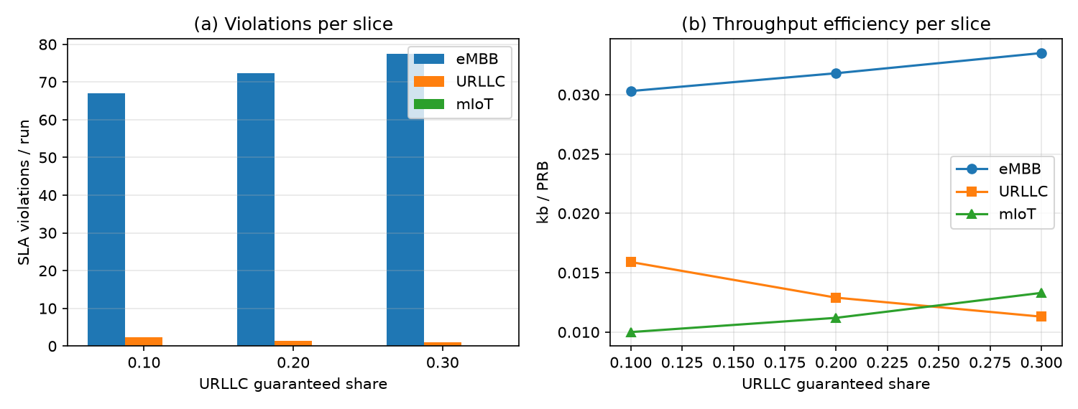
Figure 2. Per-slice view of the dimensioning grid (90 runs). (a) SLA violations per slice vs URLLC guaranteed share — eMBB dominates, mIoT never violates. (b) Throughput efficiency per slice — eMBB rises as it does more with less; URLLC's idle guarantee is spectrally expensive.
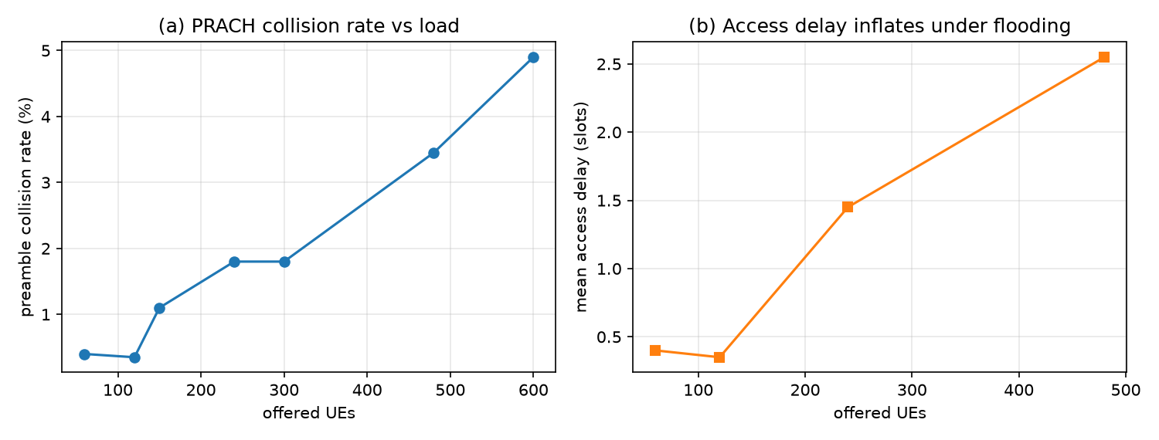
Figure 3. PRACH under flooding (measured probes, 2–3 seeds per load). (a) Preamble collision rate vs offered load. (b) Mean access delay inflates as collisions rise; mIoT data-plane violations stay at zero — backoff absorbs the flood as delay, not loss.
This is the carrier's answer in miniature: not 'allocate smarter every 10 ms' but 'guarantee this much, borrow the rest.' The morphology enters through coverage and capacity — a sparser or denser deployment moves the trade-off point, which is exactly why the structure must be derived per network rather than assumed.

VI. Allocation Dynamics Are Second-Order (Supporting Theory)
With the structure fixed, we ask the conventional question: does twin-assisted predictive allocation beat reactive allocation per epoch (10 ms)? The controller is constrained model-predictive control with receding horizon — the GRU predictor scores candidate budget vectors (reactive, pairwise tilts, bold 60%-to-one-slice reallocations, all-minimum, equal, demand-proportional) over six epochs (60 ms) by predicted served traffic minus violation and uncertainty penalties, subject to minimum-share and PRB-total constraints; the winner's first step is applied and the controller replans, falling back to reactive under high uncertainty.
An honest measurement needed two fixes beyond the predictor repair: an oracle rollout showed initial +-15% candidates moved true outcomes by under 1% (below the noise floor), so candidates were widened; and the Sionna determinism fix, without which 'matched' runs were not matched. Definitive result on 8 matched heavy-load runs: predictive serves -0.16% traffic with +3.8% violations versus reactive — a statistical tie, with the optimizer consistently selecting reactive-like allocations from a set containing bold alternatives. Under unpredictable 3x bursts both policies tie as well. Backlog-driven allocation every 10 ms is near throughput-optimal [4]; there is little 'future' for prediction to exploit. The experiment's value is the proof: the gains are in the slice structure (Section V), not the controller.

VII. Future Work
- Five seeds per layout over two layouts is stronger than pilot-grade but still narrow; publication-grade claims need more morphologies with confidence intervals.
- Poisson arrivals carry no predictable temporal structure; diurnal or periodic demand would test proactive control more fairly.
- The dimensioning grid covers global guaranteed shares; per-layer structures (e.g., URLLC pinned to the macro coverage layer) are the natural next search dimension.
- All UEs are outdoor (a Sionna indoor edge case is documented and excluded); uplink and inter-cell coordination are future work.
- The predictor-as-surrogate for dimensioning search is implemented only as per-epoch control; closing that loop is next.

VIII. Conclusion
We built an urban RAN digital twin that answers the carrier's structural question: given the network a carrier own, what is the correct slice? Fed with standard inputtable topology, it derives coverage, capacity, and KPI trade-offs per morphology — and on heavy-load urban layouts the answer is concrete: the URLLC guarantee binds, the eMBB floor does not, borrowing does the rest. Per-epoch (10 ms) predictive control, honestly measured, ties reactive control: structure beats scheduling. The digital twin is a laboratory for slicing decisions, and its product is the derived slice.

References
[1] J. Hoydis et al., "Sionna: An open-source library for next-generation physical layer research," arXiv:2203.11854, 2022.
[2] O-RAN Alliance, "O-RAN architecture description," v14.0, 2024.
[3] M. Polese et al., "OpenRAN Gym: An open toolbox for data-driven RAN control," IEEE INFOCOM WKSHPS, 2022.
[4] L. Tassiulas and A. Ephremides, "Stability properties of constrained queueing systems and scheduling policies for maximum throughput in multihop radio networks," IEEE Trans. Autom. Control, 1992.
[5] Survey of RAN slice dimensioning and optimization (representative works to be completed).
[6] 3GPP TR 38.901, "Study on channel model for frequencies from 0.5 to 100 GHz," v18.0.0, 2024.

Appendix: Verification
Every empirical claim in this paper resolves to workspace code and data outside the publication: the simulator (src/urtwin/sim/baseline.py, channel.py, hetnet.py), carrier topology import (src/urtwin/scenarios/topology.py, docs/input_formats.md, examples/carrier_topology_example.csv), the corpora (data/corpus_v2-v4 with manifests), the predictors (src/urtwin/learning/models_structured.py, train_structured.py; checkpoints/predictor_v2.pt, predictor_v5.pt), the controllers and comparison harness (src/urtwin/control/mpc.py, compare.py, oracle_test.py), the comparison results (data/stage_d_comparison_v7.json), and the dimensioning study (src/urtwin/control/dimension.py, data/stage_e_dimensioning.json). Each step replays from a single master seed.

Appendix: Computational Resources
Every number in this paper was produced on a single CPU-only Linux machine — a local PC running NVIDIA Sionna 2.2.0 with PyTorch CPU builds; no GPU was used in this study. Sionna's channel computation is GPU-accelerated, so the radio block is the natural cloud/GPU offload for larger studies — the remaining blocks are light. Measured block timings on the study machine: Sionna 3GPP coupling for 60 UEs x 33 cells, ~1.8 s; full 1000-slot system simulation (60 UEs, reactive policy), ~4.8 s; the 90-run dimensioning grid, ~6.5 minutes total; GRU predictor training (100k samples, 25 training epochs), ~3 minutes; predictor forward pass, ~15 ms per decision; PRACH flooding probes, tens of seconds per run. Corpus generation and the Stage D comparison harness are similarly CPU-bound. Configuration is a separate, browser-based block: the RAN Twin Scenario Inputs artifact is a web interface in which operators compose named scenarios — topology (or the standard CSV import), carriers, mobility, slice SLAs, traffic — and export them as JSON for batch execution; it runs in the user's browser and needs no compute beyond the artifact itself. The environment is pinned (configs/) and every run replays from a single master seed.

