RANsliceOpt AI v15 — Detailed Design Specification (IEEE Version 3 Synchronized)
DigitalTwinSim
2026-08-21
TECHNICAL DESIGN SPECIFICATION
RANsliceOpt AI v15
Browser-Based PPO–MDP Soft RAN Slicing
Implementation, Formulae, Workflow and Evolution
Scope This specification documents the behavior actually implemented in the RANsliceOpt AI v15 single-page browser prototype. Future multi-cell, clustering and production-network capabilities are explicitly marked as proposed enhancements.

Prepared by
Dr Rao S. Yenamandra
DigitalTwinSim
Version 3.0 | 22 August 2026

Document control
Item | Value
Document title | RANsliceOpt AI v15 — Browser-Based PPO–MDP Soft RAN Slicing Design Specification
Document version | 3.0
Implementation baseline | RANsliceOpt_AI_PPO_MDP_v15_FINAL.html
Prepared for | Technical review, simulator maintenance and future multi-cell development
Status | Implementation-grounded baseline synchronized with IEEE Version 3
Date | 22 August 2026

Interpretation conventions
- Implemented means the behavior is present in the v15 JavaScript source and is exercised by one or more interface controls.
- Synthetic means a normalized educational model rather than a calibrated link-level or system-level 3GPP simulation.
- Proposed means a future design recommendation and not an assertion about the current browser code.
- SLA protection distinguishes hard allocation projection from reward penalties; the terms are not used interchangeably.
- PPO clipping refers only to the policy probability-ratio update. It does not clip spectrum, PRBs, latency or throughput.
Important The simulator is suitable for architecture exploration, algorithm education and relative-policy comparison. It is not a production scheduler, conformance implementation or predictor of field KPIs.

Executive summary
RANsliceOpt AI v15 is a self-contained browser prototype that studies dynamic soft allocation of a common PRB pool among three representative service slices: eMBB, URLLC and mIoT/eMTC. A seven-input actor–critic policy selects one of seven discrete allocation changes. A synthetic environment then computes normalized throughput, latency, service, fairness and efficiency measures. The resulting composite reward includes SLA penalties, and a two-hidden-layer PPO training loop updates both actor and critic weights through backpropagation.
The design includes two execution modes. Full PPO-MDP mode initializes and trains a policy from seeded rollouts, then evaluates the trained policy against an independent fixed rule baseline using an identical traffic/noise sequence. Single-step mode creates one new traffic state per click, applies one PPO decision, updates the neural networks four times, and advances both the PPO and matched baseline histories. The Rule Baseline button never trains PPO; it applies a fixed URLLC-first decision chain.
The principal operational safeguard is allocation projection. Proposed shares are component-clamped, a configurable URLLC minimum share is applied when feasible, and the result is normalized to sum to one. eMBB and mIoT thresholds are reward penalties rather than hard guarantees. Net neutrality is represented only by identity-blind state and action variables: provider, application ownership, subscriber identity and commercial tier are absent. v15 does not implement a flow-level neutrality checker.
The implementation audit also identifies boundaries. System bandwidth and decision interval are not used by the mathematical environment; total PRBs is used to convert normalized shares into displayed counts. The model does not contain channel quality, MCS, mobility, interference, power, MIMO layers, handover, queues, per-UE scheduling, persistence or external interfaces. Two action labels involving URLLC and mIoT are reversed relative to their underlying vectors and should be corrected.
The recommended evolution adds per-cell state and policy envelopes, cluster-level coordination, explicit global and local constraints, calibrated traffic/channel models, action masking, neutrality assurance among technically equivalent flows, model persistence, auditability and safe deployment interfaces. A hierarchical global–cluster–cell–MAC structure lets slice policies remain consistent while actual resource shares vary with cell demand and radio conditions.
Version 15 retains the v14 PPO, state, action, reward, projection and matched-evaluation logic. Its implementation changes are presentation-focused: numerical min/current/max labels below each demand slider, a 0–100% allocated-share scale, and explicit Step and KPI-unit axes on reward and comparison charts. These changes improve interpretability but do not change learned-policy behavior for a fixed configuration and seed.

IEEE Version 3 synchronization
This revision synchronizes the detailed engineering specification with the separate IEEE Version 3 paper while preserving a strict distinction between implemented v15 behavior and the paper’s proposed research formulation. The v15 browser remains a seven-input, seven-action synthetic PPO–MDP demonstrator. IEEE Version 3 extends the research formulation with mobility-selective state features, explicit slice-level SLA achievement, allocation-churn monitoring, and traceable decision records. Those additions are design targets unless and until they are implemented in a later browser version; they are not retroactively attributed to v15.
Consistent with IEEE Version 3, the specification does not treat curriculum learning, operator profitability, regulatory net neutrality, or a separate fairness index as PPO reward contributions for the proposed research formulation. It also does not claim a numerical advantage over hard slicing without a separately executed like-for-like hard-slicing baseline. Soft slicing is motivated by its ability to borrow otherwise idle resources while retaining explicit slice protections.
The mobility assumption is likewise aligned: mIoT/eMTC is treated as predominantly stationary or low-mobility at aggregate level, with allowance for a smaller mobile-device fraction such as tracking and logistics devices. eMBB and URLLC mobility descriptors are represented explicitly in the proposed state because their radio conditions can change materially with motion.

Contents and reader map
Part | Subject | Location
Part I | Context and slicing concepts | Sections 1–4
Part II | v15 architecture, workflow and interface | Sections 5–9
Part III | Synthetic environment and formulae | Sections 10–14
Part IV | MDP, actor–critic and PPO implementation | Sections 15–20
Part V | Baseline, evaluation, safeguards and implementation audit | Sections 21–26
Part VI | Deployment interpretation, v15 changes, carrier aggregation, UE capacity and multi-cell evolution | Sections 27–36
Appendices | Defaults, formulae, pseudocode, traceability, references, code audit and glossary | Appendices A–G
The document uses Word heading styles throughout, allowing navigation from Word’s Navigation Pane and automatic generation of a table of contents if desired. Each equation is stated in normalized simulator terms and is followed by its implementation meaning, assumptions and limitations.

Quick answers
Question | v15 answer
Hard or soft slicing? | Soft PRB-share envelopes with a projected URLLC minimum; not dedicated physical spectrum partitions.
Is PPO clipping an SLA bound? | No. It controls training update size only.
Is net neutrality hard-enforced? | No. The policy is identity-blind, but no equivalent-flow constraint is present.
Does allocation vary by cell? | v15 is single-cell. The proposed evolution creates a separate state/action vector per cell with cluster coordination.
Are outputs field KPIs? | No. They are dimensionless synthetic indices except URLLC latency, which is a synthetic millisecond model.

1. Purpose, scope and design status
This document is the engineering baseline for understanding, reviewing and extending RANsliceOpt AI v15. It reconstructs the browser implementation as a system design: resource abstraction, UI contract, environment equations, MDP definition, action projection, actor–critic networks, PPO update, rule baseline, matched evaluation and visualization. The specification is deliberately implementation-grounded. Where a design intention is stronger than the current code, the difference is stated explicitly.

1.1 Intended uses
- Explain soft RAN slicing, PPO and MDP behavior to wireless, AI and operator reviewers.
- Provide a formula-level reference for maintaining the single-page implementation.
- Support reproducible demonstrations of PPO versus a rule-based baseline.
- Identify gaps before field-data integration or multi-cell development.
- Define a controlled path toward cluster-based 5G-Advanced/6G RAN optimization.

1.2 Out of scope
v15 does not implement a standards-compliant gNB scheduler, admission control, RRC signaling, CU/DU protocol behavior, network-slice selection, core-network slice lifecycle, actual spectrum licensing, per-UE QoS-flow mapping, link adaptation, HARQ, beam management, mobility or external telemetry. The browser does not claim measured Mbps, packet-error probability, reliability or energy consumption.
Design status The core PPO/MDP loop is executable and useful for normalized experimentation. Production claims must wait for calibrated models, measured data, safety validation and integration with an authorized RAN control point.

2. RAN slicing fundamentals

2.1 What is being sliced
RAN slicing provides logically differentiated service over shared radio infrastructure. The end-to-end network slice may include core, transport, edge-compute and RAN subnets. RANsliceOpt focuses only on a simplified RAN resource envelope: the fraction of a common PRB pool assigned to three service classes. The lower scheduler that would distribute those PRBs among UEs is represented conceptually but is not simulated.

2.2 Hard slicing
Hard slicing reserves or dedicates a defined resource partition to a slice. The reserved portion is strongly isolated and normally unavailable to competing slices even when temporarily idle. Hard slicing simplifies guarantees and fault containment but can strand capacity. A hard rule is enforced before application: an infeasible action is rejected or projected into the feasible set.

2.3 Soft slicing
Soft slicing uses policies, minimums, maximums, weights and borrowing rules over a shared pool. A slice can borrow unused capacity when another slice is below demand, but the resource must be recalled when the protected slice requires it. This improves utilization at the cost of more complex assurance. v15 models dynamic changes to slice shares in increments of five percentage points.
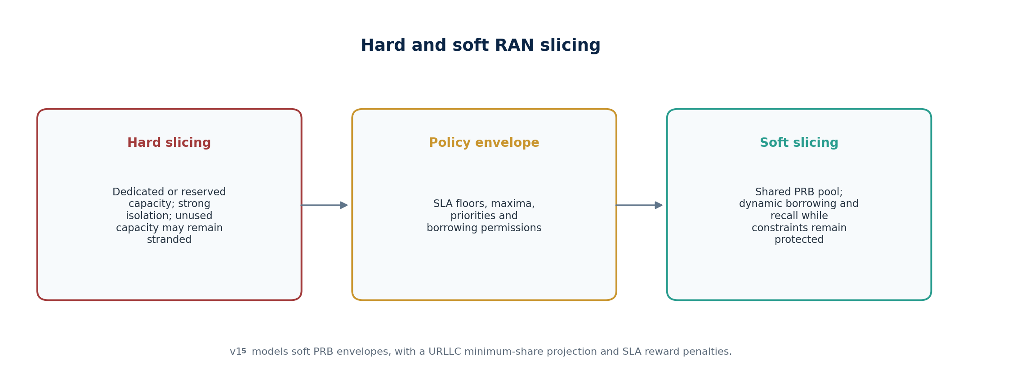
Figure 1. Hard reservation, policy envelope and soft shared allocation.
Figure 1. Hard reservation, policy envelope and soft shared allocation.

2.4 Hybrid operation
A practical RAN commonly uses a hybrid. Critical resources can have a hard minimum, while capacity above the floor is soft-shared. In v15 the configurable URLLC minimum share approximates the hard part; all remaining capacity is soft. eMBB throughput and mIoT service objectives are handled by reward penalties and therefore are not guaranteed.

3. Spectrum slicing versus PRB slicing
Spectrum slicing partitions frequency resources at carrier, component-carrier, bandwidth-part or MHz scale. PRB slicing partitions scheduled time–frequency units within configured spectrum. With fixed numerology and carrier bandwidth, the spectrum configuration determines the available PRB pool, but PRB assignment can vary at a much faster time scale. The two concepts therefore share a resource-accounting relationship but are not operationally identical.
Configured spectrum → carrier/BWP resources → available PRB pool → slice PRB envelopes → UE scheduling
Property | Spectrum slicing | PRB slicing in v15
Unit | MHz, carrier, component carrier or BWP | Normalized share and displayed PRB count
Time scale | Configuration or orchestration scale | One simulator decision step
Granularity | Coarse | Fine relative allocation
Borrowing | Limited when physically/semi-statically partitioned | Allowed through ±5% actions
v15 implementation | Not modeled | Primary resource abstraction
For a displayed total of N_PRB and share a_i, v15 reports an integer PRB count using rounding:
nᵢ = round(aᵢ · N_PRB) (3-1)
Implementation boundary The total-PRB field affects displayed counts only. The synthetic capacity, latency and reward equations operate on normalized shares and do not use N_PRB or bandwidth.

4. Service-slice profiles
Slice | Primary intent | v15 demand | Primary output | Protection mechanism
eMBB | High user-data capacity | Normalized offered load L_E | Throughput index T_E | Reward penalty below configured minimum
URLLC | Low latency and high urgency | Normalized offered load L_U | Synthetic latency D_U in ms | Minimum PRB share plus latency penalty
mIoT/eMTC | Mass device/service support | Normalized offered load L_M | Service ratio S_M | Reward penalty below configured minimum
These profiles are deliberately abstract. They express competing resource needs without implementing 5QI/QFI mapping, packet arrival processes, reliability targets or device power-saving procedures. Differentiating the three classes for legitimate QoS reasons is not a net-neutrality violation. Neutrality concerns arise when technically equivalent traffic is treated differently because of provider, application ownership, subscriber identity or commercial arrangement.

4.1 Initial allocation
a₀ = [a_E, a_U, a_M] = [0.55, 0.25, 0.20], a_E + a_U + a_M = 1 (4-1)
The initial shares are constants in v15 and are not exposed as input controls. They are reset for full training, evaluation, rule-baseline execution and the first single-step interaction.

5. Functional architecture
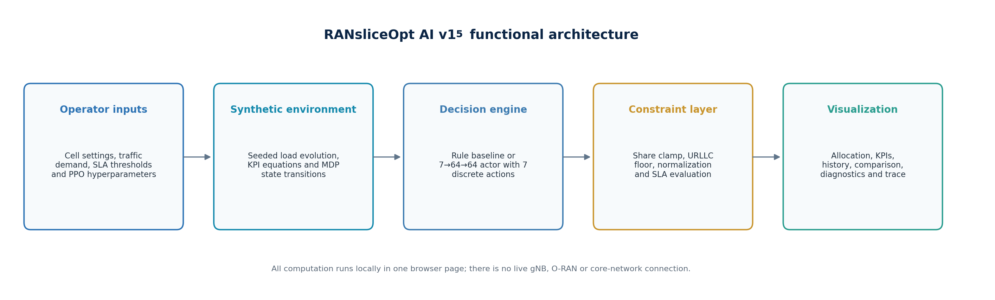
Figure 2. Functional architecture of the self-contained browser simulator.
Figure 2. Functional architecture of the self-contained browser simulator.

5.1 Browser execution model
The HTML file contains the interface, synthetic environment, seeded random generator, actor and critic networks, training loop, evaluation logic, plotting and logging. No server is required. State is held in JavaScript variables and is lost when the browser page is closed or refreshed, unless the browser restores the page from its own cache. There is no model serialization or carrier-data persistence in v15.

5.2 Separation of responsibilities
Component | Responsibility | Representative functions
Configuration | Read UI values and form a run snapshot | snapshotConfig
Traffic model | Generate deterministic stochastic load vectors | seededNoise, randnFrom, loadAt
Environment | Compute KPIs, reward and next state | metrics, rewardFnCfg, stateVector
Allocation safety | Clamp, floor and normalize proposed shares | normalizeShares, enforceShares
Learning | Actor/critic forward and backward updates | actorForward, criticForward, actorUpdate, criticUpdate
Execution | Full training, baseline and one-step modes | runPPO, runBaseline, runSingleStep
Presentation | Render KPIs, comparisons, diagnostics and trace | renderPoint, renderComparison, appendLog

6. End-to-end workflow
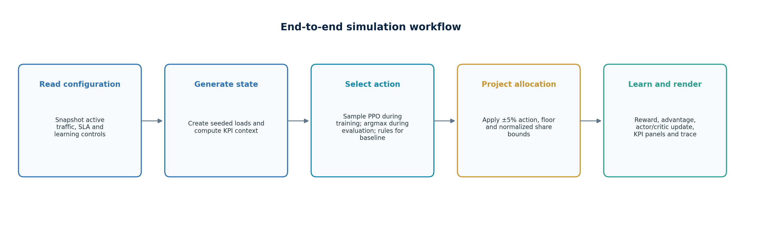
Figure 3. End-to-end state, action, environment, learning and visualization flow.
Figure 3. End-to-end state, action, environment, learning and visualization flow.

6.1 Full PPO-MDP run
1. Read the current configuration and initialize new actor and critic networks from seed 99173.
2. Collect multiple seeded rollouts. Each rollout starts from the default 55/25/20 share vector.
3. Calculate rewards, temporal-difference residuals, generalized advantages and return targets.
4. Normalize advantages and run four actor/critic update epochs over each rollout.
5. Evaluate the trained policy deterministically and evaluate the fixed rule policy using the same seed 24680.
6. Display final KPIs, allocation, history, tail-average comparison, diagnostics and trace.

6.2 Single-step run
The first click initializes persistent in-page actor and critic objects. Each click then generates one new load vector, samples one PPO action, applies projected shares, computes reward and one-step bootstrap values, performs four update epochs, and advances a matched rule-based branch with the same load. Histories are retained up to 180 points while the page remains open.

6.3 Rule-baseline run
The Rule Baseline button evaluates only the fixed rules. If a trained PPO actor exists in memory, it may be evaluated for display comparison, but it is neither trained nor modified by the baseline run.

7. User-interface input controls
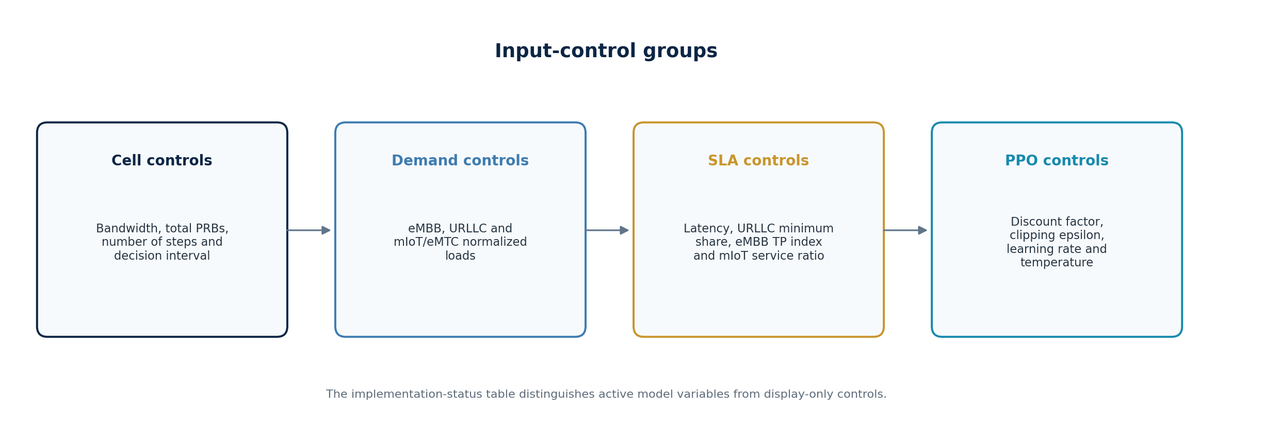
Figure 4. Configuration control groups exposed by v14.
Figure 4. Configuration control groups exposed by v15.

7.1 Cell and traffic controls
Control | Range/default | Current role
System bandwidth | 50/100/200 MHz; default 100 | UI only; not included in snapshotConfig or KPI equations
Total PRBs | 50–1000; default 273 | Converts normalized shares into displayed PRB counts
Simulation steps | 10–1000; default 120 | Controls evaluation length and indirectly rollout/iteration counts
Decision interval | 1–1000 ms; default 10 | UI only; does not scale traffic evolution, latency or run duration

7.2 Slice-demand controls
Control | Range/default | Traffic-model use
eMBB load | 0.20–1.50; default 0.90 | Center of L_E(k), plus sinusoid and Gaussian perturbation
URLLC load | 0.05–1.20; default 0.45 | Center of L_U(k), minus half sinusoid and Gaussian perturbation
mIoT/eMTC load | 0.05–1.20; default 0.35 | Center of L_M(k), Gaussian perturbation only

7.3 SLA controls
Control | Default | Mechanism
URLLC latency target | 2 ms | Reward penalty when synthetic latency exceeds target
URLLC minimum PRB share | 20% | Allocation projection before KPI calculation
eMBB minimum throughput index | 0.55 | Reward penalty and rule-baseline trigger
mIoT minimum service ratio | 0.75 | Reward penalty and rule-baseline trigger

7.4 PPO/MDP controls
Control | Range/default | Use
Gamma γ | 0.50–0.999; default 0.97 | Discounts next-state value and recursive advantage
PPO clip ε | 0.05–0.50; default 0.20 | Sets probability-ratio saturation limits 1−ε and 1+ε
Learning rate α | 0.001–0.20; default 0.035 | Base rate; actor uses 0.35α and critic uses 0.55α
Exploration temperature τ | 0.10–2.0; default 0.8 | Scales softmax logits during stochastic action selection

8. Command buttons and run-state behavior
Button | Behavior | Learning effect
Run PPO-MDP | Fresh full training followed by matched PPO/rule evaluation | Creates and trains new actor and critic
Run Single Step | One traffic transition and one matched policy comparison per click | Continues in-page learning; four actor/critic updates per click
Rule Baseline | Runs fixed priority rules; may show stored PPO for comparison | Never updates PPO
Reset | Restores shares, histories, networks, diagnostics and display | Deletes in-page learned state

8.1 Stale-output protection
After outputs exist, changing any listed configuration control marks the output region stale, dims it and changes button labels to indicate that a rerun is required. This is an interface-consistency feature; it does not automatically recompute results. The bandwidth, PRB and interval controls also trigger stale status even though some do not affect the current KPI calculations.

8.2 Persistence semantics
Single-step state persists only in JavaScript memory. Closing, reloading or navigating away from the page resets the learned weights and history. Full PPO-MDP always starts a fresh actor and critic. A future version should serialize the model, configuration schema, training provenance and validation state, with an explicit compatibility version and reset control.

9. Output visualization
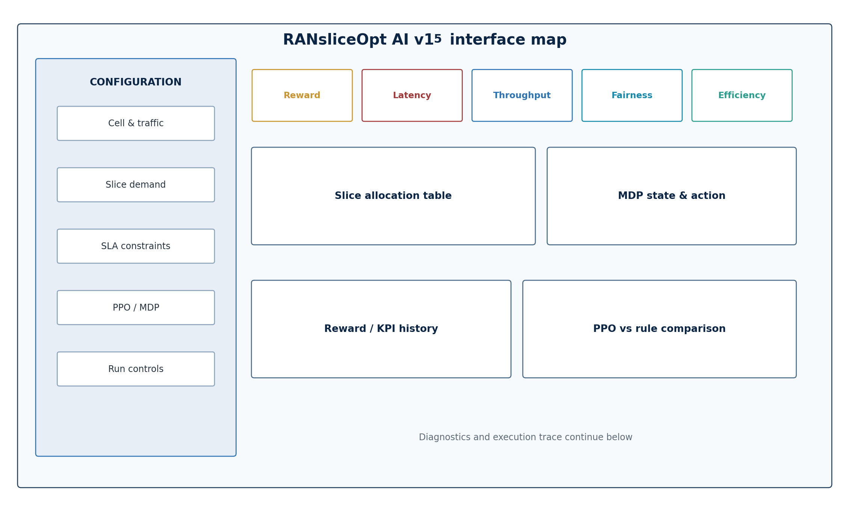
Figure 5. Schematic map of the v14 interface and output hierarchy.
Figure 5. Schematic map of the v15 interface and output hierarchy.

9.1 Primary KPI cards
The five cards show composite reward, URLLC latency, eMBB throughput index, Jain fairness and efficiency index. Except for the synthetic latency in milliseconds, all are normalized, dimensionless model outputs. They should not be relabeled as measured network KPIs without calibration.

9.2 Allocation and state
The allocation table shows rounded PRB counts, percentage shares, current normalized demand and PASS/VIOL status. The MDP panel prints the seven-element state vector and the selected action label. Colored bars show the current share envelope.

9.3 Comparison and diagnostics
The comparison table reports tail averages over the final 25% of evaluation samples for the rule baseline and PPO. Gains are percentage changes, except latency, which is reported as a reduction improvement. Diagnostics show update count, mean clip fraction, mean absolute advantage, critic loss and action-change counts. The execution trace records time index, action, shares, latency, eMBB index and reward; single-step mode additionally logs mIoT service.

10. Configuration and runtime data model

10.1 Configuration snapshot
snapshotConfig reads steps, the three base loads, three KPI/SLA thresholds, the URLLC minimum share and four learning controls. The snapshot does not contain bandwidth, total PRBs or decision interval. Total PRBs is read separately during rendering.
Runtime object | Dimensions/content | Lifetime
shares | Three current normalized slice shares | Current PPO branch
kpiHistory | Up to 180 single-step points or full evaluation series | Until reset/reload
comparison | Baseline and PPO result arrays | Until rerun/reset
liveActor | W1 64×7, W2 64×64, W3 7×64 plus biases | Until reset/reload
liveCritic | W1 64×7, W2 64×64, W3 64 plus biases | Until reset/reload
liveRnd | Seeded linear-congruential generator | Continues across single-step clicks
liveBaselineShares | Three matched rule-baseline shares | Until reset/reload

10.2 Reproducible random generation
A 32-bit linear-congruential generator updates an unsigned integer state and maps it to [0,1). Gaussian noise is formed by a Box–Muller transform. Fixed seeds make training and evaluation repeatable for a given browser implementation and configuration.
sₙ₊₁ = (1664525·sₙ + 1013904223) mod 2³², uₙ = sₙ/2³² (10-1)
z = √(−2 ln u) · cos(2πv) (10-2)

11. Synthetic traffic evolution
At simulator step k, v15 combines each configured base load with a deterministic sinusoidal component and independent Gaussian perturbations. The eMBB and URLLC waves are anticorrelated: eMBB receives the full wave and URLLC subtracts half of it. mIoT contains no sinusoidal component.
w(k) = 0.08 sin(k/9) (11-1)
L_E(k) = clip(L̄_E + w(k) + 0.04z_E, 0.05, 1.80) (11-2)
L_U(k) = clip(L̄_U − 0.5w(k) + 0.03z_U, 0.02, 1.50) (11-3)
L_M(k) = clip(L̄_M + 0.03z_M, 0.02, 1.50) (11-4)
The wave is indexed by simulation step, not physical time. Changing the decision interval therefore does not change the rate of load variation. A production-oriented model should define kΔt explicitly, calibrate arrival and session processes, and preserve correlations across cells and services.

11.1 Interpretation
- Loads are normalized demand indicators, not Mbps, packets/s or active UE counts.
- Noise is controlled and repeatable, enabling fair algorithm comparisons.
- The model creates temporal transitions, so the full run is multi-step in the simulator sense.
- The state is fully observable only with respect to the seven synthetic features; real RAN state would be partially observed and delayed.

12. Share normalization and hard constraints
Let x be the three-component share proposal after adding an action vector. normalizeShares first clips every component to [0.08,0.84], then divides by the component sum.
x̄ᵢ = clip(xᵢ, 0.08, 0.84), aᵢ = x̄ᵢ / Σⱼx̄ⱼ (12-1)
enforceShares first checks the URLLC component. If x_U is below the configured minimum u_min, it sets x_U=u_min and attempts to take the difference from eMBB, while preventing eMBB from going below 0.08. It then calls normalizeShares.
d = u_min − x_U; x_U ← u_min; x_E ← max(0.08, x_E − d) (12-2)
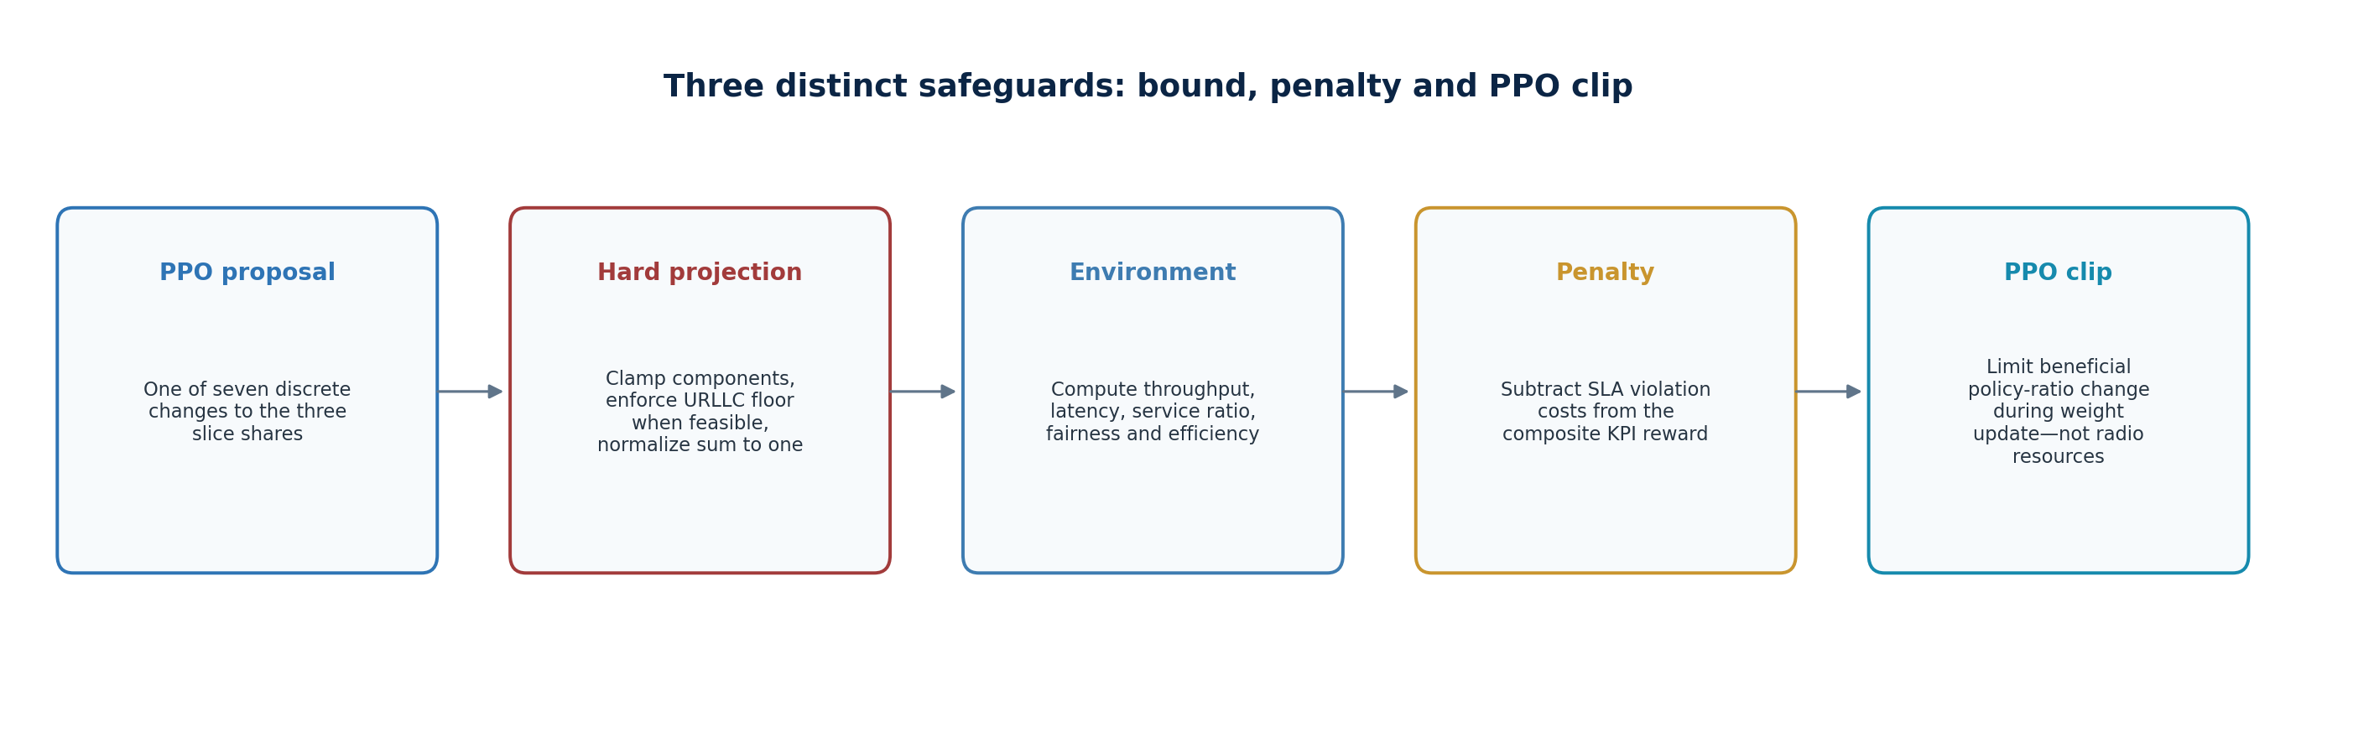
Figure 6. Allocation projection, SLA penalty and PPO clipping occur at different stages.
Figure 6. Allocation projection, SLA penalty and PPO clipping occur at different stages.

12.1 Strength of the URLLC floor
For normal five-percentage-point actions around feasible shares, the projection behaves as a hard URLLC floor. Under extreme user settings, however, normalization after an insufficient eMBB donation can reduce the normalized URLLC result below u_min. It is therefore more accurate to call the current mechanism an approximate projected floor rather than a formally proven constraint.
Recommended correction Project the complete vector onto the simplex with explicit lower and upper bounds, verify feasibility before the run, and assert a_U ≥ u_min after projection. If the bound set is infeasible, reject the configuration rather than silently renormalizing.

13. Synthetic KPI formulae

13.1 Capacity intermediates
C_E = 1.55a_E, C_U = 1.20a_U, C_M = 1.80a_M (13-1)
The coefficients 1.55, 1.20 and 1.80 are synthetic sensitivity factors. They are not spectral efficiencies and do not depend on carrier bandwidth, SCS, MCS, MIMO rank or channel quality.

13.2 eMBB throughput index
T_E = clip(C_E/(L_E+0.22), 0, 1.25) (13-2)
T_E compares synthetic eMBB capacity with offered load plus a stabilizing offset. A value near one represents approximate normalized demand coverage; it is not Mbps. The default SLA threshold is 0.55.

13.3 URLLC latency
D_U = 0.65 + 3.40[L_U/(C_U+0.12)]¹·³⁵ ms (13-3)
Latency increases nonlinearly when URLLC demand exceeds its allocated synthetic capacity. The 0.65 ms floor and other constants are demonstration parameters, not a decomposition of air-interface, queueing, transport and processing delay.

13.4 mIoT/eMTC service ratio
S_M = clip(C_M/(L_M+0.12), 0, 1.10) (13-4)
S_M is a normalized served-demand measure. A value of 0.75 represents 75% on the synthetic scale, while values slightly above one provide displayed capacity margin.
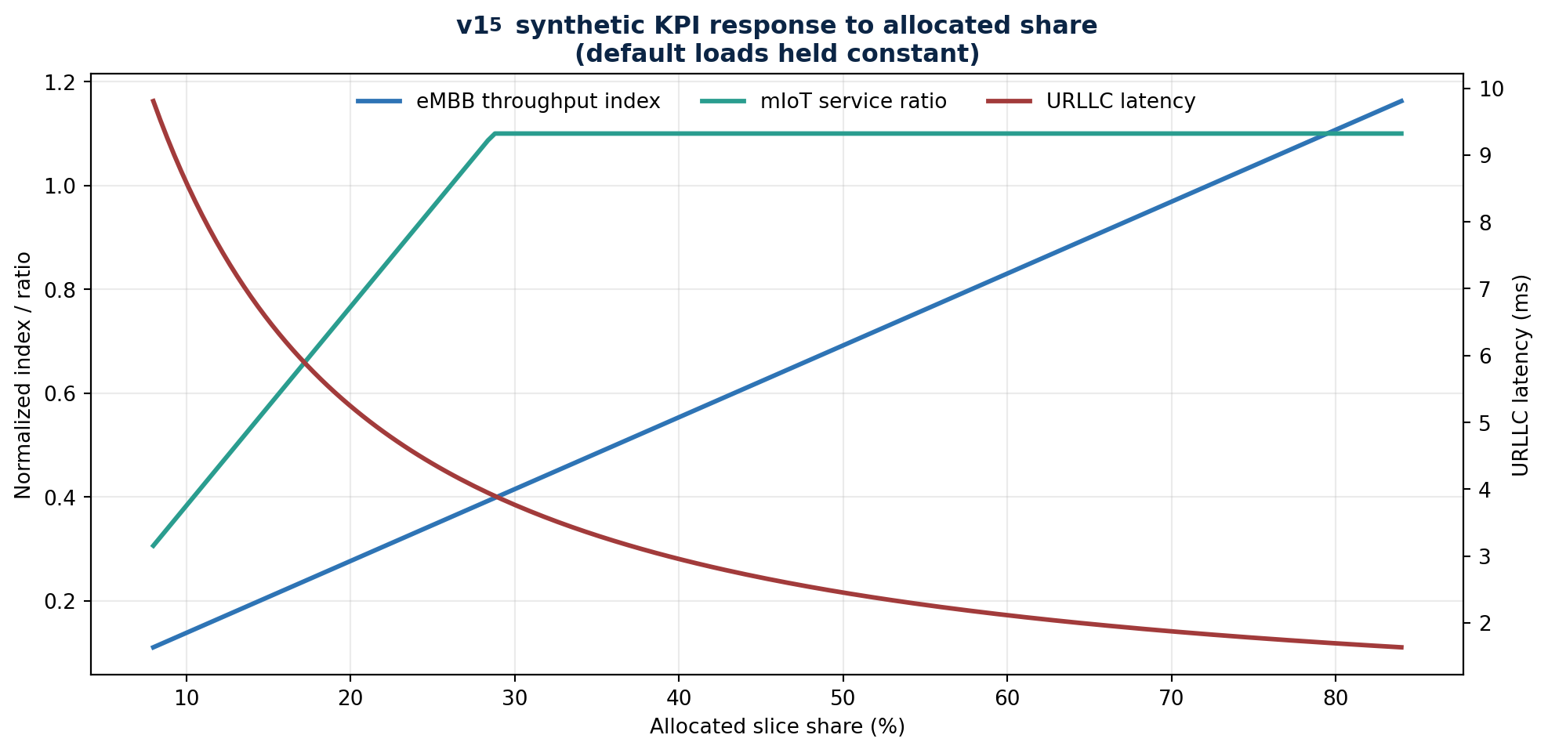
Figure 7. Response of the three primary synthetic KPIs to slice share at default loads.
Figure 7. Response of the three primary synthetic KPIs to slice share at default loads.

14. Fairness, efficiency and worked example

14.1 Fairness index
Implementation note: v15 still computes and displays this synthetic fairness heuristic and includes it in the implemented v15 reward. IEEE Version 3 does not use a separate fairness index as a PPO reward term; its proposed service protection is expressed through explicit slice-level SLA achievement. This difference is intentional and must not be read as a claim that v15 already implements the Version 3 reward.
F = clip{1 − 0.52[max(a)−min(a)] − 0.08|L_E−L_U|, 0.55, 1} (14-1)
The displayed label says Jain fairness, but the implementation is not the classical Jain index (Σx_i)²/(nΣx_i²). It is a bounded heuristic based on share spread and eMBB/URLLC load difference. The design should therefore rename it ‘synthetic fairness index’ or replace it with a true Jain calculation over per-slice or per-UE service outcomes.

14.2 Efficiency index
η = clip{[0.55T_E + 0.25S_M + 0.20/max(D_U,0.5)]/1.05, 0, 1.20} (14-2)
η rewards eMBB throughput, mIoT service and inverse latency. It does not contain Joules, watts, transmit power, sleep state or resource cost. ‘Normalized resource/energy-efficiency index’ should be interpreted cautiously; in v15 it is a composite performance-efficiency proxy.

14.3 Default initial-state example
Metric | Initial value | Interpretation
T_E | 0.761 | Above default minimum 0.55
D_U | 4.38 ms | Violates default 2 ms target
S_M | 0.766 | Above default minimum 0.75
F | 0.782 | Synthetic share/load fairness
η | 0.625 | Composite efficiency proxy

15. Reward and SLA penalties
Implementation note: the equations in this section document v15 exactly. The separate IEEE Version 3 research formulation uses a different proposed reward based on slice-SLA achievement, normalized resource/spectrum efficiency and allocation churn/stability. Profitability, regulatory neutrality and a separate fairness index are excluded from that proposed reward.
The positive reward combines capped eMBB throughput, fairness, capped mIoT service and capped efficiency. URLLC latency is represented indirectly through efficiency and directly through a violation penalty.
R₊ = 0.40·clip(T_E,0,1) + 0.25F + 0.15·clip(S_M,0,1) + 0.20·clip(η,0,1) (15-1)
P_U = 0.55·min[2,(D_U−D_target)/D_target] if D_U>D_target; otherwise 0 (15-2)
P_E = 0.30(T_min−T_E) if T_E<T_min; otherwise 0 (15-3)
P_M = 0.25(S_min−S_M) if S_M<S_min; otherwise 0 (15-4)
R = R₊ − (P_U + P_E + P_M) (15-5)

15.1 Interpretation of weights
The positive weights sum to one, but the total reward is not restricted to [0,1] because penalties can make it negative. URLLC has the steepest explicit penalty and can subtract up to 1.10 from the reward. The default 2 ms latency target is demanding relative to the initial synthetic allocation, so a low or negative reward can coexist with apparently reasonable throughput and service indices.

15.2 Penalty versus guarantee
A penalty changes what the learner prefers; it does not prevent a violating allocation from being evaluated or displayed. If an SLA must never be violated, it must be represented by action masking, a feasible-set projection, admission control or a safety controller. Penalties remain useful for shaping behavior inside the feasible set and for discouraging operation close to a boundary.

16. MDP formulation
v15 represents repeated slice-envelope decisions as a Markov decision process over synthetic load and KPI state. The next state depends on the current share allocation, selected action and generated load. Because the traffic sequence evolves over multiple steps and γ propagates value forward, the full run is not a one-step contextual bandit.

16.1 State
sₜ = [L_E, L_U, L_M, D_U/5, T_E, F, η]ᵀ ∈ ℝ⁷ (16-1)
The current share vector is not explicitly included in s_t, although its effect appears indirectly in the KPIs. mIoT service ratio is also absent from the state even though it contributes to reward and SLA penalties. This makes the observation incomplete relative to the environment and can produce state aliasing.

16.2 Action
aₜ ∈ {0,…,6}; xₜ₊₁ = a_share,t + Δ(aₜ); a_share,t₊₁ = Project(xₜ₊₁) (16-2)

16.3 Transition and reward
The transition combines deterministic action arithmetic, constrained projection and an exogenous seeded traffic process. Reward is calculated after the action. The simulator then builds the next state using the same current load and post-action KPIs; the next rollout sample generates a new load.

16.4 Discounting
The default γ=0.97 values future predicted return. A higher γ gives more weight to downstream consequences, while a lower γ makes learning more immediate. The simulator does not model an explicit terminal condition inside each rollout; the backward GAE recursion ends at the rollout boundary.

17. Discrete action space
ID | Displayed action | Δ[eMBB,URLLC,mIoT] | Implementation meaning
0 | Hold allocation | [0, 0, 0] | No share change
1 | eMBB → URLLC | [−0.05,+0.05,0] | Move five points to URLLC
2 | eMBB → mIoT | [−0.05,0,+0.05] | Move five points to mIoT
3 | URLLC → eMBB | [+0.05,−0.05,0] | Move five points to eMBB
4 | mIoT → eMBB | [+0.05,0,−0.05] | Move five points to eMBB
5 | Displayed: mIoT → URLLC | [0,−0.05,+0.05] | Actual vector is URLLC → mIoT
6 | Displayed: URLLC → mIoT | [0,+0.05,−0.05] | Actual vector is mIoT → URLLC

Source discrepancy Actions 5 and 6 have labels opposite to their vectors. Calculations follow the vectors; the UI trace follows the labels. Correcting the labels is a high-priority v15 maintenance item.

The finite action set makes policy output simple and auditable. It also restricts resolution to five percentage points and cannot jointly optimize bandwidth, transmit power, spatial layers, carrier aggregation or admission. A future action design may combine masked discrete choices with bounded continuous adjustments.

18. Actor–critic neural networks
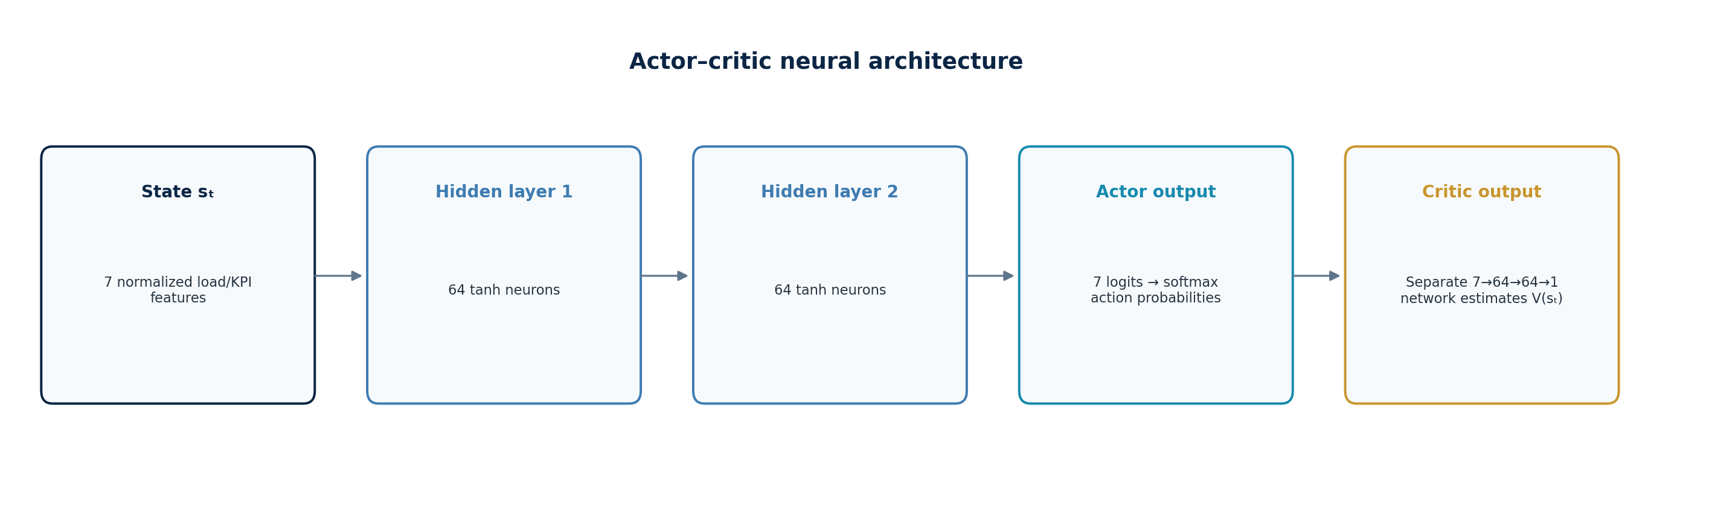
Figure 8. Separate two-hidden-layer actor and critic networks.
Figure 8. Separate two-hidden-layer actor and critic networks.

18.1 Actor
h₁ = tanh(W₁s+b₁), W₁∈ℝ⁶⁴ˣ⁷ (18-1)
h₂ = tanh(W₂h₁+b₂), W₂∈ℝ⁶⁴ˣ⁶⁴ (18-2)
z = W₃h₂+b₃, W₃∈ℝ⁷ˣ⁶⁴ (18-3)
The seven logits z are unnormalized action preferences. They are converted to probabilities using temperature-scaled softmax. Weights are initialized uniformly around zero with layer-dependent scales 0.16, 0.09 and 0.09.

18.2 Critic
The critic uses its own 7→64→64 network and a scalar linear output V(s). It does not share weights with the actor. The critic approximates expected discounted return and supplies a baseline for the advantage calculation.
V(s) = w₃ᵀh₂ + b₃ (18-4)

18.3 Why hidden layers matter
The hidden layers form nonlinear combinations of load and KPI inputs. During backpropagation, errors propagate from action logits or value output through both hidden layers, modifying every weight matrix. This is materially different from a fixed random feature transform or a rule table.

19. Policy probabilities and exploration
π_θ(a=i|s) = exp[(zᵢ−z_max)/τ] / Σⱼ exp[(zⱼ−z_max)/τ] (19-1)
Subtracting z_max improves numerical stability. During rollout collection and single-step learning, an action is sampled from the categorical probability distribution. A lower temperature sharpens preferences; a higher temperature flattens them and increases exploration.

19.1 Training versus evaluation
Phase | Temperature | Action selection
Rollout training | Configured τ | Stochastic categorical sample
Single-step learning | Configured τ | Stochastic categorical sample
Post-training evaluation | max(0.25,0.55τ) | Deterministic argmax
Evaluation computes a softened probability vector but then chooses only the maximum-probability action. The evaluation seed controls traffic, not exploration. This makes repeated comparisons stable but does not measure policy robustness under stochastic action selection.

19.2 Exploration limitations
There is no entropy bonus, explicit KL target, epsilon-greedy path or action mask. Temperature is the principal exploration control. Unsafe or infeasible actions are not removed before sampling; they are corrected afterward by share projection.

20. PPO rollout, advantage and update
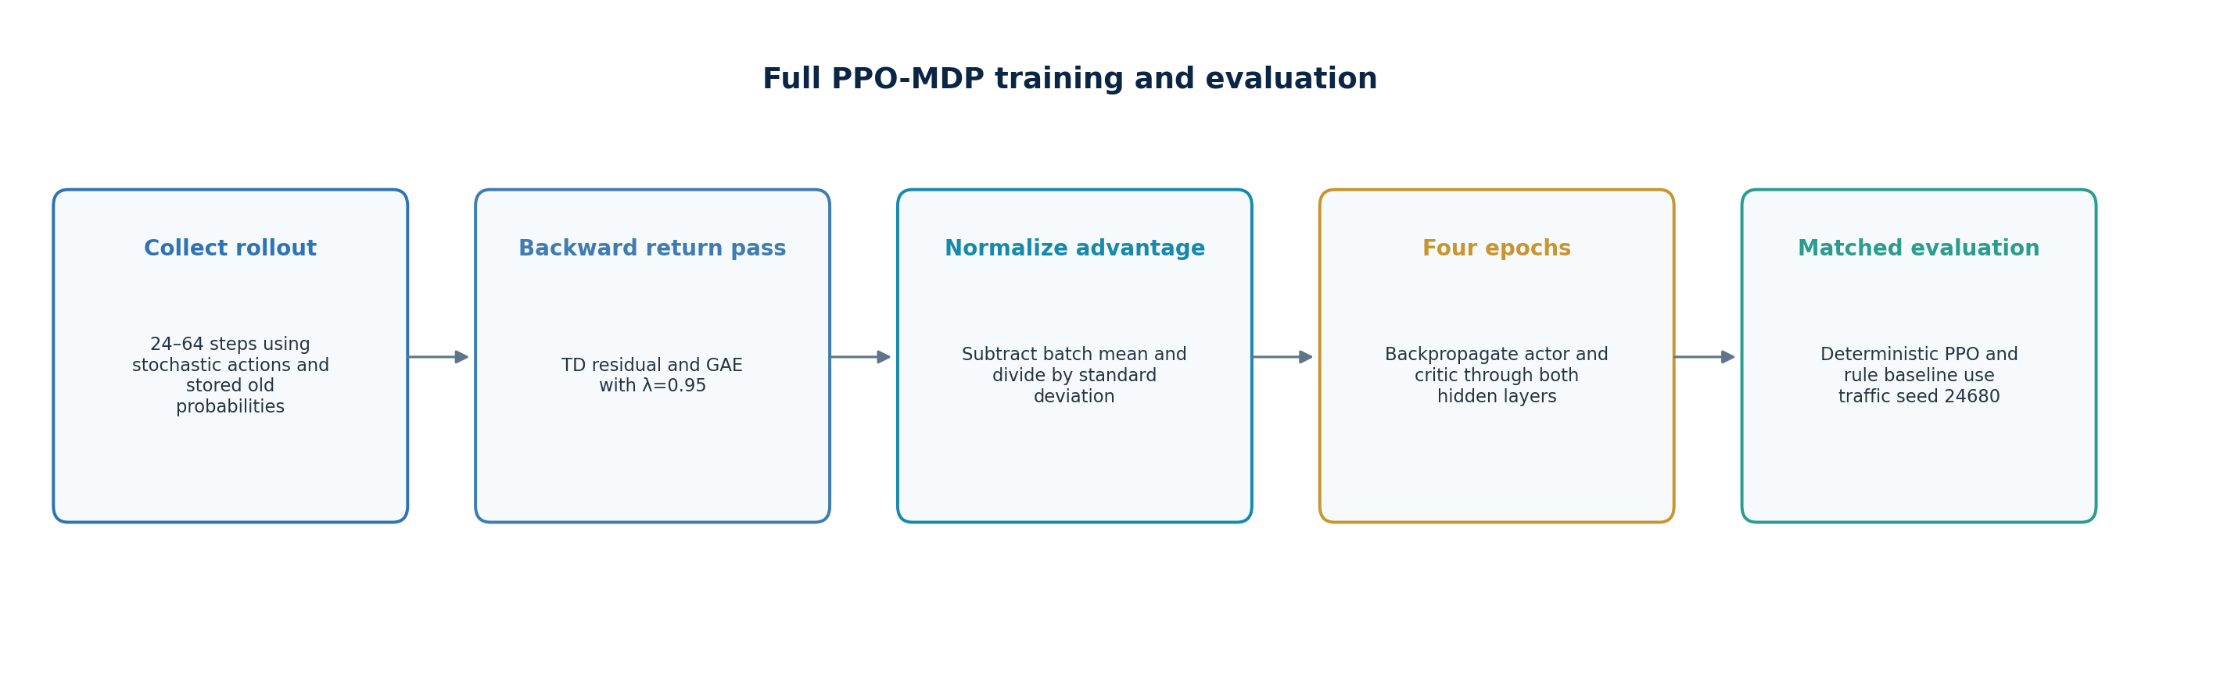
Figure 9. Full training sequence from rollout collection to matched evaluation.
Figure 9. Full training sequence from rollout collection to matched evaluation.

20.1 Rollout sizing
N_roll = max[24, min(64, N_steps)] (20-1)
N_iter = max[6, min(12, round(N_steps/15))] (20-2)
Each iteration collects a fresh rollout using seed 12345+137·iteration. Four update epochs traverse every sample. With the default 120 steps, N_roll=64 and N_iter=8, producing 8×64×4=2048 actor and critic sample updates.

20.2 Temporal-difference residual and GAE
δₜ = rₜ + γV(sₜ₊₁) − V(sₜ) (20-3)
Aₜ = δₜ + γλAₜ₊₁, λ=0.95 (20-4)
Gₜ = Aₜ + V(sₜ) (20-5)
Advantages are normalized across the rollout. Lambda is fixed at 0.95 and is not exposed in the interface. The final sample bootstraps from its computed next-state value rather than forcing a terminal value of zero.

20.3 PPO probability ratio and clipping
ρₜ(θ) = π_θ(aₜ|sₜ) / π_old(aₜ|sₜ) (20-6)
L_clip = E[min(ρₜAₜ, clip(ρₜ,1−ε,1+ε)Aₜ)] (20-7)
v15 implements the saturation logic directly. If A≥0 and ρ>1+ε, or A<0 and ρ<1−ε, the actor update is skipped for that sample. Otherwise the gradient coefficient is clip(Aρ,−4,4)/τ. The first epoch begins with ρ=1 because old probability is captured immediately before updating; later epochs can move the ratio into the clipped region.

20.4 Critic update
e = clip(Gₜ−V(sₜ),−4,4), L_V = ½e² (20-8)
The actor uses effective learning rate 0.35α and the critic uses 0.55α. Both gradients propagate through the output layer and two tanh hidden layers. There is no optimizer state, momentum, Adam, minibatch shuffle, gradient-norm clipping, value clipping or learning-rate schedule.

21. Single-step learning workflow
1. Initialize actor, critic, live random generator, PPO shares and baseline shares on the first click only.
2. Generate one new traffic load vector using the persistent seed-77777 generator.
3. Compute the current PPO state, action probabilities and sampled action; store the selected old probability.
4. Apply the action, project shares, compute post-action KPIs and reward, and build the post-action state.
5. Compute one-step advantage A=r+γV(s′)−V(s) and target G=r+γV(s′).
6. Perform four actor and critic updates on the same sample.
7. Run the fixed baseline against the same traffic state, update both histories and redraw every output.

21.1 Interpretation
Each click is one MDP transition, not one independent browser session. Multiple clicks continue from the previous share vectors and updated network weights. The user can change configuration controls between clicks, but the stale-output indicator requires a rerun; changing model semantics mid-trajectory is not a controlled training protocol.

21.2 Learning stability
A single sample reused for four epochs has high variance and can overfit the immediate transition. It is valuable for demonstrating backpropagation, but a production learner would collect batches, normalize advantages over a meaningful horizon, apply optimizer safeguards and separate training from safety-critical inference.

22. Rule-based baseline
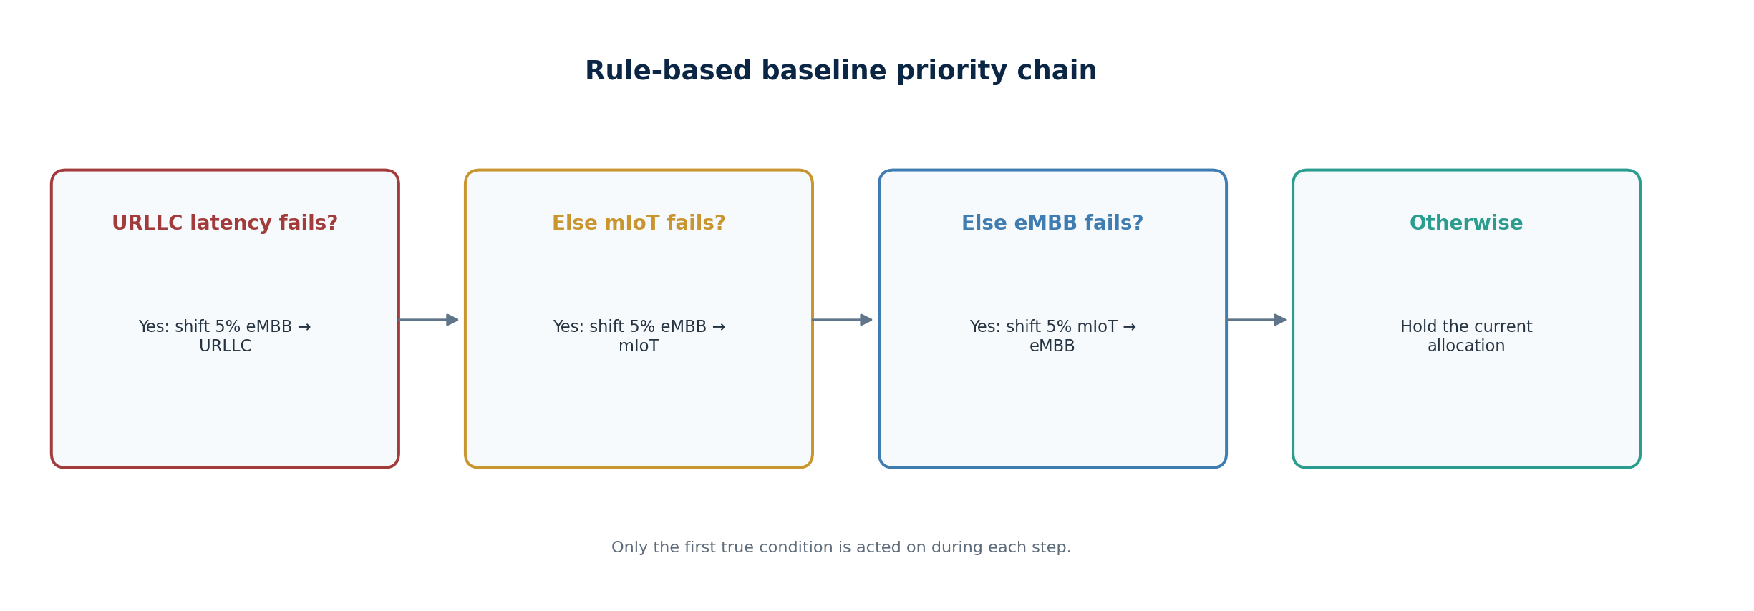
Figure 10. Fixed baseline rules and priority order.
Figure 10. Fixed baseline rules and priority order.
The baseline starts from 55/25/20 and evaluates current KPIs before acting. It chooses the first condition that is true: URLLC latency, then mIoT service, then eMBB throughput, otherwise hold. It applies the same share projection and reward equations as PPO.
a_rule = 1 if D_U>D_target; else 2 if S_M<S_min; else 4 if T_E<T_min; else 0 (22-1)

22.1 Strengths
- Transparent, deterministic and easy to audit.
- Provides an interpretable comparison point with identical environment equations.
- Reflects a plausible SLA-first operational policy.
- Does not require training, weights or hyperparameter selection.

22.2 Limitations
The priority order is fixed, only one violation is handled per step, the transfer size is fixed at five points, and the rules do not anticipate future load. Thresholds are user-configurable, but the initial allocation, priority order, donor slice and step size are code constants.

23. Matched evaluation and gain calculations
Full evaluation runs the rule baseline and trained PPO from identical initial shares using traffic seed 24680. The rule branch is evaluated independently; it does not provide samples to PPO training. This separation avoids the earlier ambiguity of a baseline button that might accidentally update a stored learner.
x̄_tail = (1/N_tail) Σ xₜ, N_tail=max[1,floor(0.25N)] (23-1)
Gain_x(%) = 100(x_PPO−x_rule)/|x_rule| (23-2)
Latency improvement(%) = 100(D_rule−D_PPO)/max(D_rule,10⁻⁹) (23-3)

23.1 Interpretation cautions
- A percentage gain can look large when the baseline denominator is small.
- The comparison is deterministic for one synthetic traffic seed, not a confidence interval across independent scenarios.
- Tail averaging emphasizes steady-state behavior but can hide early violations or unstable transients.
- Reward improvement does not imply that every individual SLA or KPI improved.

24. SLA assurance, PPO clipping and penalties
Mechanism | Controls | Violation behavior | Guarantee strength
Hard bound/projection | Actual resource proposal | Rejects or corrects before application | Strong when projection is mathematically valid
Reward penalty | Learner preference | Violation can occur but receives lower reward | Soft; improves behavior over experience
PPO clip | Probability-ratio update | Caps/blocks excessive beneficial policy movement | Training stability only; no SLA guarantee

24.1 v15 SLA classification
Requirement | Current enforcement | Status
URLLC minimum share | Projected floor plus component bounds | Approximate hard constraint
URLLC latency target | Reward penalty and rule trigger | Soft objective
eMBB throughput minimum | Reward penalty and rule trigger | Soft objective
mIoT service minimum | Reward penalty and rule trigger | Soft objective
Share sum | Normalization | Hard equality to numerical precision
A production design should define which SLAs are admission-time feasibility constraints, which are runtime hard limits, which are probabilistic targets and which are optimization objectives. Treating every SLA as a reward term can produce violations during exploration; treating every SLA as a hard reservation can waste capacity.

25. Regulatory neutrality boundary and feature discipline
v15 is identity-blind. Its state contains only three loads and four KPIs. Its action changes aggregate slice shares. It does not receive application name, content provider, subscriber identity, payment tier, commercial partner or traffic source. Consequently, the actor cannot intentionally learn provider-specific preference from those absent fields.

25.1 What is not implemented
Identity blindness is not a formal neutrality bound. Because the simulator has no per-flow or per-provider representation, it cannot verify that technically equivalent flows receive equivalent resource treatment. The synthetic fairness index measures aggregate share spread and load difference; it is not a legal or regulatory neutrality test.

25.2 Relationship to IEEE Version 3
IEEE Version 3 does not convert regulatory neutrality into a PPO reward term or claim that the simulator is a regulatory neutrality model.
- Legitimate slice differentiation is based on technical service requirements and configured SLAs. Commercial identity is outside the optimization state and outside the reported research reward.
- A deployment may separately govern the approved feature schema and audit technically equivalent traffic according to applicable operator and jurisdictional requirements.
- Such regulatory or commercial-policy checks are external assurance functions, not claimed contributions of the v15 simulator or IEEE Version 3 PPO formulation.
- The PPO safety path should instead focus on explicit technical feasibility, slice SLA constraints, action bounds, stability, and deterministic fallback.
- Generate auditable reports showing technical justification for differentiated treatment.
Key distinction Different treatment of URLLC, eMBB and mIoT is technically justified by different QoS requirements. Net-neutrality assurance is principally required among technically equivalent traffic, not by forcing all slices to receive equal shares.

26. Implementation audit and limitations
Item | What the interface suggests | What v15 actually does | Recommended action
Bandwidth | Changes cell spectrum | Not used by snapshot or equations | Connect to PRB/numerology or mark informational
Total PRBs | Changes capacity | Changes displayed PRB counts only | Use in capacity/resource-cost model
Decision interval | Changes dynamics | Not used | Scale traffic, horizon and control latency
Jain fairness | Classical Jain index | Custom heuristic | Rename or implement Jain formula
Efficiency | Resource/energy efficiency | Composite KPI proxy | Add power/resource denominator
URLLC floor | Strict minimum | Can weaken after normalization at extremes | Use bounded-simplex projection
Actions 5/6 | Labels match shifts | Labels reversed relative to vectors | Correct label/vector mapping
Persistence | Potential continuing learner | In-page memory only | Versioned model storage and validation

26.1 Model omissions
The synthetic environment omits CQI, SINR, path loss, interference, scheduler queues, MCS, BLER, HARQ, numerology, TDD pattern, carrier aggregation, MIMO rank, beam resources, UL/DL separation, power, UE mobility, handover and multi-cell coupling. These omissions are acceptable for a teaching prototype but prevent quantitative field prediction.

26.2 Software limitations
The JavaScript implementation uses dense arrays and nested loops without tensor libraries, optimizer state, numerical checks or unit tests. Configuration values are parsed directly from controls. There is no schema validation for infeasible constraint combinations, no model export, no error telemetry beyond a runtime-error banner and no cryptographic provenance.

27. Mapping to a real RAN control hierarchy
A real deployment would not place the full browser training loop inside the MAC scheduler. Policy training and lifecycle management can execute at a slower management or non-real-time control layer. Validated inference or policy-envelope selection can execute closer to the RAN, while deterministic MAC scheduling remains responsible for sub-millisecond/slot-level UE allocation.
Layer | Representative responsibility | Time scale | v15 analogue
SMO / management | Slice intent, SLA, model governance, long-horizon optimization | Minutes to days | Configuration and future model persistence
Non-RT intelligence | Training, policy generation, cluster strategy | >1 s | Full PPO-MDP training
Near-RT control | Cell/cluster envelope adjustment | ~10 ms to 1 s | PPO action selection concept
gNB scheduler | Per-UE PRB/MCS/power/rank scheduling | Slot/TTI | Not implemented
Assurance | KPI telemetry, SLA detection, rollback | Continuous | Comparison panels and diagnostics concept
3GPP Release 18 describes more dynamic radio-resource allocation and management across slices. O-RAN specifications and demonstrations address RAN slicing, SLA assurance and intelligent control. These are architectural reference points, not evidence that v15 currently implements a standards interface.

28. Future multi-cell architecture
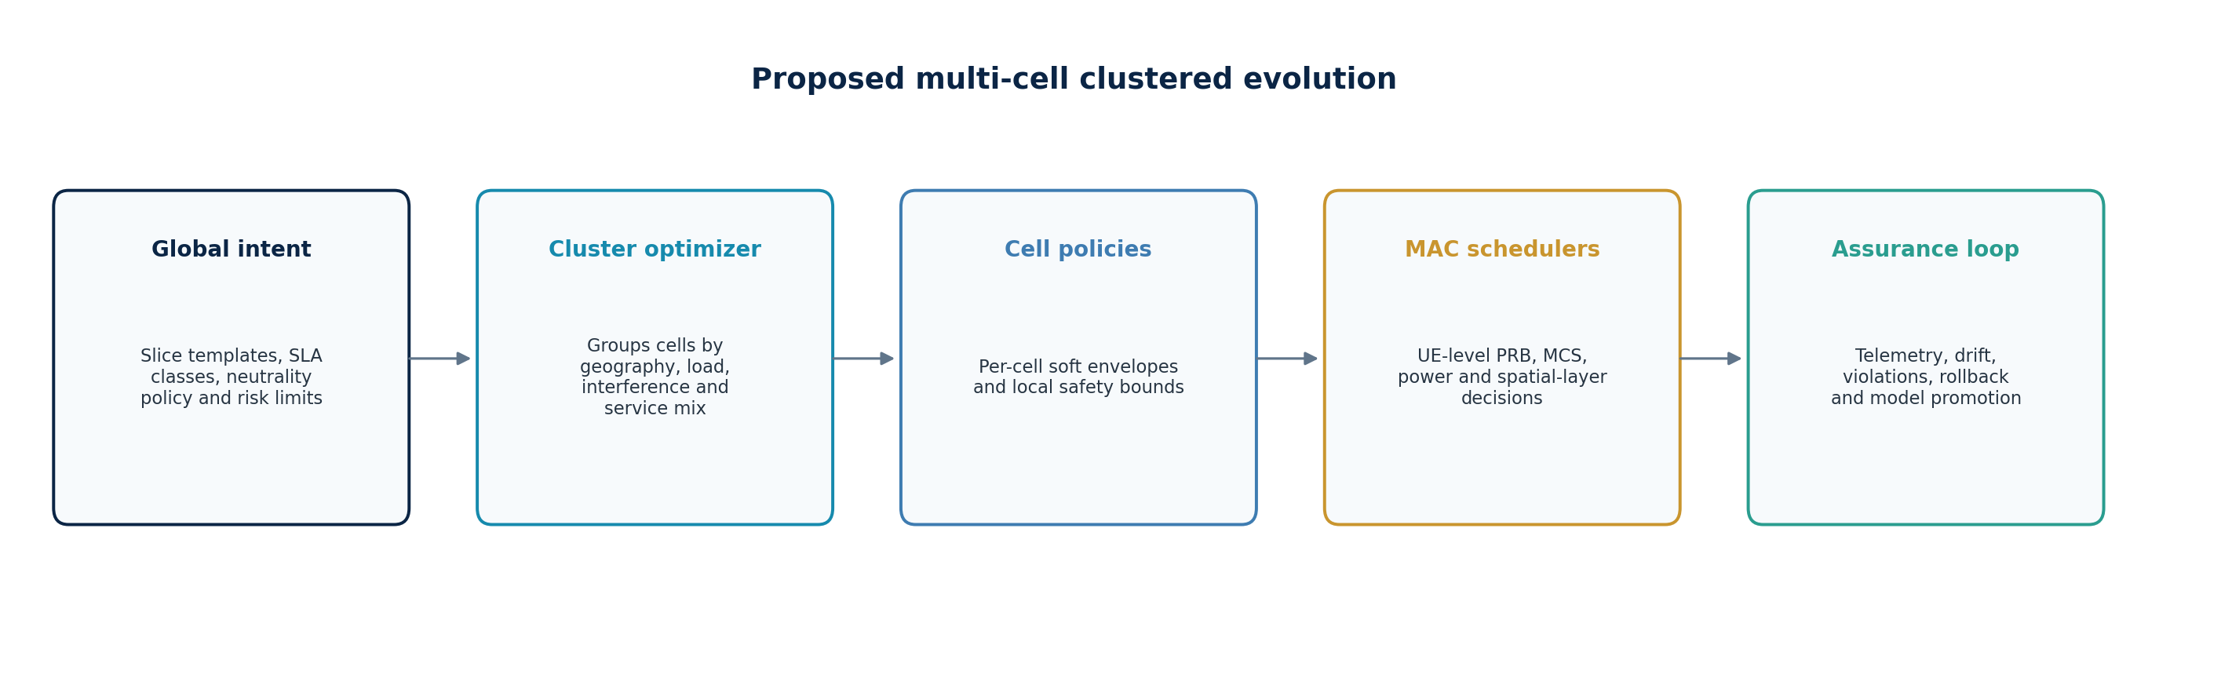
Figure 11. Proposed global, cluster, cell and scheduler hierarchy.
Figure 11. Proposed global, cluster, cell and scheduler hierarchy.
Soft-slice allocations should vary from cell to cell because service mix, coverage, interference, UE distribution and load differ. Slice identity and SLA intent can remain network-wide, while local resource envelopes adapt. A cluster controller coordinates neighboring cells to avoid locally optimal actions that create interference or mobility problems elsewhere.
a_c(t) = [a_E,c(t), a_U,c(t), a_M,c(t)], Σᵢa_i,c(t)=1 for each cell c (28-1)

28.1 Cluster definition
A cluster is a configurable group of cells that share an optimization context. Membership may be static by geography/site topology or dynamic by interference graph, handover coupling, traffic correlation and slice demand. Configuration should identify cluster ID, member cells, carrier/numerology compatibility, coordination period, shared constraints and fallback owner.

28.2 Per-cell versus common configuration
Configuration | Recommended scope
Slice identifiers, service intent, neutrality feature policy | Network-wide template
SLA targets and allowed exceptions | Template with regional/cell overrides under governance
Available carriers, PRBs, TDD pattern, power and antenna capability | Per cell/carrier
Traffic, channel, queues, mobility and interference | Per cell with neighbor context
PPO model | Shared, cluster-specific or conditioned on cell embedding
Action envelope and safety constraints | Per cell plus cluster coupling constraints

29. Proposed clustered MDP

29.1 State
s_c(t) = [B_total, ρ_E, ρ_U, ρ_M, q_E, q_U, q_M, SNR, v_E, v_U, T_coh, B_prev, τ, neighbor/context features]_c (29-1)
Aligned with IEEE Version 3, the proposed state separates eMBB and URLLC mobility descriptors while treating aggregate mIoT/eMTC as predominantly stationary or low-mobility; a mobile eMTC fraction may be represented when material. The state also carries traffic/demand, radio-condition, coherence-time, previous-allocation and timing context. Multi-cell extensions may append neighbor summaries, interference, capability and constraint-margin features, with timestamps and confidence indicators.

29.2 Action
The IEEE Version 3 action is a slice-resource budget [B_URLLC, B_eMTC, B_eMBB] constrained by the available resource pool and protected slice requirements. Future multi-cell implementations may additionally adjust PRB envelopes, scheduler weights and admission thresholds and, at slower time scales, bandwidth/carrier activation, power or spatial layers. Safety masking must remove actions that violate spectrum, hardware, SLA or stability constraints before sampling.

29.3 Reward
R_cluster = Σ_c w_c[ w_SLA I_SLA,c + w_E E_c − w_C C_c ] − λ_I·Interference − λ_H·MobilityCost − λ_V·Violations (29-2)
The IEEE Version 3 reward is intentionally restricted to reproducible technical quantities: slice-SLA achievement, normalized resource/spectrum efficiency, and allocation churn/stability. Profitability, regulatory net neutrality and a separate fairness index are not PPO reward terms. Hard guarantees remain outside the reward in a constraint layer. Multi-cell extensions may add interference and mobility/handover costs while retaining this separation.

29.4 Cluster lifecycle
1. Discover candidate cells and validate compatible resources and telemetry.
2. Assign a cluster version and freeze the optimization feature schema.
3. Train offline or in a digital-twin environment; evaluate across stress scenarios.
4. Deploy in shadow mode, then constrained canary mode with immediate rollback.
5. Monitor SLA achievement, allocation churn, drift and inter-cell effects; retrain or retire under governance.

30. Engineering improvement roadmap
Phase | Objective | Key changes | Exit criterion
v15.1 | Correctness | Fix actions 5/6, strict bounded-simplex projection, rename fairness/efficiency | Unit tests pass for every action and bound
v15 | Configuration integrity | Activate bandwidth/PRB/interval semantics; configurable initial shares and rule priority | Inputs demonstrably change corresponding equations
v16 | Calibration | Add UE/load/queue/channel models, Mbps and service-volume outputs | Benchmarked against a reference simulator or dataset
v17 | Persistence and governance | Model/config export, versioning, provenance, validation and rollback | Repeatable model lifecycle across browser sessions
v18 | Multi-cell clusters | Per-cell state/actions, neighbor coupling and cluster configuration | Scenario suite shows safe cluster-level gain
Production pilot | Controlled integration | Authorized telemetry/control adapter, shadow/canary modes, safety monitor | Operator acceptance and rollback tests complete

30.1 Priority fixes
- Correct the action label/vector mismatch before using execution traces for review.
- Make the URLLC minimum mathematically strict or explicitly label it as a soft floor.
- Prevent infeasible UI combinations and report constraint conflicts to the user.
- Separate active model inputs from informational/display controls.
- Add automated regression tests for formulas, seeded outputs, baseline logic and PPO gradients.

31. Verification and acceptance strategy

31.1 Unit verification
Area | Required checks
Share projection | Sum equals one; every bound holds; infeasible settings rejected; donor exhaustion handled
Actions | Displayed label, vector and resulting shares agree for all seven actions
KPI equations | Reference vectors reproduce expected throughput, latency, service, fairness and efficiency
Reward | Each penalty activates only beyond its threshold and matches analytical values
PPO | Ratio, saturation, actor gradient direction, critic target and hidden-layer weight changes verified
Reproducibility | Fixed configuration and seed produce identical histories
UI | Every active input changes intended computation; stale flag and reset are complete

31.2 Scenario verification
- URLLC overload with feasible recovery and with infeasible capacity.
- eMBB surge, mIoT surge and simultaneous multi-slice congestion.
- Low-load borrowing followed by rapid protected-slice recall.
- Extreme thresholds and action-boundary conditions.
- Multiple random seeds with mean, variance, percentile and violation-rate reporting.
- Multi-cell interference and mobility stress after clustered capability is added.

31.3 Acceptance metrics
Acceptance should prioritize constraint-violation rate, worst-case SLA margin, action churn, rollback success and reproducibility before average reward. PPO should be promoted only when it is at least as safe as the baseline across the approved scenario envelope and offers a statistically credible benefit.

32. v15 implementation delta and visualization contract
The v15 FINAL baseline is algorithmically equivalent to v14. A code comparison shows no change to the seeded traffic process, share projection, synthetic KPI equations, reward weights and penalties, seven-action space, 7–64–64 actor and critic, rollout sizing, GAE, four training epochs, rule baseline, matched seed 24680, or single-step persistence. The version increment addresses a major interpretability issue: output scales are now explicit rather than implied.
v15 change | Implemented behavior | Design consequence
Demand slider scales | Shows minimum, live value and maximum for eMBB, URLLC and mIoT/eMTC. | A saved screenshot now identifies the offered-load setting without reading the control thumb position.
Allocation scale | Shows 0, 20, 40, 60, 80 and 100% below slice-share bars. | Share bars become quantitative; rounded PRB counts remain separate.
Chart axes | Adds Step on x-axis and Reward, Throughput index, Latency (ms), or Service ratio on y-axis. | Curves can be interpreted without guessing units or normalization.
Dynamic ranges | Reward and latency charts select ranges from the displayed series. | Visible clipping is reduced, but runs with different scales still require care when compared visually.
The scale additions do not make the simulator calibrated. eMBB throughput and mIoT service remain normalized indices, and URLLC latency remains a synthetic formula expressed in milliseconds. A figure or table exported from v15 must carry the configuration, seed, version and aggregation rule. The comparison table uses the mean of the final 25% of evaluation steps, not the last point and not the full-run average.

32.1 Output provenance
- Implementation: RANsliceOpt_AI_PPO_MDP_v15_FINAL.html.
- Training initialization seed: 99173; rollout seeds: 12345 + 137 × iteration.
- PPO/rule evaluation seed: 24680; single-step live traffic seed: 77777.
- Full-run evaluation is deterministic for the trained actor because the maximum-probability action is selected.
- Changing any control marks displayed outputs stale; a rerun is required before interpretation.

33. Carrier aggregation and multi-carrier slicing extension
Carrier aggregation (CA) is not implemented in v15. Selecting 50, 100 or 200 MHz does not create component carriers, and bandwidth is not used in the environment equations. A future CA design must model each component carrier separately rather than treating CA only as a larger PRB number. Carrier c requires band, duplex mode, bandwidth, numerology, PRB count, DL/UL direction, activation state, cell identity, coverage class and load.
N_total = Σ(c=1…C) N_PRB,c ; n_i,c ≥ 0 ; Σ_i n_i,c ≤ N_PRB,c (33-1)
A slice may be eligible to use several carriers, but this is a network-side resource envelope. It does not mean that every UE assigned to the slice can receive simultaneously on every carrier. The scheduler must intersect slice eligibility with each UE’s supported band combination, CA class, maximum number of component carriers, MIMO capability, bandwidth capability, active BWP and current serving-cell configuration.
Capability question | Required model field | If unsupported
Can the UE aggregate these bands? | Supported CA band combination and release/category capability | Schedule the UE only on a supported carrier or single serving cell.
Is uplink CA supported? | Separate DL-CA and UL-CA flags | Use the configured primary uplink; do not infer UL CA from DL CA.
Can eMTC/RedCap use multiple carriers? | Device class and feature support | Keep the device on its supported narrowband or single-carrier resources.
Is the carrier active and schedulable? | PCell/SCell state, BWP and duplex availability | Exclude it from the instantaneous action mask.

33.1 Proposed multi-carrier action
A practical action is a matrix Δa_i,c rather than the current three-element share vector. Projection must operate per carrier, preserve carrier totals, apply slice and UE eligibility masks, and prevent an action from moving resources into an unavailable direction or carrier. A hierarchical design can first select slice budgets per carrier and then let the existing MAC scheduler allocate PRBs to eligible UEs.
a′_i,c = Π_F,c(a_i,c + Δa_i,c) (33-2)
Here Π_F,c is a carrier-specific projection onto the feasible set. In a production design it includes PRB limits, minimum reservations, TDD direction, control-channel overhead, CA activation, UE eligibility and operator policy. V15’s simple normalizeShares function is insufficient for this extension because it treats the resource pool as one unconstrained simplex.

34. Per-slice UE capacity and admission planning
The capacity of a slice cannot be specified only as a number of cells or a fixed number of active UEs. Capacity depends on the traffic generated by those UEs, radio efficiency, bandwidth, control-channel load, scheduler overhead, latency target, activity factor and admission policy. Ten continuously active eMBB UEs can demand more resources than hundreds of mostly idle sensors; fifty URLLC UEs may be supportable at low arrival rate but infeasible if all generate simultaneous deadline-constrained bursts.
G_i = N_reg,i × ρ_active,i × λ_i × b_i (34-1)
G_i is an offered payload-rate approximation for slice i; N_reg is registered UEs, ρ_active is the probability of being active, λ is transaction or packet rate per active UE, and b is mean payload bits. Radio demand must add retransmission, control and protocol overhead. A first-order admission test compares required resource to usable capacity:
u_i = G_i / (B_i × η_i × (1 − o_i)) ; Σ_i u_i ≤ U_safe (34-2)
Input | Meaning | Why v15 load alone is insufficient
Registered UEs | Devices attached or authorized for the slice | Registration does not imply simultaneous traffic.
Active UEs | UEs with current scheduling demand | The same count can have very different packet rates and payloads.
Activity factor | Fraction active in the planning interval | mIoT usually has low duty cycle but high population.
Spectral efficiency | Useful bit/s/Hz under current radio conditions | Cell-edge and indoor UEs consume more PRBs per delivered bit.
Latency/reliability | Deadline and delivery requirement | Tight URLLC targets reduce statistical multiplexing and require headroom.

34.1 Recommended v16 inputs
For each cell and slice, add registered UEs, active UEs, mean and percentile payload, packet rate, activity factor, radio-condition distribution, minimum service, admission limit and overload behavior. Capacity output should report both the estimated supported active-UE range and the assumptions used. It should never present one UE number as a property of the slice independent of traffic and radio conditions.

35. Multi-cell and cluster optimization model
V15 is a single-cell normalized environment. A future cluster contains J cells, each with its own carrier set, demand, active UE population, interference state and feasible slice allocation. Cluster membership is a configuration and coordination boundary, not a statement that a slice contains a fixed number of cells. The same slice may be instantiated across many cells, while its instantaneous capacity varies by cell.
s_t = {s_j,t : j=1…J} ∪ {q_cluster,t, policy limits, neighbor load} (35-1)
The cluster controller should set slower policy envelopes, while the cell or DU executes faster resource allocation within those envelopes. This separation prevents the RL controller from replacing time-critical HARQ, link adaptation and per-slot UE scheduling. For a 10 ms decision interval, the policy may update slice budgets every several slots; the lower scheduler continues to operate at the NR slot or mini-slot time scale.
Layer | Illustrative time scale | Responsibility
Network/orchestrator | Seconds to hours | Slice intent, policy, admission targets and cluster definitions.
Non-RT/near-RT optimization | Hundreds of ms to minutes | Training, model selection, policy bounds and cross-cell coordination.
Cell/DU slice controller | Approximately 10–100 ms | Demand-aware PRB envelope within validated limits.
MAC scheduler | Slot/mini-slot | Per-UE PRBs, MCS, HARQ, QoS and instantaneous radio feasibility.

35.1 Cluster reward and constraints
R_cluster = Σ_j w_j R_j − μ_H H − μ_I I − μ_O O (35-2)
R_j is the cell-level slice reward; H penalizes handover or service discontinuity, I penalizes avoidable inter-cell interference, and O penalizes overload or constraint violation. Hard constraints remain outside the reward: per-carrier PRB conservation, regulatory limits, unsupported CA combinations, unavailable cells and mandatory minimums should be enforced by masking or projection. Reward penalties express trade-offs only after feasibility has been established.
1. Collect synchronized, time-stamped cell and neighbor measurements.
2. Build per-cell states and a cluster summary without mixing incompatible time windows.
3. Generate a masked cluster action and project each cell/carrier allocation into its feasible set.
4. Apply slice envelopes locally; retain the existing deterministic MAC scheduler below the RL layer.
5. Evaluate slice SLA achievement, resource efficiency, allocation churn/stability and safety before accepting the next model version.

36. Deployment, lifecycle, observability and safety
The browser prototype trains and infers locally in JavaScript. A real deployment should separate offline or non-real-time training from bounded inference. URLLC does not require a large PPO training loop inside the gNB for every packet. The fast path uses a validated, compact policy to adjust resource envelopes at an appropriate control interval; deterministic scheduler logic continues to meet per-slot deadlines. Training can run outside the DU using recorded or digital-twin data, followed by staged validation and controlled rollout.
Lifecycle stage | Required evidence | Release gate
Data qualification | Schema, time alignment, missing-data policy, drift and representativeness | No training on unidentified or inconsistent counters.
Offline training | Seeded repeatability, learning curves, constraint statistics and baseline comparison | Candidate must outperform rules without unacceptable SLA regression.
Shadow inference | Actions computed but not applied; latency and counterfactual checks recorded | No timing violation, unsafe action or unbounded oscillation.
Limited activation | Small cell set, conservative action mask, automatic fallback | Rollback tested; operator can disable immediately.
Operational monitoring | SLA, action rate, clip fraction, state drift and data health | Retrain or revert on defined thresholds.

36.1 Required telemetry
IEEE Version 3 traceability record: D_t = {slot/time, policy version, state vector, active slice SLA constraints, action probabilities/selected action, projected action, guard status, reward decomposition, post-action KPIs, fallback/rejection reason}. This record supports replay, review, policy comparison and debugging while keeping the real-time decision path automated.
- Configuration version, model identifier, seed or training-data version, and policy checksum.
- Input state, selected action, projected action, rejected-action reason and fallback state.
- Per-slice demand, PRBs, active UEs, throughput/latency/service percentiles and violation duration.
- Decision latency, inference errors, stale measurements, missing counters and clock alignment.
- Operator override, rollback event, change ticket and software version.

36.2 Safety, policy boundaries and traceability
Safety requires explicit action bounds, rate-of-change limits, infeasibility detection, watchdogs and deterministic fallback. IEEE Version 3 treats regulatory neutrality and operator profitability as external policy/business considerations rather than PPO reward terms. Traceability records should capture the state, active constraints, policy version, selected and projected action, guard status, reward decomposition, post-action KPIs and fallback reason so that each resource decision can be reconstructed without requiring human approval at every control interval.

37. Conclusions
RANsliceOpt AI v15 is a useful transparent prototype for exploring multi-step PPO control of soft PRB slicing. Its strongest features are the self-contained actor–critic implementation, explicit backpropagation through two 64-node hidden layers, seeded matched comparison, visible allocation/state/diagnostics and clear separation of rule-baseline execution from PPO training.
The simulator’s outputs must be interpreted as synthetic indices. SLA protection is mixed: normalized share equality is hard, the URLLC minimum is an approximate projected floor, and KPI targets are penalties. PPO clipping stabilizes learning but provides no radio-resource or SLA guarantee. For the proposed IEEE Version 3 formulation, fair service protection is anchored in explicit slice SLA requirements; regulatory neutrality and profitability remain outside the PPO reward and outside the simulator’s claimed scope.
The next engineering step should be correctness and traceability rather than additional algorithm complexity: fix action semantics, implement strict projection, activate or relabel all controls, use accurate metric names, add tests and preserve run provenance. A later implementation can then introduce the IEEE Version 3 mobility-selective state, slice-SLA achievement and churn-based reward, followed by multi-cell clusters through a hierarchy of global slice intent, cluster coordination, per-cell envelopes and deterministic UE scheduling.
Final design principle Use learning to optimize inside a validated feasible region. Use explicit constraints, admission control, monitoring and rollback to protect the network outside the learner.

Appendix A. Default configuration catalogue
Category | Parameter | Default | Implementation note
Cell | Bandwidth | 100 MHz | UI only
Cell | Total PRBs | 273 | Display conversion only
Run | Simulation steps | 120 | Training/evaluation length control
Run | Decision interval | 10 ms | UI only
Demand | eMBB load | 0.90 | Sinusoid + Gaussian noise
Demand | URLLC load | 0.45 | Negative half-sinusoid + Gaussian noise
Demand | mIoT load | 0.35 | Gaussian noise
SLA | URLLC latency target | 2 ms | Penalty and rule trigger
SLA | URLLC minimum share | 20% | Projected floor
SLA | eMBB minimum TP index | 0.55 | Penalty and rule trigger
SLA | mIoT minimum service ratio | 0.75 | Penalty and rule trigger
PPO | Gamma | 0.97 | Discount factor
PPO | Clip epsilon | 0.20 | Ratio limits 0.8 and 1.2
PPO | Learning rate | 0.035 | Actor 0.01225; critic 0.01925
PPO | Temperature | 0.8 | Stochastic rollout/single-step control
Network | Actor | 7→64→64→7 | tanh/tanh/logits/softmax
Network | Critic | 7→64→64→1 | tanh/tanh/linear value

Appendix B. Formula catalogue
Symbol | Definition | Formula/implementation
a_E,a_U,a_M | Slice shares | Projected and normalized; sum=1
L_E,L_U,L_M | Synthetic loads | Base + waveform/noise; clipped
T_E | eMBB throughput index | clip(1.55a_E/(L_E+0.22),0,1.25)
D_U | URLLC latency | 0.65+3.4[L_U/(1.2a_U+0.12)]^1.35
S_M | mIoT service ratio | clip(1.8a_M/(L_M+0.12),0,1.1)
F | Synthetic fairness | clip(1−0.52 shareSpread−0.08|L_E−L_U|,0.55,1)
η | Efficiency proxy | clip([0.55T_E+0.25S_M+0.20/max(D_U,0.5)]/1.05,0,1.2)
R | Composite reward | 0.40T+0.25F+0.15S+0.20η−SLA penalties
s_t | State vector | [L_E,L_U,L_M,D_U/5,T_E,F,η]
π | Actor policy | softmax(logits/temperature)
δ_t | TD residual | r_t+γV(s_{t+1})−V(s_t)
A_t | GAE advantage | δ_t+γ·0.95·A_{t+1}
ρ_t | Importance ratio | π_new(a|s)/π_old(a|s)
L_clip | PPO objective | min(ρA,clip(ρ,1−ε,1+ε)A)
L_V | Critic loss | 0.5·clip(target−V,−4,4)^2

Appendix C. Implementation pseudocode

C.1 Full run
1. Read active configuration.
2. Initialize actor and critic using the fixed initialization seed.
3. For each training iteration: collect a seeded rollout from default shares; compute backward GAE and return targets; normalize advantages; repeat four actor/critic update epochs.
4. Evaluate rule baseline from default shares using seed 24680.
5. Evaluate trained PPO from default shares using the same seed 24680 and deterministic argmax actions.
6. Render final point, reward history, final-quarter averages, percentage gains, diagnostics and execution trace.

C.2 One transition
1. Generate current load vector L_t.
2. Compute pre-action metrics and state s_t.
3. Obtain actor probabilities and select action a_t.
4. Add action vector to current shares and project into the feasible allocation set.
5. Compute post-action metrics, reward r_t and post-action state s_{t+1}.
6. Update actor and critic; persist new shares and append trace.

C.3 Safety wrapper recommended for future versions
1. Validate configuration feasibility before training or inference.
2. Mask actions that cannot satisfy hard bounds and coupled cluster constraints.
3. Project the selected action with a mathematically verified bounded-simplex solver.
4. Run independent technical feasibility and slice-SLA checks on the projected action; apply any regulatory/commercial-policy assurance separately from the PPO reward.
5. Apply only if checks pass; otherwise select a certified fallback and record the rejection reason.

Appendix D. Requirements traceability
ID | Requirement | v15 status
FR-01 | Configure three normalized slice loads | Implemented
FR-02 | Configure SLA thresholds | Implemented
FR-03 | Configure learning controls | Implemented
FR-04 | Execute full multi-step PPO training | Implemented
FR-05 | Execute continuing single-step learning | Implemented
FR-06 | Execute independent rule baseline | Implemented
FR-07 | Display allocation and KPI state | Implemented
FR-08 | Compare matched PPO and baseline | Implemented
FR-09 | Expose training diagnostics | Implemented
FR-10 | Mark outputs stale after configuration change | Implemented
FR-11 | Use bandwidth in capacity equations | Not implemented
FR-12 | Use decision interval in transitions | Not implemented
FR-13 | Persist model across browser sessions | Not implemented
FR-14 | Support per-cell/cluster configuration | Proposed
SR-01 | Enforce share sum | Implemented
SR-02 | Enforce strict URLLC lower bound for all feasible settings | Partial
SR-03 | Prevent all SLA violations | Not implemented
SR-04 | Prevent identity-based policy discrimination | Identity fields absent
SR-05 | Verify equivalent-flow neutrality | Proposed
VR-01 | Fixed-seed reproducibility | Implemented
VR-02 | Automated formula and gradient tests | Proposed
VR-03 | Field-data calibration | Proposed

Appendix E. References
Implementation source
- RANsliceOpt_AI_PPO_MDP_v15_FINAL.html, implementation baseline reviewed for this specification, 21 August 2026.
External architecture and standards context
- 3GPP, ‘5G Network slice management,’ 10 July 2023. https://www.3gpp.org/technologies/slice-management
- 3GPP, ‘RAN3 Led Features in Release 18’—including more dynamic allocation and management of radio resources across slices. https://www.3gpp.org/technologies/ran3-rel-18
- 3GPP, ‘AI/ML for NG-RAN & 5G-Advanced towards 6G,’ 5 January 2026. https://www.3gpp.org/technologies/ai-ml-ngran
- 3GPP, ‘Timeline for Release 21,’ 10 June 2026. https://www.3gpp.org/news-events/3gpp-news/rel21-timeline
- O-RAN ALLIANCE, ‘O-RAN Release 3 Implements Features with 58 New or Updated Technical Documents,’ 15 March 2023. https://www.o-ran.org/blog/o-ran-release-3-implements-features-with-58-new-or-updated-technical-documents
- O-RAN ALLIANCE, ‘Minimum Viable Plan and the Acceleration towards Commercialization,’ June 2021. https://mediastorage.o-ran.org/white-papers/O-RAN.Minimum-Viable-Plan-and-Acceleration-towards-Commercialization-white-paper-2021-06.pdf
As of August 2026, 6G work is still being standardized. Future 6G material in this document is an engineering proposal informed by 5G-Advanced, O-RAN and published 6G directions; it is not a claim of an existing commercial 6G implementation.

Appendix F. v15 code-audit summary
Function or object | Exact v15 role | Key design observation
normalizeShares | Clamps each share to 0.08–0.84 and renormalizes. | Renormalization can move the post-floor URLLC share; it is not a general constrained optimizer.
enforceShares | Raises URLLC to configured minimum by first reducing eMBB, then normalizes. | URLLC is the only directly projected SLA control.
metrics | Computes five synthetic KPIs from load and shares. | Bandwidth, PRB count, channel quality and UE count are absent.
rewardFnCfg | Weighted KPI score minus URLLC/eMBB/mIoT penalties. | Penalty is not a hard guarantee; fairness has no SLA threshold.
stateVector | [three loads, latency/5, throughput, fairness, efficiency]. | Seven inputs; previous action/share is not explicit.
actions | Hold plus six nominal 5% transfers. | The last two URLLC/mIoT labels are reversed relative to their vectors.
trainPPO | 6–12 iterations, 24–64-step rollouts, GAE λ=0.95, four epochs. | Networks restart from seed 99173 for every full run.
evaluateBaseline | URLLC-first, then mIoT, then eMBB priority chain. | Only one trigger is acted on per step.
evaluatePPO | Argmax evaluation using seed 24680. | Training explores; displayed full-run evaluation is deterministic.
runSingleStep | One transition and four actor/critic updates per click. | Learning persists only while the page remains open.
renderComparison | Final-quarter averages and percentage gains. | Latency gain reverses sign so a reduction appears positive.
drawAxes | Labels steps and KPI units/scales. | New in v15; visualization change only.
Audit conclusion: v15 is a transparent educational PPO implementation with genuine forward propagation, same-state importance ratios, clipping logic and backpropagation through both hidden layers. It remains a synthetic single-cell demonstrator and should not be described as a calibrated NR scheduler.

Appendix G. Glossary and notation
Term | Meaning in this specification
Action mask | Removal of infeasible actions before sampling or argmax selection.
Actor | Network that maps the seven-element state to seven action probabilities.
Advantage | Estimate of how much better an action performed than the critic expected.
CA | Carrier aggregation across supported component carriers; not implemented in v15.
Critic | Network that estimates expected discounted return from the current state.
eMBB | Enhanced Mobile Broadband service class represented by a throughput index.
eMTC | Enhanced Machine-Type Communication; grouped with mIoT in the prototype.
GAE | Generalized Advantage Estimation; v15 uses λ = 0.95.
Hard bound | A condition enforced by projection, masking or rejection before action application.
MDP | State, action, transition and reward model used for sequential decisions.
mIoT | Massive IoT service class represented by a normalized service ratio.
PPO clip | Limit on the policy probability-ratio contribution to an update; not an SLA bound.
PRB | Physical Resource Block; v15 allocates normalized shares and displays rounded counts.
Reward | Weighted synthetic objective after SLA penalties.
Slice capacity | Service supported under stated cells, carriers, UE activity, traffic and radio assumptions.
Soft slicing | Policy-controlled sharing with borrowing and protected limits rather than fixed partitions.
URLLC | Ultra-Reliable Low-Latency Communication, represented by synthetic latency and a share floor.
UE capacity | Supported active population under a specified traffic and radio model, not a universal cell constant.
Notation: E, U and M subscripts denote eMBB, URLLC and mIoT/eMTC. Index j denotes cell, c denotes carrier and t denotes decision step. All v15 load, throughput, service, fairness and efficiency variables are normalized unless explicitly labeled in milliseconds or PRBs.

