Anatomy of ODI-BAM Integration

Below are the steps involved ODI-BAM Integration:

Steps @ ODI:

1. Creation of Physical Schema and Logical Schema in Topology Navigator.
2. Creation of Models in ODI designer.
3. Creation of interface in ODI Project, generating ODI scenario of interface.
4. Scheduling the scenario.

Steps @ BAM:

1. Creation of External Data Source Connection in BAM Console Using Architect.
2. Creation of Data Object.
3. Creation of Report.

Useful Terminology:

* Data Server
  + Object that defines the connection to database. It storage the IP, User and Password for instance. For each database we need to create one data server.
* Physical Schema
  + Defines 2 database schema’s (Oracle definition), one to read the data and other to ODI works (work area where the C$, I$ tables could be created if necessary). For each data base schema, one physical schema has to be created.
  + Ex:  
                Source: DMPRS  
                Target: DMDV4
* Context:
  + Contexts are used to group physical resources belonging to the same environment. These define an “environment” of a particular instance for code execution. For each environment one context need to be created.  
    Ex : Dev and PRS
* Logical Schema
  + Logical architecture is an alias to the physical architecture. A Logical schema/Logical agent will connect to the Physical schema/agent at run time based on the context. One Logical schema has to be created for the databases with same structure.

Define Topology

Create Data Servers, Physical Schemas, and Logical Schemas (All in Topology).

This will allow us to connect to the source data and target data that we will use

in our transformations.

Data Server:

Give schema details in Definition tab

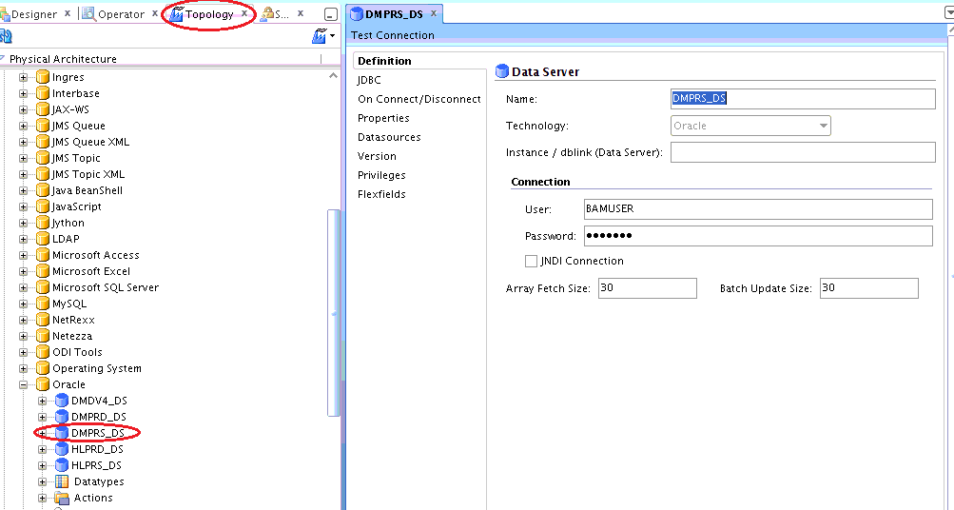

Give JDBC Connection URL details in JDBC tab.

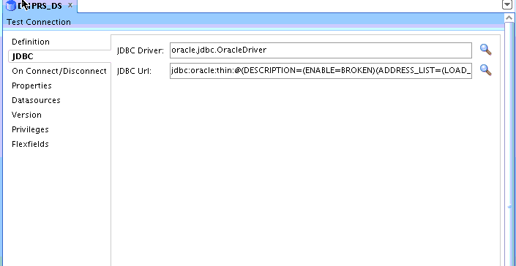

Create Physical schema as below.

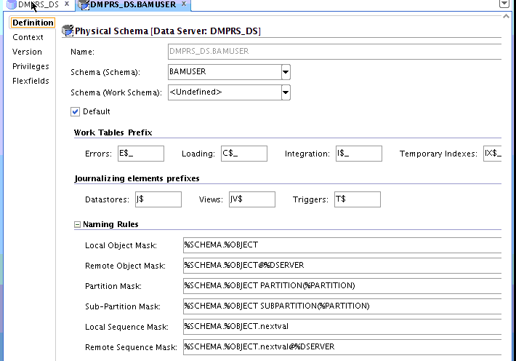

Choose any schema that contains data you want to work with.

Context tab: We are choosing Global context and Type in the name "DMPRS_LS" as the name of a new Logical Schema. ODI will automatically create the Logical Schema.

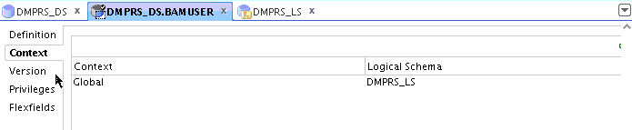

Created Logical Schema in Logical Architecture part as below.

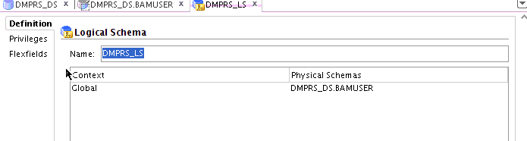

Repeat the above steps to create Physical schema and logical schema for target system also.

Now go to Designer window to create Models and Interfaces.

We have to create models for source and target systems (Here Source is PRS and Target system is DV4)

Create Model for DMPRS as follows.

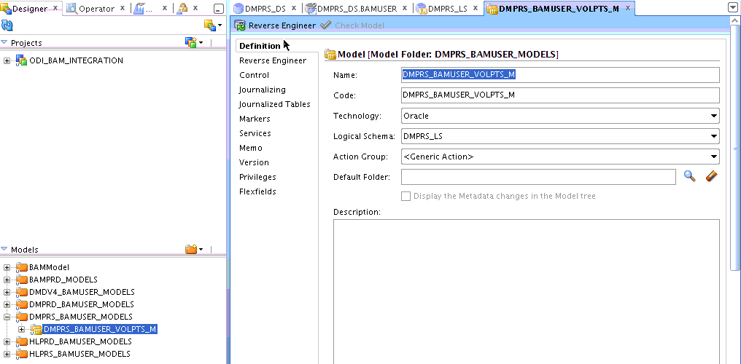

Do reverse engineering from Reverse Engineering tab and choose context as Global.

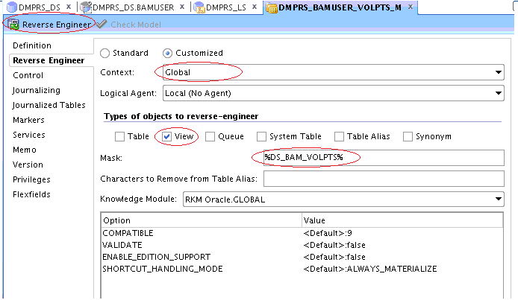

Reverse Engineering will load all the tables or views which you required to work for the PRS Instance.

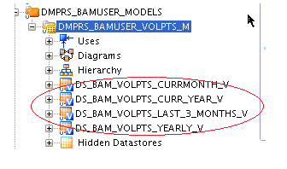

Repeat the above steps for target system also, to get all the target tables or views.

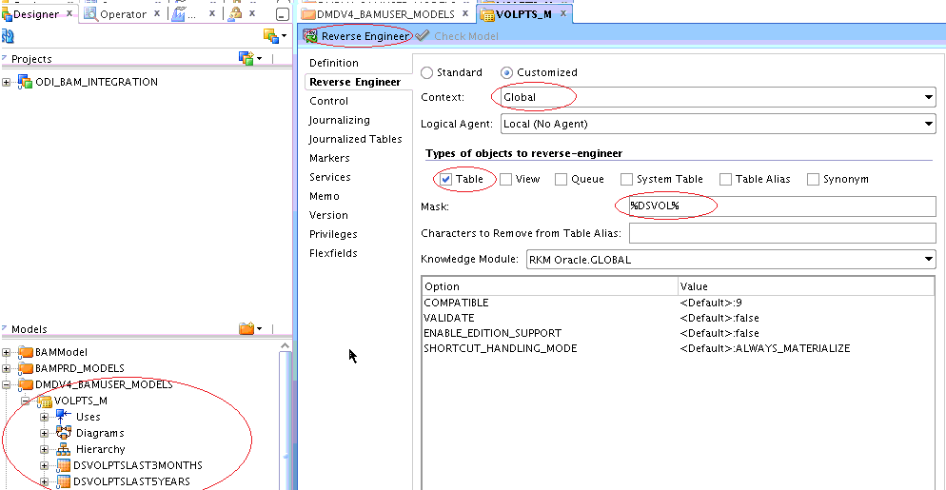

Now we have to create interface to pump the data from source system table/view to Target system table/view.

Create new interface in Projects area of Designer.

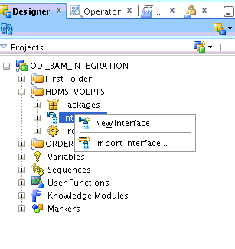

Give name to your interface

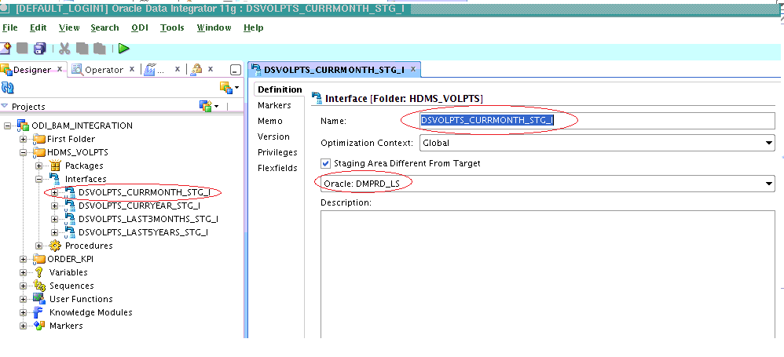

Go to Mapping Tab and drag source Data source, Target Data sources from respective models and perform auto mapping.

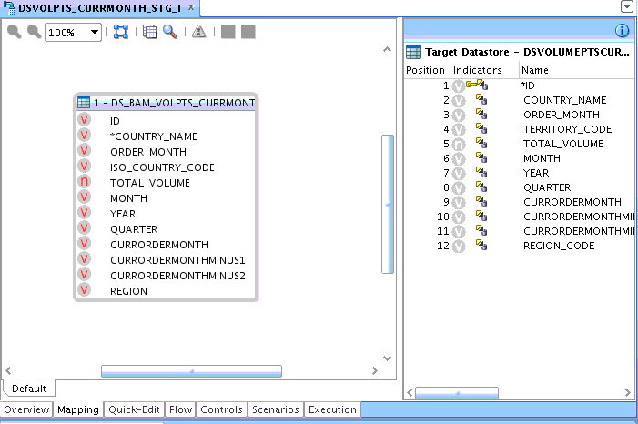

Goto Flow tab and select respective Knowledge module.

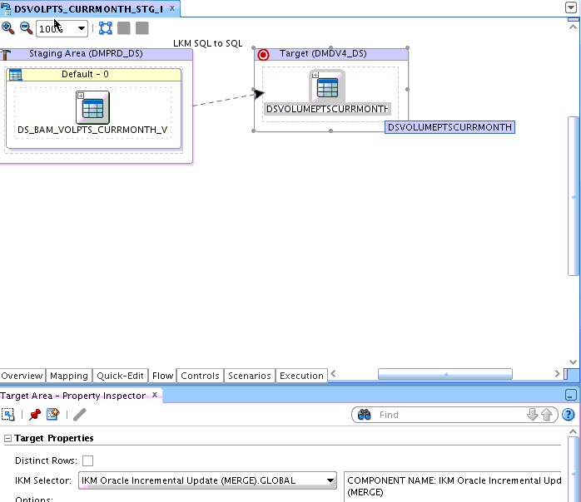

Interface creation completed.

To test interface select the interface which you want to test and click run button.

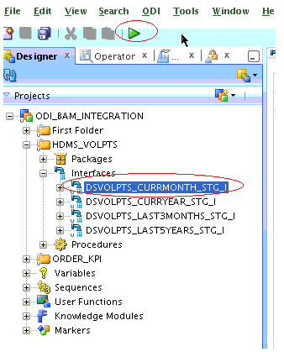

To see the result go to operator window.

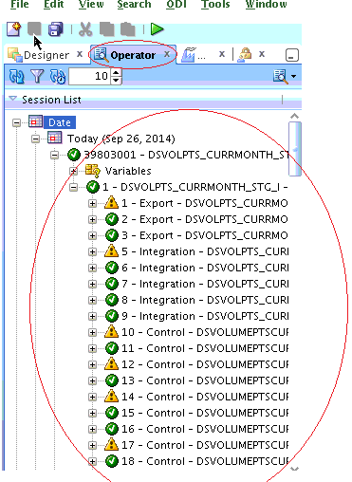

BAM:

Log Into BAM Console

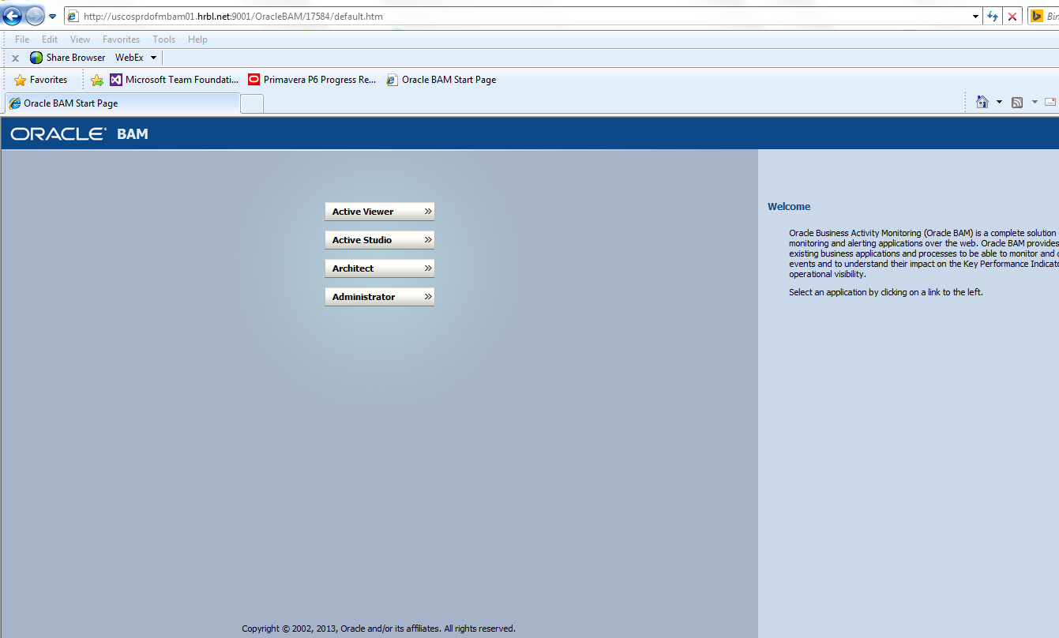

Click on Architect to create External Data Source, EDS will sync the data from Database tables/views to BAM DO’s on real time basis.

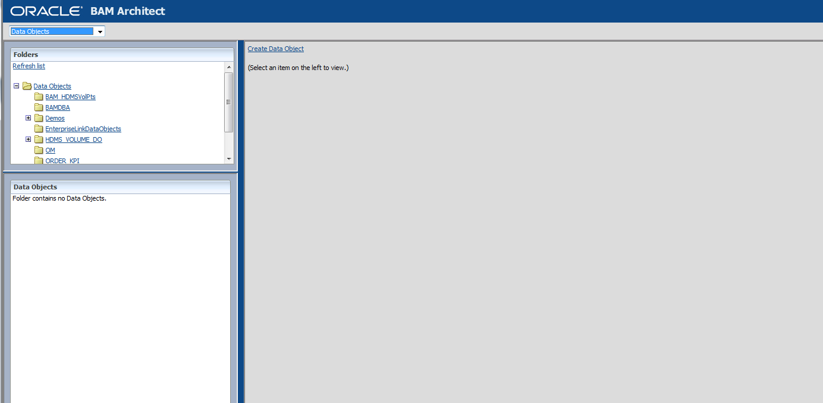

Select External Data Source from drop down and click on create button

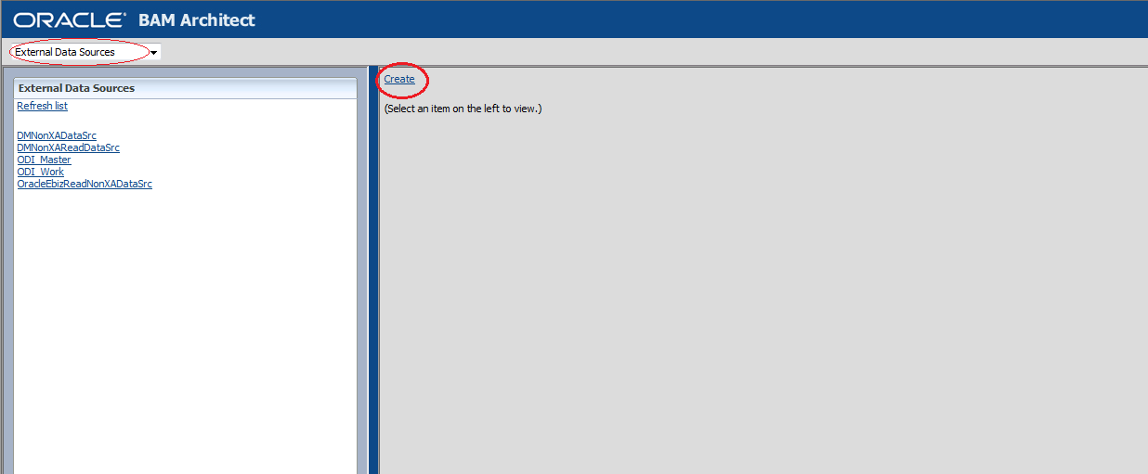

Give the schema details which you want to connect.

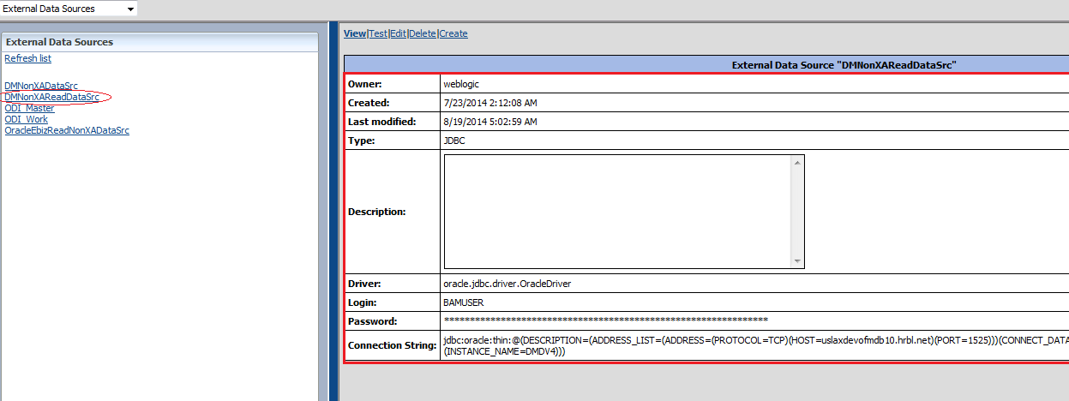

Here we are connecting to BAMUSER schema of DMDV4 DB instance.

Now select Data object from drop down to create Data Object.

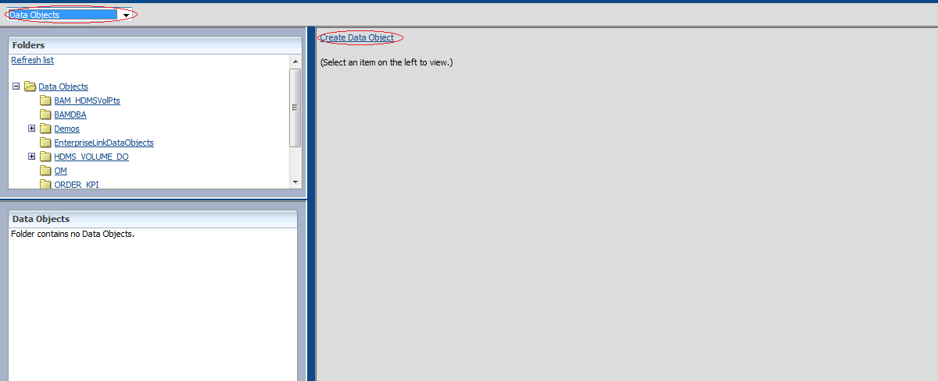

Give the details Name of DO, and choose **External Data Object** option as we are creating it from external table of BAMUSER schema.

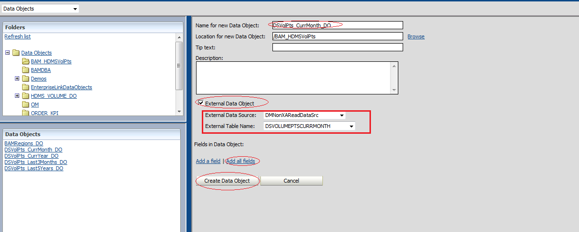

Select **Add All Fields** to add the all fields to BAM DO.

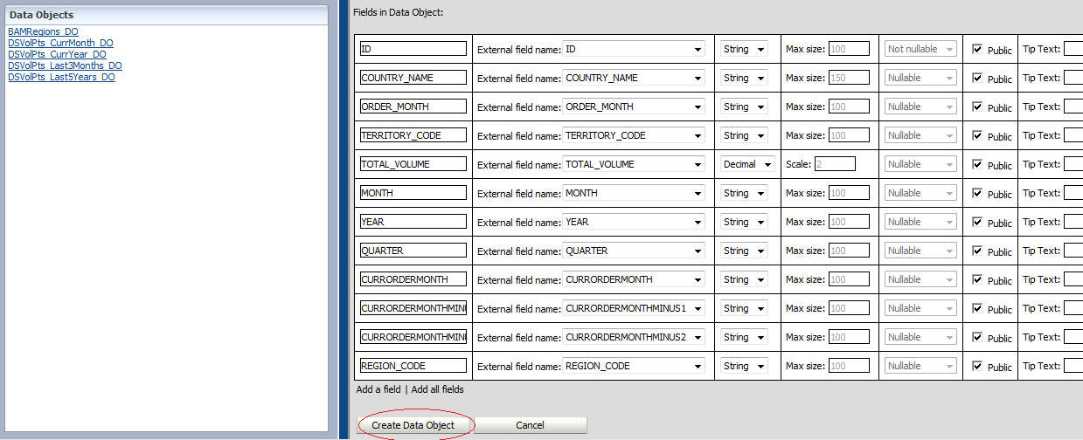

Click Create Data Object to create DO.

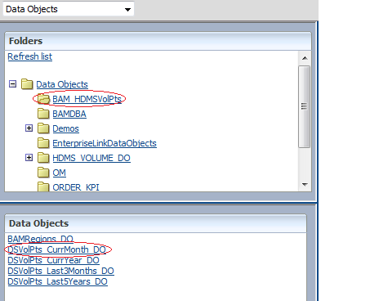

DsVolPts_CurrMonth_DO BAM DO has been created in BAM_HDMSVolPts folder.

**Report Creation:**

To create report click on Active Studio on BAM Start Page.

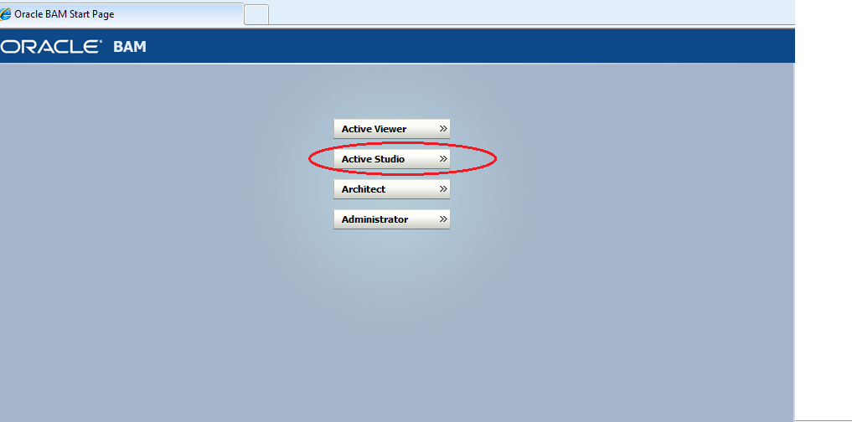

Click on Create New Report

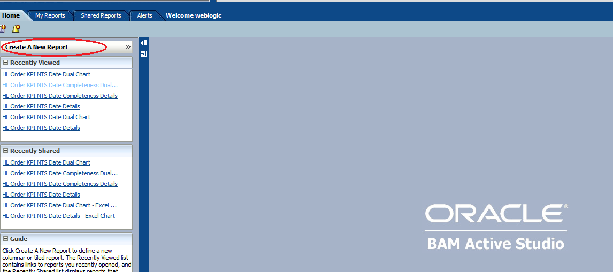

Select Template as per your requirement i.e how you want to represent your data.

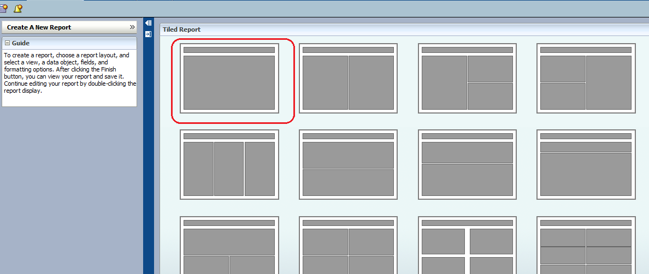

Select Template from the list, we are using Crosstab template

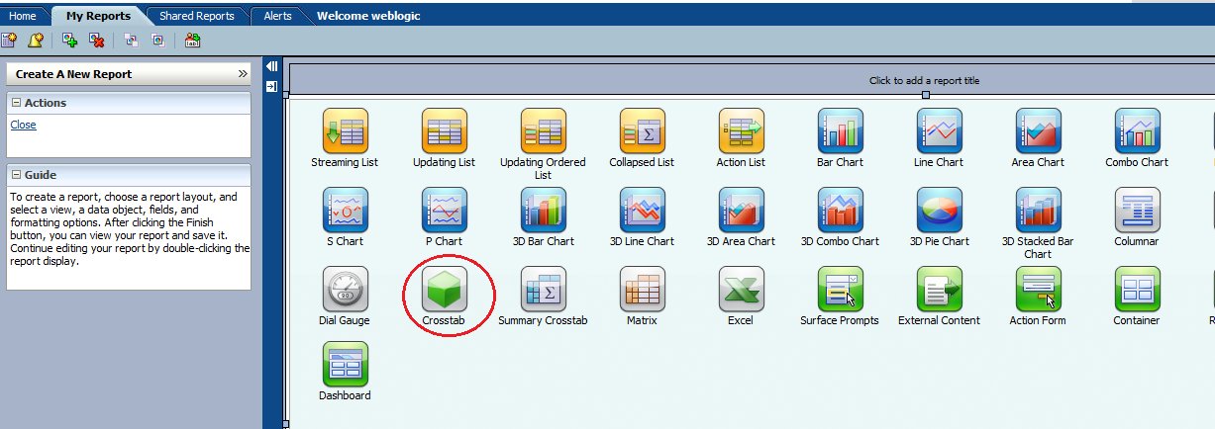

Select the DO on which we have to create report.

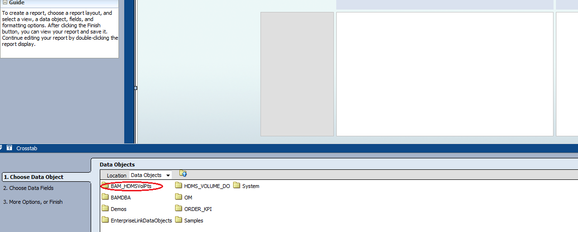

Select the Data Object from the list of DO’s.

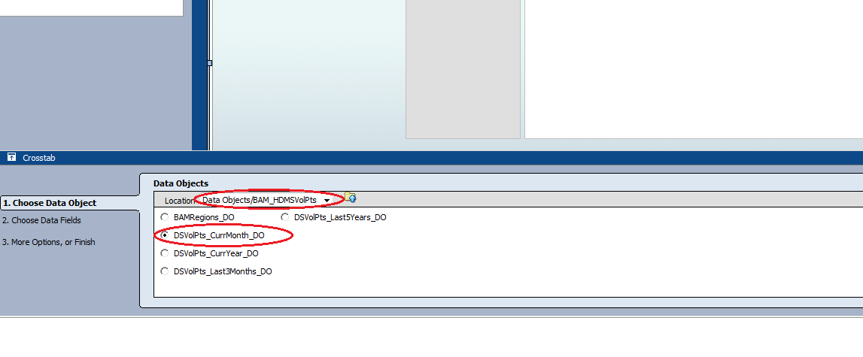

Select the fields which you want to display on the report

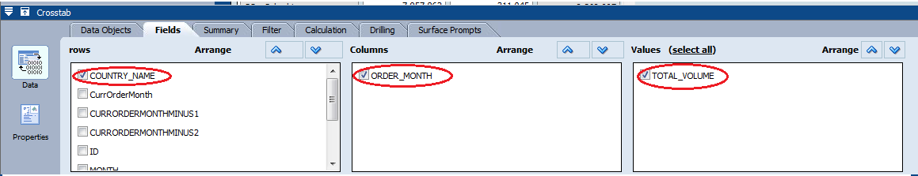

Click apply and then ok, our report is ready, give the name to the report.

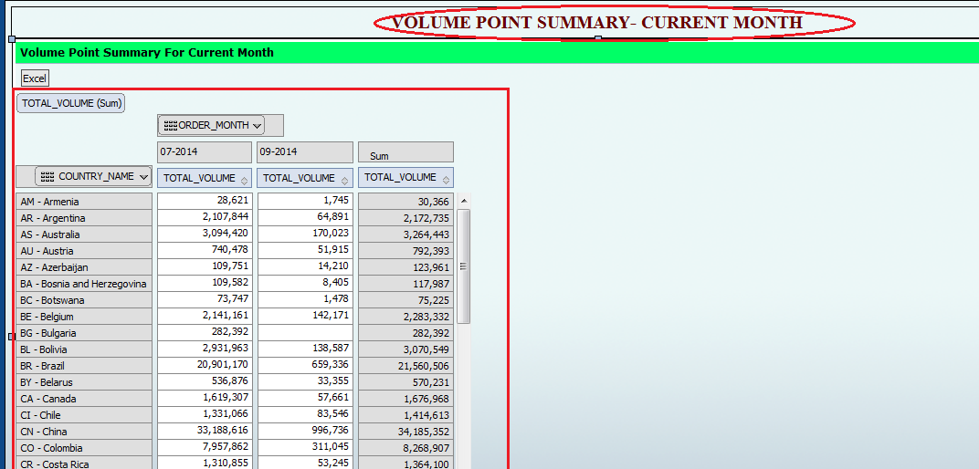

Now we have to create report for the all the existing DO’s the ), then we will put all these Crosstab Reports in Tab Group Report finally call this Tab Group Report from Dash board Report.

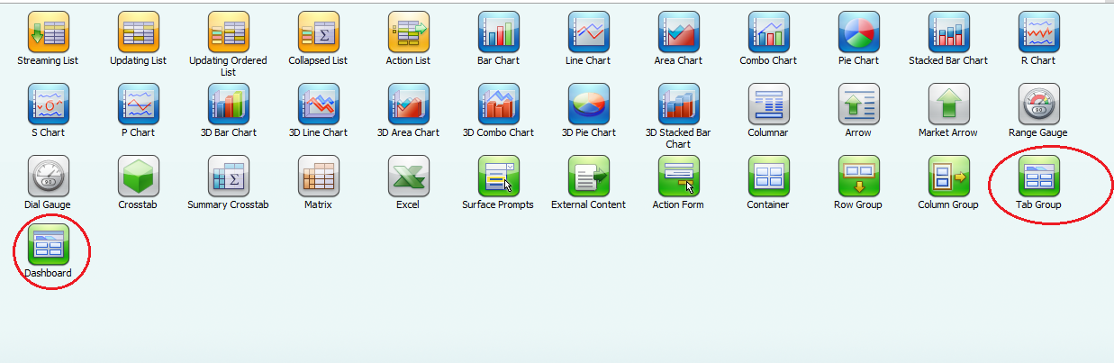

Finally save the report in Shared Reports.

