Name: Y.Sreenadh
Reg no: 192525166
5. Construct a scheduling program with C that selects the waiting process with the highest priority to execute next.
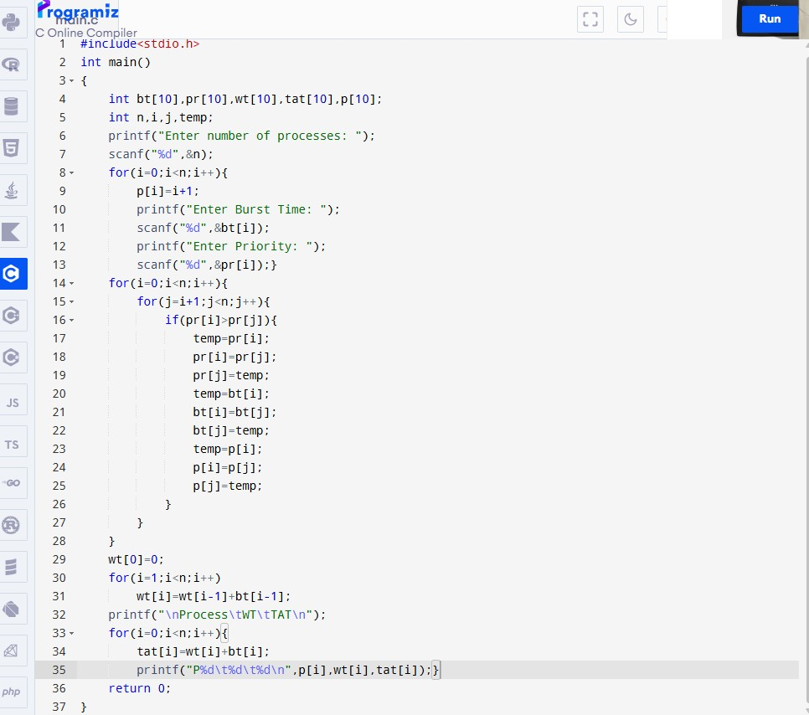
Code:

Output:

