Name: Y.Sreenadh
Reg no: 192525166
8. Construct a C program to simulate Round Robin scheduling algorithm with C.
Code:
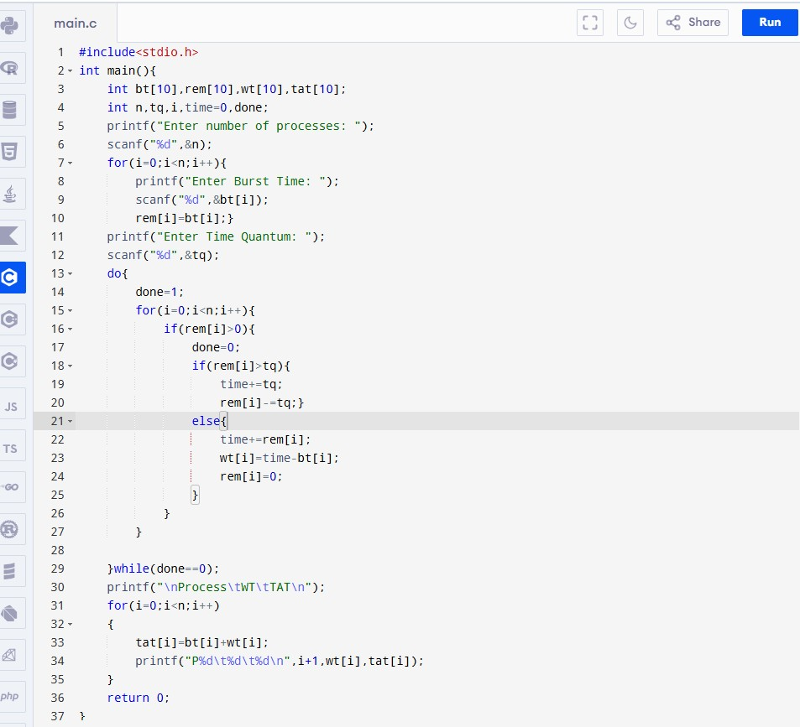

Output:

