Name: Y,Sreenadh
Reg no: 192525166
4. Construct a scheduling program with C that selects the waiting process with the smallest execution time to execute next.
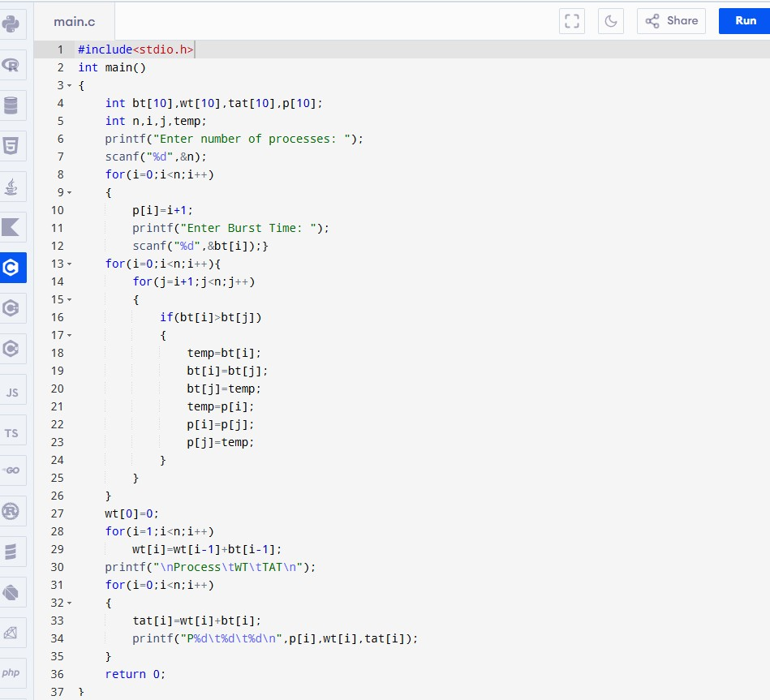
Code:

Output:

