Name: Y.Sreenadh
Reg no: 192525166
3. Design a CPU scheduling program with C using First Come First Served technique with the following considerations. a. All processes are activated at time 0.
b. Assume that no process waits on I/O devices.
Code:
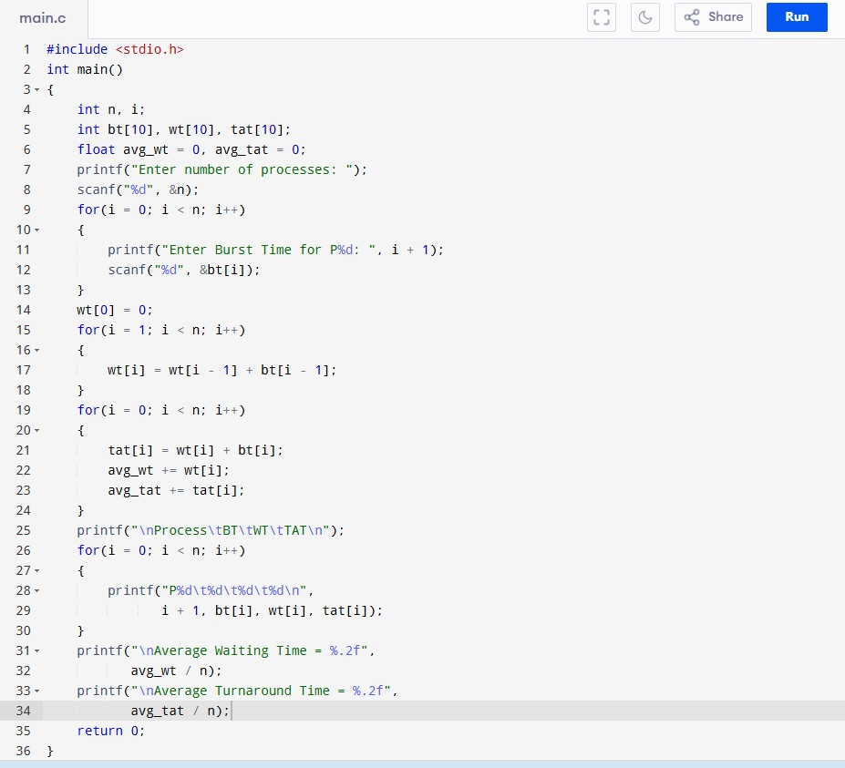

O
utput:

