Name: Y.sreenadh
Reg no: 192525166
7. Construct a C program to implement non-preemptive SJF algorithm.
Code:
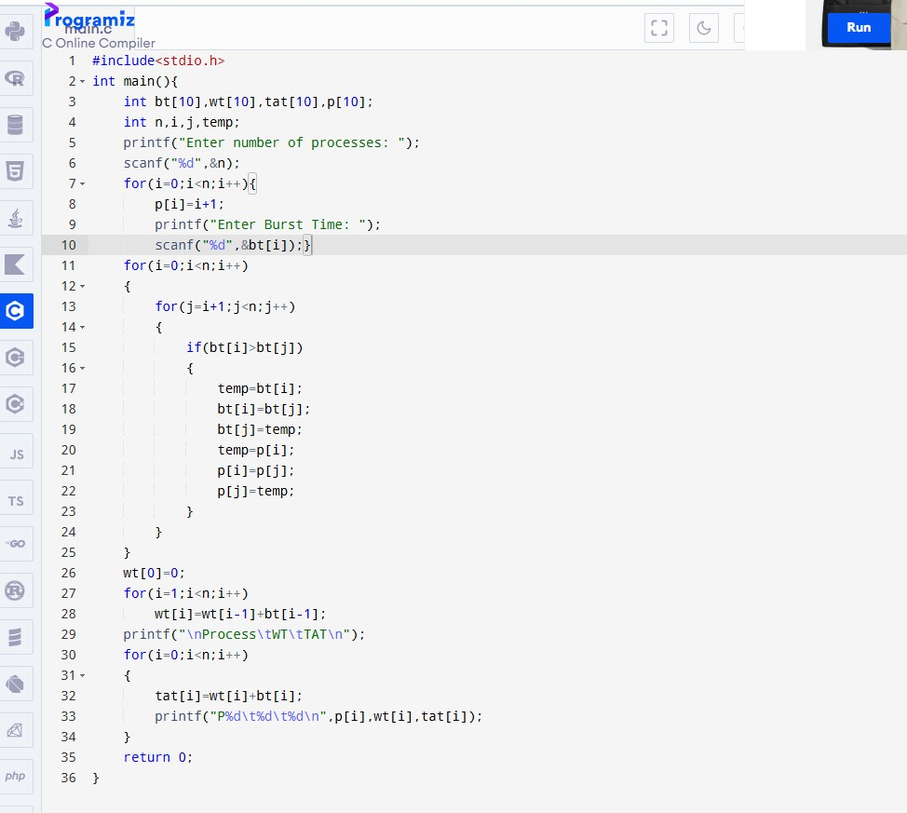

Output:

