Name: Y.Sreenadh
Reg no: 192525166
6. Construct a C program to implement pre-emptive priority scheduling algorithm.
Code:
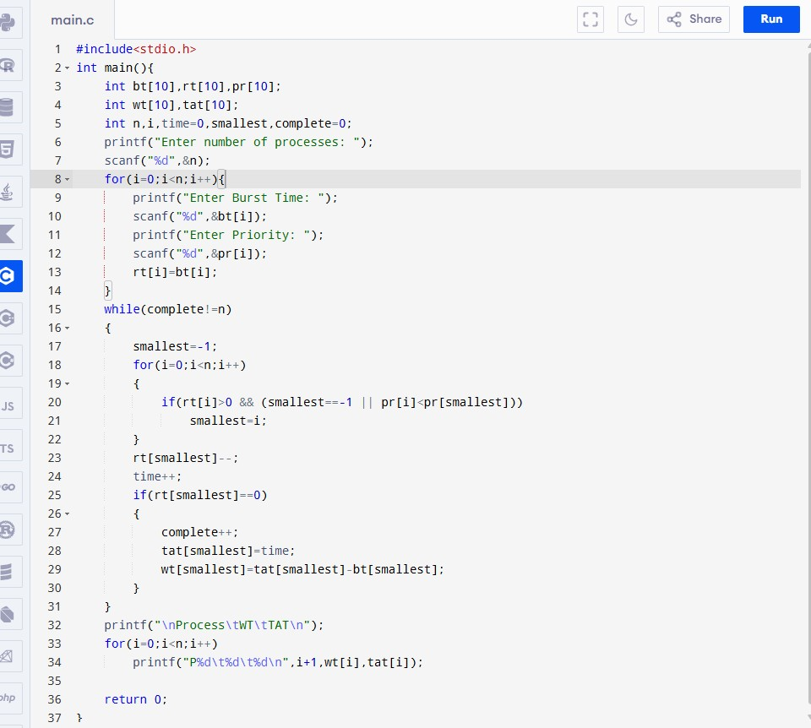

Output:

