Name:Y.Sreenadh
Reg no :192525166
2. Identify the system calls to copy the content of one file to another and illustrate the same using a C program.
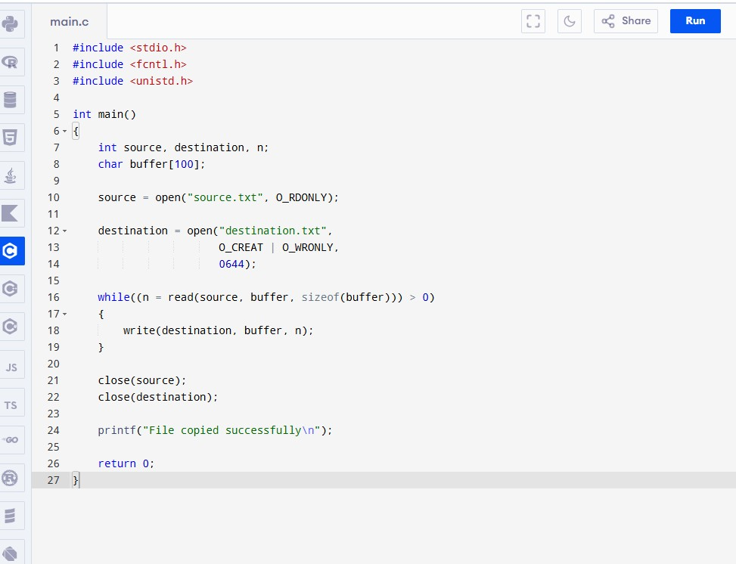
Code:

Output:

